Phishing Emails in Action- Report: TryHackMe

Author: Vineeth M
Date: May 2, 2026

Lab Overview
- Platform: TryHackMe
- Room Name: Phishing Emails in Action
- Lab Type: Static Analysis / Scenario-Based Examining

Purpose of the Lab
The primary purpose of this lab is to provide hands-on experience in Email Forensics. It simulates a real-world Security Operations Center (SOC) scenario where an analyst must move beyond simply identifying "spam" to performing a deep-dive analysis of email headers, source code, and malicious attachments. It focuses on identifying how attackers bypass email filters and use social engineering to deceive users.

Learning Objectives (What We Achieve)
By completing this investigation, we achieve the following technical competencies:
- Header Decoding: Proficiency in reading Received headers to trace the geographical and server-side origin of an email.
- Authentication Verification: Understanding how to validate SPF, DKIM, and DMARC results to detect sender spoofing.
- Attachment Forensics: Learning to safely extract file hashes and analyze malicious attachments (such as macros or executables) using sandboxed tools.
- Link Analysis: Skill in "defanging" and inspecting hidden URLs to identify credential harvesting sites without compromising the analyst's machine.
- SOC Workflow: Mastery of the end-to-end process of turning a suspicious email into a set of actionable Indicators of Compromise (IoCs).

Task #[1]: Cancel Your Order

A. Scenario Description
The scenario involves a financial impersonation attack where a fake PayPal receipt is used to trick the recipient into "disputing" a non-existent charge. The attacker combines visual mimicry with technical deception to steal credentials or deliver malware.

Phishing Techniques Used:
- Spoofed Email Address: Impersonating a trusted service (paypal) to gain immediate credibility.
- URL Shortening: Using redirection services to hide the true malicious destination.
- Branded HTML: Staging legitimate corporate Branding create a false sense of authenticity.

First Observations
Initial review of the email header reveals key red flags. The subject line creates urgency with a fake transaction. The sender address is spoofed, as the display name does not match the actual email. Additionally, the recipient address appears unusual and not a standard Yahoo domain. Mass phishing campaign indicators - Recipient address is auto-generated / unusual Yahoo subdomain,

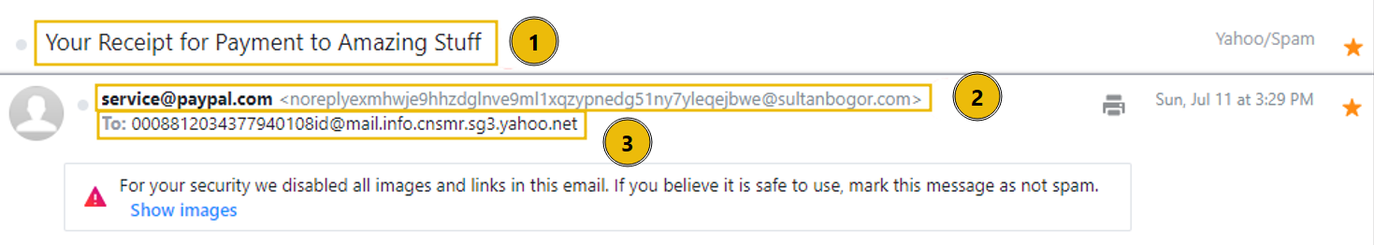

Email Body Analysis

The email body appears to be a PayPal receipt for a gift card purchase, designed to look legitimate. It contains no attachments, and the only interactive element is a “Cancel the order” button, which requires further inspection.

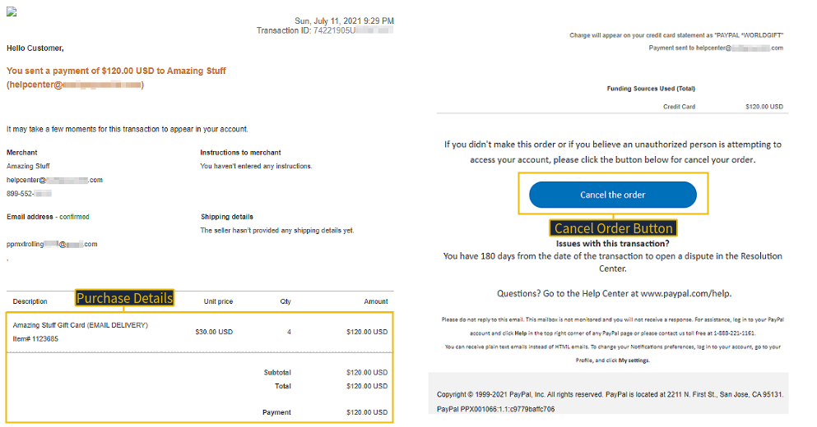

Button Investigation
Examining the email’s raw source reveals that the “Cancel the order” button links to a shortened URL(is.gd). This hides the final destination, making it difficult to verify its legitimacy. Therefore, links or buttons should not be trusted without confirming where they lead.

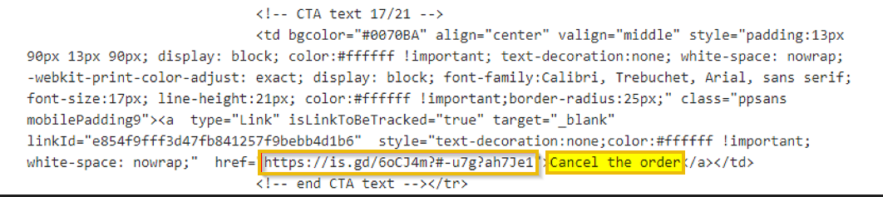

Final Verdict : Likely credential harvesting objective

Task #[2]: Track Your Package

A. Scenario Description
This scenario involves a phishing email that impersonates a shipping notification to create urgency using a fake tracking number. The attacker uses spoofed sender details, hidden tracking pixels, and a manipulated link to appear legitimate and entice the recipient to click, ultimately aiming to compromise the user.

First Observations
- Subject line uses a fake tracking number to create urgency in the subject field.
- Sender name does not match the actual email address .
- Hyperlink with Tracking number matches the subject but destination is unknown

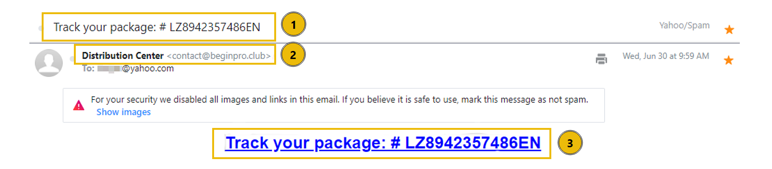
Yahoo blocked the images from automatically loading and disabled links because the email appears suspicious and may be a phishing attempt. Blocking images prevents tracking pixels from notifying the attacker, while disabling links protects the user from potentially malicious destinations.
Hyperlink Tracking
Tracking pixels are small hidden images embedded in emails that send information back to the attacker when opened. They help spammers confirm active users and monitor engagement, which is why email providers like Yahoo block images by default to protect user privacy and prevent tracking.

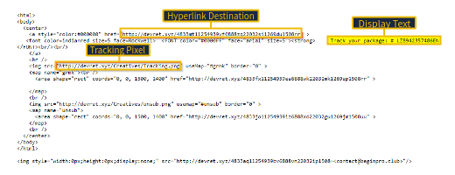

Task #[3]: Download Document Here

A. Scenario Description
This scenario describes a multi-stage phishing attack where the attacker sends an email claiming a fax document is about to expire to create urgency. When the user clicks the “Download Document” button, they are redirected through multiple fake pages impersonating trusted services like OneDrive and Adobe to build trust. Eventually, the user is taken to a fake login page that looks like an email sign-in portal. When the user enters their credentials, they are captured by the attacker, and a generic error message is shown to avoid suspicion.

First Observations
- The send date and expiry date being the same indicates a deliberate urgency tactic used by the attacker to pressure the victim into immediate action
- Download Document Here button:
There is an action to perform. In this case, a button to download the fax

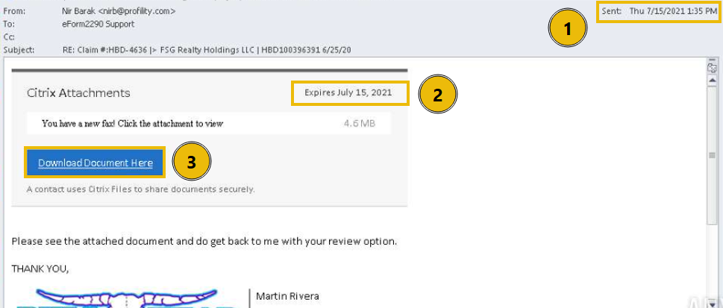

After clicking the Download Document Here button, the user is redirected to a fake OneDrive page. Further interaction leads to a second redirect to a suspicious Adobe-themed site, which ultimately sends the user to a fake login page designed to steal email credentials.

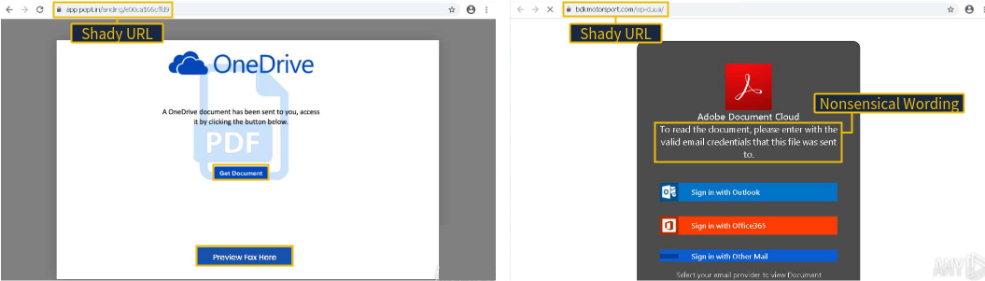

Then the victim attempts to log in with Outlook, but a generic error appears regardless of input because the page is fake and only collects credentials. Modern attackers can use AI to create more convincing phishing pages, making them harder to detect.
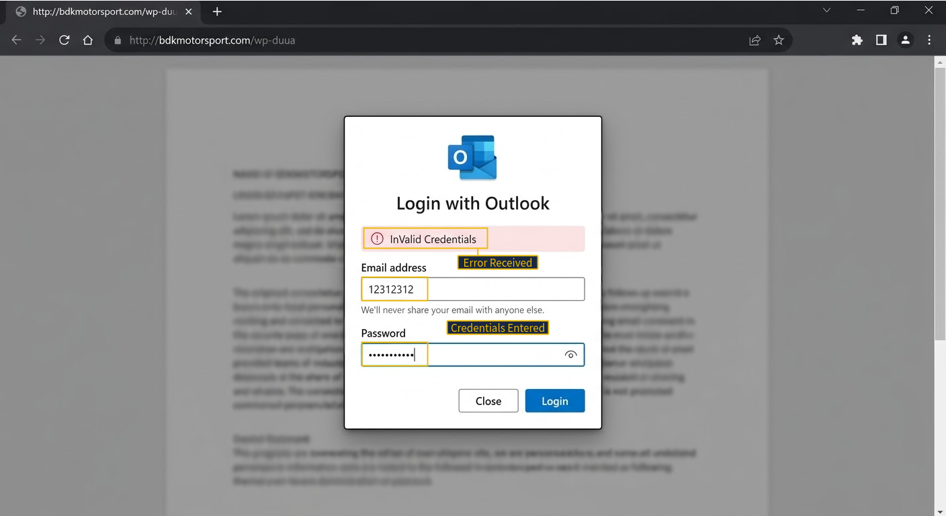

Task #[4]: Your Account Is on Hold

A. Scenario Description
This is an attachment-based phishing attack where the attacker impersonates Netflix billing and creates urgency about a suspended account. Instead of a direct link, a PDF attachment is used, which contains a link that redirects to a fake site to steal user information.

First Observations
- Email subject: The receiver's ID was suspended and must act quickly ,its create a urgency
- From address: The display name does not match the user and domain ,it indicates the sender spoofing
- Brand impersonation: The attacker created an email using HTML that visually looks like an official Netflix message

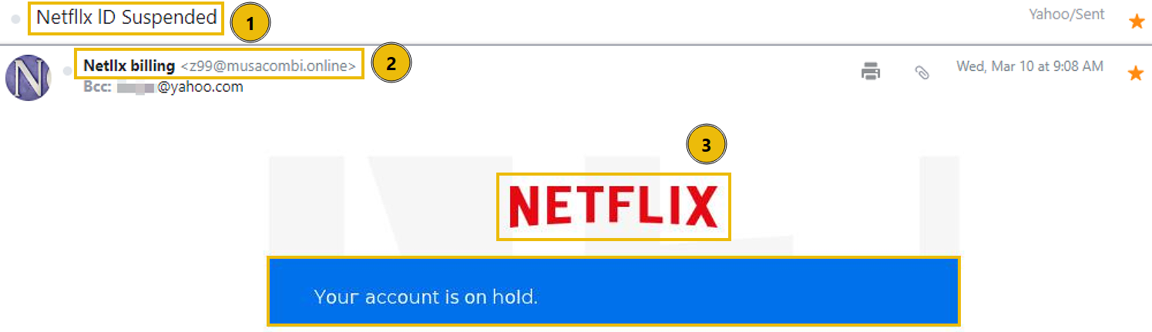

The email claims a billing issue and instructs the user to open a PDF attachment to update their account. The PDF contains a link (“Update Payment Account”) that redirects to a non-legitimate domain. Additional red flags include an unusual phone number format and the use of a real Netflix help center link to appear trustworthy.

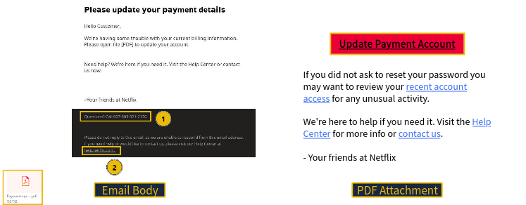

Key Points – Email Body & Attachment Analysis
- Claims billing issue to create urgency
- Asks user to open attached PDF to fix account
- PDF contains “Update Payment Account” link
- Link redirects to a non-legitimate (fake) domain
- Uses unusual phone number format (red flag)
- Includes real Netflix help center link to appear trustworthy

Finay Verdict:
Based on the analysis, this attack is an attachment-based phishing campaign designed to harvest user credentials and financial information by redirecting victims from a PDF attachment to a fake Netflix login/payment page.

Task #[5]: Your Recent Purchase

A. Scenario Description
This is an attachment-based phishing attack impersonating Apple Support, using a blank email and a malicious .dot file. Opening the attachment redirects the user to a fake website to steal information.

First Observations
- Email subject: The recipient is told they must act quickly to resolve an unauthorized purchase, creating a false sense of urgency
- From address: The display name, Apple Support, does not match the user and domain. There are also typos in the From and To addresses
- Blind Carbon Copy: The recipient was not directly emailed, instead Blind Carbon Copied (BCC)
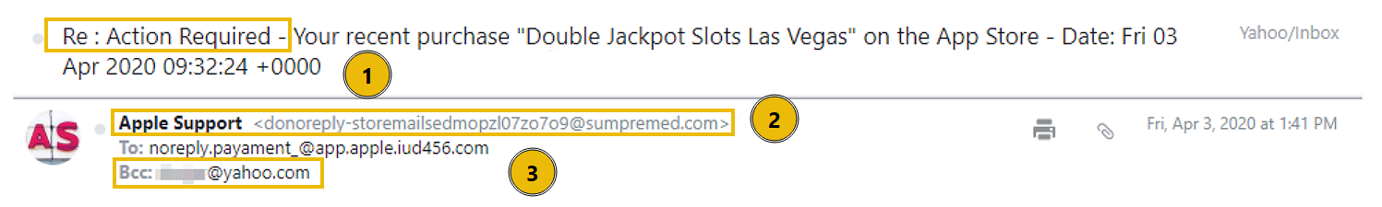

Analyzing the Attachment
The email body is completely blank, which is inherently suspicious.
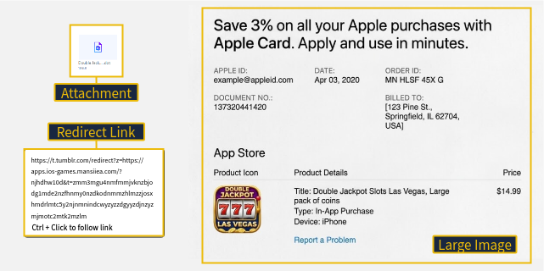
The only content included is a .dot file attachment, prompting further analysis. Upon opening the file, interacting with the embedded image redirects the user to a phishing website. Although the URL contains familiar terms such as “apps” and “iOS” to appear legitimate, its excessive length and complexity strongly indicate a malicious redirection attempt.

Final Verdit: The email is a phishing attempt using a malicious .dot attachment to redirect the victim to a likely credential harvesting site through social engineering and embedded links

Task #[6]: Scheduled Shipment

A. Scenario Description
This is a malware delivery phishing attack impersonating DHL. The email appears legitimate using branded HTML and a spoofed sender, and includes an Excel attachment.
Opening the .xlsx file reveals inconsistencies (mixed locations/languages) and a clickable link. When clicked, it attempts to download and run a malicious file (regasms.exe). Although execution fails here, the intent is to run malware on the victim’s system.

Phishing Techniques Used
- Spoofed email address: The sender's display name is set to DHL Express
- Brand impersonation: Utilizing HTML templates and logos to mimic DHL
- Attachments: An Excel document that triggers executable code upon opening

First Observations
- Email subject: Gives the impression that DHL will be shipping a package
- From address: The display name, DHL Express, does not match the user and domain
- Brand impersonation: The HTML in the email body is designed to look like it is sent from DHL
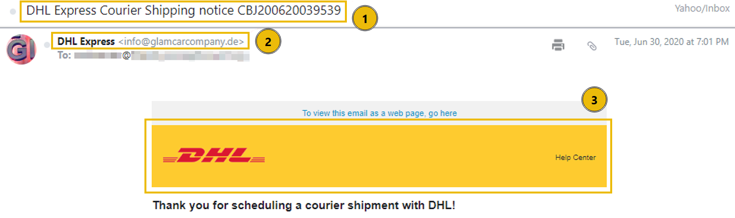

Email Body and Attachment
The email body is minimal, with the main threat in the attached .xlsx file. The document shows inconsistencies, such as a German domain, an Indian billing location, and Mandarin content—clear red flags. It also includes a clickable link that advances the attack to the next stage.
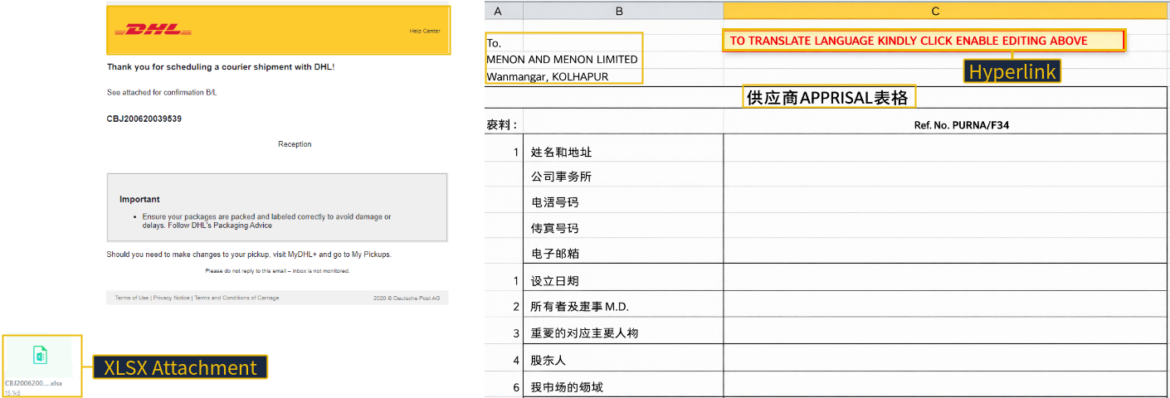

The Executable
Clicking the link in the Excel file attempts to download and run a malicious file (regasms.exe). Although it fails with a system error in this case, it shows the attacker’s intent to execute code on the victim’s machine.
If successful, the attacker could maintain access, steal sensitive data, or deploy ransomware.
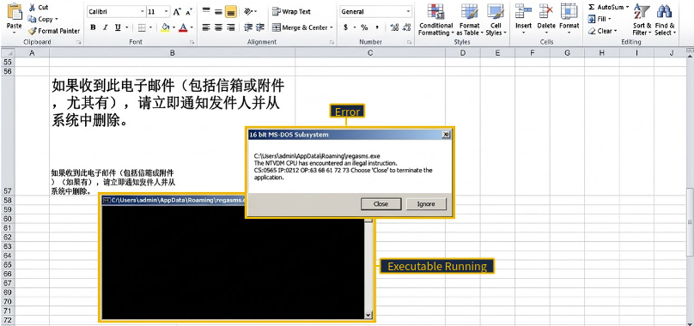

If successfully executed, the attacker could:
- Establish : Create a backdoor or scheduled task to maintain access after a reboot
- Exfiltrate Data: Steal sensitive files, credentials, or browser-stored passwords
- Deploy Ransomware: Encrypt the system and demand payment for recovery

Conclusion
In this section, I analyzed various phishing attempts and developed the ability to distinguish between legitimate and malicious emails. By examining email headers, content, links, and attachments, I learned to identify key red flags such as spoofed senders, suspicious domains, and social engineering techniques.

