Pyramid Of Pain Report: TryHackMe

Author: Vineeth M
Date: May 2, 2026

Lab Overview:

- Platform: TryHackMe
- Room Name: Pyramid of Pain
- Lab Type: Interactive Learning Lab

Purpose of the Lab
The primary objective of this lab is to master the Pyramid of Pain model to enhance defensive security operations. The content focuses on moving beyond simple technical blocks, such as IP addresses or file hashes, to detecting complex attacker behaviors. Through the analysis of real-world artifacts and sandbox reports, the lab demonstrates how to increase the "pain" for an adversary by targeting the specific tactics they find hardest to change.

Key Concepts Covered
- Indicator Ranking: Categorizing various indicators based on the level of effort required for an attacker to modify them.
- Detection Strategy: Shifting focus from "trivial" detections like hashes to "tough" detections like Tactics, Techniques, and Procedures (TTPs).
- Hands-on Investigation: Utilizing data from tools such as VirusTotal and Any.Run to identify malicious host and network artifacts.

Introduction
The Pyramid of Pain is a key framework used to improve the effectiveness of Cyber Threat Intelligence (CTI), threat hunting, and incident response. It illustrates how different Indicators of Compromise (IOCs) affect an adversary, ranging from "trivial" items like file hashes to "tough" behavioral patterns known as Tactics, Techniques, and Procedures (TTPs).
Major security platforms like Cisco Security, SentinelOne, and SOCRadar apply this concept to help SOC Analysts and Threat Hunters move beyond reactive blocking. By focusing on the higher levels of the pyramid, security teams can inflict maximum "pain" on attackers, forcing them to expend significant resources to retool or abandon their campaign entirely.

Task 2 : Hash Values (Trivial)

Hashes in the lab
I learned that a file hash is a fixed-length value used to identify data, and algorithms like MD5, SHA-1, and SHA-2 are commonly used for this purpose. MD5 and SHA-1 are no longer considered secure for strong cryptographic use, while SHA-2 is the stronger modern family.

The key observation in this lab is that changing even a small part of a file, such as appending a string, produces a completely different hash value. This shows why hashes are useful for identifying known malicious files, but also why they are easy for attackers to evade by making tiny modification

Security takeaway
Hashes are helpful as indicators of compromise because they let analysts quickly recognize a known sample. However, they are not reliable as a long-term detection method on their own, since malware can be repacked or slightly altered to generate a new hash.

My note
My main learning is that hashes are best used for fast identification, not as the only defense. In the Pyramid of Pain, file hashes are one of the easier indicators for attackers to change, so defenders should combine them with stronger indicators like filenames, behavior, and infrastructure.

Task 3 : IP Address (Easy)

IP address in the Pyramid of Pain
I learned that an IP address is used to identify devices on a network, and in the Pyramid of Pain it is considered a green indicator because it is useful but easy for an attacker to replace. Defenders can block or drop traffic from known malicious IPs, but this is not very durable because an adversary can simply switch to a different public IP address.

Why it is weak
The lab also showed that IP-based blocking can be bypassed with techniques like Fast Flux, where a domain is associated with many changing IP addresses. This makes it harder for defenders to trace malicious infrastructure and harder to rely on a single IP address as a long-term indicator.

My learning
My takeaway is that IP addresses help in short-term detection and blocking, but they are not strong enough by themselves. In real defense, IPs should be combined with other indicators such as domains, URLs, behavior, and infrastructure patterns.

Task 4 : Domain Names (Simple)

Domain Names
I learned that domain names are a slightly stronger indicator than IP addresses because attackers must usually register a domain, set up DNS records, and manage it to keep it working. In the Pyramid of Pain, this makes domain names harder to change than IPs, so they sit higher on the pyramid.
I also learned that attackers can still hide malicious domains using techniques like Punycode attacks and URL shorteners. Punycode can make a suspicious domain look legitimate at first glance, while shortened links can conceal the real destination until the URL is expanded.

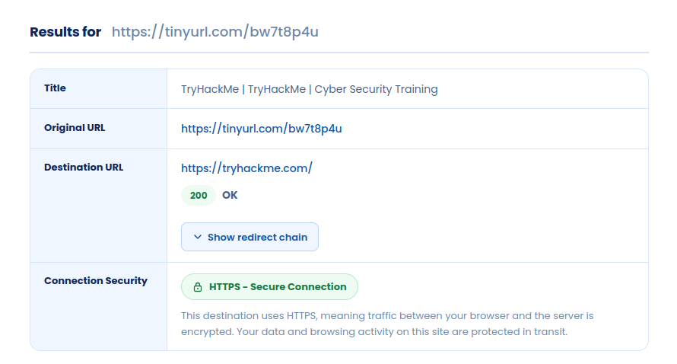
Result for the specific url that unshorten

Detection
For detection, proxy logs and web server logs can help identify malicious domain activity. In sandbox tools like Any.run, network activity such as DNS requests and HTTP connections can also reveal the domains a sample is contacting.

My learning
My main takeaway is that domain names are more useful than IP addresses for detection because they require a little more effort for attackers to change. Still, they are not perfect because attackers can rotate domains, use obfuscation, or hide behind URL shorteners.

Task 5 : Host Artifacts (Annoying)

Host Artifacts
I learned that host artifacts are the traces attackers leave behind on a system, such as registry changes, suspicious processes, dropped files, attack patterns, and other indicators of compromise. These artifacts are more valuable than IPs or hashes because they often reflect what the attacker did on the host, not just one easily replaced identifier.
This level is more annoying for attackers because they may need to change tools, modify techniques, or rewrite parts of their attack to avoid detection. That makes host artifacts a stronger defensive indicator and more time-consuming for the attacker to work around.
My main takeaway is that host artifacts help defenders detect malicious activity through system behavior and leftover traces, which makes them harder to evade than simple hashes, IP addresses, or domains.

Task 6 : Network Artifacts (Annoying)

Network Artifacts
I learned that network artifacts are signs of attacker activity visible in network traffic, such as unusual User-Agent strings, C2 communication details, and URI patterns in HTTP requests. In the Pyramid of Pain, this is part of the yellow zone because detecting these indicators can force the attacker to change tools or rebuild parts of their communication method.
I also learned that network artifacts can be found in PCAP files using tools like Wireshark or TShark, and in IDS alerts from tools like Snort. A useful example is checking HTTP requests with TShark to extract the host and User-Agent fields, which can reveal suspicious or uncommon client behavior.
My main takeaway is that network artifacts are more painful for attackers to change than IP addresses or hashes, because they often reflect how the attacker communicates rather than just a single file or server.
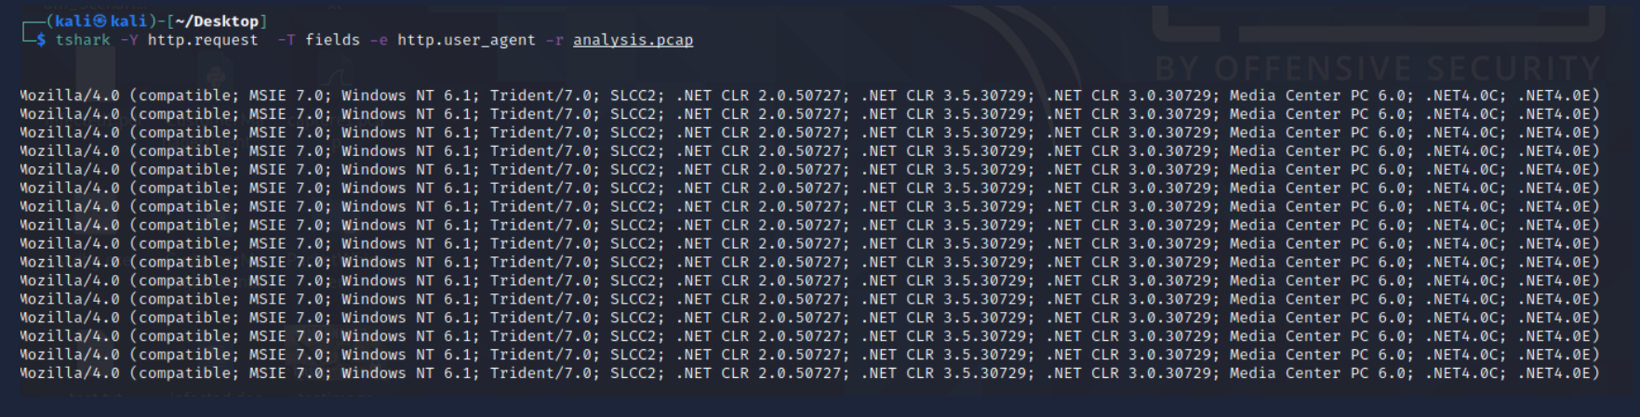
These are the most common User-Agent strings found for the Emotet trojan.

Task 7: Tools (Challenging)

Tools and techniques
I learned that this part of the Pyramid of Pain is much harder for attackers because it targets their tools and tradecraft instead of simple indicators. If defenders can detect malicious macros, backdoors, custom executables, DLLs, payloads, or password crackers, the attacker often has to build or buy a new tool, which costs time, money, and effort.
I also learned that antivirus signatures, detection rules, and YARA rules are useful at this stage. These help defenders match known malicious code patterns and hunt for related samples across different environments, which makes it much more difficult for an attacker to reuse the same tooling.

Fuzzy hashing
Another important learning was fuzzy hashing, which compares files that are similar but not identical. Unlike normal hashes, fuzzy hashes can still show a relationship between two files even if small changes were made, and SSDeep is one example of this approach.

Threat hunting value
Resources like MalwareBazaar and Malshare provide samples and feeds that can support threat hunting and incident response. SOC Prime’s detection marketplace is also useful because it shares detection content for active threats and exploited vulnerabilities.
My main takeaway is that this level is powerful because it forces attackers to change their tools, not just their file names or IPs, which makes defense far more effective.
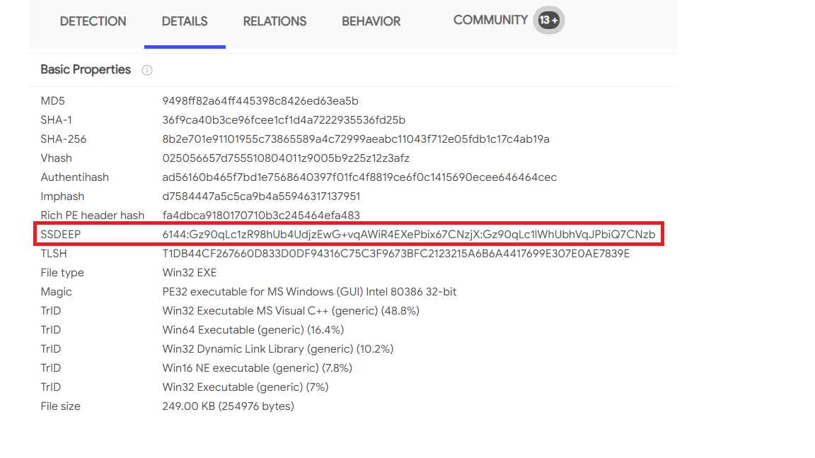
Example of SSDeep from VirusTotal

Task 8: TTP (Tough)

TTPs (Tactics, Techniques & Procedures)
I learned that TTPs means Tactics, Techniques, and Procedures, and this is the apex of the Pyramid of Pain. It covers the full attack flow, from initial phishing and persistence to lateral movement and data exfiltration.
This level is the hardest for attackers to change because it focuses on how they operate, not just on one file, IP, or domain. If defenders can detect TTPs quickly, they can respond before the attacker can adapt or continue the intrusion.
A good example is detecting a Pass-the-Hash attack through Windows Event Log monitoring and then remediating it. That kind of response can expose the compromised host fast and stop lateral movement inside the network.
My main takeaway is that TTP-based detection is the most powerful because it targets attacker behavior directly. At this stage, the attacker usually has to redesign their methods or move on to another target.

Task 9 Practical: The Pyramid of Pain

Objective
Map given attacker indicators to the correct levels of the Pyramid of Pain.

# | Prompt | Pyramid Level | Explanation
1 | These signatures can be used to attribute payloads and artefacts to an actor | Hashes | File fingerprints (MD5, SHA, ssdeep) used to identify malware or files
2 | These addresses can be used to identify the infrastructure an attacker is using for their campaign | IP Addresses | Numerical network locations of attacker servers (C2, hosting, etc.)
3 | An attacker has purchased this and used it in a typo-squatting campaign | Domain Names | Registered domains used for phishing or malicious hosting
4 | These artefacts can present themselves as C2 traffic for example | Network Artifacts | Observable network patterns like DNS, HTTP requests, beaconing
5 | The attacker has utilised these to accomplish their objective | Tools | Software or utilities used in attacks (malware, scripts, frameworks)
6 | The attackers plans and objectives | TTPs (Tactics, Techniques & Procedures) | High-level behavior and strategy of the attacker

Task 10 Conclusion

Conclusion
As the final exercise, we select any Advanced Persistent Threat (APT) group from the Rapid7 documentation and analyze its activity. By identifying the group’s indicators and behaviors, we can map them to the different levels of the Pyramid of Pain. This process helps in understanding how various indicators relate to attacker difficulty and detection effectiveness. As stated by David Bianco, “the amount of pain you cause an adversary depends on the types of indicators you are able to make use of.”

APT28 Threat Actor – Pyramid of Pain Mapping Document

Threat Actor Overview
APT28, also known by aliases such as Fancy Bear, Sofacy, STRONTIUM, Tsar Team, and Pawn Storm, is a state-sponsored threat group believed to be associated with Russia’s GRU Unit 26165 (85th Main Special Service Center). The group has been active since at least the mid-2000s and primarily targets government entities, political organizations, defense sectors, and international institutions, often with the goal of espionage and influence operations.
Open-source intelligence reports have linked APT28 to cyber intrusions involving political organizations in the United States, as well as operations against global institutions like the World Anti-Doping Agency (WADA). The group commonly employs spear-phishing campaigns, custom malware such as X-Agent and X-Tunnel, and living-off-the-land techniques to maintain persistence, move laterally within networks, and exfiltrate sensitive data.

Collected Indicators and Activities (APT28)
For this exercise, the following indicators and activities are considered:
- Hash-based indicators
  - File hashes publicly reported as belonging to APT28 malware families, referenced in threat advisories and threat intelligence libraries.
- Domain and IP infrastructure
  - Domains reported as used for command-and-control (C2) or phishing by APT28, collected from threat intel feeds such as Rapid7’s Threat Library and public advisories.
  - Supporting IP infrastructure (for example, web servers, VPS resources) where those domains resolve or host payloads.
- Network artifacts
  - HTTP/HTTPS request patterns used by APT28 malware, including characteristic URI paths, query parameters, and user-agent strings where documented.
- Host artifacts
  - Persistence mechanisms such as specific registry keys, scheduled tasks, and services used by APT28 implants to maintain access.
- Tools and malware families
  - Custom malware such as X-Agent and X-Tunnel, as well as supporting loaders and scripts that provide remote access, data theft, or tunneling capabilities.
- Tactics, techniques, and procedures (TTPs)
  - Use of spear-phishing emails with malicious attachments or links for initial access, credential dumping and theft, lateral movement using valid accounts and remote services, and data exfiltration over common protocols.

Mapping APT28 to the Pyramid of Pain
After collecting indicators and activities for APT28, I mapped each of them to the Pyramid of Pain and described the pain to the adversary.

1. Hash values (bottom – very low pain)
- Example for APT28:
  - File hashes of APT28 malware, such as X-Agent/X-Tunnel samples from public advisories.
  - Detection: Suspicious Process – APT28 Related Binary Executed (hash in Threat Library).
- Pyramid level: Hash values.
- Pain to APT28: Very low – they can recompile or pack the malware to change hashes quickly.

2. IP addresses (low pain)
- Example for APT28:
  - C2 server IPs and VPN / proxy infrastructure used to reach victims.
  - Potential detection: rules that alert on outbound connections to known APT28 C2 IPs.
- Pyramid level: IP addresses.
- Pain to APT28: Low – they can move to new IPs or hosting providers with relatively little effort.

3. Domain names (low–moderate pain)
- Example for APT28:
  - Domains used for phishing and C2, as listed in intel feeds and advisories.
  - Detections:
    - Suspicious DNS Request – APT28 Related Domain Observed (DNS logs).
    - Suspicious Web Request – APT28 Related Domain Observed (HTTP/HTTPS logs).
- Pyramid level: Domain names.
- Pain to APT28: Low–moderate – they must register or compromise new domains and reconfigure infrastructure, but core malware and TTPs can stay the same.

4. Network artifacts (medium pain)
- Example for APT28:
  - Specific HTTP request patterns, URI paths, and user-agent strings generated by APT28 malware like X-Agent/X-Tunnel.
  - Potential detection: rule that alerts on HTTP traffic matching known APT28 C2 URI structure or user-agent, regardless of the domain or IP.
- Pyramid level: Network artifacts.
- Pain to APT28: Medium – they must change how their malware communicates (protocol details and C2 behavior), not just which server it talks to.

5. Host artifacts (medium–high pain)
- Example for APT28:
  - Persistence methods such as specific scheduled tasks, services, registry keys, or file paths documented in APT28 reports.
  - Potential detection: rule that looks for creation of services/tasks with APT28-style names or binaries in suspicious locations.
- Pyramid level: Host artifacts.
- Pain to APT28: Medium–high – changing persistence means modifying malware, installers, and operational habits.

6. Tools and malware families (high pain)
- Example for APT28:
  - Use of tools/malware like X-Agent and X-Tunnel, with behaviors like keylogging, credential theft, and tunneling traffic over common ports.
  - Potential detection: behavior-based rules that detect process injection, long-lived encrypted outbound connections from unusual processes, and tunneling patterns typical of these tools.
- Pyramid level: Tools.
- Pain to APT28: High – they must significantly modify, replace, or rebuild their custom tools to avoid detection.

7. Tactics, Techniques, and Procedures (TTPs) (top – very high pain)
- Example for APT28:
  - Typical chain: spear-phishing with malicious attachments or links → malware execution → credential dumping → lateral movement using valid accounts → data exfiltration over HTTPS or other allowed channels.
  - Potential detection: correlation rule that looks for this sequence across email logs, endpoint events, authentication logs, and network traffic.
- Pyramid level: TTPs.
- Pain to APT28: Very high – detection is based on how they operate, so they must fundamentally change their playbook, timing, and workflows.

