Thumbnail | Inventory number | Title | Original size | Date | Artist name | Object link
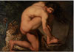 | KMS586 | The Wounded Philoctetes | 123x175,5 cm | 1775 | Abildgaard, Nicolai | http://www.smk.dk/en/explore-the-art/highlights/nicolai-abildgaard-the-wounded-philoctetes/
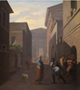 | KMS587 | Simo and his former slave Sosia. From Terence´s Andria. | 157,5x142 cm | 1803 | Abildgaard, Nicolai | http://www.smk.dk/en/explore-the-art/highlights/nicolai-abildgaard-simo-and-his-former-slave-sosia/
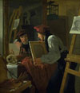 | KMS280 | A Young Artist (Ditlev Blunck) Examining a Sketch in a Mirror | 98x85 cm | 1826 | Bendz, Wilhelm | http://www.smk.dk/en/explore-the-art/highlights/wilhelm-bendz-a-young-artist-ditlev-blunck-examining-a-sketch/
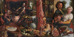 | KMSsp339 | The Fat Kitchen. An Allegory | 110,5x213 cm | 1565-1575 | Aertsen, Pieter | http://www.smk.dk/en/explore-the-art/highlights/pieter-aertsen-the-fat-kitchen-an-allegory/
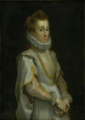 | KMSsp44 | Portrait of a Young Lady | 119,5x83 cm | c. 1600 | Barocci, Federico | http://www.smk.dk/en/explore-the-art/highlights/federico-barocci-portrait-of-a-young-lady/
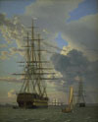 | KMS608 | The Russian Ship of the Line "Asow" and a Frigate at Anchor in the Roads of Elsinore | 63x51 cm | 1828 | Eckersberg, C.W. | http://www.smk.dk/en/explore-the-art/highlights/christoffer-wilhelm-eckersberg-the-russian-ship-of-the-line-assow/
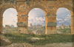 | KMS3123 | A View through Three Arches of the Third Storey of the Colosseum | 32x49,5 cm | 1815 | Eckersberg, C.W. | http://www.smk.dk/en/explore-the-art/highlights/christoffer-wilhelm-eckersberg-a-view-through-three-of-the-north/
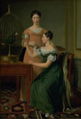 | KMS3498 | Mendel Levin Nathanson's Elder Daughters, Bella and Hanna | 125x85,5 cm | 1820 | Eckersberg, C.W. | http://www.smk.dk/en/explore-the-art/highlights/christoffer-wilhelm-eckersberg-bella-and-hanna/
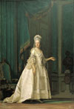 | KMS1138 | The Queen Dowager Juliane Marie | 72,5x55 cm | 1776 | Eriksen, Vigilius | http://www.smk.dk/en/explore-the-art/highlights/vigilius-eriksen-the-dowager-queen-juliane-marie-of-denmark/
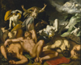 | KMSsp342 | Apollo and Diana Punishing Niobe by Killing her Children | 203x249,5 cm | 1591 | Bloemaert, Abraham | http://www.smk.dk/en/explore-the-art/highlights/abraham-bloemaert-apollon-and-diana-punishing-niobe-by-killing-her-children/
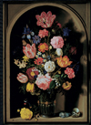 | KMSsp211 | Bouquet of Flowers in a Stone Niche | 55,5x39,5 cm | 1618 | Bosschaerts, Ambrosius, the elder | http://www.smk.dk/en/explore-the-art/highlights/ambrosius-bosschaerts-the-elder-bouquet-of-flowers-in-a-stone-niche/
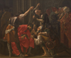 | KMSsp365 | Christ Crowned with Thorns | 207x240 cm | 1620 | Brugghen, Hendrick ter | http://www.smk.dk/en/explore-the-art/the-royal-collections/european-art-1300-1800/highlights/hendrick-ter-brugghen-christ-crowned-with-thorns/
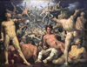 | KMS1 | The Fall of the Titans | 239x307 cm | 1588-1590 | Cornelisz. van Haarlem, Cornelis | http://www.smk.dk/en/explore-the-art/highlights/cornelis-cornelisz-van-haarlem-the-fall-of-the-titans-the-titanomachia/
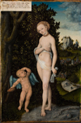 | KMSsp719 | Venus with Cupid Stealing Honey | 58x38 cm | 1530 | Cranach, Lucas, the elder | http://www.smk.dk/en/explore-the-art/highlights/lucas-cranach-the-elder-venus-with-cupid-stealing-honey/
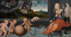 | KMSsp722 | Melancholy | 51x97 cm | 1532 | Cranach, Lucas, the elder | http://www.smk.dk/udforsk-kunsten/highlights/lucas-cranach-den-aeldre-melankolien/
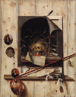 | KMSst537 | Trompe l'oeil with Studio Wall and Vanitas Still Life | 152x118 cm | 1668 | Gijsbrechts, Cornelius Norbertus | http://www.smk.dk/en/explore-the-art/highlights/cornelius-norbertus-gijsbrechts-trompe-loeil-with-studio-wall-and-vanitas-still-life/
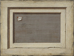 | KMS1989 | Trompe l'oeil. The Reverse of a Framed Painting | 66,4x87 cm | 1668-1672 | Gijsbrechts, Cornelius Norbertus | http://www.smk.dk/en/explore-the-art/highlights/cornelius-norbertus-gijsbrechts-trompe-loeil-the-reverse-of-a-framed-painting/
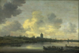 | KMS317 | View of the City of Arnhem | 65x96 cm | 1646 | Goyen, Jan Josefsz van | http://www.smk.dk/en/explore-the-art/highlights/jan-van-goyen-view-of-the-city-of-arnhem/
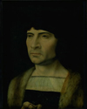 | KMS184 | Portrait of a Man | 41,5x31,5 cm | 1493-1532 | Gossaert (Mabuse), Jan | http://www.smk.dk/en/explore-the-art/highlights/jan-gossaert-portrait-of-a-man/
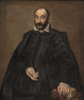 | KMSsp146 | Portrait of a Man | 116x98 cm | 1570-1575 | Greco, El | http://www.smk.dk/en/explore-the-art/highlights/el-greco-portrait-of-a-man/
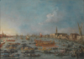 | KMS3630 | The Bucintoro Festival of Venice | 98x138 cm | 1727-1793 | Guardi, Francesco | http://www.smk.dk/en/explore-the-art/highlights/francesco-guardi-the-bucintoro-festival-of-venice-the-bacino-di-s-marco-with-the-bucintoro-the-doges-state-barge-on-ascension-day/
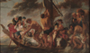 | KMS3198 | The Tribute Money. Peter Finding the Silver Coin in the Mouth of the Fish. Also called "The Ferry Boat to Antwerp" | 279,5x467 cm | 1616-1634 | Jordaens, Jacob | http://www.smk.dk/en/explore-the-art/highlights/jacob-jordaens-the-apostle-peter-finding-the-tribute-money-in-the-mouth-of-the-fish-also-called-the-ferry-boat-to-antwerp/
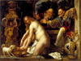 | KMSsp235 | Susanna and the Elders | 153,5x203 cm | 1653 | Jordaens, Jacob | http://www.smk.dk/en/explore-the-art/highlights/jacob-jordaens-susanna-and-the-elders/
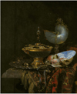 | KMS1531 | Pronk Still Life with Holbein Bowl, Nautilus Cup, Glass Goblet and Fruit Dish | 68x56 cm | 1678 | Kalf, Willem | http://www.smk.dk/en/explore-the-art/highlights/willem-kalf-pronk-still-life-with-holbein-bowl-nautilus-cup-glass-goblet-and-fruit-dish/
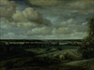 | KMS3876 | Dutch Panorama Landscape with a Distant View of Haarlem | 150x203 cm | 1654 | Koninck, Philips | http://www.smk.dk/en/explore-the-art/highlights/philips-koninck-dutch-panorama-landscape-with-a-river/
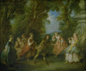 | KMS3893 | Children at Play in the Open | 27x32,5 cm | 1705-1743 | Lancret, Nicolas | http://www.smk.dk/en/explore-the-art/highlights/nicolas-lancret-children-playing-in-the-open/
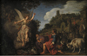 | KMS3922 | The Angel Raphael Takes Leave of Old Tobit and his Son Tobias | 62x93 cm | 1618 | Lastman, Pieter | http://www.smk.dk/en/explore-the-art/highlights/pieter-lastman-the-angel-raphael-takes-leave-of-old-tobit-and-his-son-tobias/
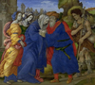 | KMSsp40 | The Meeting of Joachim and Anne outside the Golden Gate of Jerusalem | 112,5x124 cm | 1497 | Lippi, Filippino | http://www.smk.dk/en/explore-the-art/highlights/filippino-lippi-the-meeting-of-joachim-and-anne-outside-the-golden-gate-of-jerusalem/
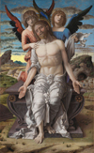 | KMSsp69 | Christ as the Suffering Redeemer | 78x48 cm | 1495-1500 | Mantegna, Andrea | http://www.smk.dk/en/explore-the-art/highlights/andrea-mantegna-christ-as-the-suffering-redeemer/
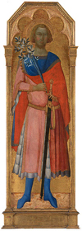 | KMS3625 | St Victor of Siena | 158x47,5 cm | About 1350 | Master of Palazzo Venezia Madonna | http://www.smk.dk/en/explore-the-art/highlights/master-of-the-palazzo-venezia-madonna-st-corona-and-st-vittorio-of-siena/
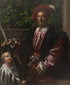 | KMSsp73 | Portrait of Lorenzo Cybo | 126,5x104,5 cm | 1523 | Parmigianino | http://www.smk.dk/en/explore-the-art/highlights/parmigianino-portrait-of-lorenzo-cybo/
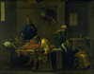 | KMS3889 | The Testament of Eudamidas | 110,5x138,5 cm | 1644-1648 | Poussin, Nicolas | http://www.smk.dk/en/explore-the-art/highlights/nicolas-poussin-the-testament-of-eudamidas/
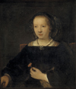 | KMS388 | Young Woman with a Carnation | 78,6x67,8 cm | 1656 | Workshop of Rembrandt van Rijn | http://www.smk.dk/en/explore-the-art/highlights/rembrandts-workshop-willem-drost-young-woman-with-a-carnation/
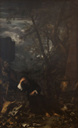 | KMS4112 | Democritus in Meditation | 344x214 cm | 1650-1651 | Rosa, Salvator | http://www.smk.dk/en/explore-the-art/highlights/salvator-rosa-democritus-in-meditation/
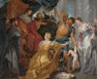 | KMSsp185 | The Judgement of Solomon | 234x303 cm | About 1617 | Rubens, Peter Paul | http://www.smk.dk/en/explore-the-art/highlights/peter-paul-rubens-the-judgement-of-solomon/
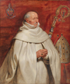 | KMSsp191 | Matthaeus Yrsselius (1541-1629), Abbot of Sint-Michiel's Abbey in Antwerp | 120x102,5 cm | c. 1624 | Rubens, Peter Paul | http://www.smk.dk/en/explore-the-art/highlights/peter-paul-rubens-matthaeus-yrsselius-1541-1629-abbot-of-sint-michiels-abbey-in-antwerpen/
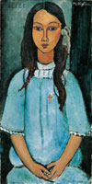 | KMSr145 | Alice | 78,5x39 cm | About 1918 | Modigliani, Amedeo | http://www.smk.dk/en/explore-the-art/highlights/amedeo-modigliani-alice/
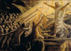 | KMS3141 | Christ in the Realm of the Dead | 351,5x489 cm | 1891-1894 | Skovgaard, Joakim | http://www.smk.dk/en/explore-the-art/highlights/joakim-skovgaard-christ-in-the-realm-of-the-dead/
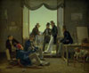 | KMS3236 | A Group of Danish Artists in Rome | 62x74 cm | 1837 | Hansen, Constantin | http://www.smk.dk/en/explore-the-art/highlights/constantin-hansen-a-group-pf-danish-artists-in-rome/
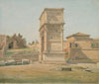 | KMS3679 | The Arch of Titus in Rome | 24x29 cm | 1839 | Hansen, Constantin | http://www.smk.dk/en/explore-the-art/highlights/constantin-hansen-the-arch-of-titus-in-rome/
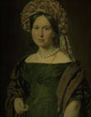 | KMS3595 | Cathrine Jensen, née Lorenzen, the Artist's Wife Wearing a Turban | 68x53 cm | About 1842 - 1844 | Jensen, C.A. | http://www.smk.dk/en/explore-the-art/highlights/christian-albrecht-jensen-cathrine-jensen-nee-lorenzen-the-artists/
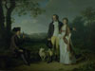 | KMS6251 | Niels Ryberg with his Son Johan Christian and his Daughter-in-Law Engelke, née Falbe | 253x336,5 cm | 1797 | Juel, Jens | http://www.smk.dk/en/explore-the-art/highlights/jens-juel-niels-ryberg-with-his-son-johan-christian-and-his/
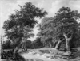 | KMS3366 | Road through an Oak Forest | 65x85 cm | 1646-1647 | Ruisdael, Jacob Isaacksz. van | http://www.smk.dk/en/explore-the-art/highlights/rembrandt-van-rijn-the-gust-of-wind/
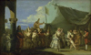 | KMS3830 | The Triumph of Pulcinella | 35x57,5 cm | 1760-1770 | Tiepolo, Giovanni Domenico | http://www.smk.dk/en/explore-the-art/highlights/giovanni-domenico-tiepolo-the-triumph-of-pulcinella/
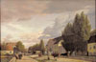 | KMS844 | View of a Street in Østerbro outside Copenhagen. Morning Light | 106,5x161,5 cm | 1836 | Købke, Christen | http://www.smk.dk/en/explore-the-art/highlights/christen-koebke-morning-of-oesterbro/
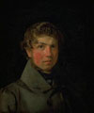 | KMS3150 | Self-Portrait | 42x35,5 cm | c. 1833 | Købke, Christen | http://www.smk.dk/en/explore-the-art/highlights/christen-koebke-self-portrait/
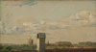 | KMS3156 | View from a Window in Toldbodvej Looking Towards the Citadel in Copenhagen | 15x27,5 cm | c. 1833 | Købke, Christen | http://www.smk.dk/en/explore-the-art/highlights/christen-koebke-view-from-a-window-in-toldbodvej-looking/
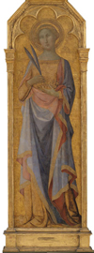 | KMS3624 | St. Corona | 155x48 cm | About 1350 | Master of Palazzo Venezia Madonna | http://www.smk.dk/en/explore-the-art/highlights/master-of-the-palazzo-venezia-madonna-st-corona-and-st-vittorio-of-siena/
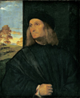 | DEP15 | Portrait of the Venetian Painter Giovanni Bellini (?) | 80x66 cm | 1511-1512 | Tizian | http://www.smk.dk/en/explore-the-art/highlights/tiziano-vecellio-portrait-of-the-venetian-painter-giovanni-bellini/
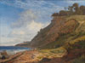 | KMS412 | A Danish Coast. View from Kitnæs on Roskilde Fjord. Zealand | 188,5x255,5 cm | 1843 | Lundbye, Johan Thomas | http://www.smk.dk/en/explore-the-art/highlights/johan-thomas-lundbye-a-danish-coast-view-from/
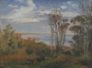 | KMS4753 | Kolås Wood, Vejrhøj | 24x33 cm | 1846 | Lundbye, Johan Thomas | http://www.smk.dk/en/explore-the-art/highlights/johan-thomas-lundbye-kolaas-wood-vejrhoej/
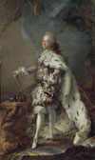 | KMS856 | Portrait of Frederik V in Anointment Robe | 231,5x139,5 cm | About 1750 | Pilo, C.G. | http://www.smk.dk/en/explore-the-art/highlights/carl-gustaf-pilo-frederik-v-in-his-anointing-robes/
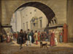 | KMS206 | The Prison of Copenhagen | 47,5x63 cm | 1831 | Rørbye, Martinus | http://www.smk.dk/en/explore-the-art/highlights/martinus-roerbye-the-prison-of-copenhagen/
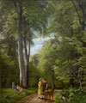 | KMS4580 | A Beech Wood in May near Iselingen Manor, Zealand | 189,5x158,5 cm | 1857 | Skovgaard, P.C. | http://www.smk.dk/en/explore-the-art/highlights/peter-christian-skovgaard-a-beech-wood-in-may-near/
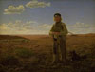 | KMS1496 | A Jutland Sheperd on the Moors | 59,5x80 cm | 1855 | Vermehren, Frederik | http://www.smk.dk/en/explore-the-art/highlights/frederik-vermehren-a-jutland-shepherd-on-the-moor/
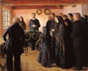 | KMS1433 | A Funeral | 103,5x124,5 cm | 1891 | Ancher, Anna | http://www.smk.dk/en/explore-the-art/highlights/anna-ancher-a-funeral/
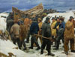 | KMS1222 | The Lifeboat is Taken through the Dunes | 171x221 cm | 1883 | Ancher, Michael | http://www.smk.dk/en/explore-the-art/highlights/michael-ancher-the-lifeboat-is-taken-through-the-dunes/
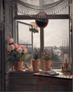 | KMS7452 | View from the Artist's Window | 38x29,8 cm | About 1825 | Rørbye, Martinus | http://www.smk.dk/en/explore-the-art/highlights/martinus-roerbye-view-from-the-artists-window/
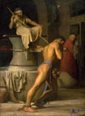 | KMS830 | Samson and the Philistines | 245,5x184 cm | 1863 | Bloch, Carl | http://www.smk.dk/en/explore-the-art/highlights/carl-bloch-samson-and-the-philistines/
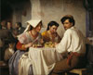 | KMS4087 | In a Roman Osteria | 148,5x177,5 cm | 1866 | Bloch, Carl | http://www.smk.dk/en/explore-the-art/highlights/carl-bloch-in-a-roman-osteria/
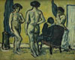 | KMS6489 | The Judgment of Paris | 121,5x149 cm | 1909 | Giersing, Harald | http://www.smk.dk/en/explore-the-art/highlights/harald-giersing-the-judgement-of-paris/
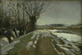 | KMS3294 | Winter Landscape. Utterslev near Copenhagen | 33x48,5 cm | 1887 | Gottschalk, Albert | http://www.smk.dk/en/explore-the-art/highlights/albert-gottschalk-winter-landscape-utterslev-near-copenhagen/
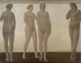 | KMS3358 | Artemis | 193x251,5 cm | 1893-1894 | Hammershøi, Vilhelm | http://www.smk.dk/en/explore-the-art/highlights/vilhelm-hammershoei-artemis/
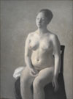 | KMS3766 | Seated Female Nude | 126x93 cm | 1889 | Hammershøi, Vilhelm | http://www.smk.dk/en/explore-the-art/highlights/vilhelm-hammershoei-seated-female-nude/
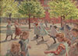 | KMS2075 | Playing Children, Enghave Square | 109,5x151,5 cm | 1907-08 | Hansen, Peter | http://www.smk.dk/en/explore-the-art/highlights/peter-hansen-playing-children-enghave-square/
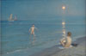 | KMS1658 | Boys Bathing at Skagen. Summer Evening | 100,5x153 cm | 1899 | Krøyer, P.S. | http://www.smk.dk/en/explore-the-art/highlights/peder-severin-kroeyer-boys-bathing-at-skagen-summer-evening/
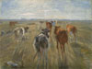 | KMS3334 | Long Shadows. Cattle on the Island of Saltholm | 61x81,5 cm | About 1890 | Philipsen, Theodor | http://www.smk.dk/en/explore-the-art/highlights/theodor-philipsen-long-shadows-cattle-on-the-island-of-saltholm/
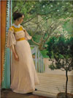 | KMS3716 | The Artist's Wife | 191x144 cm | 1897 | Ring, L.A. | http://www.smk.dk/en/explore-the-art/highlights/laurits-andersen-ring-the-artists-wife/
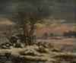 | KMS167 | Winter landscape. Near Vordingborg. | 173x205,5 cm | 1829 | Dahl, J.C. | http://www.smk.dk/en/explore-the-art/highlights/johan-christian-dahl-winter-landscape-near-vordingborg/
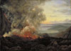 | KMS871 | Eruption of the Volcano Vesuvius | 98,3x137,5 cm | 1821 | Dahl, J.C. | http://www.smk.dk/en/explore-the-art/highlights/johan-christian-dahl-eruption-of-the-volcano-vesuvius/
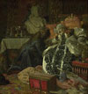 | KMS1231 | The Death of Queen Sophie Amalie | 92,5x86,5 cm | 1882 | Zahrtmann, Kristian | http://www.smk.dk/en/explore-the-art/highlights/kristian-zahrtmann-the-death-of-queen-sophie-amalie/
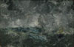 | KMS3432 | Storm in the Skerries. "The Flying Dutchman" | 62x98 cm | 1892 | Strindberg, August | http://www.smk.dk/en/explore-the-art/highlights/august-strindberg-storm-in-the-skerries-the-flying-dutchman/
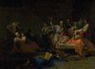 | KMS7066 | The Death of Socrates | 98x133,5 cm | 1786/1787 | Peyron, Jean Francois Pierre | http://www.smk.dk/en/explore-the-art/highlights/jean-francois-pierre-peyron-the-death-of-socrates/
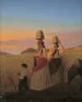 | KMS7485 | Rural Scene | 120,5x96 cm | 1848 | Sonne, Jørgen V. | http://www.smk.dk/en/explore-the-art/highlights/joergen-sonne-rural-scene/
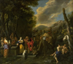 | KMSsp119 | Rebecca and Eliezer at the Well | 135x157 cm | 1627-1679 | Gargiulo, Domenico | http://www.smk.dk/en/explore-the-art/highlights/domenico-gargiulo-called-micco-spadaro-rebecca-and-eliezer-at-the-well/
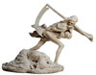 | KMS5387 | Motif from The Story of a Mother by Hans Christian Andersen | 152x183x108 cm | 1892 | Hansen Jacobsen, Niels | http://www.smk.dk/en/explore-the-art/highlights/niels-hansen-jacobsen-motif-from-the-story-of-a-mother/
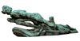 | KMS5806 | The Shadow | 76,5x275x85,5 cm | 1897-1898 | Hansen Jacobsen, Niels | http://www.smk.dk/en/explore-the-art/highlights/niels-hansen-jacobsen-the-shadow/
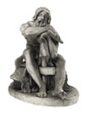 | KMS6245 | Thor Resting with his Hammer | 71x51x77 cm | 1828-1829 | Freund, Hermann Ernst | http://www.smk.dk/en/explore-the-art/highlights/hermann-ernst-freund-thor-resting-with-his-hammer/
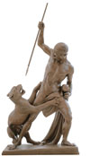 | KMS5250 | The Panther Hunter | 209,5x105x65 cm | 1845-1846 | Jerichau, J.A. | http://www.smk.dk/en/explore-the-art/highlights/jens-adolf-jerichau-panther-hunter/
 | KMS6017 | Amor patriae. Allegory symbolizing patriotism | 112,5x45,7x39 cm | 1777 | Stanley, C.F. | http://www.smk.dk/en/explore-the-art/the-royal-collections/danish-and-nordic-art-1750-1900/highlights/carl-frederik-stanley-amor-patriae/
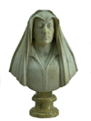 | DEP44 | Bust of Camilla Barbadori (dead 1609). Mother of Pope Urban VIII Barberini | 77x54,5x26 cm | 1619 | Bernini, Giovanni Lorenzo | http://www.smk.dk/en/explore-the-art/highlights/giovanni-lorenzo-bernini-bust-of-camilla-barbadori-mother-of-pope-urban-viii-barberini/
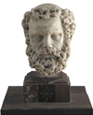 | KMS5962 | Head of a bearded Man | 17,5x12x13,5 cm | 1312-1314 | Pisano, Giovanni | http://www.smk.dk/en/explore-the-art/highlights/giovanni-pisano-head-of-a-bearded-man/
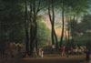 | KMS7661 | The Dancing Glade at Sorgenfri, North of Copenhagen | 42x61 cm | 1800 | Juel, Jens | http://www.smk.dk/en/explore-the-art/highlights/jens-juel-the-dancing-glade-at-sorgenfri-north-of-copenhagen/
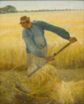 | DEP289 | Harvest | 190,2x154,2 cm | 1885 | Ring, L.A. | http://www.smk.dk/en/explore-the-art/highlights/laurits-andersen-ring-harvest/
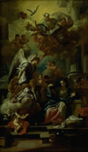 | KMS7976 | The Annunciation | 129x75,8 cm | 1672-1747 | Solimena, Francesco | http://www.smk.dk/en/explore-the-art/highlights/francesco-solimena-the-annunciation/
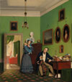 | KMS8003 | The Waagepetersen Family | 99,5x88,5 cm | 1830-04-07 | Bendz, Wilhelm | http://www.smk.dk/en/explore-the-art/highlights/wilhelm-bendz-the-waagepetersen-family/
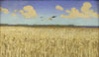 | DEP297 | Danish Landscape | 41x70 cm | 1891 | Slott-Møller, Harald | http://www.smk.dk/en/explore-the-art/highlights/harald-slott-moeller-danish-landscape/
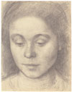 | KKS1964-288 | Portrait of Ida, the Artist's Wife | 242x188 mm | 1898 | Hammershøi, Vilhelm | http://www.smk.dk/en/explore-the-art/highlights/vilhelm-hammershoei-portrait-of-ida-the-artists-wife/
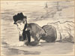 | KKS10280 | Woman Lying on the Beach. Annabel Lee | 302x409 mm | About 1881 | Manet, Édouard | http://www.smk.dk/en/explore-the-art/highlights/edouard-manet-woman-lying-on-the-beach-annabel-lee/
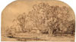 | KKS18014 | Landscape with Cottages under Tall Trees. ("The Puff of Wind") | 116x203 mm | 1650-1652 | Rembrandt van Rijn | http://www.smk.dk/en/explore-the-art/highlights/rembrandt-van-rijn-the-gust-of-wind/
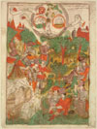 | KKS10458/5 | Venus | 270x183 mm | About 1460 | Unknown Dutch artist mid 1400's | http://www.smk.dk/en/explore-the-art/highlights/unknown-artist-venus/
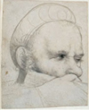 | KKSgb2989 | The head of a crossbowman taking aim | 120x96 mm | 1514-1515 | Holbein, Hans, the elder | http://www.smk.dk/en/explore-the-art/highlights/hans-holbein-the-elder-head-of-a-crossbowman/
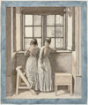 | KKS1196 | At a Window in the Artist's Studio | 274x231 mm | 1852 | Eckersberg, C.W. | http://www.smk.dk/en/explore-the-art/highlights/christoffer-wilhelm-eckersberg-at-a-window-in-the-artists-studio/
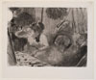 | KKS9159 | Intimacy | 119x161 mm | About 1877 | Degas, Edgar | http://www.smk.dk/en/explore-the-art/highlights/edgar-degas-intimacy/
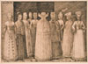 | KKS1966-13 | Ten Women from Stralsund | 222x313 mm | About 1571 | Lorck, Melchior | http://www.smk.dk/en/explore-the-art/highlights/melchior-lorck-ten-women-of-stralsund/
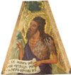 | KMS8314 | St. John the Baptist | 52,3x47 cm | 1337-1342 | Lorenzetti, Ambrogio | http://www.smk.dk/en/explore-the-art/highlights/ambrogio-lorenzetti-st-john-the-baptist/
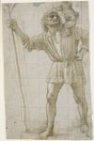 | KKSgb7066 | St. Christopher with the Infant Jesus | 308x190 mm | About 1490 | Bramante, Donato | http://www.smk.dk/en/explore-the-art/highlights/donato-bramante-st-christopher-with-the-infant-jesus/
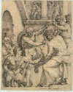 | KKSgb7068 | Christ Being Crowning with Thorns | 255x204 mm | About 1548 | Heemskerck, Maarten van | http://www.smk.dk/en/explore-the-art/highlights/maerten-van-heemskerck-christ-being-crowned-with-thorns/
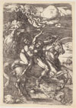 | KKSgb7076 | Abduction of Proserpine on a Unicorn | 393x230 mm | 1516 | Dürer, Albrecht | http://www.smk.dk/en/explore-the-art/highlights/albrecht-duerer-abduction-on-a-unicorn/
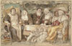 | KKSgb7077 | Like to like | 139x218 mm | 1640-1645 | Jordaens, Jacob | http://www.smk.dk/en/explore-the-art/highlights/jacob-jordaens-like-to-like/
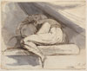 | KKS1992-1 | Woman Sitting, Curled up | 211x264 mm | 1778 | Füssli, Johann Heinrich | http://www.smk.dk/en/explore-the-art/highlights/johann-heinrich-fuessli-woman-sitting-curled-up/
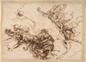 | KKSgb438 | Studies for the Death of Empedokles | 127x183 mm | After 1666 | Rosa, Salvator | http://www.smk.dk/en/explore-the-art/highlights/salvator-rosa-studies-for-the-death-of-empedocles/
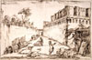 | KKSgb7078 | The Tomb of the Istacidi, Pompeii | 515x775 mm | About 1777 | Piranesi, Giovanni Battista | http://www.smk.dk/en/explore-the-art/highlights/giovanni-battista-piranesi-the-tomb-of-the-istacidi-pompeii/
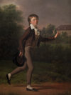 | KMS3635 | A Running Boy. Marcus Holst von Schmidten | 180,5x126 cm | 1802 | Juel, Jens | http://www.smk.dk/en/explore-the-art/highlights/jens-juel-running-boy/
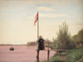 | KMS359 | A View from Dosseringen near the Sortedam Lake Looking towards Nørrebro outside Copenhagen | 53x71,5 cm | 1838 | Købke, Christen | http://www.smk.dk/en/explore-the-art/highlights/christen-koebke-a-view-from-dosseringen-near-the-sortedam-lake/
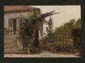 | KMS6605 | The Garden Steps Leading to the Artist's Studio on Blegdammen | 22,5x33 cm | c. 1845 | Købke, Christen | http://www.smk.dk/en/explore-the-art/highlights/christen-koebke-the-garden-steps-leading-to-the-artists-studio/
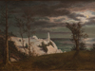 | KMS7240 | The "Summer Spire" on the Chalk Cliffs of the Island Møn. Moonlight | 30x41,5 cm | 1831 | Sødring, F. | http://www.smk.dk/en/explore-the-art/highlights/frederik-soedring-the-summer-spire-on-the-cliffs-of-the-island-moen-moonlight/
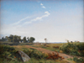 | KMS402 | Zealand Landscape. Open Country in North Zealand | 94,5x127,5 cm | 1842 | Lundbye, Johan Thomas | http://www.smk.dk/en/explore-the-art/highlights/johan-thomas-lundbye-zealand-landscape-open-country/
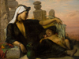 | KMS8589 | An Egyptian Fellah Woman with her Baby | 98,5x129,2 cm | 1872 | Jerichau Baumann, Elisabeth | http://www.smk.dk/en/explore-the-art/highlights/elisabeth-jerichau-baumann-an-egyptian-fellah-woman/
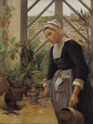 | KMS8289 | Breton Girl Looking After Plants in the Hothouse | 121x110 cm | 1884 | Petersen, Anna | http://www.smk.dk/en/explore-the-art/highlights/anna-petersen-breton-girl-looking-after-plants-in-hothouse/
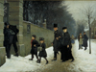 | KMS1218 | A Funeral | 95x141,5 cm | 1883 | Henningsen, Frants | http://www.smk.dk/en/explore-the-art/highlights/frants-henningsen-a-funeral/
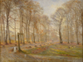 | KMS1950 | Late Autumn Day in the Jægersborg Deer Park, North of Copenhagen | 66,5x84,5 cm | 1886 | Philipsen, Theodor | http://www.smk.dk/en/explore-the-art/highlights/theodor-philipsen-late-autumn-day-in-the/
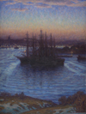 | KMS3401 | Ships at Anchor. Winter | 120,4x85,3 cm | 1908 | Eugen | http://www.smk.dk/en/explore-the-art/highlights/prince-eugen-ships-in-winter/
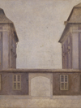 | KMS6657 | The Buildings of the Asiatic Company, seen from St. Annæ Street | 146,5x140,5 cm | 1902 | Hammershøi, Vilhelm | http://www.smk.dk/en/explore-the-art/highlights/vilhelm-hammershoei-the-buildings-of-the-asiatic-compaigni/
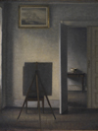 | KMS7444 | Interior with the Artist's Easel | 84x69 cm | 1910 | Hammershøi, Vilhelm | http://www.smk.dk/en/explore-the-art/highlights/vilhelm-hammershoei-the-artists-easel/
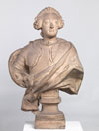 | KMS5655 |  | 101,5 cm | 1754 | Saly, Jacques François Joseph | http://www.smk.dk/en/explore-the-art/highlights/jacques-francois-joseph-saly-king-frederik-v/
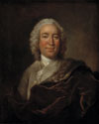 | KMSsp844 | Gerhard Morell, Keeper of the Royal Danish Kunstkammer | 78x62,5 cm | 1704-1765 | Wahl, Johann Salomon | http://www.smk.dk/en/explore-the-art/highlights/johann-salomon-wahl-gerhard-morell-curator-of-the-royal-danish-kunstkammer/
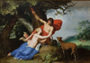 | KMSsp343 | Venus and Adonis | 134x191 cm | 1632 | Bloemaert, Abraham | http://www.smk.dk/en/explore-the-art/highlights/abraham-bloemaert-venus-and-adonis/
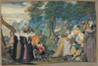 | KMS6938 | A Party in the Open Air. Allegory on Conjugal Love | 11,3x17,4 cm | 1590-1595 | Oliver, Isaac, I | http://www.smk.dk/en/explore-the-art/highlights/isaac-oliver-i-a-party-in-the-open-air-an-allegory/
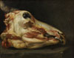 | KMS6260 | Skinned Head of a Young Bull | 57,1x70,6 cm | About 1690 | Boselli, Felice | http://www.smk.dk/en/explore-the-art/highlights/felice-boselli-skinned-head-of-a-young-bull/
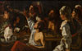 | KMSsp92 | Card and Backgammon Players. Fight over Cards | 150x241 cm | 1620-1629 | Rombouts, Theodoor | http://www.smk.dk/en/explore-the-art/highlights/theodoor-rombouts-card-and-backgammon-players-fight-over-cards/
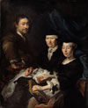 | KMS3814 | The Artist with his Family | 136,5x111,5 cm | 1624-1670 | Mander, Karel van, III | http://www.smk.dk/en/explore-the-art/highlights/karel-van-mander-iii-the-artist-with-his-family/
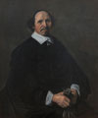 | KMS3847 | Portrait of a Man | 104x84,5 cm | 1655-1660 | Hals, Frans, I | http://www.smk.dk/en/explore-the-art/highlights/frans-i-hals-portrait-of-a-man/
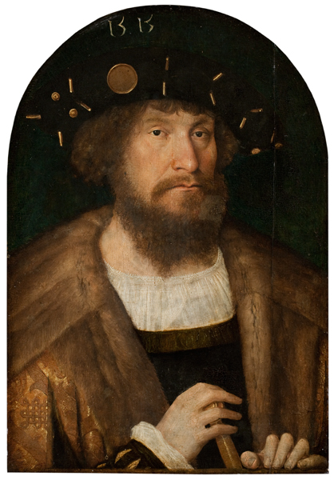 | KMSsp789 | Portrait of the Danish King Christian II | 31x22 cm | 1514/1515 | Sittow, Michel | http://www.smk.dk/en/explore-the-art/highlights/michel-sittow-portrait-of-the-danish-king-christian-ii/
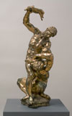 | KMS5492 | Cain killing Abel | 70x21x26 cm | 1622 | Vries, Adriaen de | http://www.smk.dk/en/explore-the-art/highlights/adriaen-de-vries-cain-killing-abel/
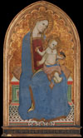 | KMS3378 | Virgin and Child playing with a Goldfinch and holding a Sheaf of Millet | 105x58 cm | 1379 | Cecco di Pietro | http://www.smk.dk/en/explore-the-art/highlights/karel-dujardin-boy-blowing-soap-bubbles/
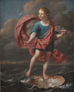 | KMSsp561 | Boy Blowing Soap Bubbles. Allegory on the Transitoriness and the Brevity of Life | 116x96,5 cm | 1663 | Dujardin, Karel | http://www.smk.dk/en/explore-the-art/the-royal-collections/european-art-1300-1800/highlights/karel-dujardin-boy-blowing-soap-bubbles/
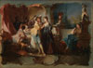 | KMS6469 | The Prodigal Son Living with Harlots | 27,8x38 cm | 1724-1761 | Baumgartner, Johann Wolfgang | http://www.smk.dk/en/explore-the-art/highlights/johann-wolfgang-baumgartner-the-prodigal-son-living-with-harlots/
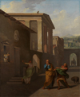 | KMS589 | The Midwife Taking Leave of the girl from Andros. From Terence´s Andria | 157,5x128,5 cm | 1801 | Abildgaard, Nicolai | http://www.smk.dk/en/explore-the-art/highlights/nicolai-abildgaard-the-midwife-taking-leave-of-the-girl-from-andros-from-terences-andria-1801/
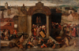 | KMS3924 | Christ Driving the Traders from the Temple | 102x155,5 cm | After 1569 | Unknown artist | http://www.smk.dk/en/explore-the-art/highlights/unknown-artist-christ-driving-the-traders-from-the-temple/
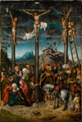 | KMSsp712 | The Crucifixion | 67x46,5 cm | 1506-1520 | Cranach, Lucas, the elder | http://www.smk.dk/en/explore-the-art/highlights/lucas-cranach-the-elder-the-crucifixion/
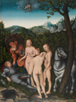 | KMSsp718 | The Judgement of Paris | 50,5x38 cm | 1527 | Cranach, Lucas, the elder | http://www.smk.dk/en/explore-the-art/highlights/lucas-cranach-the-elder-c-1472-1553-the-judgement-of-paris-1527/
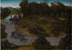 | KMSsp728 | The Stag Hunt of the Elector Frederic the Wise (1463-1525) of Saxony | 56,5x80,5 cm | After 1529 | Cranach, Lucas, the elder | http://www.smk.dk/en/explore-the-art/highlights/lucas-cranach-the-elder-the-stag-hunt-of-the-elector-frederic-the-wise-1463-1525-of-saxony/
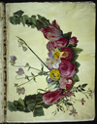 | KKSgb2947/1 | Floral vine | 505x385 mm | 1649-1659 | Holtzbecher, Johannes Simon | http://www.smk.dk/en/explore-the-art/highlights/johannes-simon-holtzbecker/
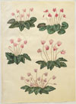 | KKSgb2947/8 | Cyclamen purpurascens; Cyclamen hederifolium | 505x385 mm | 1649-1659 | Holtzbecher, Johannes Simon | http://www.smk.dk/en/explore-the-art/highlights/johannes-simon-holtzbecker/
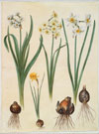 | KKSgb2947/20 | Narcissus tazetta; Narcissus orientalis; Corbularia bulbocodium | 505x385 mm | 1649-1659 | Holtzbecher, Johannes Simon | http://www.smk.dk/en/explore-the-art/highlights/johannes-simon-holtzbecker/
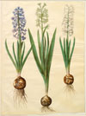 | KKSgb2947/26 | Hyacinthoides orientalis simp et pl | 505x385 mm | 1649-1659 | Holtzbecher, Johannes Simon | http://www.smk.dk/en/explore-the-art/highlights/johannes-simon-holtzbecker/
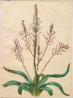 | KKSgb2947/36 | Asphodelus ramosus | 505x385 mm | 1649-1659 | Holtzbecher, Johannes Simon | http://www.smk.dk/en/explore-the-art/highlights/johannes-simon-holtzbecker/
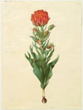 | KKSgb2947/44 | Tulipa gesneriana | 505x385 mm | 1649-1659 | Holtzbecher, Johannes Simon | http://www.smk.dk/en/explore-the-art/highlights/johannes-simon-holtzbecker/
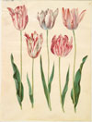 | KKSgb2947/55 | Tulipa gesneriana | 505x385 mm | 1649-1659 | Holtzbecher, Johannes Simon | http://www.smk.dk/en/explore-the-art/highlights/johannes-simon-holtzbecker/
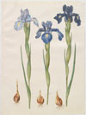 | KKSgb2947/65 | Iris xiphioides | 505x385 mm | 1649-1659 | Holtzbecher, Johannes Simon | http://www.smk.dk/en/explore-the-art/highlights/johannes-simon-holtzbecker/
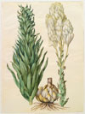 | KKSgb2947/82 | Lilium candidum monstrosum | 505x385 mm | 1649-1659 | Holtzbecher, Johannes Simon | http://www.smk.dk/en/explore-the-art/highlights/johannes-simon-holtzbecker/
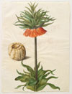 | KKSgb2947/85 | Fritillaria imperialis | 505x385 mm | 1649-1659 | Holtzbecher, Johannes Simon | http://www.smk.dk/en/explore-the-art/highlights/johannes-simon-holtzbecker/
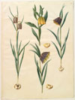 | KKSgb2947/97 | Fritillaria meleagris; Fritullaria lutea eller Fritullaria latifolia var lutea; Fritillaria pyrenaica | 505x385 mm | 1649-1659 | Holtzbecher, Johannes Simon | http://www.smk.dk/en/explore-the-art/highlights/johannes-simon-holtzbecker/
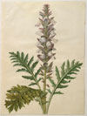 | KKSgb2948/9 | Acanthus mollis | 505x385 mm | 1649-1659 | Holtzbecher, Johannes Simon | http://www.smk.dk/en/explore-the-art/highlights/johannes-simon-holtzbecker/
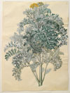 | KKSgb2948/20 | Senocio bicolor | 505x385 mm | 1649-1659 | Holtzbecher, Johannes Simon | http://www.smk.dk/en/explore-the-art/highlights/johannes-simon-holtzbecker/
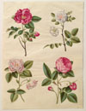 | KKSgb2948/24 | Rosa gallica | 505x385 mm | 1649-1659 | Holtzbecher, Johannes Simon | http://www.smk.dk/en/explore-the-art/highlights/johannes-simon-holtzbecker/
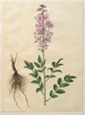 | KKSgb2948/28 | Dictamnus albus | 505x385 mm | 1649-1659 | Holtzbecher, Johannes Simon | http://www.smk.dk/en/explore-the-art/highlights/johannes-simon-holtzbecker/
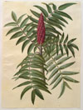 | KKSgb2948/41 | Rhus typhina | 505x385 mm | 1649-1659 | Holtzbecher, Johannes Simon | http://www.smk.dk/en/explore-the-art/highlights/johannes-simon-holtzbecker/
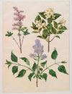 | KKSgb2948/44 | Syringa x persica; Philadelphus coronarius; Syringa vulgaris | 505x385 mm | 1649-1659 | Holtzbecher, Johannes Simon | http://www.smk.dk/en/explore-the-art/highlights/johannes-simon-holtzbecker/
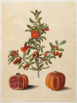 | KKSgb2948/59 | Punica granatum simp et pl | 505x385 mm | 1649-1659 | Holtzbecher, Johannes Simon | http://www.smk.dk/en/explore-the-art/highlights/johannes-simon-holtzbecker/
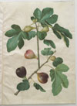 | KKSgb2948/67 | Ficus carica | 505x385 mm | 1649-1659 | Holtzbecher, Johannes Simon | http://www.smk.dk/en/explore-the-art/highlights/johannes-simon-holtzbecker/
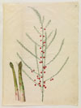 | KKSgb2948/77 | Asparagus officinalis | 505x385 mm | 1649-1659 | Holtzbecher, Johannes Simon | http://www.smk.dk/en/explore-the-art/highlights/johannes-simon-holtzbecker/
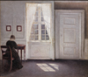 | KMS3696 | A Room in the Artist's Home in Strandgade, Copenhagen, with the Artist's Wife | 46,5x52 cm | 1901 | Hammershøi, Vilhelm | http://www.smk.dk/en/explore-the-art/highlights/vilhelm-hammershoei-interior-in-strandgade-sunlight-on-the-floor/
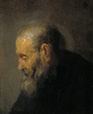 | KMS1636 | Study of an Old Man in Profile | 19,5x16 cm | About 1630 | Rembrandt van Rijn | http://www.smk.dk/en/explore-the-art/highlights/rembrandt-van-rijn-study-of-an-old-man-in-profile/
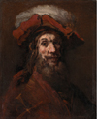 | KMS1384 | Sketch for The Knight with the Falcon, known as "The Crusader" | 68,5x55,5 cm | 1659-1661 | Rembrandt van Rijn | http://www.smk.dk/en/explore-the-art/highlights/rembrandt-van-rijn-sketch-for-the-knight-with-the-falcon-known-as-the-crusader/
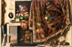 | KMSsp812 | Trompe l'oeil. A Cabinet in the Artist's Studio | 132x199 cm | 1670-1671 | Gijsbrechts, Cornelius Norbertus | http://www.smk.dk/en/explore-the-art/highlights/cornelius-norbertus-gijsbrechts-trompe-loeil-a-cabinet-in-the-artists-studio/
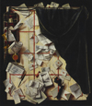 | KMS3059 | Trompe l'oeil. Board Partition with Letter Rack and Music Book | 123,5x107 cm | 1668 | Gijsbrechts, Cornelius Norbertus | http://www.smk.dk/en/explore-the-art/highlights/cornelius-norbertus-gijsbrechts-trompe-loeil-board-partition-with-letter-rack-and-music-book/
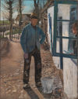 | KMS4223 | Whitewashing the Old House | KMS4223 | 1908 | Ring, Laurits Andersen | http://www.smk.dk/en/explore-the-art/highlights/laurits-andersen-ring-whitewashing-the-old-house/

