3 实验三 数据操作实验

3.1 实验目的
①了解和掌握Sharedperferences的使用；
②了解和掌握普通文件的读写操作；
③了解和掌握SqliteDatabase的创建、编辑和查询功能。

3.2 实验内容
利用已学的知识， 综合利用Sharedperferences、file、contentprovider、Sqlite，完成一个用户注册与登录程序，同时支持用户信息保存的功能，设计1~2个简单表格，完成数据的插入、删除、修改和查询等基本数据库操作。
创建表格student(no,name,provinceID)和表格province(ID,name)
完成如下操作：
1、省份信息的增、删改和查询工作
2、学生信息的增、删改和查询工作
3、为了减少冗余信息的存储，学生表格中仅存储省份的ID信息，但操作时显示省份名称信息。
4、数据库文件存放在SD卡中。
5、登录信息（用户名，密码）需要存放在Sharedperferences中。

3.3 实验体会及评语
专业 | 物联网工程 |  | 班级 | 物联网2202
学号 | 223428010210 |  | 姓名 | 陈梓欣
实验体会
本次实验中，我深入学习并掌握了Android开发中SQLite数据库的使用方法。通过创建StudentDatabaseHelper类，我了解了如何在应用中创建和管理本地数据库，以及如何在SQLite中定义表结构、插入初始数据。在项目开发过程中，我实现了点击列表项显示详细信息、长按删除数据等功能，巩固了对数据库基本操作（增删改查）的理解。
在删除操作中，采用了参数化删除语句，避免了SQL注入问题，并通过事务处理和异常捕获，提升了程序的健壮性和用户体验。同时，我学习了如何通过更新ListView的数据源来同步界面显示，确保数据一致性。
这次实验让我更熟悉了Android中的本地数据持久化技术，提升了开发实际应用的能力，为今后处理更复杂的数据存储与管理任务打下了坚实的基础。
问题及解决办法
问题描述：数据库无法正常链接。
解决方法：修改程序运行权限。
问题描述：addButton按钮无法正常点击。
解决方法：在FrameLayout布局中，将addButton按钮置于顶层。
问题描述：输入框无法输入中文。
解决方法：为输入框添加一个属性：android:inputType="text"。
问题描述：用户无法正常。
解决方法：由于表结构和注册/登录逻辑不一致，需要修改 regsterBTN.setOnClickListener() 里面的插入逻辑，把 "id" 改成 "STUDENTID"。
成绩
评语

3.4 实验记录（内容不够可以添加）
主要布局文件
<LinearLayout
android:id="@+id/login"
android:layout_width="match_parent"
android:layout_height="match_parent"
android:orientation="vertical"
app:layout_constraintBottom_toBottomOf="parent"
app:layout_constraintEnd_toEndOf="parent"
app:layout_constraintStart_toStartOf="parent"
app:layout_constraintTop_toBottomOf="@+id/app">
<androidx.cardview.widget.CardView
android:layout_width="337dp"
android:layout_height="365dp"
android:layout_marginHorizontal="35dp"
android:layout_marginVertical="150dp"
android:background="#9FFFFFFF"
app:cardBackgroundColor="#ABFFFFFF"
app:cardCornerRadius="25dp">
<TextView
android:id="@+id/textView"
android:layout_width="337dp"
android:layout_height="360dp" />
<LinearLayout
android:layout_width="match_parent"
android:layout_height="match_parent"
android:orientation="vertical">
<TextView
android:id="@+id/welcome"
android:layout_width="wrap_content"
android:layout_height="wrap_content"
android:layout_marginStart="100dp"
android:layout_marginTop="10dp"
android:text="@string/welcome"
android:textColor="@color/dark_brown"
android:textSize="30sp"
android:textStyle="bold" />
<TextView
android:id="@+id/ID_input"
android:layout_width="match_parent"
android:layout_height="wrap_content"
android:layout_marginStart="55dp"
android:layout_marginTop="20dp"
android:text="@string/请输入您的学号"
android:textColor="@color/dark"
android:textStyle="italic" />
<LinearLayout
android:layout_width="match_parent"
android:layout_height="50dp"
android:layout_marginStart="10dp"
android:layout_marginTop="5dp"
android:orientation="horizontal">
<ImageView
android:id="@+id/peopleID"
android:layout_width="0dp"
android:layout_height="wrap_content"
android:layout_margin="5dp"
android:layout_weight="1"
android:contentDescription="@string/todo"
app:srcCompat="@drawable/people" />
<EditText
android:id="@+id/ID"
android:layout_width="261dp"
android:layout_height="50dp"
android:layout_marginStart="8dp"
android:layout_marginEnd="20dp"
android:ems="10"
android:hint="@string/studentid"
android:inputType="text" />
</LinearLayout>
<TextView
android:id="@+id/PASSWORD_input"
android:layout_width="match_parent"
android:layout_height="wrap_content"
android:layout_marginStart="55dp"
android:layout_marginTop="15dp"
android:text="@string/请输入您的密码"
android:textColor="@color/dark"
android:textStyle="italic" />
<LinearLayout
android:layout_width="match_parent"
android:layout_height="50dp"
android:layout_marginStart="10dp"
android:layout_marginTop="10dp"
android:orientation="horizontal">
<ImageView
android:id="@+id/PASSWORD"
android:layout_width="0dp"
android:layout_height="wrap_content"
android:layout_margin="5.5dp"
android:layout_weight="1"
app:srcCompat="@drawable/password2" />
<EditText
android:id="@+id/password"
android:layout_width="261dp"
android:layout_height="50dp"
android:layout_marginStart="8dp"
android:layout_marginEnd="20dp"
android:ems="10"
android:hint="@string/password"
android:inputType="textPassword" />
</LinearLayout>
<CheckBox
android:id="@+id/checkBox"
android:layout_width="wrap_content"
android:layout_height="48dp"
android:layout_gravity="end"
android:layout_marginEnd="25dp"
android:text="@string/注册后自动登录" />
<LinearLayout
style="?android:attr/buttonBarStyle"
android:layout_width="match_parent"
android:layout_height="50dp"
android:layout_marginStart="20dp"
android:layout_marginTop="1dp"
android:layout_marginEnd="20dp"
android:orientation="horizontal">
<Button
android:id="@+id/regster_btn"
style="?android:attr/buttonBarButtonStyle"
android:layout_width="20dp"
android:layout_height="wrap_content"
android:layout_marginStart="30dp"
android:layout_marginEnd="40dp"
android:layout_weight="1"
android:backgroundTint="#C97A02"
android:text="@string/注册"
android:textColor="@color/white_dark"
android:textSize="15sp" />
<Button
android:id="@+id/login_btn"
android:layout_width="20dp"
android:layout_height="wrap_content"
android:layout_marginEnd="30dp"
android:layout_weight="1"
android:backgroundTint="#C97A02"
android:text="@string/登录"
android:textColor="@color/white_dark"
android:textSize="15sp" />
</LinearLayout>
</LinearLayout>
</androidx.cardview.widget.CardView>
</LinearLayout>
<FrameLayout
android:id="@+id/app"
android:layout_width="match_parent"
android:layout_height="match_parent"
android:orientation="vertical"
android:background="#9FFFFFFF"
app:cardBackgroundColor="#ABFFFFFF"
app:layout_constraintBottom_toBottomOf="parent"
app:layout_constraintEnd_toEndOf="parent"
app:layout_constraintStart_toStartOf="parent"
app:layout_constraintTop_toTopOf="parent">
<ImageView
android:id="@+id/imageView4"
android:layout_width="137dp"
android:layout_height="50dp"
android:layout_marginStart="30dp"
android:layout_marginTop="10dp"
app:srcCompat="@drawable/title1" />
<ImageView
android:id="@+id/imageView3"
android:layout_width="211dp"
android:layout_height="40dp"
android:layout_gravity="end"
android:layout_marginTop="55dp"
android:layout_marginEnd="25dp"
app:srcCompat="@drawable/title2" />
<ImageView
android:id="@+id/imageView5"
android:layout_width="140dp"
android:layout_height="45dp"
android:layout_marginStart="28dp"
android:layout_marginTop="90dp"
app:srcCompat="@drawable/title3" />
<LinearLayout
android:id="@+id/main"
android:layout_width="match_parent"
android:layout_height="match_parent"
android:background="#9FFFFFFF"
android:orientation="vertical"
app:cardBackgroundColor="#ABFFFFFF">
<androidx.cardview.widget.CardView
android:id="@+id/imageView"
android:layout_width="match_parent"
android:layout_height="60dp"
android:layout_marginTop="150dp"
app:cardElevation="0dp"
android:background="#00FFFFFF"
android:backgroundTint="#00FFFFFF">
<ImageView
android:id="@+id/imageView2"
android:layout_width="match_parent"
android:layout_height="55dp"
android:layout_marginStart="20dp"
android:layout_marginEnd="20dp"
android:scaleType="fitXY"
app:srcCompat="@drawable/sousuo1" />
<LinearLayout
android:id="@+id/findstudent"
android:layout_width="match_parent"
android:layout_height="match_parent"
android:layout_marginStart="20dp"
android:layout_marginEnd="20dp"
android:orientation="horizontal">
<ImageButton
android:id="@+id/findIcon"
android:layout_width="35dp"
android:layout_height="35dp"
android:layout_marginStart="20dp"
android:layout_marginTop="12dp"
android:background="#00FFFFFF"
android:contentDescription="TODO"
android:scaleType="fitCenter"
android:src="@drawable/sousuo_2" />
<EditText
android:id="@+id/findInput"
android:layout_width="309dp"
android:layout_height="50dp"
android:layout_marginStart="15dp"
android:layout_marginTop="3dp"
android:layout_marginEnd="10dp"
android:layout_weight="1"
android:hint="Input"
android:textColor="@color/dark_black"
android:textSize="26sp" />
</LinearLayout>
</androidx.cardview.widget.CardView>
<FrameLayout
android:id="@+id/FrameLayout"
android:layout_width="match_parent"
android:layout_height="635dp">
<LinearLayout
android:id="@+id/more"
android:layout_marginTop="45dp"
android:layout_marginStart="0dp"
android:layout_width="match_parent"
android:layout_height="500dp"
android:orientation="vertical">
<LinearLayout
android:layout_width="match_parent"
android:layout_height="50dp"
android:layout_gravity="bottom"
android:layout_marginStart="10dp"
android:layout_marginTop="10dp"
android:orientation="horizontal">
<ImageView
android:id="@+id/number"
android:layout_width="40dp"
android:layout_height="40dp"
android:layout_marginStart="40dp"
android:contentDescription="@string/todo"
app:srcCompat="@drawable/biaoqian" />
<EditText
android:id="@+id/number2"
android:layout_width="260dp"
android:layout_height="48dp"
android:layout_marginStart="8dp"
android:layout_marginEnd="45dp"
android:ems="10"
android:hint="@string/number"
android:inputType="text" />
</LinearLayout>
<LinearLayout
android:layout_width="match_parent"
android:layout_height="50dp"
android:layout_marginStart="10dp"
android:layout_marginTop="20dp"
android:orientation="horizontal">
<ImageView
android:id="@+id/name"
android:layout_width="40dp"
android:layout_height="40dp"
android:layout_marginStart="40dp"
android:contentDescription="@string/todo"
app:srcCompat="@drawable/people" />
<EditText
android:id="@+id/name2"
android:layout_width="260dp"
android:layout_height="45dp"
android:layout_marginStart="8dp"
android:layout_marginEnd="45dp"
android:ems="10"
android:hint="name"
android:inputType="text" />
</LinearLayout>
<LinearLayout
android:layout_width="match_parent"
android:layout_height="50dp"
android:layout_marginStart="10dp"
android:layout_marginTop="20dp"
android:orientation="horizontal">
<ImageView
android:id="@+id/email"
android:layout_width="40dp"
android:layout_height="40dp"
android:layout_marginStart="40dp"
android:contentDescription="@string/todo"
app:srcCompat="@drawable/email" />
<EditText
android:id="@+id/email2"
android:layout_width="260dp"
android:layout_height="45dp"
android:layout_marginStart="8dp"
android:layout_marginEnd="45dp"
android:ems="10"
android:hint="email"
android:inputType="text" />
</LinearLayout>
<LinearLayout
android:layout_width="match_parent"
android:layout_height="50dp"
android:layout_marginStart="10dp"
android:layout_marginTop="20dp"
android:orientation="horizontal">
<ImageView
android:id="@+id/location"
android:layout_width="40dp"
android:layout_height="40dp"
android:layout_marginStart="40dp"
android:contentDescription="@string/todo"
app:srcCompat="@drawable/ditu" />
<EditText
android:id="@+id/location2"
android:layout_width="260dp"
android:layout_height="45dp"
android:layout_marginStart="8dp"
android:layout_marginEnd="45dp"
android:ems="10"
android:hint="location"
android:inputType="text" />
</LinearLayout>
</LinearLayout>
<ListView
android:id="@+id/UserList"
android:layout_width="match_parent"
android:layout_height="590dp"
android:layout_margin="20dp"
app:layout_constraintBottom_toBottomOf="parent"
app:layout_constraintStart_toStartOf="parent"
app:layout_constraintTop_toTopOf="parent" />
<ImageButton
android:id="@+id/addButton"
android:layout_width="80dp"
android:layout_height="80dp"
android:layout_gravity="bottom"
android:layout_marginStart="300dp"
android:layout_marginBottom="20dp"
android:background="#00FFFFFF"
android:contentDescription="TODO"
android:scaleType="fitCenter"
app:srcCompat="@drawable/add" />
</FrameLayout>
<androidx.coordinatorlayout.widget.CoordinatorLayout
android:layout_width="match_parent"
android:layout_height="80dp"
android:layout_marginTop="0dp"
android:background="@color/yellowLight">
<com.google.android.material.bottomnavigation.BottomNavigationView
android:id="@+id/bottomNavigationView"
android:layout_width="match_parent"
android:layout_height="80dp"
android:layout_gravity="bottom"
android:background="@color/yellowLight">
<LinearLayout
android:layout_width="match_parent"
android:layout_height="wrap_content"
android:layout_gravity="center_vertical"
android:baselineAligned="false">
<ImageButton
android:id="@+id/user"
android:layout_width="80dp"
android:layout_height="60dp"
android:layout_weight="3"
android:background="#00FFFFFF"
android:contentDescription="TODO"
android:scaleType="fitCenter"
android:src="@drawable/tuceng28" />
<ImageButton
android:id="@+id/all"
android:layout_width="80dp"
android:layout_height="60dp"
android:layout_weight="3"
android:background="#00FFFFFF"
android:contentDescription="TODO"
android:scaleType="fitCenter"
android:src="@drawable/tuceng12" />
<ImageButton
android:id="@+id/setting"
android:layout_width="80dp"
android:layout_height="60dp"
android:layout_weight="3"
android:background="#00FFFFFF"
android:contentDescription="TODO"
android:scaleType="fitCenter"
android:src="@drawable/tuceng27" />
</LinearLayout>
</com.google.android.material.bottomnavigation.BottomNavigationView>
</androidx.coordinatorlayout.widget.CoordinatorLayout>
</LinearLayout>
<LinearLayout
android:id="@+id/edit"
android:layout_width="match_parent"
android:layout_height="match_parent"
android:background="#9FFFFFFF"
android:orientation="vertical"
app:cardBackgroundColor="#ABFFFFFF">
<com.google.android.material.bottomnavigation.BottomNavigationView
android:layout_width="match_parent"
android:layout_height="50dp"
android:layout_gravity="top"
app:elevation="0dp"
android:layout_marginTop="150dp"
android:layout_margin="20dp"
android:background="#00FFFFFF">
<LinearLayout
android:layout_width="match_parent"
android:layout_height="match_parent"
android:orientation="horizontal">
<ImageButton
android:id="@+id/exit"
android:layout_width="50dp"
android:layout_height="50dp"
android:background="#00FFFFFF"
android:contentDescription="TODO"
android:scaleType="fitCenter"
app:srcCompat="@drawable/last" />
<ImageButton
android:id="@+id/addok"
android:layout_width="50dp"
android:layout_height="50dp"
android:layout_marginStart="260dp"
android:background="#00FFFFFF"
android:contentDescription="TODO"
android:scaleType="fitCenter"
app:srcCompat="@drawable/dui1" />
</LinearLayout>
</com.google.android.material.bottomnavigation.BottomNavigationView>
<TextView
android:id="@+id/ID_input2"
android:layout_width="322dp"
android:layout_height="wrap_content"
android:layout_marginStart="110dp"
android:layout_marginTop="100dp"
android:text="@string/请输入您的学号"
android:textColor="@color/dark"
android:textStyle="italic" />
<LinearLayout
android:layout_width="match_parent"
android:layout_height="50dp"
android:layout_gravity="bottom"
android:layout_marginStart="10dp"
android:layout_marginTop="10dp"
android:orientation="horizontal">
<ImageView
android:id="@+id/peopleIDinput"
android:layout_width="50dp"
android:layout_height="50dp"
android:layout_marginStart="40dp"
android:contentDescription="@string/todo"
app:srcCompat="@drawable/biaoqian" />
<EditText
android:id="@+id/IDinput"
android:layout_width="260dp"
android:layout_height="50dp"
android:layout_marginStart="8dp"
android:layout_marginEnd="45dp"
android:ems="10"
android:hint="number"
android:inputType="text" />
</LinearLayout>
<TextView
android:id="@+id/PASSWORD_input2"
android:layout_width="match_parent"
android:layout_height="wrap_content"
android:layout_marginStart="110dp"
android:layout_marginTop="15dp"
android:text="@string/请输入您的姓名"
android:textColor="@color/dark"
android:textStyle="italic" />
<LinearLayout
android:layout_width="match_parent"
android:layout_height="50dp"
android:layout_marginStart="10dp"
android:layout_marginTop="10dp"
android:orientation="horizontal">
<ImageView
android:id="@+id/peopleNameinput"
android:layout_width="50dp"
android:layout_height="50dp"
android:layout_marginStart="40dp"
android:contentDescription="@string/todo"
app:srcCompat="@drawable/people" />
<EditText
android:id="@+id/Nameinput"
android:layout_width="260dp"
android:layout_height="50dp"
android:layout_marginStart="8dp"
android:layout_marginEnd="45dp"
android:ems="10"
android:hint="name"
android:inputType="text" />
</LinearLayout>
<TextView
android:id="@+id/Email"
android:layout_width="322dp"
android:layout_height="wrap_content"
android:layout_marginStart="110dp"
android:layout_marginTop="15dp"
android:text="请输入您的邮箱"
android:textColor="@color/dark"
android:textStyle="italic" />
<LinearLayout
android:layout_width="match_parent"
android:layout_height="50dp"
android:layout_gravity="bottom"
android:layout_marginStart="10dp"
android:layout_marginTop="10dp"
android:orientation="horizontal">
<ImageView
android:id="@+id/Emailinput"
android:layout_width="50dp"
android:layout_height="50dp"
android:layout_marginStart="40dp"
android:contentDescription="@string/todo"
app:srcCompat="@drawable/email" />
<EditText
android:id="@+id/EMAILinput"
android:layout_width="260dp"
android:layout_height="50dp"
android:layout_marginStart="8dp"
android:layout_marginEnd="45dp"
android:ems="10"
android:hint="email"
android:inputType="text" />
</LinearLayout>
<TextView
android:id="@+id/location_input2"
android:layout_width="match_parent"
android:layout_height="wrap_content"
android:layout_marginStart="110dp"
android:layout_marginTop="15dp"
android:text="@string/请输入您所在的省份"
android:textColor="@color/dark"
android:textStyle="italic" />
<LinearLayout
android:layout_width="match_parent"
android:layout_height="50dp"
android:layout_marginStart="10dp"
android:layout_marginTop="10dp"
android:orientation="horizontal">
<ImageView
android:id="@+id/LOCATIONinput"
android:layout_width="50dp"
android:layout_height="50dp"
android:layout_marginStart="40dp"
android:contentDescription="@string/todo"
app:srcCompat="@drawable/ditu" />
<EditText
android:id="@+id/Locationinput"
android:layout_width="260dp"
android:layout_height="50dp"
android:layout_marginStart="8dp"
android:layout_marginEnd="45dp"
android:ems="10"
android:hint="location"
android:inputType="text" />
</LinearLayout>
<!-- <FrameLayout-->
<!-- android:layout_width="match_parent"-->
<!-- android:layout_height="match_parent">-->
<!-- </FrameLayout>-->
</LinearLayout>
</FrameLayout>

主要源代码
# MainActivity.java
@Override
protected void onCreate(Bundle savedInstanceState) {
super.onCreate(savedInstanceState);
setContentView(R.layout.activity_main);
EdgeToEdge.enable(this);
ViewCompat.setOnApplyWindowInsetsListener(findViewById(R.id.background), (v, insets) -> {
Insets systemBars = insets.getInsets(WindowInsetsCompat.Type.systemBars());
v.setPadding(systemBars.left, systemBars.top, systemBars.right, systemBars.bottom);
return insets;
});
// 设置全屏标志
// getWindow().setFlags(WindowManager.LayoutParams.FLAG_FULLSCREEN,
// WindowManager.LayoutParams.FLAG_FULLSCREEN);
getWindow().setSoftInputMode(WindowManager.LayoutParams.SOFT_INPUT_STATE_HIDDEN);
getWindow().setFlags(WindowManager.LayoutParams.FLAG_FULLSCREEN, WindowManager.LayoutParams.FLAG_FULLSCREEN);
View decorView = getWindow().getDecorView();
int uiOptions = View.SYSTEM_UI_FLAG_HIDE_NAVIGATION | View.SYSTEM_UI_FLAG_IMMERSIVE_STICKY;
decorView.setSystemUiVisibility(uiOptions);
LinearLayout loginLayout = findViewById(R.id.login);
loginLayout.setVisibility(View.VISIBLE);
FrameLayout appLayout = findViewById(R.id.app);
appLayout.setVisibility(View.GONE);
LinearLayout mainLayout = findViewById(R.id.main);
mainLayout.setVisibility(View.GONE);
LinearLayout moreLayout = findViewById(R.id.more);
moreLayout.setVisibility(View.GONE);
LinearLayout editLayout = findViewById(R.id.edit);
editLayout.setVisibility(View.GONE);
findViewById(R.id.FrameLayout);
helper=new StudentDatabaseHelper( MainActivity.this);
Button loginBTN = findViewById(R.id.login_btn);
loginBTN.setOnClickListener(v -> {
EditText idInput = findViewById(R.id.ID);
EditText passwordInput = findViewById(R.id.password);
String inputId = idInput.getText().toString().trim();
String inputPassword = passwordInput.getText().toString().trim();
if (inputId.isEmpty() || inputPassword.isEmpty()) {
Toast.makeText(MainActivity.this, "请输入学号和密码", Toast.LENGTH_SHORT).show();
return;
}
try (SQLiteDatabase db = helper.getWritableDatabase()) {
ContentValues values = new ContentValues();
values.put("STUDENTID", inputId); // ✅ 改对字段
values.put("PASSWORD", inputPassword);
long newRowId = db.insert("USER", null, values);
if (newRowId != -1) {
Toast.makeText(MainActivity.this, "注册成功！", Toast.LENGTH_SHORT).show();
loginLayout.setVisibility(View.GONE);
appLayout.setVisibility(View.VISIBLE);
mainLayout.setVisibility(View.VISIBLE);
} else {
Toast.makeText(MainActivity.this, "注册失败，该用户名已存在！", Toast.LENGTH_SHORT).show();
}
} catch (Exception e) {
e.printStackTrace();
Toast.makeText(MainActivity.this, "注册异常！", Toast.LENGTH_SHORT).show();
}
});
Button regsterBTN = findViewById(R.id.regster_btn);
regsterBTN.setOnClickListener(new View.OnClickListener() {
@Override
public void onClick(View v) {
EditText idInput = findViewById(R.id.ID);
EditText passwordInput = findViewById(R.id.password);
String inputId = idInput.getText().toString().trim();
String inputPassword = passwordInput.getText().toString().trim();
if (inputId.isEmpty() || inputPassword.isEmpty()) {
Toast.makeText(MainActivity.this, "请输入学号和密码", Toast.LENGTH_SHORT).show();
return;
}
SQLiteDatabase db = helper.getReadableDatabase();
Cursor cursor = db.rawQuery(
"SELECT * FROM USER WHERE STUDENTID = ? AND PASSWORD = ?",
new String[]{inputId, inputPassword}
);
if (cursor.moveToFirst()) {
Toast.makeText(MainActivity.this, "登录成功！", Toast.LENGTH_SHORT).show();
loginLayout.setVisibility(View.GONE);
appLayout.setVisibility(View.VISIBLE);
mainLayout.setVisibility(View.VISIBLE);
} else {
Toast.makeText(MainActivity.this, "账号或密码错误！", Toast.LENGTH_SHORT).show();
}
cursor.close();
db.close();
}
});
// ============= 显示学号列表 ==============
ListView userList = findViewById(R.id.UserList);
StudentDatabaseHelper dbHelper = new StudentDatabaseHelper(this);
SQLiteDatabase db = dbHelper.getReadableDatabase();
Cursor cursor = db.rawQuery("SELECT number FROM student", null);
ArrayList<String> numberList = new ArrayList<>();
if (cursor.moveToFirst()) {
do {
String number = cursor.getString(cursor.getColumnIndexOrThrow("number"));
numberList.add(number);
} while (cursor.moveToNext());
}
cursor.close();
db.close();
// 用自定义 list_item_main 布局
ArrayAdapter<String> adapter = new ArrayAdapter<>(this, R.layout.list_item_main, R.id.textViewItem, numberList);
userList.setAdapter(adapter);
// ============= 详细信息 ==============
// 找到按钮
ImageButton addButton = findViewById(R.id.addButton);
ImageButton addok = findViewById(R.id.addok);
userList.setOnItemClickListener((parent, view, position, id) -> {
// 1. 获取点击的number
String selectedNumber = numberList.get(position);
// 2. 查询数据库，拿到该number对应的完整信息
SQLiteDatabase db1 = helper.getReadableDatabase();
Cursor cursor1 = db1.rawQuery("SELECT * FROM student WHERE number = ?", new String[]{selectedNumber});
if (cursor1.moveToFirst()) {
String number = cursor1.getString(cursor1.getColumnIndexOrThrow("number"));
String name = cursor1.getString(cursor1.getColumnIndexOrThrow("name"));
String email = cursor1.getString(cursor1.getColumnIndexOrThrow("email"));
String location = cursor1.getString(cursor1.getColumnIndexOrThrow("location"));
// 3. 显示到more布局
EditText number2 = findViewById(R.id.number2);
EditText name2 = findViewById(R.id.name2);
EditText email2 = findViewById(R.id.email2);
EditText location2 = findViewById(R.id.location2);
number2.setText(number);
name2.setText(name);
email2.setText(email);
location2.setText(location);
// 4. 显示more，隐藏其他可点击，main禁用
userList.setVisibility(View.GONE);
moreLayout.setVisibility(View.VISIBLE);
addButton.setVisibility(View.GONE);
appLayout.setEnabled(false);
mainLayout.setEnabled(false);
loginLayout.setEnabled(false);
editLayout.setEnabled(false);
// 可以顺便给背景加一层透明蒙版（美观效果）
}
cursor1.close();
db1.close();
});
// 5. 给more布局设置点击事件，点击返回main布局
moreLayout.setOnClickListener(v -> {
moreLayout.setVisibility(View.GONE);
userList.setVisibility(View.VISIBLE);
addButton.setVisibility(View.VISIBLE);
// 恢复其他布局的可点击
appLayout.setEnabled(true);
mainLayout.setEnabled(true);
loginLayout.setEnabled(true);
editLayout.setEnabled(true);
});
// ============= 删除操作 ==============
// 给UserList的item添加长按删除功能
userList.setOnItemLongClickListener((parent, view, position, id) -> {
String selectedNumber = numberList.get(position); // 拿到被长按的number
// 弹出确认对话框
new AlertDialog.Builder(MainActivity.this)
.setTitle("删除确认")
.setMessage("确定要删除学号为 " + selectedNumber + " 的学生吗？")
.setPositiveButton("确定", (dialog, which) -> {
try {
// 执行删除操作，注意条件写成 "number = ?" 并传参数
int rowsDeleted = db.delete("STUDENT", "number = ?", new String[]{selectedNumber});
if (rowsDeleted > 0) {
Toast.makeText(MainActivity.this, "删除成功！", Toast.LENGTH_SHORT).show();
// 同时从列表里删除该项
numberList.remove(position);
adapter.notifyDataSetChanged();
} else {
Toast.makeText(MainActivity.this, "删除失败，找不到该学号！", Toast.LENGTH_SHORT).show();
}
} catch (Exception e) {
Log.e("DELETE_ERROR", "删除操作失败: " + e.getMessage(), e);
Toast.makeText(MainActivity.this, "删除失败，操作异常！", Toast.LENGTH_SHORT).show();
} finally {
if (db != null && db.isOpen()) {
db.close();
}
}
})
.setNegativeButton("取消", null)
.show();
return true; // 注意：长按事件必须返回true，否则还会触发短按
});
// ============= 查找功能 ==============
// 找到输入框和查询按钮
EditText findInput = findViewById(R.id.findInput);
ImageButton findIcon = findViewById(R.id.findIcon);
// 给 findIcon 添加点击事件
findIcon.setOnClickListener(v -> {
String searchText = findInput.getText().toString().trim();
SQLiteDatabase db1 = helper.getReadableDatabase();
Cursor searchCursor;
if (searchText.isEmpty()) {
// 输入为空，查询所有
searchCursor = db1.rawQuery("SELECT number FROM student", null);
} else {
// 输入不为空，进行模糊查询（支持中文）
searchCursor = db1.rawQuery(
"SELECT number FROM student WHERE number LIKE ? OR name LIKE ? OR email LIKE ? OR location LIKE ?",
new String[]{"%" + searchText + "%", "%" + searchText + "%", "%" + searchText + "%", "%" + searchText + "%"}
);
}
ArrayList<String> searchResultList = new ArrayList<>();
if (searchCursor.moveToFirst()) {
do {
String number = searchCursor.getString(searchCursor.getColumnIndexOrThrow("number"));
searchResultList.add(number);
} while (searchCursor.moveToNext());
}
searchCursor.close();
db1.close();
// 更新 ListView
ArrayAdapter<String> searchAdapter = new ArrayAdapter<>(MainActivity.this, R.layout.list_item_main, R.id.textViewItem, searchResultList);
userList.setAdapter(searchAdapter);
if (searchResultList.isEmpty()) {
Toast.makeText(MainActivity.this, "未找到相关记录", Toast.LENGTH_SHORT).show();
}
});
// 找到输入框
EditText numberInput = findViewById(R.id.IDinput);
EditText nameInput = findViewById(R.id.Nameinput);
EditText emailInput = findViewById(R.id.EMAILinput);
EditText locationInput = findViewById(R.id.Locationinput);
// 点击addButton，显示edit界面
addButton.setOnClickListener(v -> {
mainLayout.setVisibility(View.GONE);
editLayout.setVisibility(View.VISIBLE);
});
// 点击addokButton，保存到数据库
addok.setOnClickListener(v -> {
String number = numberInput.getText().toString().trim();
String name = nameInput.getText().toString().trim();
String email = emailInput.getText().toString().trim();
String location = locationInput.getText().toString().trim();
if (number.isEmpty() || name.isEmpty() || email.isEmpty() || location.isEmpty()) {
Toast.makeText(MainActivity.this, "请完整填写所有信息", Toast.LENGTH_SHORT).show();
return;
}
SQLiteDatabase db2 = helper.getWritableDatabase();
// 先查询number是否已存在
Cursor cursorCheck = db2.rawQuery(
"SELECT * FROM student WHERE number = ?", new String[]{number}
);
if (cursorCheck.moveToFirst()) {
// number已存在，提示错误
Toast.makeText(MainActivity.this, "学号已存在，请重新输入", Toast.LENGTH_SHORT).show();
} else {
// 插入新数据
ContentValues values = new ContentValues();
values.put("number", number);
values.put("name", name);
values.put("email", email);
values.put("location", location);
long insertResult = db2.insert("student", null, values);
if (insertResult != -1) {
Toast.makeText(MainActivity.this, "添加成功！", Toast.LENGTH_SHORT).show();
// 切换回mainLayout，刷新列表
editLayout.setVisibility(View.GONE);
mainLayout.setVisibility(View.VISIBLE);
refreshUserList(); // ⬅️ 重新加载列表
} else {
Toast.makeText(MainActivity.this, "添加失败！", Toast.LENGTH_SHORT).show();
}
}
cursorCheck.close();
db2.close();
});
}
// 刷新列表的方法
private void refreshUserList() {
ListView userList = findViewById(R.id.UserList);
SQLiteDatabase db = helper.getReadableDatabase();
Cursor cursor = db.rawQuery("SELECT number FROM student", null);
ArrayList<String> numberList = new ArrayList<>();
if (cursor.moveToFirst()) {
do {
String number = cursor.getString(cursor.getColumnIndexOrThrow("number"));
numberList.add(number);
} while (cursor.moveToNext());
}
cursor.close();
db.close();
ArrayAdapter<String> adapter = new ArrayAdapter<>(this, R.layout.list_item_main, R.id.textViewItem, numberList);
userList.setAdapter(adapter);
}
}
# StudentDatabaseHelper.java
public class StudentDatabaseHelper extends SQLiteOpenHelper {
// 数据库名称
private static final String DBNAME = "student.db";
// 数据库版本
private static final int VERSION = 1;
private Context mContext;
// 日志插入结果
private static void insertUser(SQLiteDatabase db, String studentid, String password){
ContentValues userValues = new ContentValues();
userValues.put("STUDENTID", studentid);
userValues.put("PASSWORD", password);
long result = db.insert("USER", null, userValues);
Log.d("sqlite", "insert" + studentid + ",_id:" + result);
}
private static void insertStudent(SQLiteDatabase db, String name, String number, String email, String location) {
ContentValues studentValues = new ContentValues();
studentValues.put("name", name);
studentValues.put("number", number);
studentValues.put("email", email);
studentValues.put("location", location);
long result = db.insert("STUDENT", null, studentValues);
Log.d("sqlite", "insert student: " + name + ", rowid: " + result);
}
public StudentDatabaseHelper(@Nullable Context context) {
super(context, DBNAME, null, VERSION);
mContext = context;
}
@Override
public void onCreate(SQLiteDatabase db) {
// 创建 USER 表
db.execSQL("CREATE TABLE USER (_id INTEGER PRIMARY KEY AUTOINCREMENT," +
"STUDENTID TEXT," +
"PASSWORD TEXT);"
);
// 插入用户信息
insertUser(db, "admin", "123456");
// 创建 STUDENT 表
db.execSQL("CREATE TABLE STUDENT (" +
"name TEXT, " +
"number TEXT PRIMARY KEY, " +
"email TEXT, " +
"location TEXT" +
");"
);
// 插入三条学生信息
insertStudent(db, "陈梓欣", "223428010210", "chenzixin@stu.sau.edu.cn", "辽宁");
insertStudent(db, "郑羽婷", "223428010209", "zhengyuting@stu.sau.edu.cn", "辽宁");
insertStudent(db, "刘渤", "223428010103", "liubo@stu.sau.edu.cn", "辽宁");
}
@Override
public void onUpgrade(SQLiteDatabase db, int oldVersion, int newVersion) {
db.execSQL("drop table if exists USER");
db.execSQL("drop table if exists STUDENT");
onCreate(db);
}
}

实验截图
用户登陆界面，输入用户名和密码进行登录，如图1所示。
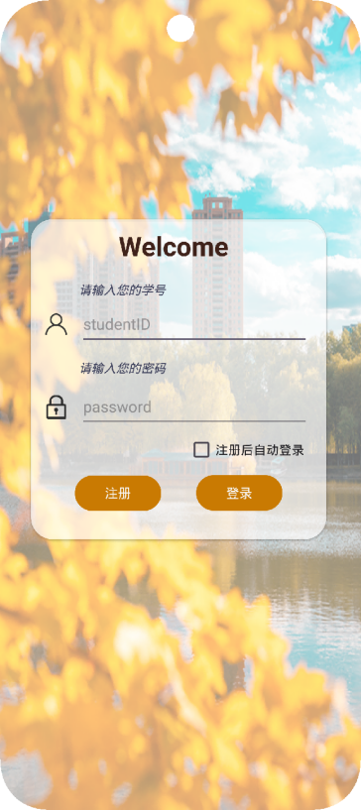
图1用户登陆界面
正确登录/注册后，进入APP主界面，如图2所示。
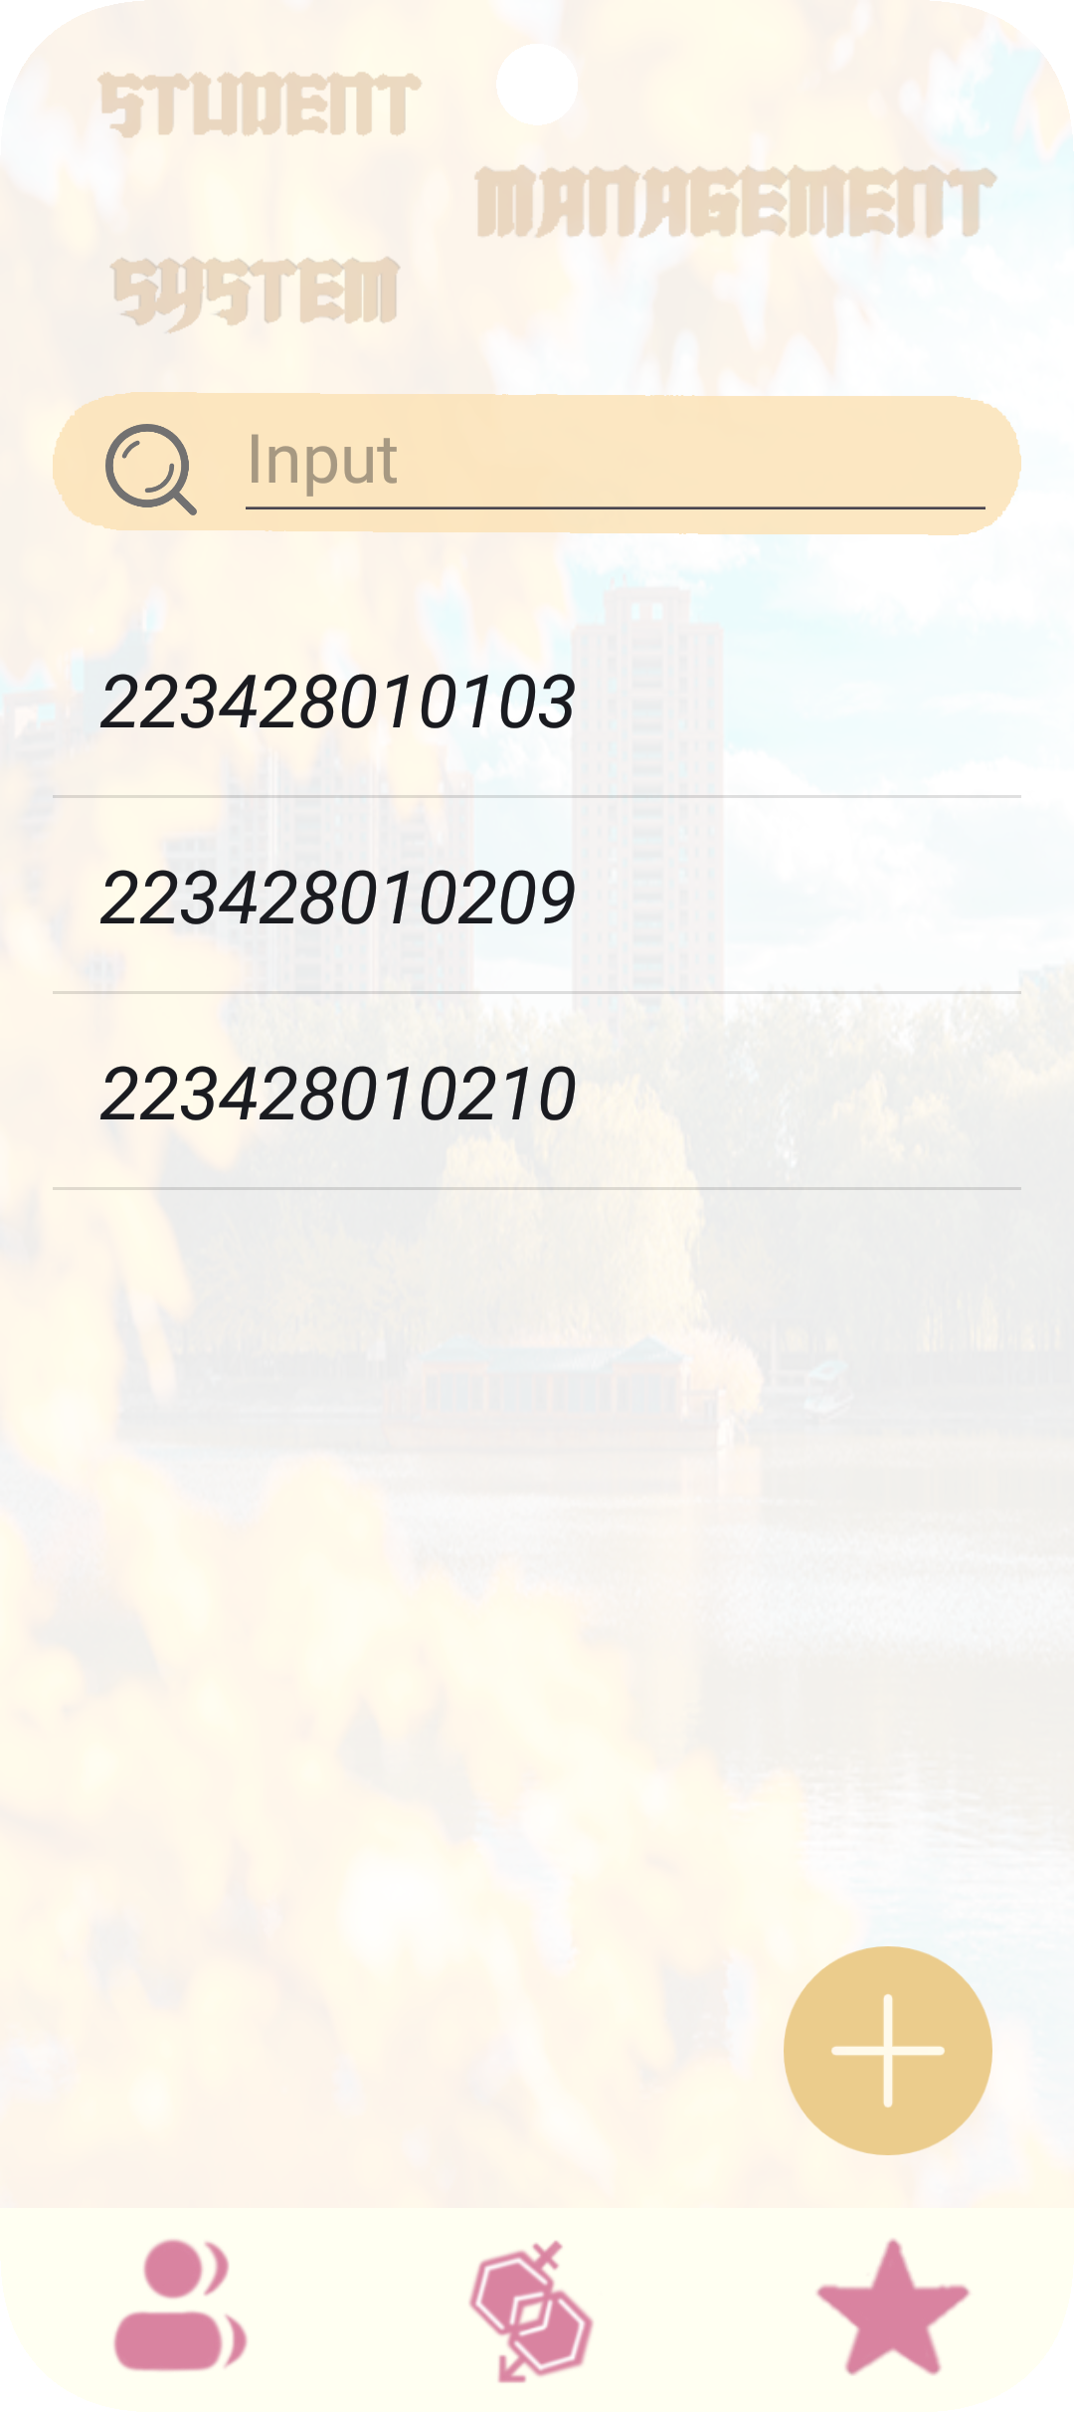
图2 APP主界面
增加学生信息，输入学号姓名和省份，进行添加操作，如图3所示。
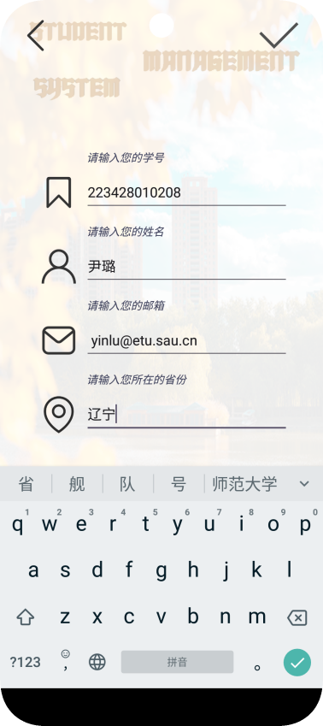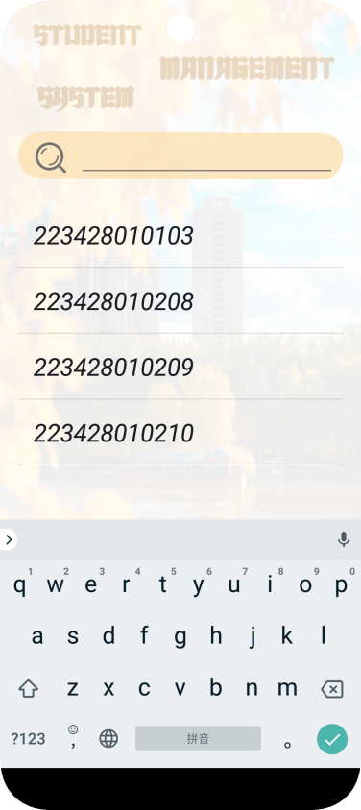
图3 增加用户信息
输入学号、姓名、省份三者之一进行查询，如图4所示
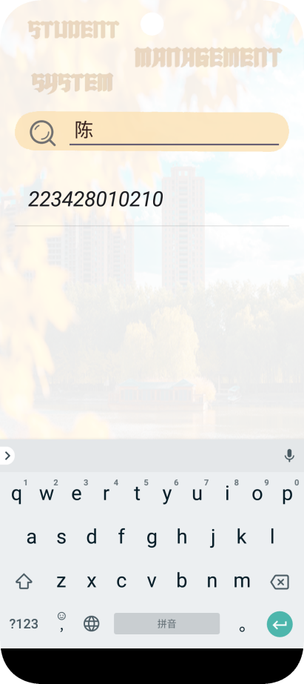
图4 查询学生信息
在更改/删除界面进行删除更改操作，如图5所示。
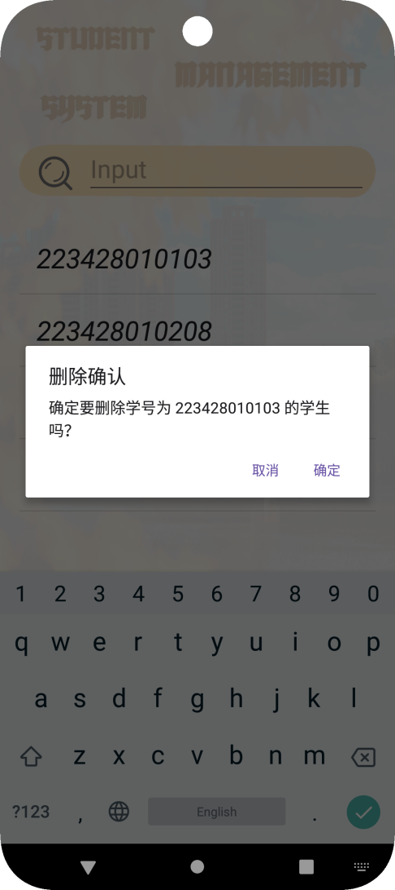
图5 更改删除操作

