//正方形挖出一个45°的扇形

.box1{

margin-top: 60px;

float: left;

width:40px;

height:40px;

background:radial-gradient(at 0px 0px,transparent,40px,transparent,0%,orange,orange);

background:-webkit-radial-gradient(at 0px 0px,transparent,40px,transparent,0%,orange,orange);

}

.box2{

margin-top: 60px;

float: left;

width:40px;

height:40px;

background:radial-gradient(at 40px 0px,transparent,40px,transparent,0%,orange,orange);

background:-webkit-radial-gradient(at 0px 0px,transparent,40px,transparent,0%,orange,orange);

}

【2】

.box{

width: 0;

height: 0;

border-radius: 100px;

border:100px solid orange;

border-left-color:transparent;

}



【】

.box{

height:100px;

width:200px;

background: red;

border-radius:50%;

}

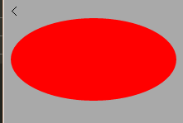

【】

.box{

width:100px;height:100px;border-radius:50px;

background:radial-gradient(at 35px 35px,#FFF,#CCC,#FFF);

background:-webkit-radial-gradient(35px 35px,#FFF,#CCC,#FFF);

}

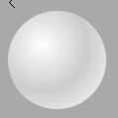

【】

.box{

width: 0;

height: 0;

border-bottom: 140px solid lightgreen;

border-left: 70px solid transparent;

border-right: 70px solid transparent;

}

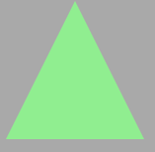

.box{

width: 0;

height: 0;

border-**top**: 140px solid lightgreen;

border-left: 70px solid transparent;

border-right: 70px solid transparent;

}

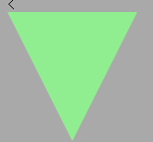

【】

.box{

width: 0;

height: 0;

border-right: 140px solid lightgreen;

border-top: 70px solid transparent;

border-bottom: 70px solid transparent;

}

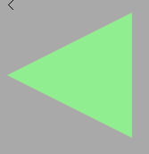

播放图标：

.box{

width: 0;

height: 0;

border-left: 140px solid lightgreen;

border-top: 70px solid transparent;

border-bottom: 70px solid transparent;

}

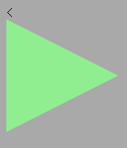

【】

.box{

width: 100px;

height:100px;

background-color: lightblue;

-webkit-transform: rotate(-45deg);

    -moz-transform: rotate(-45deg);

    -ms-transform: rotate(-45deg);

    -o-transform: rotate(-45deg);

    transform: rotate(-45deg);

}

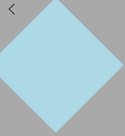

【】

.box{

height: 0;

width: 120px;

border-bottom: 120px solid lightpink;

border-left: 60px solid transparent;

border-right: 60px solid transparent;

}

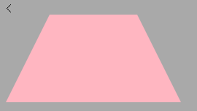

【】

.box{

width: 160px;

height: 100px;

background: #8734f7;

-webkit-transform: skew(30deg);

-moz-transform: skew(30deg);

-o-transform: skew(30deg);

transform: skew(30deg);

}

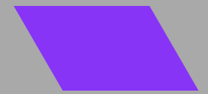

【】

.box{

width: 0;

height: 0;

margin: 50px 0;

color: #fc2e5a;

position: relative;

display: block;

border-right: 100px solid transparent;

border-bottom: 70px solid #fc2e5a;

border-left: 100px solid transparent;

-moz-transform: rotate(35deg);

-webkit-transform: rotate(35deg);

-ms-transform: rotate(35deg);

-o-transform: rotate(35deg);

}

.box:before{

content: '';

height: 0;

width: 0;

position: absolute;

display: block;

top: -45px;

left: -65px;

border-bottom: 80px solid #fc2e5a;

border-left: 30px solid transparent;

border-right: 30px solid transparent;

-webkit-transform: rotate(-35deg);

-moz-transform: rotate(-35deg);

-ms-transform: rotate(-35deg);

-o-transform: rotate(-35deg);

}

.box:after{

content: '';

width: 0;

height: 0;

position: absolute;

display: block;

top: 3px;

left: -105px;

color: #fc2e5a;

border-right: 100px solid transparent;

border-bottom: 70px solid #fc2e5a;

border-left: 100px solid transparent;

-webkit-transform: rotate(-70deg);

-moz-transform: rotate(-70deg);

-ms-transform: rotate(-70deg);

-o-transform: rotate(-70deg);

}

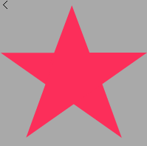

【】

.box{

position: relative;

}

.box:before,.box:after{

content: "";

width: 70px;

height: 115px;

position: absolute;

background: red;

left: 70px;

top: 0;

-webkit-border-radius: 50px 50px 0 0;

-moz-border-radius: 50px 50px 0 0;

border-radius: 50px 50px 0 0;

-webkit-transform: rotate(-45deg);

-moz-transform: rotate(-45deg);

-ms-transform: rotate(-45deg);

-o-transform: rotate(-45deg);

transform: rotate(-45deg);

-webkit-transform-origin: 0 100%;

-moz-transform-origin: 0 100%;

-ms-transform-origin: 0 100%;

-o-transform-origin: 0 100%;

transform-origin: 0 100%;

}

.box:after{

left: 0;

-webkit-transform: rotate(45deg);

-moz-transform: rotate(45deg);

-ms-transform: rotate(45deg);

-o-transform: rotate(45deg);

transform: rotate(45deg);

-webkit-transform-origin: 100% 100%;

-moz-transform-origin: 100% 100%;

-ms-transform-origin: 100% 100%;

-o-transform-origin: 100% 100%;

transform-origin: 100% 100%;

}

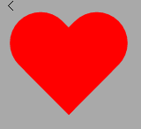

【】

.box{

width: 136px;

height: 190px;

background: #ffc000;

display: block;

-webkit-border-radius: 63px 63px 63px 63px / 108px 108px 72px 72px;

border-radius: 50% 50% 50% 50% / 60% 60% 40% 40%;

}

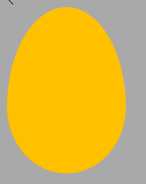

【】

.box{

width: 220px;

height: 100px;

position: relative;

}

.box:before,.box:after{

content: "";

width: 60px;

height: 60px;

position: absolute;

top: 0;

left: 0;

border: 20px solid lightgreen;

-moz-border-radius: 50px 50px 0;

border-radius: 50px 50px 0 50px;

-webkit-transform: rotate(-45deg);

-moz-transform: rotate(-45deg);

-ms-transform: rotate(-45deg);

-o-transform: rotate(-45deg);

transform: rotate(-45deg);

}

.box:after{

left: auto;

right: 0;

-moz-border-radius: 50px 50px 50px 0;

border-radius: 50px 50px 50px 0;

-webkit-transform: rotate(45deg);

-moz-transform: rotate(45deg);

-ms-transform: rotate(45deg);

-o-transform: rotate(45deg);

transform: rotate(45deg);

}

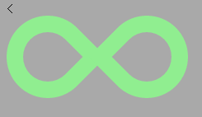

【】

.box{

width: 140px;

height: 100px;

background: #088cb7;

position: relative;

-moz-border-radius: 12px;

-webkit-border-radius: 12px;

border-radius: 12px;

}

.box:before{

content: "";

width: 0;

height: 0;

right: 100%;

top: 38px;

position: absolute;

border-top: 13px solid transparent;

border-right: 26px solid #088cb7;

border-bottom: 13px solid transparent;

}

