# 目标:

从裸机的linux到svn+Jenkins+

# 搭建svn

|  |
| --- |
| #!bin/sh自动化创建svn仓库  svn  # 移除  sudo apt-get remove --purge subversion  # 更新  sudo apt-get update  #  sudo mkdir -p /home/svn/repository  sudo chmod -R 777 /home/svn/repository  # 创建版本库  sudo svnadmin create /home/svn/repository  # db进行权限设置  sudo chmod -R 777 /home/svn/repository/db  # 备份  cp /home/svn/repository/conf/svnserve.conf{,.bak}  cp /home/svn/repository/conf/passwd{,.bak}  cp /home/svn/repository/conf/authz{,.bak}  # 改配置 svnserve.conf  cat > /home/svn/repository/conf/svnserve.conf <<EOF  [general]  #匿名用户可读  anon-access = read（可改成none，即不可读）  #权限用户可写  auth-access = write  #密码文件为passwd  password-db = passwd  #权限文件为authz  authz-db = authz  [sasl]  EOF  # passwd 用户  cat > /home/svn/repository/conf/passwd <<EOF  [users]  test=123456  EOF  # 权限  cat > /home/svn/repository/conf/authz <<EOF  [aliases]  [groups]  admin = test  [/]  @admin = rw  * = rw  EOF  ## 启动服务器  svnserve -d -r /home/svn  ps aux | grep svnserve  # 本地测试check out简写  #svn co svn://127.0.0.1/repository --username test --password 123456 |

# 安装jdk

|  |
| --- |
| #! /bin/sh 安装jdk1.8不是oracle的，仅仅供测试  sudo apt install openjdk-8-jre-headless -y  java  sudo apt install openjdk-8-jdk-headless -y  javac  # 配置环境变量  export JAVA_HOME=/usr/lib/jvm/java-8-openjdk-amd64 >> ~/.bashrc  echo export CLASSPATH=. >> ~/.bashrc  # 加载  source ~/.bashrc |

# 安装tomcat8

|  |
| --- |
| #! /bin/sh 安装tomcat服务 ， 在配置文件在/var/lib/tomcat8/目录下面  sudo apt-get install -y tomcat8 tomcat8-docs tomcat8-examples tomcat8-admin |

# 安装jenkins

|  |
| --- |
| wget -P /var/lib/tomcat8/webapps/ http://mirrors.jenkins.io/war-stable/latest/jenkins.war |

# 安装maven

|  |
| --- |
| #! /bin/sh tar安装maven  wget http://mirror.bit.edu.cn/apache/maven/maven-3/3.6.1/binaries/apache-maven-3.6.1-bin.tar.gz  # 解压  sudo tar zxvf apache-maven-3.6.1-bin.tar.gz -C /opt  # 仅对当前用户  echo export M2_HOME=/opt/apache-maven-3.6.1-bin >> ~/.bashrc  echo export CLASSPATH=$CLASSPATH:$M2_HOME/lib >> ~/.bashrc  echo export PATH=$PATH:$M2_HOME/bin >> ~/.bashrc  # 加载  source ~/.bashrc  mvn -v |

# 初始化jenkins

## 步骤

1. service tomcat8 start
2. 访问: <http://39.98.226.203:8080/jenkins>
3. chmod -R 777 /usr/share/tomcat8
4. service tomcat8 restart
5. cat /usr/share/tomcat8/.jenkins/secrets/initialAdminPassword
6. 跟着页面一直走

## 参考

windows上Jenkins安装及其部署:

<https://blog.csdn.net/zk0920zk/article/details/79115162>

# 配置maven项目

## 准备

1. 在[插件管理](http://39.98.226.203:8080/jenkins/pluginManager/)中，安装以下插件：  
   Maven Integration     #构建maven风格项目需要的插件  
   Deploy to container     #构建war包需要的插件  
   Subversion Plug-in        #svn需要的插件  
   Publish Over SSH   #通过ssh构建推送版本需要的插件  
   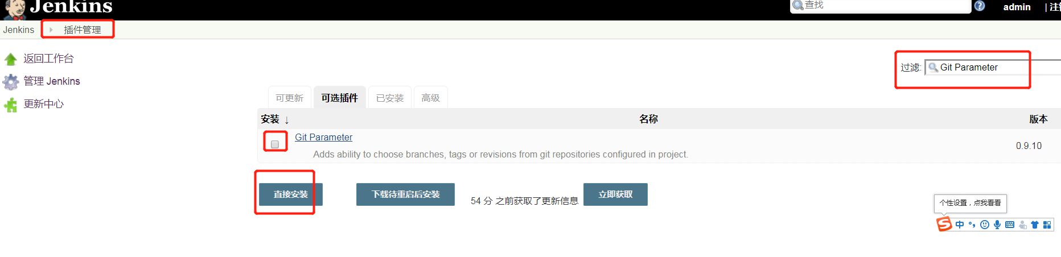
2. 配置插件环境  
   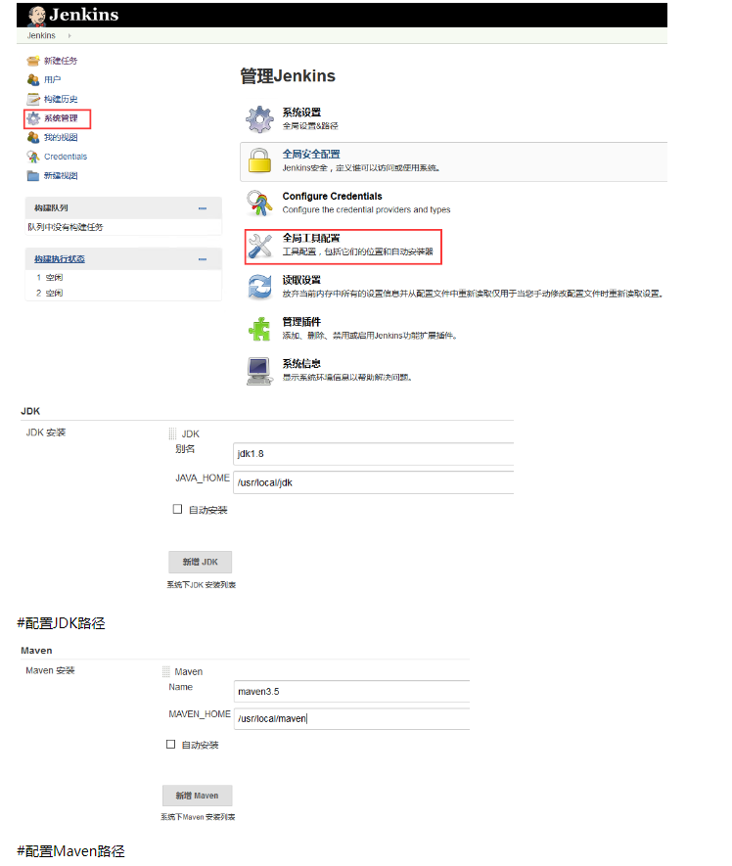

## 流程

## 步骤