DEBRE BERHAN UNIVERSITY
College of Computing
Department of Information Technology
Course Title: Introduction to Artificial Intelligence
Group Assignment Report

Topics:
- Chapter 3: Adversarial Search – Minimax Algorithm
- Chapter 7: Generative AI Table of Contents
1. Introduction
2. Adversarial Search and the Minimax Algorithm
- 2.1 What is Adversarial Search?
- 2.2 Minimax: MAX vs MIN Players
- 2.3 Pseudocode and Minimax Values
3. Game Tree Representation Using Tic-Tac-Toe
- 3.1 What is a Game Tree?
- 3.2 Simplified Game Tree Diagram (Tic-Tac-Toe)
4. Step-by-Step Decision Making with Minimax
- 4.1 Setup and Assumptions
- 4.2 Evaluation of Terminal States
- 4.3 Backing Up Values (Bottom-Up Propagation)
5. Applications of the Minimax Algorithm
6. Generative AI
- 6.1 Definition and Key Idea
- 6.2 How Generative AI Works (Simplified)
7. Applications of Generative AI
8. Benefits of Generative AI
9. Risks and Challenges of Generative AI
10. Real-World Applications Summary
11. Conclusion
12. References

1. Introduction
Artificial Intelligence (AI) is divided into many subfields, including search under uncertainty and learning from data. This report focuses on two important topics: adversarial search (Minimax algorithm) and Generative AI.
Adversarial search deals with two-player, turn-based games where one player tries to maximize their advantage while the other tries to minimize it. Generative AI, on the other hand, is a branch of AI that creates new content such as text, images, audio, and code from user prompts. This report explains the Minimax algorithm, demonstrates its use with a Tic-Tac-Toe game tree, and then explores Generative AI’s workings, applications, benefits, and risks.
2. Adversarial Search and the Minimax Algorithm
2.1 What is Adversarial Search?
• Adversarial Search is a search technique used when multiple agents compete against each other.
• In earlier search methods, we studied single-agent problems where only one agent tries to find a solution.
• However, in many real-world situations like games, more than one agent is involved.
• Such environments are called multi-agent environments, where each agent’s success depends on the opponent’s actions.
• When two or more players with conflicting goals explore the same search space, it is called Adversarial Search.
• Adversarial search is commonly used in game-playing AI.
In adversarial search, two agents (players) share the same environment and act against each other. Examples include Tic-Tac-Toe, Chess, and Checkers. The key assumptions are:
- Players alternate turns.
- The game is deterministic (no randomness).
- The game is fully observable (both players see the whole state).
Because the opponents work against each other, the algorithm must reason about optimal behavior from both sides.
2.2 Minimax: MAX vs MIN Players
Minimax Algorithm
The Minimax Algorithm is a recursive decision-making algorithm used in two-player games.
It assumes both players play optimally.
There are two players:
- MAX → tries to maximize the score
- MIN → tries to minimize the score
Each board state is assigned a numerical value.
Positive values favor MAX.
Negative values favor MIN.
Minimax explores the game tree completely to determine the best move.
The Minimax algorithm computes the best move for a player assuming that the opponent also plays optimally.
-MAX is the player whose turn it is; its goal is to maximize the score (e.g., win = +1, draw = 0, loss = -1).
-MIN is the opponent; its goal is to minimize the score (i.e., minimize MAX’s payoff).
The core idea is: *“Choose the move that leads to the best worst-case outcome, assuming the opponent always replies in the most harmful way. 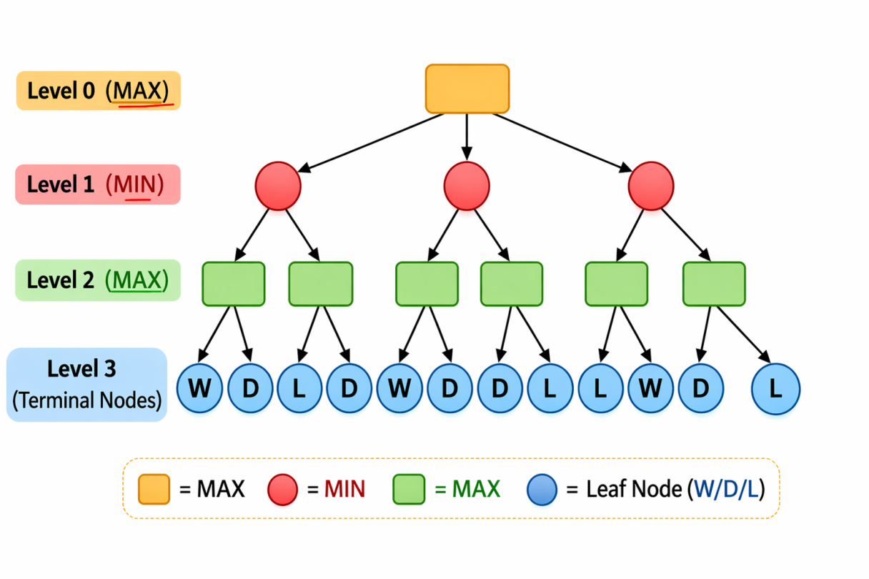

2.3 Pseudocode and Minimax Values
The recursive Minimax function can be written as:
function value(s):
if Terminal-Test(s): return Utility(s)
if Player(s) == MAX:
return max_{a ∈ Actions(s)} value(Result(s,a))
if Player(s) == MIN:
return min_{a ∈ Actions(s)} value(Result(s,a))
- s = current state of the game.
- Utility(s) = numeric value assigned to terminal states (outcome).
- Actions(s) = all legal moves from state s.
- Result(s,a) = the new state after applying move a.
At the root of the tree, the algorithm picks the action whose result gives the highest value for MAX.
3. Game Tree Representation Using Tic-Tac-Toe
3.1 What is a Game Tree?
A game tree is a diagram where:
- Each node is a game state (board configuration).
- Each edge is a legal move.
- Leaf nodes are terminal states (win, loss, or draw).
For Tic-Tac-Toe, the full tree is extremely large, so in practice we consider only a small subtree (e.g., 2–3 moves deep).

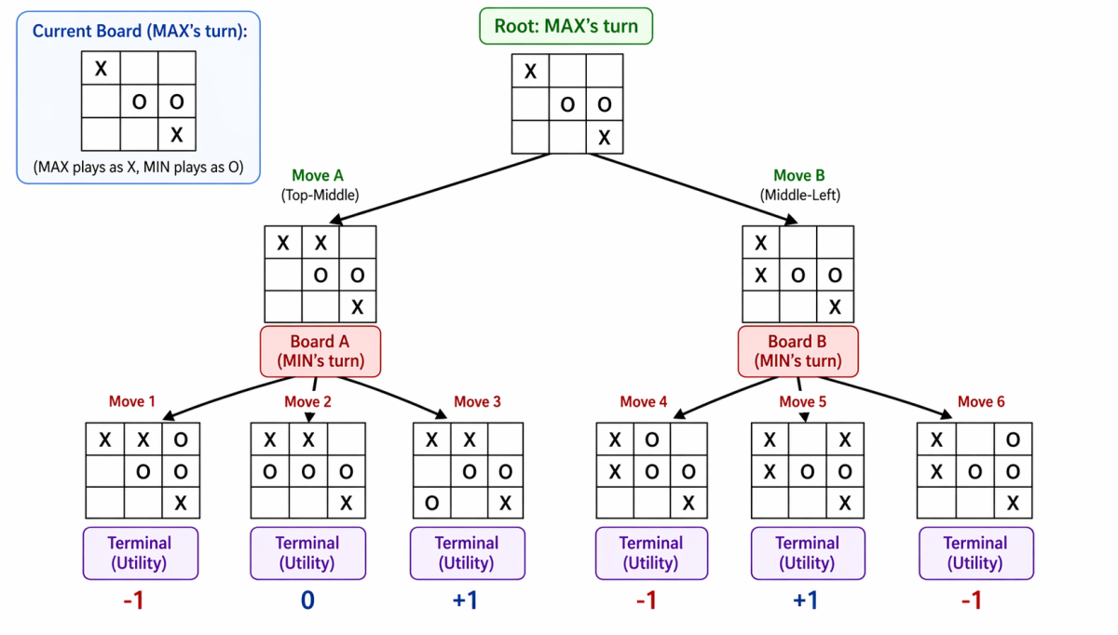
Because the full Tic-Tac-Toe tree is too big, this report shows a simplified subtree. Full implementations use depth limits and evaluation functions for efficiency.
4. Step-by-Step Decision Making with Minimax
Here we walk through a small example to show how Minimax decides the best move by backing up values from leaves to the root.
4.1 Setup and Assumptions
- MAX is X, MIN is O.
- Utility values: X wins = +1, O wins = -1, Draw = 0.
- Current state: Tic-Tac-Toe board where X has three possible moves (A, B, C).
4.2 Evaluation of Terminal States
1. For each terminal node (end of the game), assign the appropriate utility based on who wins.
2. For each MIN node (O’s turn), the value is the minimum of its children’s utilities.
3. For each MAX node (X’s turn), the value is the maximum of its children’s utilities.
4.3 Backing Up Values (Bottom-Up Propagation)
Consider a small abstract game tree:
MAX
/ \
MIN MIN
/ \ / \
4 6 2 8
Step 1: Evaluate MIN Nodes (opponent’s turn)
- Left MIN chooses the smallest value: min(4, 6) = 4
- Right MIN chooses the smallest value: min(2, 8) = 2
Step 2: Evaluate MAX Node (AI’s turn)
- MAX chooses the largest value: max(4, 2) = 4
Final Decision: The best move for MAX is the left branch with value 4.
- At MIN nodes, O will choose the move that minimizes X’s utility (e.g., choose -1 over +1).
- At MAX node, X chooses the move that maximizes the result. If both subtrees lead to a guaranteed loss (-1), either move is equally optimal.
5. Applications of the Minimax Algorithm
The Minimax algorithm is used in many real-world applications:
1. Board Games: Used in chess engines (e.g., Stockfish), checkers, and Tic-Tac-Toe AI.
2. Decision-Making Systems:Helps AI systems choose optimal strategies in competitive scenarios.
3. Robotics: Used in competitive robotic systems like soccer-playing robots.
4. Strategic Planning: Applied in military and business strategy simulations where two opposing forces act optimally.
6. Generative AI
6.1 Definition and Key Idea
Generative AI (GenAI) is a class of AI models that generate new content instead of just classifying or predicting.
- It learns patterns from large datasets (text, images, code, etc.).
- Given a prompt (question, instruction, or partial input), it synthesizes a plausible, coherent output.
Common types of GenAI include:
- Large Language Models (LLMs) such as GPT, Claude, and others that generate text.
- Diffusion models and other image generators (e.g., DALL·E, Stable Diffusion) that create images from text descriptions.
6.2 How It Works (Simplified)
- The model is trained on vast corpora of text, images, or code to learn patterns such as grammar, style, and structure.
- During generation, the model predicts the next token (word, pixel, code element) in a sequence, repeatedly, until the output is complete.
- The system uses techniques like probability sampling to balance creativity and coherence.
Step1 : Data Collaction And Learning Step 2: Neural Networks And Transformers

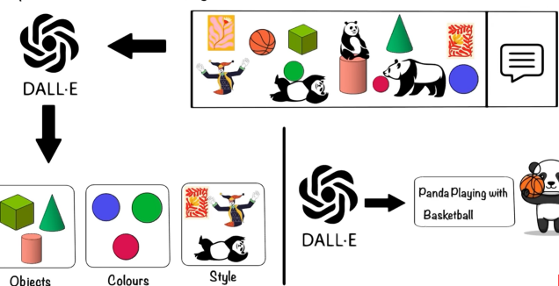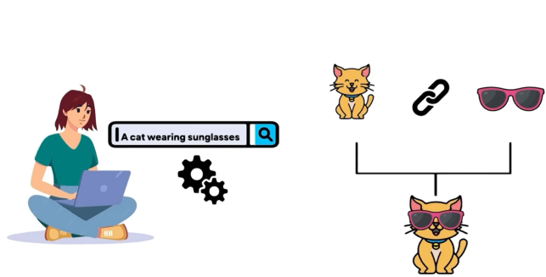
Step3 :Token And Context step4:Feedback machanism
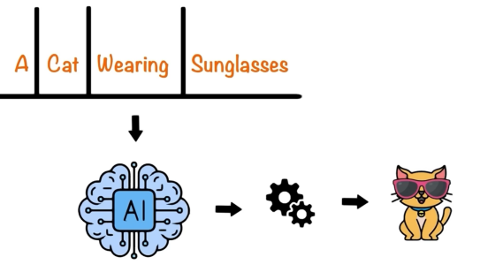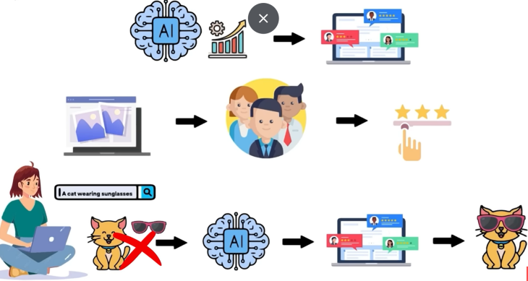
Step5 :Rainforcement Learning
Step6: Data Science And AI Model
Step7: Generating Orginal Content
7. Applications of Generative AI
Generative AI is being used in many real-world domains.
Domain | Application | Example
Text & Conversation | Chatbots, content creation, summarization | ChatGPT answering questions; Jasper writing blog posts.
Software & Code | Code generation, debugging, documentation | GitHub Copilot suggesting function bodies.
Media & Design | Image, audio, and video generation. | DALL·E creating art; ElevenLabs cloning voices
Education & Science | Tutoring, research assistance, drug discovery | Personalized study notes; AlphaFold for protein folding.

Concrete Example: A student uses a chatbot to get step-by-step help for algebra homework, where the AI generates tailored explanations and practice problems.
8. Benefits of Generative AI
1. Productivity and Speed: Automates repetitive tasks such as drafting emails, reports, or code, freeing humans for higher-level thinking. Generates multiple variations much faster than a human could.
2. Creativity and Exploration: Suggests new ideas and designs that humans might not have thought of directly. Helps in brainstorming (e.g., “give me 10 ideas for…”).
3. Accessibility: Lowers barriers for non-experts to create professional-quality content (e.g., small business owners generating marketing material). Supports multilingual applications.
9. Risks and Challenges of Generative AI
1.Misinformation and Hallucination: GenAI can generate plausible-looking but false information (hallucination). This is dangerous in news, education, or medical advice.
2. Bias and Fairness:Models trained on biased data can reproduce or amplify stereotypes (e.g., gender, race, cultural bias), leading to discriminatory outputs in hiring or lending.
3. Privacy and Security: Training data may contain sensitive information that can be leaked. Malicious actors can use GenAI to generate deepfakes, phishing emails, or fake news at scale.
4. Copyright and Ownership: It is unclear who owns AI-generated content. There is ongoing debate about plagiarism when models learn from copyrighted works.
5. Job Displacement and Trust: Some tasks in writing, design, and customer service may be automated, reducing human roles. Over-reliance on AI may reduce critical thinking.
10. Real-World Applications Summary

Minimax Algorithm | Generative AI
Chess AI systems (Deep Blue, Stockfish) | ChatGPT for text generation |
Game-playing bots (Tic-Tac-Toe, Checkers) | DALL·E, Midjourney for art creation |
Strategic simulations in business/military | GitHub Copilot for coding assistance |
Competitive robotics | Virtual assistants and tutors
11. Conclusion
Adversarial search and the Minimax algorithm provide a principled way to make decisions in competitive, two-player games by assuming the opponent plays optimally. By building a game tree and backing up values from terminal states, an AI agent can choose the best move in games such as Tic-Tac-Toe.
On the other hand, Generative AI has become a powerful tool for creating new content across many domains, from text and code to images and audio. However, its benefits come with important ethical, legal, and technical risks, including misinformation, bias, privacy issues, and job-related concerns that must be managed carefully. Understanding both traditional AI search strategies and emerging AI technologies is essential for developing intelligent and responsible AI systems.
12. References
1. Russell, S., & Norvig, P. (2021). *Artificial Intelligence: A Modern Approach* (4th ed.). Pearson. (Chapters 5 and 21).
2. Goodfellow, I., Bengio, Y., & Courville, A. (2016). *Deep Learning*. MIT Press.
3. Goodfellow, I., et al. (2014). "Generative Adversarial Nets." *NIPS*.
4. Brown, T. B., et al. (2020). "Language Models are Few-Shot Learners." *Advances in Neural Information Processing Systems*.
5. OpenAI Documentation on Generative AI.
6. IBM AI Resources on Minimax Algorithm.
7. Bommasani, R., et al. (2021). "On the Opportunities and Risks of Foundation Models." Stanford CRFM.

