**Subdivision Surface with Sharp Edges**

Yupeng Wu

**1. Introduction to the concept**

Given a structure and specific edges, do subdivision recursively to the structure to get smooth surface with the specific edges sharp in order to obtaining the desired stereoscopic graphics. The processes are as following [1]:

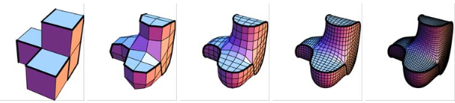

**Figure:** The first graph shows a four unit cubes glued structure and specific edges (bold). The following pictures indicates the process of its loop subdivision surface.

Setting a boundary framework to a given 3-D model. By assigning boundaries of the framework, the 3-D model forms sharp edges stick to these boundaries with surface smooth. The illustration shows the process [2]:

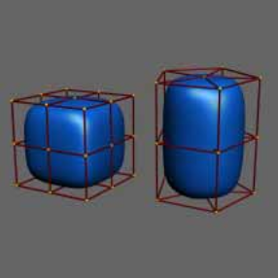 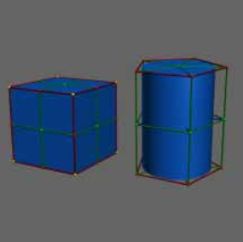

**Figure:** The first graph shows two 3-D models with boundary frameworks. By choosing boundaries (red) and edge control, the volumes get their surface smooth with specific edge sharpen.

**2. Specific Deliverables**

A structure combined only with a set of cubes can be used for surface subdivision. Each side of the cube can be specified as a sharp edge. The surfaces with the unspecified edges are subdivided until they are smooth. The cubes can not be transformed.

**3. Possible Extensions**

The cubes can be transformed into arbitrary shape, and the model can adapt itself accordingly with specific edges sharpen. Sharpe edge can be reselected during each loop of subdivision surface so that the model can be modified more precisely.

**4. Expected Challenges**

The implementation of subdivision surface and the design of this subdivision system. Besides, the drawing speed of stereoscopic graphics is another problem to take into consideration.

**5. References**

[1] Jan Hakenberg, Ulrich Reif, Scott Schaefer, Joe Warren: Volume Enclosed by Subdivision Surfaces with Sharp Creases. <http://vixra.org/pdf/1406.0060v1.pdf>

[2] Ron MacCracken, Kenneth I. Joy: Free-Form Deformations with Lattices of Arbitrary Topology. In Computer Graphics Proceedings, Annual Conference Series, Proceedings of SIGGRAPH 96, pages 181-188. ACM SIGGRAPH, 1996.