Forest Park Southeast, Botanical Heights, Central West End, Medical Campus

Monthly Crime report: August 2019

Washington University Medical Center

(September 30, 2019)

## Forest Park Southeast: Summary Notes

* **20 total crimes in August 2019**
* **11.1% change compared to August 2018 (18 total crimes)**
* **1 crime(s) against persons in August 2019**
* **-75.0% change compared to August 2018 (4 crimes against persons)**
* **165 total crimes in 2019**
* **25.0% change compared to this time in 2018 (132 total crimes)**
* **27 crime(s) against persons in 2019**
* **-20.6% change compared to this time in 2018 (34 crimes against persons)**

## Forest Park Southeast: Year to Year Comparison

### FPSE Total Crimes 2018

| Part 1 Crimes | Jan | Feb | Mar | Apr | May | Jun | Jul | Aug | Sep | Oct | Nov | Dec | Total |
| --- | --- | --- | --- | --- | --- | --- | --- | --- | --- | --- | --- | --- | --- |
| Aggravated Assault | 1 | 2 | 0 | 3 | 7 | 4 | 4 | 3 | 1 | 7 | 0 | 3 | 35 |
| Arson | 0 | 0 | 1 | 0 | 0 | 0 | 0 | 0 | 0 | 0 | 0 | 0 | 1 |
| Burgalry | 0 | 1 | 1 | 3 | 0 | 1 | 1 | 1 | 0 | 1 | 0 | 0 | 9 |
| Homicide | 1 | 0 | 0 | 0 | 0 | 0 | 0 | 0 | 0 | 0 | 0 | 0 | 1 |
| Larceny | 5 | 5 | 5 | 8 | 20 | 4 | 14 | 11 | 15 | 7 | 10 | 3 | 107 |
| Motor Vehicle Theft | 2 | 1 | 2 | 0 | 3 | 3 | 3 | 2 | 2 | 2 | 2 | 2 | 24 |
| Robbery | 0 | 0 | 1 | 1 | 1 | 4 | 2 | 1 | 0 | 2 | 1 | 2 | 15 |
| Total | 9 | 9 | 10 | 15 | 31 | 16 | 24 | 18 | 18 | 19 | 13 | 10 | 192 |

### FPSE Total Crimes 2019

| Part 1 Crimes | Jan | Feb | Mar | Apr | May | Jun | Jul | Aug | Total |
| --- | --- | --- | --- | --- | --- | --- | --- | --- | --- |
| Aggravated Assault | 0 | 3 | 1 | 2 | 2 | 4 | 2 | 0 | 14 |
| Arson | 0 | 0 | 1 | 0 | 0 | 1 | 0 | 0 | 2 |
| Burgalry | 0 | 0 | 1 | 1 | 0 | 0 | 3 | 1 | 6 |
| Larceny | 7 | 10 | 15 | 12 | 9 | 21 | 16 | 17 | 107 |
| Motor Vehicle Theft | 3 | 6 | 1 | 2 | 0 | 4 | 6 | 1 | 23 |
| Robbery | 1 | 0 | 1 | 1 | 2 | 5 | 2 | 1 | 13 |
| Total | 11 | 19 | 20 | 18 | 13 | 35 | 29 | 20 | 165 |

## Forest Park Southeast: Summary Tables

| Part 1 Crimes | Number of Crimes |
| --- | --- |
| Burgalry | 1 |
| Larceny | 17 |
| Motor Vehicle Theft | 1 |
| Robbery | 1 |
| Total | 20 |

| Day of the Week | Number of Crimes |
| --- | --- |
| Sun | 1 |
| Mon | 1 |
| Tue | 4 |
| Wed | 3 |
| Thu | 6 |
| Fri | 2 |
| Sat | 3 |
| Total | 20 |

| Crimes Against Persons | Number of Crimes |
| --- | --- |
| FALSE | 19 |
| TRUE | 1 |
| Total | 20 |

| Time of Day | Number of Crimes |
| --- | --- |
| Day | 15 |
| Night | 5 |
| Total | 20 |

## Forest Park Southeast: Total Crime Map

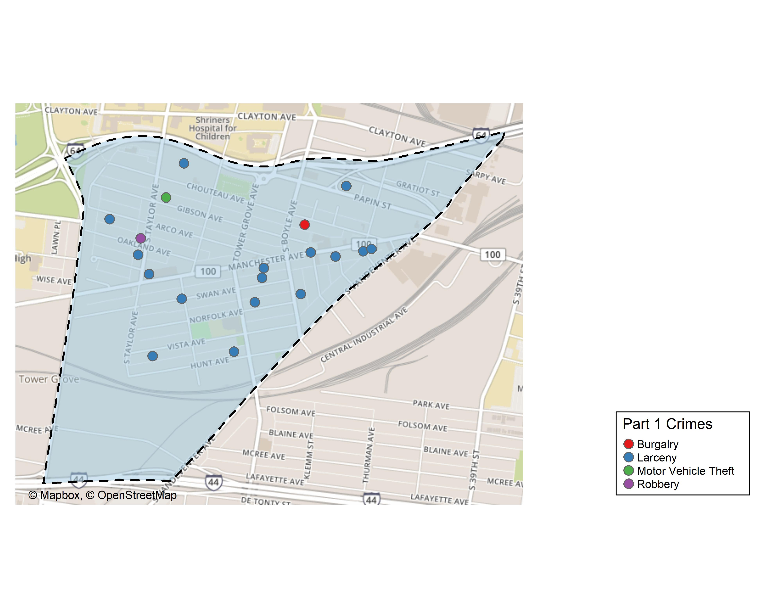

## Forest Park Southeast: Neighborhood Detail

## Forest Park Southeast: Time of Crimes Map

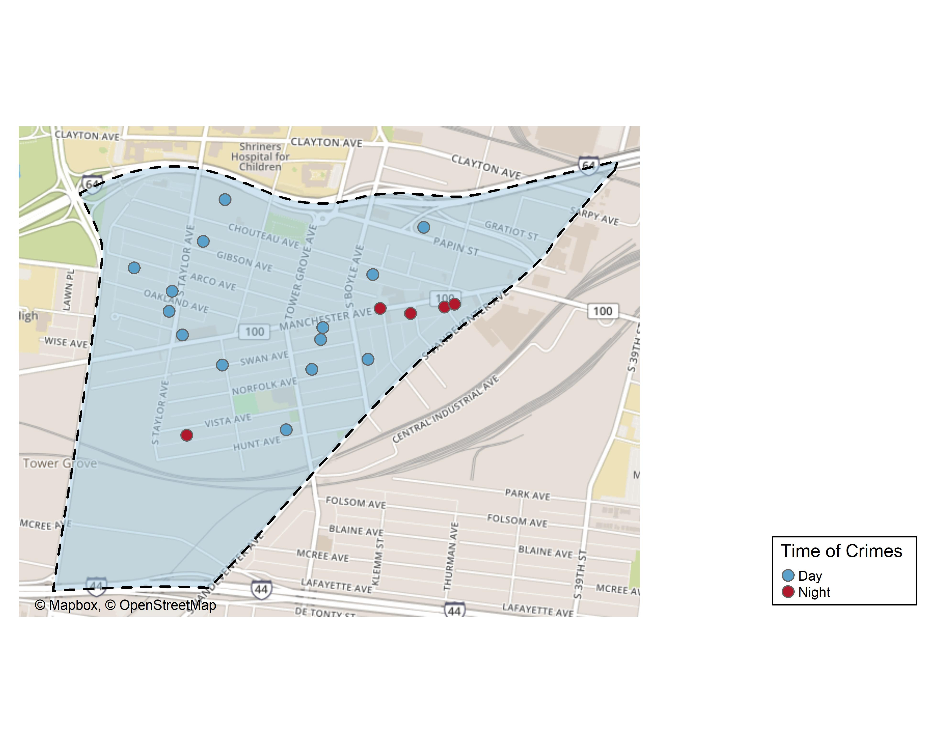

## Forest Park Southeast: Violent Crime Map

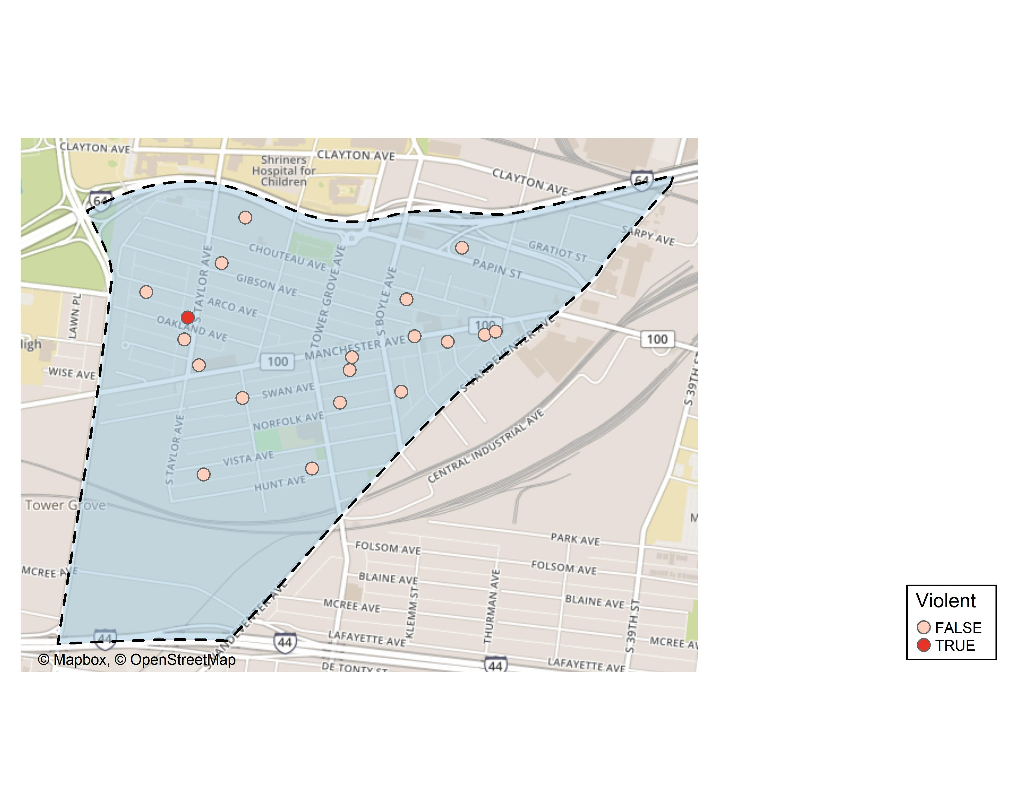

## Forest Park Southeast: Crime Density Map

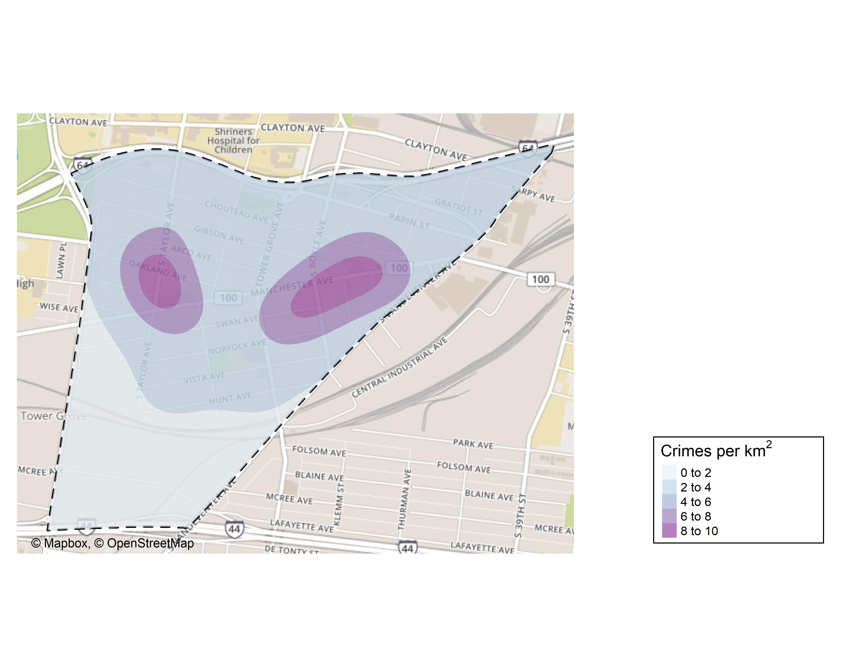

## Forest Park Southeast: Larceny Breakdown

| Day of the Week | Number of Crimes |
| --- | --- |
| Sun | 1 |
| Mon | 1 |
| Tue | 3 |
| Wed | 2 |
| Thu | 6 |
| Fri | 2 |
| Sat | 2 |
| Total | 17 |

| Time of Day | Number of Crimes |
| --- | --- |
| Day | 12 |
| Night | 5 |
| Total | 17 |

| Type of Larceny | Number of Crimes |
| --- | --- |
| All Other | 2 |
| Bicycle | 1 |
| From Building | 2 |
| From Motor Vehicle | 8 |
| From Person | 2 |
| Motor Vehicle Parts | 1 |
| Shoplifting | 1 |
| Total | 17 |

| Monetary | Number of Crimes |
| --- | --- |
| $500 - $24,999 | 6 |
| Under $500 | 11 |
| Total | 17 |

## Forest Park Southeast: Total Crimes by Days of the Week

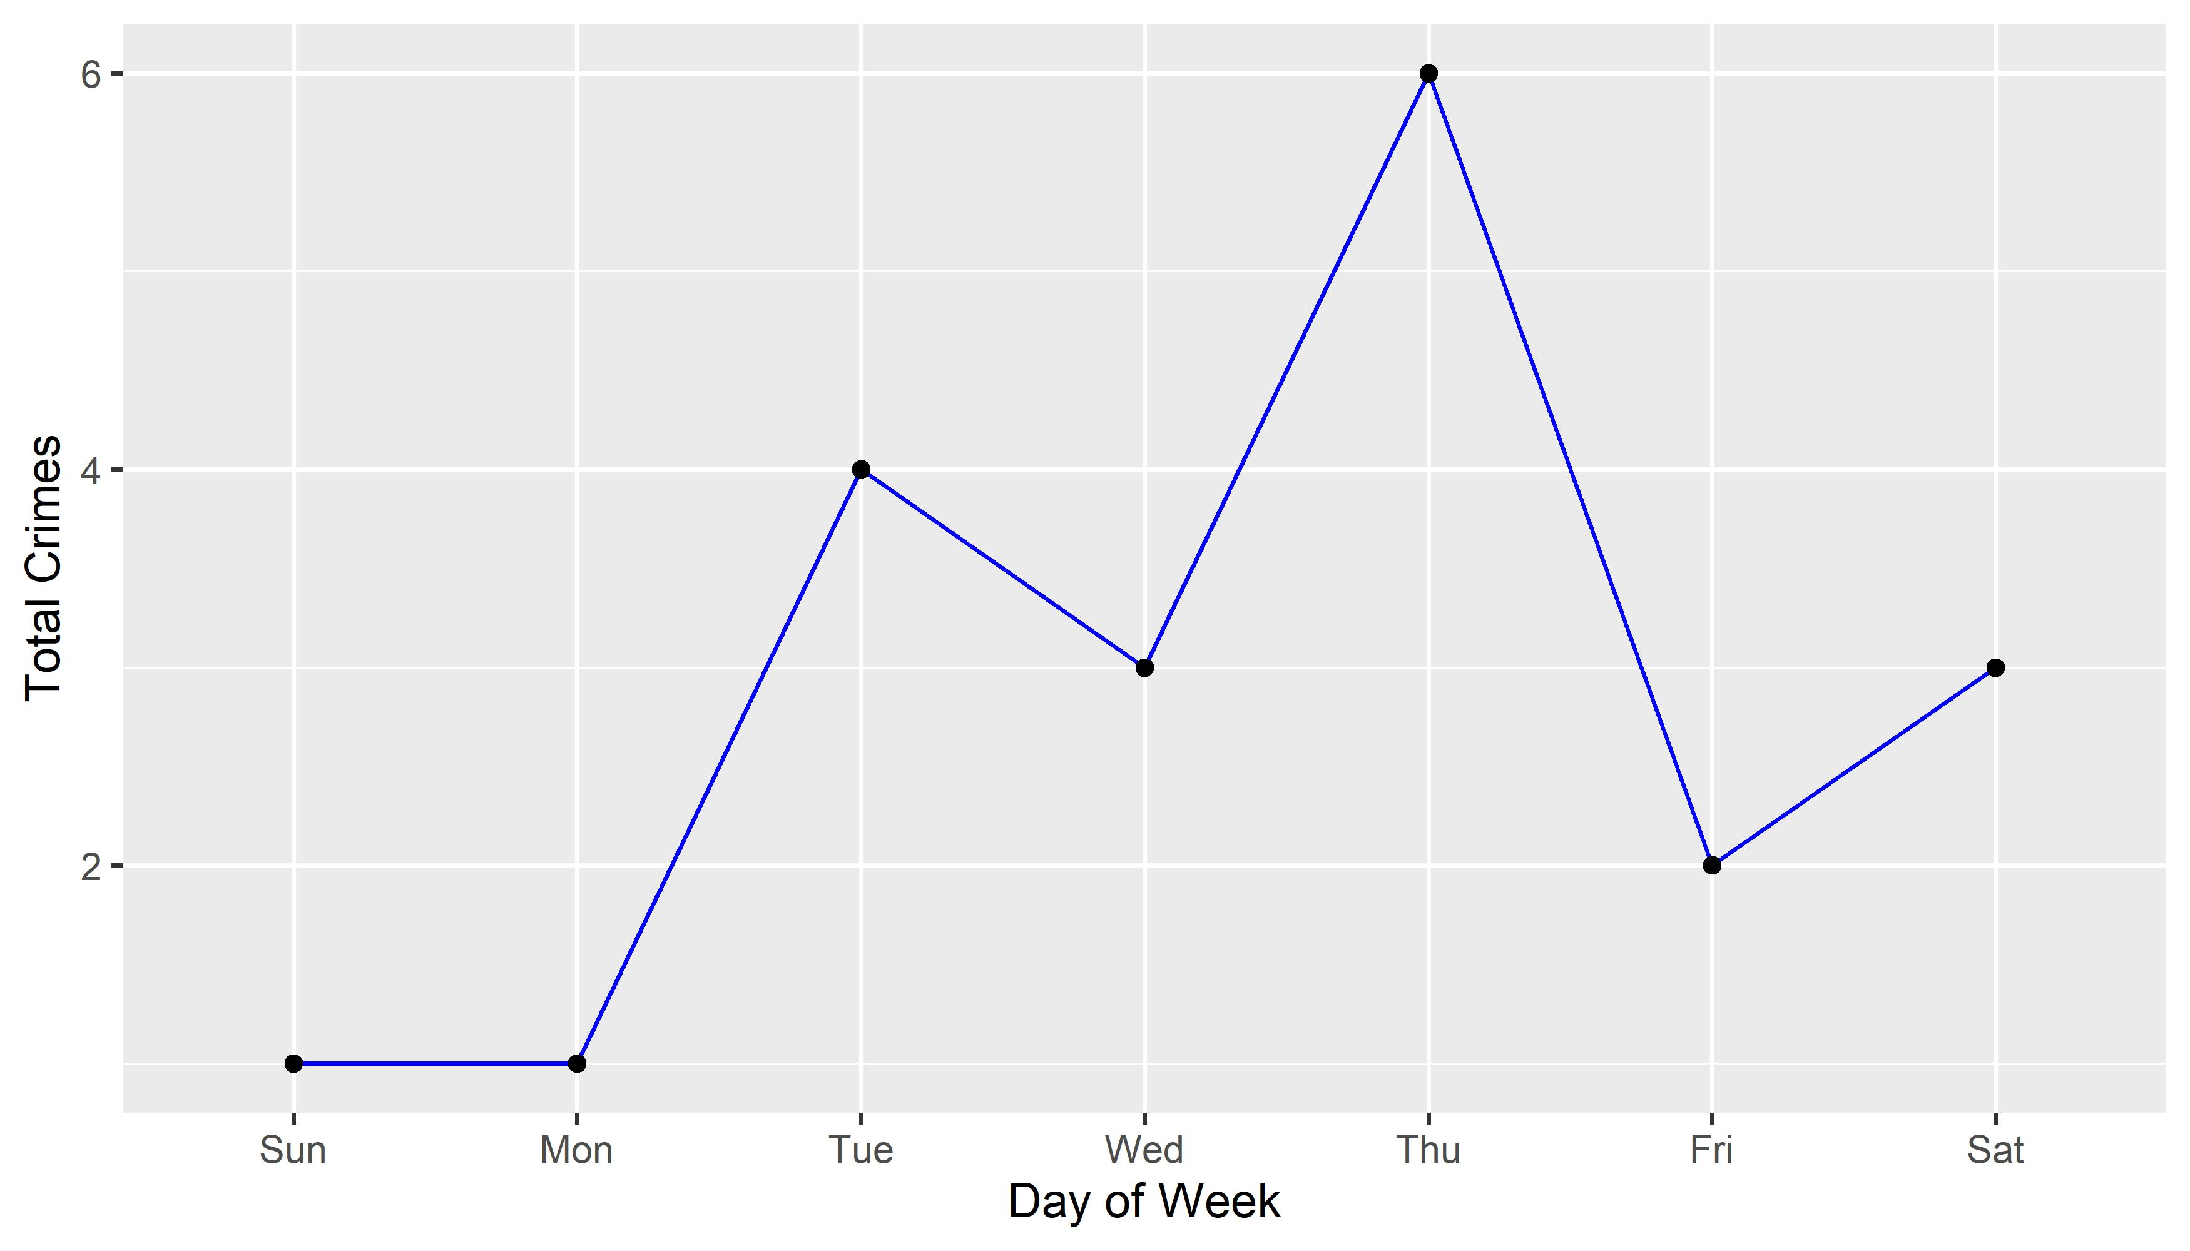

## Forest Park Southeast: Crimes by Time of Day

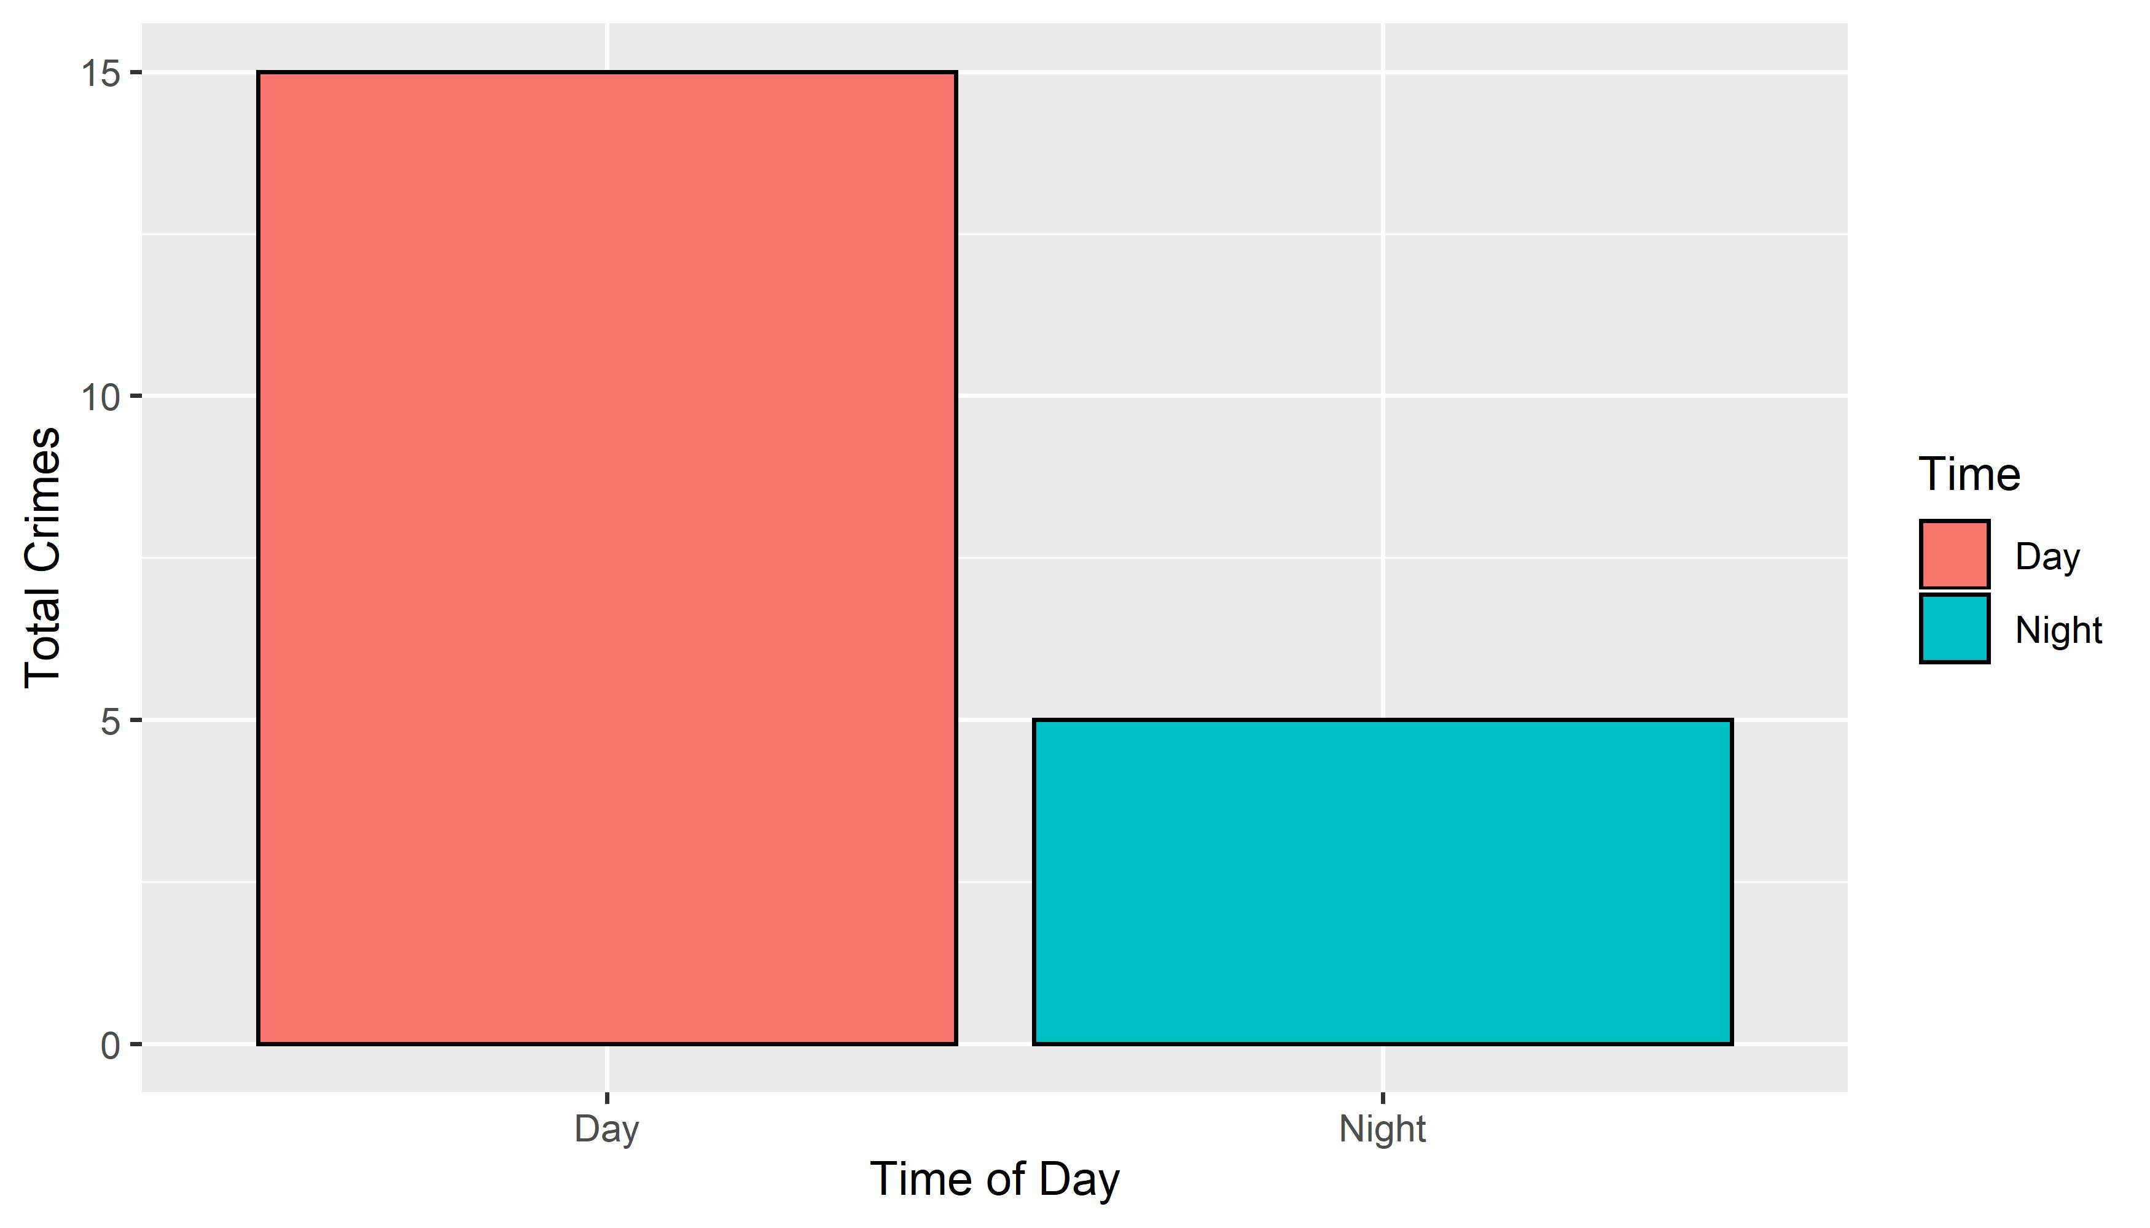

## Forest Park Southeast: Crimes by Day & Category

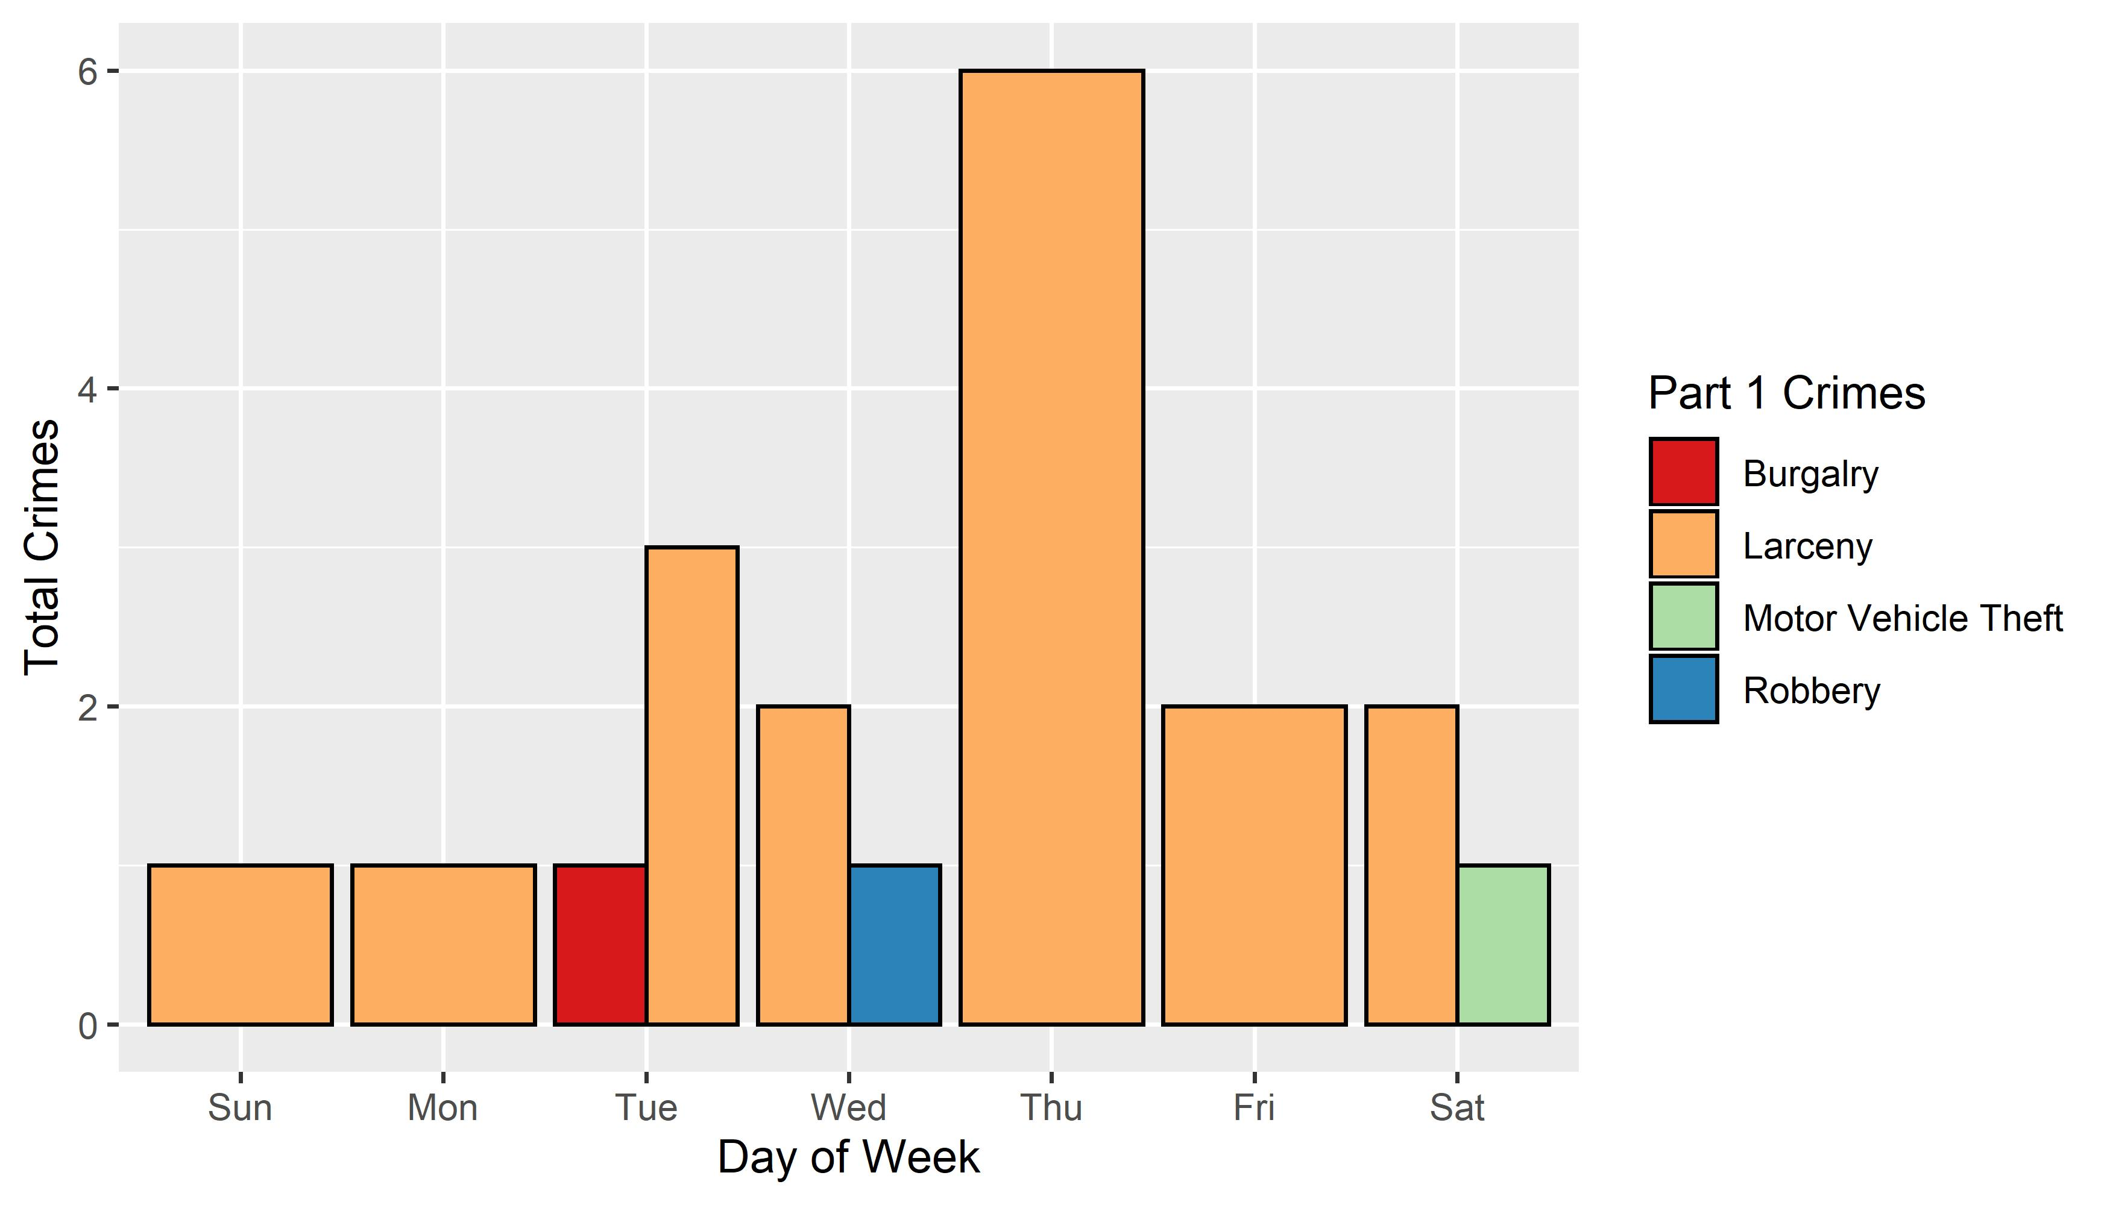

### Disclaimer

* All crime data comes directly from the St. Louis Metropolitan Police Department. Some crimes are reclassified or reported at a later date. Crime data presented in this report includes only selected categories of crime most relevant to overall neighborhood safety and security.