**A gift for my daughter**

**给女儿的礼物**

**Robert Wu**

**FM103.5《家有宝贝》**

**白爸双语故事**

**我要我的牙**

小公主有一口漂亮的牙齿，又白又亮。

The little princess has beautiful teeth, they are white and bright.

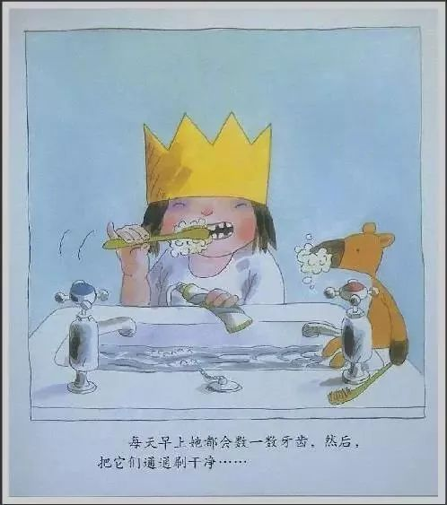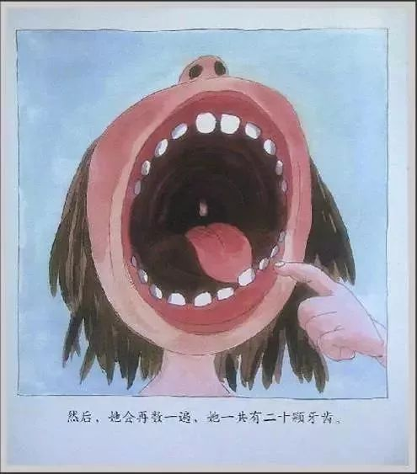

每天早晨，她刷牙的时候都要把牙齿数一遍。

Every morning, when she brushes her teeth, she would count them.

“我有20颗牙！

I have twenty teeth!” she said proudly.

“我的好朋友LUCY和ANNA都没有20 颗牙，但她们不是皇室成员。”

“My good friends Lucy and Anna, they don’t have 20 teeth … but they are not Royal”

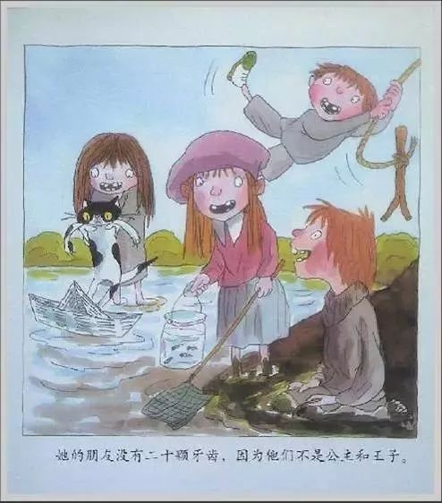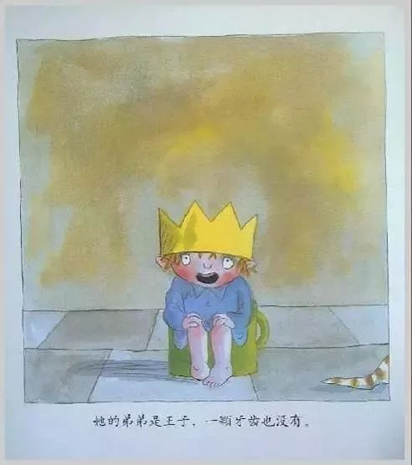

“可是我弟弟是皇室成员啊 … 他怎么一颗牙都没有 …

But my brother is a Roayl..how come he doesn’t have a single tooth”

小公主指着坐在小马桶上的弟弟问道，

she said as she looked at her little brother sitting on a potty.

小公主在池塘边遇到了大臣们。

The princess came across the ministers by the pond.

“哦！小公主的牙真是最漂亮的！

Our little princess has the prettiest teeth！”

“没错！整整齐齐的！

No doubt, and they are soooooo tidy.”

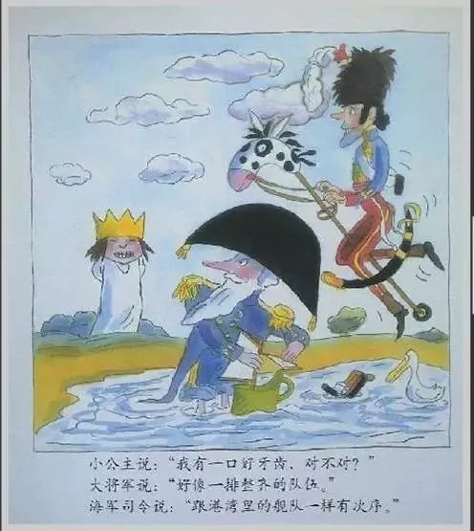

晚上，国王给小公主讲故事的时候，小公主问。

At night, when the king told the little princess her bed-time story, she asked:

“我的牙齿是不是好棒呀？

Aren’t my teeth wonderful, Daddy?”

Of course, they are Royal teeth.”

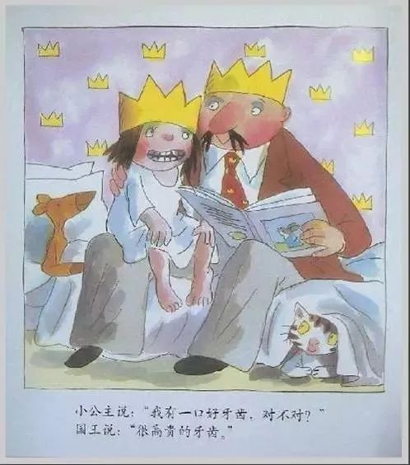

有一天早上，小公主在刷牙的时候数自己的牙。

One day, the little princess was counting her teeth.

突然她发现有一颗牙摇晃了。

Suddenly, she found one tooth began to shake.

“啊啊！！”她尖叫到，she cried,”

一颗牙齿晃了，

one tooth is shaking!”

于是，这颗牙齿一天比一天晃的厉害。

So, this tooth became more shaky each day.

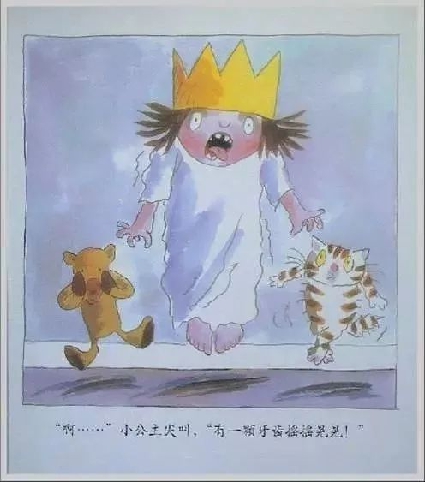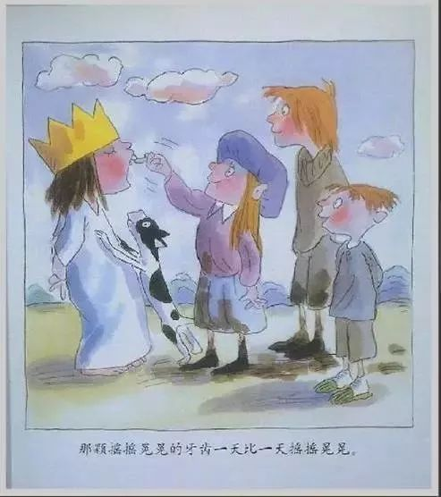

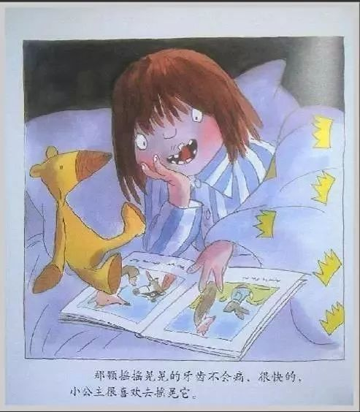

但是，它一点儿也不疼。小公主经常用舌头舔舔它，晃晃它，真好玩！

But it doesn’t hurt at all, the little princess often licked it, just for fun!

她就这样舔舔它，晃晃它，直到有一天，可怕地事情发生了！

So she played with it …until one day …something terrible happened!

那颗摇晃的牙齿不见了！

That shaky tooth disappeared!

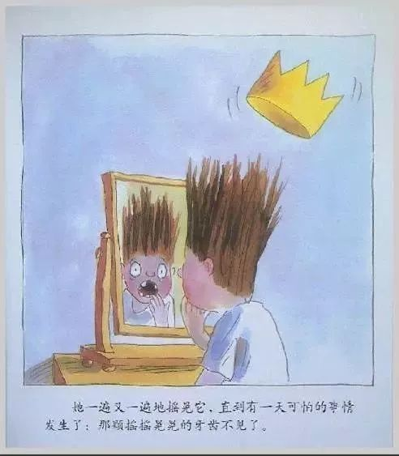

“我要我的牙！

I want my tooth!”

小公主的喉咙都快喊破了，

she cried, almost breaking her voice.

女仆喊道““她要她的牙，

The maid shouted：“she wants her tooth!”

and she looked for it in chests and draws.

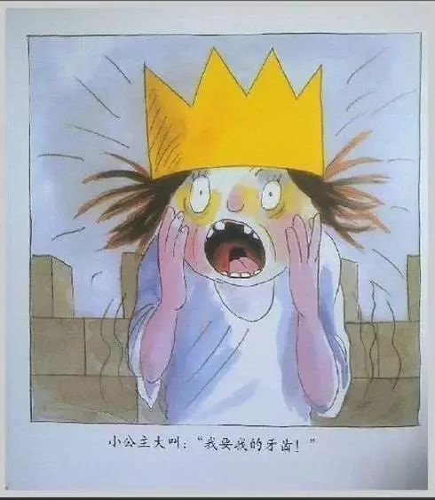 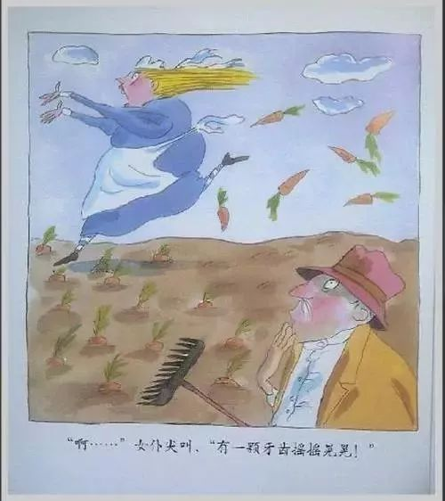

"哎！她要她的牙，

she wants her tooth”

国王无奈地说道,said the king in a helpless tone.

他甚至把猫窝都翻过来找，

he even turned the cattery upside down.

she wants her tooth”

大臣们说，said the ministers.

他们拿着望远镜跑到城堡顶楼到处看，

as they ran up to the castle top with binoculars to look for it.

可是，他们到处都找遍了，都找不到那颗牙。

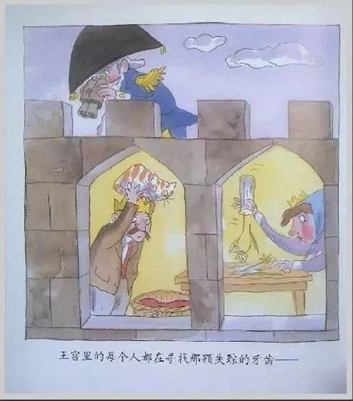

They searched every inch but still couldn’t find the missing tooth.

这时候，小公主突然说。

Then the little princess said :

Oh, I found my tooth.”

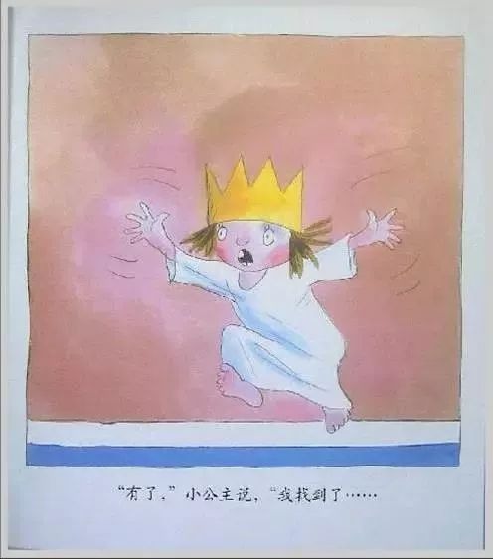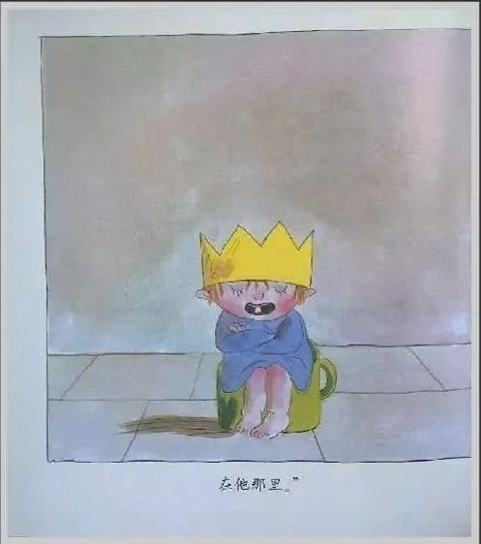

所有人都赶紧跑到她身边,

everyone rushed to her side.

她指着坐在小马桶上的弟弟，

She pointed to her little brother sitting on a potty.

弟弟裂开嘴一笑，露出一颗新长出来的牙齿，

her brother smiled and showed his first tooth.

My tooth is right there, in my brother’s mouth.”

**我有友情要出租**

从前，有一只大猩猩，他常常想：

“我好寂寞，**我没有朋友。**”

**I have no friends.**

“我有友情要出租，**一小时五块钱。**”

**Five yuan（one hour）.**

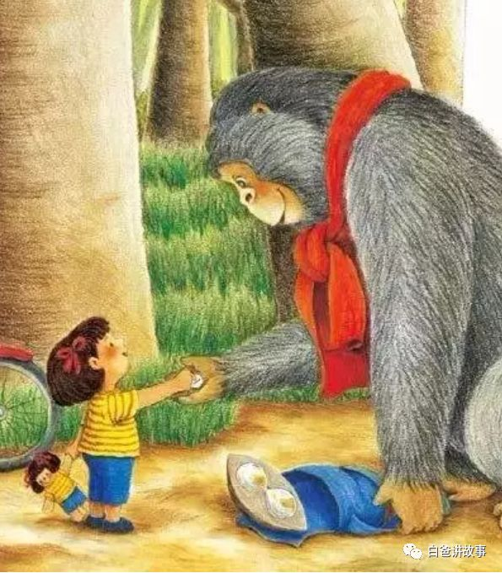

这时候，一个叫咪咪的女孩骑着自行车来了，她看到了叶子，跳下车问大猩猩：

“什么叫友情出租？”

“就是你给我五块钱，我陪你玩一个小时。”

**“可不可以便宜一点？**我只有一块钱。”

**Cheaper**?

“好哇！”

**All right.**

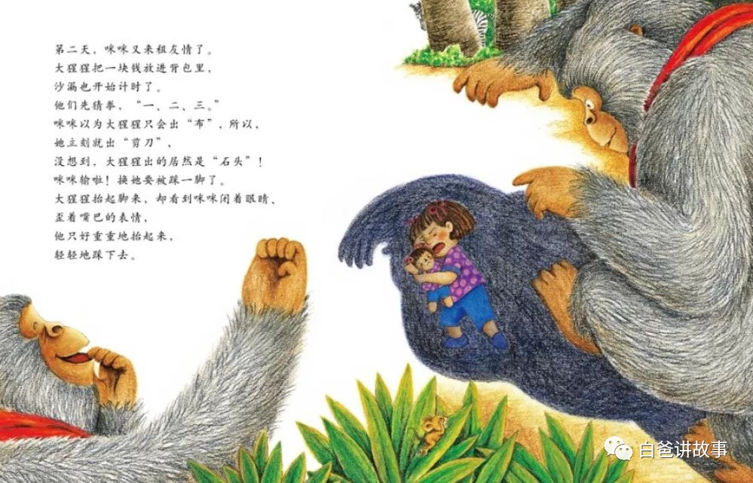

“我们先来玩猜拳游戏——石头、剪刀、布！”

**快一点啦！**

**Quick！**

**“我喊一二三，**你把手伸出来就对了。"

**One, two,three.**

我出的是剪刀，你出的是布，所以我贏了，你要让我踩一下！”

“哎呀！”

**“很痛吗？”**

**Does it hurt?**

**"不痛，一点也不痛，**

**No, not at all**.

我已经学会了，**很好玩！**”

**It’s funny.**

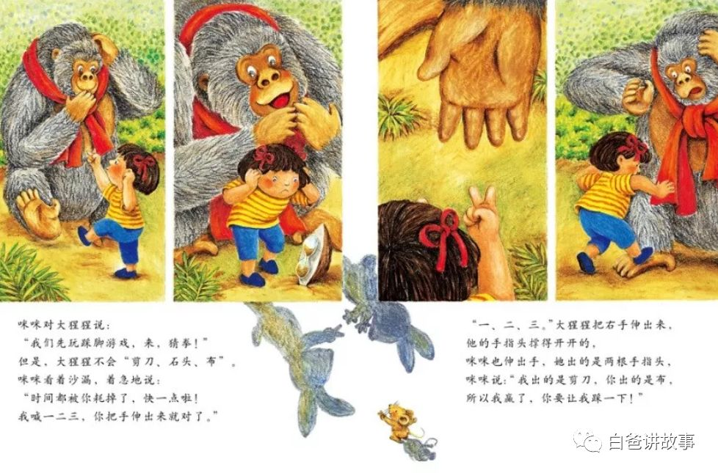

“喂，**大猩猩，我沒有钱了，I have no money.**而且我们要搬家了！

再见！”**Goodbye！**

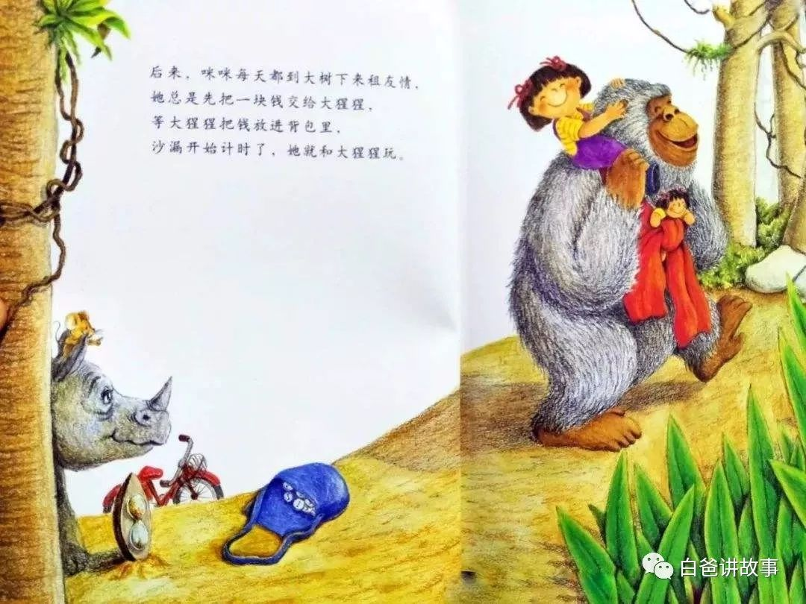

唉！我今天沒有带小背包，也沒有带计时器，不收咪咪的钱，而且还要请她吃饼干呢，可是，她怎么走了？

