**一、程序优化性说明**

**1．用户交互界面说明（建议 200 字以内，给出主要用户交互界面图）**

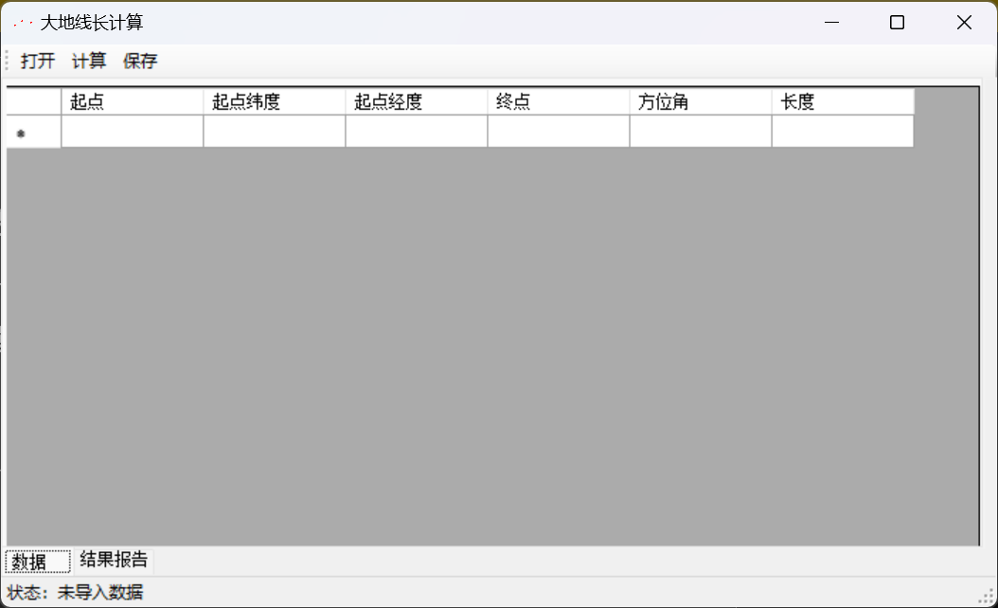

**2．程序运行过程说明（建议 200 字以内，给出程序运行过程截图）**

打开：

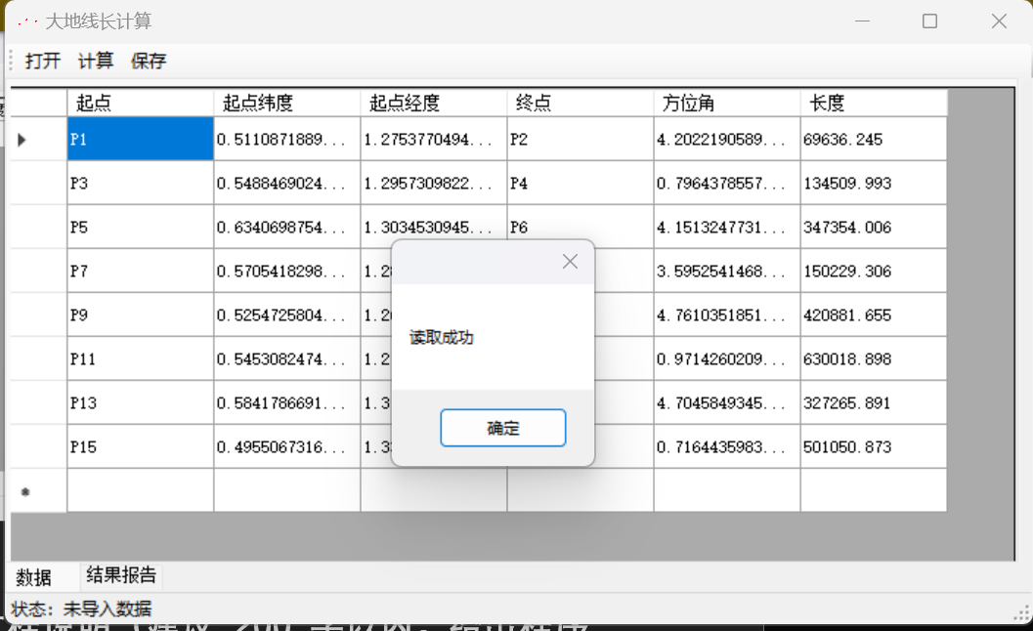

计算：

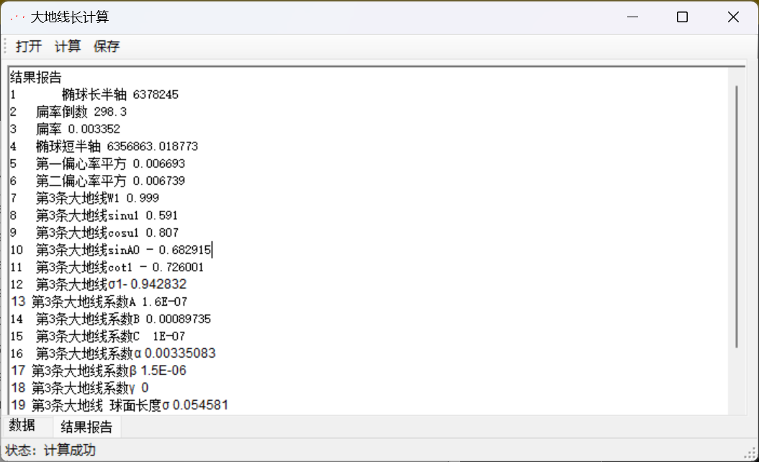

**3．程序运行结果（给出程序运行结果）**



**二、程序规范性说明**

**1．程序功能与结构设计说明（建议 500 字以内）**

功能：已知：大地线起点 P1 的纬度 B1，经度 L1，大地方位角 A1，起点 P1 到终点 P2 的大地线 长度 S；

计算得到：大地线终点 P2 的纬度 B2，经度 L2及大地方位角 A2。

结构设计：Session类里保存每条大地线的数据，Output进行结果数据统一保存

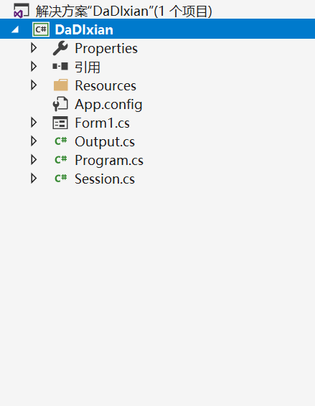

**2．核心算法源码（给出主要算法的源码）**

using System;

namespace DaDIxian

{

class Session

{

///<summary>

///每一条大地线

/// </summary>

public double e2;

public double ep2;

public double b;

public string Startname;

public double B1;

public double L1;

public string Endname;

public double Angle;

public double S;

public double W1;

public double SinU1;

public double CosU1;

public double SinA0;

public double Cotfai1;

public double fai1;

double A;

double B;

double C;

double alpha;

double beta;

double gama;

double fai;

double result25;

double B2;

double L2;

double A2;

public Session()

{

}

public Session(string line,double e2,double ep2,double b)

{

this.e2 = e2;

this.ep2 = ep2;

this.b = b;

var buf = line.Trim().Split(',');

Startname = buf[0];

B1 = CalAngle(buf[1]);

L1 = CalAngle(buf[2]);

Endname = buf[3];

Angle = CalAngle(buf[4]);//弧度

S = Convert.ToDouble(buf[5]);

Algo21();

Algo22();

Algo23();

Algo24();

Algo25();

Algo26();

}

private double CalAngle(string line)

{

double ddmmsss = Convert.ToDouble(line);

double du = (int)ddmmsss;

double fen = (int)((ddmmsss - du) * 100);

double miao = (((ddmmsss - du) * 100) - fen) * 100;

double res = du + fen / 60.0 + miao / 3600.0;

res = res / 180.0 * Math.PI;

return res;

}

private void Algo21()

{

W1 = Math.Sqrt(1.0 - e2 * Math.Sin(B1) * Math.Sin(B1));

SinU1 = Math.Sin(B1) * Math.Sqrt(1.0 - e2) / W1;

CosU1 = Math.Cos(B1) / W1;

}

private void Algo22()

{

SinA0 = CosU1 * Math.Sin(Angle);

Cotfai1 = CosU1 * Math.Cos(Angle) / SinU1;

fai1 = Math.Atan(1.0 / Cotfai1);

}

private void Algo23()

{

double CosAo2 = 1.0 - SinA0 * SinA0;

double K2 = ep2 * CosAo2;

A = (1.0 - K2 / 4.0 + 7.0 * K2 * K2 / 64.0 - 15.0 * K2 * K2 * K2 / 256.0);

A = A / b;

B = (K2 / 4.0 - K2 * K2 / 8.0 + 37.0 * K2 * K2 * K2 / 512.0);

C = K2 * K2 / 128.0 - K2 * K2 * K2 / 128.0;

alpha = e2 / 2.0 + e2 * e2 / 8.0 + e2 * e2 * e2 / 16.0;

alpha = alpha - (e2 * e2 / 16.0 + e2 * e2 * e2 / 16.0) * CosAo2;

alpha = alpha + 3.0 * e2 * e2 * e2 / 128.0 * CosAo2 * CosAo2;

beta = (e2 * e2 / 16.0 + e2 * e2 * e2 / 16.0) * CosAo2;

beta = beta - e2 * e2 * e2 / 32.0 * CosAo2 * CosAo2;

gama = e2 * e2 * e2 / 256.0 * CosAo2 * CosAo2;

}

private void Algo24()

{

double faiStart = A * S;

double faiEnd = 0;

while(true)

{

faiEnd = A * S + B * Math.Sin(faiStart) * Math.Cos(2 * fai1 + faiStart) + C * Math.Sin(2 * faiStart) * Math.Cos(4 * fai1 + 2 * faiStart);

if(Math.Abs(faiEnd - faiStart) < 1.0 * Math.Pow(10, -10))

{

fai = faiEnd;

break;

}

faiStart = faiEnd;

}

}

private void Algo25()

{

result25 = alpha * fai + beta * Math.Sin(fai) * Math.Cos(2 * fai1 + fai);

result25 += gama * Math.Sin(2 * fai) * Math.Cos(4 * fai1 + 2 * fai);

result25 = result25 * SinA0;

}

private void Algo26()

{

double SinU2 = SinU1 * Math.Cos(fai) + CosU1 * Math.Cos(Angle) * Math.Sin(fai);

B2 = Math.Atan(SinU2 / (Math.Sqrt(1.0 - e2) * Math.Sqrt(1.0 - SinU2 * SinU2)));

double nameda = Math.Atan(Math.Sin(Angle) * Math.Sin(fai) / (CosU1 * Math.Cos(fai) - SinU1 * Math.Sin(fai) * Math.Cos(Angle)));

if(Math.Sin(Angle) > 0)

{

if(Math.Tan(nameda) > 0)

{

nameda = Math.Abs(nameda);

}

if (Math.Tan(nameda) < 0)

{

nameda = Math.PI - Math.Abs(nameda);

}

}

if (Math.Sin(Angle) < 0)

{

if (Math.Tan(nameda) > 0)

{

nameda = Math.Abs(nameda) - Math.PI;

}

if (Math.Tan(nameda) < 0)

{

nameda = - Math.Abs(nameda);

}

}

L2 = L1 + nameda - result25;

A2 = Math.Atan(CosU1 * Math.Sin(Angle) / (CosU1 * Math.Cos(fai) * Math.Cos(Angle) - SinU1 * Math.Sin(fai)));

if(Math.Sin(Angle) > 0)

{

if(Math.Tan(A2) > 0)

{

A2 = Math.PI + Math.Abs(A2);

}

if (Math.Tan(A2) < 0)

{

A2 = 2 * Math.PI - Math.Abs(A2);

}

}

if (Math.Sin(Angle) < 0)

{

if (Math.Tan(A2) > 0)

{

A2 = Math.Abs(A2);

}

if (Math.Tan(A2) < 0)

{

A2 = Math.PI - Math.Abs(A2);

}

}

if(A2 < 0)

{

A2 += 2 * Math.PI;

}

if (A2 > 2 * Math.PI)

{

A2 -= 2 * Math.PI;

}

Angle2DDmmssss();

}

private void Angle2DDmmssss()

{

B2 = B2 / Math.PI * 180.0;

L2 = L2 / Math.PI * 180.0;

A2 = A2 / Math.PI * 180.0;

double ddb = (int)B2;

double mmb = (int)((B2 - ddb) * 60);

double ssb = B2 * 3600 - ddb * 3600 - mmb * 60;

B2 = ddb + mmb * 0.01 + ssb * 0.0001;

double ddl = (int)L2;

double mml = (int)((L2 - ddl) * 60);

double ssl = L2 * 3600 - ddl * 3600 - mml * 60;

L2 = ddl + mml * 0.01 + ssl * 0.0001;

double dda = (int)A2;

double mma = (int)((A2 - dda) * 60);

double ssa = A2 * 3600 - dda * 3600 - mma * 60;

A2 = dda + mma * 0.01 + ssa * 0.0001;

}

}

}