|  |
| --- |
| Thinkpalm_Logo-small |

b

|  |
| --- |
| **Enterprise Technology**  **Capability Document – ThinkPalm** |

 

**ThinkPalm Technologies,**

Athulya Building, B1-1st Floor

Infopark, Cochin, Kerala.

India

[www.thinkpalm.com](http://www.thinkpalm.com)

[info@thinkpalm.com](mailto:info@thinkpalm.com)

**Contents**

[1 Introduction 4](#_Toc302998141)

[2 Key Technology Areas in Enterprise Technology 4](#_Toc302998142)

[3 Key Projects in Enterprise domain at ThinkPalm 4](#_Toc302998143)

[3.1 Ship Palm 4](#_Toc302998144)

[3.1.1 Building Blocks 6](#_Toc302998145)

[3.1.2 High Level Architecture-ShipPalm 7](#_Toc302998146)

[3.1.3 Technology used –ShipPalm 7](#_Toc302998147)

[3.2 CRM Software 8](#_Toc302998148)

[3.2.1 Overview- CRM Software 8](#_Toc302998149)

[3.2.2 High level architecture-CRM Software 9](#_Toc302998150)

[3.2.3 Technology used –CRM Software 10](#_Toc302998151)

[3.3 Interplay on Android /IPhone 10](#_Toc302998152)

[3.3.1 InterPlay Web Editor 10](#_Toc302998153)

[3.3.2 InterPlay Content Delivery Server 11](#_Toc302998154)

[3.3.3 Technology used- Interplay server 11](#_Toc302998155)

[3.3.4 InterPlay Viewer: 11](#_Toc302998156)

[3.3.5 Features of InterPlay 11](#_Toc302998157)

[3.3.6 Technology used –Interplay Viewer 12](#_Toc302998158)

[3.4 Palm Konnect 12](#_Toc302998159)

[3.4.1 Exchange Business Card 12](#_Toc302998160)

[3.4.2 Meeting Scheduler 13](#_Toc302998161)

[3.4.3 Building Network 13](#_Toc302998162)

[3.4.4 Technology used –Palm Konnect 14](#_Toc302998163)

[3.5 Relationship Management (RM) made easy! 14](#_Toc302998164)

[3.5.1 Technology used- RM 15](#_Toc302998165)

[3.6 Spot Charter Web Portal 15](#_Toc302998166)

[3.6.1 System Architecture 16](#_Toc302998167)

[3.6.2 Technology used 17](#_Toc302998168)

[4 Few interesting projects undertaken by the team 18](#_Toc302998169)

**List of Figures**

[Figure 1: Enterprise Technology Focus Areas 4](#_Toc302998170)

[Figure 2: SHIPPALM Modules 6](#_Toc302998171)

[Figure 3: ShipPalm – High Level Architecture 7](#_Toc302998172)

[Figure 4 Overview CRM FJ Next 8](#_Toc302998173)

[Figure 5: CRM - Overview 9](#_Toc302998174)

[Figure 6: CRM – High Level Architecture 9](#_Toc302998175)

[Figure 7: Typical Workflow 10](#_Toc302998176)

[Figure 8: InterPlay Features 11](file:///C:\Users\Ann.r\Desktop\Capability_Document_EnterpriseTechnology_ThinkPalm.docx#_Toc302998177)

[Figure 9: Exchange Business Card 12](file:///C:\Users\Ann.r\Desktop\Capability_Document_EnterpriseTechnology_ThinkPalm.docx#_Toc302998178)

[Figure 10: Attendees can search for events 13](file:///C:\Users\Ann.r\Desktop\Capability_Document_EnterpriseTechnology_ThinkPalm.docx#_Toc302998179)

[Figure 11: Konnecting People 13](file:///C:\Users\Ann.r\Desktop\Capability_Document_EnterpriseTechnology_ThinkPalm.docx#_Toc302998180)

[Figure 12 Flow diagram RM 14](#_Toc302998181)

[Figure 13 Overview Ship Charter 16](#_Toc302998182)

[Figure 14 High Level system architecture-Spot charter 17](#_Toc302998183)

# Introduction

# Key Technology Areas in Enterprise Technology

In the enterprise technology domain, we offer services to our customers in the following areas

1. Software solutions for shipping industry
2. Software solutions for media
3. Custom Applications
4. Web portal development

Figure : Enterprise Technology Focus Areas

# Key Projects in Enterprise domain at ThinkPalm

## Ship Palm

ShipPalm is the flagship product of ThinkPalm. ShipPalm is a comprehensive software suite to handle technical and commercial management of ships & vessels at sea. Its different modules cover a wide spectrum of Ship’s technical and commercial operations onboard as well as at the control/ management centers onshore. It will be used by various categories of users onboard as well as by technical and non-technical staff located at control centers/ offices onshore, ship owners and agents. The product is being built on a highly customizable framework and aims to provide simple and easy to use user interfaces for the end users.

ShipPalm has the following functions:

* Single unique platform providing robust ship monitoring & management capability.
* Seamless integration of ship side and shore side operations and thereby achieving transparency at optimal level.
* Real time reporting of ship data on 24 x7 basis.
* Offers increased quality, safety & security management along with strong inventory management system.
* Effective representation of critical data enables the decision makers to take the right decision at the right time.
* Integrates crew management, finance & accounting module along with the operations
* Robust planned maintenance and repair management system forms an integral part of this unique platform.
* Document management system caters the need of effective document sharing and accessibility needs of the shipping industry.

### Building Blocks

Following are the modules of the product, ShipPalm:

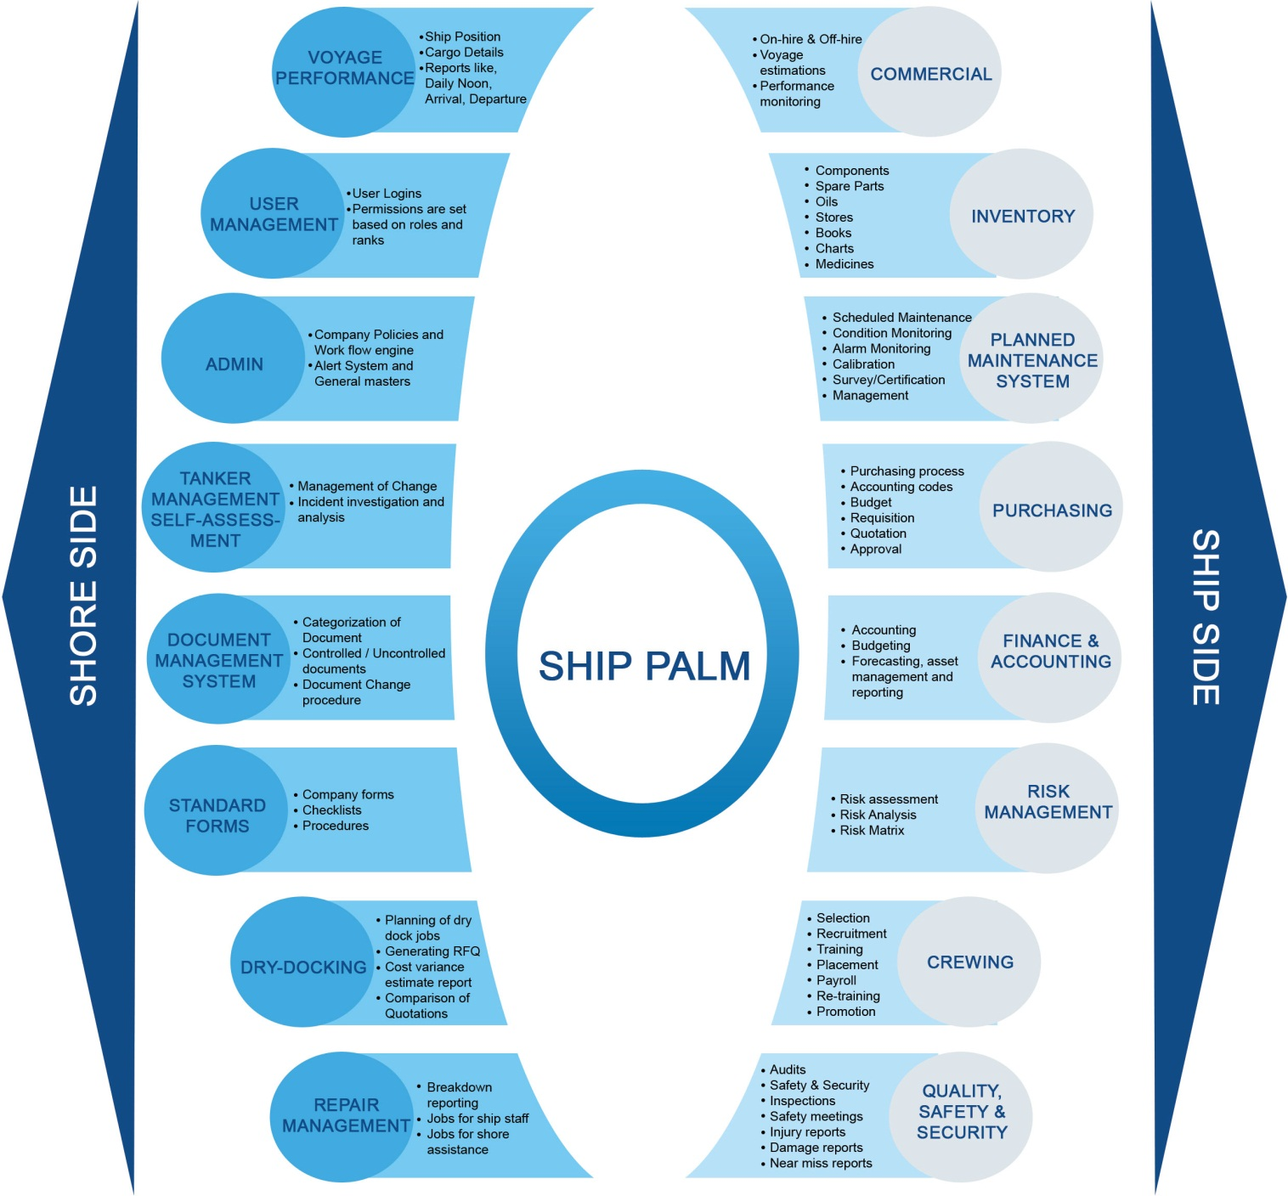

Figure : SHIPPALM Modules

### High Level Architecture-ShipPalm

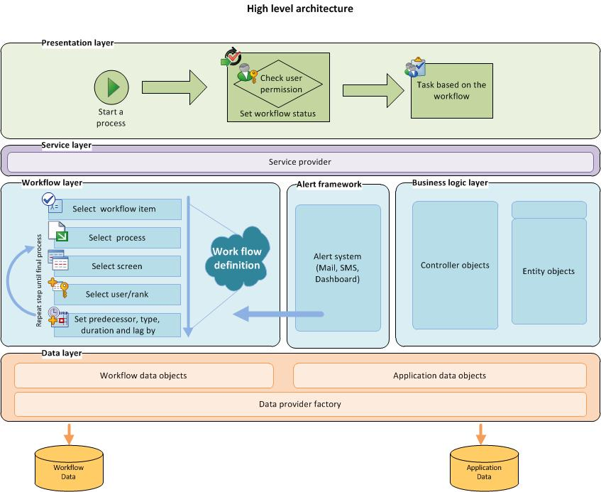

Figure : ShipPalm – High Level Architecture

### Technology used –ShipPalm

|  |  |
| --- | --- |
| **Language** | C#, Fluorinefx, Flex |
| **Database** | SQL Server 2008 |
| **OS** | Windows 2007 & above |

## CRM Software

### Overview- CRM Software

Call Center Management System is a software product which helps to manage User, Name List, Prospect, Employee and Call center activities.

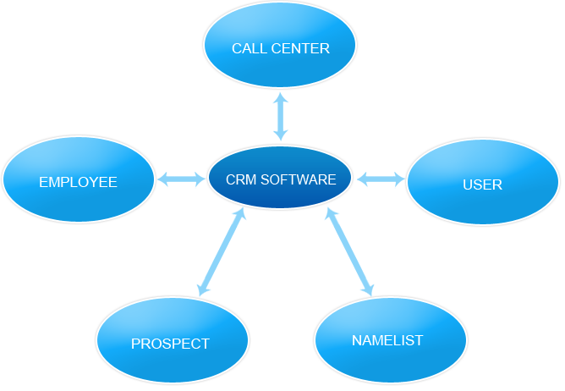

Figure Overview CRM FJ Next

The objective of the project is to develop a system for managing the call handling activities of a call center through a web based system.

User Management module helps to manage role based access to the system. There are three types of users for the system namely the call center executive, the supervisor and the manager who uses the different functions of the system. The functionalities of the Name List management includes Import Purchased Name list, Collation/Grouping of contacts, Extract Name list, Assign Name List to sales person and Inducement Break. The Prospect and Call management functionalities include Company Registration, Call Prohibition, Call settings and PBX Functionalities.

Using the Employee management module a user can do the following activities Department creation, Division / Group Creation, Employee Registration and Track Employee Movements.

The below figure explains the usage scenario of the system.

****

Figure : CRM - Overview

### High level architecture-CRM Software

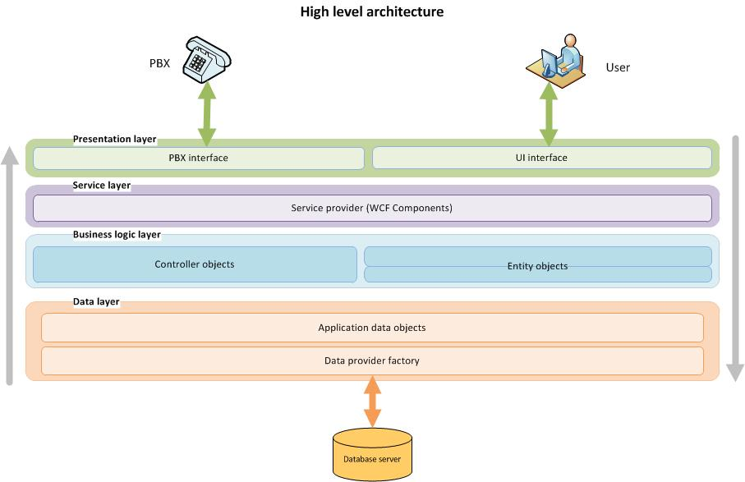

Figure : CRM – High Level Architecture

### Technology used –CRM Software

|  |  |
| --- | --- |
| **Language** | C#, WCF, WPF |
| **Tools** | PBX API (IP based) |
| **Database** | SQL Server 2008 |
| **OS** | Windows 2007 & above |

## Interplay on Android /IPhone

InterPlay is a complete software framework meant for Digital Signage needs of customers. It is a network of customizable displays that can be controlled digitally using a computer/ mobile allowing content to be changed remotely for the most targeted messaging possible. InterPlay is a comprehensive product consisting of Signage Viewer, Content Editor/Manager and Content Delivery Server.

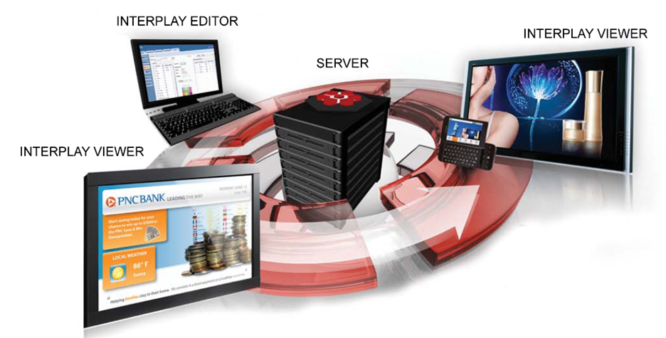

Figure : Typical Workflow

### InterPlay Web Editor

This is a very distinctive and diverse web application, which allows creating multimedia contents / playlists / sequences / schedules including HD videos, sound effects, pictures, telops (image/texts), web contents etc., and ensures creation of attention grabbing communication material. It allows creation of Playlists, Sequences, Daily Schedules and Projects and supports Playlist event settings & looping at multiple levels and also includes Playlist Preview. It supports a wide variety of layout templates (with multiple splits/windows) and also provides support for a wide variety of resolutions (including HD).

The Content Delivery Server, which handles the content distribution across the signage terminals, is integrated with Web Editor.

### InterPlay Content Delivery Server

The Server is a comprehensive content management system which is responsible for content delivery to the Viewer Terminals. The Server enables to group the terminals and deliver identical contents to them. Its extensive administrative feature enables to support 5 different levels of hierarchy under user management. License Key validation and authorization is required for installing / controlling each terminal. Its log management feature provides log details of Viewer Terminals and Users. The Server also has a Viewer Terminal heart monitoring, which provides the Viewer Terminal connection status.

### Technology used- Interplay server

|  |  |
| --- | --- |
| **Language** | PHP,FLEX,VC++ |
| **Database** | My SQL |
| **OS** | Windows XP & above |

### InterPlay Viewer:

The Viewer plays back the contents set using the Editor and delivered via the Content Delivery Server. A wide variety of contents are supported on the viewer including video, audio, HTML and flash. It can support up to 3 HD flash contents in a single playlist. Fast downloading and quick playback, 3G support, etc. are some of the unique features offered in the viewer software.

### Features of InterPlay

Figure : InterPlay Features

* **Powerful** – Relevant message at the right time at right place! The relevant message at relevant location will ensure attention. It can enable interaction with the end user.
* **Dynamic** – InterPlay is interactive and based on the demographics of the audience contents can be customized. Schedule/Content changes can be made quickly & remotely.
* **Focused** – A unique delivery model of messages to targeted audience at each location.
* **Versatile** – InterPlay can be placed anywhere from Airports, Retail Outlets, Restaurants, Banks to Streets. It helps to communicate with the audience in a versatile manner; can reach out to customer at all places.
* **Controlled** – Customer friendly User Interface allow controlling hundreds of display from one place. In addition its real-time telop allows updating a message instantly for important announcements.
* **Cost effective** – Eliminates printing and distribution cost associated with campaign. With change of campaign, new campaign can be send instantaneously without bearing any cost.

### Technology used –Interplay Viewer

|  |  |  |
| --- | --- | --- |
| **Platform** | **Language** | **Data base** |
| **Windows** | VC++ | MY SQL |
| **Android** | JAVA | SQ LITE |

## Palm Konnect

PalmKonnect is a mobile application developed for Android/IPhone. PalmKonnect will have 3 levels of functionality:

* Level 1 – Exchange Business Card
* Level 2 – Meeting Scheduler
* Level 3 – Building Network

### Exchange Business Card

This application is used for exchange of business cards through phone device rather than physical exchange.

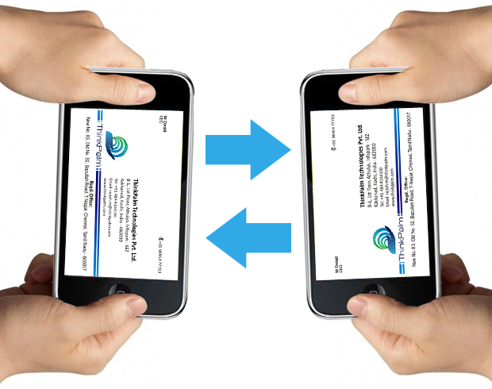Some of its features are:

* It maintains all contacts in form of business card and will allow to sort them based on date received, name, company name, designation etc.
* For people who don’t have the application, the contact details will be sent to their phone via email - send text message with email id of the concerned person from registered mobile no.
* The application will allow the users to save the contact details, call or text the contacts, and maintains a record of location and time of exchange and also provide data analysis on the same.

Figure : Exchange Business Card

### C:\Users\admin\Desktop\events.jpgMeeting Scheduler

This will have three users:

1. Organizers
2. Attendees
3. Exhibitors

* Application will help organizers to organize events and send invitations along with details of the event, exhibitors, schedule and link to registration form. It will also provide intelligent list of invitees whom organizers can send invitations.
* Attendees will have options to accept or decline the event/browse for events/view profiles of other attendees etc.

Figure : Attendees can search for events

* Intelligent suggestions of upcoming events based on the individual’s profession, interest, designation, industry.
* Notifications in case of any changes related to the schedule, meetings, attendees list, exhibitors etc.
* Attendees will be able to request meeting with the other attendees during / before and after event and schedule for meeting based on the available timeslot.
* Downloading marketing materials of the exhibitors will also be possible. Sponsor page and photo gallery can also be viewed.
* Analysis and reports to the exhibitors like how many attendees viewed their profile, List of attendees scheduled to attend the exhibitor’s event, etc. will be provided
* The schedule can be exported to the phone/calendar/Outlook, Google, etc. Information on the venue lists and directions of event location information like hotel, restaurant, bus stop, cab services, etc will be provided.

### Building Network

Figure : Konnecting People

Professionals will be able to connect to others through groups. Any registered user can browse for other registered user & view their professional details barring their personal and contact information.

The groups can be classified as

1. People Met
2. Like to Meet
3. Follow / Track
4. Create own groups/circles

The users will be able to schedule meetings, chat, call, share information with all of them at one go.

### Technology used –Palm Konnect

|  |  |
| --- | --- |
| **Language** | .NET/PHP |
| **Database** | SQ LITE/SQL COMPACT/MY SQL |
| **Platform** | Android/iPhone/ Windows |

## Relationship Management (RM) made easy!

ThinkPalm is developing unique software for the banking industry which enables the relationship managers to monitor their customers efficiently thereby reducing the customer drop outs. This is highly useful to the senior managers also for tracking the performance of the relationship managers, product performance and understanding customer investments. This software enables the user to generate reports based on product, performance and customers send alerts to customers and support email campaign. It also ensures security to the bank by enabling secured login.

This software helps the senior managers to keep an eye on the performance of the relationship managers and also have a detailed understanding of the customer investments.

The flow diagram is given below.

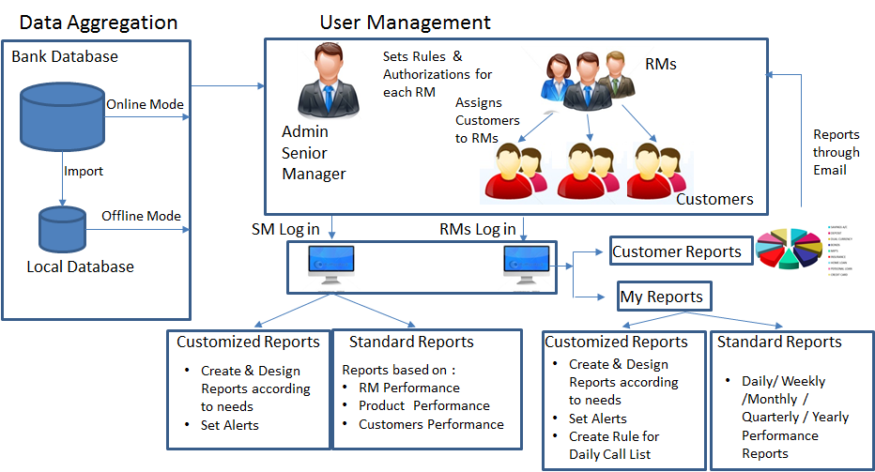

Figure 12 Flow diagram RM

### Technology used- RM

|  |  |
| --- | --- |
| **Language** | C# |
| **Database** | SQL server |
| **OS** | Windows |

## Spot Charter Web Portal

ThinkPalm is developing a Spot Charter Web Portal for Ship owners, Brokers and Charters. There are 3 types of users using this portal; Owners, Brokers and the Charters. The user creation and billing will be managed by the Admin module.

The owners can register the vessel with the portal. Details like the frequently changing data, the vessel parameters, vessel Schedule and the vessel Status can be added to the portal along with the supporting documents. The Owners are provided an option to manage the vessel visibility to the intended audience. The vessel is then available for the search depending on the rights.

The Brokers are given a provision to add the vessel for the spot charter and sale. The Software also provides a higher search placement bidding interface. The Owners and the Brokers are also provided with an option to do Paid advertising.

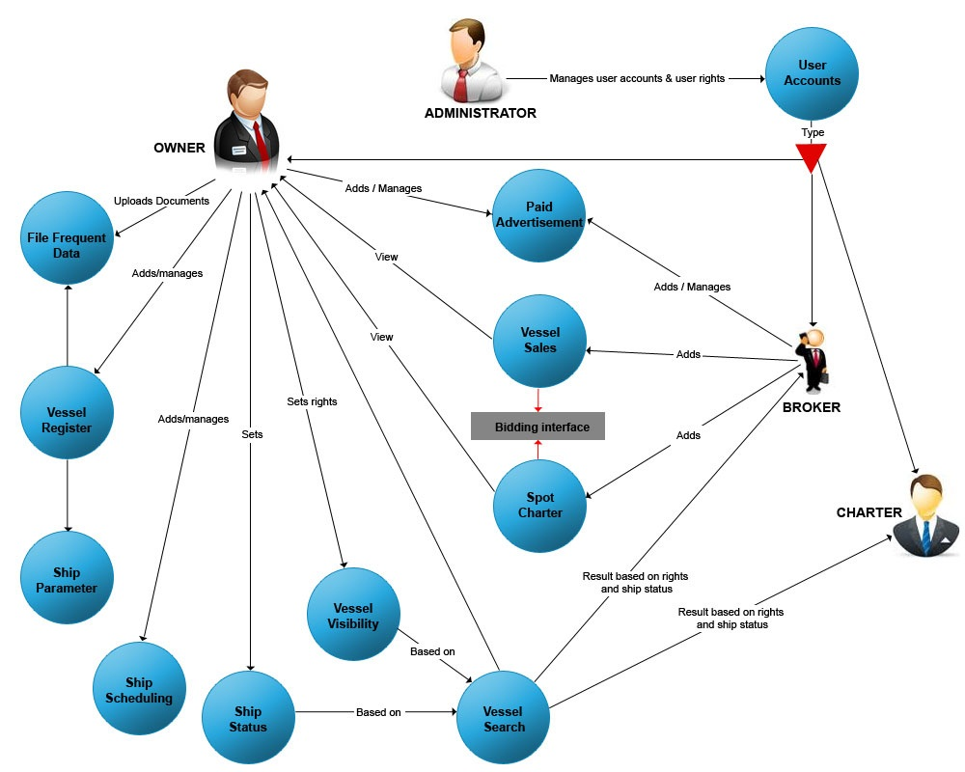

Figure Overview Ship Charter

### System Architecture

The architecture depends on functional and nonfunctional requirements of the portal application. The Portal has a three-tier or n-tier architecture which includes client tier, application tier and data tier.

Figure below shows a high level System Architecture

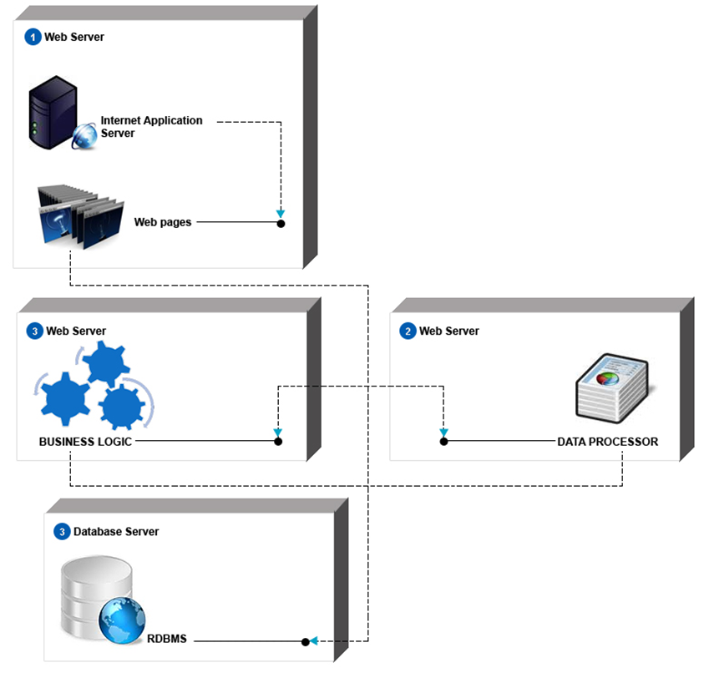

Figure High Level system architecture-Spot charter

### Technology used

|  |  |
| --- | --- |
| **Language** | ASP.NET, PHP |
| **Database** | MS SQL/ MY SQL |
| **OS** | Windows |

# Few interesting projects undertaken by the team

Team has worked on projects in the following domains:

|  |  |  |  |
| --- | --- | --- | --- |
| Supply Chain Management | Logistics and Ware House | Shipping | Information Kiosks and training |
| CRM | ERP | HRM | Printing Solutions |
| Construction | Finance | Hospital Management | Chat Server |
| Search Engine | Telecom billing Application | Asset Tracking and maintenance | Resource Management in Mining |
| Content Management | Transportation | Air Cargo Management | Government Projects |
| School Management | Library Management |  |  |