 | MINISTRY OF EDUCATION AND TRAINING  FPT UNIVERSITY

Capstone Project Documents
Toll Fee Management
Unstopable
Group Members
  Nguyễn Anh Nhật Linh | 00499
  Nguyễn Duy Vũ | 00521
  Trần Hải Đăng | 00357
  Nguyễn Xuân Hiếu | 00380
  Tô Văn Quân | 00425
S
pervisor
Teacher Nguyễn Văn Sang
Ext Supervisor | Huỳnh Anh Dũng,Nguyễn Tất Trung
Capstone Project code | TFM

Hanoi, June 2011

Record of Changes
Date | Change Item | Description | By | Version
10/06/2011 | All | Create the document | QuanTV1 | 1.0

Table 1-1: References

TABLE OF CONTENTS
Part 1 INTRODUCTION
TABLE OF CONTENTS 3
1 Design overview 5
1.1 Overview 5
1.2 Definition and acronyms 5
2 Architecture design 6
2.1 Basic Structure 6
2.2 Architecture Design 6
2.2.1 PNRS Components Design 6
2.2.2 TCMW Components Design 8
2.2.3 DSS Components Design 9
3 Detailed design 10
3.1 PNRS design 10
3.1.1 Login/Switch User 10
3.1.2 Search 14
3.1.3 Camera capture 18
3.1.4 Auto plate number recogniton 21
3.1.5 Enter plate number info 25
3.1.6 View and get update price list 29
3.1.7 View help 33
3.1.8 Print ticket 35
3.1.9 Display plate number info 38
3.2 TCMW design 40
3.3 DSS design 40
4 Database Design 41
4.1 Entity-Relationship Diagram 41
4.2 Table Design 41
4.2.1 Table Car 41
4.2.2 Table Car_Groups 41
4.2.3 Table car_type 42
4.2.4 Table evidence 43
4.2.5 Table fare 43
4.2.6 Table role_permissions 44
4.2.7 Table roles 44
4.2.8 Table Station 45
4.2.9 Table ticket_registration 45
4.2.10 Table users 45
4.2.11 Table user_detail 46
4.2.12 Table transaction 47
4.2.13 Table ticket_type 47

Design overview

Overview
This document will show the technical and UI design of the TFM system. It includes 2 parts: the application and the website. In each part we will describe the architectural design and the detailed design of common functions and business functions. It also includes the design of database model, and overall design of user interface.
The architectural design describes the overall architecture of the system, and the architecture of each main component and subsystem. It will describe the patterns being used, the role of each component and the role of the system in the working environment.
The detailed design describes static and dynamic structure for each component and function. It includes class diagrams, class explanations, and sequence diagrams of the main use cases. The detailed design uses notations of .NET framework 4.0 and C# 4.0 as they are the framework and language for developing the system.
The database design describes the relationship between entities, and details of each entity. It uses notations of SQL Server 2008 as it is the database server for developing the system.
The user interface design describes the layout of the system, and some design for the screens.

Definition and acronyms
Acronyms | Definition | Note
TFM | Toll Fee Management | Name of project
PNRS | Plate Number Recognition System | Name of main application that’s used to recognize plate number.
TCMW | Toll Collection Managerment Website | The website that’s used to manage toll collection.
SA | Sub-Application | Sub-Application

Table 1-2: Definition and acronyms

Architecture design

Basic Structure
Basic structure of the system is described in the following figure:
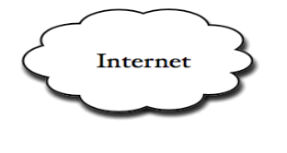
Database
Server
TCMW
DSS
Vietnam Register System database
Web service
Clients
Browser
PNRS app
Get data
Update data
Figure 1-1: Basic structure

Architecture Design
The system is divided into 3 sub SAs: PNRS, TCW and DSS, they are developed in just one solution and in some components. The specific architecture will be described below:

PNRS Components Design
The architecture for the PNRS will be depicted as the following diagram
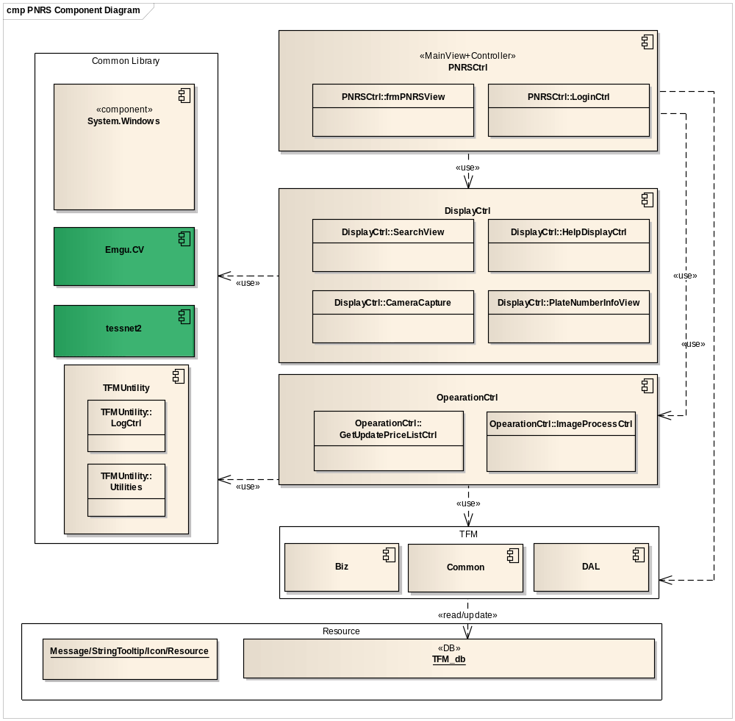
Figure 1-2: Basic PNRS components
The following table describes components of PNRS.
No | Name | C | Description
1 | PNRSCtrl | C# | - Main controller of PNRS, controls main business of PNRS.  - Load and manage all GUI components to create main screen of PNRS.  - Entry point of PNRS, control loging in and switching user in PNRS of users.
2 | OpearationCtrl | C# | - Main core of PNRS, provide features to process place number recognition: receive signal from sensor, shot image and recognize it.  - This component process viewing and updating latest price list.
3 | DisplayCtrl | C# | - Show usage guideline to user.  - Process getting image information from camera and displaying on screen.  - Control all search activities of user on PNRS, provide features for user to search and display result on screen.  - Display place number info after recognizing activity.  - Provide features for users to manipulate when PNRS cannot recognize inputed image.
4 | Common library | C# | - Include all opened components that PNRS use such as .Net, opened component for image processing.  - Proview all untilties that are used in the PNRS such as log process, common constant, function library…
5 | Resource | N/A | This component contains static resources for the system. It includes localized strings and messages

TCMW Components Design
The architecture for the TCMW will be depicted as the following diagram:
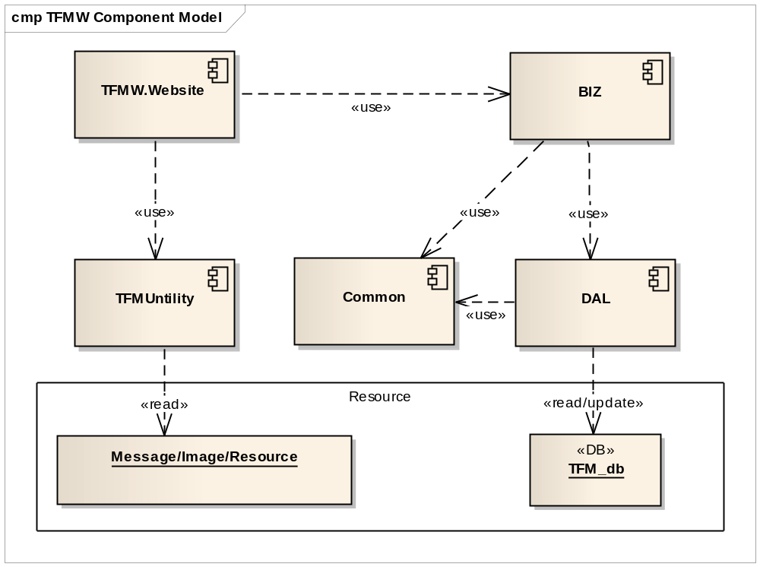
Figure 1-3: Basic TCMW components

DSS Components Design
The architecture for the DSS will be depicted as the following diagram
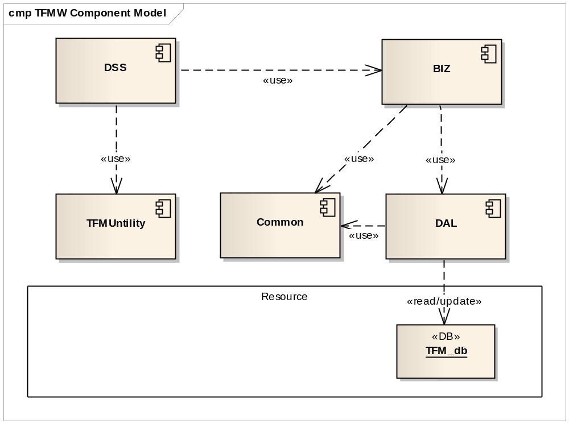
Figure 1-4: Basic DSS components

Detailed design

PNRS design

Login/Switch User

Class Diagram
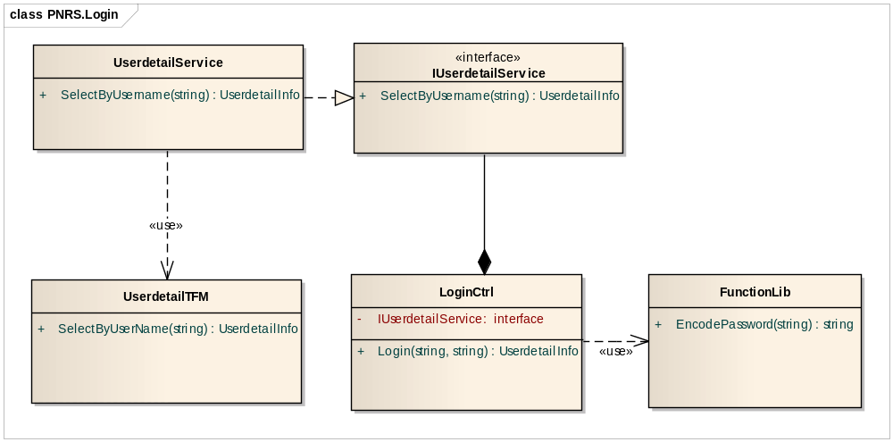
Figure 1-5: Class diagram

Class Explanations

IUserdetailService interface
- Attributes
N/A
- Operations
- SelectByUsername (string username)
Check and select the correct username provided
Parameter | Type | Description
Username | string | User ID
return | UserdetailInfo | User information

UserDetailTFM class
- Attributes
N/A
- Operations
- SelectByUsername (string username)
Check and select the correct username provided
Parameter | Type | Description
Username | string | User ID
return | UserdetailInfo | User information

LoginCtrl class
- Attributes
Attribute | Type | Visibility | Description
IUserdetailService | IUserdetailService | Private | Call Userdetail Service
- Operations
- Login(string username,string password)
Check and select the correct username and password provided
Parameter | Type | Description
Username | string | User ID
Password | string | Password to validate
return | UserdetailInfo | User Information

FunctionLib class
- Attributes
N/A
- Operations
- EncodePassword (string password)
Encrypt the password user types.
Parameter | Type | Description
Password | string | Password to validate
return | string | Encrypted password

Sequence Diagram

Login
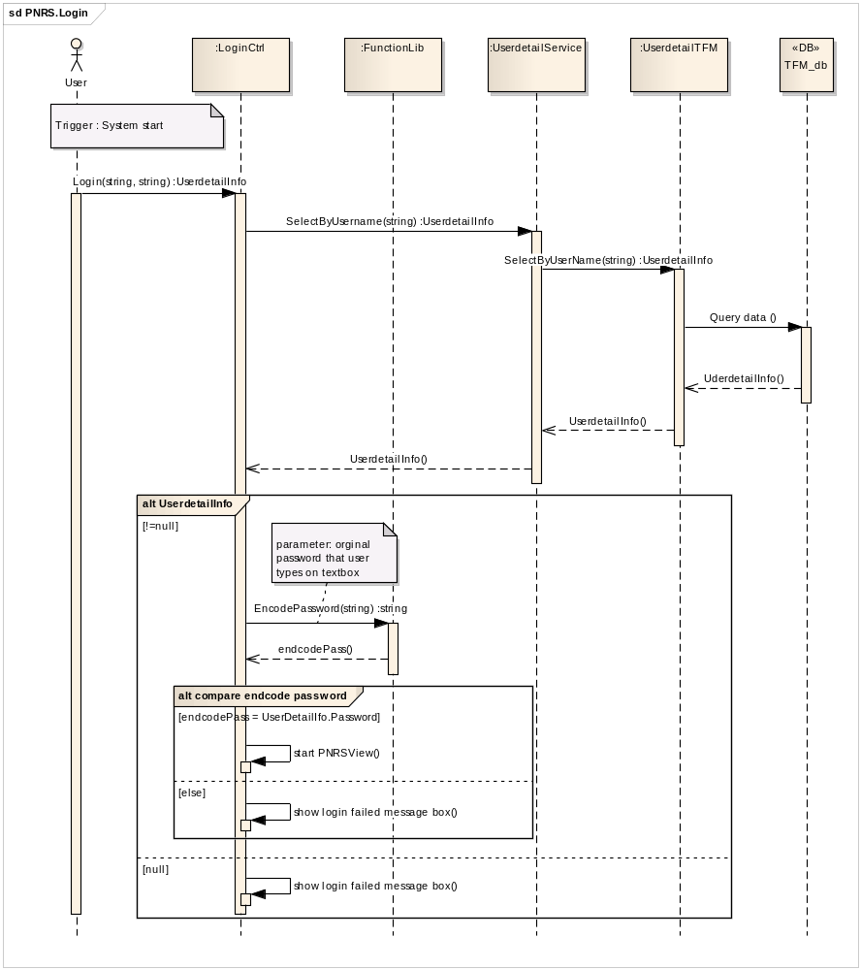

Switch user
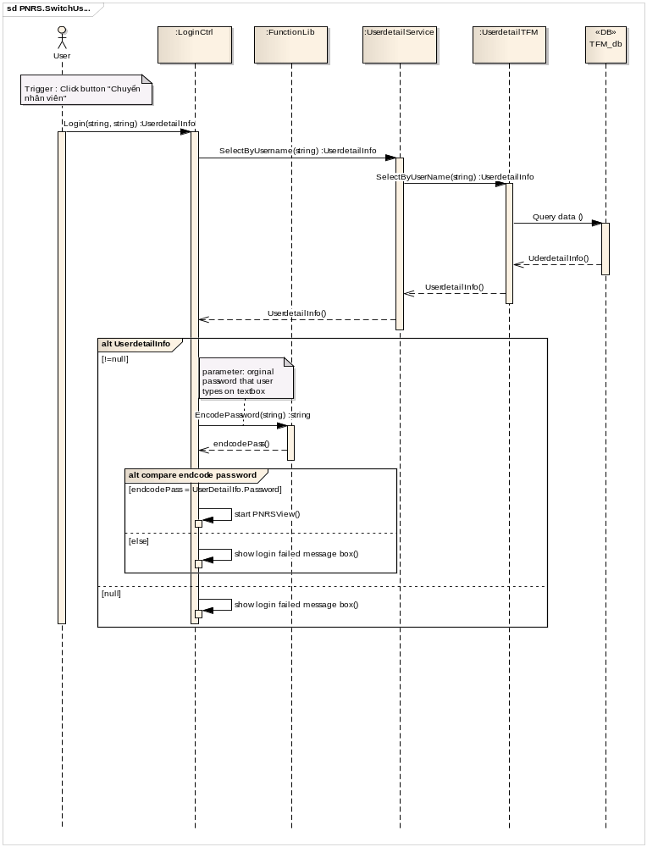

Search

Class Diagram
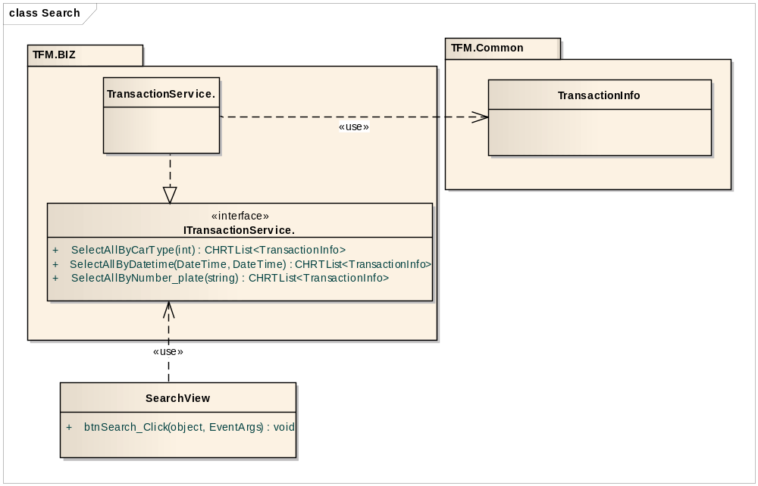

Class Explanations

ITransactionService interface
- Attributes
N/A
- Operations
- SelectAllByNumber_plate(string)
Search all transactions by plate number string.
Parameter | Type | Description
number_plate | string | Plate number string
return | CHRTList<TransactionInfo> | Collection of result record

- SelectAllByCarType(int)
Search all transactions by cartype.
Parameter | Type | Description
carType | int | Car type ID
return | CHRTList<TransactionInfo> | Collection of result record
- SelectAllByDatetime(DateTime, DateTime)
Search all transactions by date time.
Parameter | Type | Description
fromDate | DateTime | Date from of transansaction.
toDate | DateTime | Date to of transansaction.
return | CHRTList<TransactionInfo> | Collection of result record

SearchView class
- Attributes
N/A
- Operations
- btnSearch_Click(object, EventArgs)
Search all transactions by plate number string.
Parameter | Type | Description
sender | objectt | Button search
e | EventArgs | N/A
return | N/A | N/A

TransactionService class
- Attributes
N/A
- Operations
Implement from ITransactionService.

TransactionInfo entiry
- Attributes
All attributes of this entity are referring to all fields of table transaction of TFM_DB.
- Operations
N/A

Sequence Diagram
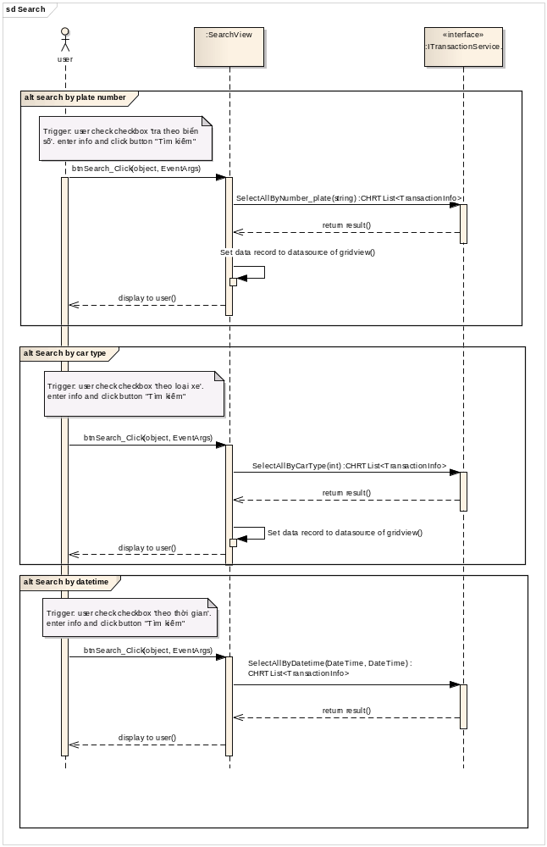

Camera capture

Class Diagram
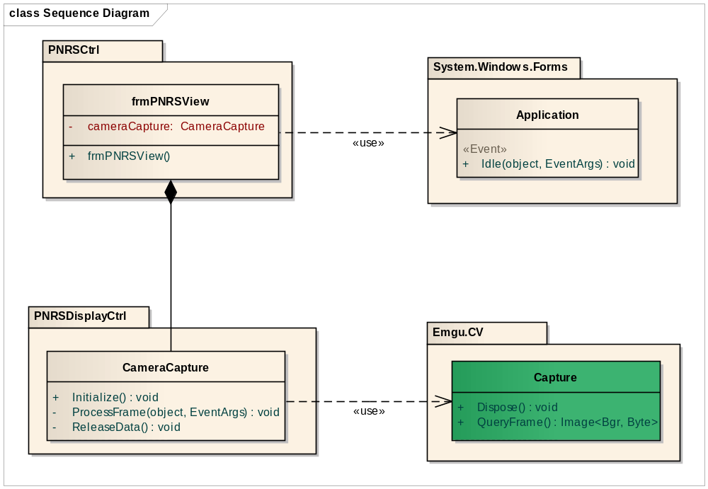

Class Explanations
3.1.3.2.1 frmPNRSView Class
- Attributes
Attribute | Type | Visibility | Description
cameraCapture | CameraCapture | Private | Call CameraCapture Class’s functions and attributes
- Operations
frmPNRSView()
Class’s constructor
Parameter and return: N/A
Parameter | Type | Description
N/A | N/A | N/A
return | N/A | N/A
3.1.3.2.2 CameraCapture Class
- Attributes
N/A
- Operations
Initialize()
Parameter and return: N/A
Parameter | Type | Description
N/A | N/A | N/A
return | N/A | N/A
ProcessFrame(object o, EventArgs e)
Show image continuously
Parameter and return:
Parameter | Type | Description
o | object | Event Object
e | EventArgs | Event Argument
return | N/A | N/A
Release Data()
Stop showing image when close form
Parameter | Type | Description
N/A | N/A | N/A
return | N/A | N/A
3.1.3.2.3 Application Class
- Attributes
N/A
- Operations
Idle(object o, EventArgs e)
Parameter and return:
Parameter | Type | Description
o | object | Event Object
e | EventArgs | Event Argument
return | N/A | N/A
3.1.3.2.4 Capture Class
- Attributes
N/A
- Operations
Dispose()
Parameter and return: N/A
Parameter | Type | Description
N/A | N/A | N/A
return | N/A | N/A
QueryFrame()
Parameter and return: N/A
Parameter | Type | Description
N/A | N/A | N/A
return | N/A | N/A

Sequence Diagram

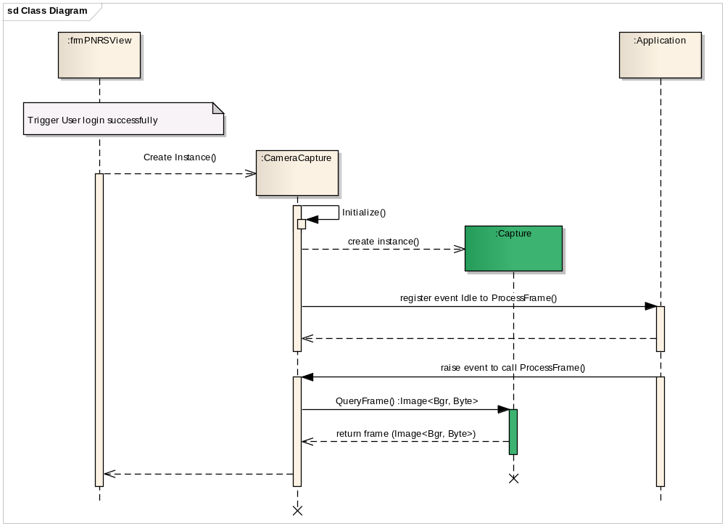

Auto plate number recogniton

Class Diagram
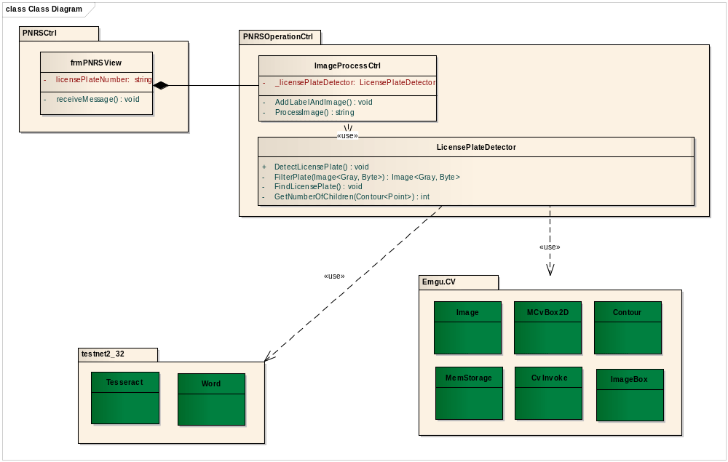

Class Explanations
3.1.4.2.1 frmPNRSView Class
- Attributes
Attribute | Type | Visibility | Description
licensePlateNumber | string | Private | License Plate Number
- Operations
receiveMessage()
Receive Message
Parameter and return: N/A
Parameter | Type | Description
N/A | N/A | N/A
return | N/A | N/A
3.1.4.2.2 ImageProcessCtrl Class
- Attributes
Attribute | Type | Visibility | Description
_licensePlateDetector | LicensePlateDetector | Private | License Plate Detector
- Operations
AddLabelAndImage()
Add label and image
Parameter and return: N/A
Parameter | Type | Description
N/A | N/A | N/A
return | N/A | N/A
ProcessImage()
Return Plate Number
Parameter | Type | Description
N/A | N/A | N/A
return | string | Plate Number

3.1.4.2.3 LicensePlateDetector Class
- Attributes
N/A
- Operations
DetectLicensePlate()
Detect the Plate License
Parameter and return: N/A
Parameter | Type | Description
N/A | N/A | N/A
return | N/A | N/A
FindLicensePlate()
Find the Plate License
Parameter and return: N/A
Parameter | Type | Description
N/A | N/A | N/A
return | N/A | N/A
FilterPlate(Image<Gray,Byte>)
Filter the Plate License
Parameter and return: N/A
Parameter | Type | Description
Image | Image<Gray,Byte> | 1 type of image
return | Image<Gray,Byte> | Image’s properties
GetNumberOfChildren(Contour<point>)
Get number of children
Parameter and return: N/A
Parameter | Type | Description
Point | Contour<point> | Wrapped class for Contour
return | int | Number of children

Sequence Diagram

Recognize plate number
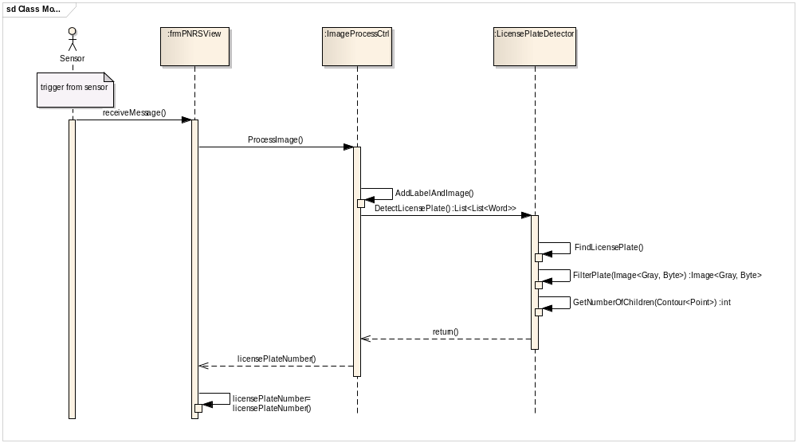

Enter plate number info

Class Diagram
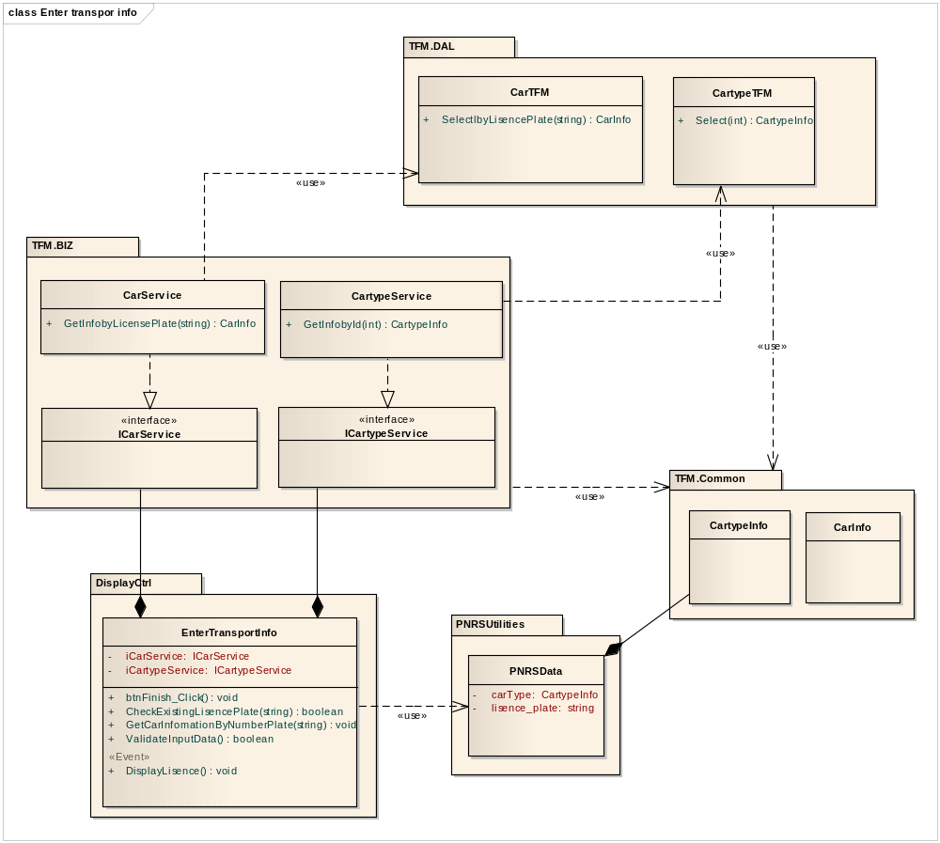

Class Explanations

ICarService interface
- Attributes
N/A
- Operations
- GetInfobyLicensePlate(string).
Get car information by string plate number.
Parameter | Type | Description
number_plate | string | Plate number string
return | CarInfo | All information of the car

ICartypeService interface
- Attributes
N/A
- Operations
- GetInfobyId (int).
Get car type by ID.
Parameter | Type | Description
Id | int | ID of the car type
return | CartypeInfo | All information of the car type

EnterTransportInfo interface
- Attributes
N/A
- Operations
- CheckExistingLisencePlate (int).
Check whether the plate number existing in DB.
Parameter | Type | Description
number_plate | string | Plate number string
return | boolean | True if existed, false otherwise

- DisplayLisence ().
Event request main view displaying the plate number information
Parameter | Type | Description
N/A | N/A | N/A
return | void | N/A

- ValidateInputData ().
Validate information that is entered by user.
Parameter | Type | Description
N/A | N/A | N/A
Return | bool | True if valid, false otherwise

CarTFM class
- Attributes
N/A
- Operations
- SelectlbyLisencePlate (string).
Get car information by string plate number.
Parameter | Type | Description
number_plate | string | Plate number string
return | CarInfo | All information of the car

CartypeTFM class
- Attributes
N/A
- Operations
- Select (int).
Get car type by ID.
Parameter | Type | Description
typeID | int | ID of the car type
return | CartypeInfo | All information of the car type

PNRSData class
- Attributes
Attribute | Type | Visibility | Description
carType | CartypeInfo | public | Current cartype info
lisence_plate | string | public | Current palte number string
- Operations
N/A

Sequence Diagram

Enter plate number info
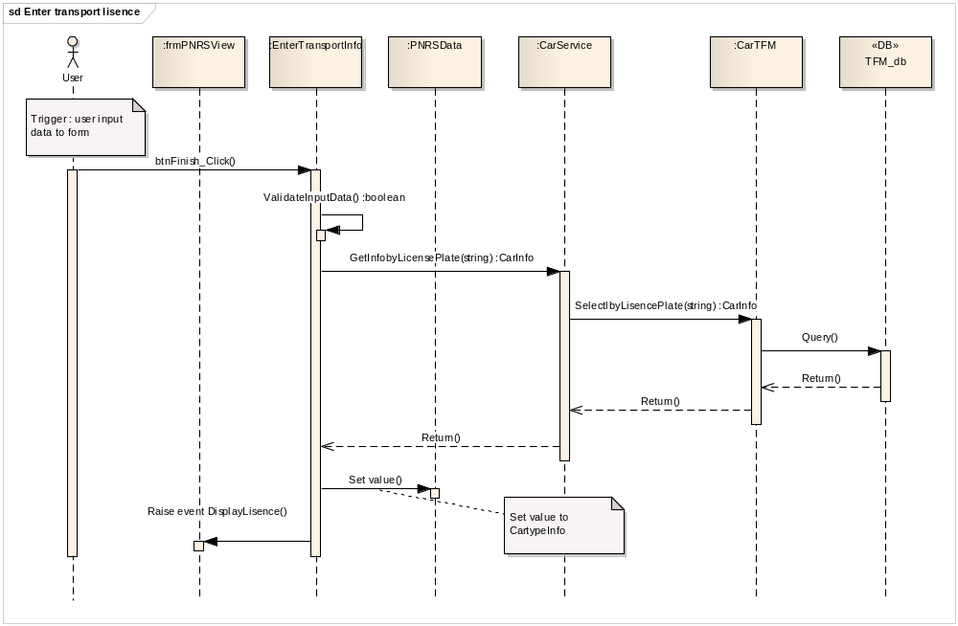

Enter transport type info
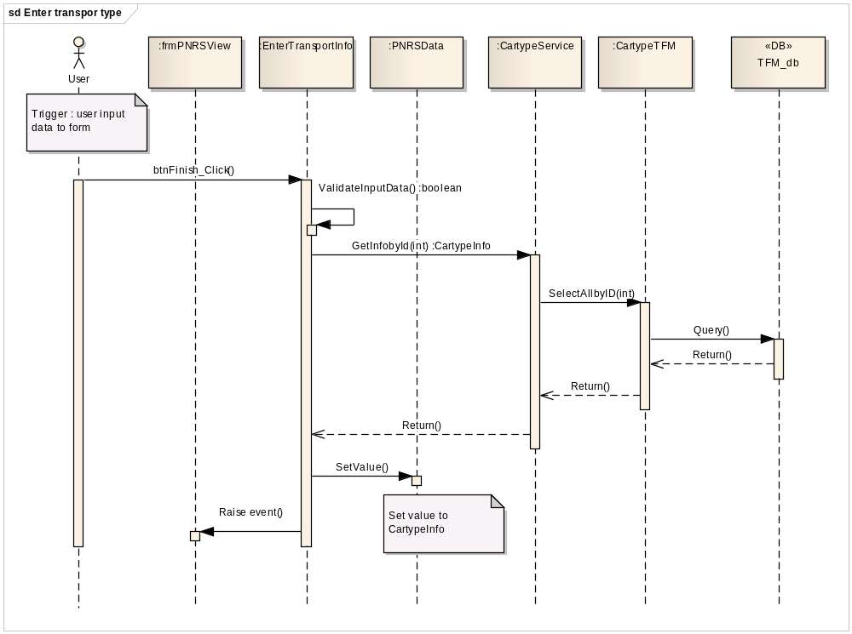

View and get update price list

Class Diagram
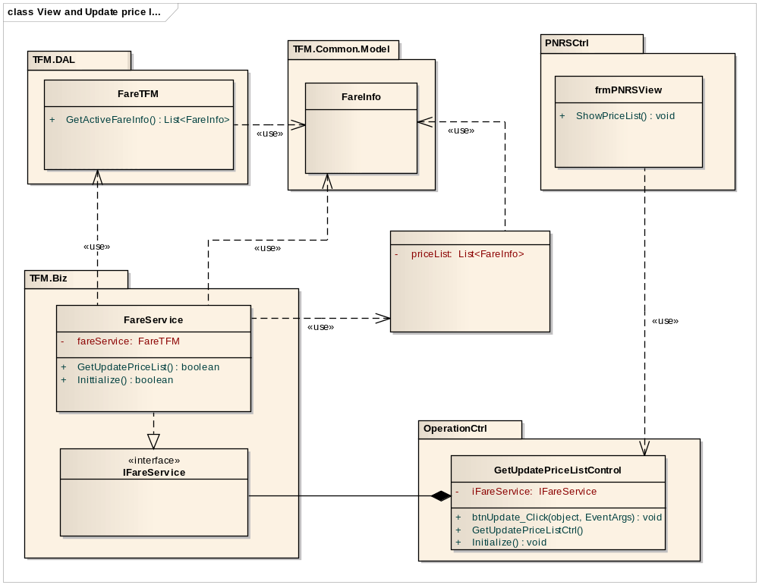

Class Explanations

CarTFM class
- Attributes
N/A
- Operations
- GetActiveFareInfo ().
Get list of active fare information.
Parameter | Type | Description
N/A | N/A | N/A
return | List<FareInfo> | List of fares information

GetUpdatePriceListControl class
- Attributes
N/A
- Operations
- btnUpdate_Click (object, EventArgs).
Handler button click event .
Parameter | Type | Description
sender | object | Button update
e | EventArgs | N/A
return | void | N/A

- Initialize().
Show price list. .
Parameter | Type | Description
N/A | N/A | N/A
return | void | N/A

FareService class
- Attributes
N/A
- Operations
- GetUpdatePriceList ().
Parameter | Type | Description
N/A | N/A | N/A
return | return | void

frmPNRSView class
- Attributes
N/A
- Operations
- ShowPriceList().
Called when User click button "Cap nhap bang gia"
Parameter | Type | Description
N/A | N/A | N/A
return | return | void

Sequence Diagram

Display price list
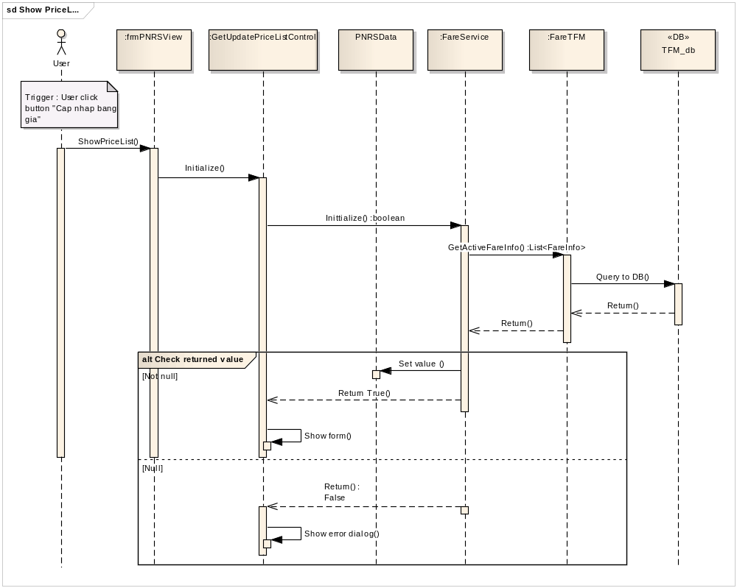

Get update price list
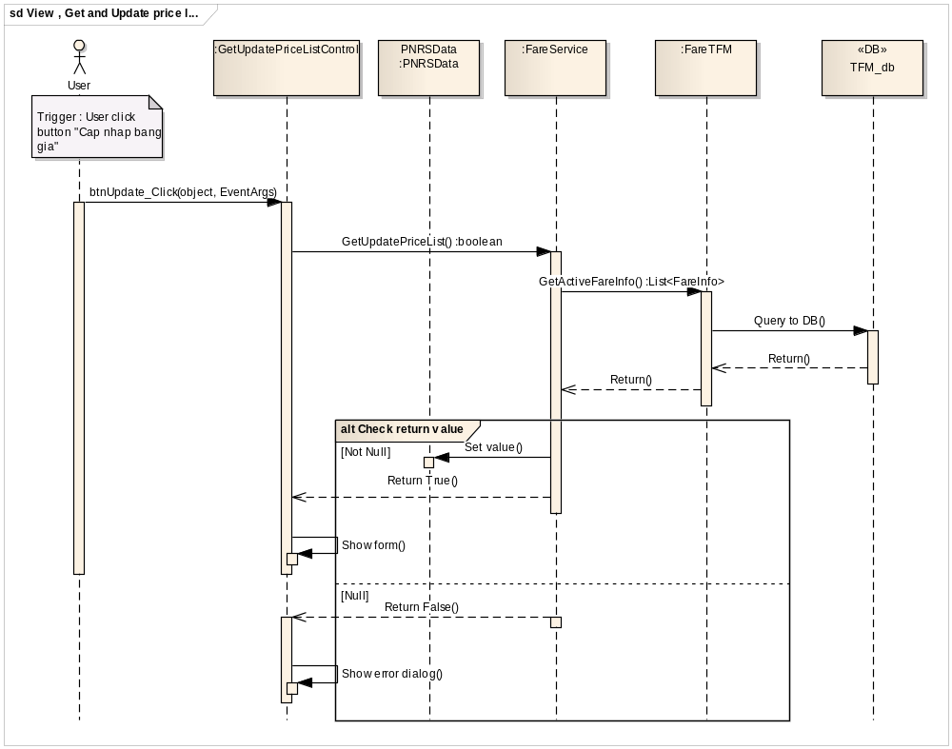

View help

Class Diagram
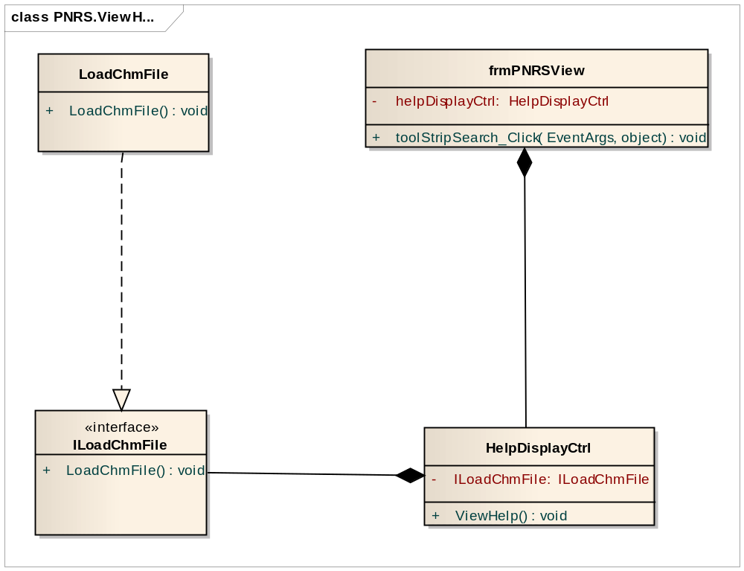

Class Explanations

ILoadChmFile Interface
- Attributes
N/A
- Operations
- LoadChmFile()
Load Chm File from file
Parameter and return: N/A
Parameter | Type | Description
N/A | N/A | N/A
return | N/A | N/A

HelpDisplayCtrl Class
- Attributes
Attribute | Type | Visibility | Description
ILoadChmFile | ILoadChmFile | Private | Load Chm File
- Operations
- ViewHelp()
View the help information
Parameter | Type | Description
N/A | N/A | N/A
return | N/A | N/A

frmPNRSView Class
- Attributes
Attribute | Type | Visibility | Description
helpDisplayCtrl | HelpDisplayCtrl | Private | Call operation in HelpDisplayCtrl form
- Operations
- toolStripSearch_Click(object sender,EventArgs e)
Catch toolStripSearch_Click event
Parameter | Type | Description
e | EventArgs
sender | object

Sequence Diagram
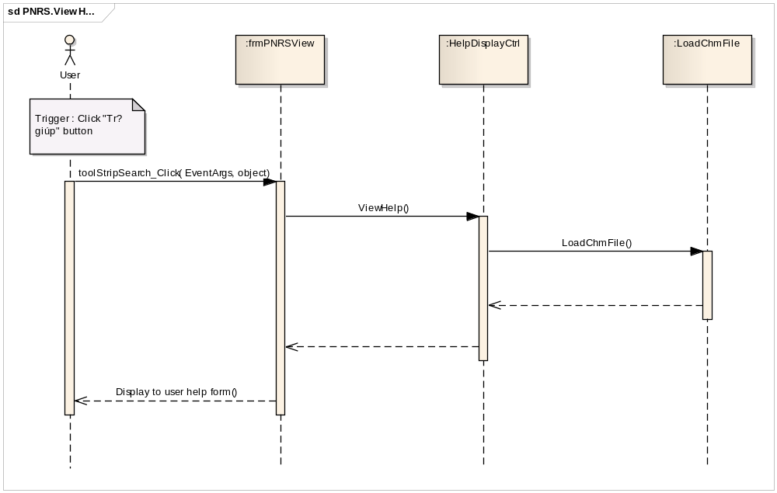

Print ticket

Class Diagram
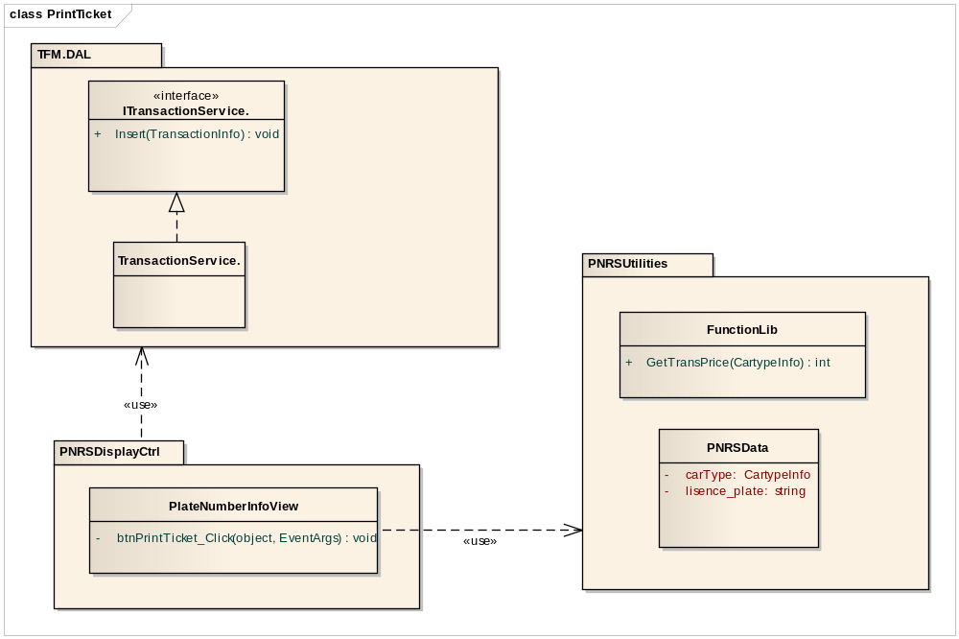

Class Explanations

PlateNumberInfoView class
- Attributes
N/A
- Operations
- btnPrintTicket_Click (object, EventArgs).
Method handles click event.
Parameter | Type | Description
sender | object | Print button
e | EventArgs | N/A
return | N/A | N/A

FunctionLib class
- Attributes
N/A
- Operations
- GetTransPrice(CartypeInfo)
Calculate price of the transaction by car type.
Parameter | Type | Description
cartypeInfo | CartypeInfo | All info of the cartype
return | int | Price of the transaction

ITransactionService interface
- Attributes
N/A
- Operations
- Insert(TransactionInfo)
Calculate price of the transaction by car type.
Parameter | Type | Description
transactionInfo | TransactionInfo | All info of the transaction
return | void | N/A

PNRSData class
- Attributes
Attribute | Type | Visibility | Description
carType | CartypeInfo | public | Current cartype info
lisence_plate | string | public | Current palte number string
- Operations
N/A

Sequence Diagram
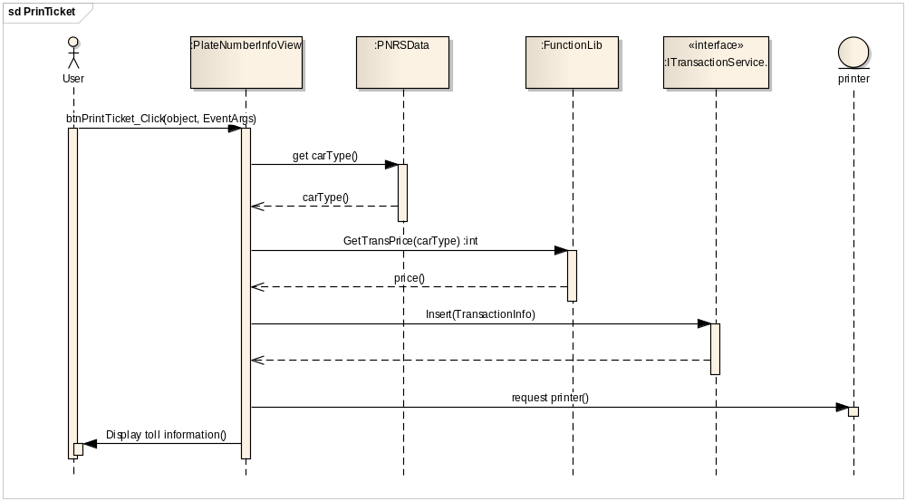

Display plate number info

Class Diagram
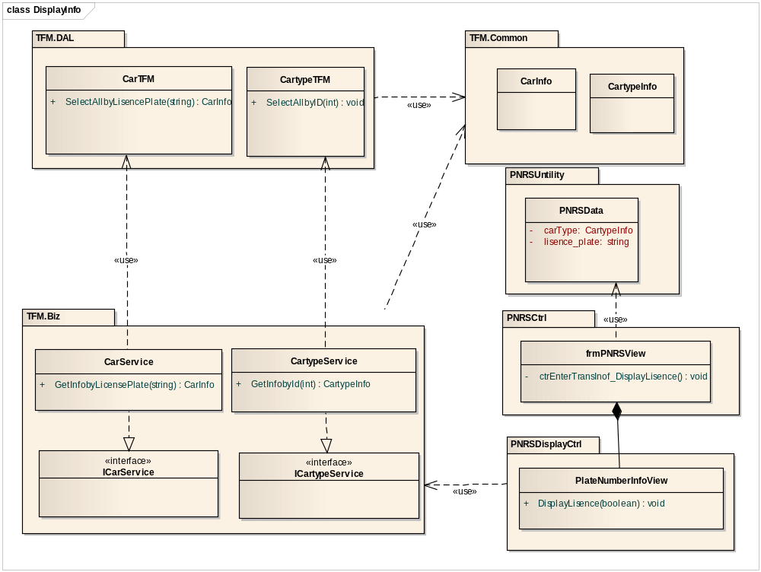

Class Explanations

PlateNumberInfoView class
- Attributes
N/A
- Operations
- DisplayLisence(boolean)
Display plate number information on screen.
Parameter | Type | Description
isNormal | bool | Indicate whether the car info is displayed normaly or not.
return | void | N/A

ICarService interface
- Attributes
N/A
- Operations
- GetInfobyLicensePlate(string).
Get car information by string plate number.
Parameter | Type | Description
number_plate | string | Plate number string
return | CarInfo | All information of the car

PNRSData class
- Attributes
Attribute | Type | Visibility | Description
carType | CartypeInfo | public | Current cartype info
lisence_plate | string | public | Current palte number string
- Operations
N/A

Sequence Diagram
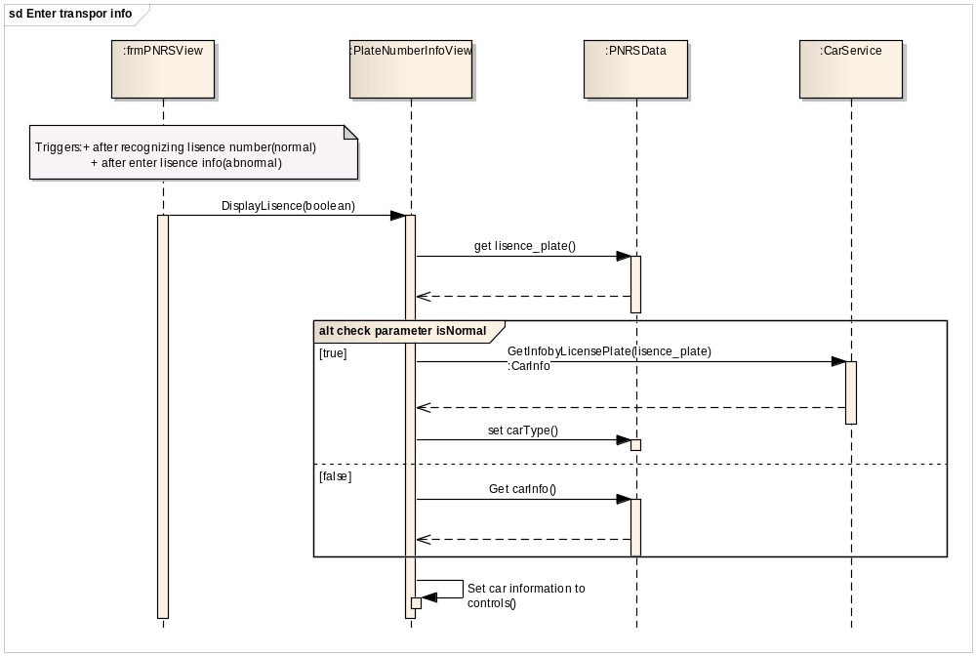

TCMW design
TBD

DSS design
TBD

Database Design

Entity-Relationship Diagram
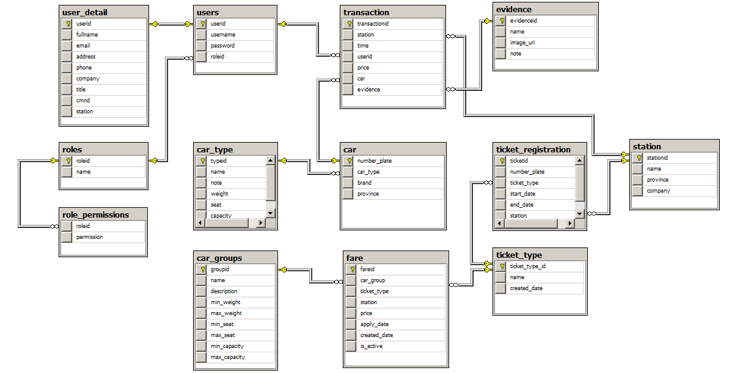

Table Design

Table Car
No | Field Name | Type | P/F Key | Allow Nulls | Description
1 | number_plate | Nvarchar | P | No | The number plate of the car and this is indentify primary key of this table.
2 | car_type | int | P | No | The primary key reference to table car_type which identify car type. [car].cartype = [cartype].typeid
3 | brand | nvarchar(200) |  | Yes | Brand of the car. Ex Toyota, Honda, ... etc..
4 | province | nvarchar(50) |  | Yes | Province where the car register

Table Car_Groups
No | Field Name | Type | P/F Key | Allow Nulls | Description
1 | groupid | int | P | No | Indentify primary key of the Car Group
2 | name | nvarchar(50) |  | No | Name of the car group.
3 | description | nvarchar(500) |  | Yes | Description of the car group
4 | min_weight | nvarchar(200) |  | Yes | Min of weight of the car in this group
5 | max_weight | nvarchar(200) |  | Yes | Maximum of weight of the car in this car group
6 | min_seat | nvarchar(200) |  | Yes | Minimum value amount of seats of the car in this car group
7 | max_seat | nvarchar(200) |  | Yes | Maximum value amount of seats of the car in this car group
8 | min_capacity | nvarchar(200) |  | Yes | Minimum capacity’s value of the car in this car group
9 | max_capacity | nvarchar(200) | F | Yes | Maximum capacity’s value of the car in this car group

Table car_type
No | Field Name | Type | P/F Key | Allow Nulls | Description
1 | typeid | int | P | No | Indentify primary key of the Car Group
2 | name | nvarchar(200) |  | Yes | Name of the car type
3 | note | nvarchar(500) |  | Yes | Note or description of the car type, what is the station administrator want to note about the car type.
4 | weight | nvarchar(200) |  | Yes | The weight of car in this type
5 | seat | nvarchar(200) |  | Yes | The seat amount of car in this type
6 | capacity | nvarchar(200) |  | Yes | The capacity of car in this type

Table evidence
No | Field Name | Type | P/F Key | Allow Nulls | Description
1 | evidenceid | int | P | No | Indentify primary key of the evidence
2 | name | nvarchar(50) |  | Yes | Name of the evidence
3 | image_uri | nvarchar(50) |  | No | The uri of evidence’s images which capture on the time stransport is at station.
4 | note | nvarchar(4000) |  | Yes | Note of the evidence.

Table fare
No | Field Name | Type | P/F Key | Allow Nulls | Description
1 | fareid | int | P | No | Indentify primary key of this fare.
2 | car_group | int |  | No | The car_group key, reference to table car_group
3 | ticket_type | int |  | No | The ticket tpe key, reference to table ticket_type ( [fare].ticket_type = [ticket_type].ticket_type_id )
4 | station | int |  | No | The station key, This is the station where apply this fare. Reference to table station  [Fare].station = [station].stationid
5 | Price | nvarchar(200) |  | No | Price value of this fare.
6 | Apply_date | int |  | No | The Date when the station apply this fare
7 | Created_date | int |  | Yes | The date when the station created this fare
8 | Is_active | int |  | No | This value indentify the fare is available or not at current time.

Table role_permissions
No | Field Name | Type | P/F Key | Allow Nulls | Description
1 | Roleid | int | F | No | The foreign key reference to table Role  [Role_permissons].roleid = [roles].id
2 | permission | nvarchar(50) | F | No | The permission name which are constants in system to define permission for users.

Table roles
No | Field Name | Type | P/F Key | Allow Nulls | Description
1 | Roleid | int | P | No | The indentify primary key of Role.
2 | name | nvarchar(50) | F | No | The role name

Table Station
No | Field Name | Type | P/F Key | Allow Nulls | Description
1 | stationid | int | P | No | The indentify primary key of station
2 | name | nvarchar(50) | F | No | Name of this station
3 | Province | Nvarchar(200) |  | Yes | Province where this station is
4 | Company | Nvarchar(200) |  | Yes | The company manage this station

Table ticket_registration
No | Field Name | Type | P/F Key | Allow Nulls | Description
1 | Ticketed | int | P | No | The indentify primary key of station
2 | Number_plate | nvarchar(50) | F | No | The foreign key reference to table car. Define which car register ticket
3 | Ticket_type | int | F | Yes | The foreign key reference to table ticket_type. Define ticket type and price
4 | Start_date | int |  | Yes | The date this ticket begin available
 | End_Date | int |  |  | the date this ticket not available
 | Station | int | F | No | The station where car register this ticket.

Table users
No | Field Name | Type | P/F Key | Allow Nulls | Description
1 | userid | int | P | No | Indentify primary key of user.
2 | username | nvarchar(50) |  | No | The name which user use to login
3 | password | nvarchar(50) |  | No | The password which user use to login
4 | roleid | int |  | No | This is id of permission of user. Reference to table  [users].roleid = [role_permission].roleid

Table user_detail
No | Field Name | Type | P/F Key | Allow Nulls | Description
1 | userid | int | P | No | Indentify primary key of user.
2 | fullname | nvarchar(50) |  | No | First name and last name of user
3 | email | nvarchar(50) |  | No | Email of user
4 | address | nvarchar(50) |  | Yes | Address of user
5 | phone | nvarchar(50) |  | Yes | Phone of user
6 | company | nvarchar(50) |  | Yes | Company of user
7 | title | nvarchar(50) |  | Yes | Function of user
8 | cmnd | nvarchar(50) |  | Yes | CMND of user
9 | station | nvarchar(50) |  | No | Station where user work for

Table transaction
No | Field Name | Type | P/F Key | Allow Nulls | Description
1 | transactionId | int | P | No | Indentify primary key of transaction.
2 | station | int |  | No | The station where the transaction happen
3 | time | int |  | No | Time when transaction happen
4 | userid | int |  | Yes | Id of user who create transaction
5 | price | Int |  | No | Fee which driver pay
6 | car | nvarchar(50) |  | Yes | Number of plate
7 | evidence | int |  | Yes | id of image which camera capture the car

Table ticket_type
No | Field Name | Type | P/F Key | Allow Nulls | Description
1 | ticket_type_id | int | P | No | Indentify primary key of ticket_type
2 | Name | nvarchar(200) |  | No | Type of ticket
3 | created_date | int |  | No | The date when the ticket create

Appendix 1: ….

