 | MINISTRY OF EDUCATION AND TRAINING  FPT UNIVERSITY

Capstone Project Documents

TOLL MANAGEMENT
Group Name: Unstoppable
Group Members
  Name | Student ID
  Nguyễn Anh Nhật Linh | 00499
  Nguyễn Duy Vũ | 00521
  Trần Hải Đăng | 00357
  Nguyễn Xuân Hiếu | 00380
  Tô Văn Quân | 00425
Supervisor | Nguyễn Văn Sang
Ext Supervisor | Huỳnh Anh Dũng, Nguyễn Tất Trung
Capstone Project Code | Toll Management v1

Hanoi, May 2011
Contents
TOLL MANAGEMENT 1
Definitions and Acronyms 3
I) Background 4
II) Literature Review 4
1) Overview of toll collection in the world 4
✓ The functional concept of a basic toll system in the world 4
✓ Development of automatic toll collection in different countries 5
2) Overview of toll collection in Viet Nam 5
3) Overview of existing or similar solutions and methods 5
✓ Existing method for automatic toll collection (ANPR) 5
✓ Existing automatic toll collection in Viet Nam using ANPR 6
✓ Automatic fee collection at parking in Viet Nam using ANPR: 6
4) Limitations of existing system 6
✓ Difficult to deploy large numbers car 6
✓ No control issues negative 6
✓ Ability to identify low number plates 6
III) The proposals 7
IV) Outstanding Features : 8
V) References: 8

Definitions and Acronyms

Acronym | Definition | Note
MIS | Management Information Systems
DB | Database
ANPR | Automatic Number Plate Recognition
OBU | Offshore banking unit

Background
In all areas of economic, political, cultural, social ... Information technology has gradually asserted its role is extremely important and inevitable. The comprehensive development of a society goes hand in hand with the development of science and technology. Management Information Systems (MIS) have changed the dynamics of running businesses efficiently. Decentralization is one of the biggest advantages; it allows monitoring of operations at low levels and frees up resources for departmental managers to devote time to strategic activities. Coordination of specialized projects and activities is much better and decision makers in the organization are aware of issues and problems in all departments. Another advantage of MIS is that it minimizes information overload, which can be quite common with conventional businesses in the modern era. Vietnam is not out of trend, however, some systems are not put to use again promote the strengths of the MIS.
Actually, Vietnam is a developing country, in recent years, a series of bridges and roads were built and put into use, the toll booths were set up to recover capital reinvestment. We can see that in Vietnam there are many Road Charging Stations. However, this system in Vietnam is so complicated and not flexible. Because the procedure in most of stations forces people to spend a lot of time for charging, they have to drive slowly and stop to buy a ticket, and queue until their turn came to pass the station. This process always causes the traffic jams in every station and maybe it causes the negative phenomena. To save time t the system we’ll identify the Number Plates of vehicles passing through charging station summed up the car to see how many times it went through and at the end of month we’ll send bill payment on that car. Based on the above, we want to build a total solution for the traffic charges. This system will control the entire process of collecting fees from the monthly tickets or daily tickets, printing ticket based on the information of plates which are read automatically. We can control traffic flow through the day, to minimize cheating in charge of transport. With this process, we hope to reduce processing time operations to avoid traffic jams, the situation is very common in the current charging station with the above, and we hope to bring the best management system for tolls in Vietnam today.

Literature Review

Overview of toll collection in the world

The functional concept of a basic toll system in the world
The functional concept of a basic toll system is simple: the motorist takes a ticket at the entrance to the station and presents it at the toll booth at the exit. Ticketing and toll barriers can also be placed on each section of station. With technological progress, these systems have evolved towards automatic toll collection, allowing traffic to flow more smoothly and improving service to both users and operators

Development of automatic toll collection in different countries
The first congestion charging system – toll collection to control city traffic – was set up in Singapore in the 1990s using Japanese free flow technology. More recently the City of London has launched an ambitious urban taxation programmed aimed at reducing traffic in the city centre by approximately 15%. The system has been in operation since February 2003 and has been generally successful in attaining its traffic goals in terms reduction of flow. Approximately 800 video cameras have been placed at entrances to and inside a 22 km2 area of central London. The cameras recognize vehicle number plates and automatically compare them with a database of numbers for which a toll has been paid. This system has no gates or tollbooths and was chosen to avoid wasting motorists’ time as they drive into the city.
Two types of systems are currently in use. The first is the single-lane system used in France and in Southern European countries such as Italy, Spain and Portugal. The second, known as the free flow system, simultaneously manages several lanes, electronically collecting tolls from cars as they pass beneath an overhead gantry. This system is used in the United States, Australia, Canada, Chile and Israel, among other countries
Automatic toll collection, which allows motorists to pay tolls without stopping, has developed in different ways around the world.

Overview of toll collection in Viet Nam
Most of colleting toll stations in Vietnam are still operating traditionally with following process: Station’s procurement organizations meet tax agency to follow received ticket for warehousing procedure, then tickets are sent to ticket sellers. After ticket seller receive them, accountant bases on bills to note accounting books to track selling tickets daily. Ticket selling and checking process are executed in two steps: stopping to get tickets and check tickets.
- Drivers stop the car at the ticket selling station; get ticket if they have no moth ticket. Ticket sellers keep counterfoil part to send accounting place.
- After getting ticket, they run to ticket checking station, show employee the ticket that’s gotten or monthly ticket (if have) and continue the trip,

Overview of existing or similar solutions and methods

Existing method for automatic toll collection (ANPR)
Automatic Number Plate Recognition (ANPR) is a mass surveillance method that uses optical character recognition on images to read the number plates on vehicles. They can use existing closed-circuit television or road-rule enforcement cameras, or ones specifically designed for the task. They are used by various police forces and as a method of on pay-per-use roads and cataloging the movements of traffic or individuals. ANPR can be used to store the images captured by the cameras as well as the text from the number plate, with some configurable to store a photograph of the driver. Systems commonly use infrared lighting to allow the camera to take the picture at any time of the day. ANPR technology tends to be region-specific owing to plate variation from place to place.

Existing automatic toll collection in Viet Nam using ANPR
An typical example for a an automatic toll collection system of one of largest bridges: Can Tho bridge. It’s deployed in 14/11.
- Features: integrated card placed on the vehicle OBU, and link with the bank, when the car run through, the system will identify OBU combined with vehicle number plate recognition if the match will go through and subtract money in your bank account.
- Pros: To ensure the speed, the car runs faster still ok in a box placed on the vehicle OBU
- Cons: problems about payment, not all the drivers always have a bank account for payment.

Automatic fee collection at parking in Viet Nam using ANPR:
Vietparking is an example for an automatic fee collection at parking
- Pros: many ways to deal with the various vehicles identification number plates, using the chip in the ticket, etc ... Point to note is that "treatment center." All processors are located on the server should enhance security, ease of maintenance.
- Cons: affecting processing speed.

Limitations of existing system

Difficult to deploy large numbers car
Currently the system automatically and semi-automatic in Vietnam has not been implemented much. In some units have been deployed but the system has not really justified. For example, Can Tho Bridge toll plaza integrated card is placed on the vehicle OBU. The process of installation and maintenance on the car is a big problem, sometimes can cause waste of time money.

No control issues negative
In any other system at present, the negative is always a problem unresolved. We can see the current situation: crocheted employees with improper driving ticket value to each party better off. Or at night anymore, but they do not sell tickets directly charge transport in some stations.

Ability to identify low number plates
Some systems have the ability to identify low-only about 60% - 70%. On the other hand hot climate in Vietnam, abnormal rain and wind, humidity all affect image quality. Therefore requirements for recognition capabilities are extremely urgent good. Moreover, some of the old system only identified a series of number plates, causing duplication of number plates as they pass through

The proposals
From shortcomings and challengers of systems that are applied in Viet Nam, we consider them like an opportunity to implement a general solution for all toll booths that can be met all requirements that we research above. We intend developed a system with three main components / modules
          - Application: This is the main core of the project:
- Extract number and text from the Number Plate’s picture which was captured by camera on the station
- Because of real condition in Vietnam , there are some cases like can not recognize the Number Plate or a car which was registered but the driver do not take the plate, Station’s staffs will input directly Number Plate to system
- Check infomation of the transport basing on the text data from a database (discribed in next part). If the transport paid toll in the month, it can continue the trip. Otherwise the system automatically prints daily ticket for the transport basing on it’s information like kind of car for it to continue the trip.
- Website
- Managing collecting fee, months booking.
- View information about running clients.
- Report number of turns transport through the station in a day, in a month, turnover of the station.
- Server (store database)
- Store statistic information of Clients
- Store number plate’s information in Local Database of System
- Crawl and Synchronize Data of Number Plate from Vietnam Register System
- Format database to fit Local Database’s structure of our system
To archive this goal, we have identified the need for the system:
- Ability to recognize fastly, exactly (improves ANPR, designing database suits the system)
- Ability to manage data well, friendly to user.
- Ability to crawl and synchronize data fastly and effectively.
However, because there are restrictions on capstone project completion time and resources involved, present our initial goals will focus on recognizing and amazing toll collection. Later, when these modules are successfully developed, we will continue to develop, integrate the rest to complete the idea of the whole group.
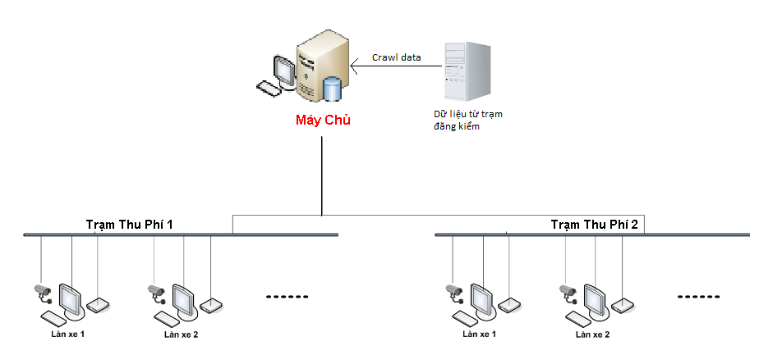

Outstanding Features:
- Connect directly to the Database of Vietnam Registration and Inspection Station ,so we can avoid the faked Registration Paper from drivers (determine correctly vehicle class, vehicle type, station fee of vehicle)
- Input directly the Number Plate to system in cases like cannot recognize plates because of dirty plates, the cars do not have plates, the plate is old, etc.
- Recognize fast and exactly the plates, our system can also recognize the plates which have two lines-character.

References:
[1] http://www.thalesgroup.com/Pages/Solution.aspx?id=9364&pid=1568
[2] http://en.wikipedia.org/wiki/Automatic_number_plate_recognition
[3]http://www.itd.com.vn/news/vn/10/101/Chinh-thuc-thu-phi-tu-dong-tai-cau-Can-Tho.html
[4] http://vietparking.vn/bai-do-xe-tu-dong-cong-nghe-cua-hungry.htmlss

