#### 2.6.2 Filling in the decision field

As shown in the previous sub-paragraph, when improving a complex problem situation, we get many solutions. These are several final solutions by iteration, as well as a large number of intermediate ideas from which these final solutions are built. There are two ways of using this important information.

In the *first method,* we design or select one solution as the final solution and recommend it to the customer for evaluation and implementation. This is possible when the task is relatively simple and the business situation is sufficiently clear.

*The second method is to* consider and analyse the full range of intermediate solutions alongside the recommended final solution. This method is used when the task involves a complex object environment that cannot be fully analysed in advance. In this case it is difficult to recommend any final solution, it is necessary to analyse the whole field of solutions together with the customer's specialists.

In essence, after applying the Problem Flow technique, a kind of mini-study is produced, showing promising ways of eliminating undesirable effects present in the situation.

However, with many options for solutions, we have the problem of choosing the best one. In order to realise this approach, we need to organise the variants of a useful system into a visual information structure that is easy to analyse. If we have an information structure, a field of solutions, with easy navigation through it, it seems appropriate to extend the range of preliminary solutions even further. Ideally, we should see all possible solutions to our problem and choose the most appropriate to the problem situation. This approach allows us to involve the customer's specialists more fully into the task, to use their experience and knowledge to evaluate intermediate solutions, to choose the most promising variants of the useful system and to predict the directions of their development. This enables the specifics of the particular situation to be better taken into account when implementing the ideas.

This approach requires the maximum filling of the field of solutions, presenting both the existing variants of the system with the necessary improvements and prospective, predictable ones. To implement it, we propose to use a special method based on the technology of constructing the so-called evolutionary trees and analyzing their branches for completeness and consistency (see [21] for details). The method is used to identify trends in the development of useful systems found in problem solving and to formulate non-obvious ideas missed earlier.

The purpose of filling in the decision box is as follows:

* make sure that no important options for solving the problem are overlooked;
* maximise the range of solution options on offer;
* reinforce the preliminary solutions previously obtained;
* get all the main areas of improvement in the problem system.

In this step, it is necessary to find the transformation variants of the useful system that will complement the set of preliminary solutions. Each preliminary solution proposes some transformation of the original system, i.e. it describes one of the technical system variants. It is necessary to understand what the proposed transformations have in common and trace how the idea of solving the problem develops from one system variant to another. If such commonalities (criteria) are identified, the solutions can be grouped into appropriate groups. Then the variants of each group have to be lined up in logical sequences. These sequences may be interrupted or incomplete; they must be supplemented by suggesting suitable ways of new transformations of the system (Figure 2.142).

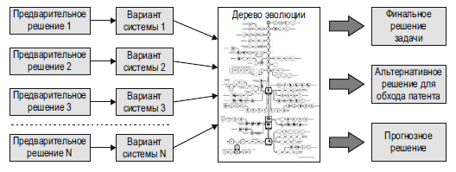

**Figure 2.142.** Filling in the decision box and obtaining the final decision, alternative and predicted decisions

According to this method, the solutions obtained in all iterations should be presented as variants of the useful system described by each of the solutions. Then, these variants have to be placed along the lines of development to form an evolutionary tree [21]. The resulting information structure must then be analyzed. The logic of each development line shows what other transformations of the system are possible. Next, the lines should be supplemented by generating new preliminary solutions on the basis of the omitted transformations. Finally, the resulting tree has to be analysed again, in order to identify the final and predicted solutions, as well as the alternative solutions that give the possibility to bypass the competing patents.

The basis of this method *is* the baseline development lines. When organising provisional decisions into concrete development lines, the baselines should be constantly checked (see appendix 11).

First, it is necessary to identify into which lines of development the resulting system variants can be organised. To do this, group them according to which component changes are proposed in them. Next, we identify the essence of the transformation of the original system, which is contained in each solution, and check whether there are solutions with similar transformations.

If at least one other similar transformation is detected, we can talk about the manifestation of some pattern, a trend. Then it is necessary to understand which of the basic lines of development this pattern may correspond to. If no trend is observed, one should simply relate the single transformation to the policy-based development baseline.

It is useful to look at the same system option from different perspectives. Each solution is usually a set of changes, so it can be incorporated into different lines of development. This will significantly widen the field of search for new options.

The system variants described in the solutions must then be arranged according to the transformations of the development lines. The basic development lines can be likened to a template, a matrix. The cells of the template correspond to the key line transformations. The variants of the system found during work with the problem are to be placed in these cells. Those cells that are left empty will suggest other variants of the system (Figure 2.143).

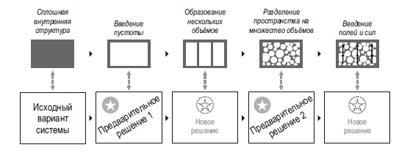

**Figure 2.143.** Schematic diagram of the "Fill in the Decision Field" method

Having found the option of changing the system as recommended by the line, it must be assessed whether there is any benefit to solving the problem. If such a benefit is anticipated, a tentative solution can be formulated.

Finally, it is possible to develop the solutions obtained. The first step is to check whether several solutions can be proposed based on the same transformation. It is also useful to apply transformations of any other lines of development to improve the solutions found.

##### Example. Filling in the solution field for the abrasive tool wear problem

*After the glass has been cut to size, it must be chamfered, i.e. the sharp edges must be blunted. This is done using a shaped abrasive wheel. The problem is that the wheel quickly wears out where it comes into contact with the glass and cracks and chips occur on the glass (Fig. 2.144).*

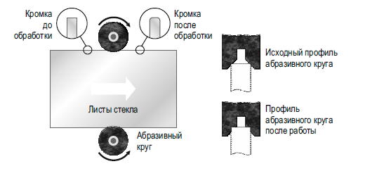

**Figure 2.144.** Abrasive wheel wear reduction problem

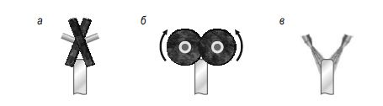

**Figure 2.145.** Solution options:

*a* - two abrasive discs at an angle; *b* - two abrasive discs perpendicular to the glass end; *c —* sandblasting

*In solving this problem, the following options were obtained:*

1. *two abrasive discs mounted at an angle (Fig. 2.145, a);*
2. *two abrasive discs mounted perpendicular to the glass end (Fig. 2.145, b);*
3. *sandblasting (Fig. 2.145, c).*

*None of the proposed options suited the customer. The first two options are complex in design, while the third leads to contamination of the glass. Let's widen the search for solutions with development lines.*

*All of the options describe transformations of one component, the abrasive tool. The logic of the solutions suggests that they can be lined up in a 'crushing' line. But a more important feature of the solutions is that their mobility* (*activity*) *increases. Consequently, the 'Dynamisation' line is more appropriate here (Figure 2.146).*

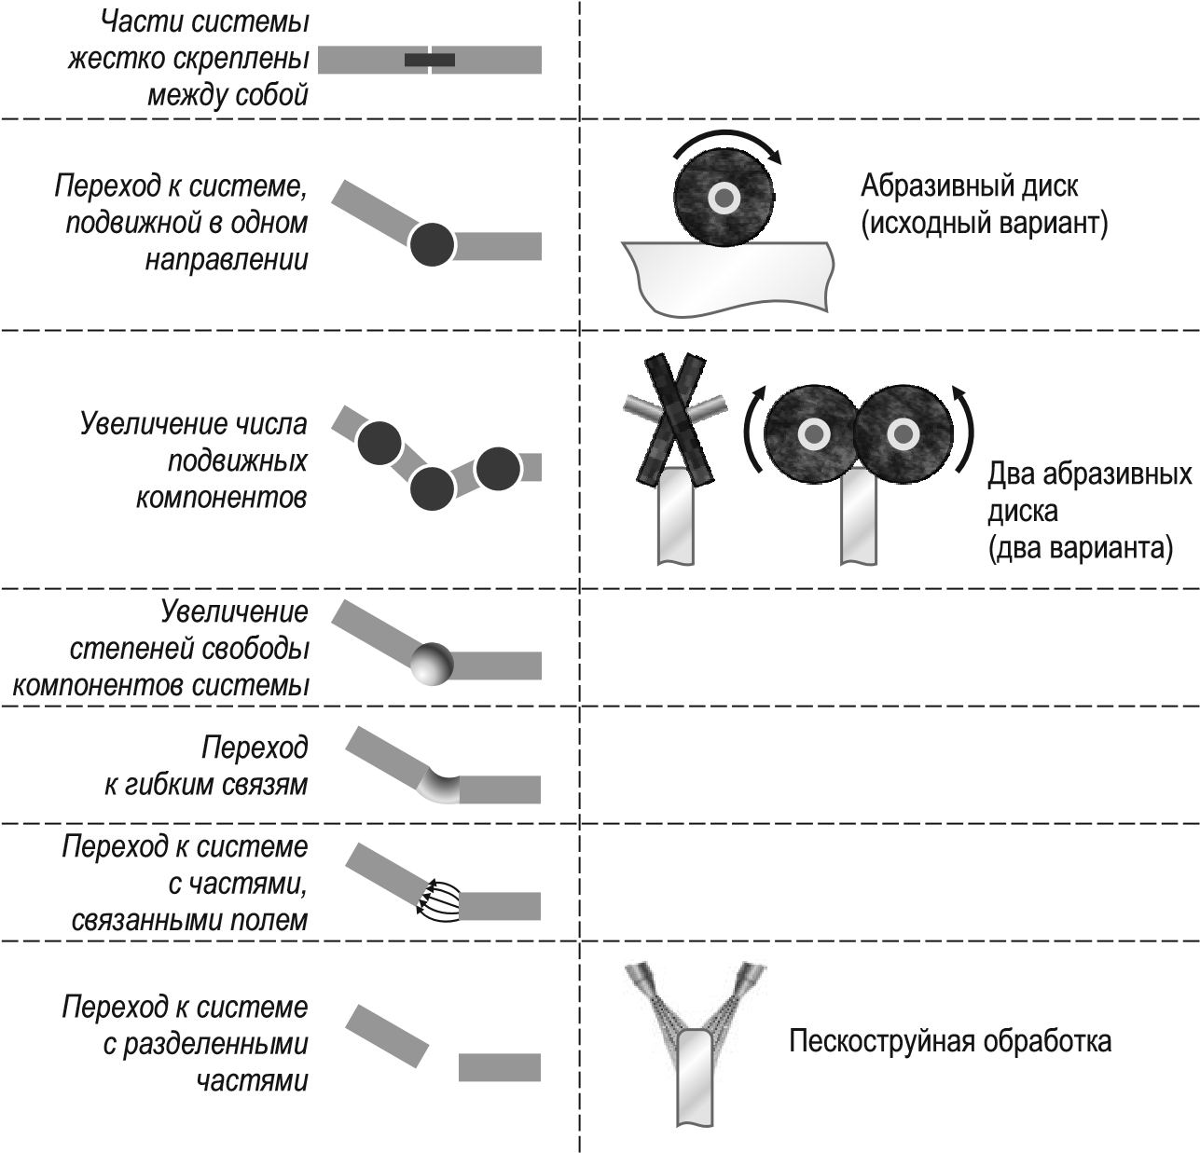

**Fig. 2.146.** Building preliminary decisions into a development line

*Let's try to find solutions through* the *transformations suggested by the development line*.

1. *A rigid system. No ideas.*
2. *Increase the degrees of freedom. Mount the discs on spring-loaded axles. This will help avoid chipping and cracking the glass* (*Fig. 2.147*, *a*)*.*
3. *Transition to flexible links. Use abrasive tape* (*Fig. 2.147*, *b*)*.*
4. *Switching to a system with field-bonded components. The disadvantage of sandblasting can be eliminated*: *ferromagnetic abrasive particles can be used instead of sand. The flow of such particles lends itself well to magnetic field control* (*Fig. 2.147*, *c*)*. Surface contamination can be reduced.*

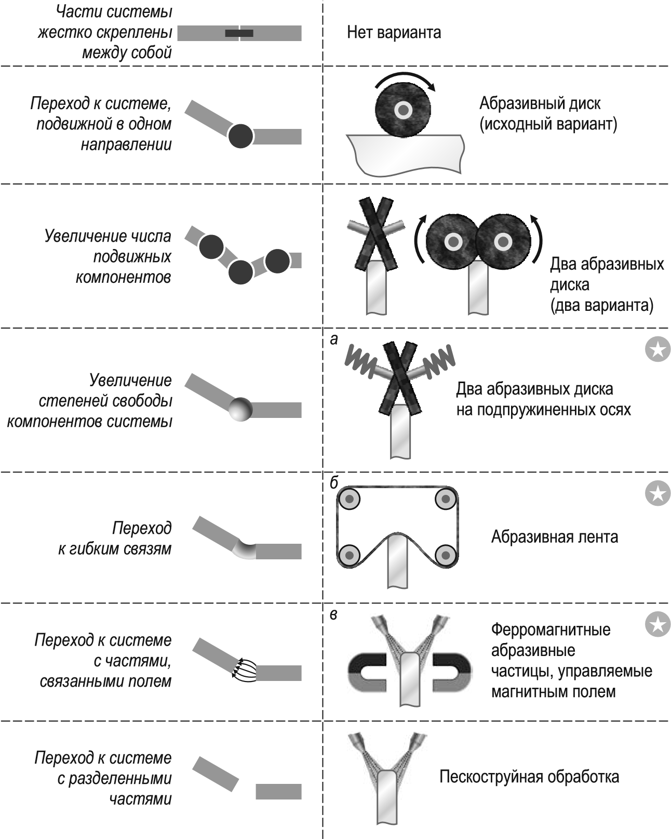

**Figure 2.147.** Alternative generation: *a* - two abrasive discs on spring-loaded axes; *b* - abrasive belt; *c* - ferromagnetic abrasive particles driven by a magnetic field

*The preliminary decision to use an abrasive belt can be reinforced* by *making one belt process several sheets of glass at once* (*Fig. 2.148*)*.*

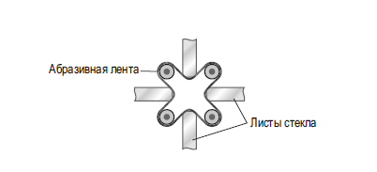

**Figure 2.148.** Abrasive belt,

which processes several sheets of glass simultaneously