**Door and baby**

Generated with Solving Mill software

Solving Mill

Author(s):

Created: 22 Jan 2020, 19:44  
Deadline: 22 Jan 2020  
State: 3/0 final solutions are constructed

Problem models: 3  
Solution models: 2  
Sets of requirements to a resource: 1  
Preliminary solutions: 7  
Final solutions: 3

|  |
| --- |
|  |
|  |

**Analysis of problem situation**

**Describing problem situation**

Problem situation:

A child plays in front of a closed door. If you suddenly open the door, you can hit the child hard.  
How to increase the safety of the child?

[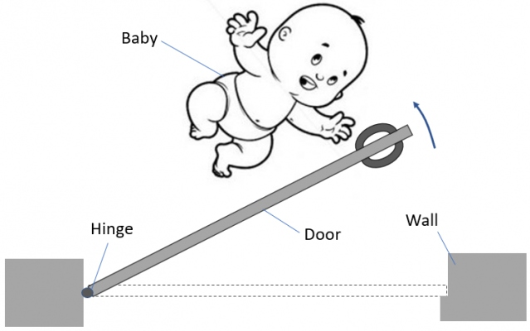](http://www.solving-mill.com/Data/ProjImages/0000008162/9fwlkZO8.png)

Undesirable effect:

Injured child

Useful product connected with problem situation:

Opened door

Production process essence:

An adult push the door. The door pivots and opens.

|  |
| --- |
|  |
|  |

**Revealing problem operation**

Scheme of machine:

[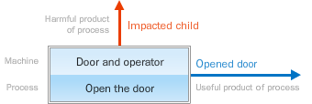](http://www.solving-mill.com/Data/ProjImages/0000008166/scheme.png)

Machine function:

Provide a niche in a wall and close it

Machine components:

A door, hinges, doorway

What is the structure of the machine?

the door located into doorway with possibility to pivot and open.

How does the machine work?

The operator pushes the door. The door is opened in direction to a child.

Production process model:

[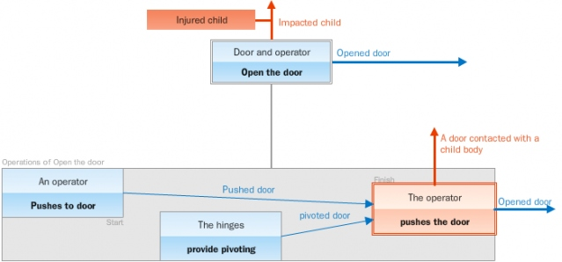](http://www.solving-mill.com/Data/ProjImages/0000008171/scheme.png)

Scheme of problem operation:

[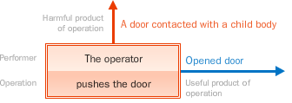](http://www.solving-mill.com/Data/ProjImages/0000008177/scheme.png)

Model of useful system for producing Opened door:

|  |
| --- |
|  |
|  |

**Investigating conflict**

Scheme of conflict:

[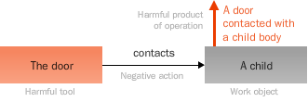](http://www.solving-mill.com/Data/ProjImages/0000008178/scheme.png)

Exact conflict place:

A door and a child

Conflict time:

Time of contact a door and a child

[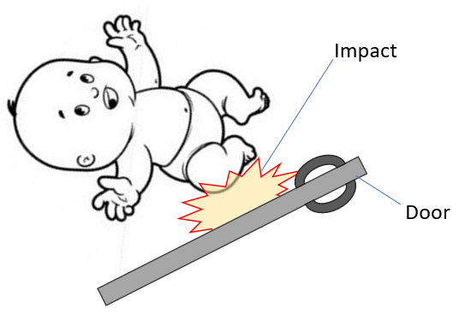](http://www.solving-mill.com/Data/ProjImages/0000008169/2Wq2S2Rz.png)

Conclusion:

**The conflict is significant and should be eliminated.**

Harmful system model:

Root cause scheme:

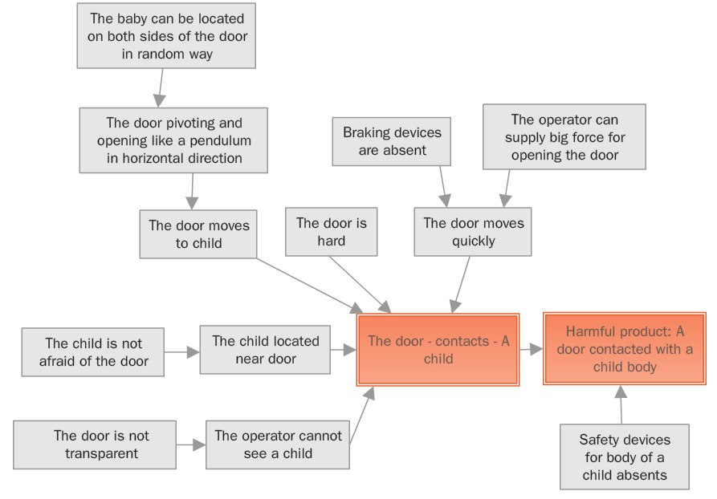

Main causes of the conflict:

The door pivoting and opening like a pendulum in horizontal direction

The baby can be located on both sides of the door in random way

The operator cannot see a child

The door is not transparent

The door is hard

The door moves quickly

Safety devices for body of a child absents

|  |
| --- |
|  |
|  |

**Suggesting conflict eliminating hypotheses**

|  |
| --- |
|  |
|  |

**Problem solving**

**Hypothesis 1**

Conflict can be eliminated if  
the door would be opened in direction from place of location of the child

|  |  |
| --- | --- |
| **http://www.solving-mill.com/images/ReportPM.png** | **Formalized problem model (hyp. 1)** |

Short formulation:

There is a conflict in the machine "Door and operator" for producing "Opened door". The conflict essence is "The door - contacts - A child. Harmful product is A door contacted with a child body". Conflict can be eliminated ifthe door would be opened in direction from place of location of the child .

Goal:

Provide conditions indicated in the hypothesis &lt;Conflict can be eliminated if  
the door would be opened in direction from place of location of the child&gt;

Operational zone:

A door and a child

Available resources:

|  |  |
| --- | --- |
| Substances | Fields |
| A door hinges doorway | mechanical electrical |
| Time | Space |
| Time of contact a door and a child | A door and a child |

|  |  |
| --- | --- |
| **http://www.solving-mill.com/images/ReportPS.png** | **Preliminary solution 1 for FPM1** |

Description:

Accurately identify the room for the child. Run the door so that it does not open in the nursery, but rather, outward.

[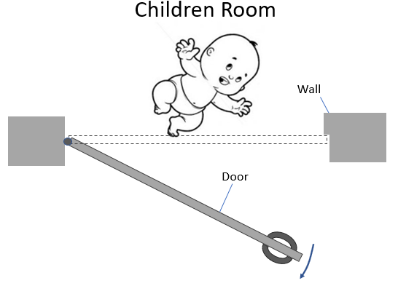](http://www.solving-mill.com/Data/ProjImages/0000008180/nFaUYv7c.png)

Advantages:

The contact a door and a child is absent

Disadvantages:

The child could located from both place of the door in random way

**Additional preliminary solutions**

|  |  |
| --- | --- |
| **http://www.solving-mill.com/images/ReportPS.png** | **Preliminary solution GA1** |

Description:

Make the door opened into two directions. Use supports fron double hinges.  
To prevent injury to the child, the operator can always open the door for himself.

[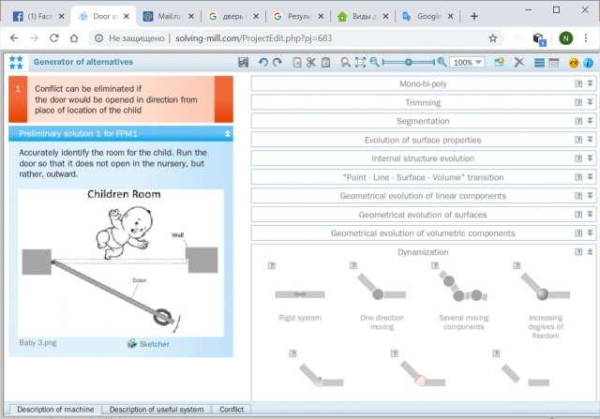](http://www.solving-mill.com/Data/ProjImages/0000008185/ZYxay2Yh.png)

[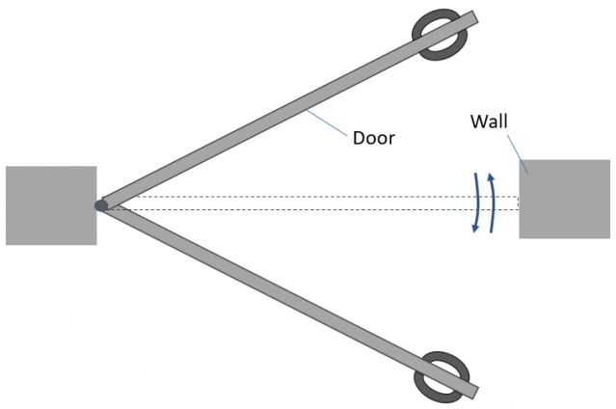](http://www.solving-mill.com/Data/ProjImages/0000008186/u70MQUaX.png)

|  |  |
| --- | --- |
| **http://www.solving-mill.com/images/ReportPS.png** | **Preliminary solution GA2** |

Description:

Make the door like accordione.

[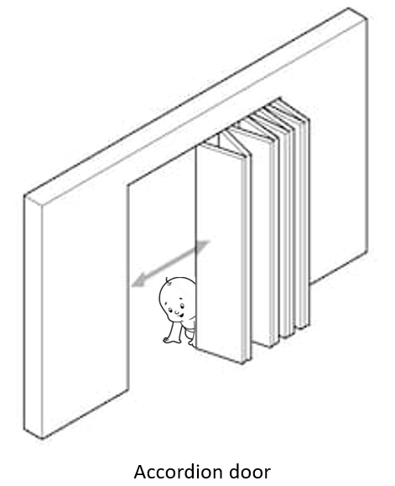](http://www.solving-mill.com/Data/ProjImages/0000008183/bdytsDs8.png)

|  |  |
| --- | --- |
| **http://www.solving-mill.com/images/ReportPS.png** | **Preliminary solution GA3** |

Description:

Use a roll-up door.

[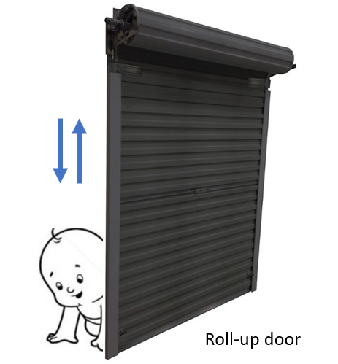](http://www.solving-mill.com/Data/ProjImages/0000008184/LxLRjgN5.png)

|  |
| --- |
|  |
|  |

|  |  |
| --- | --- |
| **http://www.solving-mill.com/images/ReportFS.png** | **Final solution (hyp. 1)** |

Description:

Proposed idea:  
Make the door opened into two directions. Use supports fron double hinges.  
To prevent injury to the child, the operator can always open the door for himself.

[](http://www.solving-mill.com/Data/ProjImages/0000008187/qS5KbsrU.png)

[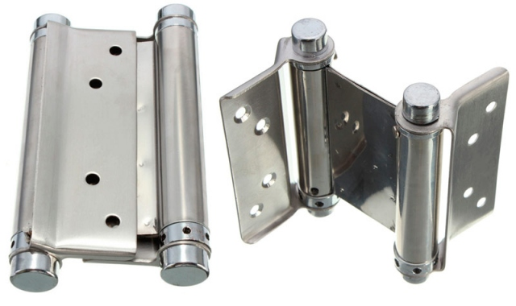](http://www.solving-mill.com/Data/ProjImages/0000008188/lZfDLR3B.jpg)

|  |
| --- |
|  |
|  |

**Hypothesis 2**

Conflict can be eliminated if the door would be soft and elastic

|  |  |
| --- | --- |
| **http://www.solving-mill.com/images/ReportFS.png** | **Final solution (hyp. 2)** |

Description:

Make the door soft and elastic. Place on the door a pillow from soft material.

[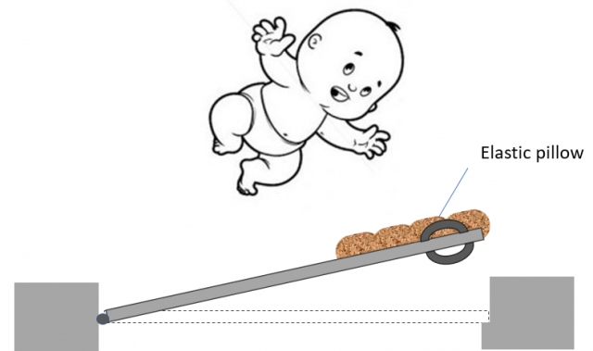](http://www.solving-mill.com/Data/ProjImages/0000008189/IiJUZ17y.png)

|  |
| --- |
|  |
|  |

**Hypothesis 3**

Conflict can be eliminated if an operator would be understand the child is located behind the door during opening

|  |  |
| --- | --- |
| **http://www.solving-mill.com/images/ReportPM.png** | **Formalized problem model (hyp. 3)** |

Short formulation:

There is a conflict in the machine "Door and operator" for producing "Opened door". The conflict essence is "The door - contacts - A child. Harmful product is A door contacted with a child body". Conflict can be eliminated if an operator would be understanding the child is located behind the door during opening.

Goal:

Provide conditions indicated in the hypothesis &lt;Conflict can be eliminated if an operator would be understand the child is located behind the door during opening&gt;

Operational zone:

A door and a child

Available resources:

|  |  |
| --- | --- |
| Substances | Fields |
| A door hinges doorway | Mechanical Electrical |
| Time | Space |
| Time of contact a door and a child | A door and a child |

|  |  |
| --- | --- |
| **http://www.solving-mill.com/images/ReportSM.png** | **Solution model 1 for FPM1** |

What and how should be done:

Provide a property Ability to observe place behind a door for operator in a system by means of a component which exhibits this property.

|  |  |
| --- | --- |
| **http://www.solving-mill.com/images/ReportRR.png** | **Resource (component) requirements** |

|  |  |
| --- | --- |
| what is it making in the system, where and when | to provide the operator with surveillance of the space behind the door |
| size | coordinate with size of the door |
| shape | coordinate with shape of the door |
| internal space | should to be evacuated in the center of the door to provide the void |
| material | transparent material (glass) |
| ability of control | handly |

IFR:

the door itself provides the operator with surveillance of the space behind the door

|  |  |
| --- | --- |
| **http://www.solving-mill.com/images/ReportPS.png** | **Preliminary solution 1 for FPM1 by SM1** |

Description:

Computer's description of an idea:  
Provide a property Ability to observe place behind a door for operator by means of the system component A door. Use resource:  
with size coordinated with size of the door  
with shape coordinated with shape of the door  
with internal space evacuated in the center of the door to provide the void  
with material transparent material (glass)  
with control handly  
  
Translated description of an idea:  
Make a door with transparent glass incert.

[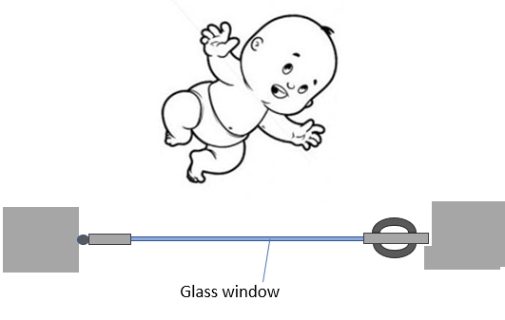](http://www.solving-mill.com/Data/ProjImages/0000008191/0EyYSh9f.png)

Advantages:

We obtain desired result  
The design of the door is simple

Disadvantages:

no signal

**Additional preliminary solutions**

|  |  |
| --- | --- |
| **http://www.solving-mill.com/images/ReportPS.png** | **Preliminary solution GA4** |

Description:

Use a signal based on field principles: motion detektor and signal lamp.

[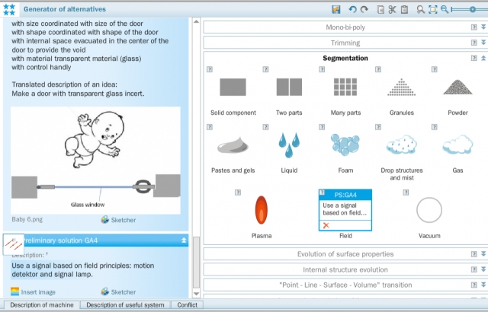](http://www.solving-mill.com/Data/ProjImages/0000008192/AylukL6e.png)

[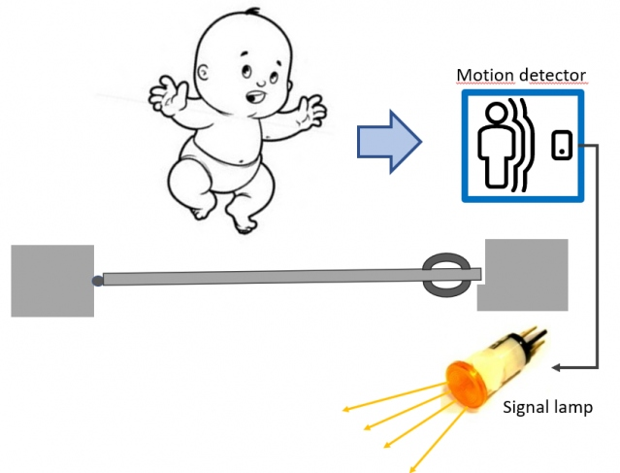](http://www.solving-mill.com/Data/ProjImages/0000008193/7PRdhr1U.png)

|  |
| --- |
|  |
|  |

|  |  |
| --- | --- |
| **http://www.solving-mill.com/images/ReportFS.png** | **Final solution (hyp. 3)** |

Description:

Make a door with transparent glass incert.

[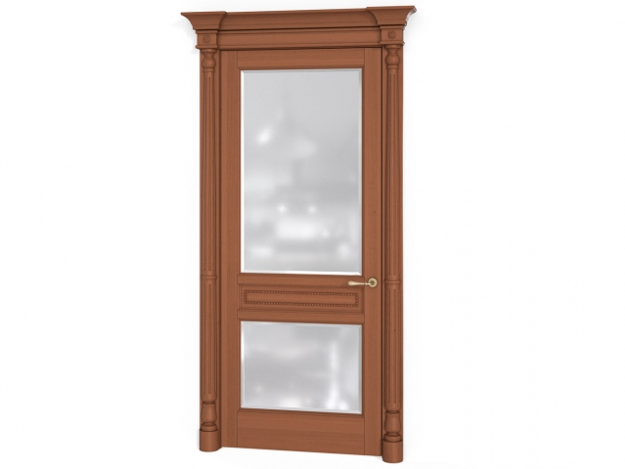](http://www.solving-mill.com/Data/ProjImages/0000008194/F22IJbvC.jpg)

|  |
| --- |
|  |
|  |

**Hypothesis 4**

Conflict can be eliminated if the door would be move slowly during opening

|  |  |
| --- | --- |
| **http://www.solving-mill.com/images/ReportPM.png** | **Structural problem model (hyp. 4)** |

Short formulation:

There is a conflict in the machine "Door and operator" for producing "Opened door". The conflict essence is "The door - contacts - A child. Harmful product is A door contacted with a child body". Conflict can be eliminated if the door would be move slowly during opening.

Goal:

Improve the performance of the action &lt;operator&gt; - &lt;pushes&gt; - &lt;door&gt;

Operational zone:

A door and a child

Available resources:

|  |  |
| --- | --- |
| Substances | Fields |
| A door hinges doorway | mechanical electrical |
| Time | Space |
| Time of contact a door and a child | A door and a child |

|  |  |
| --- | --- |
| **http://www.solving-mill.com/images/ReportSM.png** | **Solution model 1 for SPM1** |

What and how should be done:

Weaken the action by introducing into the system a protective component.

[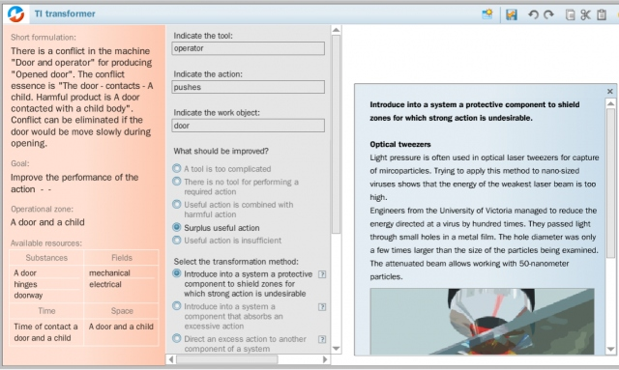](http://www.solving-mill.com/Data/ProjImages/0000008195/frJtiPkI.png)

|  |  |
| --- | --- |
| **http://www.solving-mill.com/images/ReportRR.png** | **Resource (component) requirements** |

|  |  |
| --- | --- |
| **http://www.solving-mill.com/images/ReportPS.png** | **Preliminary solution 1 for SPM1 by SM1** |

Description:

Weaken the action by introducing into the system a protective component.  
The introduced component is: a brake.  
  
The place and position of the component in the system is: between a doorway and a door.

[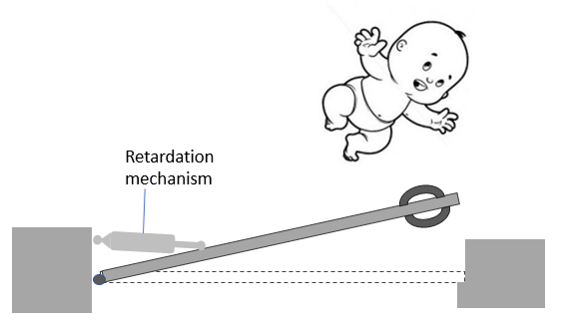](http://www.solving-mill.com/Data/ProjImages/0000008196/ijzJWdDa.png)

|  |
| --- |
|  |
|  |

**Analysis of situation improving**

**Composing technical proposal**

|  |
| --- |
|  |
|  |

**Estimating conflict elimination**

|  |
| --- |
|  |
|  |

**Draft of patent claims**

**Please note that the patent claim is automatically generated based on your texts. It is necessary to check whether the texts fit the patent application rules.**

Claim 1. A device (equipment) for Provide a niche in a wall and close it, comprising:  
A door, hinges, doorway  
wherein  
proposed idea:  
Make the door opened into two directions. Use supports fron double hinges.  
To prevent injury to the child, the operator can always open the door for himself.

Claim 2. A device (equipment) in accordance with claim 1  
wherein  
accurately identify the room for the child. Run the door so that it does not open in the nursery, but rather, outward.

Claim 3. A device (equipment) in accordance with claims 1, 2  
wherein  
make the door opened into two directions. Use supports fron double hinges.  
To prevent injury to the child, the operator can always open the door for himself.

Claim 4. A device (equipment) in accordance with claims 1, 2, 3  
wherein  
make the door like accordione.

Claim 5. A device (equipment) in accordance with claims 1, 2, 3, 4  
wherein  
use a roll-up door.

Claim 6. A device (equipment) in accordance with claims 1, 2, 3, 4, 5  
wherein  
computer's description of an idea:  
Provide a property Ability to observe place behind a door for operator by means of the system component A door. Use resource:  
with size coordinated with size of the door  
with shape coordinated with shape of the door  
with internal space evacuated in the center of the door to provide the void  
with material transparent material (glass)  
with control handly  
  
Translated description of an idea:  
Make a door with transparent glass incert.

Claim 7. A device (equipment) in accordance with claims 1, 2, 3, 4, 5, 6  
wherein  
use a signal based on field principles: motion detektor and signal lamp.

Claim 8. A device (equipment) in accordance with claims 1, 2, 3, 4, 5, 6, 7  
wherein  
weaken the action by introducing into the system a protective component.  
The introduced component is: a brake.  
  
The place and position of the component in the system is: between a doorway and a door.