Source: https://shchedrovitskiy.com/chto-est-myshlenie/

Peter Shchedrovitsky

What is thinking? The concept and working hypothesis of MMC

-2019-
Against the sophists or a commentary on Georgi Shchedrovitsky's programme and some of his research findings.

Lecture 1: Basic Hypotheses

Section 1.4 What is thinking? The concept and working hypothesis of MMC

Back to the history of the Moscow Methodological Circle (MMC)
From the lengthy historical digression undertaken in the last section, let us move on to the history of the MMC.
So, our thesis consisted in the fact that, from 1952 to 1963, several research and engineering programs took shape within the framework of the Moscow Logical Circle (later MMC), some of them unfolding in parallel and some succeeding each other. In the end, the programme of building a theory of thinking or a science of thinking became central.
Georgi Petrovich himself repeatedly analysed the early stages of the story in an attempt to assess the contribution of individual projects or research tasks to the overall direction of the work. In particular, he emphasised the importance of the two sub-programmes that emerged in the first phase:
- A. Zinoviev's logico-methodological sub-programme aimed at constructing the methodology and logic of scientific research. This was outlined in his dissertation work, dedicated to the analysis of the method of logic "ascending from the abstract to the concrete" on the material of Marx's Capital; after 1958, the provisions of the dissertation evolved into a project of developing a "new logic" by Alexander Alexandrovich and a group of his closest students;
- A sub-programme to analyse and describe the development of (natural science) concepts, which was fairly quickly transformed into a project to reconstruct basic operations of thinking on the basis of texts describing the solution of complex problems.
The second programme, Georgi Petrovich's programme proper, began with an analysis of texts containing statements of complicated reasoning – mathematical, physical, astronomical, chemical, biological – in the material of which methodologists sought general patterns of thought, realising that all this reasoning was certainly not constructed according to Aristotelian logic or the logic of Port-Royal.

Constructing a working concept of 'thinking'
The realisation of the programme of building a theory of thought as the scientific basis for building a new logic and methodology, as its first stage, involved constructing a working concept of "thinking".
On a side note, let me remark, that to answer the question "what is thinking", a lot of research has to be done, a series of engineering studies, to see how they work and whether they work at all.
This is similar to research engineering that is done in other fields. For example, if you want to create a nuclear reactor, you first have to understand how the physical process works, do the research, do the modelling. In this sense, the very prototype of the work is borrowed from the surrounding practice, it's to the question – what comes first the chicken or the egg. Next we have to put the initial basic hypothesis inside the programme: what we will call thinking. Shortly before Georgi Petrovich left, we had an interesting conversation; at the time we were dealing with the topic of programming students' research work. He said: "You see, the initial hypothesis can be anything; the history of thought is the history of productive fallacies.

Commentary
For an example of the history of different hypotheses in philosophy, see the article «Thinking», by V.A. Lektorsky. The New Encyclopaedia of Philosophy (digital library of the Russian Academy of Sciences)
You should not expect in reflection that your initial hypothesis has any relevance to reality, but it should be, and it should be articulated enough that you can then critique and change it.
Karl Popper (Austrian and British philosopher and sociologist) expresses the same idea in his definition of knowledge: knowledge is that what we can reject, which is falsifiable, that is, it has a structure in which there is that present which we renounce and that which we retain. If there is no such structure, it is not a hypothesis.

Working hypothesis
MMC's working hypothesis is that "thinking" can be thought of as a particular activity or operation with signs which replaces operation with "things" in such cases when such practical operation is impossible or meets severe difficulties.

Commentary
The method of "damming" or, as MMC would later say, "breaking" in activity was borrowed from studies of thought (intellectual) processes in the French and German tradition.
So we have a baseline, we have a substitution level (or substitution procedure), a sign level (sign operation) and a reference procedure.
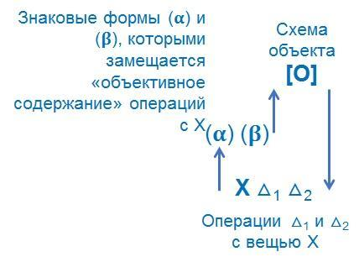
Thinking arises as the effect of substituting "things" for the practical operation of signs, transforming these signs and "returning" from the results obtained in the plane of the operation with signs, to actions with "things" or to things themselves with their qualities. This "return" is called the procedure of "attribution".
Naturally, complicated forms of thinking, unlike simple ones, were described on schemes (models) with many substitution floors. The movement along these floors eventually made it possible to redefine the initial things of practical operation or to construct new things (which could already be described in terms of "objects" and objectification). Georgi Petrovich was very fond of joking about this: "you can add and subtract rams, but you can not raise them to a degree". We do this operation already not with rams, but with signs, and such floors of substitution can be very many.
As an explanation, we can use an example from the pedagogical developments of the Moscow Methodological Circle, which Georgi Petrovich often cited in his lectures and speeches. Let us imagine that a preschool child is given eight dolls and asked to go to the next room and bring from there plates, spoons and forks to serve the table. If the child can't yet count, doesn't know mathematical rules of operations with signs (number rows, counting and counting) or, according to the basic hypothesis, "thinking", he goes to the next room and gets a number of plates. For example, the number of plates is smaller than the number of dolls, so he goes back and gets some extra ones. And so many times until, by trial and error, in a long enough time, he brings the four item sets into line with each other.
What does a child who knows how to count do? He acts differently and does things that make absolutely no sense in terms of directly solving a practical problem. He is told: "Bring plates, spoons and forks from the next room or from the kitchen", and instead he starts counting dolls … That is he does something completely different: having an initial set X, he applies the procedure of "counting" and gets a number which characterizes both the number of initial objects (dolls) and the number of other objects Y, which now needs to be "counted" in the required quantity.

The influence of world philosophical traditions on the notion of thinking in the Moscow Logical Circle
The hypothesis originally introduced did not correlate directly with other, already culturally available notions of 'thinking'.
Today we can make a number of assumptions in retrospect about the lines of borrowing that may have influenced the work of Georgi Petrovich and a group of his closest associates. First of all, let us stress that Georgi Petrovich himself used German as a working language, as did many members of his generation.
You can identify three authors in whom you will find not as articulate as I have just told you, but a very similar idea of what thinking is all about.
At a certain point Georgi Petrovich was impressed by Husserl's "program" set forth in the famous article "Philosophy as a rigorous science", as well as by the detailed critique of "psychologism" present both in the works of Gottlieb Frege and in the first volume of Husserl's "Logical Studies". This volume is still in my family library, both in Russian (as you know, it was published in 1909 in a translation by E.A. Bernstein edited by S.L. Frank) and in German.
A. Bogdanov (Malinovsky), a critic of Lenin and author of the theory of empiriomonics and the organisational science of Tectology, certainly played an important role in shaping the original ideas. His works, despite their well-known conflict with Lenin, remained widely available.
N. Alekseev believed that E. Cassirer's "Philosophy of Symbolic Forms" was also a major influence, and I can confirm that the first volume of this three-volume book in German has been preserved in my home library. "The Philosophy of Symbolic Forms" is essentially a work about sign systems, which are used in replacing the real operation with things in culture and are the foundations of different forms of thinking.

Who were you disputing with?
Despite all the lines of continuity mentioned with the world philosophical agenda, in the domestic socio-cultural situation of the early and mid-50s the content of such a basic hypothesis about the structure of thinking turned out to be "scandalous". Perhaps this was due to the fact that its content was directly directed against the concept of "reflection", widespread at that period, which was based on Lenin's numerous statements about the structure of "cognitive processes".
In 1953, for the world philosophy the thesis that thinking has nothing to do with consciousness is the basics. Gottlieb Frege built his conception of thinking on this back in 1892-93, i.e. at the end of the 19th century, while Husserl developed this idea to the extent of an enormous programme, and the entire European philosophy after Husserl cannot even imagine putting an identity mark between thinking and consciousness.
Frege's work had been published 60 years before the Moscow Logical Circle (MLC) began its work; Husserl devoted his "logical studies" largely to a critique of "psychology"; in Russia, the Shchedrovites, who had adopted the "substitution" hypothesis, were virtually alone on this (i.e. anti-psychological) side of the barricades.
In order not to be unsubstantiated, I will give two quotations from a dictionary article. Radloff's Dictionary of Philosophy, 1904: "Thinking denotes some mental activity, understood sometimes in a wider, then in a narrower meaning. In the first sense it refers to all mental processes, in the second only to the arbitrary connection or disconnection of two or more elements of consciousness". You will say, "1904, that's a hundred years ago”. Well, then let us take a 2001 article, Philosophical Dictionary: "Descartes' definition, if not reducing thinking to consciousness, at least repels from consciousness as an experience or one of the dimensions of the subject. Obviously, no other definition of thinking is possible because every definition implies consciousness and addresses the subject. "To think," Kant would later say, "is to connect perceptions in consciousness".
The fact that thinking is the result of processing sensory images transmitted to us by the senses has been believed by a number of philosophers for a thousand years, and some still think so. And MMC representatives said: "no, of course, there is no such thing, there is no such process, thinking arises from something entirely else". Georgi Petrovich states: thinking is an operation with signs according to certain rules, and it does not take place in the mind, it takes place on a piece of paper, on a blackboard.

"Psyche" and "consciousness" can be the material on which "thinking" unfolds
What for world philosophy has long been an axiom, for Soviet philosophy is simply a break with all stereotypes, a move against Lenin's theory of "reflection".
The members of the Moscow logical circle did not simply refuse to look for the processes and mechanisms of "thinking" in the head of an individual; they claimed that "psyche" and "consciousness" can, under certain conditions, become the material on which "thinking" unfolds – but it is only material and, moreover, far from being the only material.
For example, if we multiply one four-digit number by another, it makes no difference whether we do it in our mind or on a piece of paper in order to characterise this procedure or operation as a thinking operation.
Thinking seems to be parasitic on the material of the brain, psyche, consciousness and the processes inherent in these types of material – just as it can unfold on man-machine systems, machines or 'mega-machines'. Naturally, MMC representatives recognised that material characteristics would influence the realisation of 'thinking' processes, but in no way could one be reduced to or substituted for the other.

Section 1.5 How to catch "thinking before ": on new schemes and categories

Commentary
The Russian philosopher V. Podoroga once suggested a good metaphor: there is "thinking before" and "thinking after". Descartes was interested in how "thinking before" works; before you already know what you want to communicate and ponder how to communicate it. How to properly express the thought in the linguistic forms available to you, such as natural speech. And what and how does it happen before that?

Scheme of the "square"
The 'square' model, which is being introduced at the time by the MMC, states that we are always dealing with a moulded process.
We have thinking itself, which is an expression of some kind of operation, manual or intellectual, with things or with their substitutes, with signs (high floors), with sign forms, with movement in these sign forms. And there is a reflection, a grasping of both the former and the latter in consciousness, that is, both subject and thing are grasped by consciousness, and signs are grasped by consciousness, but in different ways. Not one thinking consciousness, but four different entities in a very complex relationship.
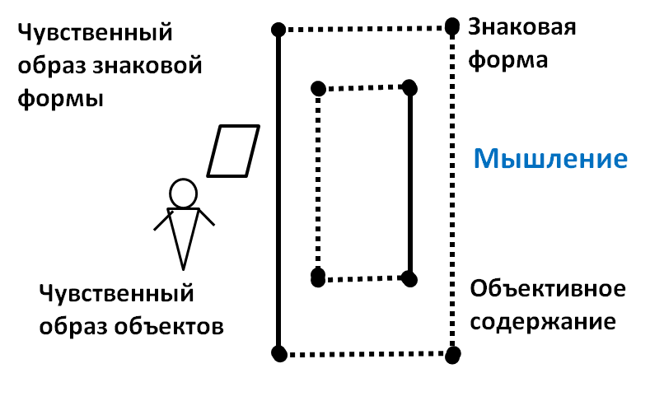
This idea was expressed in the so-called "square" scheme. It was this scheme that became the basis of a critique of the ideas of mental action developed during this period by P.J. Halperin and his pupils. A vivid discussion took place in 1959 at the 1st Congress of the Society of Psychologists, and was later developed into a research and development programme known today as the monograph "Pedagogy and Logic".
The programme of pedagogy and logic was based on the premise that it was important not so much to deal with psychology as with logic; not the reflection of consciousness, but what is on the board, what is common. And then the material on which this logic unfolds. Frege explained this idea on a very intelligible example: I see a house through a window, and tell me, is the house larger than the window or smaller? If the house is bigger, how can we see it through the window? But the house is objectively larger. And what we imagine when we look at it through the window is our perception.

On the historical dimension of thinking
On the other hand, it has been suggested that the possibilities of aggregate humanity in carrying out these procedures of substitution of real things with signs, of operation with these signs and of attributing the results of such operation back to things (including those artificially created in some kind of material as products of the operation itself) are constantly changing and developing.
Initially, the acceptance of this assumption acted as another argument in terms of criticism of the formal-logical approach to thinking.
Indeed, a substantial group of formal-logical developments of the mid-twentieth century, which acted as a subject of analysis and criticism for Georgi Petrovich, proceeded from the assumption that 'thinking', described in a set of rules and methods of reasoning in formal logic, was historically unchanging. Some others recognised that 'thinking' does change in its content, while remaining unchanged in form.
And what did the French Turgot and Condorcet write about that in the 18th century when they introduced the notion of progress of the human mind? Not about man with his individual psyche and consciousness, but about the progress of semiotic systems, changes in the rules of operation, the accumulation of aggregate human experience, it is about thinking. Georgi Petrovich says:
"they first presented thinking as a historical process because they saw that the mind "accumulates" and as a consequence changes take place. And borrowed from traditional philosophy, the Cartesian-Lockean or Berkeley-Lockean notions that thinking exists in the mind, did not allow the phenomenon to be explained. A gap has been fixed. Actually, it goes all the way back to Kant, and Kant is the last psychologist, already on the verge, because further on Fichte says that thinking is a special process”.
For the traditional psychological theory of thought, it is impossible to give an answer to the question "what evolves historically?” They struggled for a long time and came up with the following: the contents change because socio-historical practice changes – earlier there were carts and later on aeroplanes – but the forms remain unchanged. Formal logic got tangled up in contradictions.

The change in the way thinking is organised fixes the scheme of activity reproduction and translation of culture
Georgi Petrovich stated that all traditional logical schemes and related logical concepts only normalised the process of formal inference or deduction and thus dismantled the sign material of speech in such a way as to fix and organise just this basic process. These dissections did not take into account and did not fix other processes in thinking and, naturally, could not "capture" the changes in the forms of the organization of thinking.
This line of analysis and schematisation of the problems of thinking development has found expression in a series of schemes, among which the most famous is the so-called "activity reproduction and translation of culture" scheme. This aspect is often overlooked in the consideration and interpretation of this scheme.
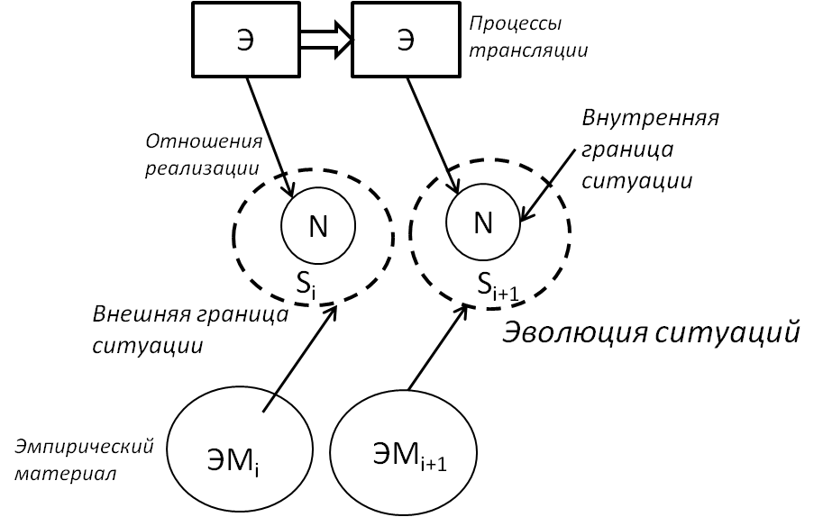

The traditional units attributed to "thinking" have come to be treated as means
On the third hand, such a "cultural-historical" rather than individual-psychological interpretation of "thinking" required a change in the categorical characterisation of the basic units or, as MMC representatives began to say, "organisms" of thought work. Instead of traditional "representations" (the German term) or images that consciousness combines and superimposes on one another, they began to speak primarily of "means" providing those or other ways of sign substitution and mediation of real operations and transformations.
The units traditionally attributed to 'thinking': knowledge, concepts, categories, came to be treated as means, along with 'approaches', 'ways', 'techniques', 'forms of organisation', 'schemes' and, finally, 'methods'.
Georgi Petrovich said:
"Descartes bequeathed to us that the units of thought are means and methods, so methodology is the doctrine of methods, but this thesis was not seen in Descartes."
This interpretation made possible a new reading of Descartes and other lines of analysis and research on 'thinking' in philosophy and the social sciences.
The different types of instrumental organisation of thought came to be seen as key elements in the processes of reproduction of activity, transmitted in the form of "cultural" norms and as an essential type of content.
Georgi Petrovich did not use the term "representation" in his discourse, but rather the term "means". He was saying that means and ways of thinking are the form of packaging and the content of the channels of cultural transmission.
These can be simple tools, or they can be complicated, such as an approach.

"Thinking" is not the same as "knowing"
On the fourth side, this has allowed us to demarcate "thinking" and "cognition", introducing another important line of opposition to traditional ideas about the place and role of "thinking", in particular in the processes of socio-historical practice. It is no secret that in many philosophical dictionaries thinking is still treated primarily and mainly as an instrument of cognition.
So on Wikipedia we read: "Thinking is a cognitive human activity. It is a mediated and generalised way of reflecting reality. The result of thinking is a thought (concept, meaning, idea). Thinking is opposed to ‘lower’ ways of mastering the world in the form of sensing or perception, which are also characteristic for animals.
Gogotsky's Dictionary of Philosophy, published in the mid-nineteenth century, reads: "Thinking is the highest cognitive activity of our spirit. In thinking we recognise consciously and lawfully both different relations between things, and these things themselves, and the objective world: the simple sensual consciousness arising from sensations, by means of thinking is transformed into a distinct and conscious recognition of the objective world " (Gogotsky S.S. Philosophical Lexicon in 4 volumes, 1857-1873)
We are not Berkeleyans, we are not solipsists, we are not followers of A. Kurpatov, we understand that the world exists objectively. But beyond that, unfortunately, we only deal with our perceptions.
The German philosophers, building philosophical language, at one point said that the word 'representation' is ambiguous, because there is 'representation' and there is 'presenting', in the sense of putting before oneself. Where put before oneself, put on a piece of paper out of consciousness, there it is about thinking.
And since thinking are systems of means, and they can be configured in different ways, we can build typologies of thinking by distinguishing these types to solve certain classes of problems.

Typological ideas about thinking
In adopting the MMC approach outlined above, the identification and systematisation of different types of "means" on different bases allow a wide range of typological conceptions of "thinking" to be introduced. The traditional notion of "cognition" begins to be viewed and treated as one of the types of thinking – exploratory thinking, the deployment of which is based primarily on the instrumental capabilities of "modeling" and "experiment". In addition to it, such types of thinking as "constructing", "designing" and "programming" can be distinguished in the sphere of thinking. These are four different types of thinking.
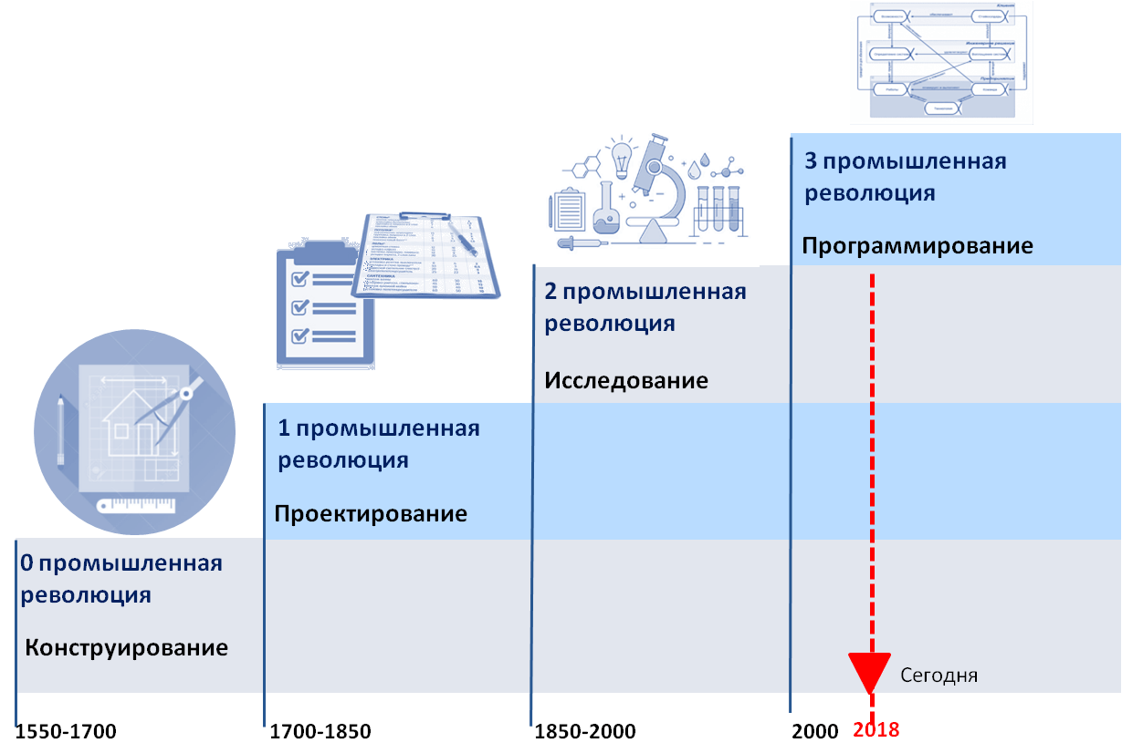
Based on this typology I build a genetic typology, saying that they are not only different, they still emerged historically at different stages of industrial revolutions, together with specific classes of actual problems that had to be solved.
At the same time, it is possible to talk about "ontological" or "historical-critical" types of thinking (in the narrower case of critical thinking). The term "systemic thinking" emerges. Why? It is also a set of means, methods, and techniques, but developed within the systemic approach and applied to a wide range of different phenomena. We think systemically, no matter what subject we are talking about – some cockroach or society. Sometimes people ask, 'but what about economic thinking? If you really want to, you can use this turn, because within economic theory we can identify some set of means which we conventionally combine into such an integrity, although in fact economics is an agglomeration of different-scale theoretical models, it is not a unified discipline.

Section 1.6 Questions and answers
What evoked the change in logic?
In short, a change in the picture of the world. The world has changed, and our view of the world has certainly changed too.
Why is the picture of the world changing now, and changing very fast, and we understand this, but we are not getting out of the old logic?
You don't have the strength for that. This is a revolution. Georgi Petrovich was not the first and only one in this movement; he was not the only one who realised that a new programme was needed. As I said, A. Zinoviev tried to do this work too, highlighted the method from the abstract to the concrete, based on K. Marx's Capital. Studying Marx, he found a bunch of holes in him, well known gaps in thinking. Then he went into mathematical formal logic, i.e. he started to implement the programme, and then abandoned it, and is said to have burned his dissertation. Zinoviev has a whole series of papers on complex logic, he went back to the more traditional Fregean approach, I mean Gottlieb Frege. The construction of the new program was not an action only in the MMC, it took place in a cultural context, but in the degree of its sweep, it was more radical than what other schools and thinkers were doing in parallel.
Am I correct in assuming that logic is a certain tool of thought and that thinking is another substance?
No, you don't have to understand it that way. There is only one way to understand me so far: the answer to the question "what is thinking" does not exist by itself, in a vacuum, it is one of the important elements of intellectual programmes, both research and normative-applied, which are connected with the formation of such substance, which you have called thinking. One way (but not the only way) is the logical way of rationing, because if you pay attention, I made a small caveat that Descartes was criticising Aristotelian logic, because it is only about how to tell another exactly what you have already thought up.
The Russian philosopher Valery Podoroga once suggested a good metaphor: there is "thinking before" and "thinking after". Descartes was interested in how "thinking before" works; before you already know what you want to communicate and pondering how to communicate it. How to properly express the thought in the linguistic forms available to you, such as natural speech. And what and how does it happen before that? Descartes, in addition to the rules of reasoning about method, proposed models for the new sciences, i.e. he didn't just answer the question 'how do people invent', he also invented himself. Descartes is considered the author of modern methodology, the doctrine of method, and in this sense he extended logic to methodology. Although he believed that Aristotle's "Organon" is also a methodology, in the sense that it is a logico-ontological construction. If you choose the genus-species system of the picture of the world, then, naturally, you will reason differently.
Valery Alexandrovich Podoroga (born September 15, 1946, Moscow, USSR) is a Russian philosopher. He has a doctorate in philosophy. Head of the Analytical Anthropology Department, Institute of Philosophy, Russian Academy of Sciences.
- 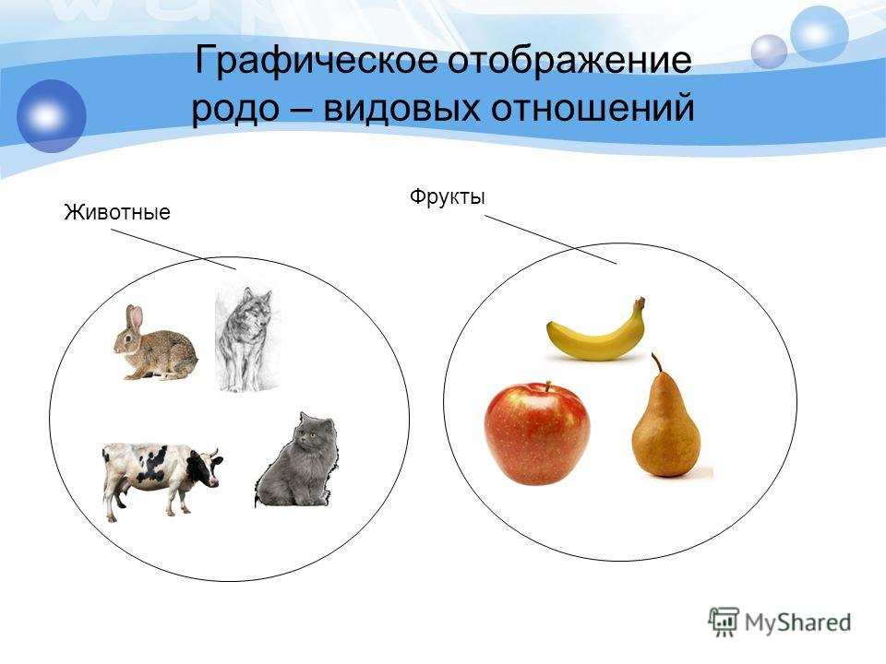
It turns out that if the Port Royalist group had described in such detail some other kind of thinking rather than logic, we would now have just as easily mastered the "thinking before" method?
Yes. You could even put it more harshly: of all the things Descartes came up with about intelligence and cogito, the guys took one little piece, shaped it into logic, and it started to work. There was no one to correct it, Descartes was dead, he couldn't come in and say "you're doing it wrong". The programme was implemented in Arnaud and Nicolas's version, until Husserl came along and said: "This is not what Descartes meant, you have taken the most important thing out of his reasoning, and we phenomenologists are now re-reading Descartes and building a new programme of research and development in thinking – phenomenology." That is why one of Husserl's works is called "Cartesian Reflections".
Two people determined the course of the development...
Not two, a little more, but there are few people of this scale. There may be more applicants, but those who have been able to create powerful enough, long enough schools are few. You see, without the Arabs we wouldn't know anything about Aristotle, it was the Arab students who preserved him. And Alexander the Great helped Aristotle to survive by taking over parts of the Arab East and thereby enabling both the library and the people to survive after the crisis of the Greek city-states. Macedonian proved to be a transfer of Greek thinking, of Greek dialectic.
And how do you recognise, how do you distinguish, the fine line between thinking and not-thinking?
Keep common sense. In answer to the question 'what is thinking', the use of the term will vary from programme to programme: with Aristotle it is νοῦς (thought, reason, mind), not thinking, with Descartes it is cogito, and with Arnaud and Nicolas it is 'thinking', if you translate accurately from French – so it is not about mindset (мышление), but about thinking (думание), the art of thinking (думать). In Kant it is reason (рассудок) and mind (разум).
By the way, in the rigid opposition of reason and mind, Kant tried to grasp what I am trying to explain by saying that by formulating thinking, one can lose thinking. He says that there are forms of reasoning, such as logical forms, there is no thinking, and there are forms of mind, they necessarily involve the ability not only to think, but also to think as you think, that is, reflexivity. If I do not control in the very act of thinking how I think, that is, the scheme, the procedure, the method, then it is not thinking.

Commentary
Mind is one of the basic categories of ancient philosophy; the summation of all sense, reason and thought patterns prevailing in the cosmos and in man.
In this sense, which is primary – the rule or the practice? I may know nothing about the transition from the abstract to the subject matter, but still think...
You are not Robinson Crusoe, somebody gave birth to you, you have some kind of language, certain rules are already sewn into ordinary language, for example, there is a subject and a predicate, what about you are saying and what you are saying. Perhaps you have some semiotic systems that are designed specifically to express thought, such as geometry and drawing.
Do the programme developers you are talking about describe existing practices?
They were creating programmes, including researching something. What was Descartes researching in our sense of the word research? He was engaged in retrospection. I'm very fond of a story. Descartes was in poor health, lung problems, and he went to a Jesuit college. The Jesuits started their training practice at 5am with fencing – it's a monastery, patio, everyone is fencing from 5am, and Descartes, exempt from physical exercises, is lying in his cell and reflecting, impossible to sleep because of the noise. What's left for him to do? Cogitation only. In fact, this is how his concept emerged. I find it very plausible.
And then he encountered a curious situation when he was forced to emigrate to Holland and lived there in the same street as the exiled future King Charles II of England, with whom he drank coffee in a coffee shop every day. This situation forced him to translate his thoughts from Latin into Flemish, into English to speak to the king and into French. As soon as you express some complex content in different language forms, even if they are natural languages, your nuclear structure crystallises. You can say it in different ways, the question is what, what is the content. Then there are certain techniques of self-organisation: someone needs to drink coffee, someone needs to look at the rising sun, clear the mind from the running line (impressions, emotions that interfere with thinking) and focus, concentrate. Kant would call this the synthesis of apperception on some content, on the 'whatness' of thought. And the rest is very simple. If you know how to do these two procedures: to translate, to express in different languages, and to concentrate, then you are almost at the finish line. The next thing is 40 years of practice and that's it.
Can we, following the logic of Aristotle's critics, say that the twentieth century has led us to describe 'thinking after', for example by referring to the work of early Wittgenstein?
We can. But, look, if you have read Wittgenstein, you should understand that, he problematised the means of expression that are available to us, and formulated the reverse thesis – we say not what we think, but what we can say. It is language that thinks in us, not we that think in language. It is paradoxical, but it is true.
The development of civilisation is an accumulation of knowledge and experience. It turns out that we accumulate some knowledge, pass it on, and, in fact, get the reality in which we now live. But maybe it is different and we could use it very differently, in a different way?
What does it mean to use? The world you live in is already built. I don't need to investigate how a car is built, I know how it is designed and engineered. I can investigate the wear and tear of some parts, but I don't need to investigate the blueprint, everything is already mapped out, what is there to investigate. Half of the world we live in is man-made. At the juncture of the man-made world and the natural world, there are sparks for various reasons. And if you consider yourself a subject of this process, then you have to deal with what sparks and at what point it short-circuits.
What is your ontology in the theory of inventive problem solving (TRIZ) – the ways of thinking?
Yes, Georgi Petrovich and Altshuller met several times, and I was even present at one meeting. They regarded thinking as a certain way, certain normative rules of organizing engineering thinking. And one of their disputes was about the question of where the boundary lies between engineering and design thinking.
Where can I read about the classification?
I will explain in the next lectures how Georgi Petrovich moved and how he arrived at a certain typological scheme. And hopefully this will become clearer if you have accepted the initial hypotheses. Georgi Petrovich often argued with Merab Mamardashvili, who was a pure consciencealist – he believed that thinking exists in consciousness, and even exists not in any consciousness at all, but exclusively in his, Merab Konstantinovich, consciousness, while everybody else does not. That's why he kept trolling Georgi Petrovich: "You should also go to uncle Vanya, the concierge, and investigate what kind of thinking he has" – meaning that there is no thinking there. And Georgi Petrovich said: "You, too, do not have any thinking. Thinking exists objectively, you simply attached to it in one way, while Uncle Vanya the concierge had another, he was unlucky, he was born into a single-parent family, they starved, and so on. Somehow in this sense ...
You said that human is an accidental carrier of thought. Then by whom is it generated?
It is generated by mankind in its historical development in the form of the creation of sign systems that enable certain classes of practical tasks to be solved.
What, then, is a sign of the presence of thinking?
Having an appropriate whiteboard or tablet in your possession. A piece of your thinking in your notes, but on one condition: that you are trained, i.e. you know how to extract a thought from a text (because a text is not a thought, it is an expression of some thought), to schematise back the thought expressed in the communication text, and to lay it out in an adequate form on a piece of paper. And if you are not trained, then instead of understanding, you carry out recognition, which is a psychological process, because psychological processes are connected with natural typification. For example, a child learns that although the form of what a person sits on differs, it is all designed for sitting, it is true that there is a difference, this is a chair, and this is an armchair, and chairs also come in different shapes. And by empirical typification he makes these primary generalisations, and on the basis of these generalisations he carries out recognition, an empirical type fitting. This ability sits on a psychophysiological substrate to a great extent, although if you work with the autistic or the dowdy or the aphasiac, you can immediately see from this empirical material that it's not a very psychophysiological ability either, it's also tied to the cultural-historical context of communication.
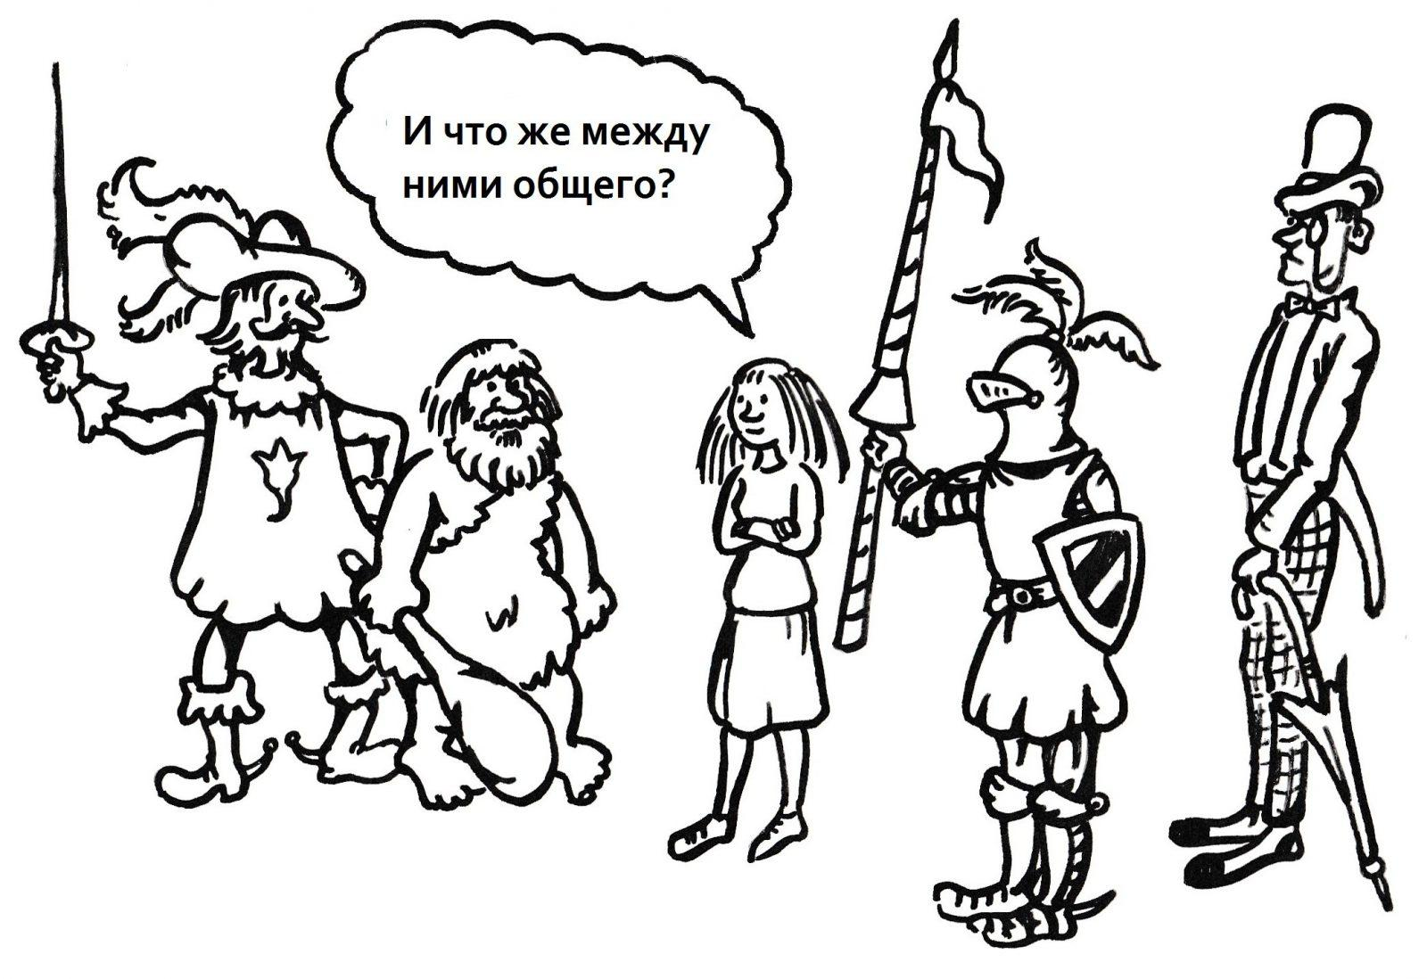
Are there other carriers of thought besides writing, machines and the occasional human being?
Probably. Georgi Petrovich has always been concerned with the question of how collectivities of various kinds support, provide, and reproduce thinking. Because, by and large, attributing the ability to think to individual empirical individuals is an enlightenment project. The Enlighteners, including Condorcet and Turgot, put forward the value hypothesis that the individual empirical individual is capable of carrying thinking. But the twentieth century greatly problematised the fact that a single individual is capable of it.
What is culture in relation to thinking?
Culture is the name for the transmission channels of the normative part, a secondary way of fixing these sign systems, the rules of operating with them, the contents obtained within these sign systems. Let's say your library burned down and you lost a part of humanity's heritage. I don't give this example by accident. If it were not for Alexander the Great and the Arabian thinkers, we would not have seen Aristotle and we would have had to rediscover him. We would have rediscovered him, of course, but who, how and when is unknown.
What is primary: a paradigm shift in thinking, and only after that can we talk about the advent of the next industrial revolution, or is this shift a natural consequence and necessity after the fact?
The diagram is a little bit wrong because you have to take all four ribbons of types of thinking beyond the indicated time period, elements of design and engineering existed before zero ribbon (Leonardo da Vinci, Archimedes), projecting also existed before stage 1 ribbon. It is important that during the mentioned periods they become the dominant forms that encompass, assimilate and incorporate the previous ones. Levels of thinking provide continuity between industrial revolutions: the countries of implementation changed, people naturally changed many times, machinery and machines are already different, the system of division of labour is different. But thinking, on the other hand, has been alive for at least 600 years. And at this level, there is continuity between the industrial revolutions.
What still survives is the geographical landscape; it has gone through several industrial revolutions, but the ways in which humans have developed the landscape are of course also changing dramatically.

