**Basic Techniques in Computer Graphics**

**Assignment 02**

Lei Yan 363032

Sally Chau 370584

Dan Wang 374787

**Exercise 1:**

1. As shown in the picture below, each point on the sphere is determined by two parameters, i.e. angle to the positive Z-axis **($φ$)** and the angle between its projection on X-Y plane and the X-axis **($θ$)**, so we can use these two angles for a parametric representation of the sphere.

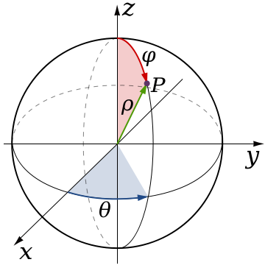

With the center at ***c*** and the radius of ***r***, the formula for this representation is simply derived as:

$$f\left(θ,φ\right)=c+r⋅ {[\begin{matrix}sinφcosθ, sinφsinθ, cosφ \end{matrix}]}^{T}$$

$$θ∈ \left(0,\right.\left.2π\right], φ∈ \left(0,\right.\left.π\right]$$

1. A sphere is a set of points which has the same distance to the center. Thus all the points meet the following equation:

${\left||P-C|\right|}_{2}=r$,

P: Point on Sphere

C: Center of Sphere

r: Radius of Sphere

And this is exactly an implicit representation of the given sphere.

1. It is better to use parametric representation when one is told to find all points on the object, e.g. drawing the object, as all the points on object can be easily specified by a set of parameters with parametric representation. Implicit representation, oppositely, is useful for query tasks (check if a point is on the object), e.g. finding the intersection point between a line and a plane. The reason is that the object is specified with an equation in implicit representation, and query task can easily be done with that equation.

**Exercise 2:**

1. Transformation matrices are as following:

Translation to the origin by (-1.5,-1.5), $T_{1}= \left[\begin{matrix}1 & 0 & -1.5 \\ 0 & 1 & -1.5 \\ 0 & 0 & 1\end{matrix}\right]$

Rotation around origin by ${ 45}^{°}$, anti-clockwise, $R= \left[\begin{matrix}\sqrt{2}/2 & -\sqrt{2}/2 & 0 \\ \sqrt{2}/2 & \sqrt{2}/2 & 0 \\ 0 & 0 & 1\end{matrix}\right]$

Scaling by ($2\sqrt{2}, \sqrt{2})$, $S= \left[\begin{matrix}2\sqrt{2} & 0 & 0 \\ 0 & \sqrt{2} & 0 \\ 0 & 0 & 1\end{matrix}\right]$

Translation by (4, 2), $T_{2}= \left[\begin{matrix}1 & 0 & 4 \\ 0 & 1 & 2 \\ 0 & 0 & 1\end{matrix}\right]$

Final transformation $M= T_{2}⋅S ⋅R⋅ T_{1}= \left[\begin{matrix}2 & -2 & 4 \\ 1 & 1 & -1 \\ 0 & 0 & 1\end{matrix}\right]$

1. As we deal with linear transformation here, the transformation matrix M actually consist of the transformed standard basis. Thus the standard basis $e_{1}= {[1, 0, 0]}^{T}$**(used extended coordinates here!!! also for the rest vectors in this exercise)** and $e_{2}= {[0, 1, 0]}^{T}$ are transformed to $M(e_{1})= {[2, 1, 0]}^{T}$ and $M(e_{2})= {[-2, 1, 0]}^{T}$.

The origin is transformed to $M\left(O\right)= {[4, -1, 1]}^{T}$.