Họ và tên: Trần Long Vũ
MSSV : 22717471
Lab 05 : Docker Compose (Part 2)

Phần 1: Một số lệnh Docker Compose cơ bản
- docker compose version:
- docker compose up:
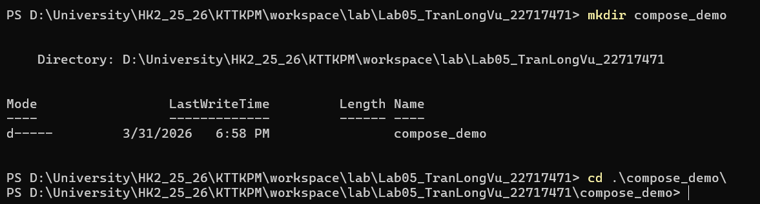
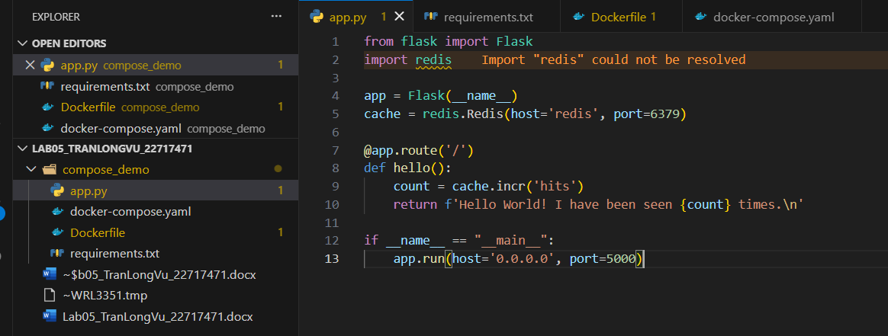
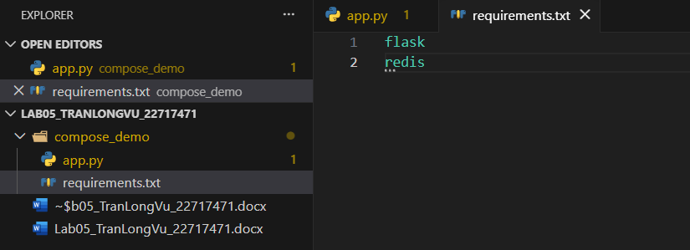
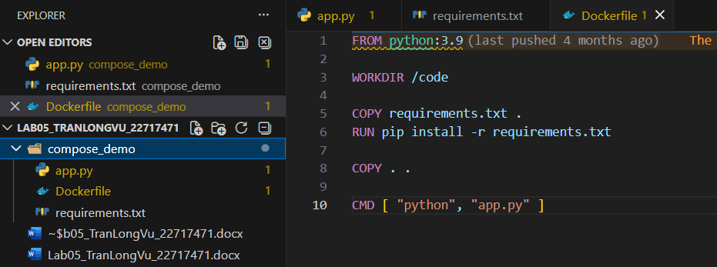
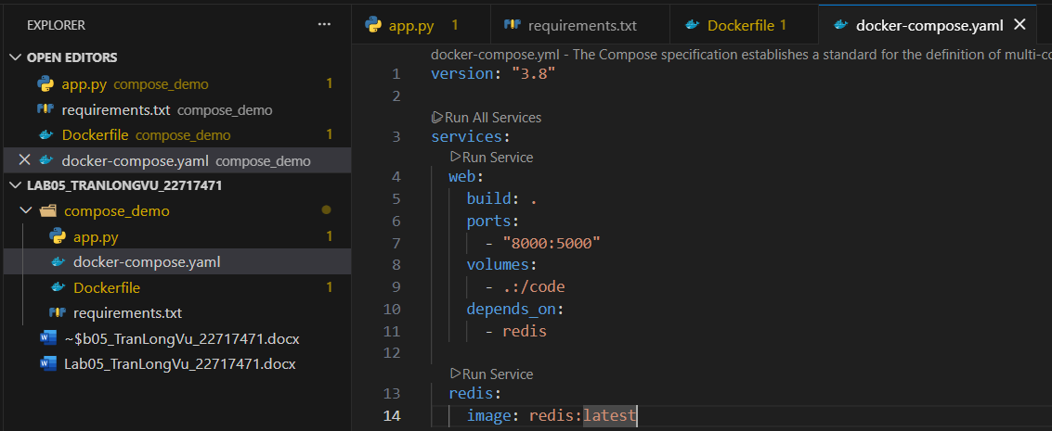
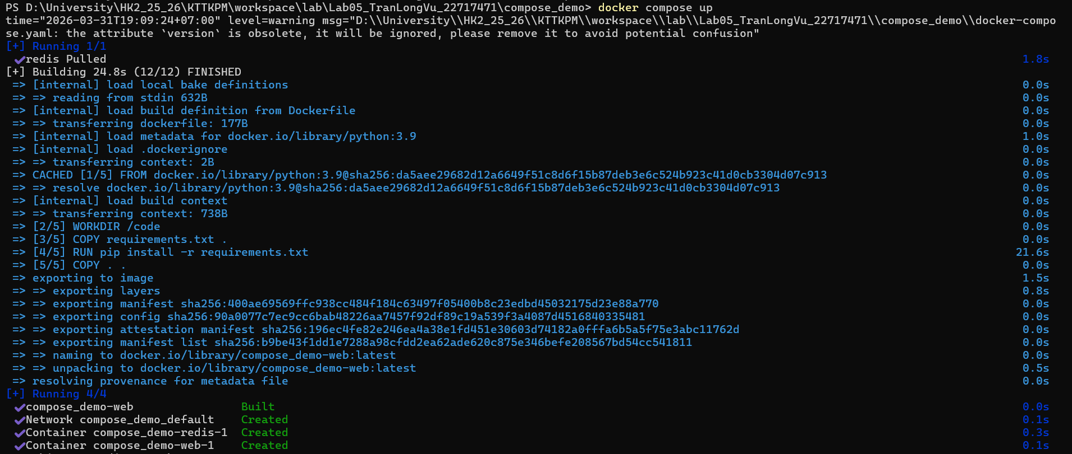

Chạy http://localhost:8000:
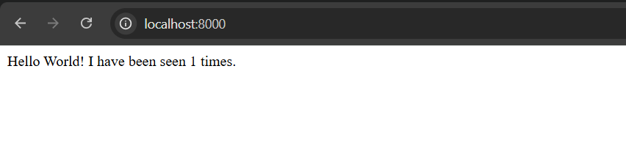
- docker compose up -d:
- docker compose ps:
- docker compose down:
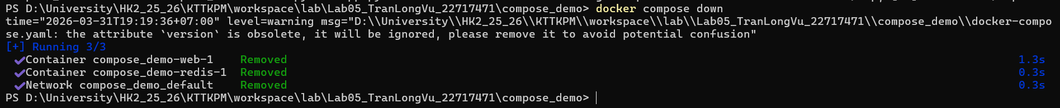

- docker compose restart:
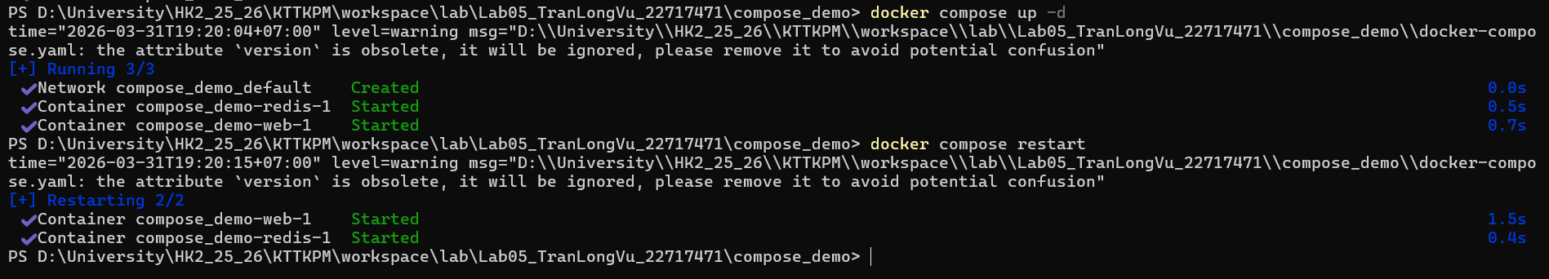
- docker compose logs -f:
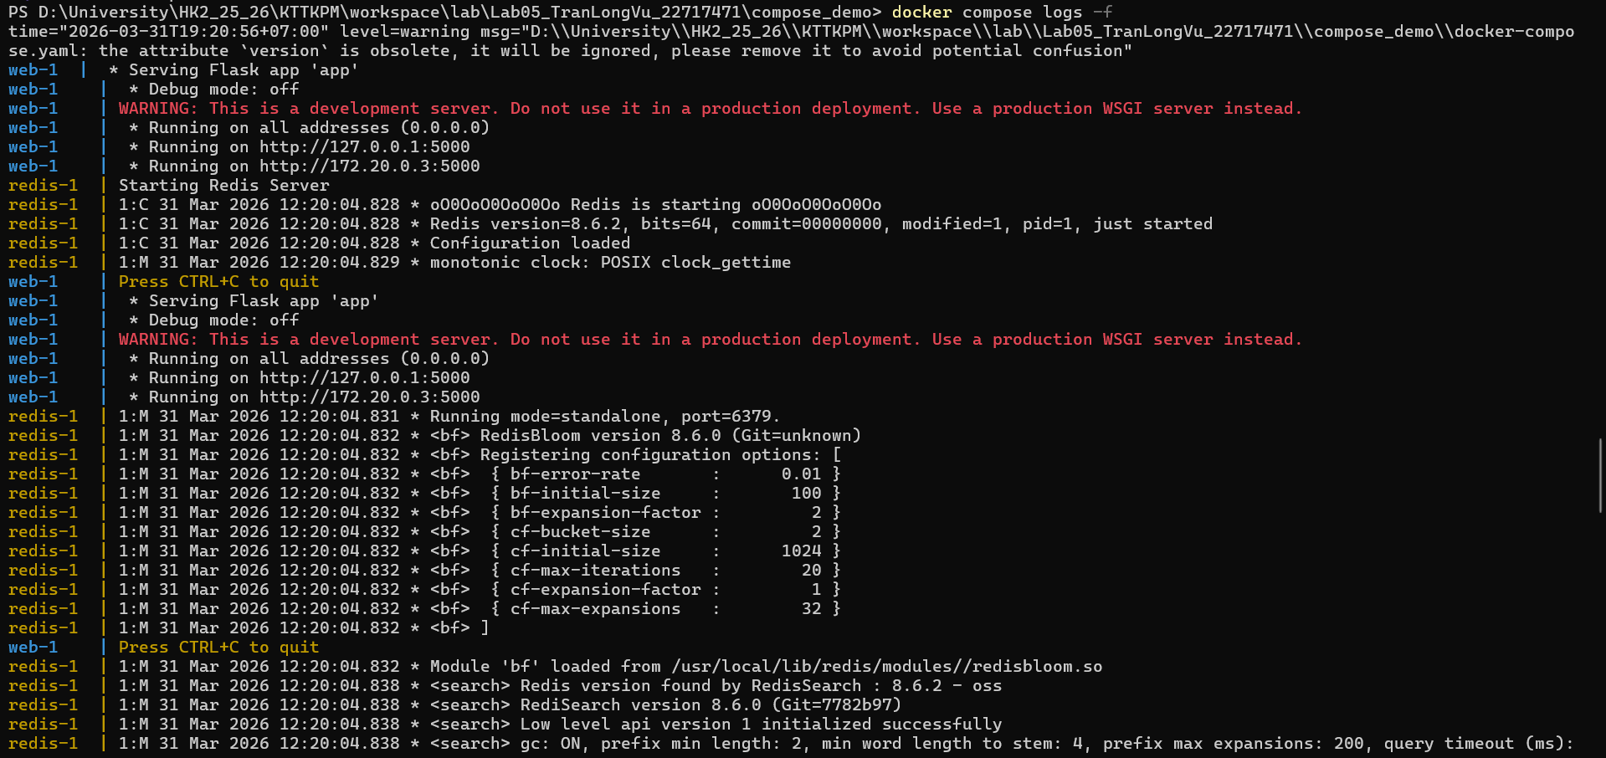
- docker compose build:
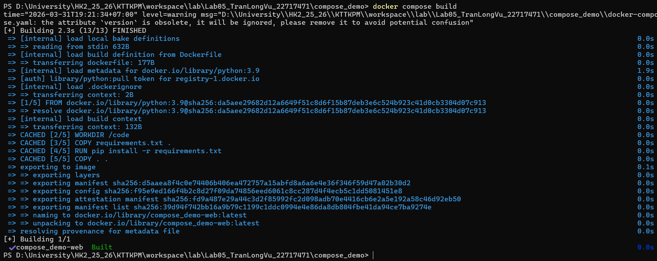
- docker compose exec <service_name> <command>:
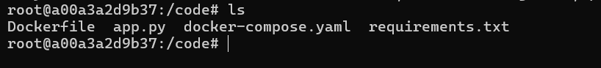
- docker compose down -v:
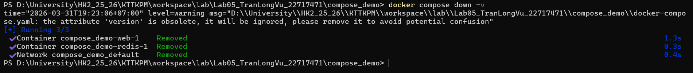
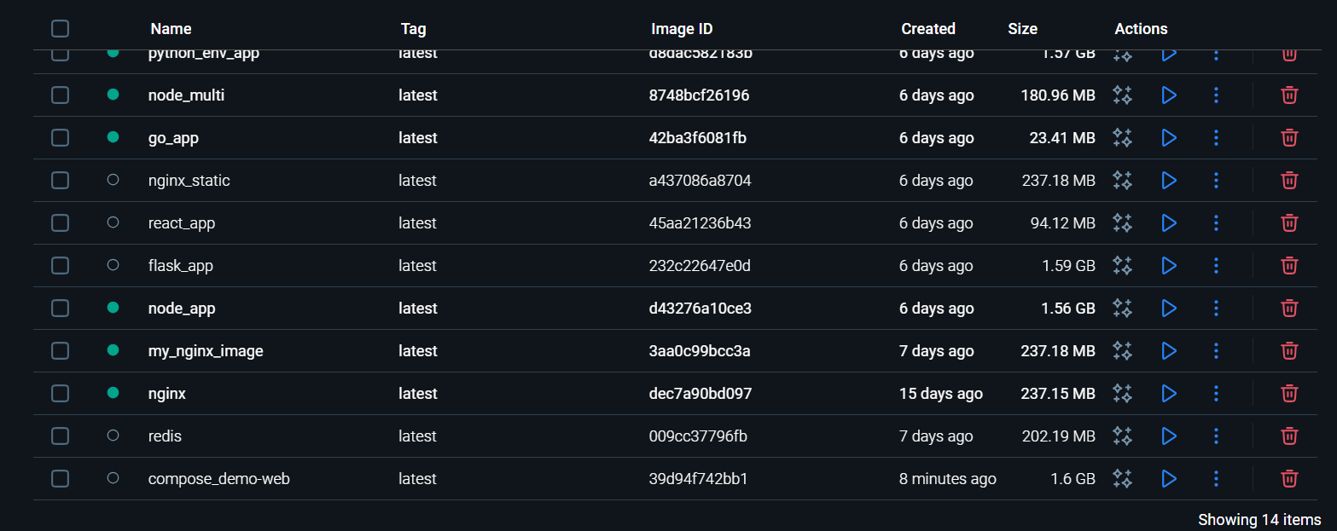
- docker compose run <service_name> <command>:
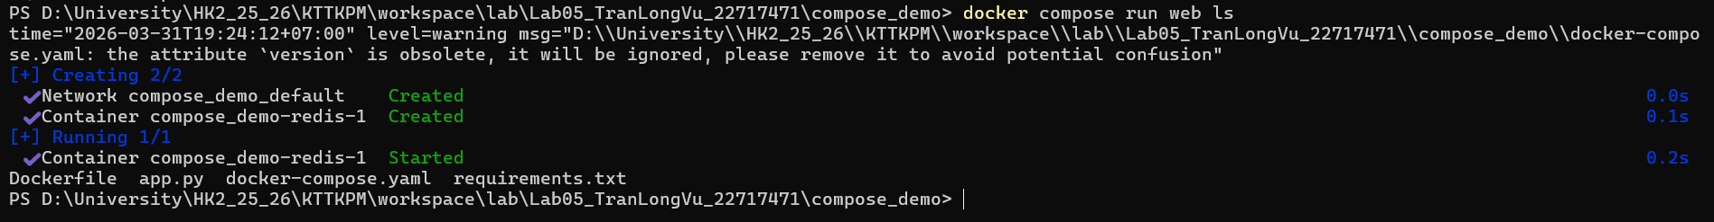
- docker compose stop <service_name>:
- docker compose rm <service_name>:

- docker compose config:
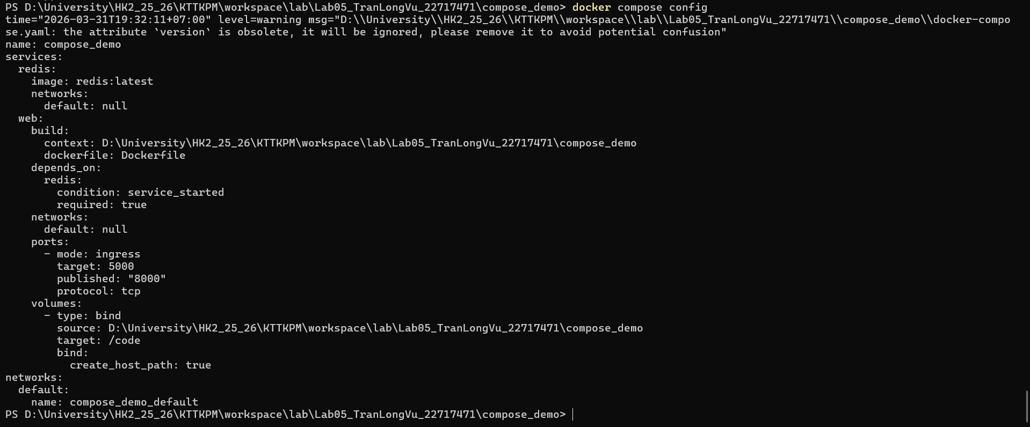
- docker compose up -d --build:
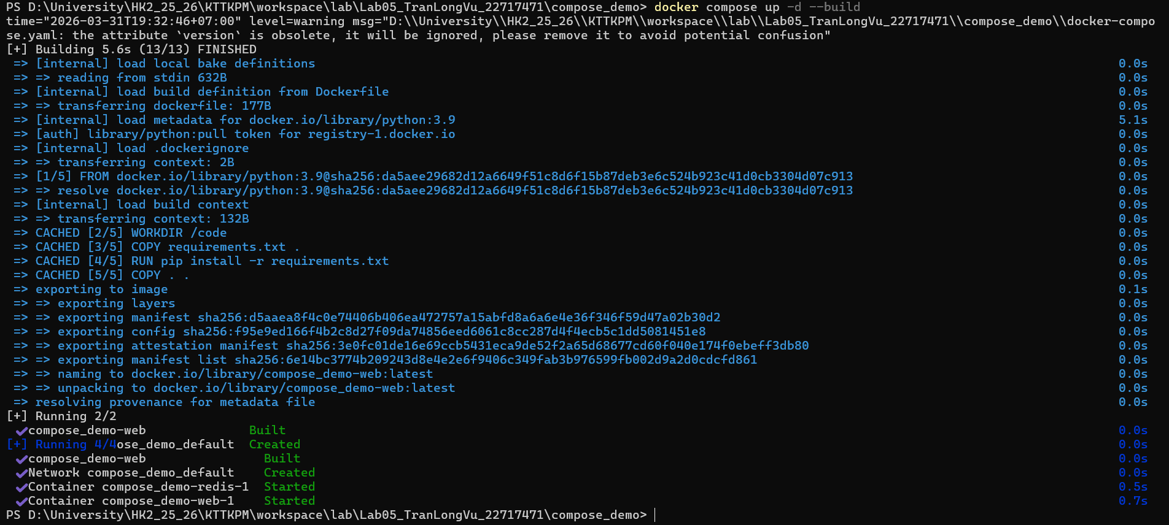

Phần 2: Docker Compose file

Docker Compose file

