⇨
[Document Title]
[Document Subtitle]
Mathew Rowley


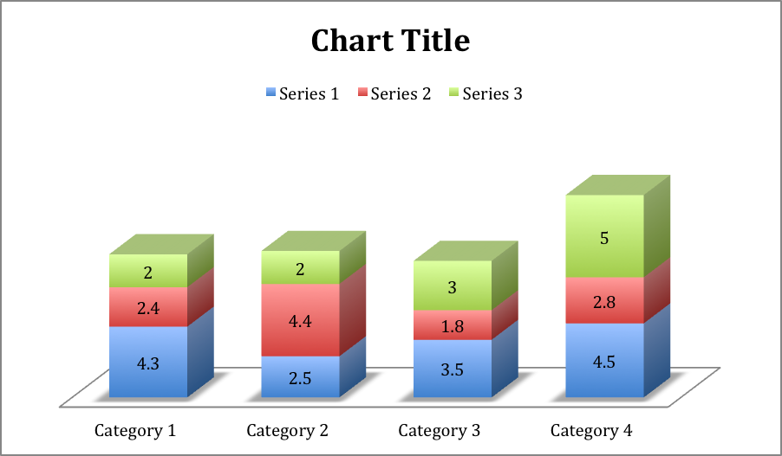

12/11/13
Asdf

12/11/13

asdf

asdf

asdf
asdf
asdf
- sadf
asdf

asdf

