机器学习概述□

http://blog.csdn.net/han_xiaoyang/article/details/50469334

http://blog.csdn.net/han_xiaoyang/article/details/52910022

**特征选择：**

scikit learn的预处理中比较常用的函数

http://scikit-learn.org/stable/modules/preprocessing.html

http://scikit-learn.org/stable/modules/classes.html#modulesklearn.feature_extraction

特征选择 基于模型

http://scikit-learn.org/stable/modules/feature_selection.html

❶ 过滤型

Ø➢ sklearn.feature_selection.SelectKBest

❷ 包裹型

Ø➢ sklearn.feature_selection.RFE

❸ 嵌入型

Ø➢ feature_selection.SelectFromModel

Ø➢ Linear model，L1正则化

**模型选择：**

K折交叉验证（K-fold cross validation）

l http://scikit-learn.org/stable/modules/cross_validation.html

把数据分成几个fold, 每次用其中一个fold

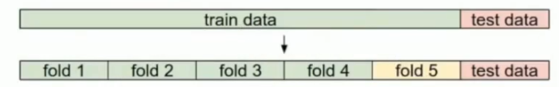

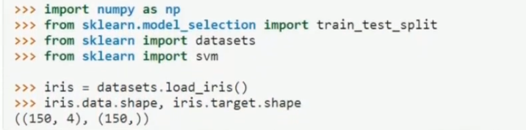

**超参数的选择:**

http://scikit-learn.org/stable/modules/grid_search.html

http://scikit-learn.org/stable/modules/generated/sklearn.model_selection.GridSearchCV.html

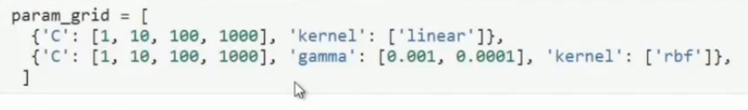

**plot learning curve**:绘制学习曲线

https://www.zybuluo.com/hanxiaoyang/note/545131

**模型集成：model assemble**

bagging / stacking(blending) / adaboost

http://scikit-learn.org/stable/modules/classes.html#module-sklearn.ensemble

**bagging:**

http://scikit-learn.org/stable/modules/generated/sklearn.ensemble.BaggingClassifier.html

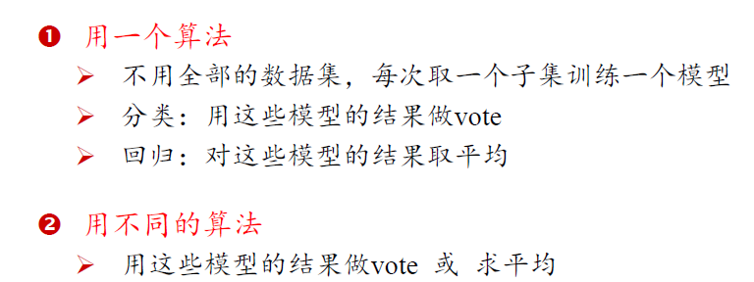

**stacking:**



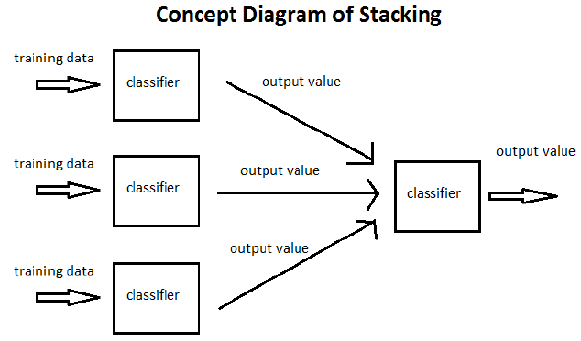

blending:

把 一同模型的输出线性组合