Quick Start for Librarians on the Library App

Perry Wu

10/29/2019

CS 6360.501

**Search based IBSN, Author, or book name**

When you first enter the application, the top bar allows you to choose which functionality to execute.

Click on “Search for a book”, and a prompt will pop up.

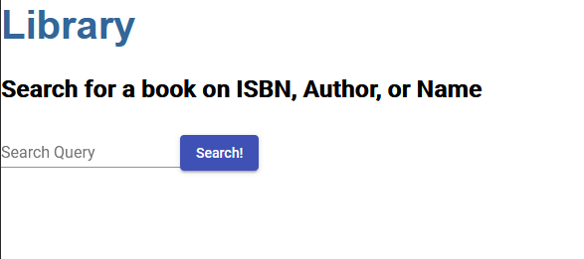

From here, we can search for a book and check in a borrower to the book.

After clicking on the respective “check out” button, you can enter the card number to be used to check out the book. There is validation in place so that one card number cannot check out more than 3 books.

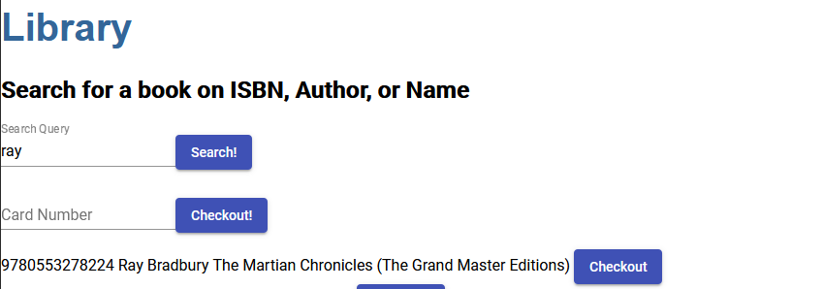

There is similar functionality with checking in a book. Click on the top bar for “Check In a Book”, where we can search for a checked out book.

For example, when search for “mark” we see that “mark morgan” has some books to check out that we can check back in.

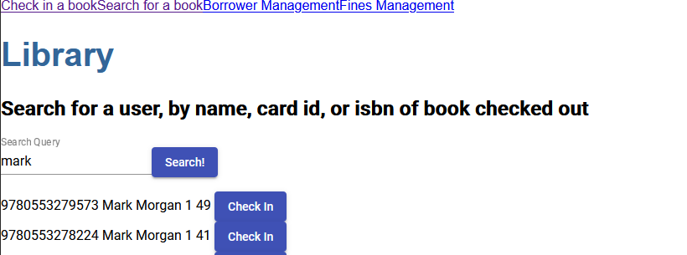

Clicking on the respective check in button allows us to check that book back in.

Borrower management allows us to create a new borrower. All we need to do is fill in the form and a new borrower will be created.

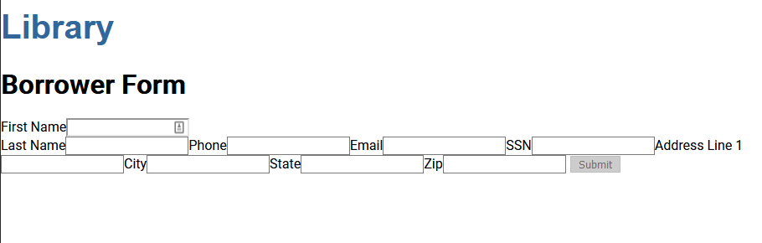

Validation is in place for this, so we must fill out all fields before a request can be submitted.

With fines, we can select a way to get all fines, get unpaid fines only, and update all fines to current amounts.

Clicking on “update fines” will trigger the script to bring all fine amounts up to date. Getting fines will get all fines, paid and unpaid, while “get unpaid fines only” will only get unpaid fines.

Further, given a loan_id, we can mark a fine as paid.

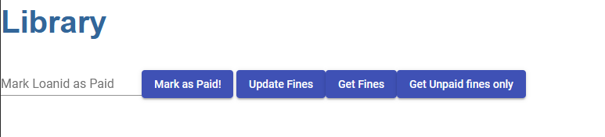

This is all the functionality within the library application. Thanks!