Show your markup knowledge

1. Task 1. Create a login page of [Facebook](https://www.facebook.com/) using html/html5 and css/css3.

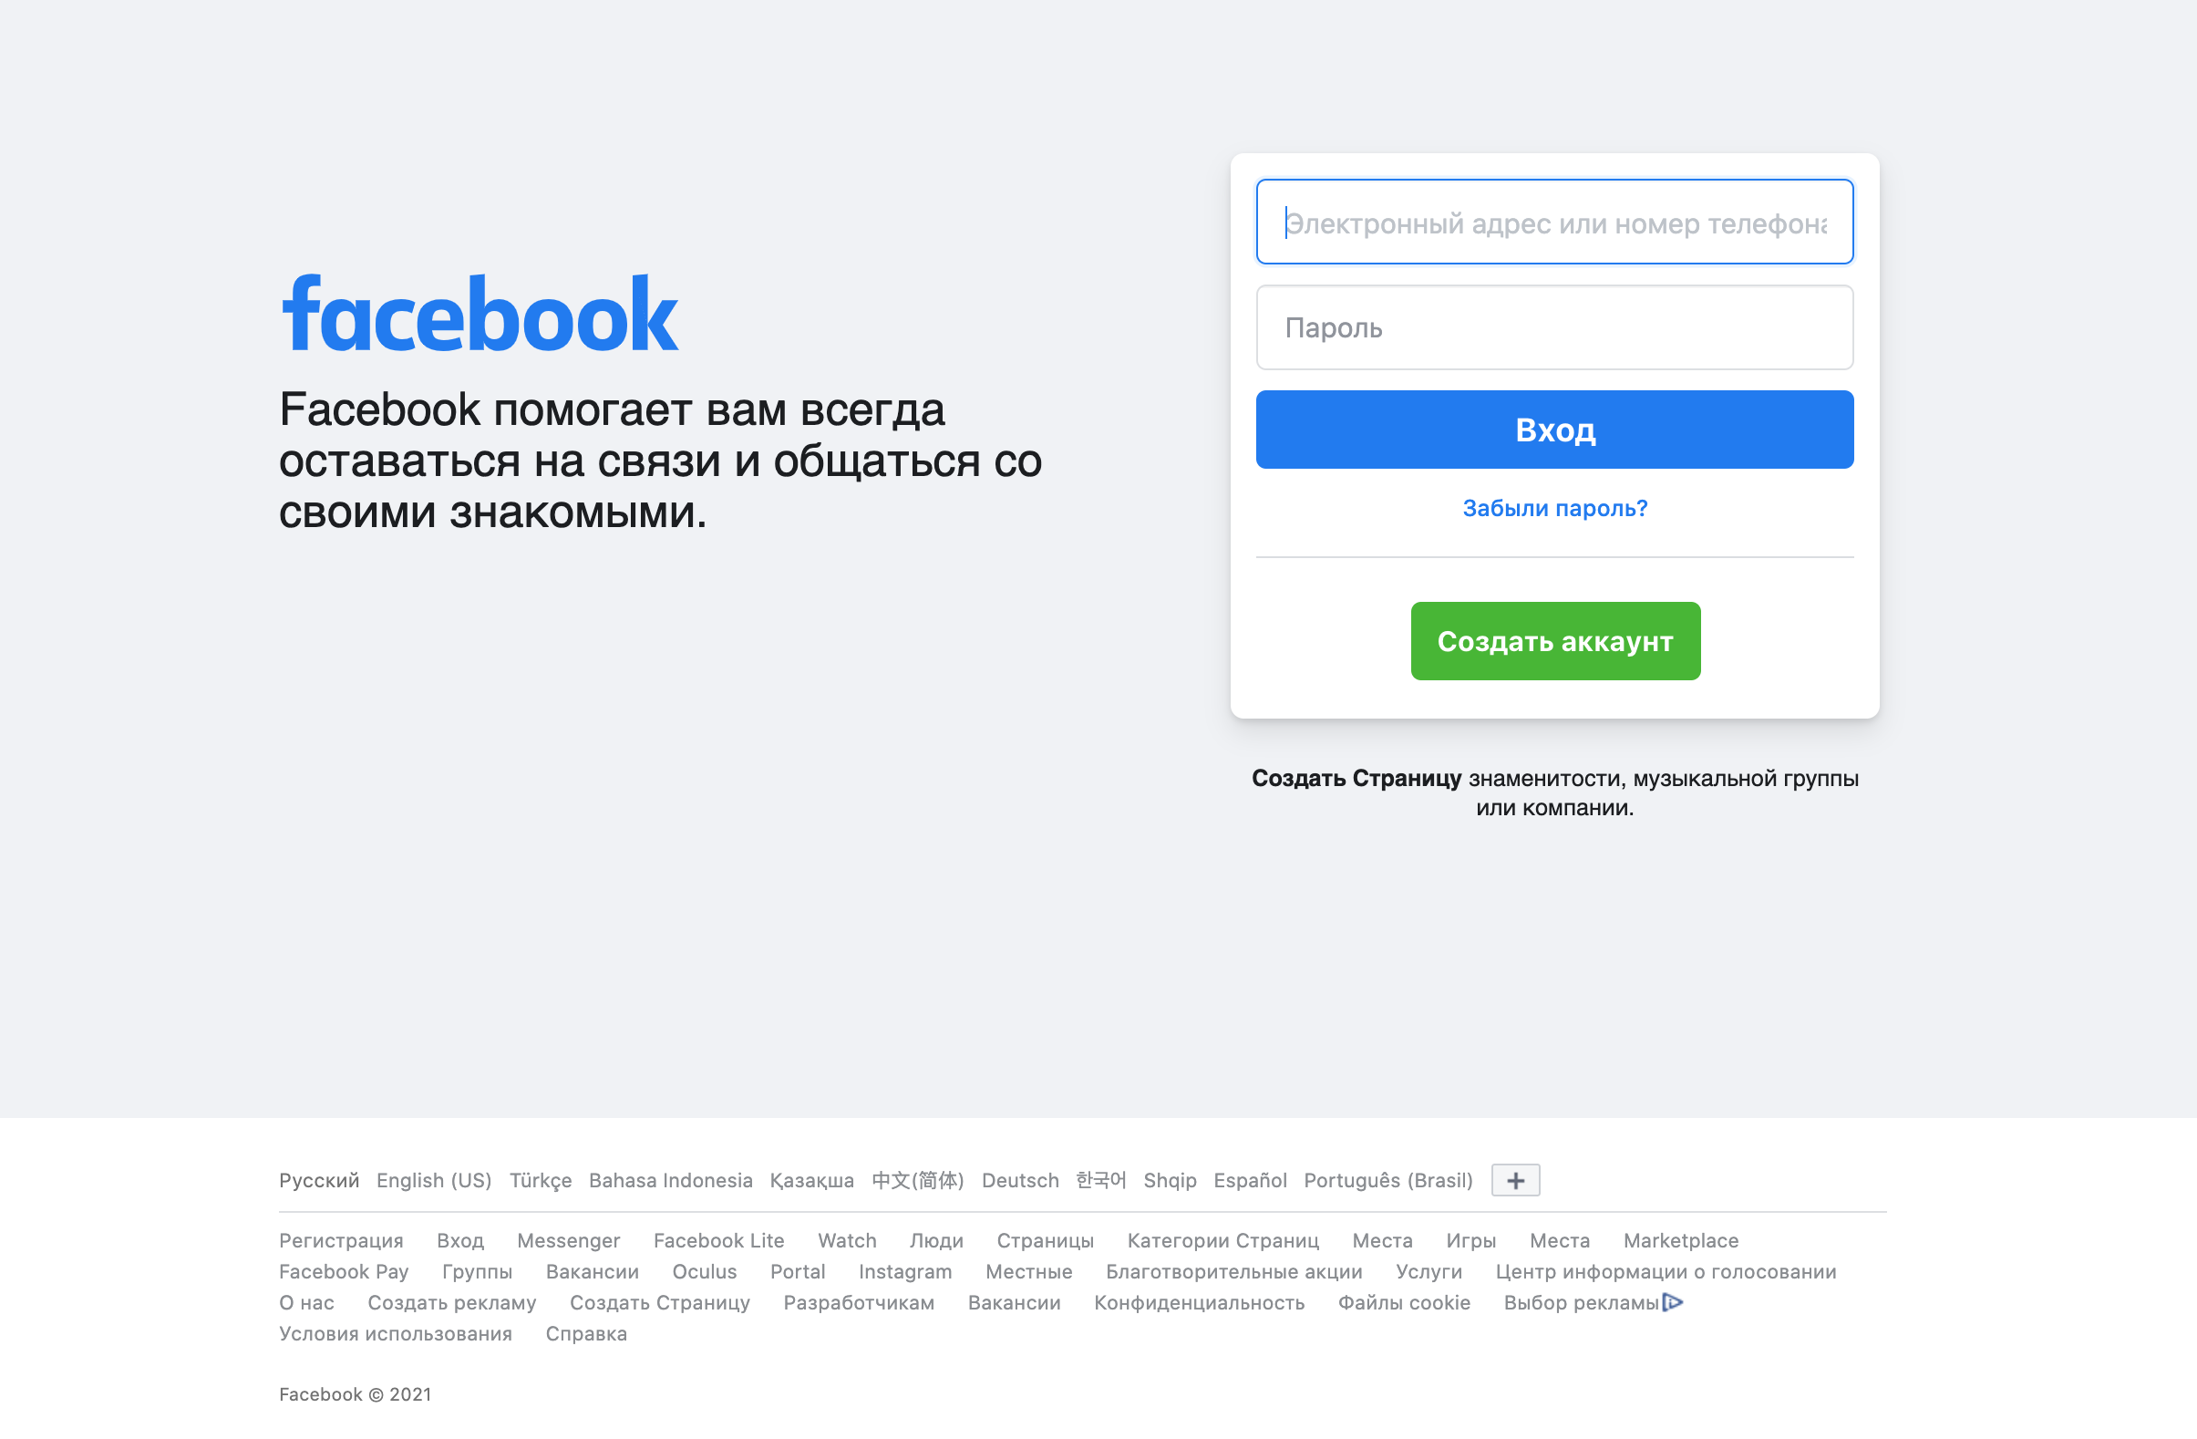

1. Task 2. Create a login page of [Instagram](https://www.instagram.com/) using html/html5 and css/css3.

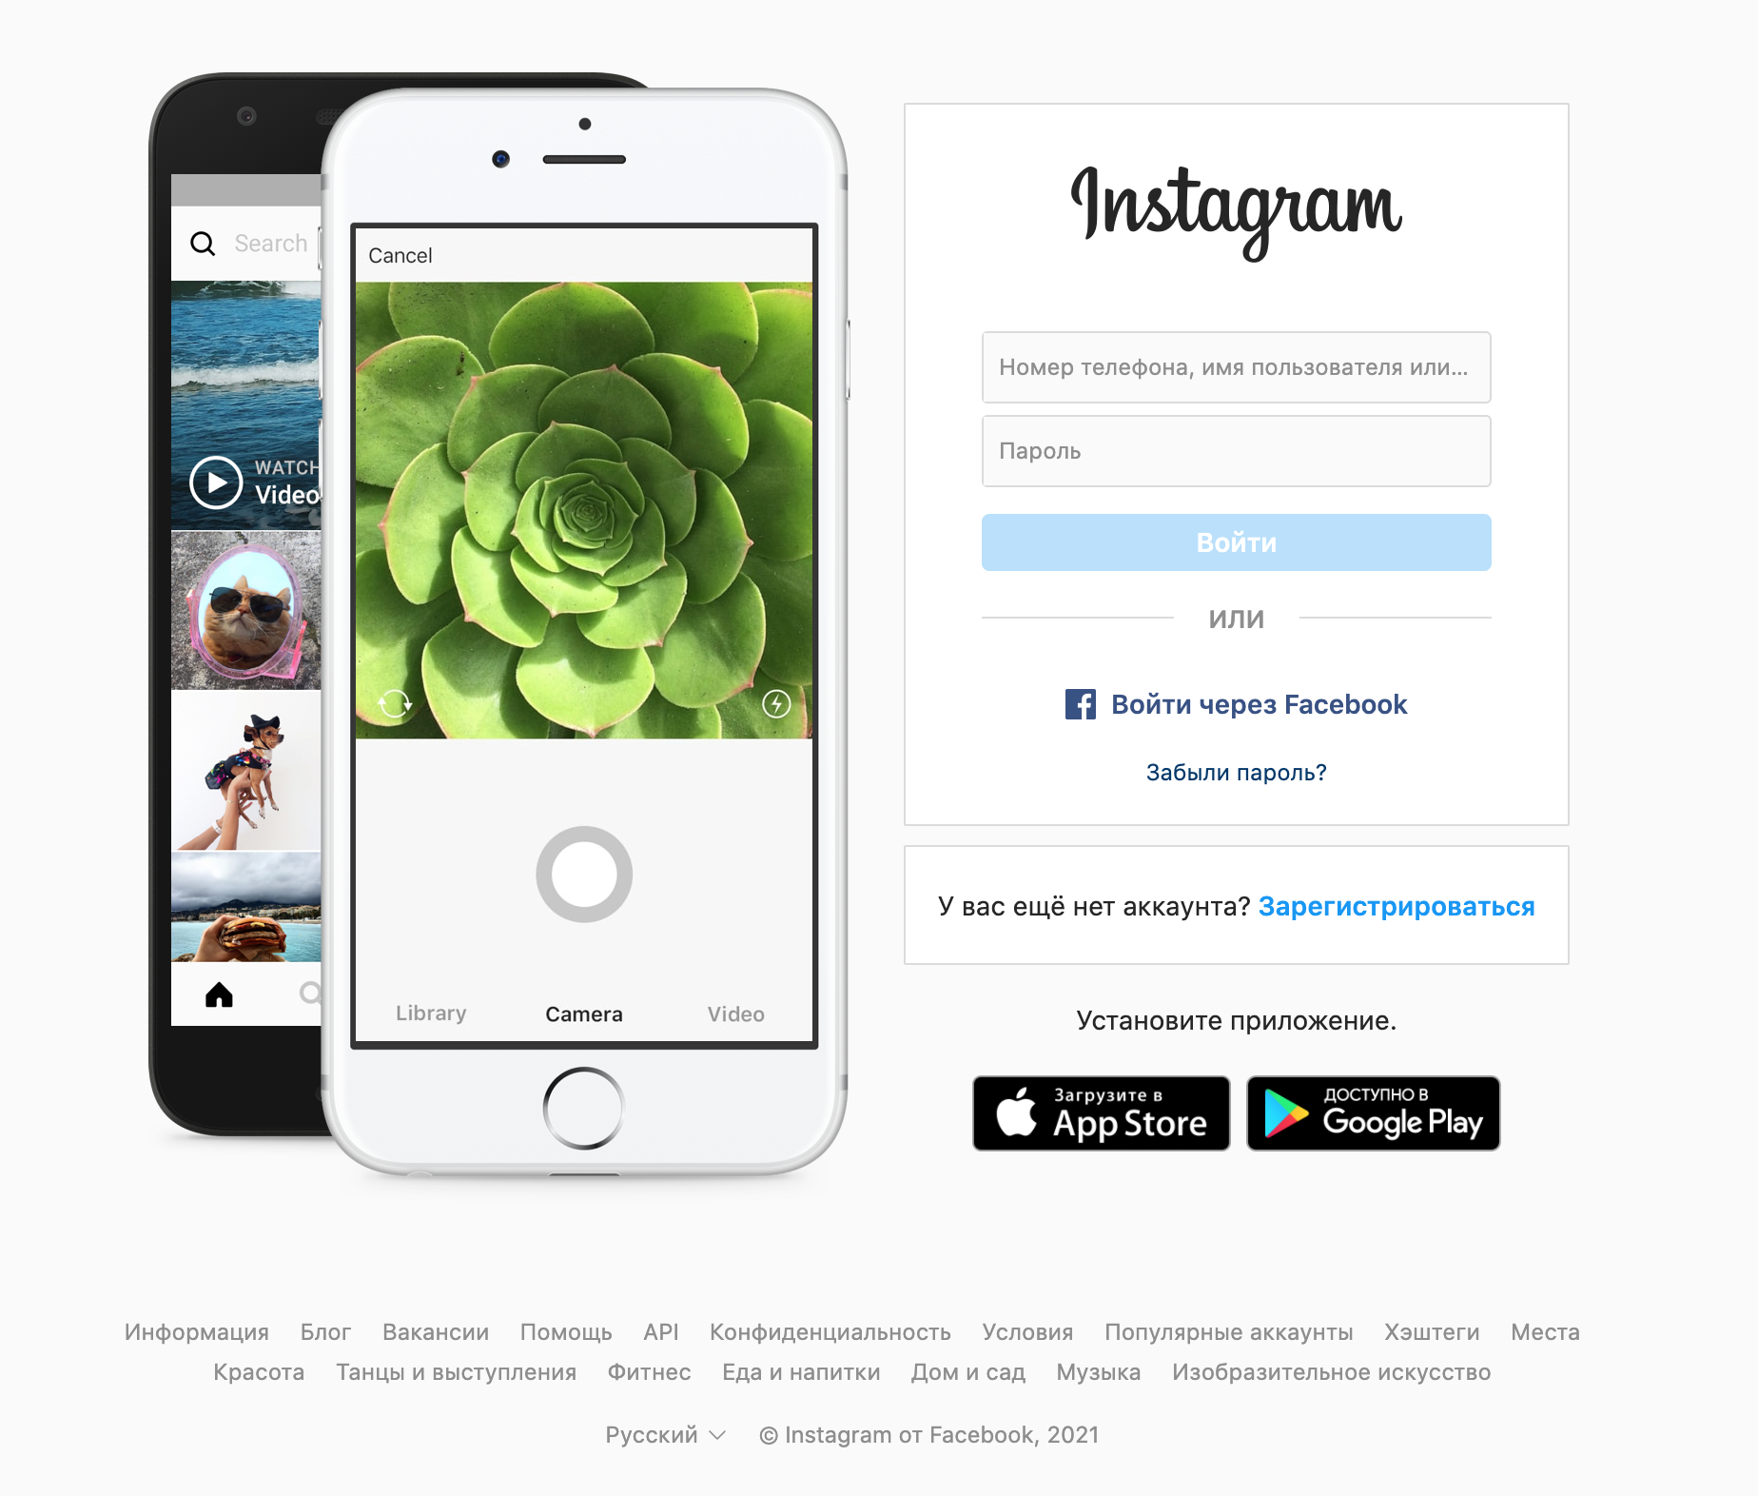

1. Task 3. Create a homepage (blocks in following screen) of [Microsoft](https://microsoft.com/ru-kz) using html/html5 and css/css3.

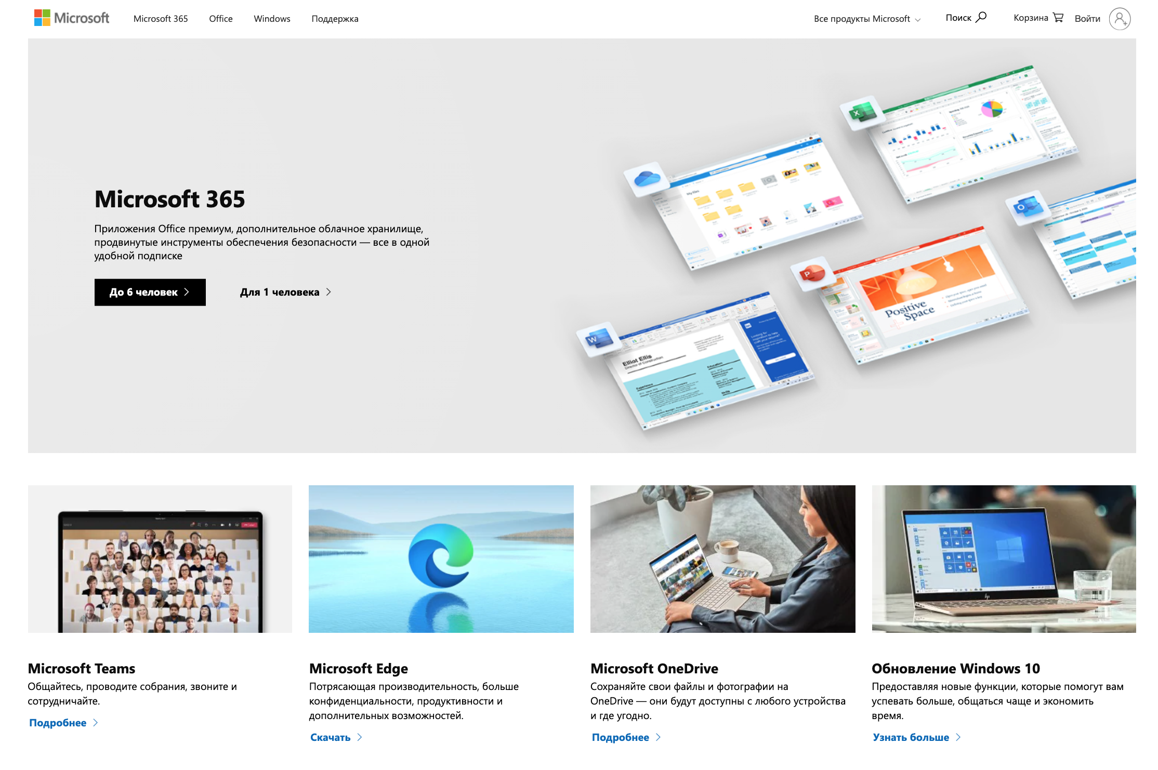

GOOD LUCK :)