Show your knowledge for HTML/CSS/JavaScript

Recommended folder structure in your repo:

* WebDev
  + Lab 3
    - JavaScript Info
    - ToDo app

First task:

1. <https://javascript.info/>
   1. till section **data-types** inclusively
2. Collect all the solutions in one folder and push it to your git repo

Second task:

Create a simple todo list app with all working actions.

* adding new item
* marking as “**done**” (checkbox)
* deleting item

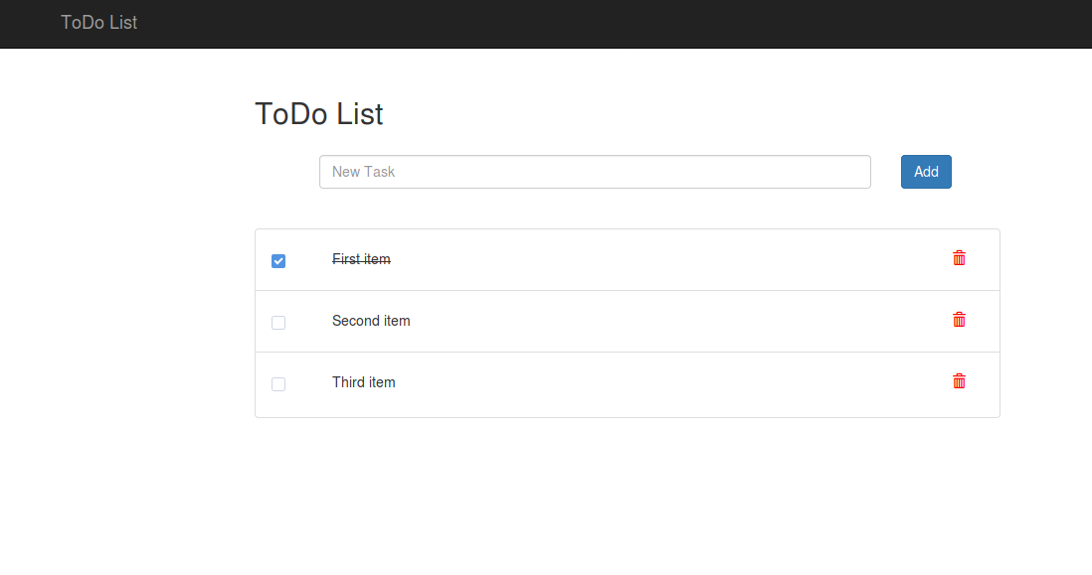

GOOD LUCK :)