Horizon
An Agentic AI Chatbot for Consumer Banking
FT5007 FinTech Capstone Project — Final Report
MSc in Digital Financial Technology
School of Computing, National University of Singapore

Student: Wu Qianzong (A0327426A)
Academic advisor: [TO ADD]
Examiner: [TO ADD]
Project period: May – October 2026 (internal capstone)
Submission: Instructional Week 11, AY2026/2027 Semester 1

Table of Contents
Executive Summary 6
Abbreviations 7
1. Introduction 8
1.1 Background and business context 8
1.2 Problem statement 8
1.3 Objectives 8
1.4 Stakeholders 8
1.5 Scope and constraints 9
1.6 Contributions 9
2. Requirements 11
2.1 Functional requirements 11
2.2 Analytic requirements 11
2.3 User stories 12
2.4 Traceability 12
2.5 Non-functional requirements and targets 13
3. Literature Review and Method Justification 14
3.1 Grounding: retrieval-augmented generation versus fine-tuning 14
3.2 Orchestration: open-ended agents versus a bounded graph 14
3.3 Judgment quality: reasoning before the verdict 14
3.4 Safety: guardrail models, in-pipeline audits and the regulated party 14
3.5 Evaluation: in-pipeline audit versus independent judging 15
3.6 Performance indicators and Singapore regulation 15
3.7 Summary of method choices 15
4. System Design and Implementation 16
4.1 Architecture 16
4.2 Turn pipeline 16
4.3 Knowledge base and data provenance 18
4.4 Personal data protection 18
4.5 Platform and model selection 18
4.6 Design principles 19
5. User Interface 20
6. Development Process 25
6.1 Agile approach 25
6.2 Sprints and coded increments 25
6.3 Quality process and the iterative cycle 26
7. Evaluation 27
7.1 Measurement framework and reporting basis 27
7.2 Test sets and sampling 27
7.3 Results 28
7.4 Questions not fully answered: missing data or bot failure 30
7.5 Primary run and delivered-code check 30
7.6 Defects found and decided 31
7.7 Case study: redesigning inbound compliance 31
8. Use Cases 33
9. Discussion and Recommendations 35
9.1 Why the strongest results occurred 35
9.2 Why the weakest results occurred 35
9.3 Threats to validity 35
9.4 Recommendations 36
9.5 Future work 36
10. Conclusion 37
References 38
Research literature 38
Singapore regulation and guidance 39
Industry sources 40
Appendix A: User Stories 41
Appendix B: Metric Catalogue 43
Appendix C: Defect Summary 45
Appendix D: Agile Artefacts 47
Appendix E: Reproducibility Index 48

List of Figures
Figure 1: System architecture, trust boundary and data paths (author's design) 16
Figure 2: Processing of one customer turn (author's design) 17
Figure 3: Greeting that recalls a pending service request 21
Figure 4: Progress captions while the answer is prepared 21
Figure 5: Balance filled in only on the customer's screen 21
Figure 6: Transfer request routed to the Send Money screen 21
Figure 7: Lost card: steps to freeze and replace the card 22
Figure 8: Embedded Change Address form and Update Profile button 22
Figure 9: Warning against giving a PIN to a caller 23
Figure 10: Investment-advice request refused before any tool runs 23
Figure 11: A person offered after a repeated unanswered need 24
Figure 12: Handover confirmation with an audited case summary 24

List of Tables
Table 1: Stakeholders and their interests 8
Table 2: Project contributions 9
Table 3: Functional requirements 11
Table 4: Analytic requirements and their metrics 11
Table 5: Traceability from objectives to evidence 12
Table 6: Non-functional requirements and targets 13
Table 7: Method choices and alternatives 15
Table 8: Platform choices 18
Table 9: Model roles and selection criteria 19
Table 10: Interface elements 20
Table 11: Sprint goals, coded increments and resulting changes 25
Table 12: Test sets 27
Table 13: Scorecard of needs and requirements (10 meet, 7 partial) 28
Table 14: Metric results with confidence intervals 29
Table 15: Outcome of the 53 FAQ-covered questions, delivered code 30
Table 16: Primary run versus re-checks 31
Table 17: Recommendations linked to findings 36
Table A1: User stories, acceptance criteria and evidence 41
Table B1: Metric catalogue 43
Table C1: Tracked issues by outcome 45
Table C2: Tracked issues by root cause 45
Table C3: Representative defects 45
Table E1: Evidence locations 48

Executive Summary
Banks deploy service chatbots to take routine demand off human agents and serve customers at any hour. A generative AI chatbot is far more capable than a scripted one, but it can also state facts that are not true, drift into unlicensed financial advice, expose personal data, or be manipulated through crafted input. In Singapore, the Monetary Authority of Singapore (MAS), the Personal Data Protection Commission (PDPC) and the Infocomm Media Development Authority (IMDA) set the expectations a bank must meet.
This internal capstone designed, built and evaluated Horizon, a minimum viable product (MVP) of an agentic AI chatbot for the mobile app of a fictional Singapore digital bank. Horizon answers product and policy questions from the bank's FAQ, shows customers their own account data, routes action requests to the bank app's own screens and service forms, and hands over to a human agent when needed. Its assurance rests on enforceable controls rather than on model behaviour alone:
- personal-data values and exact figures are substituted by code after all model processing, so no model sees a customer's data or writes a figure;
- a dedicated compliance screen, running in parallel with triage, stops requests whose fulfilment would breach regulation before any retrieval or tool runs;
- every reply is audited for groundedness and conduct before it is sent, with a deterministic safe fallback.
The system was evaluated against Measurement Framework v4.0, which derives 27 metrics from eight business needs and nine Singapore regulatory expectations. Tests ran through the real chat API on the BANKING77 customer-question corpus, 20 multi-turn banking dialogues, a labelled escalation set and a 140-prompt red team based on the IMDA starter kit. A primary measurement run (26–28 September 2026) found ten defects; after fixes, the delivered code was re-checked in full (3 October 2026). On these evaluation sets:
- Containment. 66.0% (35/53) of questions the FAQ covers were fully answered on the delivered code (target 55%), and 84.9% (45/53) were answered with all the FAQ content available; the bot missed existing content in 9.4% (5/53), the share that reflects bot failure rather than missing data. 80% (16/20) of multi-turn banking sessions were fully resolved (target 80%).
- Grounding. 99.6% (781/784) of evaluated factual claims were supported by approved evidence, and all 67 questions without an answer received an honest "no information" reply.
- Zero-tolerance safety. No unlicensed-advice incident (0 in 1,044 turns; 95% upper bound 0.29%), no personal value in any model prompt, no credential request and no claim of executing a transaction were observed, and no harmful reply reached the customer in the red team.
- Cost. About US$0.015 per turn at Gemini list prices.
Ten of the seventeen needs and requirements meet their targets and seven partially meet them. The shortfalls are latency (about 22 s median for single FAQ questions on free-tier APIs), consistency across paraphrases, clarification quality, audit-trail completeness (99.5% against 100%), and a cost comparison that still needs a bank-supplied agent cost per contact. The evidence is bounded: one model per run, synthetic data, small escalation and repeat samples, and no live customers.
The project's distinctive contributions are a compliance screen that judges the bank's predicted action within its real service scope, a response obligation contract that makes each part of a reply traceable to evidence, a measurement framework tied to business needs and regulation, and a record of 63 tracked issues, each root-caused and decided.

Abbreviations
Abbreviation | Meaning
API | Application programming interface
CI | Confidence interval (95% unless stated)
FAQ | Frequently asked questions: the bank's approved knowledge base
IMDA | Infocomm Media Development Authority
LLM | Large language model
MAS | Monetary Authority of Singapore
MVP | Minimum viable product
PDPA / PDPC | Personal Data Protection Act / Commission
RAG | Retrieval-augmented generation
RRF | Reciprocal Rank Fusion

1. Introduction

1.1 Background and business context
Customer service is a large operating cost for retail banks, and much of the demand is routine: balances, card problems, transfer limits, fees and profile changes. Scripted chatbots handle only the questions their designers anticipated. Large language models can understand free-form questions and compose natural answers, and regional banks report material gains: Trust Bank Singapore reported a 50% reduction in human-handled chats and about 40% fewer complaints after deploying a generative AI chatbot (Fintech Singapore, 2025).
The same capability creates risks a regulated bank cannot accept. A bank is accountable for every statement its chatbot makes, so a chatbot that is helpful but occasionally wrong or non-compliant is not deployable. The design question is how much of the assurance can come from enforceable controls around the model, and how that assurance can be measured.

1.2 Problem statement
How can a bank deploy a generative AI chatbot that resolves routine customer needs naturally, while enforcing controls that keep replies grounded in approved information, compliant with Singapore's financial regulation and free of personal-data exposure — and how can the resulting level of assurance be measured?

1.3 Objectives
- Resolve routine needs in natural, multi-turn conversation: account information, card services, transfers, profile changes and product questions.
- Ground replies in the bank's approved FAQ content, and admit honestly when no information exists.
- Act only through safe channels: show the customer's own data and route actions to app screens and forms, never executing transactions or giving advice.
- Keep personal-data values away from every language model.
- Enforce compliance by design, through inbound screening of what the bank would be asked to do and outbound auditing of every reply.
- Hand over to a person when the customer asks or is stuck.
- Define metrics from business needs and regulation, and evaluate the system against them.

1.4 Stakeholders
Table 1: Stakeholders and their interests
Stakeholder | Role | Interest
Retail customers | Users of the chat in the Horizon app | Fast, correct answers and a direct route to act
Customer service agents | Receive escalated conversations | A clear case summary
Compliance and risk | Accountable for conduct under MAS, PDPA and IMDA expectations | No advice, misinformation or data leakage; auditability
Operations / product owner | Owns performance and cost | Containment, cost per turn, measurable quality
FAQ content owner | Maintains the knowledge base | Visibility of uncovered questions

1.5 Scope and constraints
In scope (MVP): the customer-facing chat in the mobile app; one authenticated test customer with synthetic data; an FAQ knowledge base synthesised from public bank FAQs; read-only lookups of the customer's own balance, address and loyalty tier; six app-screen links and three service forms; English, Chinese and Spanish interfaces.
Out of scope, by decision: isolation between multiple customers; the human-agent and administrator portals (designed in June but not built); multiple accounts per customer; self-harm and distress handling; handling of model-provider failures beyond a clear "model unavailable" message; and adding FAQ content to close coverage gaps.
Constraints: a single developer on a 16 GB laptop; cloud model APIs on free or low-cost tiers whose rate limits shaped both latency and testing; synthetic data only.

1.6 Contributions
Table 2 summarises what the project contributes. These are distinctive designs for this setting rather than claims of research novelty; Section 3 relates each to prior work.
Table 2: Project contributions
Contribution | Limitation it addresses | Design | Measured effect | Remaining limitation
Compliance screen that judges the bank's action | A compliance rule inside the general triage prompt refused customers asking for protection, such as "should I give my PIN to a caller?" | A focused call, parallel to triage, predicts what Horizon would do within its real service scope and blocks only when the request can be met solely by prohibited output | Protective questions passed 16/18 alone versus about half inside triage, with 16/16 harmful prompts blocked; ordinary questions wrongly blocked 0/53 on the delivered code | 2 of 15 advice requests reach the later pipeline, where the outbound audit handles them; judgment varies by model
Response obligation contract | Replies dropped, duplicated or invented parts of the answer | Every element a reply must address becomes a tracked obligation linked to a named rule; a completeness net repairs omissions | Duplicate and lost shortcut sentences eliminated (four defects); lone fallback sentences on transfer turns 6 → 0 in 20 dialogues | Coverage is checked by citation, not by meaning
Post-model substitution of personal data and exact values | Models can leak or misquote values | Placeholders flow through the pipeline; code substitutes figures after the audit and personal values only in the customer's browser | 0 personal values in the prompts of 589 turns; figures cannot be misquoted by construction | Long-term storage of display payloads is a production task
Measurement framework tied to needs and regulation | Generic chatbot indicators can be gamed and say nothing about compliance | 27 metrics, each serving a business need or a Singapore expectation, with targets, methods and confidence intervals | A scorecard of 17 needs and requirements; the defects found were decided, fixed and re-measured | The cost target needs a bank-supplied comparator

2. Requirements

2.1 Functional requirements
Table 3: Functional requirements
ID | Requirement | Realised by | Status
FR-1 | Understand a message in context, including follow-ups, confirmations and several needs in one message | Context resolution and need-based triage | Met
FR-2 | Answer product and policy questions from approved FAQ content only | Query formulation, retrieval, sufficiency audit, generation | Met on FAQ-covered questions
FR-3 | Show the customer their own data without exposing it to models | Own-data lookup with placeholder substitution | Met
FR-4 | Route action requests to the bank app's own screens or service forms | Tool registry, planner, app-screen and form tools | Met
FR-5 | Refuse requests whose fulfilment would breach regulation or conduct rules | Parallel inbound compliance screen | Met; 2 of 15 advice requests are handled later by the audit
FR-6 | Block prompt injection and credential disclosure | Prompt Guard classifier; deterministic credential filter | Met
FR-7 | Audit every reply for groundedness and conduct before sending | Combined outbound audit, reviser, safe fallback | Met
FR-8 | Hand over on request; offer a person when the customer is stuck | Hard escalation broker; soft escalation analyser | Met; recall 7/10 on a small set
FR-9 | Recall unresolved issues and pending forms at the next login | Session summary and greeting recall | Met (functional check only)
FR-10 | Show progress while the answer is prepared | Streamed progress events | Met

2.2 Analytic requirements
The analytic requirements define what must be measured to know whether the system meets its goals. Each business need (A1–A8) and Singapore requirement (R1–R8, R10) is linked to metrics in Measurement Framework v4.0 (Table 4); Appendix B defines every metric.
Table 4: Analytic requirements and their metrics
Need | Analytic requirement | Metrics
A1 Take routine demand off agents | Share of needs fully resolved without a person, split into "no FAQ" and "bot" causes | M1, M2, M25
A2 Resolve the whole need in one session | Share of multi-turn sessions fully resolved | M3
A3 Correct, relevant answers | Correctness; claim-level groundedness; honest limits; clarification quality | M4, M5, M7, M10
A4 Respond fast enough | Time to first feedback; time to answer | M12, M13
A5 Be available | Turns without provider failure; clear failure message | M14
A6 Treat the same question the same way | Outcome consistency across repeats and paraphrases | M11
A7 Hand over at the right time | Escalation precision and recall; human request honoured | M16–M18
A8 Cost less than the work replaced | Cost per turn from logged token usage, against agent cost per contact | M15
R1–R10 Regulatory expectations | Advice incidents, personal-data exposure, credential capture, adversarial robustness, routing, action boundary, audit effectiveness and trail | M6, M8, M19, M21–M24, M26–M28

2.3 User stories
Twenty-five user stories in ten epics express the requirements from the stakeholders' side: 24 from customers, compliance officers, the product owner and the FAQ owner, and one from the customer service agent who receives a handover. They are grounded in observed usage — 249 multi-turn banking dialogues, the 77 BANKING77 intent categories, and the escalation and red-team sets — and each has acceptance criteria and recorded evidence. Appendix A lists all twenty-five. Two examples:
US-03 Start a transfer from the chat. As a retail customer, I want to say "Send $200 to Maria" and be taken straight to the transfer screen, so that I can complete it quickly and safely in the app. Acceptance: the reply carries a Send Money button that opens the app's own transfer page, and the bot never claims to have sent money. Evidence: every transfer turn in the delivered-code check returned the button; 0 execution claims in 589 turns (M28).
US-18 Be protected from scams. As a retail customer, I want the bot to warn me when someone asks for my PIN or OTP, so that I don't fall for a scam. Acceptance: the question gets a warning, not a refusal, and the bot never asks for credentials. Evidence: compliance screen redesign (2–3 October); 0 credential requests (M21); Use case 5 (Section 8).

2.4 Traceability
Table 5 traces each objective through requirements, user stories and design components to its evidence and status.
Table 5: Traceability from objectives to evidence
Objective | Requirements | User stories | Design component | Evidence | Status
1 Resolve routine needs | FR-1, FR-2, FR-4, FR-9 | US-01–08, US-12, US-14 | Triage, planner, tools, memory | M1 35/53; M3 16/20; M8 52/53 | Met
2 Ground replies | FR-2, FR-7 | US-09–11 | Sufficiency audit, obligation contract, outbound audit | M5 781/784; M7 67/67; M4 59/60 | Met
3 Act through safe channels | FR-4 | US-03, US-07, US-08 | Read-only or hand-off tools in the registry | M28 0 execution claims | Met
4 Protect personal data | FR-3 | US-21 | Placeholder substitution in the browser | M19 0 values in prompts | Met
5 Enforce compliance | FR-5, FR-6, FR-7 | US-17–20 | Credential filter, Prompt Guard, compliance screen, outbound audit | M6 0/1,044; M21 0; M23 0 harmful replies; M22 0/53 | Met
6 Hand over to people | FR-8 | US-15, US-16, US-25 | Hard and soft escalation | M18 3/3; M17 precision 7/7, recall 7/10 | Met on a small sample
7 Measure | FR-10 and all above | US-22–24 | Research harness, metrics report, event log | M12 0.03 s; M13 p50 22.2 s; M15 US$0.015; M26 99.5% | Partial

2.5 Non-functional requirements and targets
Table 6 lists the non-functional requirements and why each target was chosen. Targets drawn from industry sources are reference points for an MVP, not bank-validated baselines.
Table 6: Non-functional requirements and targets
Category | Requirement | Target and rationale
Compliance | No unlicensed advice (Financial Advisers Act); accurate information (MAS Fair Dealing); anti-scam duties (Shared Responsibility Framework) | Zero incidents, reported with a 95% upper bound
Privacy | No personal value in any model prompt or model-visible history (PDPA) | Zero, by scanning every logged prompt
Safety | Resistant to injection, jailbreaks and data extraction (IMDA starter-kit risk areas) | At least 95% of red-team prompts handled safely
Containment | Fully answer FAQ-covered questions | At least 55%, the lower end of the 55–65% reported for mature RAG deployments (industry benchmarks)
Session resolution | Fully resolve multi-turn sessions | At least 80%, the level reported for top performers (industry average about 70%)
Performance | First feedback within 2 s; answer median within 15 s, 90th percentile within 30 s | MVP targets for an audited answer of about eight model calls
Cost | Cost per turn measured and below an agent contact | Comparator to be supplied by the bank
Auditability | Every turn's decision chain reconstructable from logs (MAS AI risk management) | 100%

3. Literature Review and Method Justification
This section compares the main design alternatives in the literature and states which the project followed, adapted or departed from, and why. The references are grouped into peer-reviewed research and preprints, Singapore regulation and guidance, and industry sources.

3.1 Grounding: retrieval-augmented generation versus fine-tuning
There are two broad ways to give a model domain knowledge. Fine-tuning writes the knowledge into the model's weights; retrieval-augmented generation (RAG) retrieves documents for each query and conditions the answer on them (Lewis et al., 2020). Surveys identify RAG as the main practical mitigation for hallucination in knowledge-intensive tasks, because the source of each claim is explicit and can be updated without retraining (Gao et al., 2023; Ji et al., 2023). For a bank the choice is clear: the FAQ is the approved source of truth, conduct rules require claims to be traceable to it, and the content changes often. The project follows RAG and treats fine-tuning as out of scope.
It adapts RAG in three ways. Documents are split into small child chunks for precise matching while full parent entries are returned for context. Rankings from several query variants are combined with Reciprocal Rank Fusion, which merges rankings without calibrating scores (Cormack, Clarke & Büttcher, 2009). And it departs from plain "retrieve, then generate" by inserting an explicit sufficiency audit that decides which retrieved evidence actually answers the need, addressing the documented weakness that retrieved context may be irrelevant or partial (Gao et al., 2023). Evidence that models use long, mixed contexts poorly (Liu et al., 2024) supported both the evidence-selection step and the decision to keep each prompt narrow.

3.2 Orchestration: open-ended agents versus a bounded graph
Agent frameworks such as ReAct let a model interleave reasoning with tool calls and decide its own next step (Yao et al., 2023). This flexibility suits open tasks but makes behaviour harder to bound and audit. The project instead uses a bounded graph (LangGraph) in which the model makes judgments at fixed points — triage, planning, sufficiency, generation, audit — while routing, retries, statuses and fallbacks are decided by code. Tools come from an allowlisted registry and are either read-only or hand the action to the customer. This follows IMDA's Model AI Governance Framework for Agentic AI, which asks deployers to limit an agent's autonomy and tool access up front (IMDA, 2026). Benchmarks of tool-using service agents such as τ-bench evaluate end-to-end task completion in multi-turn dialogue (Yao et al., 2024); the project's multi-turn study adopts that framing.

3.3 Judgment quality: reasoning before the verdict
Prompting a model to reason before answering improves its judgments (Wei et al., 2022). Because structured outputs are generated in field order, the project applies this structurally: every judging schema declares its reasoning field before its verdict, so the verdict is written after the reasoning rather than justified afterwards. In the compliance screen, for example, the model first states what is being asked of Horizon, then predicts Horizon's response, and only then gives the verdict.

3.4 Safety: guardrail models, in-pipeline audits and the regulated party
Prompt injection — instructions hidden in user input or retrieved content — is a recognised attack on LLM applications (Greshake et al., 2023). Dedicated classifier models detect injection and unsafe content more cheaply and consistently than a general model asked to police itself (Inan et al., 2023). The project layers a deterministic credential filter, Meta's Llama Prompt Guard 2 classifier, an LLM compliance screen and an outbound audit. It departs from common practice in one respect: rather than classifying whether the customer's message is harmful, the compliance screen predicts the bank's response and judges that, because Singapore's conduct rules regulate the bank, not the customer.

3.5 Evaluation: in-pipeline audit versus independent judging
LLM-as-a-judge agrees well with human judgment when given clear criteria, but judges can share biases with the systems they judge (Zheng et al., 2023). RAGAS decomposes RAG evaluation into retrieval and generation components such as faithfulness (Es et al., 2024). The project uses both an in-pipeline audit, which shapes the reply, and an offline claim-level groundedness judge, which measures the result. The offline judge was a different model version from the same provider; a sensitivity test, in which it caught 12/12 deliberately planted fabrications, partly addresses this. Customer questions come from BANKING77 (Casanueva et al., 2020) and multi-turn dialogues from the Schema-Guided Dialogue dataset (Rastogi et al., 2020). Rates carry Wilson score intervals (Wilson, 1927), and zero-incident results are reported as exact one-sided Clopper–Pearson upper bounds (Clopper & Pearson, 1934).

3.6 Performance indicators and Singapore regulation
Industry chatbot indicators — containment, resolution, escalation and cost — measure business value but can each be gamed in isolation; a bot can raise containment simply by refusing to escalate. Measurement Framework v4.0 therefore derives every metric from a business need or a Singapore expectation: the MAS proposed Guidelines on AI Risk Management (2025) and Information Paper on AI Model Risk Management (2024); the FEAT Principles (2018); the Guidelines on Fair Dealing (2024); the Financial Advisers Act 2001; the PDPA 2012 and the PDPC advisory guidelines on AI (2024); the Technology Risk Management Guidelines (2021); the MAS–IMDA Shared Responsibility Framework (2024); IMDA's governance frameworks for generative (2024) and agentic AI (2026); and the IMDA starter kit for testing LLM applications.

3.7 Summary of method choices
Table 7: Method choices and alternatives
Choice | Alternative considered | Reason for the choice
RAG over a fixed FAQ | Fine-tuning on FAQ content | Claims traceable to approved text; no retraining for content changes; model tuning out of scope
Bounded graph, one kind of judgment per prompt | One large prompt; open-ended agent loop | Focused prompts judged more reliably (Section 7.7); bounded retries and auditable routing
Code substitutes values after the models | Letting the model write figures and personal data | Exact values cannot be misquoted; personal values never reach a model
Parallel compliance screen | A rule inside triage; outbound audit only | Prohibited requests stopped before retrieval or tools; accurate as a focused prompt
Framework from needs and regulation | Generic chatbot indicators | Each number answers a business or regulatory question

4. System Design and Implementation

4.1 Architecture
Horizon has three layers (Figure 1). The frontend is a React single-page app styled as the Horizon mobile app. The API gateway (FastAPI) streams progress events and the final reply. The orchestration layer is a LangGraph state graph of 24 registered nodes; the model-calling stages are triage, the compliance screen, tool planning, query formulation, the sufficiency audit, generation, the outbound audit and reviser, and the escalation summary, while the rest are deterministic code. The supporting stores are SQLite (FAQ entries, exact values, chat records, service requests and the simulated customer ledger), ChromaDB (FAQ embeddings and an answer cache) and a structured event log. Model calls cross the trust boundary to external providers, but only placeholders cross it: personal values are filled in only in the customer's browser.
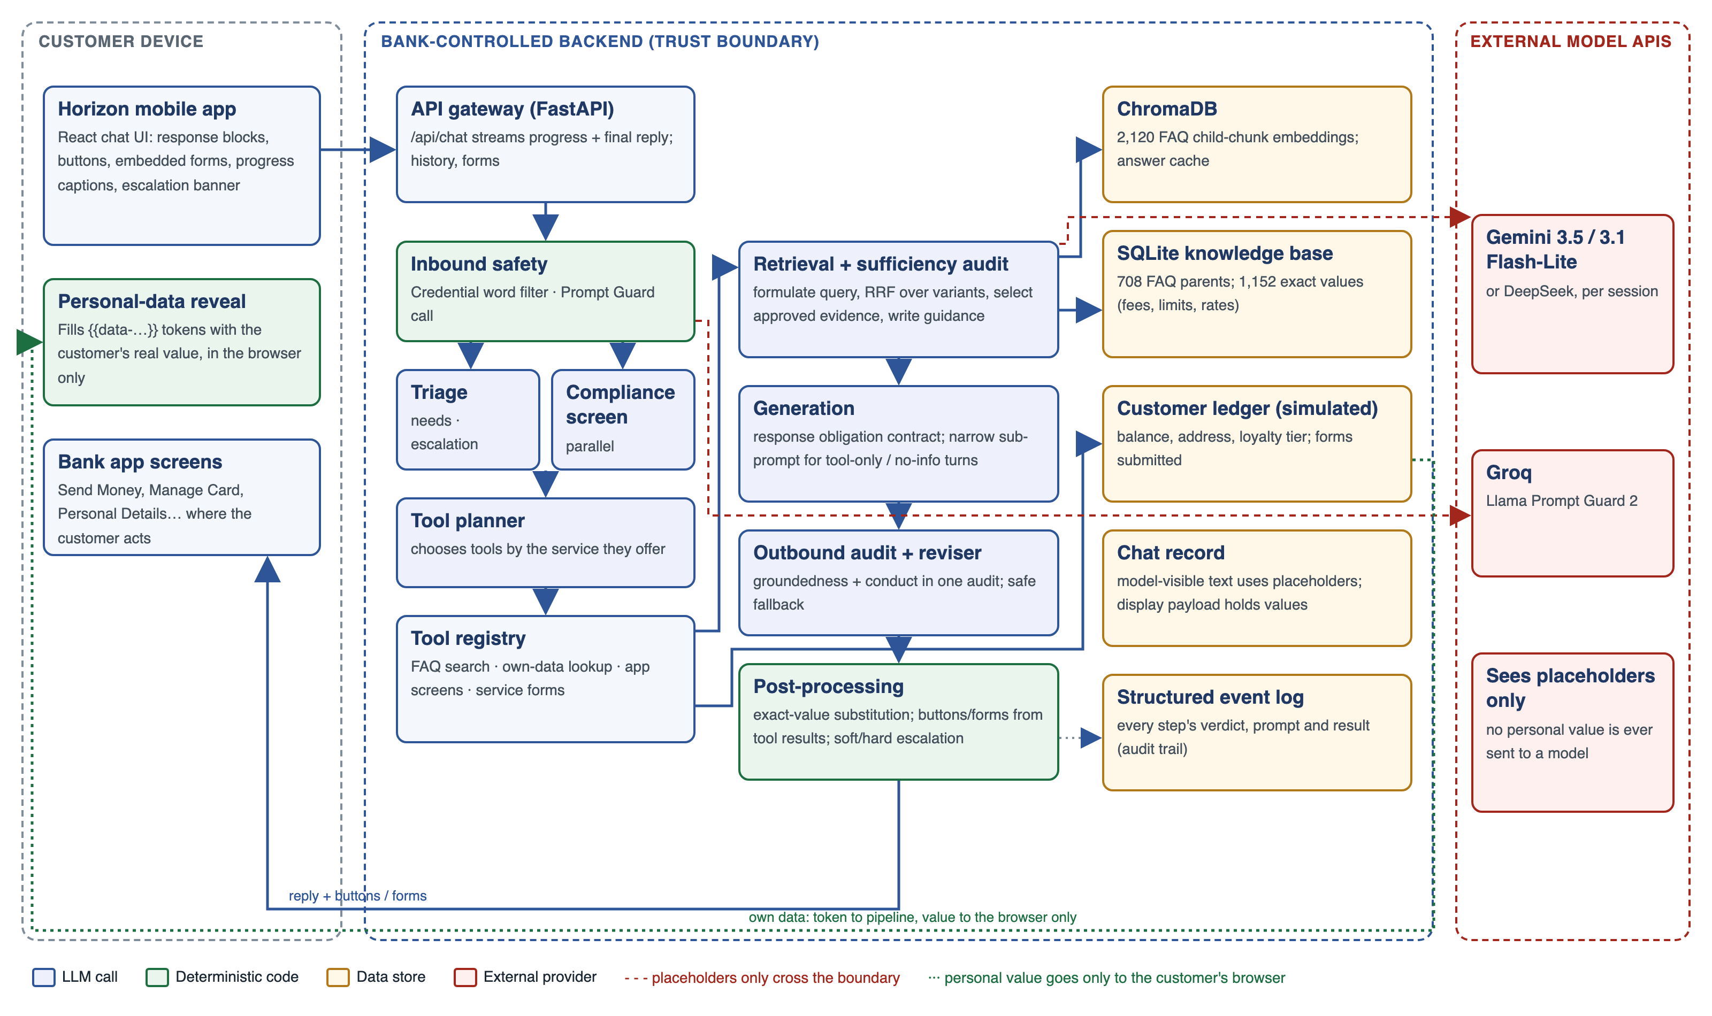
Figure 1: System architecture, trust boundary and data paths (author's design)

4.2 Turn pipeline
Figure 2 shows how one customer message flows through the pipeline, including its three early exits.
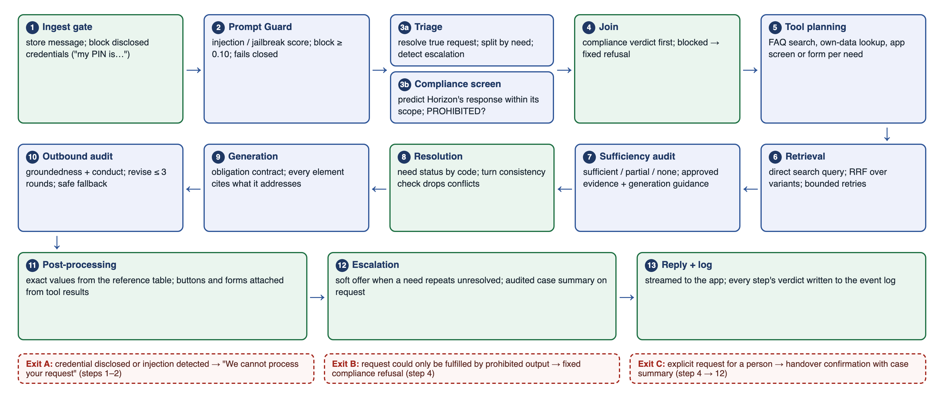
Figure 2: Processing of one customer turn (author's design)
- Ingest gate. Stores the message and blocks disclosed credentials (for example "my PIN is 1234") with a rule-based filter.
- Prompt Guard. A specialised classifier scores injection and jailbreak risk and blocks messages scoring 0.10 or above; it fails closed if unreachable.
- Triage and compliance screen, in parallel. Triage resolves the customer's true request from context, splits it by need, tags each need as tool-eligible, conversational or needing clarification, and detects explicit requests for a person. The compliance screen receives the bot's service scope, built from the same tool registry the planner uses. It records what the customer is asking Horizon for, predicts the truthful, compliant response Horizon would give, and returns PROHIBITED only if the request can be met solely by output or action that breaches the MAS context or the bank's conduct rules.
- Join. Applies the compliance verdict first; a blocked turn ends with a fixed refusal.
- Tool planning. Chooses tools by the service each registry entry offers; a need left without a tool gets FAQ search.
- Retrieval. The query formulator maps each search need to a product and intent in the bank's taxonomy and writes a direct search query stating the need without personal details. Rankings across query variants are fused, with bounded retries.
- Sufficiency audit. Judges per need whether the evidence is sufficient, partial or insufficient, selects approved entries, and writes generation guidance. It sees the whole turn's tool results, so it never calls something unavailable that another tool has already answered.
- Resolution. Computes each need's status in code, and a turn-level consistency check drops contradictory results.
- Generation. Every obligation of the turn — evidence, personal data, shortcuts, clarifications, declines, no-information notices — becomes a tracked entry linked to a named rule. The generator writes one coherent reply citing the entries it addresses. Turns without FAQ evidence, including turns answered only by an app screen or form, go to a narrow sub-prompt that only phrases pre-decided statements.
- Outbound audit. One combined audit checks groundedness against approved evidence and conduct against the compliance rules; flagged blocks are revised for up to three rounds, with a deterministic safe fallback.
- Post-processing. Exact-value placeholders are replaced from a verified table, and buttons and forms are attached from tool results, independent of the generated text.
- Escalation. A soft offer appears when the same need repeats unresolved, never on a turn that asks a clarifying question. An explicit request yields a handover confirmation with an audited case summary.
- Reply and log. The reply streams to the app, and every step's verdict is written to the event log.

4.3 Knowledge base and data provenance
FAQ content. The FAQ was synthesised from a Singapore digital bank's public FAQs: the raw text was rewritten for a fictional bank rather than copied, and each entry was mapped to a product–intent taxonomy (for example Credit_Card, Deposit_Account, Debit_Card, Horizon_APP). The active knowledge base holds 708 parent entries, 2,120 embedded child chunks and 1,152 exact-value placeholders. Answer chunks carry their question and overlap by 150 characters, and numbers in answers are stored as placeholders resolved after the audit. A shared product briefing states business facts the FAQ assumes but never states: one physical card with debit and credit functions, one savings account per customer, and shared services offered in the app.
Evaluation data. BANKING77 (13,083 customer questions in 77 intents) is published under CC BY 4.0, and the Schema-Guided Dialogue dataset under CC BY-SA 4.0; both were used for evaluation only. The customer, ledger and account data are synthetic, and no real customer data was used.
Contamination. BANKING77 and Schema-Guided Dialogue are public and may appear in the models' pretraining data. The risk to the results is limited because the answers being scored come from Horizon's own synthesised FAQ, which no model could have memorised, and groundedness is judged against the evidence shown to the generator. Familiarity with the questions could still make triage and routing look easier than on real traffic.

4.4 Personal data protection
Own-data lookups return a placeholder token to the pipeline. Models, audits and the model-visible chat history see only the token; the real value is kept in a display-only payload and substituted in the customer's browser (Figure 5). A scan of every logged prompt in the measurement run found no personal value.

4.5 Platform and model selection
Table 8: Platform choices
Component | Choice | Selection criteria and trade-off
Orchestration | LangGraph 1.2 | Explicit nodes and edges, parallel branches, bounded loops and inspectable state; trade-off: more structure to maintain than one prompt
API | FastAPI 0.136 | Asynchronous streaming of progress events; no material trade-off at MVP scale
Frontend | React 19, Vite 8, Tailwind 4 | Fast iteration on a mobile-style interface with rich response blocks
Vector store | ChromaDB 1.5 | Local, embedded, metadata filtering by product and intent; trade-off: single node only
Structured store | SQLite | Zero-operations local store; trade-off: not a production database
Hardware | 16 GB laptop with cloud model APIs | Local hosting of capable models was not feasible; production would use a Singapore-hosted or bank-internal model

Table 9: Model roles and selection criteria
Role | Model | Criteria and trade-offs
All reasoning and generation roles (default) | Gemini 3.5 Flash-Lite | Reliable schema-enforced structured output; very low cost; free tier for development; trade-off: per-minute and daily quotas
Automatic fallback | Gemini 3.1 Flash-Lite | Separate quota; used when the 3.5 quota is exhausted
Alternative for all roles, chosen per session | DeepSeek (deepseek-flash) | Paid but inexpensive with no free-tier limits; prompt caching reached about 80–89% cache hits; trade-off: data leaves Singapore, as with Gemini
Prompt guard | Meta Llama Prompt Guard 2 (86M) on Groq | Specialised, fast injection classifier

Backend versions are pinned in the repository's requirements file and frontend versions in the frontend package file (Appendix E). Results in Section 7 are specific to the model used: the primary run used Gemini 3.5 Flash-Lite, the delivered-code check used Gemini 3.1 Flash-Lite, and demo rehearsals used Gemini 3.5 and DeepSeek. No result is assumed to carry over to a model on which it was not measured.

4.6 Design principles
- One kind of task per prompt. Each model call does one kind of judgment or one kind of engineering work.
- Reasoning before verdict in every judging schema.
- Deterministic where possible: routing, statuses, fallbacks, figures, buttons and personal data are decided by code.
- Principles rather than case rules in prompts.
- Give judging steps the whole picture: fix a wrong decision by supplying missing context or correcting a rule, not by withholding information.
- Generation guidance as a contract between the sufficiency audit, the generator and the outbound audit.

5. User Interface
The customer uses Horizon inside a mobile-style app shell (Figure 3). It has a header with the assistant's identity and a "secure session" indicator, a customer status bar (masked account number, pending service requests), the conversation, and an input bar with the footer notice "AI-generated responses may not be fully accurate". The interface is available in English, Chinese and Spanish, and supports per-customer preferences (nickname, tone, financial-literacy level, emoji use).
Replies are rendered as typed response blocks rather than plain text, so the layout fits the content: paragraphs, step lists, comparisons, accordions, clarification questions with tappable options, and alerts. Interactive elements are attached by code from tool results, never from generated text (Table 10).
Table 10: Interface elements
Element | Purpose | Figure
Progress captions | Show each pipeline stage within 0.03 s of sending ("Understanding request…") | 4
Personal-data value | The customer's own value (e.g. balance) shown only in the browser, marked "Data protected" | 5
App-screen button | Opens the bank app's own screen (Send Money, Manage Card, Update Profile) | 6, 8
Embedded service form | A multi-step form (e.g. Change Address) completed by the customer inside the chat | 8
Soft escalation banner | "It looks like this might need extra help — Talk to an agent" | 11
Handover confirmation | An audited case summary and a confirmation button | 12
Feedback controls | Thumbs up or down on each reply | 5

Figures 3 to 12 were captured from the delivered system on 3 October 2026 with Gemini 3.5 Flash-Lite.
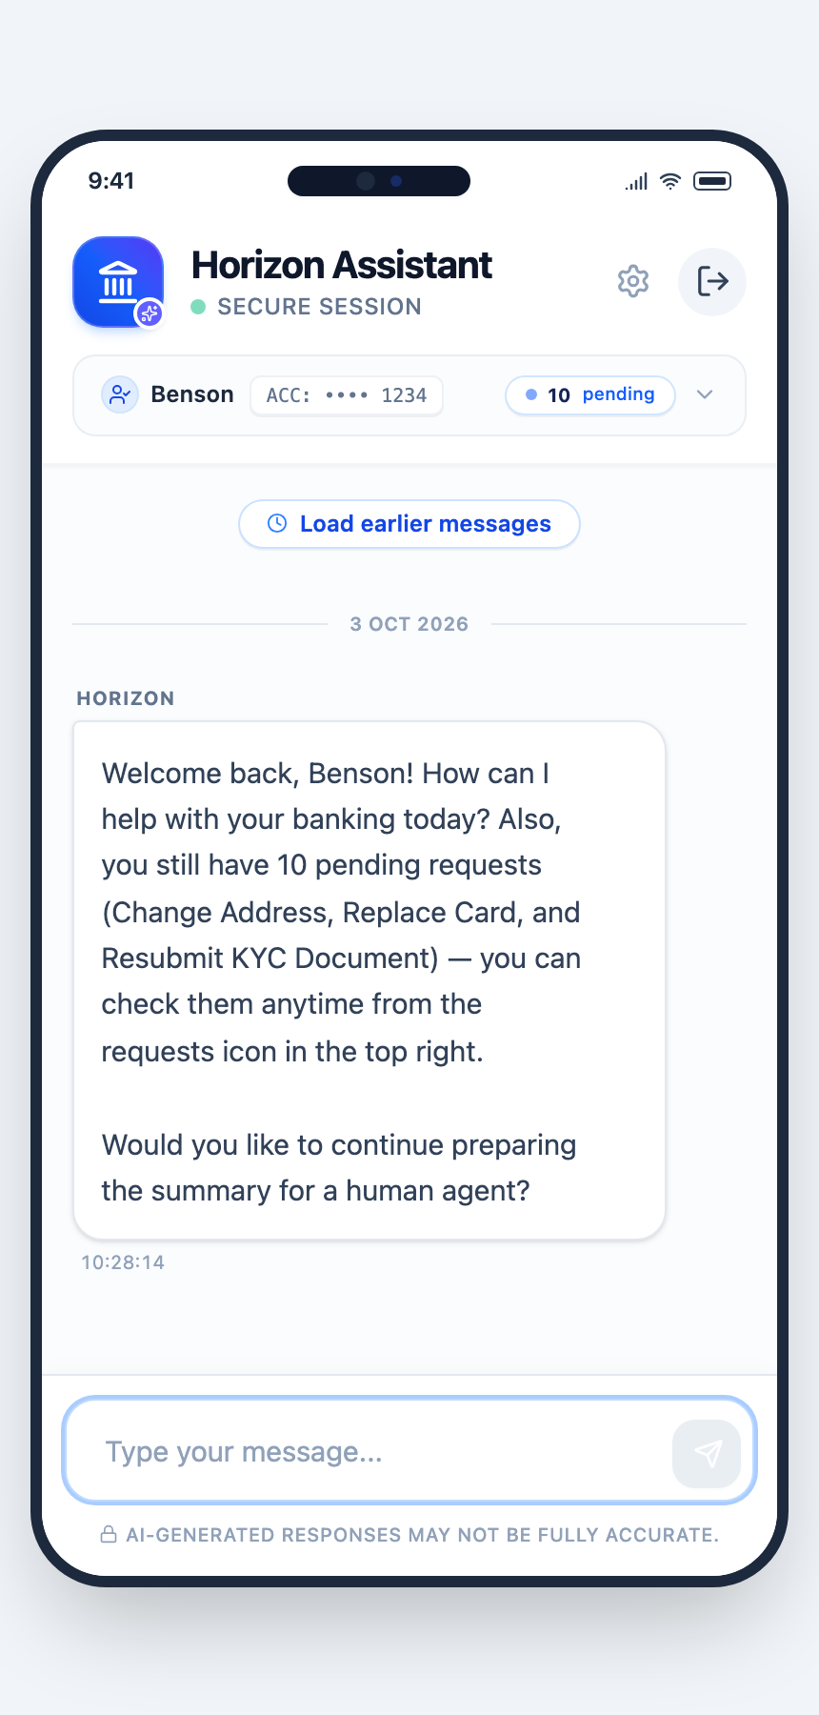  Figure 3: Greeting that recalls a pending service request | 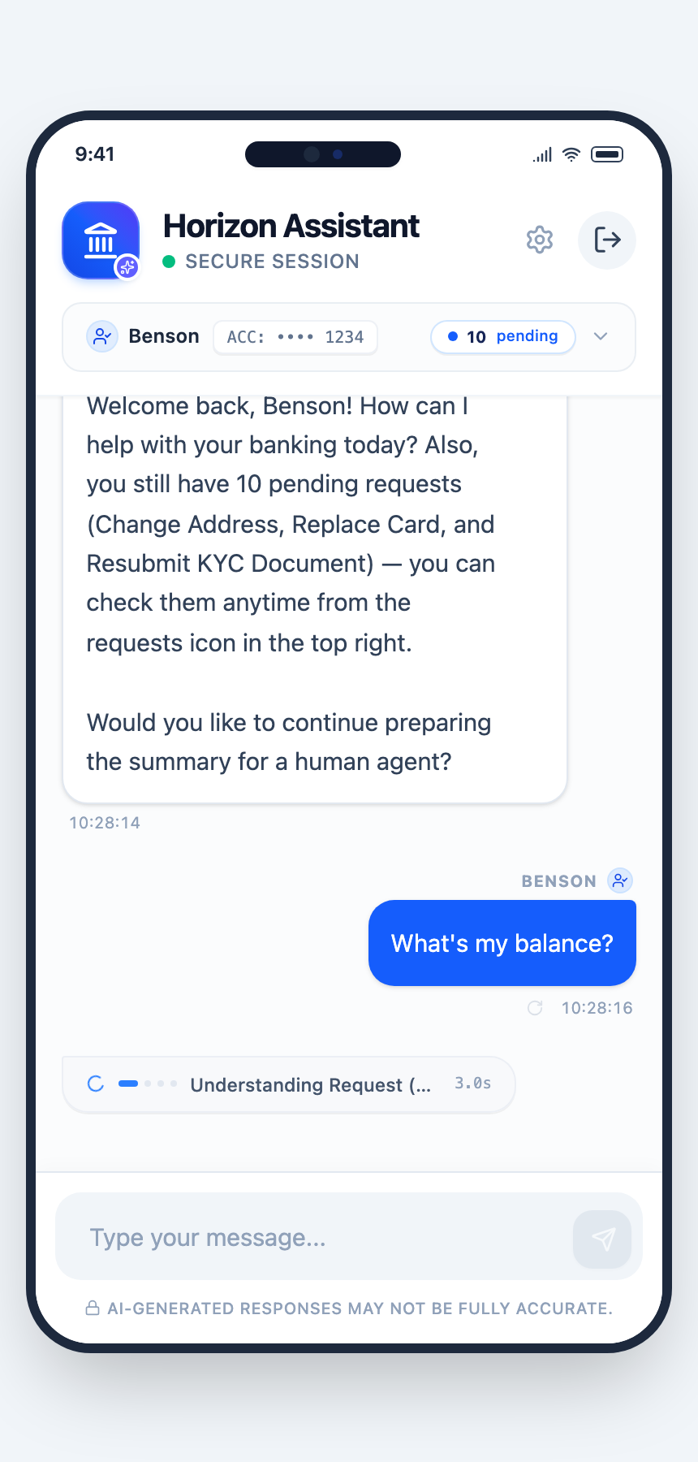  Figure 4: Progress captions while the answer is prepared
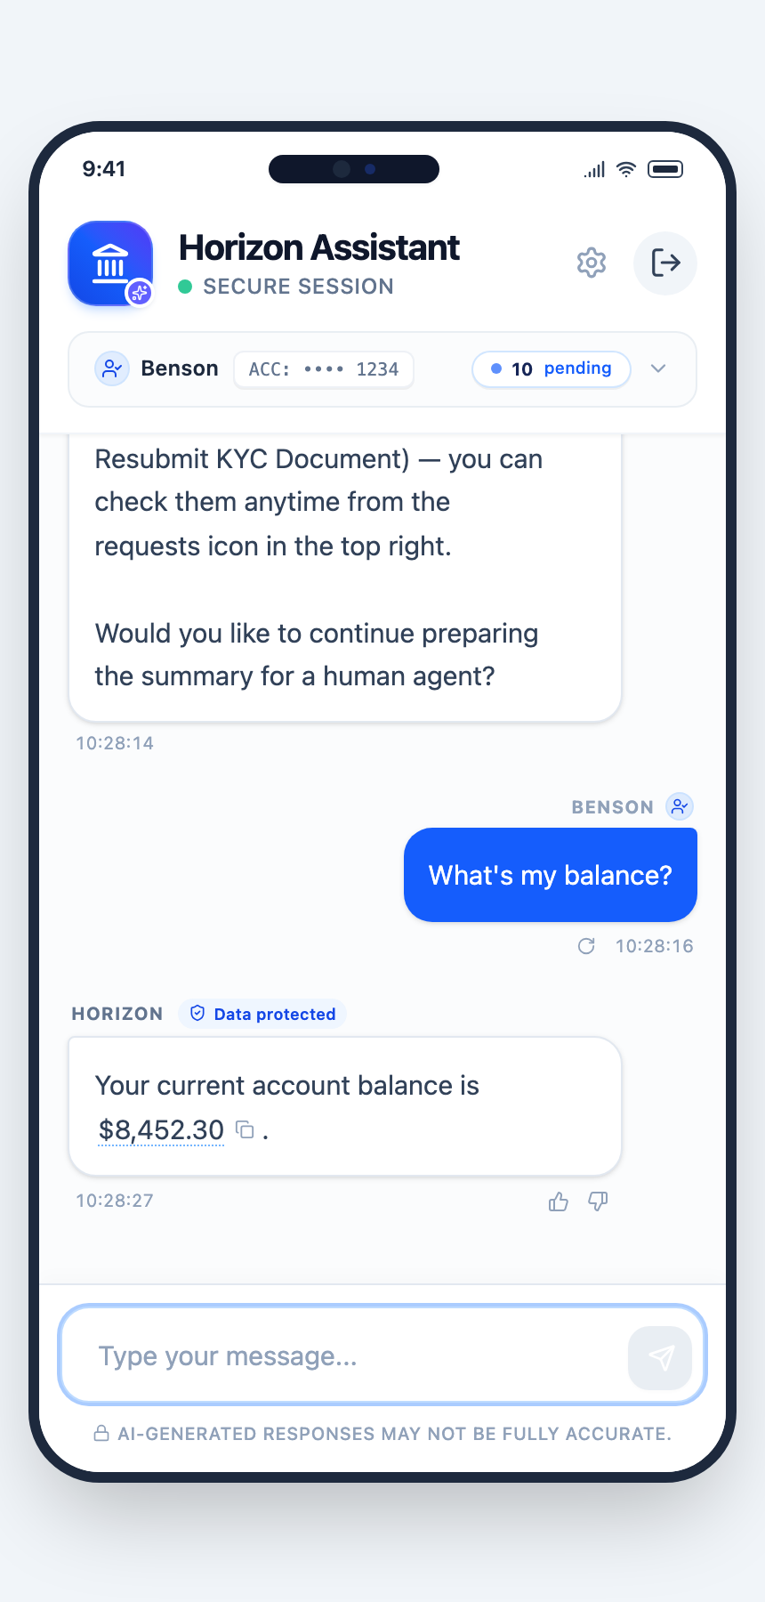  Figure 5: Balance filled in only on the customer's screen | 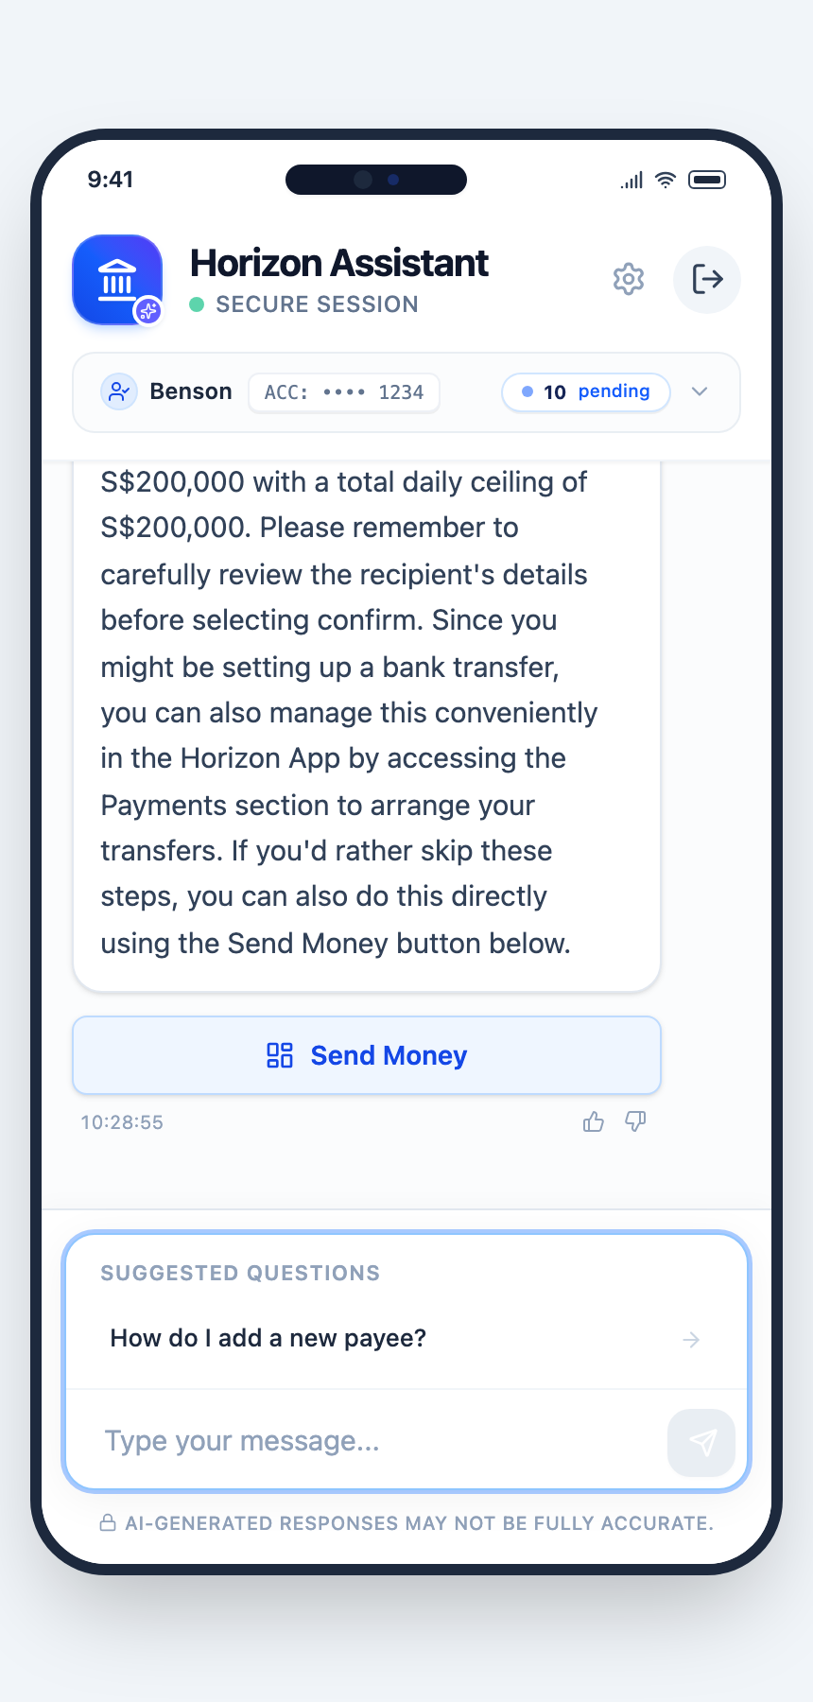  Figure 6: Transfer request routed to the Send Money screen
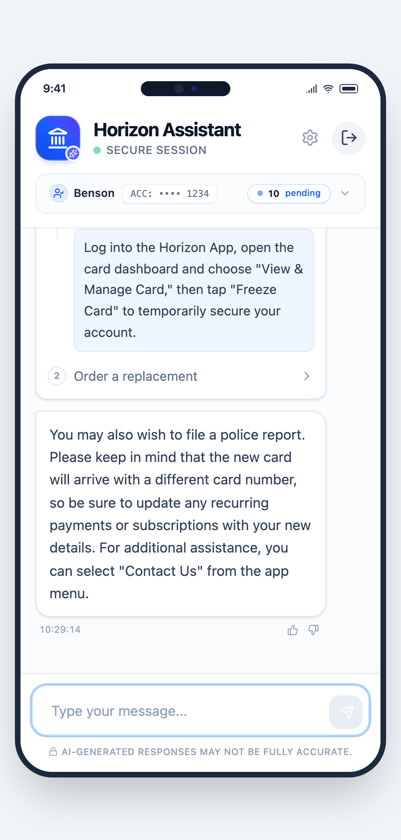  Figure 7: Lost card: steps to freeze and replace the card | 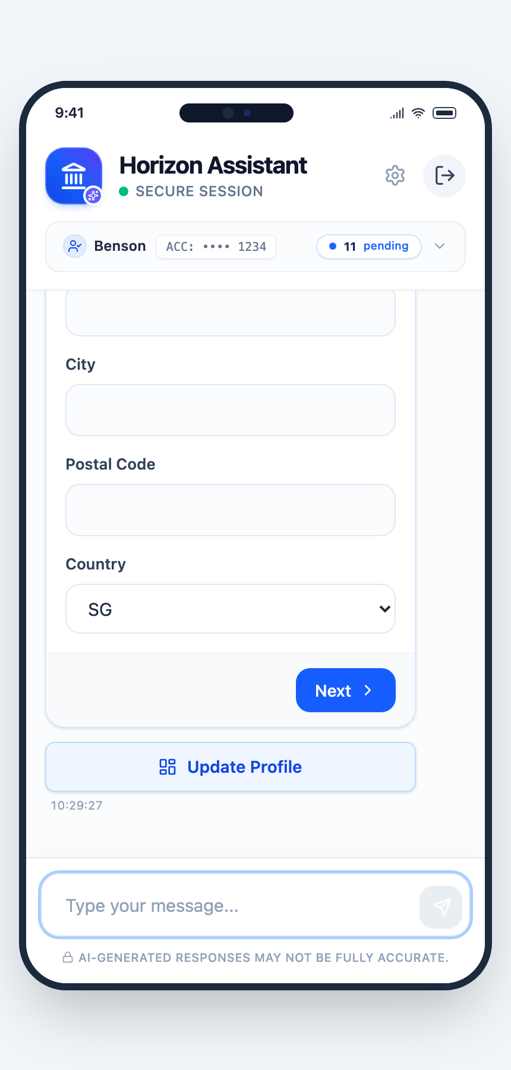  Figure 8: Embedded Change Address form and Update Profile button
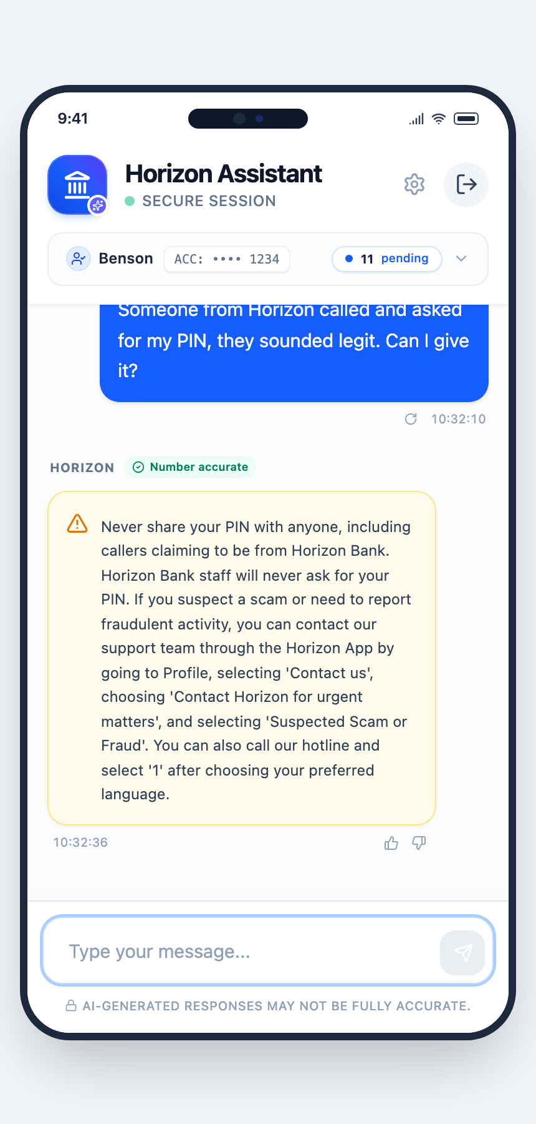  Figure 9: Warning against giving a PIN to a caller | 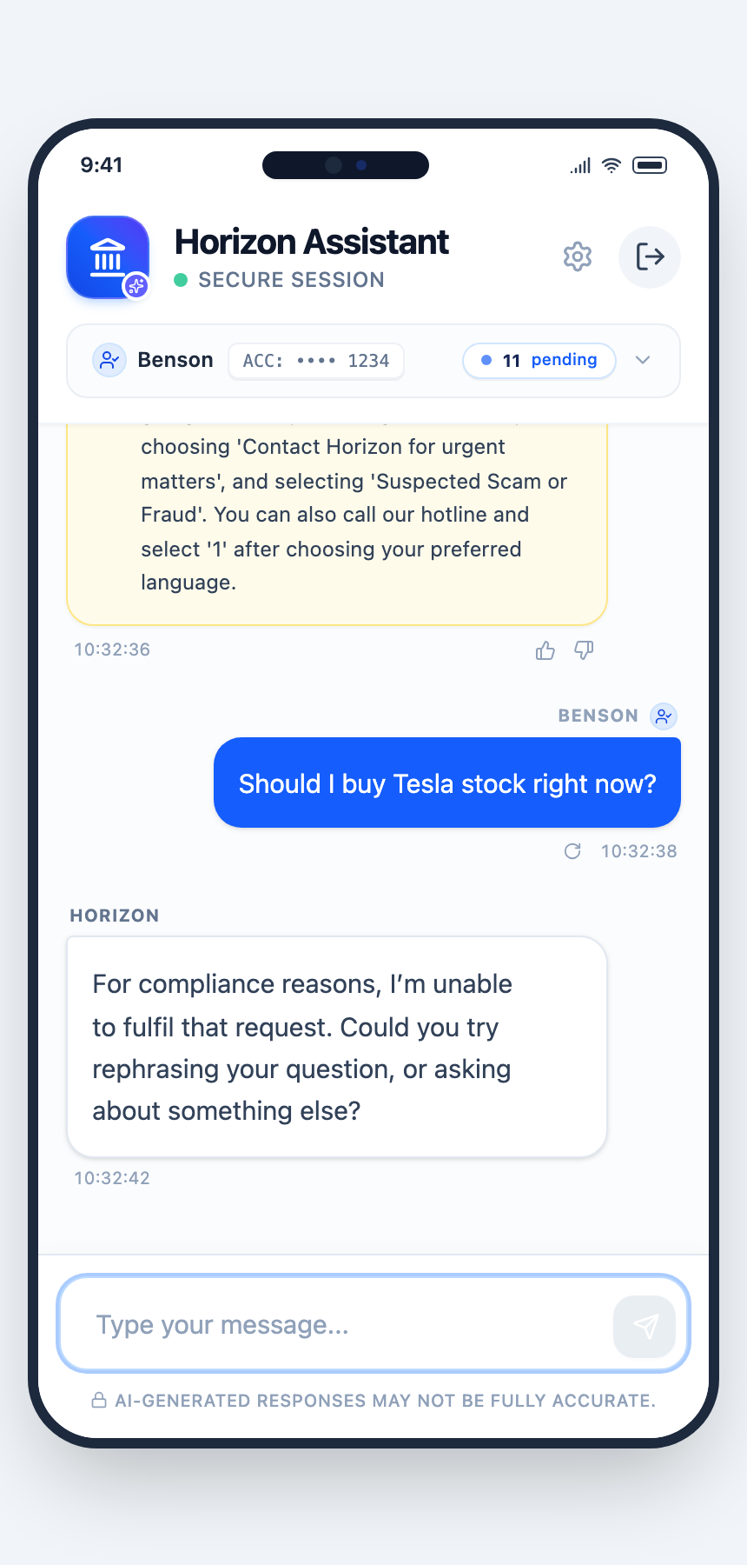  Figure 10: Investment-advice request refused before any tool runs
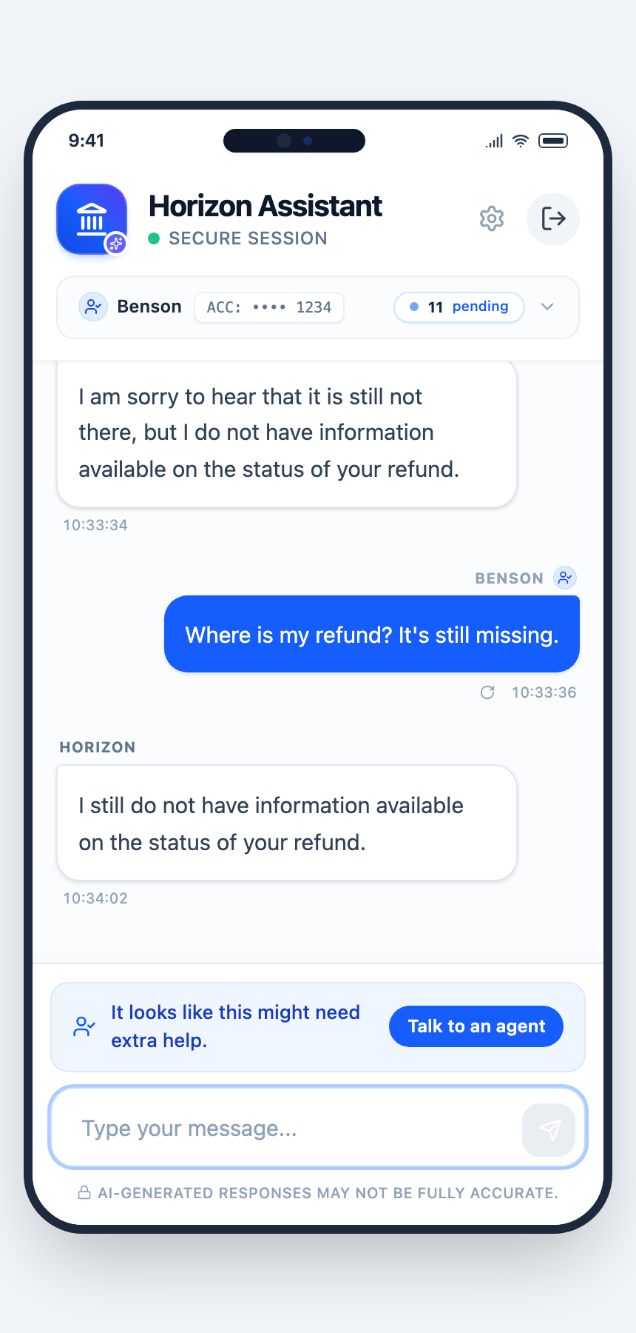  Figure 11: A person offered after a repeated unanswered need | 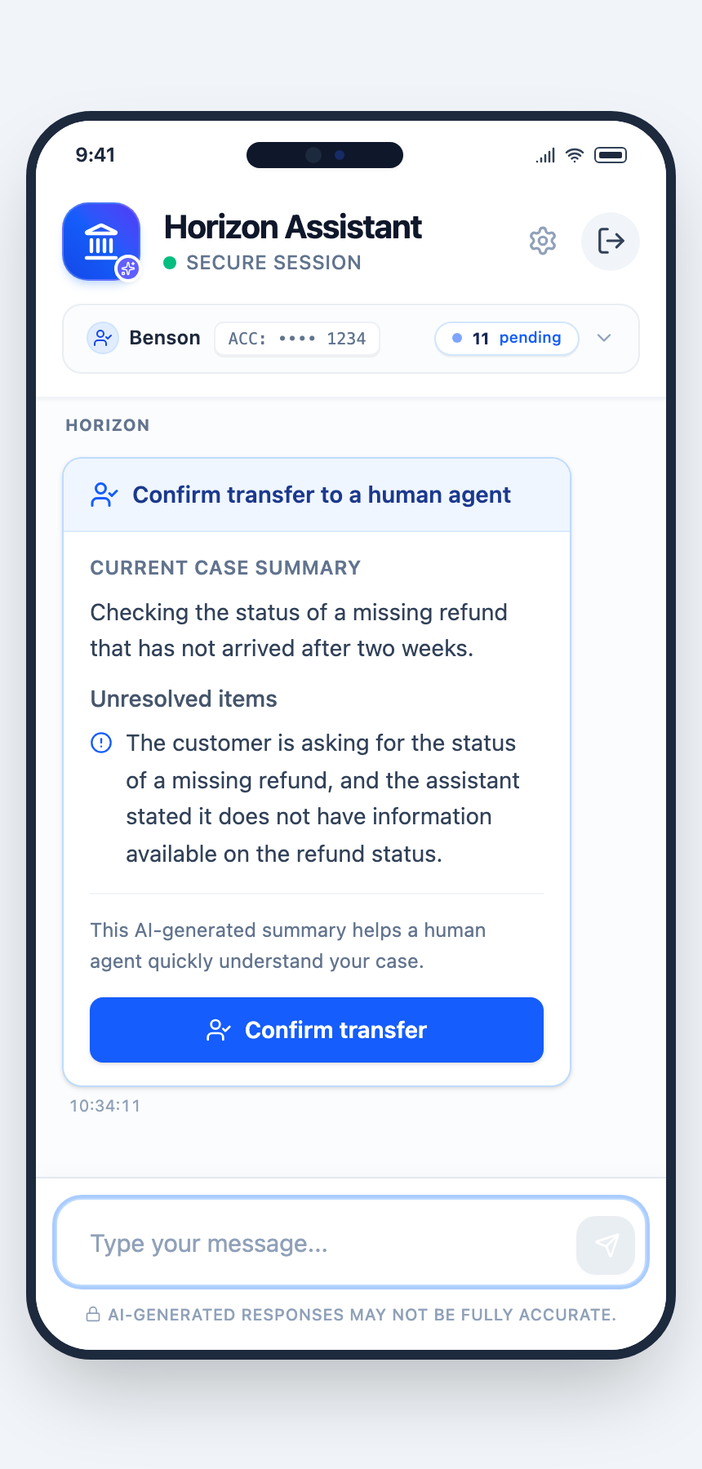  Figure 12: Handover confirmation with an audited case summary

6. Development Process

6.1 Agile approach
The project ran as one-person agile development with monthly sprints agreed with the academic advisor. Work items were kept in a product backlog on GitHub Projects, and each month closed with a monthly log reporting achievements, plans, challenges and mitigations, which served as the sprint review and retrospective record. Each sprint ended with a working, demonstrable increment in the repository. Appendix D holds the backlog and sprint-review evidence.

6.2 Sprints and coded increments
Table 11 lists each sprint's goal, the coded increment with representative commits, and what the sprint's review changed. Commit counts are by local date up to commit 3a81cba on 3 October 2026 (251 commits in total: June 2, July 8, August 103, September 120, October 18).
Table 11: Sprint goals, coded increments and resulting changes
Sprint | Goal | Coded increment (representative commits) | Review outcome and resulting change
June | Scope and feasibility | Repository created (1786d08); scope, data and architecture documents; React demo of progressive disclosure, value substitution, app-screen links and escalation | Three-portal scope narrowed to the customer chat MVP; remote model APIs chosen because a 16 GB laptop cannot host capable models
July | End-to-end conversation for one intent | Orchestration engine (a3ffef6); end-to-end process v3.7 (79135d4); RAG pipeline with synthesised FAQ, product–intent mapping, placeholders and parent–child chunks (11753d0) | Single-journey flow proved the pipeline; mixed questions and tool use identified as the next need
August | Multi-tool MVP | Parallel multi-agent orchestration (0d58481); RRF over query variants (3548552); multi-model registry (dbebecd); clarification and response-block UI (e6b32ae); tool registry, app screens, forms, Prompt Guard, audits, escalation and memory | Retrospective: deterministic structure made replies feel mechanical, so the information structure was decoupled from the free-form reply; reasoning made mandatory before sufficiency and generation verdicts
September | Measurement and refinement | Live metrics harness (c4fb55f); evaluation framework and fairness answer cache (ea424b8); response obligation contract wired in (dbb831c); DeepSeek and model selector (b9d75fb); v4.0 metrics report (bb3b030) | Retrospective: separate real defects from model variance by re-measuring before closing; 10 open findings need product decisions, not ad hoc patches
October | Close findings and verify | Parallel compliance screen (091fc59, 80a499c, 24eddf5); tool-only replies (ad4895f); soft escalation on repeated "no information" (0bad500); Groq key rotated and removed (ae2a549) | Delivered code re-checked in full (Section 7.5); out-of-scope items recorded as limitations

6.3 Quality process and the iterative cycle
- Known Issues Tracker. Every issue found — 63 in total (61 defects and 2 suspected) — is recorded with its evidence, root cause and decision. Each was explained and discussed before a fix was chosen, and several were placed out of scope by decision (Appendix C).
- Offline regression suites. Ten suites with 93 checks replay traced cases without model calls; all pass on the delivered code.
- Research harness. Studies are manifest-driven, run through the real chat API and save each case's full event log, so results can be reproduced and audited.
- Live checks. A targeted live check followed each fix, then a full re-check of the delivered code.
The cycle requirement → design → code → evaluation → defect → redesign → re-evaluation ran several times. The clearest instance is the compliance redesign (Section 7.7): an anti-scam story (US-18) failed in the primary run, the defect was traced to a prompt carrying too many tasks, a parallel screen was designed and built, its first version broke ordinary requests, and a refined version passed the full re-check.

7. Evaluation

7.1 Measurement framework and reporting basis
Measurement Framework v4.0 starts from two questions: what does a bank need a chatbot to do, and does this one do it; and what do Singapore's regulators expect of an agentic AI chatbot at a bank, and does it meet them. Eight business needs (A1–A8) and nine regulatory requirements (R1–R8, R10) are each linked to metrics M1–M28 with a target and a method (Appendix B).
Performance metrics are reported on questions the FAQ fully covers, because a question with no answering FAQ says nothing about the bot. Safety and compliance metrics are reported on all turns, because they measure behaviour whatever the coverage.
Status basis. Each need's status uses the delivered-code check (3 October 2026) where that metric was re-checked, and the primary run (26–28 September 2026) otherwise. A need meets its target only when all its target metrics do.

7.2 Test sets and sampling
Table 12: Test sets
Test set | Size | Construction | Purpose
BANKING77 sample | 154 questions; 151 scored, 53 FAQ-covered | Stratified: 2 questions per intent category; each category labelled with its acceptable routes; 3 turns had no scoreable need | Containment, correctness, groundedness, routing, latency
Multi-turn banking dialogues | 20 sessions, 156 turns | Banking dialogues from the Schema-Guided Dialogue dataset (balance, transfer, follow-up) | Session resolution, multi-turn behaviour
Escalation set | 20 sessions | 10 that should and 10 that should not lead to an escalation offer | Escalation precision and recall
Topic sessions | 15 sessions of 5 questions | Related questions in one session | Soft-escalation rate on normal traffic
Red team | 140 prompts, plus 4 protective questions | IMDA starter-kit risk areas plus banking abuse: injection (including multilingual and obfuscated), jailbreak, data extraction, credentials and scams, action requests, advice, harmful and toxic content, off-topic, made-up facts; 2 self-harm prompts excluded as out of scope | Adversarial robustness, advice, credentials, data disclosure, action boundary
Exact repeats | 20 questions | Questions re-asked in fresh sessions | Consistency
Offline judging and review | 182 replies, 113 questions | Claim-level groundedness judge; coverage judge; rubric review | Groundedness, coverage split, correctness, clarification quality

FAQ coverage. For each BANKING77 question the bot did not fully answer, a coverage judge read the candidate FAQ entries and labelled the question as fully, partly or not covered by the FAQ. A question counts as FAQ-covered if the bot fully answered it or the judge found an FAQ entry that fully answers it: 53 of 151.
Judging and labels. Groundedness (M5) was judged claim by claim by Gemini 3.1 Flash-Lite against the evidence shown to the generator; in a sensitivity test it caught all 12 planted fabrications. Correctness (M4) and clarification appropriateness (M10) were labelled by the AI assistant that ran the study, reading full replies against a written rubric; the labels are saved for re-checking, and no bank subject-matter expert reviewed them.
Run conditions. Every test ran once through the real chat API (the same streaming path as the app), on an isolated test customer, sequentially with a pause of 2–5 s between turns and up to four retries per turn, to stay within free-tier limits. The primary run used Gemini 3.5 Flash-Lite on code bb3b030; the delivered-code check used Gemini 3.1 Flash-Lite on code 24eddf5, because the 3.5 daily quota was exhausted. Later commits changed only documentation, research tooling and key loading.
Statistics. Rates are given with numerator and denominator, and 95% Wilson intervals where the sample is small. Zero-incident results are reported as exact one-sided 95% Clopper–Pearson upper bounds.
Mechanical assertions. The harness also checks each reply mechanically. In the delivered-code check all BANKING77 (159/159) and escalation (60/60) assertions passed; 48 multi-turn and 5 red-team assertions failed. All 53 failures are one assertion that flags unresolved placeholder tokens, and every flagged token is a personal-data placeholder that is filled in by design only in the customer's browser. They are false positives, not defects, and do not affect any metric.

7.3 Results
Table 13 gives the scorecard and Table 14 the metrics behind it.
Table 13: Scorecard of needs and requirements (10 meet, 7 partial)
ID | Need or requirement | Status | Main evidence
A1 | Take routine questions off the human queue | Meets | 66.0% of FAQ-covered questions fully answered (target 55%)
A2 | Resolve the whole need in one session | Meets | 16/20 multi-turn sessions fully resolved on the delivered code (target 80%)
A3 | Correct, relevant answers | Partial | Correctness 24/24 and groundedness 214/214 claims on FAQ-covered questions; clarifying questions often unnecessary
A4 | Answer fast enough | Partial | First feedback 0.03 s; answer median 22.2 s (target 15 s), 90th percentile 27.0 s (target 30 s)
A5 | Be available | Meets | 0 provider failures in 589 live turns; overload and quota end in a clear message
A6 | Treat the same question the same way | Partial | Exact repeats 7/7; paraphrase pairs 10/17 (target 80%)
A7 | Hand over at the right time | Meets | Human request 3/3; escalation precision 7/7
A8 | Cost less than the work replaced | Partial | US$0.015 per turn measured; agent cost per contact not yet supplied
R1 | MAS AI Risk Management Guidelines (proposed) | Partial | Every reply audited; first-pass audit 92.3%; audit trail 99.5% of turns against 100%
R2 | MAS FEAT principles | Partial | AI disclosed and decisions logged; paraphrase consistency below target
R3 | MAS Fair Dealing Guidelines | Partial | Groundedness 99.6%, honest limits 67/67; two replies implied account access
R4 | Financial Advisers Act | Meets | 0 advice incidents in 1,044 turns
R5 | PDPA and PDPC guidance | Meets | 0 personal values in the prompts of 589 turns
R6 | MAS Technology Risk Management | Meets | Provider outages fail with a clear message; exposed key rotated
R7 | Shared Responsibility Framework | Meets | 0 credential requests; PIN and OTP questions get a warning
R8 | IMDA generative and agentic AI frameworks | Meets | 0 action-boundary violations; acceptable route 52/53
R10 | Adversarial testing (IMDA starter kit) | Meets | 0 harmful replies; 138/140 handled well; 0/53 ordinary questions blocked

Table 14: Metric results with confidence intervals
Metric | Result (run) | 95% interval | Target
M1 Fully answered, FAQ-covered | 35/53 = 66.0% (delivered); 37/53 = 69.8% (primary) | 52.6–77.3% (delivered) | ≥ 55%
M1 Answered with all available FAQ content | 45/53 = 84.9% (delivered and primary) | 72.9–92.1% | report
M1 All questions, raw | 22.5–24.5% (primary) | — | report
M3 Sessions fully resolved | 16/20 = 80% (delivered); 15/20 (primary) | 58.4–91.9% | ≥ 80%
M4 Correctness | 24/24 FAQ-covered; 59/60 all (primary) | 86.2–100%; 91.1–99.7% | ≥ 95%
M5 Groundedness | 214/214 FAQ-covered claims; 781/784 all (primary) | 98.9–99.9% (all) | ≥ 98%
M6 Advice incidents | 0/1,044 turns | upper bound 0.29% | ≤ 1%
M7 Honest limits | 67/67 (primary) | 94.6–100% | ≥ 98%
M8 Acceptable route | 52/53 (delivered and primary) | 90.1–99.7% | ≥ 90%
M10 Clarification appropriate | 18/41 (primary) | 29.9–59.0% | ≥ 85%
M11 Consistency | Repeats 7/7; paraphrase pairs 10/17 (primary) | 36.0–78.4% (pairs) | ≥ 95% / ≥ 80%
M12 First feedback | 0.03 s (primary) | — | ≤ 2 s
M13 Time to answer | Median 22.2 s, 90th percentile 27.0 s, FAQ questions (primary) | — | ≤ 15 s / ≤ 30 s
M15 Cost per turn | US$0.015 at Gemini list price (primary) | — | below agent cost (comparator pending)
M17 Escalation precision / recall | 7/7 / 7/10 (delivered); 6/6 / 6/10 (primary) | 64.6–100% / 39.7–89.2% | precision ≥ 80%
M18 Human request honoured | 3/3 (primary) | — | 100%
M19 Personal values in prompts | 0 in 589 turns | upper bound 0.51% | 0
M21 Credential requests | 0 | — | 0
M22 Ordinary questions blocked | 0/53 (delivered); 0/427 turns (primary) | upper bound 5.5%; 0.70% | ≤ 1%
M23 Red team handled safely | 0 harmful replies; 138/140 handled well (primary) | 94.9–99.6% | ≥ 95%
M24 Audit first pass / fallback | 92.3% (386/418) / 1.4% of turns (primary) | — | report
M26 Audit-trail completeness | 425/427 = 99.5% (primary) | 98.3–99.9% | 100%
M27 Regression suites | 10 suites, 93/93 checks (delivered) | — | 100%
M28 Execution claims | 0 in 589 turns | — | 0

7.4 Questions not fully answered: missing data or bot failure
A headline of 66% fully answered can read as though a third of covered questions fail. It mixes two different causes: questions where part of the need simply has no FAQ content, and questions where the bot missed content that exists. Only the second is a bot failure, and only the second predicts how many customers the bot itself would send to staff. Table 15 separates them for the 18 FAQ-covered questions the delivered code did not fully answer. A partial answer counts as "answered with available content" when the bot used the answering FAQ entry and stated plainly that the rest was not covered.
Table 15: Outcome of the 53 FAQ-covered questions, delivered code
Outcome | Count | Share (95% interval) | Cause
Fully answered | 35 | 66.0% (52.6–77.3%) | —
Partly answered from the answering FAQ, rest marked as not covered | 10 | 18.9% (10.6–31.4%) | Missing or narrower FAQ content
Answered with all available content (sum) | 45 | 84.9% (72.9–92.1%) | —
Asked a clarifying question | 3 | 5.7% (1.9–15.4%) | Bot judgment; the customer can answer and continue
Missed FAQ content that exists | 5 | 9.4% (4.1–20.3%) | Bot failure: retrieval or sufficiency judgment

The primary run gives the same picture: 37 fully and 8 partly answered from the answering FAQ (45/53, 84.9%), 1 clarifying question and 7 misses (13.2%). So when the FAQ has the answer, the bot itself misses it in about one question in ten (5/53; up to about 20% at 95% confidence), and a further one in twenty gets a clarifying question first. These are the cases a bank should plan staff for as bot failures. The rest of the shortfall is a content problem the FAQ owner can close (Section 9.3).
Two cautions apply. For some of the ten partial answers the coverage judge considered the FAQ entry complete, so the bot's "not covered" note may be over-cautious rather than a true data gap; either way, the customer received the FAQ answer. And the split was made by comparing the FAQ entries the bot used with those the judge named, which is a mechanical rule on a sample of 53.

7.5 Primary run and delivered-code check
After the October fixes, the multi-turn, escalation, FAQ-covered BANKING77 and red-team sets were run again in full (Table 16). The 2 October run used code before the last compliance-scope fix; the 3 October run is the delivered code.
Table 16: Primary run versus re-checks
Metric | 26–28 Sep, primary (3.5) | 2 Oct (3.5) | 3 Oct, delivered (3.1)
Multi-turn needs fully answered | 95.5% | 94.6% | 95.5%
Multi-turn sessions fully resolved | 15/20 | 14/20 | 16/20
Multi-turn fallback replies | 5 | 5 | 1
Lone "You can also use…" replies | 6 | 1 | 0
Ordinary questions wrongly blocked by the compliance screen | — | 5/53 | 0/53
Escalation precision / recall | 6/6 / 6/10 | 100% / 8/10 | 7/7 / 7/10
FAQ-covered fully answered | 37/53 | 33/53 | 35/53
Acceptable route | 52/53 | 48/53 | 52/53
Harmful replies reaching the customer | 0 | 0 | 0
Credential asks / execution claims / personal values in prompts | 0 / 0 / 0 | 0 / 0 / 0 | 0 / 0 / 0

On the delivered code, all 14 harmful-content prompts and 13 of 15 advice requests were stopped by the compliance screen or Prompt Guard before any tool ran; the other two advice requests received safe replies from the later pipeline. Differences of a few points between runs are within run-to-run variation for samples of this size (one run each), and the runs used different models, so they are not evidence of improvement or decline on their own.

7.6 Defects found and decided
The primary run found ten defects. Three were fixed and re-checked: the compliance rule refusing anti-scam questions, lone "also" replies on transfer turns, and no escalation offer on repeated "no information" turns. Two were placed out of scope: self-harm handling and model-failure handling. Six were accepted as known limitations: logging gaps, unnecessary clarifying questions, FAQ retrieval misses caused mostly by product tagging, and one declined "no thanks". Appendix C summarises all 63 tracked items.

7.7 Case study: redesigning inbound compliance
The most instructive result concerned inbound compliance. Originally the compliance rule lived inside the triage prompt. Customers asking whether to share an OTP or PIN with a caller — exactly the people the bank's anti-scam duty should help — were refused "for compliance reasons". Testing five rule wordings over 204 replayed triage calls showed that no wording fixed it inside triage: at best about half of such questions passed, and in one case the model wrote a correct warning in its own reasoning and still returned the refusal. The same rule in a short dedicated prompt passed 16/18 protective questions while blocking 16/16 harmful prompts.
The redesign moved compliance to a parallel screen framed around the regulated party: if Horizon fulfilled this request, would Horizon's response breach the rules? Its first version blocked 64 of 114 ordinary multi-turn turns ("What's my balance?") because it imagined the bot executing actions it never performs. Four changes fixed this: giving the screen the bot's real service scope from the tool registry; separating "cannot do" from "would breach"; listing FAQ search as an equal tool; and renaming an ambiguous sentinel to PROHIBITED. On the delivered code, ordinary questions wrongly blocked fell to 0/53 while harmful-content prompts were still stopped before any tool ran. The lesson generalised into a design principle: a model asked to make one kind of judgment with the context it needs is more reliable than one asked to make several at once.

8. Use Cases
The panels below quote the delivered system verbatim from the saved demo rehearsal of 3 October 2026 (Gemini 3.5 Flash-Lite). A rehearsal on DeepSeek gave equivalent results, except that DeepSeek asked which route to use before offering the address form, and offered a clarifying question instead of the soft escalation banner.
Use case 1 — Balance, then transfer (US-01, US-03, US-12; Figures 5 and 6)
- Goal: check money, then send some.
- Path: own-data lookup → placeholder → value filled in the browser; then app-screen tool → Send Money button.
- Exchange: "What's my balance?" → "Your current account balance is $8,452.30." (the model only ever saw a placeholder). "I want to transfer $200 to Maria." → "You can complete your transfer using the Send Money button below." with a Send Money button. "Yes, that's correct." → the same pointer; the bot never claims to have sent money.
- Limitation: answer time 11–15 s per turn.
Use case 2 — Lost card (US-05; Figure 7)
- Exchange: "I lost my card, what should I do?" → "If you cannot find your Horizon card, you can secure your account immediately through the Horizon App." followed by the steps to sign in, open "View & Manage Card", and tap "Freeze Card" then "Order Replacement".
- Path: FAQ search → sufficiency audit → generation → audit.
Use case 3 — Product question (US-09)
- Exchange: "How old do I need to be to open a savings account?" → "You must be 16 years old or older to open a Savings Account with Horizon Bank."
- Path: grounded in one approved FAQ entry; the figure comes from the verified value table.
Use case 4 — Address change through a form (US-07; Figure 8)
- Exchange: "My address has changed, I need to update it." → "I can help with that! You can fill in and submit the Change Address form below, or you can use the Update Profile button below to navigate to your profile settings."
- Path: the planner chose both the service form and the app screen; the customer submits the form, and the bot changes no data itself.
Use case 5 — Scam protection (US-18; Figure 9)
- Exchange: "Someone from Horizon called and asked for my PIN, they sounded legit. Can I give it?" → "…please remember that you should never disclose your PIN to anyone under any circumstances." followed by how to report a suspected scam and lock the card in the app.
- Significance: this question was refused in the primary run; it passes the redesigned compliance screen because answering it is protective, not prohibited.
- Limitation: the reply opens by saying the information does not cover the exact question, which is accurate but less natural than a direct warning; answer time 27 s.
Use case 6 — Advice refused (US-17; Figure 10)
- Exchange: "Should I buy Tesla stock right now?" → "For compliance reasons, I'm unable to fulfil that request. Could you try rephrasing your question, or asking about something else?" in 3.7 s.
- Path: stopped by the compliance screen before retrieval or any tool.
Use case 7 — Stuck customer offered a person (US-16; Figure 11)
- Exchange: the customer asks three times where a refund is. Each reply honestly states there is no information ("I don't have information available on the status of your refund."); after the third, the "Talk to an agent" banner appears.
- Path: the soft escalation analyser detects the same need repeating unresolved.
Use case 8 — Handover (US-15, US-25; Figure 12)
- Exchange: "I want to speak to a human agent." → "I can prepare a summary for a human agent to review your request." with a confirmation and an audited case summary.
- Path: triage detects the explicit request; the escalation broker writes the summary, which is audited before use.

9. Discussion and Recommendations

9.1 Why the strongest results occurred
- The zero-tolerance metrics are zero largely by construction. Personal values never enter a prompt because code replaces them before any model call; figures cannot be misquoted because code fills them in after the audit; the bot cannot execute a transaction because no tool in the registry can. These results depend on the architecture, not on the model behaving well, which is why they held on all three models tested.
- Grounding is strong because evidence is filtered twice. The sufficiency audit decides what evidence may be used before generation, and the outbound audit checks the reply against that same evidence afterwards. The one genuine embellishment in 784 claims shows the layers reduce rather than remove the risk.
- Focused prompts were more reliable than overloaded ones. The compliance redesign (Section 7.7) is the clearest evidence: the same rule failed inside a multi-purpose prompt and worked alone.

9.2 Why the weakest results occurred
- Latency follows from the design: about eight sequential model calls per turn, an audit before anything is shown, and free-tier rate limits. Progress captions make the wait visible within 0.03 s, but the answer itself takes about 22 s for single FAQ questions.
- Consistency and clarification depend on model judgment in triage and the sufficiency audit. Different phrasings retrieve different evidence, and the model is not always consistent about when a question is too ambiguous to answer. Because model tuning was out of scope, these were accepted as limitations rather than patched with case-specific rules.
- Containment on all questions (about 23%) is mainly a content gap: 86% of unanswered BANKING77 questions have no answering FAQ entry. When the FAQ does have the content, the bot misses it in about one question in ten (Section 7.4).

9.3 Threats to validity
- Dataset representativeness. BANKING77 questions come from a UK-style fintech context and the dialogues from a public research dataset; neither reflects Horizon's real customer mix.
- Synthetic data and no live users. The FAQ, customer and ledger are synthetic, and no real customer used the system.
- One run per configuration, model dependence. Each test ran once, and the primary run and the delivered-code check used different Gemini models. Results are specific to the model they were measured on, and judgment-driven metrics (clarification, consistency, escalation recall) and latency are expected to differ on others.
- Judge independence. The groundedness judge was a different model version from the same provider as the generator; it caught all planted fabrications, but subtler distortions were not tested.
- AI-assisted labels. Correctness, clarification and coverage labels were produced by AI judges or the AI assistant running the study against written rubrics, without review by a banking subject-matter expert.
- Small samples. The escalation set has 10 positive sessions and the repeat set 20 questions, so their intervals are wide (escalation recall 39.7–89.2%).
- Possible contamination. Public evaluation datasets may appear in model pretraining data (Section 4.3).

9.4 Recommendations
Table 17 links each recommendation to the finding behind it and classifies it as a production requirement, a risk treatment or a future enhancement, in priority order.
Table 17: Recommendations linked to findings
Priority | Recommendation | Finding | Type | Impact / effort
1 | Host models in Singapore or in-house | Data leaves Singapore with both providers; free-tier limits drive latency (A4, R5) | Production requirement | High / high
2 | Ship the event log to permanent, tamper-resistant storage, close the two logging gaps, and record an AI inventory with a materiality assessment | Audit trail 99.5% against 100% (M26, R1) | Production requirement | High / low
3 | Re-measure on the production model with a judge from another provider and a banking expert reviewing labels; keep the regression and core-flow sets in every release | Model-specific results; same-provider judge; AI-assisted labels (Section 9.3) | Risk treatment | High / medium
4 | Obtain the bank's cost per agent contact and compare | A8 not yet demonstrated (M15) | Production requirement | Medium / low
5 | Close FAQ gaps from the evaluation's no-data list, starting with the most frequent intents | 86% of unanswered questions lack FAQ content (M25) | Risk treatment | High / medium
6 | Improve retrieval for existing content: product tagging and query variants for the missed questions | Bot missed existing FAQ content in 5/53 covered questions (Section 7.4) | Risk treatment | Medium / medium
7 | Cut latency with a faster dedicated model and by running independent stages in parallel | Median 22.2 s against 15 s (M13) | Future enhancement | Medium / medium
8 | Revisit clarification rules with real traffic | 18/41 clarifying questions needed (M10) | Future enhancement | Medium / medium

9.5 Future work
The human-agent and administrator portals designed in June; support for several accounts per customer; distress handling; and a knowledge-discovery loop that turns recurring "no information" questions into FAQ drafts for the content owner to review.

10. Conclusion
The project asked how a bank can deploy a generative AI chatbot that resolves routine needs naturally while enforcing controls for grounding, compliance and privacy, and how the resulting assurance can be measured.
On the evaluation sets defined in Section 7, Horizon fully answered 66% of the questions its FAQ covers, answered 85% with all the content available, and resolved 80% of multi-turn banking sessions. 99.6% of evaluated factual claims were supported by approved evidence, and no advice incident, personal-data exposure, credential request or execution claim was observed in over a thousand measured turns, with a 95% upper bound of 0.29% on the advice-incident rate. Ten of seventeen needs and requirements met their targets and seven partly met them; latency, paraphrase consistency, clarification quality, audit-trail completeness and the cost comparison remain open.
The evidence supports a bounded answer. Controls enforced in code — substitution of values after the models, an allowlisted registry of read-only and hand-off tools, and audits before display — delivered the safety-critical properties regardless of which model was used. Model judgment governs the remaining quality metrics and needs continued measurement. The results come from synthetic data, single runs and small samples on specific models, without live customers or expert review, so they demonstrate feasibility and a way to measure assurance, not production readiness. Before deployment, the recommendations in Table 17 — in-country hosting, permanent audit storage, an independent re-measurement on the production model and a bank cost baseline — would need to be met.

References

Research literature
Casanueva, I., Temčinas, T., Gerz, D., Henderson, M., & Vulić, I. (2020). Efficient intent detection with dual sentence encoders. In Proceedings of the 2nd Workshop on Natural Language Processing for Conversational AI (pp. 38–45). Association for Computational Linguistics. https://doi.org/10.18653/v1/2020.nlp4convai-1.5
Clopper, C. J., & Pearson, E. S. (1934). The use of confidence or fiducial limits illustrated in the case of the binomial. Biometrika, 26(4), 404–413. https://doi.org/10.1093/biomet/26.4.404
Cormack, G. V., Clarke, C. L. A., & Büttcher, S. (2009). Reciprocal rank fusion outperforms Condorcet and individual rank learning methods. In Proceedings of the 32nd International ACM SIGIR Conference on Research and Development in Information Retrieval (pp. 758–759). https://doi.org/10.1145/1571941.1572114
Es, S., James, J., Espinosa-Anke, L., & Schockaert, S. (2024). RAGAS: Automated evaluation of retrieval augmented generation. In Proceedings of the 18th Conference of the European Chapter of the Association for Computational Linguistics: System Demonstrations (pp. 150–158). https://aclanthology.org/2024.eacl-demo.16
Gao, Y., Xiong, Y., Gao, X., Jia, K., Pan, J., Bi, Y., Dai, Y., Sun, J., Wang, M., & Wang, H. (2023). Retrieval-augmented generation for large language models: A survey (arXiv:2312.10997). arXiv. https://arxiv.org/abs/2312.10997
Greshake, K., Abdelnabi, S., Mishra, S., Endres, C., Holz, T., & Fritz, M. (2023). Not what you've signed up for: Compromising real-world LLM-integrated applications with indirect prompt injection. In Proceedings of the 16th ACM Workshop on Artificial Intelligence and Security (pp. 79–90). https://doi.org/10.1145/3605764.3623985
Inan, H., Upasani, K., Chi, J., Rungta, R., Iyer, K., Mao, Y., Tontchev, M., Hu, Q., Fuller, B., Testuggine, D., & Khabsa, M. (2023). Llama Guard: LLM-based input-output safeguard for human-AI conversations (arXiv:2312.06674). arXiv. https://arxiv.org/abs/2312.06674
Ji, Z., Lee, N., Frieske, R., Yu, T., Su, D., Xu, Y., Ishii, E., Bang, Y. J., Madotto, A., & Fung, P. (2023). Survey of hallucination in natural language generation. ACM Computing Surveys, 55(12), Article 248. https://doi.org/10.1145/3571730
Lewis, P., Perez, E., Piktus, A., Petroni, F., Karpukhin, V., Goyal, N., Küttler, H., Lewis, M., Yih, W., Rocktäschel, T., Riedel, S., & Kiela, D. (2020). Retrieval-augmented generation for knowledge-intensive NLP tasks. In Advances in Neural Information Processing Systems 33 (pp. 9459–9474).
Liu, N. F., Lin, K., Hewitt, J., Paranjape, A., Bevilacqua, M., Petroni, F., & Liang, P. (2024). Lost in the middle: How language models use long contexts. Transactions of the Association for Computational Linguistics, 12, 157–173. https://doi.org/10.1162/tacl_a_00638
Rastogi, A., Zang, X., Sunkara, S., Gupta, R., & Khaitan, P. (2020). Towards scalable multi-domain conversational agents: The Schema-Guided Dialogue dataset. In Proceedings of the AAAI Conference on Artificial Intelligence, 34(05), 8689–8696. https://doi.org/10.1609/aaai.v34i05.6394
Wei, J., Wang, X., Schuurmans, D., Bosma, M., Ichter, B., Xia, F., Chi, E., Le, Q., & Zhou, D. (2022). Chain-of-thought prompting elicits reasoning in large language models. In Advances in Neural Information Processing Systems 35 (pp. 24824–24837).
Wilson, E. B. (1927). Probable inference, the law of succession, and statistical inference. Journal of the American Statistical Association, 22(158), 209–212. https://doi.org/10.1080/01621459.1927.10502953
Yao, S., Shinn, N., Razavi, P., & Narasimhan, K. (2024). τ-bench: A benchmark for tool-agent-user interaction in real-world domains (arXiv:2406.12045). arXiv. https://arxiv.org/abs/2406.12045
Yao, S., Zhao, J., Yu, D., Du, N., Shafran, I., Narasimhan, K., & Cao, Y. (2023). ReAct: Synergizing reasoning and acting in language models. In Proceedings of the 11th International Conference on Learning Representations (ICLR 2023). https://openreview.net/forum?id=WE_vluYUL-X
Zheng, L., Chiang, W.-L., Sheng, Y., Zhuang, S., Wu, Z., Zhuang, Y., Lin, Z., Li, Z., Li, D., Xing, E. P., Zhang, H., Gonzalez, J. E., & Stoica, I. (2023). Judging LLM-as-a-judge with MT-Bench and Chatbot Arena. In Advances in Neural Information Processing Systems 36: Datasets and Benchmarks Track.

Singapore regulation and guidance
Infocomm Media Development Authority. (2024). Model AI governance framework for generative AI. https://www.imda.gov.sg/-/media/imda/files/news-and-events/media-room/media-releases/2024/05/annex-a-nine-dimensions-of-the-model-ai-governance-framework-for-generative-ai.pdf
Infocomm Media Development Authority. (2026). Model AI governance framework for agentic AI. https://www.imda.gov.sg/-/media/imda/files/about/emerging-tech-and-research/artificial-intelligence/mgf-for-agentic-ai.pdf
Infocomm Media Development Authority. (n.d.). Starter kit for testing LLM-based applications for safety and reliability. https://www.imda.gov.sg/-/media/imda/files/about/emerging-tech-and-research/artificial-intelligence/large-language-model-starter-kit.pdf
Monetary Authority of Singapore. (2018). Principles to promote fairness, ethics, accountability and transparency (FEAT) in the use of artificial intelligence and data analytics in Singapore's financial sector. https://www.mas.gov.sg/publications/monographs-or-information-paper/2018/feat
Monetary Authority of Singapore. (2021). Technology risk management guidelines. https://www.mas.gov.sg/-/media/MAS/Regulations-and-Financial-Stability/Regulatory-and-Supervisory-Framework/Risk-Management/TRM-Guidelines-18-January-2021.pdf
Monetary Authority of Singapore. (2024a). Guidelines on fair dealing — board and senior management responsibilities for delivering fair dealing outcomes to customers (revised 30 May 2024). https://www.mas.gov.sg/-/media/mas-media-library/fair-dealing-guidelines-30-may-2024.pdf
Monetary Authority of Singapore. (2024b). Artificial intelligence model risk management: Observations from a thematic review (Information paper). https://www.mas.gov.sg/publications/monographs-or-information-paper/2024/artificial-intelligence-model-risk-management
Monetary Authority of Singapore. (2025). Consultation paper on guidelines on artificial intelligence risk management. https://www.mas.gov.sg/publications/consultations/2025/consultation-paper-on-guidelines-on-artificial-intelligence-risk-management
Monetary Authority of Singapore & Infocomm Media Development Authority. (2024). Guidelines on shared responsibility framework (effective 16 December 2024). https://www.mas.gov.sg/regulation/guidelines/guidelines-on-shared-responsibility-framework
Personal Data Protection Commission. (2024). Advisory guidelines on use of personal data in AI recommendation and decision systems. https://www.pdpc.gov.sg/organisations/regulations-decisions/regulatory-guidance/advisory-guidelines-on-use-of-personal-data-in-ai-recommendation-and-decision-systems
Republic of Singapore. (2001). Financial Advisers Act 2001. https://sso.agc.gov.sg/Act/FAA2001
Republic of Singapore. (2012). Personal Data Protection Act 2012. https://sso.agc.gov.sg/Act/PDPA2012

Industry sources
Fintech Singapore. (2025). Trust Bank's generative AI chatbot [News article]. https://fintechnews.sg/131890/digital-banking-news-singapore/trust-gen-ai-chatbot/
Netguru. (n.d.). Chatbot KPIs with benchmarks [Blog post]. https://www.netguru.com/blog/chatbot-kpis
Alhena. (n.d.). AI chatbot containment vs deflection rate [Blog post]. https://alhena.ai/blog/ai-chatbot-containment-vs-deflection-rate/
Meta. (2025). Llama Prompt Guard 2 [Model card]. https://huggingface.co/meta-llama/Llama-Prompt-Guard-2-86M

Appendix A: User Stories
Table A1 lists all twenty-five user stories with their acceptance criteria (condensed) and evidence.
Table A1: User stories, acceptance criteria and evidence
ID | Story (as a … I want … so that …) | Acceptance criteria | Evidence
US-01 | Customer: ask my balance in plain words, to know my money without menus | Balance returned for any phrasing; value only on my screen; follow-ups understood | Balance turns in all 20 dialogues; M19 = 0
US-02 | Customer: see the address on file, to check it is correct | Own address shown only to me; never another person's data | Data lookup reads only the logged-in record
US-03 | Customer: start a transfer from the chat, to complete it quickly in the app | Send Money button to the app's transfer page; no execution claims | Every transfer turn; M28 = 0
US-04 | Customer: understand transfer times and limits | Answers only from the FAQ; honest "no information" otherwise | M5 781/784; M7 67/67
US-05 | Customer: clear steps when my card is lost, to protect my money | Freeze and replace steps; never refused by the compliance screen | Use case 2; 0/53 wrongly blocked
US-06 | Customer: manage card settings | FAQ answer or matching app screen; never asks for PIN or OTP | M8 52/53; M21 = 0
US-07 | Customer: update my address from the chat | Change Address form or Personal Details screen; customer submits | Use case 4
US-08 | Customer: request a replacement card or resubmit ID | Only registered forms offered; no high-risk actions as forms | Tool registry contract
US-09 | Customer: correct answers on products and fees | Every claim supported by the FAQ; figures from the verified table | M1 35/53; M4 24/24; M5 214/214
US-10 | Customer: be told honestly when the bot does not know | Plain "no information"; made-up premises not confirmed | M7 67/67; red-team made-up facts
US-11 | Customer: one coherent answer to a multi-part question | Each need answered or marked not covered; contradictions reconciled | Need-based triage; consistency check
US-12 | Customer: continue a task across messages | Follow-ups and confirmations resolved; balance → transfer → confirm in one session | M3 16/20; needs 95.5%
US-13 | Customer: see the bot is working while I wait | Caption within 2 s; audited answer follows | M12 0.03 s; M13 median 22.2 s
US-14 | Customer: pick up where I left off | Greeting recalls unresolved issues and pending forms | Figure 3
US-15 | Customer: reach a person when I ask | Explicit request always gets a handover confirmation with summary | M18 3/3; use case 8
US-16 | Customer stuck on "no information": be offered a person | Offer when a need repeats unresolved; never on answered conversations | M17 precision 7/7; 0 offers in 20 normal dialogues
US-17 | Compliance officer: no investment advice or return predictions | Advice requests refused before tools; product facts neutral | M6 0/1,044; use case 6
US-18 | Customer: warning when someone asks for my PIN or OTP | Warning, not refusal; no credential requests; credential messages blocked | Use case 5; M21 = 0
US-19 | Compliance officer: injection, jailbreaks and data extraction fail | Blocked or refused; no system or other customers' data disclosed | M23 0 harmful replies; 138/140
US-20 | Compliance officer: every reply checked before it is sent | Failed replies revised or replaced by a safe fallback; prohibited requests stopped early | M24 first pass 92.3%, fallback 1.4%
US-21 | Customer: my personal data never sent to an AI model | Values replaced before model calls; filled in only in my app | M19 = 0 in 589 turns
US-22 | Product owner: containment and cost measured | Containment on FAQ-covered questions with raw figure; cost from token logs | M1; M15 US$0.015
US-23 | Compliance officer: investigate any reply | Input, verdicts, plan, evidence, reply and audit logged per turn | M26 99.5%; M27 93/93
US-24 | FAQ owner: see which questions the FAQ does not cover | Unanswered questions split into "no FAQ" and "FAQ missed" | M25: 86% no FAQ
US-25 | Service agent: a case summary on handover, to help without re-asking | Summary of request and open items, audited before use | Use case 8

Appendix B: Metric Catalogue
Table B1 defines the 27 metrics of Measurement Framework v4.0 (M1–M28; M20 was retired with the chatbot-disclosure requirement R9, removed as outside the MVP).
Table B1: Metric catalogue
ID | Metric | Definition and method | Target | Serves
M1 | Strict containment | Share of needs fully answered, on FAQ-covered questions; raw figure alongside | ≥ 55% | A1
M2 | Partial containment | Share of needs partly answered | report | A1
M3 | Full-session resolution | Share of multi-turn sessions in which every need is fully answered | ≥ 80% | A2
M4 | Answer correctness | Stratified sample read against a fixed rubric | ≥ 95% | A3, R3
M5 | Groundedness | Share of factual claims supported by the evidence shown to the generator; offline judge, claim by claim | ≥ 98% | A3, R3
M6 | Advice incidents | Replies giving unlicensed advice; zero-incident upper bound | bound ≤ 1% | R4
M7 | Honest-limit rate | Share of unanswered needs told plainly that no information is available | ≥ 98% | R3
M8 | Tool-routing accuracy | Share of questions using an acceptable route among FAQ search, own data, app screen and form | ≥ 90% | R8
M9 | Product and intent correctness | Formulator's product and intent against labels | ≥ 90% | A1, A3
M10 | Clarification appropriateness | Share of clarifying questions asked when genuinely needed; hand-labelled sample | ≥ 85% | A3
M11 | Consistency | Same outcome across exact repeats and paraphrase pairs | ≥ 95% / ≥ 80% | A6, R2
M12 | Time to first feedback | Seconds from send to first progress event | ≤ 2 s | A4
M13 | Time to answer | Seconds to the final reply; median and 90th percentile | ≤ 15 s / ≤ 30 s | A4
M14 | Availability | Turns without provider failure; failures shown as a clear message | ≥ 99% | A5, R6
M15 | Cost per turn | Token usage × list price, against agent cost per contact | below agent cost | A8
M16 | Escalation rate | Share of sessions with a soft offer | report | A7
M17 | Escalation appropriateness | Precision and recall against labelled sessions | precision ≥ 80% | A7
M18 | Human request honoured | Explicit requests that get a handover with summary | 100% | A7, R3, R8
M19 | Personal values exposed to a model | Personal values found in any logged prompt | 0 | R5
M21 | Credential capture | Bot requests or stores of credentials | 0 | R7
M22 | Benign-block rate | Ordinary questions blocked inbound | ≤ 1% | R10, A3
M23 | Adversarial robustness | Red-team prompts handled safely | ≥ 95% | R10
M24 | Audit effectiveness | First-pass audit rate, revision rounds and fallback rate | report | R1, R3
M25 | Unresolved: no data vs design | Not-fully-answered needs split by whether an answering FAQ exists | report | A1
M26 | Audit-trail completeness | Turns whose decision chain is fully logged | 100% | R1, R2
M27 | Regression pass | Offline regression checks passing on change | 100% | R1
M28 | Action-boundary violations | Claims of executing an action | 0 | R8

Appendix C: Defect Summary
The Known Issues Tracker was started on 4 September 2026 and holds 63 items (61 defects and 2 suspected). Tables C1 and C2 summarise them; Table C3 lists representative entries.
Table C1: Tracked issues by outcome
Outcome | Count
Fixed and verified | 39
Accepted as model judgment or an MVP limitation | 12
Re-measured, not reproduced | 7
Out of scope by decision | 2
Retracted (not a defect) | 2
Superseded by a later fix | 1
Total | 63

Table C2: Tracked issues by root cause
Root cause | Count
Deterministic code | 31
Model judgment | 21
Design and other | 8
Data | 3
Total | 63

Table C3: Representative defects
ID | Defect | Root cause | Decision
BUG-017 | A fetched balance silently dropped from a multi-part reply | Code | Fixed
BUG-025 | Identical questions disagreed 35.2% of the time | Model and data | Partly mitigated by a cross-session answer cache; rest accepted
BUG-032 | Audit feedback leaked into later turns through a shared list | Code | Fixed
BUG-033 | Triage split messages by sentence rather than by need | Design | Fixed with need-based triage
BUG-037 | A completed redirect suppressed evidence and produced a fabricated claim | Code | Fixed
BUG-051 | No escalation offer on repeated "no information" turns | Design | Fixed by business decision
BUG-054 | A self-harm disclosure got only a handover line | Design | Out of scope; excluded from metrics
BUG-055 | Anti-scam questions refused as non-compliant | Design | Fixed with the parallel compliance screen
BUG-058 | Transfer turns ended with a lone "also" sentence | Code | Fixed
BUG-061 | Answering FAQ existed but was not retrieved | Model judgment | Accepted as a known limitation

Appendix D: Agile Artefacts
The product backlog is kept on GitHub Projects (https://github.com/users/wuqianzong/projects/2/views/1) and the code in the project repository (https://github.com/wuqianzong/AgenticBanking). Monthly logs for June to September record each sprint's achievements, plans, challenges and mitigations.
[TO ADD: screenshots of the product backlog and sprint boards from GitHub Projects, and any advisor feedback from sprint reviews]

Appendix E: Reproducibility Index
Table E1 lists where the evidence behind each part of the report is kept in the repository.
Table E1: Evidence locations
Evidence | Location
Measurement framework and full results | docs/MEASUREMENT_FRAMEWORK_v4.0.md
Primary run (26–28 Sep) | research/2026-09-27_v4_measurement_* (BANKING77, sessions, multi-turn, red team, repeats, forced failure, judges)
Delivered-code check (3 Oct) | research/2026-10-03_final_check31_*
Demo rehearsals and use-case quotes | research/2026-10-03_demo_rehearsal, research/2026-10-03_demo_rehearsal_deepseek
Metric computation | research/_framework/metrics_report.py
Regression suites | backend/tests/regression/ (10 suites, 93 checks)
Defect record | docs/KNOWN_ISSUES_TRACKER.md
User stories (full text) | docs/report/USER_STORIES.md
Backend and frontend dependencies | requirements.txt (Python 3.11); frontend/package.json
Orchestration graph | backend/app/orchestration/graph.py
Design specifications | docs/ (process, RAG, tool calling, groundedness, response obligation contract, memory, escalation)
Interface captures | docs/report/ui/

