Predicting delivery lead time and detractor reviews for Olist orders
Final report
Group 11
ZHANG HANG
YU SUMIN
WU QIANZONG
SII TOH SIM
National University of Singapore
IT5006 Fundamentals Of Data Analytics
AY2026/2027 Semester 1
Application: https://it5006grp11ecommerce.streamlit.app/
GitHub repository: https://github.com/wuqianzong/Team11_IT5006_Ecommerce_Analytics_AY2627Sem1
Branch: main or milestone-3
Submitted: 8 November 2026

Executive summary
For each Olist order the business needs two answers: how many days delivery will take, so the customer can be promised a realistic range, and whether the customer is likely to leave a 1 or 2 star review, so customer service can act before it is written. We predict the first at checkout and the second when the parcel is handed to the carrier.
Why. Revenue grew 2.5 times, then stalled below its November 2017 peak, while late deliveries reached 21.4% and detractors 22.5% in March 2018; only 2.9% of customers ordered more than once in fourteen months. The goal: restart sales with a promise Olist keeps, and lift retention by reaching unhappy customers first.
Method. Every model row holds only what is known at its prediction moment; every step learned from data is fitted inside time-ordered, customer-purged folds; correlated and nested features are removed by a stated rule before selection; and models are compared from the simplest upwards, keeping the simpler one unless a more complex one is better by more than the fold-to-fold variation. We first built Pipeline A, a complete baseline for every order, and then Pipeline B, the delivered model, a focused improvement: the seven largest states, the seller's and the route's recent delivery history, and the alert moved to carrier handover. The rule for adopting the improvement was fixed before the test, and both pipelines were frozen and scored once on the same test period.
Table 1. Headline test results, Pipeline B and Pipeline A on the same test orders.
Task | Pipeline B | Pipeline A on the same orders | Difference (95% interval)
Delivery lead time, MAE in days (lower is better) | 3.30 | 4.03 | -0.729 [-0.754, -0.703]
Share of orders predicted within 3 days | 57.6% | 44.3%
Detractor ranking, average precision (higher is better) | 0.197 | 0.178 | +0.0187 [+0.0089, +0.0291]
Pipeline B is better on the same test orders in both tasks, and both intervals exclude zero. On the validation folds, most of the lead-time gain comes from the narrower scope, the rest from the new features; for the alert it comes from the features and the later moment. Orders outside the seven states are served by Pipeline A's frozen model.
Use. Olist's own estimate missed the actual lead time by 12.62 days on the same test orders. Pipeline B plus a buffer set on recent weeks at 5% late (6.5 days, chosen without test data) promises a median of 15.0 days against Olist's 18.6, and was late for 4.2% of test orders against 5.5% (post-test analysis). Flag missed dispatch, and alert customer service at handover (about 20.5 alerts a day, including the fallback).
Limits. The test period was faster than development, the operating threshold was chosen after the test (the frozen threshold's result is reported as the unbiased one), and all findings are associations, not causes.

1 Problem and metrics
Olist is a Brazilian marketplace: independent sellers ship each order to the customer through a carrier, and the customer reviews the purchase afterwards. Two things go wrong often enough to matter. Deliveries arrive later than the customer expected, and a share of customers leave a 1 or 2 star review, which hurts the seller's and the platform's reputation.
Why it matters to the business. The development period, January 2017 to late May 2018, holds 76,925 delivered orders, each worth on average R$ 137 in goods plus R$ 22 in freight. The business grew fast, then stalled: monthly revenue from item prices rose from R$ 374,255 in March 2017 to R$ 944,975 in April 2018, 2.5 times as much, but no later month passed the November 2017 peak of R$ 1,010,016 (R$ 664,219 in October; figure below). Delivery is where the experience breaks under pressure. When volume jumped in November 2017 (Black Friday: 7,284 orders against 4,478 in October), the share of orders delivered after Olist's promised date rose from 5.3% to 14.3%, and it peaked at 21.4% in March 2018. Late orders go with bad reviews: 57.2% of late orders received a 1 or 2 star review, against 9.5% of orders delivered on time, and the detractor share rose from 11.9% in October 2017 to 22.5% in March 2018 (14.8% over the whole period). Promising faster is not a free fix either: in an experiment with an online retailer, faster delivery promises raised sales and profit but also reduced customer retention (Cui et al., 2024). In a typical month only 1.5% of customers placed more than one order that month (between 0.8% and 2.3%), and over the fourteen months only 2.9% ordered more than once, so for most customers one late delivery or bad review is their whole experience of the platform.
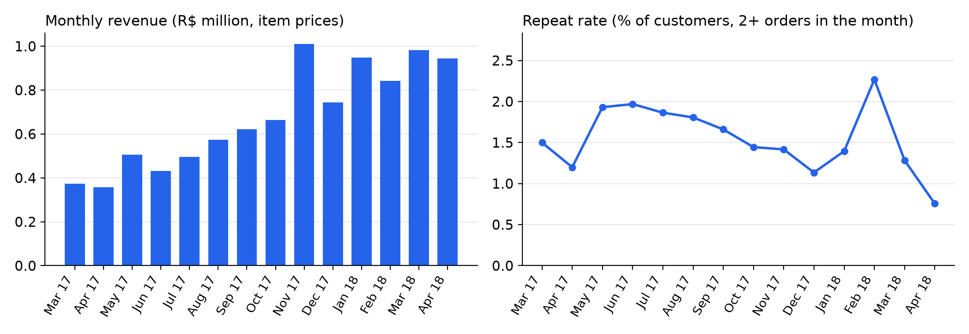
Figure 1. Monthly revenue and customer repeat rate, March 2017 to April 2018 (dashboard Business overview data) (F.BIZ.revenue_repeat).
Problem statement. The business goal is to restart sales growth and to raise satisfaction, and with it retention. Can Olist promise a delivery date it keeps, and reach unhappy customers before they review? The lead-time model gives a keepable promise, shorter than Olist's estimate and late less often (section 9); that this raises sales is a literature-supported hypothesis (Cui et al., 2024; Salari et al., 2022). The alert lets customer service reach at-risk customers first; that the contact improves retention is an unmeasured mechanism (section 10). We frame one delivery experience as two prediction tasks, each made at the moment the business can still act on it.
Table 2. The two prediction tasks.
 | Regression: delivery lead time | Classification: detractor alert
Question | How many days from purchase to delivery? | Will the customer leave a 1–2 star review?
Target | Lead time in days, purchase to delivery (modelled on the log scale) | Detractor: the order's lowest valid review score is 1 or 2
Prediction moment | At checkout | At carrier handover (Pipeline A predicts at checkout)
Who uses it, and how | Fulfilment and customer service show a delivery range to the customer when the order is placed | Customer service contacts customers at risk after the parcel is handed to the carrier, before the review is written
Primary metric | MAE in days; RMSE, R² and the share within 3 days reported beside it | Average precision (AP); ROC-AUC, Brier score, precision and recall at the threshold reported beside it
Cost of an error | A late promise breaks the customer's expectation; an early one only looks pessimistic | One missed detractor is weighted as five false alerts (an assumption, used to set the threshold)
Why these moments. At checkout the platform has the basket, prices, locations and the seller's past behaviour, which is what a delivery promise can use. A review alert at checkout would come too early: the strongest signal of a bad review is a late delivery, and nothing about this order's dispatch is known yet. At carrier handover the seller's delay is known and there is still time to contact the customer. Orders that are never handed over cannot be scored; a simple rule flags them when the shipping limit passes (section 9).
Why MAE and AP. MAE is measured in days, the unit of the promise, and is less driven by a few very late orders than RMSE, which we report alongside. Detractors are a minority of orders (9.9% of Pipeline B's test orders), so accuracy would look high for a model that never alerts: with imbalanced classes, accuracy can hide weak detection of the minority class (He and Garcia, 2009). AP summarises precision over all recall levels; a random ranking scores about the detractor share, so that share is the baseline AP is judged against. The cost weighting turns the ranking into a decision: the alert threshold is the probability above which an alert costs less than a likely missed detractor.
How we judge success. Each task has two yardsticks on the same test orders. The first is the dummy model (the median lead time or the detractor share for every order), which a useful model must beat clearly: the delivered model's test MAE is 3.30 days against 4.38, and its AP 0.197 against a detractor share of 9.9%. The second is Pipeline A (section 1.1). The rules for keeping a more complex model and for adopting Pipeline B were fixed before the test was read; no business target was set in advance.
Stakeholders. Fulfilment owns the delivery promise; customer service owns the alert and the contact; seller management uses both to see which sellers and routes fall behind. Each gets a view in the dashboard (section 8).

1.1 From baseline to delivered model
Pipeline A was built first, for every order, and is sound. Its validation results beat its dummies: MAE 5.47 days against 6.49 for its dummy, and AP 0.232 against 0.148.
Its own exploration then showed three limits, and each led to one change in Pipeline B, the delivered model (Table K1):
- Late delivery, the strongest signal of a bad review, is unknown at checkout (57.2% detractors when late against 9.5% on time). The alert moves to carrier handover, where this order's dispatch delay is known; orders never handed over are flagged by a rule.
- Delivery speed varies with the route and over time (section 4), but checkout features carry no recent seller or route behaviour. Pipeline B adds seller and route history features (section 5.1), checked by ranking and selection (section 5.3) and by validation scores.
- Distant, thinly served states add noise that a single model fits poorly. Pipeline B is scoped to the seven largest states with a known distance; Pipeline A serves every other order, and the scope effect is measured separately (section 7.3).
Pipeline B was adopted only after it beat Pipeline A on the same validation folds, under a rule fixed before the test (section 6.5). Pipeline A's frozen model still serves every order outside the seven states.

2 Literature review
The literature shaped what the predictions are for, how the models are compared and how the evaluation guards against optimistic results. Every source was checked against the publisher's record; a source whose detailed results were not audited is cited only for the question it studies.
Delivery promises and ratings. Cui et al. (2024) separate the delivery speed promised to shoppers from the speed actually delivered: in an experiment with an online retailer, faster promises raised sales and profit, but also raised returns and reduced customer retention. Faster actual delivery raised online sales at a US retailer (Fisher et al., 2019), and forecast-based promises raised simulated sales at JD.com (Salari et al., 2022). Our lead-time model is therefore the input to a promise range (section 9), not a single date to display. Deshpande and Pendem (2023) study how logistics performance and ratings relate to purchasing behaviour and sales; we cite them only for that question, not for any effect or direction. The link our alert relies on, between late delivery and bad reviews, is measured in our own data (section 4). None of the audited sources predicts a bad review at the moment a parcel is handed to the carrier, or separates the seller's dispatch delay from the carrier's transit time; both are central to this project (section 5).
Choosing models. Müller and Guido (2016) recommend simple baselines, keeping training and test data apart, and fitting preprocessing inside a pipeline so that it does not leak information from the evaluation data. James et al. (2023) explain that a more flexible model trades lower bias for higher variance, and that resampling estimates how a model generalises. Our model ladder therefore starts from a dummy and from plain linear and logistic regression, and keeps a more complex model only when resampled validation shows it is better (section 6.2). A random forest averages many randomised trees (Breiman, 2001), and on the medium-sized tabular datasets they studied, tree ensembles remained strong baselines against deep learning (Grinsztajn et al., 2022), so the forest is our non-linear comparison. Stacked generalisation (Wolpert, 1992) and gradient tree boosting (Chen and Guestrin, 2016) were considered but not added: the project limits the number of model families, and the forest itself did not clear the selection rule.
Evaluation without optimism. Kapoor and Narayanan (2023) show that leakage takes several forms beyond overlap between training and test rows, and find it inflating reported results across many published studies. Our defences are a leakage rule for each prediction moment, time-ordered folds that purge returning customers, preprocessing fitted inside each fold and a test period read once (sections 3 and 6). He and Garcia (2009) review learning with unequal class sizes: accuracy can hide weak detection of the minority class, and evaluation should reflect the class balance and the cost of each error. We therefore judge the alert by average precision against the detractor share and set its threshold from an assumed cost ratio. For logistic risk models, Van den Goorbergh et al. (2022) show that imbalance corrections can harm the calibration of the predicted risks; our cost threshold needs calibrated probabilities, so we tested class weighting as a grid option but did not resample (section 6.3).

3 Data and preprocessing
Every model row is one order, built only from what is known at that task's prediction moment, and every step below states its rule, its reason and where it is fitted. Steps learned from data are fitted on each training fold only, inside one scikit-learn pipeline, so no statistic from a validation or test order reaches a model (Kapoor and Narayanan, 2023; Müller and Guido, 2016).
Sources and joins. We use the nine tables of the Canvas copy of the Olist dataset, with the order as the unit. Items, payments and reviews have several rows per order, so each is aggregated to the order first and then joined one to one; customers join many to one. From the items we take the counts of items, products, sellers and categories, the total price, freight, weight and volume, and the primary item (the highest-priced, ties broken by item id), which gives the primary category and the primary seller. From the payments we take the main payment type and the largest number of instalments. Locations come from the median latitude and longitude of each ZIP prefix inside Brazil; the distance feature is the largest seller-to-customer distance in the order. Customers are matched across orders on customer_unique_id, because customer_id is new for every order; this is what lets us keep the same customer out of both training and test. Table G1 gives the data model: each table's grain, key and how it reaches the order.
Targets. Lead time is the number of days from purchase to delivery, for delivered orders with valid timestamps. The detractor label is 1 when the order's lowest valid review score is 1 or 2. An order can have more than one review; taking the lowest could bias the label towards detractors, so every classification result is also scored against the first-review label. The two agree closely on the test: Pipeline B's AP is 0.197 under the lowest-review label and changes only in the fourth decimal under the first-review label (Table K2), so the choice does not drive the conclusions.
Which orders each task keeps. Both tasks drop orders purchased before 2017 (the 2016 months are too thin to represent the business), orders without items, orders without a usable payment or with missing instalments, orders with a negative price, freight, weight, volume or distance, and orders whose distance exceeds the width of Brazil. Regression keeps delivered orders with a valid lead time, and removes lead times that are extreme against the development orders (above the larger of 100 days and the mean plus 12 standard deviations). Classification keeps orders that were not cancelled or unavailable and have a valid review; an order whose review is dated at or before its purchase is removed, because its label cannot be trusted. These are the eligible orders.
Leakage rules, set for each prediction moment. A column may be a predictor only if its value exists at the moment of prediction.
- At checkout (lead time, and Pipeline A's alert): delivery dates, carrier dates, the order status, the approval time and every review field are outcomes or later events and never predictors.
- At carrier handover (Pipeline B's alert): this order's handover facts are known, its handover delay against the shipping limit and its dispatch time, but its delivery and review are not.
- Olist's estimated delivery date is known at checkout but is never used, because it is the output of the very process our lead-time model would replace.
- History features (the seller's and the route's recent behaviour) use only other orders whose events were complete in the weeks before this order's prediction week; no order ever sees its own outcome.
Missing values, skew and outliers. Numeric gaps are filled with the training fold's median, and a missing-value indicator is added so the model can tell a filled value from a real one; categorical gaps become their own "Unknown" level. Skewed money, weight, volume, distance and day-count features are log-transformed (log of 1 plus the value); integer counts are left as they are. The long late tail of lead time is kept: very late orders are real customer experiences, so the regression predicts the log of 1 plus the lead time instead of trimming them.
Encoding and scaling. States, route and category are one-hot encoded; the linear and logistic models drop one reference level per variable so that the design matrix stays full rank, while trees keep every level. A level never seen in training is ignored at prediction time. Numeric features are standardised for the linear and logistic models only. All of this is learned on the training fold and applied unchanged to its validation fold.
Test period. For each task the newest 20% of eligible orders, by purchase time, form the test period. It was held out before any exploration or feature work, and development customers who reappear in it were removed. It was scored exactly once, for both pipelines together.
Pipeline B's population. Pipeline B (section 1.1) keeps orders whose customer and primary seller are both in the seven largest states (SP, MG, RJ, PR, RS, BA, SC) and whose distance is known, applies a tighter lead-time cap computed on its own rows (mean plus 8 standard deviations), and drops the first six weeks of data, which are needed to start the seller and route history. For the alert it also drops orders never handed over and orders reviewed before their handover. Table K3 and appendix G account for every order, including the final fit and fold 5.

4 Exploratory analysis
Exploration used development orders only, before each task's test period, so it never saw a test outcome. Each fact below led to a decision in the design; Table K4 lists them side by side. Patterns are described, not explained: the data does not record why a route is slow or why a customer is unhappy.
Lead time is right-skewed. Half of the orders arrive within 11.2 days, but a long tail of very late orders pulls the mean above the median: median 11.2 days, mean 13.4, 95th percentile 31.1, skewness 2.41. A model fitted on raw days would chase the tail, so the regression predicts the log of 1 plus the lead time, and day-count inputs are log-transformed the same way.
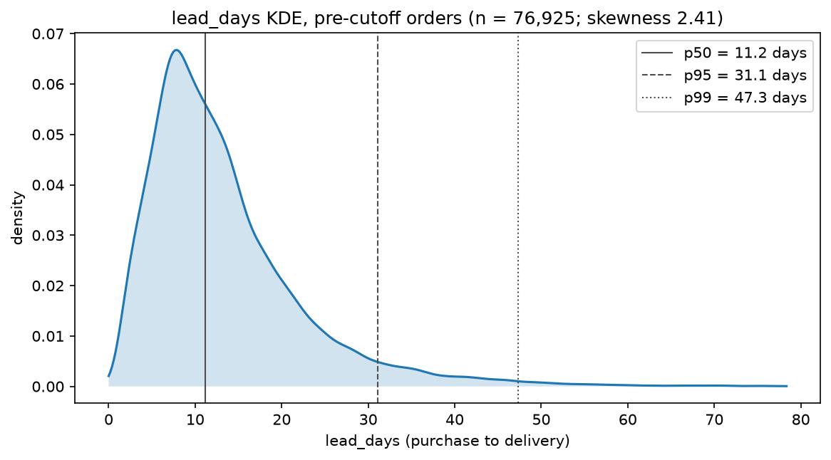
Figure 2. Lead-time distribution, development orders (F.A3.reg.target_kde).
Late delivery and bad reviews go together. Among orders delivered after Olist's promised date, the detractor rate is 57.2%; among orders delivered on time it is 9.5%. Lateness is known only after delivery, so it is never a predictor. But it explains why an alert made at checkout has little to work with, and why Pipeline B waits for carrier handover, when the seller's part of any delay is already known.
Speed depends on the route. Median lead time ranges from 7.8 days for customers in SP to 27.1 days in AM, and the share of late handovers differs between seller states and routes. A single distance number does not capture this, which motivated the route feature and the route's recent speed.
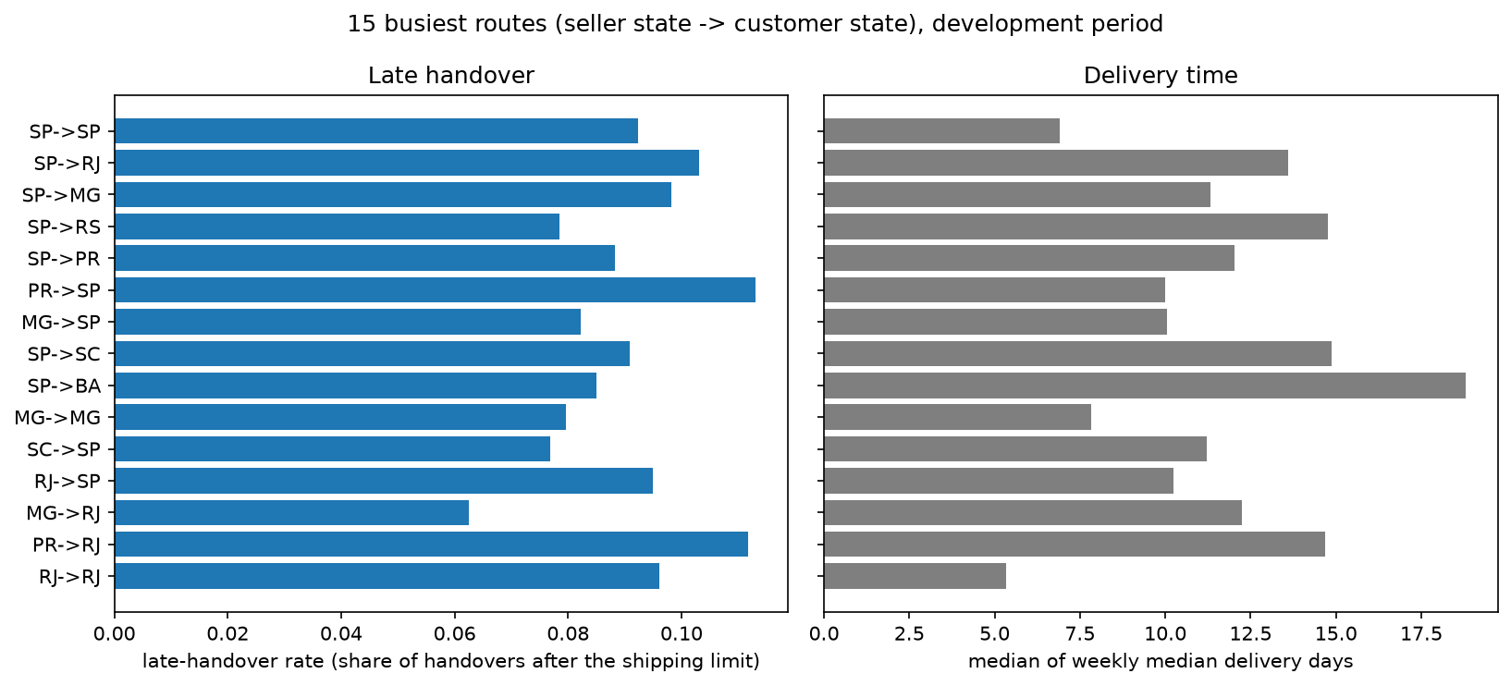
Figure 3. Late handover by route (F.reg.lateness_by_route).
The business changes over time. Order volume, lead time, the late-delivery rate and the detractor rate all move across 2017 and 2018. November 2017, with Black Friday, had 7,284 orders against 4,478 in October, and delivery slowed in the weeks after. A model evaluated on a random split would mix these periods; every evaluation here is time-ordered instead.
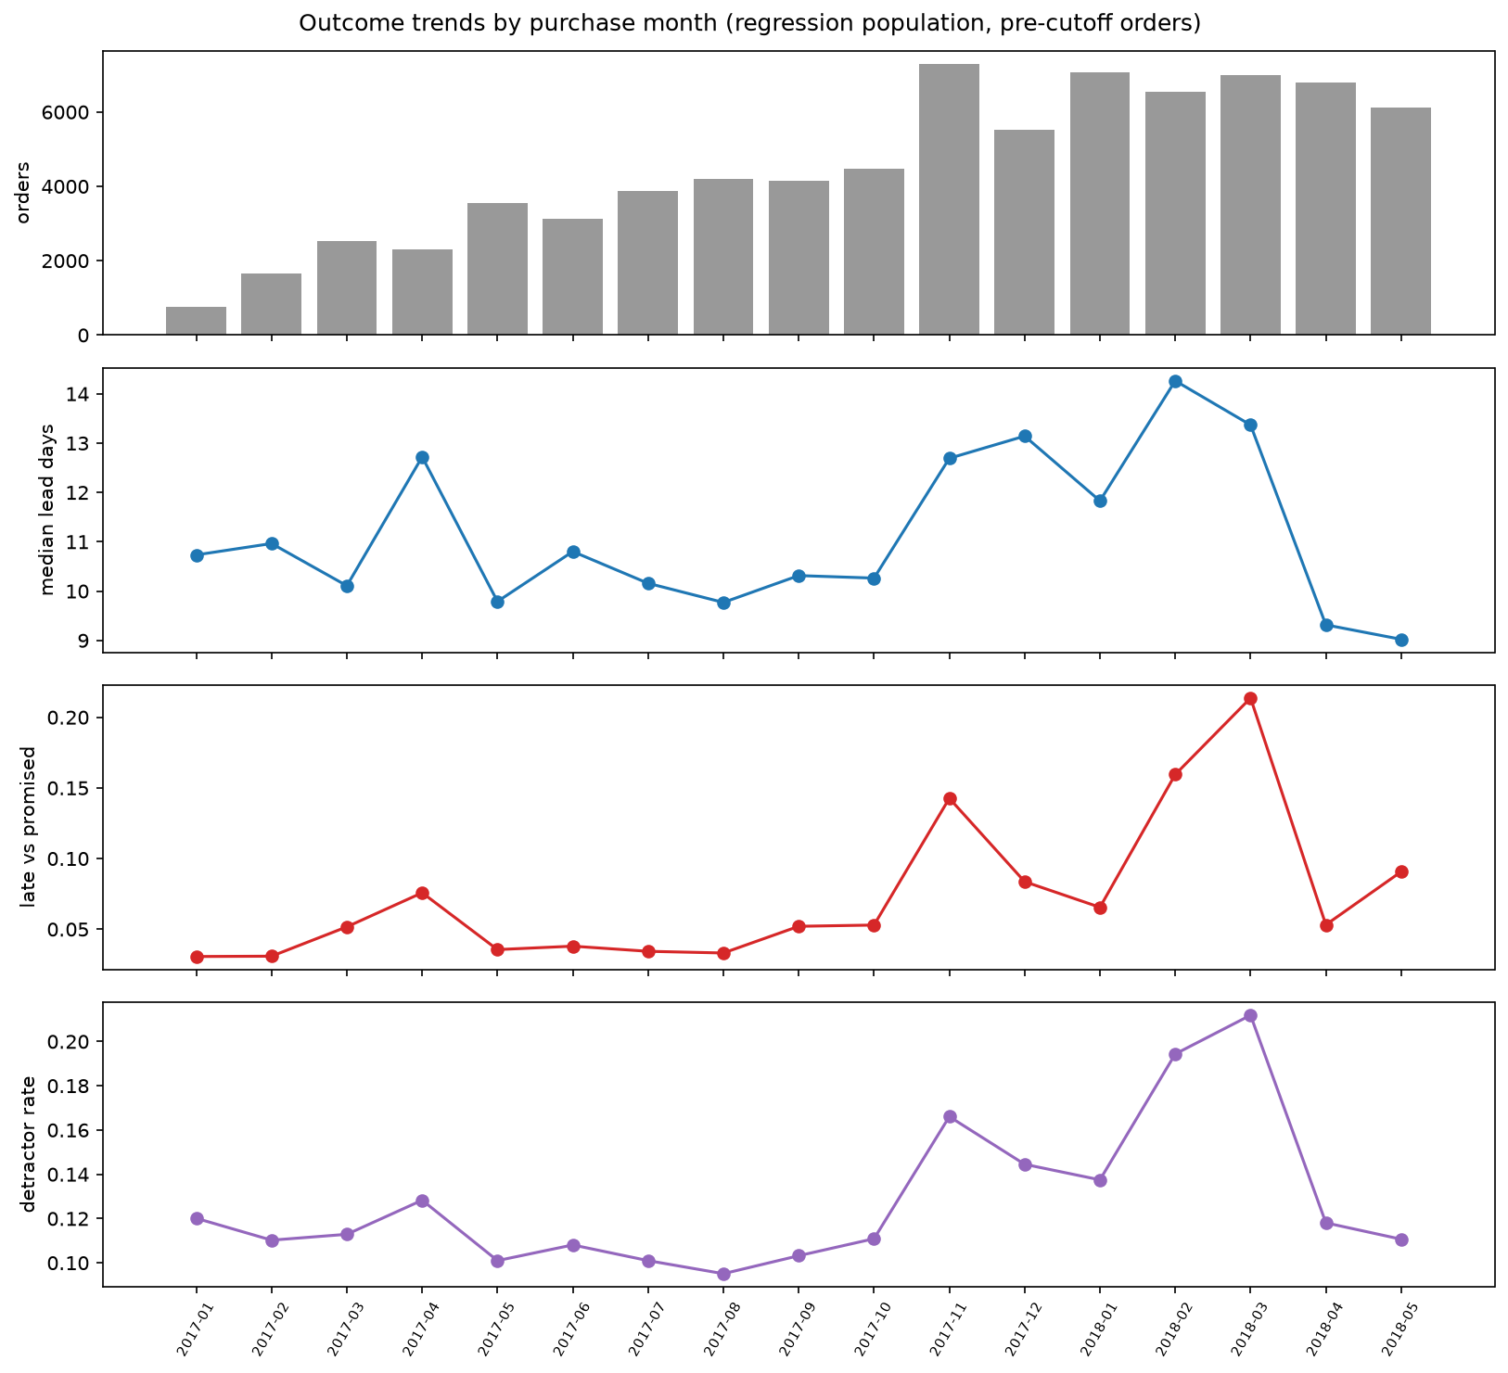
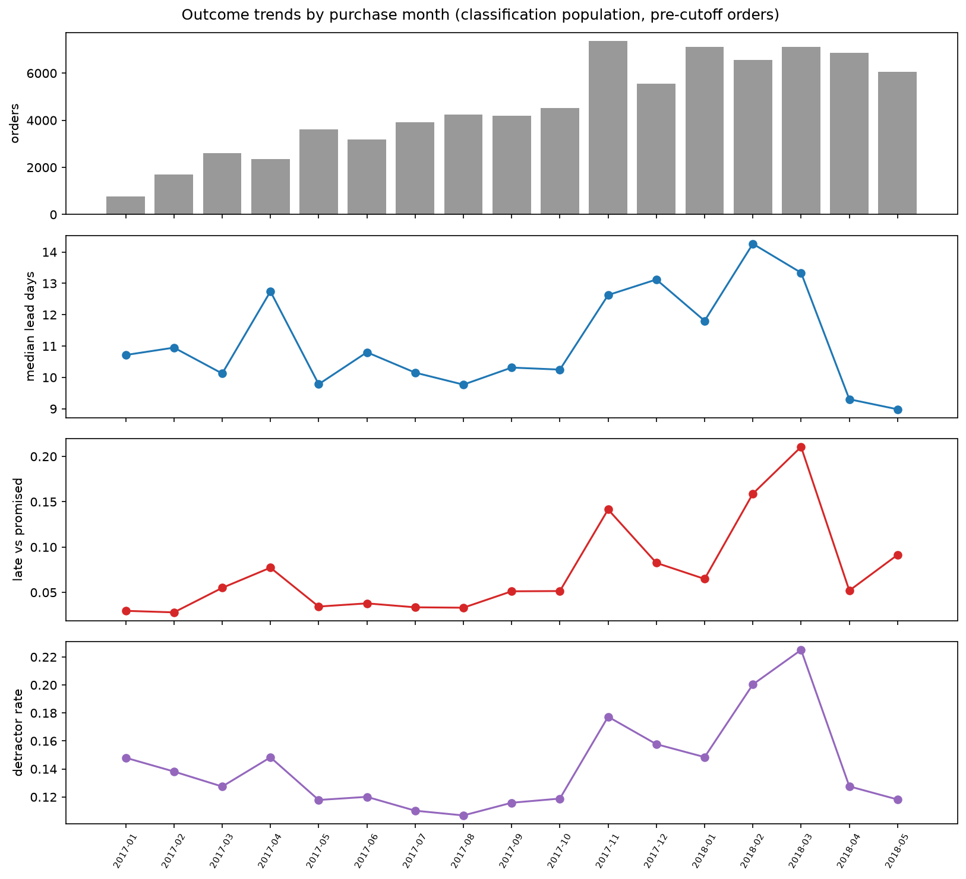
Figure 4. Monthly orders and lead time (F.A3.reg.outcome_trends).
Figure 5. Monthly detractor rate (F.A3.clf.outcome_trends), development orders.
Detractors are a minority. 14.8% of development orders are detractors (on Pipeline B's test orders, 9.9%), so a model that never alerts would look accurate. We report average precision against the detractor share and set the alert threshold from error costs.
Predictors overlap little. A first look at pairwise correlations among the numeric predictors found one identical pair and no other pair above the cut-off; section 5.2 checks this formally with the variance inflation factor.
The newest weeks may be incomplete. The data ends in late 2018. The slowest deliveries for orders placed in the final weeks may not have arrived when the data was extracted, so the test period, the newest fifth of orders, may under-represent very late deliveries and make its error look slightly better (section 10).

5 Features, multicollinearity and selection
Every feature has a definition, a time window and a reason. Correlated and nested features are removed by a stated rule before selection, and a ranking rule then keeps the smallest set that carries 99% of the ranked signal. Both steps run on development orders only, never on the test period.

5.1 Pipeline B's feature set
Pipeline B's new features describe how this seller and this route have delivered recently, measured only on other orders. None uses Olist's estimated delivery date, so none inherits the old promise. Pipeline B adds the route (seller state to customer state); the seller's prior late-handover rate, late-handover days and dispatch days, over all complete weeks before the prediction week; and the route's recent delivery days and carrier transit days, a weighted mean of the last three complete weeks (0.5, 0.3, 0.2). For the alert it adds two facts known at handover: whether, and by how many days, this order's handover missed its shipping limit, and the days from purchase to handover. Table K5 gives each feature's definition, window and reason. Table 3 gives the reason for each family of features, old and new.
Table 3. Feature families: when each is known and why it is included. The reasons are predictive hypotheses that selection and the models test, not causes.
Feature family | Examples | Available at | Why included
Geography and distance | Customer and seller state, route, distance, interstate share | Checkout | Longer and interstate journeys need more carrier legs; lead time rises with distance (section 4)
Route history (Pipeline B) | Route's recent delivery days and carrier transit days | Checkout, from complete weeks before | A route slow in recent weeks is likely slow now; tracks the current period's speed without Olist's estimate
Seller history (Pipeline B) | Seller's prior late-handover rate, late-handover days, dispatch days | Checkout, from complete weeks before | A seller who dispatched late before is likely to again; late handovers differ between sellers and states (section 4)
Basket complexity | Items, products, sellers and categories in the order | Checkout | More items and sellers mean more picking and separate parcels, and more chances for one part to go wrong
Price, freight and size | Price, freight, freight-to-price ratio, weight, volume, category | Checkout | Freight reflects distance and parcel size; heavy or bulky parcels may travel by slower services
Payment and calendar | Payment type, instalments, purchase hour, weekday and month | Checkout | Boleto payments clear before dispatch; weekend orders wait for the next working day; seasonal peaks load carriers
Handover lateness (alert only) | Missed shipping limit (yes or no, days late), days from purchase to handover | Carrier handover | A late handover is the first sign of a late delivery, and late delivery goes with more detractors (section 4)
A seller with no earlier handovers takes the recent mean of sellers in the same state. A route with fewer than ten deliveries in the last three weeks takes a blend of its seller state's and customer state's recent means, and then the overall mean. Most rows soon have their own seller and route history (figure below), which is why the first six weeks are used as a warm-up and not modelled.
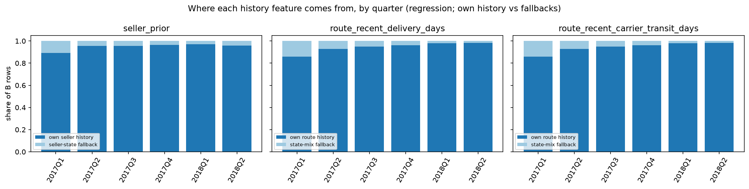
Figure 6. Share of rows with their own seller and route history, by quarter (F.reg.history_coverage).
Grounding. Logistics performance is studied alongside ratings and sales on e-commerce platforms (Deshpande and Pendem, 2023; cited for the question only). The reason to expect the seller's history to matter comes from our own data: late delivery goes with more detractors, and late handovers differ between seller states and routes (section 4). For the route features we found no audited source, so they rest on an operational assumption, that a route slow last week is likely slow this week, which section 7 tests.
Inherited from Pipeline A. Pipeline B starts from Pipeline A's 24 checkout predictors (the geography, basket, price and payment families of Table 3; formula and reason for each in Table D3). For the alert Pipeline A added three candidates kept after the exploratory screening: the primary product's photo count and description length, which set the customer's expectations, and the seller's average review score on earlier orders, which summarises the seller's past service. Skewed money, size, distance and day-count features are log-transformed, as described in section 3.

5.2 Multicollinearity check
Strongly correlated predictors make linear coefficients unstable and split importance between partners, even when accuracy is unaffected. The check uses only stored outputs:
- Pipeline B. The route determines both the customer state and the seller state: every route level fixes both, so their one-hot columns are sums of the route's columns. Keeping all three would make the linear design matrix rank-deficient, so the two state columns are dropped whenever the route is kept. The same step drops the missing-distance share, which is constant because every kept order has a distance, and the duplicate pair found in Pipeline A's pool (appendix J; Table K6). After encoding, a missing-value indicator identical to another column is also dropped (weight for the alert, volume for lead time).
- Every fold. After the drops, the linear design matrix is full rank in every training fold, so plain least squares and unpenalised logistic regression have unique coefficients. The condition number shows how close the columns come to collinearity (appendix C).
Pipeline A's pool, the inherited base, passed a correlation and variance-inflation check; correlation among the new history features was not measured (appendix J; section 10).

5.3 Feature selection
Selection ranks each candidate by its association with the target on development orders: the absolute Spearman correlation for lead time and mutual information for the alert. It then keeps features in rank order until they reach 99% of the cumulative score.
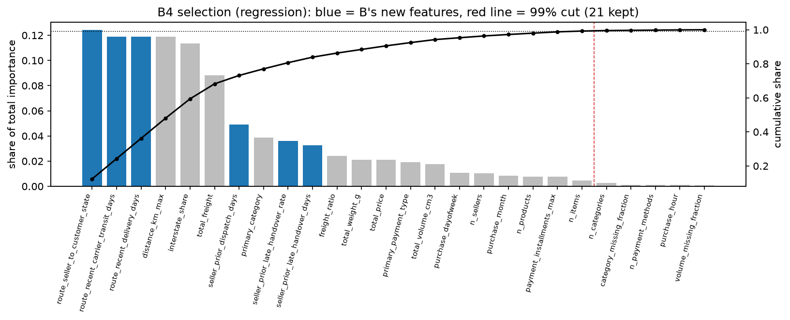
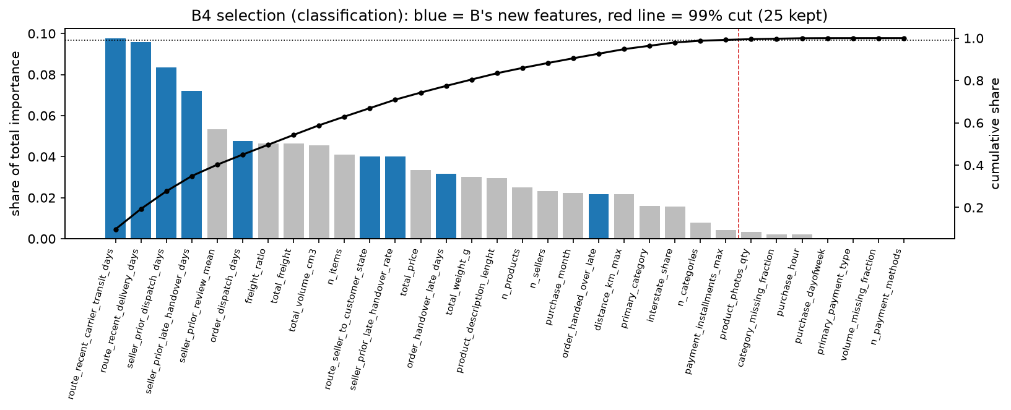
Figure 7. Feature ranking and the 99% rule, lead time (F.reg.selection).
Figure 8. Feature ranking and the 99% rule, detractor alert (F.clf.selection).
Ranking once on all development orders is a design choice, and it makes the validation scores slightly optimistic, because the folds' validation orders helped choose the features; the test period is unaffected. Repeating the ranking inside each training fold measures how much it depends on the rows (appendix I).
For lead time the ranking is stable: the route and its recent speed, distance and the interstate share stay at the top in every fold. For the alert the ranks move a lot between folds, most in the early folds with the fewest training orders, so its selected set is a reasonable choice, not a uniquely determined one (section 10; charts by fold in appendix I).
Every new feature passed the cut in both tasks where it applies. The full list of selected features, with transforms and ranks, is in appendix D, beside Pipeline A's, so the two pipelines can be compared feature by feature.

6 Modelling and the A-to-B decision
Models are compared from the simplest upwards, on the same time-ordered folds, under rules fixed before any test order was read. We first built a complete baseline (Pipeline A), then one focused improvement (Pipeline B) that changes only what Pipeline A's evidence pointed to; both were frozen and scored once on the test together.

6.1 Validation design
Leakage takes several forms beyond rows shared between training and test (Kapoor and Narayanan, 2023). Our orders are dated and customers return, so a random or stratified split would train on orders placed after the ones it predicts, and could put one customer on both sides. We therefore use five chronological, expanding folds before the test period: each fold trains on all orders up to a date and validates on the following weeks (windows and sizes in Tables A2 and A3). Customers seen in a validation window are removed from its training rows, and a training order counts only if its label (delivery or review) was known before the validation window starts.
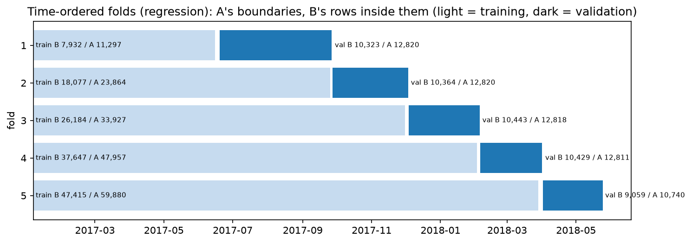
Figure 9. Time-ordered folds and the test period (F.reg.partition).
Minimum fold sizes were set before the folds were built; Pipeline B's fold 1 falls short on training orders and was kept as a recorded deviation, and instead of stratifying, each fold's detractor share is reported (appendix A). Every random step uses seed 42, so a rerun on the same machine reproduces every stored output exactly.

6.2 Model ladder
We use two model families, linear and tree-based, each started from its simplest variant, as the project description requires: a dummy that predicts the median lead time or the detractor share; plain linear regression or unpenalised logistic regression; a single decision tree; and a random forest of 200 trees (Breiman, 2001). Tree ensembles are the natural non-linear comparison for tabular data of this kind (Grinsztajn et al., 2022). Plain least squares and unpenalised logistic regression need a full-rank design matrix, which section 5.2 shows holds in every fold. Stacking and gradient boosting were considered but not added (section 2).
Each step up the ladder must beat the step below it on the same folds. Appendix H gives every candidate's fold scores; Tables K8 and K9 give the mean gain over the five folds, its paired standard error and the number of folds in which the more complex model wins (MAE in days, a positive gain means lower error; AP for the alert).
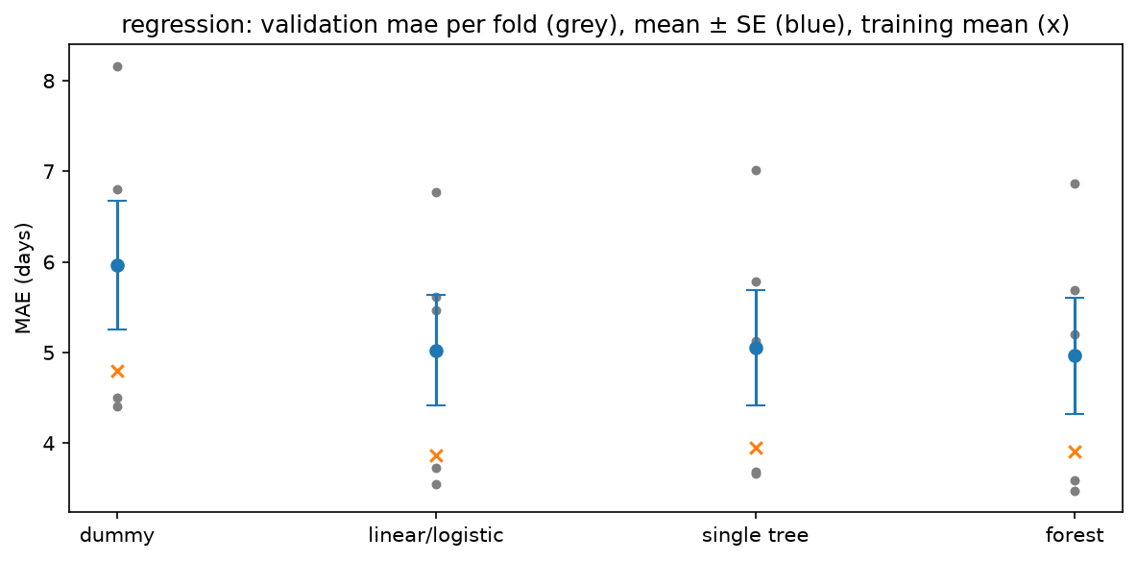
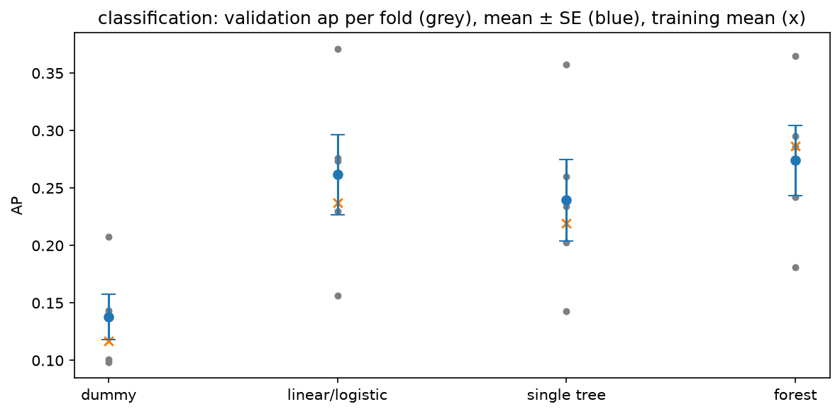
Figure 10. Model ladder on the five folds, lead time (F.reg.family_ladder).
Figure 11. Model ladder on the five folds, detractor alert (F.clf.family_ladder).
Training results. Tables 4 and 5 put each delivered model's training, validation and test scores side by side. Training and validation are means over the five folds; the test model is refitted once on all development rows. The gap is validation minus training.
Table 4. Training results, delivery lead time (MAE in days; lower is better).
Model | Final-fit rows | Training MAE | Validation MAE | Test MAE | Gap
Pipeline B, plain linear (delivered) | 59,683 | 3.86 | 5.02 | 3.30 | +1.16
Dummy (median) | 59,683 | 4.79 | 5.97 | 4.38 | +1.18
Table 5. Training results, detractor alert (AP; higher is better).
Model | Final-fit rows | Training AP | Validation AP | Test AP | Gap
Pipeline B, plain logistic, raw probabilities | 59,188 | 0.237 | 0.262 | 0.199 | +0.025
Pipeline B, plain logistic, calibrated (delivered) | 59,188 | none (see text) | 0.248 | 0.197 | none
Dummy (detractor share) | 59,188 | 0.117 | 0.138 | 0.099 | +0.021
The plain models do not overfit. For lead time the dummy, which has no features, shows the same gap as the linear model, so the gap is a period effect: the validation weeks were slower than the training weeks, and the test weeks faster. For the alert, validation AP is slightly above training AP for both the logistic model and the dummy, because the validation windows hold more detractors. The calibrated model has no single training AP: its sigmoid is fitted on time-ordered inner splits of each training fold, so the calibrated scores exist only out of sample. The raw row shows how the same logistic model fits its own training rows; calibration then maps its probabilities onto the shared scale used for the threshold and costs (section 6.4). The learning curves (appendix H) show that the most recent orders predict best and that more data narrows the gap without lifting validation much.

6.3 Tuning
Each family was then tuned on the same folds, with grids fixed before any tuning result was seen (Ridge alpha, logistic C, tree and forest depth and leaf size, and class weight for every classifier; appendix F). Class weighting is how the grid treats the imbalance. We did not resample: the alert uses calibrated probabilities and a cost-based threshold, and in logistic risk models imbalance corrections can distort the calibration of the predicted risk (Van den Goorbergh et al., 2022).
Tuning changed little (Tables K10 and K11). For lead time the tuned linear model's paired gain is +0.004 days and the tuned forest's -0.119; for the alert the tuned logistic model gains +0.012 AP, well inside its fold-to-fold standard error of 0.032, and the tuned forest -0.011. No tuned configuration beat its plain model by enough to be carried forward. The forest's best configuration sits at the edge of its grid in both tasks, so a wider grid might do better; the grid was fixed in advance and not extended, because the selection rule below keeps the plain model either way (section 10).

6.4 Selection, calibration and threshold
The one-standard-error rule. Among the finalists, we keep the simplest model whose mean validation score is within one standard error of the best mean, where the standard error measures how much the score varies from fold to fold. The forest had the best mean in both tasks, but within one standard error of the plain model, so the plain linear model (lead time) and the plain logistic model (alert) were selected. This is a deliberate preference for simplicity: for the alert the forest wins in four of five folds by more than its paired standard error, but by much less than the fold-to-fold variation the rule uses, and the simpler model is easier to explain, calibrate and serve.
Calibration. The alert's probabilities are calibrated with a sigmoid fitted on time-ordered inner splits, so that both pipelines share one probability scale for thresholds and costs. The pre-set rule preferred the raw probabilities (slightly better Brier score); we kept the sigmoid for comparability, a recorded deviation (section 10).
Threshold. With a missed detractor weighted as five false alerts, an alert pays off when the predicted risk exceeds 1/6, and that is the frozen threshold. After the test, the business chose a higher operating threshold for Pipeline B, 4/15, to cut false alarms; the frozen 1/6 result stays the unbiased test result (section 7).

6.5 Adopting Pipeline B
Section 1.1 sets out Pipeline A's limits and the change each one led to.
The adoption rule, fixed before the test. Pipeline B is adopted for a task if, on its own validation rows, its five-fold mean beats Pipeline A's frozen model refitted on the same folds, even by a small margin. It did, in every fold of both tasks (Tables K12 and K13): Pipeline B's MAE is lower by 0.001 days in fold 1 up to 0.337 in fold 4, and its AP (before calibration, as the rule specifies) higher by 0.006 in fold 5 up to 0.035 in fold 2.
Both pipelines then went to the single test read regardless of this result, and the test did not re-choose any model, calibration or threshold. Everything else was inherited unchanged from Pipeline A: the folds, the model families and grids, the selection rule, the metrics and the calibration and threshold procedure.

7 Results
On the same test orders Pipeline B beats Pipeline A in both tasks. Validation scores were used to choose the models, so they are optimistic selection scores; only the test, read once, is an unbiased estimate.

7.1 Delivery lead time
Table 6. Delivery lead time, validation and test results.
 | Training MAE | Validation MAE (selection) | Test MAE [95% interval] | Test RMSE | Test R² | Within 3 days (test)
Pipeline B (delivered) | 3.86 | 5.02 | 3.30 [3.24, 3.35] | 4.77 | 0.185 | 57.6%
Pipeline A on the same test orders |  |  | 4.03 | 5.36 | -0.027 | 44.3%
Dummy (median) on the same test orders |  |  | 4.38
Pipeline B's MAE minus Pipeline A's is -0.729 days on the same 15,422 test orders (paired bootstrap interval -0.754 to -0.703), so the gain is not an accident of the sample. RMSE, which weights large misses more, and R², the share of the variation in lead time that the model explains, point the same way. R² is low for both: much of the variation in delivery time is not visible at checkout. Pipeline A's R² on these orders is below zero, so it does worse than predicting the test period's average lead time, consistent with the faster test period (section 7.4).
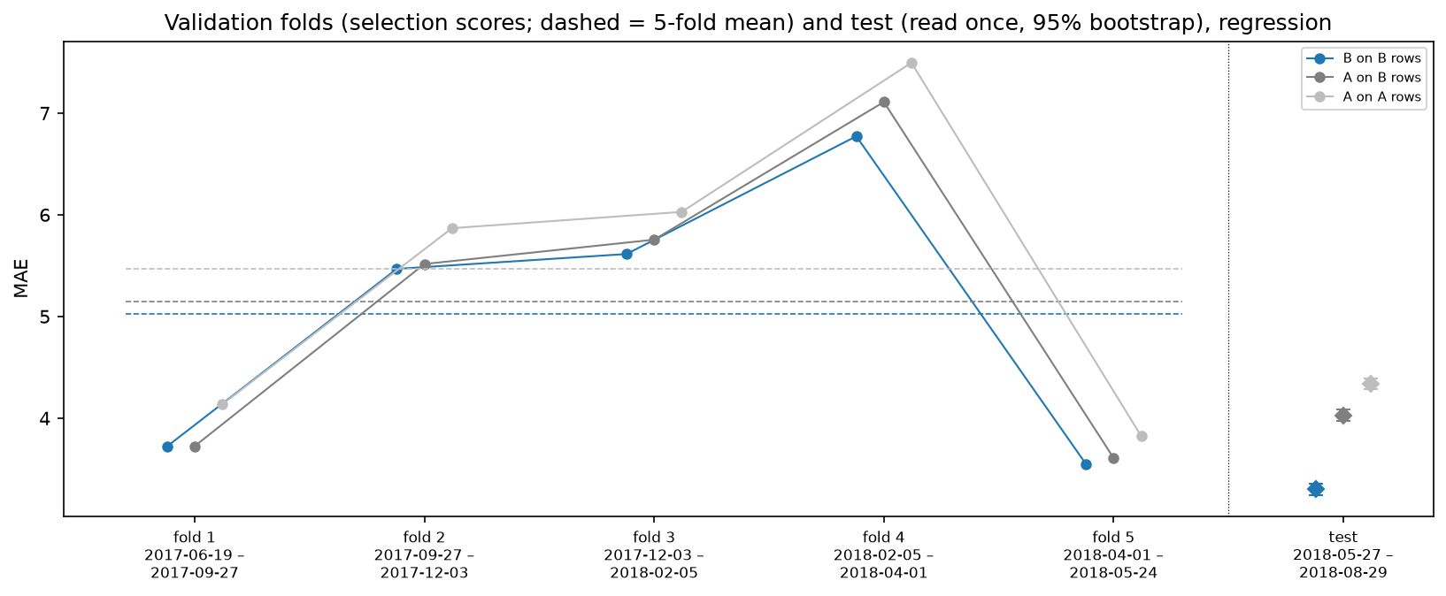
Figure 12. Delivery lead time: validation folds (selection scores) and the test, A and B (F.reg.validation_and_test).

7.1.1 Error analysis, lead time
A residual is the actual lead time minus the prediction: positive means the order arrived later than predicted.
Table 7. Residuals on the test orders (days, actual minus predicted).
 | Mean | Median | 5th / 95th percentile | Within 3 days | Over 3 days late | Over 6 days late | Over 3 days early
Pipeline B | -1.14 | -1.64 | -6.93 / +5.77 | 57.6% | 11.1% | 4.7% | 31.4%
Pipeline A, same orders | -2.22 | -2.72 | -8.34 / +5.33 | 44.3% | 9.3% | 4.3% | 46.4%
Early or late. On the test the errors lean early (mean -1.1 days): the typical order arrives sooner than predicted, and early misses of more than 3 days outnumber late ones. On validation they leaned late (mean +2.9 days, with a long right tail), because the test period was faster than the development period (section 7.4). The residuals are therefore neither centred on zero nor constant in spread, so a promise built on the prediction needs a buffer chosen for the current period (section 9). The late tail is what breaks a promise, and Pipeline B's is slightly heavier than Pipeline A's because it predicts shorter lead times (residual figure in appendix E).
Where it errs. Error grows with distance, from 2.46 days of MAE in the shortest distance band to 5.31 in the longest. By customer state it is largest in Bahia (6.01) and smallest in São Paulo (2.61); the worst judged route is São Paulo to Bahia (6.12). Single-item baskets err slightly more than baskets of three or more items (3.33 against 3.01). The one slice where Pipeline B is not better than Pipeline A is the first, partial test month, May 2018 (3.38 against 3.33 on 507 orders).
Too small to judge. Slices are judged only with at least 100 test orders. Every state, distance band, basket size and month qualifies, but 28 routes do not; Pipeline B is better on 20 of the 20 judged routes (Table K14; by state in appendix E).

7.2 Detractor alert
Table 8. Detractor alert, validation and test results.
 | Validation AP (selection) | Test AP [95% interval] | Test ROC-AUC | Test Brier
Pipeline B (at handover) | 0.248 | 0.197 [0.181, 0.218] | 0.636 | 0.0867
Pipeline A on the same test orders (at checkout) |  | 0.178 | 0.604 | 0.0893
Pipeline B ranks detractors better by +0.0187 AP (paired interval +0.0089 to +0.0291) on 15,492 test orders with 1,541 detractors, and is better on ROC-AUC and on the Brier score, which measures how well calibrated the probabilities are. The two pipelines predict at different moments, so part of the gain is the later moment itself.
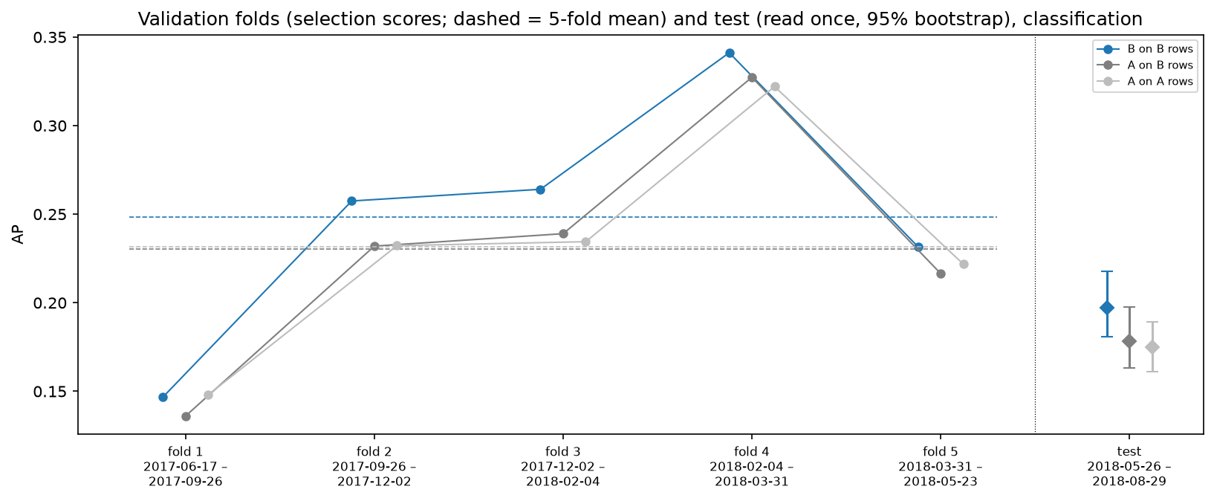
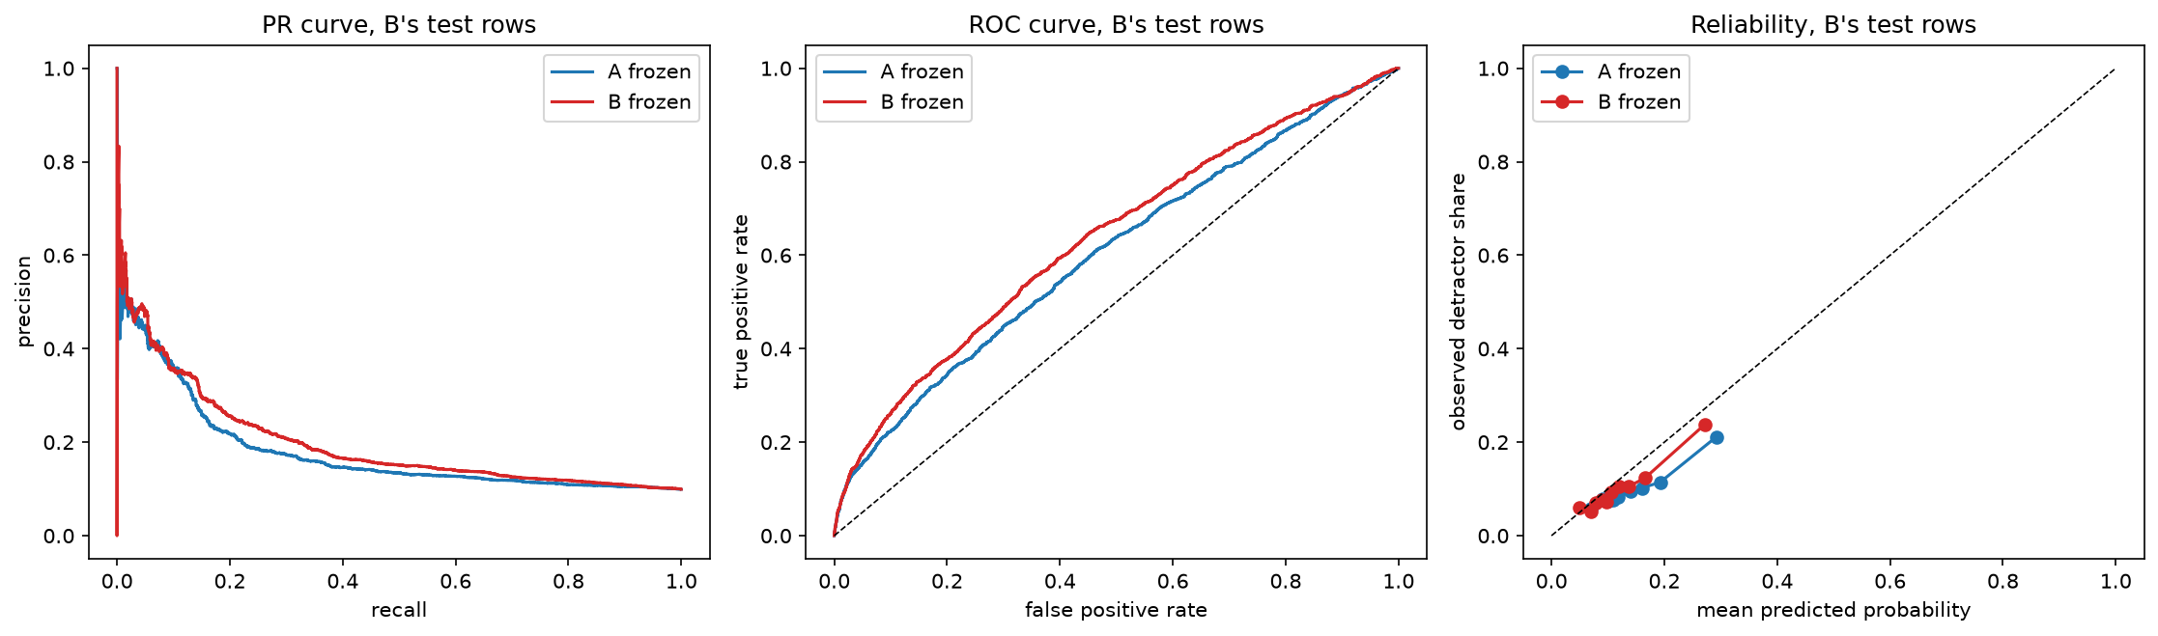
Figure 13. Detractor alert: validation folds (selection scores) and the test, A and B (F.clf.validation_and_test).
Figure 14. PR, ROC and reliability curves on B's test rows (F.clf.test_curves).
At the threshold. At the frozen 1/6, the unbiased result, Pipeline B sends 23.2 alerts a day on the test, with an F1 score of 0.246 against Pipeline A's 0.219 at its own 1/6 on the same orders (precision and recall in Table 9). After the test the business moved its operating threshold to 4/15 to cut false alarms (5.6 alerts a day), a post-test change reported beside the frozen result. Orders outside the seven states are alerted by Pipeline A at its frozen 1/6 (section 9).
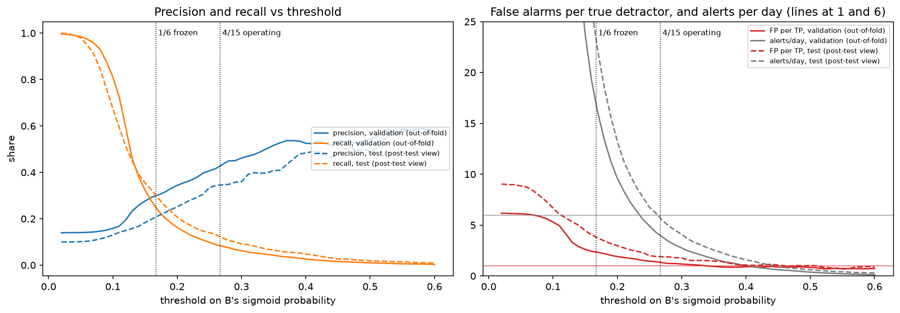
Figure 15. Precision, recall and alerts per day against the threshold (F.clf.threshold_options).

7.2.1 Error analysis, detractor alert
A true positive (TP) is an alerted detractor, a false positive (FP) an alert on a customer who was not a detractor, and a false negative (FN) a detractor the alert missed.
Table 9. Confusion counts on Pipeline B's test orders (15,492 orders, 1,541 detractors).
Model and threshold | Alerts | TP | FP | FN | Precision | Recall | FP per TP
Pipeline B, frozen 1/6 | 2,229 | 463 | 1,766 | 1,078 | 0.208 | 0.300 | 3.8
Pipeline B, operating 4/15 (post-test) | 540 | 187 | 353 | 1,354 | 0.346 | 0.121 | 1.9
Pipeline A, frozen 1/6, same orders | 3,462 | 548 | 2,914 | 993 | 0.158 | 0.356 | 5.3
More false positives or false negatives. At the frozen 1/6 Pipeline B makes more false positives than false negatives (1,766 against 1,078), as the cost weighting intends: a missed detractor counts as five false alerts. At 4/15 the balance flips: false positives fall to 353 and false negatives rise to 1,354. Pipeline A catches more detractors on the same orders, but with 5.3 false alerts for each one.
Which threshold for which constraint. 1/6 minimises the five-to-one cost and suits a team that can work 23.2 alerts a day. 4/15 suits a team with capacity for about 5.6 a day that wants each contact to be worth making (precision 0.346). Missing fewer detractors would need a threshold below 1/6 and more capacity (figure above).
Which orders it gets wrong. Pipeline B misses 70% of the detractors at 1/6, and for most of them the delivery went to plan, so the reason for the review is not in the data; false alerts are often late handovers that the carrier made up (appendix E, Table E4).
Too small to judge. Slices are judged only with more than 100 test detractors: 3 customer states and 3 routes qualify, while 4 states and 45 routes are too small (Table E3). In every judged slice Pipeline B is more precise; Pipeline A, which alerts more orders, has the higher recall in most of them.

7.3 Where the gain comes from
Pipeline B changed three things at once: the scope, the features and, for the alert, the prediction moment. Scoring Pipeline A's frozen model on Pipeline B's own validation rows separates the scope effect from the rest (five-fold means, Table K15).
For lead time, Pipeline A's MAE falls from 5.470 days on all states to 5.142 on the seven-state rows, and Pipeline B reaches 5.025: most of the lower error comes from the narrower scope, the rest from the new features. For the alert, on the calibrated scale of Table 8, Pipeline A's AP barely moves (0.232 to 0.230) while Pipeline B reaches 0.248, so the gain comes from the history features and the later prediction moment. ROC-AUC and Brier by population are in appendix E.
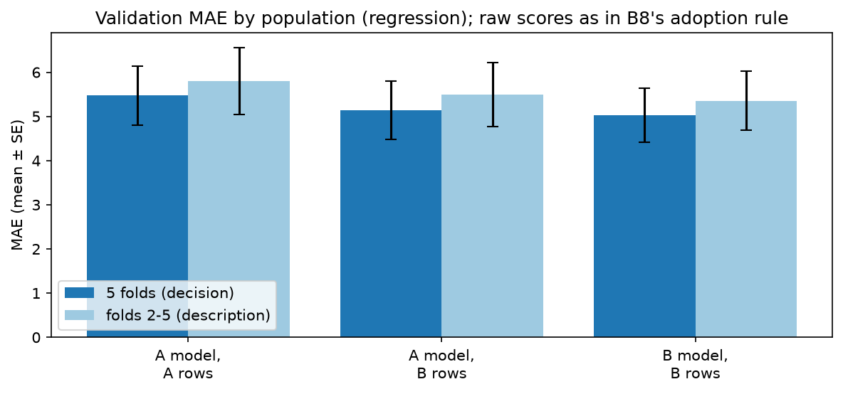
Figure 16. Where B's gain comes from: scope vs features (F.reg.population).

7.4 What the models rely on, and drift
Permutation importance is the test score the frozen model loses when a feature is shuffled. For lead time the seller's earlier dispatch days, the route and the distance rank highest, so the seller's own delay matters at least as much as the journey. For the alert, the number of sellers in the order and the route's recent delivery and transit times rank above this order's handover delay, so route conditions and basket complexity carry more signal about a bad review than the dispatch delay alone. These are associations in the frozen model, not causes.
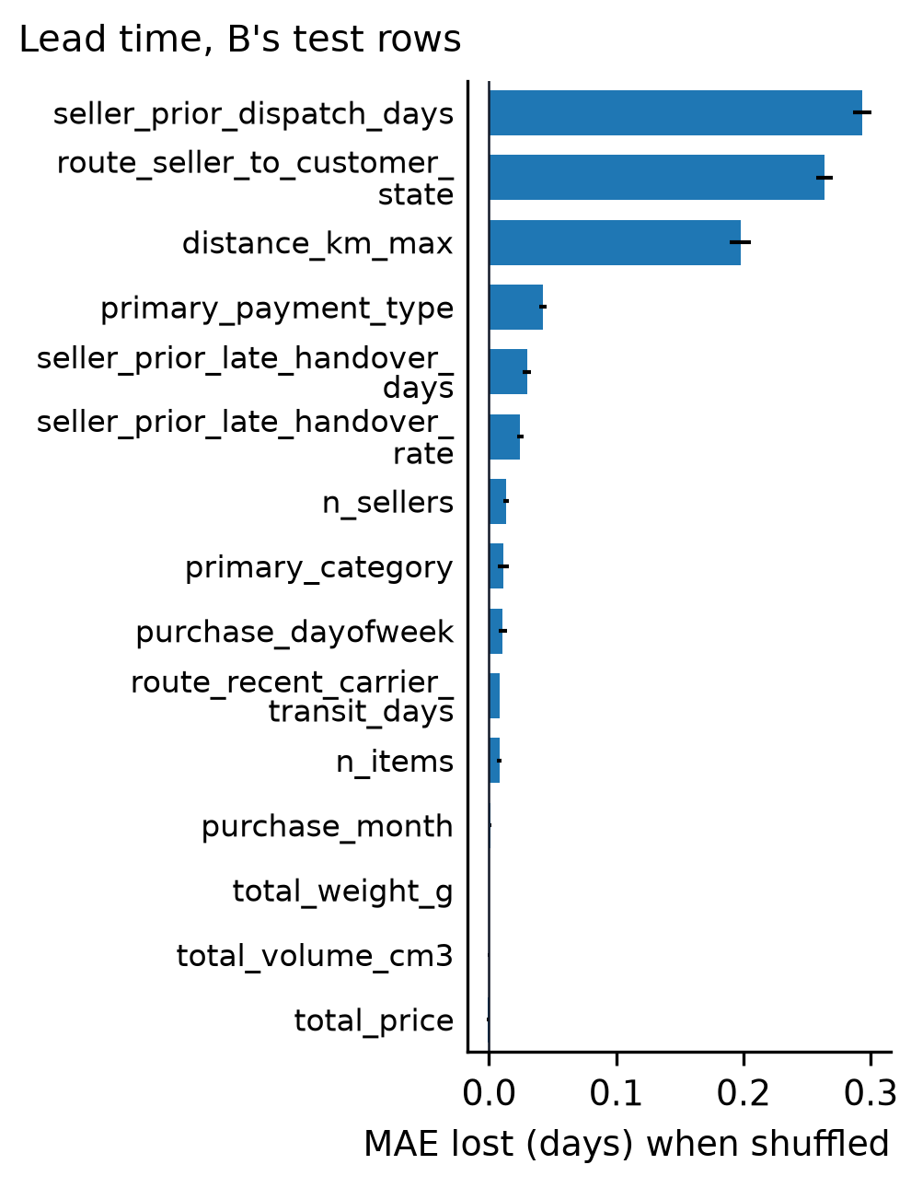 | 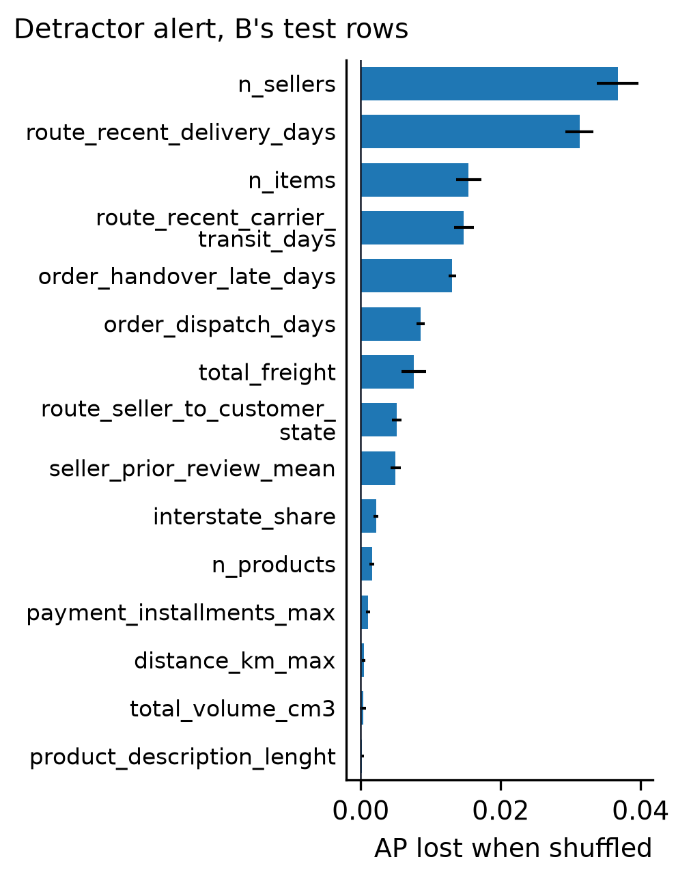
Figure 17. Permutation importance, lead time (F.reg.importance.report). | Figure 18. Permutation importance, detractor alert (F.clf.importance.report).
It differs from the selection ranking of section 5.3, as expected: selection scored one feature at a time, while importance is measured inside the fitted model, where correlated features share credit (appendix I).
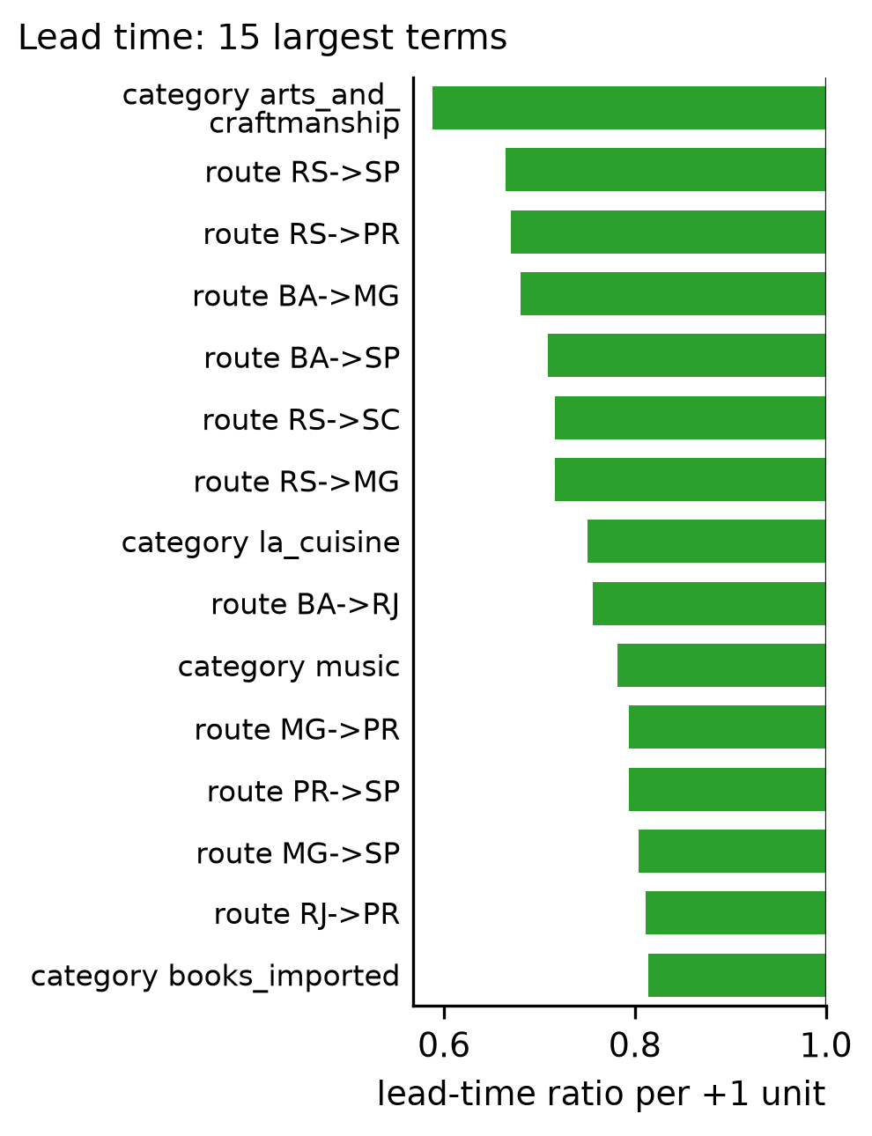 | 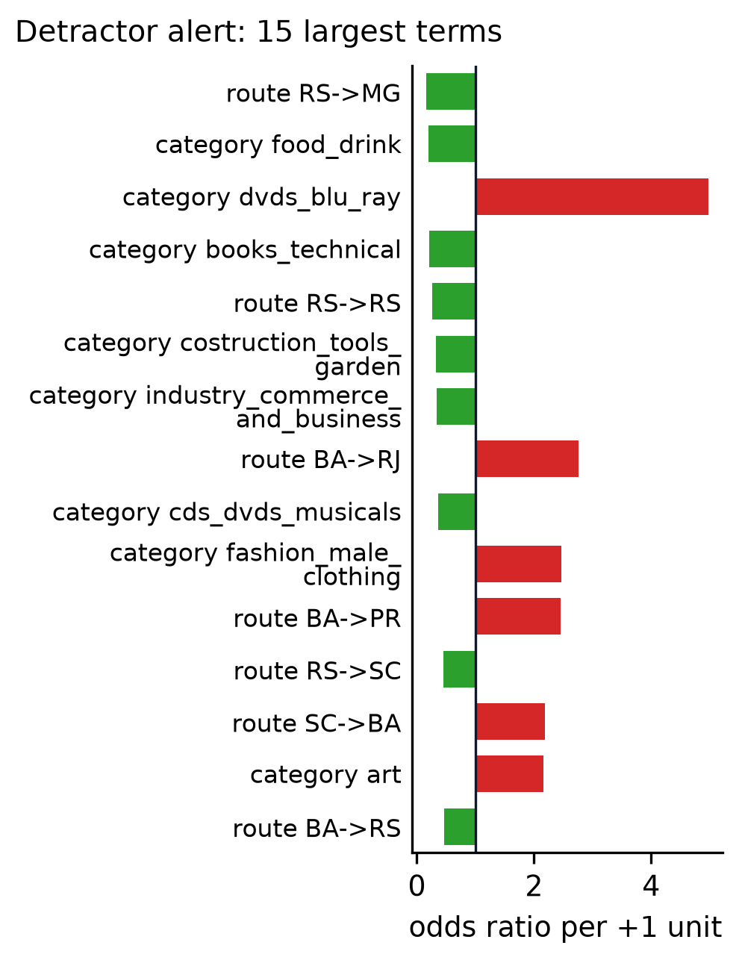
Figure 19. Coefficients, lead time (F.reg.coefficients.report). | Figure 20. Odds ratios, detractor alert (F.clf.coefficients.report).
The test period was faster and happier than development, and the route history features shifted most (drift by fold in appendix A).

8 Deployment and dashboard
The released models predict exactly what was tested, and the dashboard shows only stored results, each labelled with the model that produced it.
Release package. For each task, Pipeline B's frozen model and Pipeline A's (as fallback) are packaged with their feature schemas, training profiles and checksums. Reloaded from disk, they re-predict the saved test predictions exactly (largest difference 1e-14 for lead time and 2e-16 for the alert), from test rows rebuilt with every label column emptied, so no label is read.
Serving rule. A router sends each order to Pipeline B when its customer and seller are both in the seven states and its distance is known, and to Pipeline A otherwise (15,570 and 3,396 of the alert's test orders). Every prediction carries a badge naming the model and, outside the seven states, the reason. Inside the seven states, an order not yet handed over gets no alert score; the missed-dispatch rule flags it if its shipping limit passes.
Dashboard. A Streamlit app with four tabs: a business overview of all orders (descriptive, labelled as a separate scope from the model results), delivery lead time, detractor risk at handover, and ML deployment, which scores the alerted held-out orders. The model tabs read only stored outputs and score held-out historical orders. The alert tab's threshold slider moves Pipeline B's threshold over the stored options (default 4/15) and shows alerts per day, precision, recall and cost; the baseline's fallback stays at its frozen 1/6.
Using the app. The app lives in deliverables/dashboard/app/ with its own pinned environment; streamlit run app.py, from that folder or from the repository root, opens it locally (its README gives the commands). The hosted app at https://it5006grp11ecommerce.streamlit.app/ runs the same frozen bundles. Appendix L describes each tab, the files it reads, the input checks and the app's tests.

9 Business recommendations
The models serve one chain: promise, dispatch, transit and, if the order is still late, service recovery before the review. This section reuses the saved test predictions and labels of Pipeline B's 15,422 test orders after the test, with no refit; the 12.0-day buffer chosen on validation remains the unbiased result. Tables K16 and K18 to K22 give the detail.
1. Promise (observation; literature-supported hypothesis for sales). Olist's own estimate promised a median of 18.6 days, missed the actual lead time by 12.6 days on average, and was late for 5.5% of orders; Pipeline B shown as a date is late for 29.5%. A buffer turns the prediction into a promise, a business dial (figure below, Table K18). Candidate rule: the smallest buffer with at most 5% late on the most recent weeks; on the last validation fold, without test data, it gives 6.5 days, which on the test promises a median of 15.0 days with 4.2% late: shorter than Olist's promise and late less often (matching Olist's late share on those weeks, 2.1%, would need 10.0 days). It was set on one window and needs a rolling backtest before monthly use. The 12-day buffer is conservative because validation includes the late-2017 crisis, when Pipeline B without a buffer was late for 59.7% of orders, against 29.5% on the test. Shorter promises raised sales in an experiment (Cui et al., 2024) and a simulation (Salari et al., 2022), but lowered retention in the experiment, so the dial is watched against reviews.
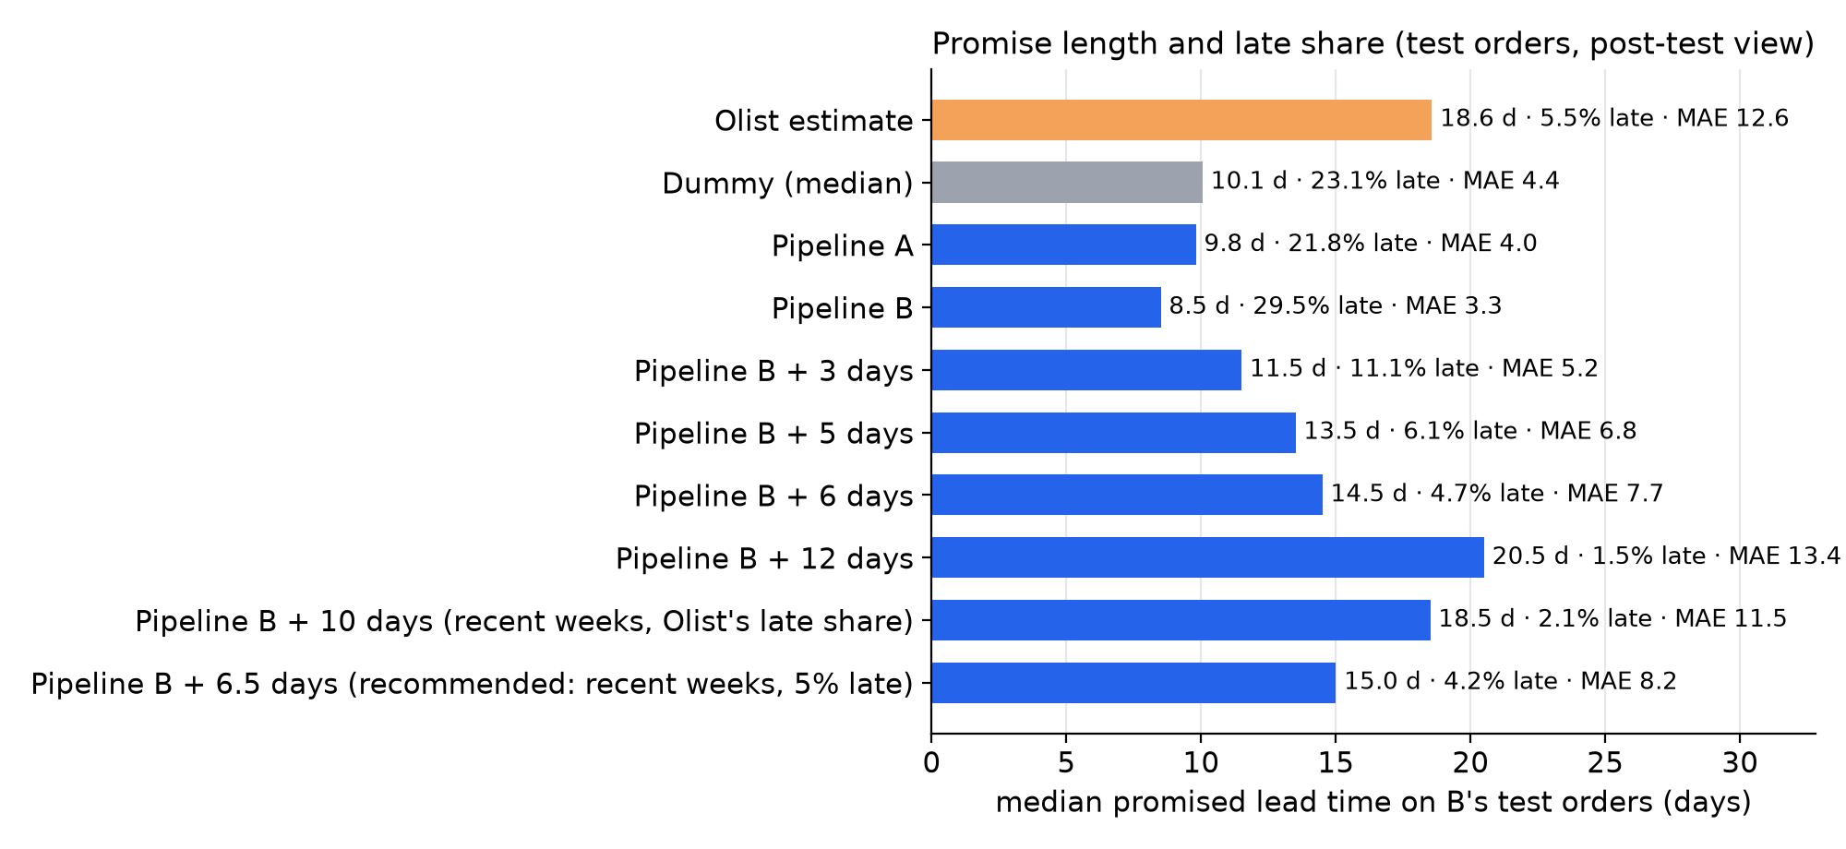
Figure 21. Median promised lead time, late share and MAE on Pipeline B's test orders: Olist's estimate, Dummy, A, B and B with buffers (post-test view) (F.BC.promise_compare).
2. Dispatch and transit (observation; scenario). Under that promise, 37% of late orders left the seller after the shipping limit. A rule that flags missed dispatch has precision 21.2% and catches 16.8% of all detractors in the seven states, with no model. Had transit been 10% faster for those late handovers, only 3.1% of late orders would have arrived on time, so most need service recovery; that working with slow sellers cuts late deliveries is an unmeasured mechanism.
3. Service recovery (observation). Pipeline B at 4/15 sends 5.6 alerts a day at precision 0.346, reaching about 1.9 detractors a day. The fallback at 1/6 adds 14.9 a day at precision 0.133, for a total of 20.5 a day at precision 0.192 (populations in Table K19). 1/6 is the cost threshold set before the test, cheaper than no alert on validation for both models; 4/15 is a capacity choice. On the test the fallback's alerts cost more than none (2,088 against 1,800; Table K21), so a higher fallback threshold is an option to test. The missed-dispatch rule serves the seven states beside Pipeline B, not the fallback's orders.
Proposed workflow (operational rule). Customer service would work a daily queue in the dashboard and let the reason for the risk pick the action (appendix K, Table K22).
Cost (assumption). Weighting a missed detractor as five false alerts, the serving rule's test cost is 9,211 (7,123 from Pipeline B, 2,088 from the fallback), against 9,505 with no alerts. A contact pays when precision × the value kept per detractor reached exceeds its cost; both values are unknown, so a randomised hold-back pilot comes first (section 10).

10 Limitations
Table K17 lists every remaining limit and how it is handled. The ones that matter most for reading the results: Pipeline B covers only the seven states and alerts at a later moment than Pipeline A; the operating threshold 4/15 was chosen after the test, so the frozen 1/6 is the unbiased result; the test period was faster than development; validation scores are slightly optimistic and the alert's feature ranks unstable; three deviations are recorded (section 6); every finding is an association, not a cause; and section 9's business case is a post-test view in which the effect of a contact is unmeasured. Appendix K explains each beside Table K17.
Next steps. Run a randomised hold-back pilot (contact a random half of alerted customers and compare reviews and repeat orders), log every action on an alert, backtest the buffer rule on rolling months before resetting it monthly, and monitor alert precision and late deliveries by state.

References
Breiman, L. (2001). Random Forests. Machine Learning, 45(1), 5–32. https://doi.org/10.1023/A:1010933404324
Chen, T., & Guestrin, C. (2016). XGBoost: A Scalable Tree Boosting System. Proceedings of the 22nd ACM SIGKDD International Conference on Knowledge Discovery and Data Mining, 785–794. https://doi.org/10.1145/2939672.2939785
Cui, R., Lu, Z., Sun, T., & Golden, J. M. (2024). Sooner or Later? Promising Delivery Speed in Online Retail. Manufacturing & Service Operations Management, 26(1), 233–251. https://doi.org/10.1287/msom.2021.0174
Deshpande, V., & Pendem, P. K. (2023). Logistics Performance, Ratings, and Its Impact on Customer Purchasing Behavior and Sales in E-Commerce Platforms. Manufacturing & Service Operations Management, 25(3), 827–845. https://doi.org/10.1287/msom.2021.1045
Fisher, M. L., Gallino, S., & Xu, J. J. (2019). The Value of Rapid Delivery in Omnichannel Retailing. Journal of Marketing Research, 56(5), 732–748. https://doi.org/10.1177/0022243719849940
Grinsztajn, L., Oyallon, E., & Varoquaux, G. (2022). Why Do Tree-Based Models Still Outperform Deep Learning on Typical Tabular Data? Advances in Neural Information Processing Systems, 35 (Datasets and Benchmarks Track). https://proceedings.neurips.cc/paper_files/paper/2022/file/0378c7692da36807bdec87ab043cdadc-Paper-Datasets_and_Benchmarks.pdf
He, H., & Garcia, E. A. (2009). Learning from Imbalanced Data. IEEE Transactions on Knowledge and Data Engineering, 21(9), 1263–1284. https://doi.org/10.1109/TKDE.2008.239
James, G., Witten, D., Hastie, T., Tibshirani, R., & Taylor, J. (2023). An Introduction to Statistical Learning: with Applications in Python. Springer. https://doi.org/10.1007/978-3-031-38747-0
Kapoor, S., & Narayanan, A. (2023). Leakage and the Reproducibility Crisis in Machine-Learning-Based Science. Patterns, 4(9), 100804. https://doi.org/10.1016/j.patter.2023.100804
Müller, A. C., & Guido, S. (2016). Introduction to Machine Learning with Python: A Guide for Data Scientists. O'Reilly. https://www.oreilly.com/library/view/introduction-to-machine/9781449369880/
Salari, N., Liu, S., & Shen, Z.-J. M. (2022). Real-Time Delivery Time Forecasting and Promising in Online Retailing: When Will Your Package Arrive? Manufacturing & Service Operations Management, 24(3), 1421–1436. https://doi.org/10.1287/msom.2022.1081
van den Goorbergh, R., van Smeden, M., Timmerman, D., & Van Calster, B. (2022). The Harm of Class Imbalance Corrections for Risk Prediction Models: Illustration and Simulation Using Logistic Regression. Journal of the American Medical Informatics Association, 29(9), 1525–1534. https://doi.org/10.1093/jamia/ocac093
Wolpert, D. H. (1992). Stacked Generalization. Neural Networks, 5(2), 241–259. https://doi.org/10.1016/S0893-6080(05)80023-1
Data. Olist Brazilian E-Commerce Public Dataset, the Canvas copy provided for the course (originally published on Kaggle).

Appendices

A. Validation and test windows
Validation folds are selection scores; the test was read once.
Each fold must have at least 10,000 training orders and, for the alert, 100 detractors in each part; the minimums were set before the folds were built. Fold 1 of Pipeline B falls short on training orders (7,932 for lead time, 7,592 for the alert), because the seven-state scope and the warm-up remove early orders. We kept it, as a recorded deviation, so the two pipelines are compared on identical periods; every detractor minimum is met. Instead of stratifying, each fold's detractor share is reported, and it moves with the business over time. Every metric is defined in appendix B. Every random step (trees, forests, tuning) uses seed 42, and forests predict on a single thread, so a rerun on the same machine reproduces every stored output exactly.
Table A1. Validation and test windows.
period | kind | start | end | festival_days
fold 1 | validation (selection score, G-10) | 2017-06-19 | 2017-09-27
fold 2 | validation (selection score, G-10) | 2017-09-27 | 2017-12-03 | 2017-11-24
fold 3 | validation (selection score, G-10) | 2017-12-03 | 2018-02-05 | 2017-12-25
fold 4 | validation (selection score, G-10) | 2018-02-05 | 2018-04-01
fold 5 | validation (selection score, G-10) | 2018-04-01 | 2018-05-24
test | test (unbiased, read once) | 2018-05-27 | 2018-08-29
Table A2. Fold sizes, lead time.
fold | train_first | train_last | train_rows | validation_first | validation_last | validation_rows
1 | 2017-02-12 00:20:45 | 2017-06-15 17:52:57 | 7932 | 2017-06-19 15:25:29 | 2017-09-27 08:48:59 | 10323
2 | 2017-02-12 00:20:45 | 2017-09-25 12:23:20 | 18077 | 2017-09-27 08:56:52 | 2017-12-03 17:04:39 | 10364
3 | 2017-02-12 00:20:45 | 2017-12-01 08:49:02 | 26184 | 2017-12-03 17:11:47 | 2018-02-05 00:05:58 | 10443
4 | 2017-02-12 00:20:45 | 2018-02-02 15:26:38 | 37647 | 2018-02-05 00:06:00 | 2018-04-01 16:46:20 | 10429
5 | 2017-02-12 00:20:45 | 2018-03-29 01:12:21 | 47415 | 2018-04-01 16:53:25 | 2018-05-24 18:56:59 | 9059
Table A3. Fold sizes and class support, detractor alert.
fold | a_train_start | a_train_end | a_validation_start | a_validation_end | train_rows | train_first | train_last | a_train_rows | train_positives | train_prevalence | validation_rows | validation_first | validation_last | a_validation_rows | validation_positives | validation_prevalence
1 | 2017-01-05 11:56:06 | 2017-06-13 03:24:05 | 2017-06-17 23:50:22 | 2017-09-26 09:23:05 | 7592 | 2017-02-12 00:20:45 | 2017-06-13 03:24:05 | 11077 | 874 | 0.1151 | 10324 | 2017-06-17 23:50:22 | 2017-09-26 09:10:27 | 12956 | 1014 | 0.09822
2 | 2017-01-05 11:56:06 | 2017-09-21 09:04:59 | 2017-09-26 09:37:01 | 2017-12-02 18:56:39 | 17595 | 2017-02-12 00:20:45 | 2017-09-21 09:04:59 | 23573 | 1872 | 0.1064 | 10342 | 2017-09-26 09:37:01 | 2017-12-02 18:56:39 | 12950 | 1443 | 0.1395
3 | 2017-01-05 11:56:06 | 2017-11-29 19:35:55 | 2017-12-02 19:00:27 | 2018-02-04 16:04:56 | 25529 | 2017-02-12 00:20:45 | 2017-11-29 19:35:55 | 33568 | 2734 | 0.1071 | 10450 | 2017-12-02 19:00:27 | 2018-02-04 16:04:56 | 12941 | 1497 | 0.1433
4 | 2017-01-05 11:56:06 | 2018-02-01 13:41:36 | 2018-02-04 16:10:12 | 2018-03-31 20:05:18 | 37140 | 2017-02-12 00:20:45 | 2018-02-01 13:41:36 | 47933 | 4472 | 0.1204 | 10453 | 2018-02-04 16:10:12 | 2018-03-31 20:05:18 | 12925 | 2173 | 0.2079
5 | 2017-01-05 11:56:06 | 2018-03-28 11:52:01 | 2018-03-31 20:10:17 | 2018-05-23 11:29:51 | 47237 | 2017-02-12 00:20:45 | 2018-03-28 11:52:01 | 60361 | 6363 | 0.1347 | 8646 | 2018-03-31 20:10:17 | 2018-05-23 11:29:51 | 10251 | 873 | 0.101
Drift is measured for each fold as the standardised mean difference of each numeric feature, and of the target, between the fold's validation rows and its training rows: the difference of the two means divided by the pooled standard deviation, the square root of the average of the two variances. The last column compares the test rows with the rows of the final fit in the same way. A positive value means the later rows have the higher mean.
The test period differs from development: deliveries were faster and reviews happier, and the route history features shifted most. Validation and test scores therefore describe different periods, and the test gain partly reflects that the history features track the faster period as it happens (figure below).
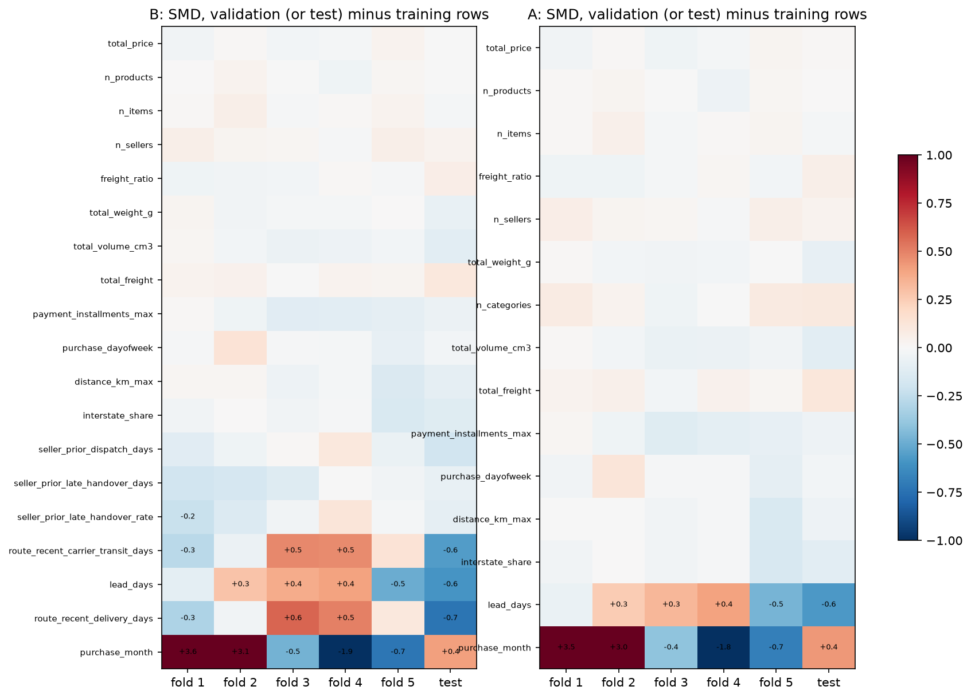
Figure 22. Drift by fold, lead time: standardised mean difference of each feature and of the target, validation rows against training rows for each fold, and test rows against the final fit's rows (F.reg.drift).

B. Metric glossary
Table B1. Metric glossary.
Metric | Meaning
MAE | Mean absolute error of the predicted lead time, in days (primary for lead time; lower is better)
RMSE | Root mean squared error in days; penalises large misses more than MAE
R² | Share of the variance in lead time explained; can be negative on a shifted period
Within 3 days | Share of orders whose prediction is within 3 days of the actual lead time
AP | Average precision, the area under the precision–recall curve (primary for the alert)
ROC-AUC | Probability that a random detractor scores higher than a random non-detractor
Brier | Mean squared error of the predicted probability (calibration and sharpness)
Precision, recall | At a threshold: share of alerts that are detractors; share of detractors alerted
Paired gain | Per-fold difference between two models on the same rows; its mean and standard error describe the comparison
One-SE rule | Keep the simplest model whose fold mean is within one standard error of the best
Selection score | A fold score used to choose models; optimistic. Only the test is unbiased

C. Full rank of the linear design matrix
Full rank means no column is an exact linear combination of the others, so the coefficients are unique. The number of columns grows by fold because the one-hot step learns its categories from each training fold. The condition number shows how close the columns come to collinearity.
Table C1. Rank and condition number of the linear design matrix by fold, lead time.
fold | rows | encoded_columns | columns | rank | full_rank | condition_number
1 | 7932 | 131 | 130 | 130 | True | 244.7
2 | 18077 | 139 | 138 | 138 | True | 285.1
3 | 26184 | 140 | 139 | 139 | True | 243.5
4 | 37647 | 141 | 140 | 140 | True | 385.8
5 | 47415 | 141 | 140 | 140 | True | 433.6
Table C2. Rank and condition number of the linear design matrix by fold, detractor alert.
fold | rows | encoded_columns | columns | rank | full_rank | condition_number
1 | 7592 | 135 | 134 | 134 | True | 910.1
2 | 17595 | 143 | 142 | 142 | True | 912.8
3 | 25529 | 144 | 143 | 143 | True | 834.5
4 | 37140 | 145 | 144 | 144 | True | 864.5
5 | 47237 | 145 | 144 | 144 | True | 934.2

D. Selected features
Table D1. Selected features, lead time.
feature | kind | transform | pool_rank
route_seller_to_customer_state | categorical | categorical: one-hot (drop-first for linear/logistic, every level for trees) | 1
route_recent_carrier_transit_days | numeric | log1p: day count | 2
route_recent_delivery_days | numeric | log1p: day count | 3
distance_km_max | numeric | log1p because pre-cutoff skewness 1.26 > 1 (A's 4.2 rule on B rows) | 4
interstate_share | numeric | never logged: bounded 0-1 share (G-47) (A's 4.2 rule on B rows) | 5
total_freight | numeric | log1p because pre-cutoff skewness 9.42 > 1 (A's 4.2 rule on B rows) | 7
seller_prior_dispatch_days | numeric | log1p: day count | 8
primary_category | categorical | categorical: one-hot, never logged (A's 4.2 rule on B rows) | 9
seller_prior_late_handover_rate | numeric | never logged: rate or flag, scaled only | 10
seller_prior_late_handover_days | numeric | log1p: day count | 11
freight_ratio | numeric | never logged: team decision in the s01 review (G-62) (A's 4.2 rule on B rows) | 12
total_weight_g | numeric | log1p because pre-cutoff skewness 6.94 > 1 (A's 4.2 rule on B rows) | 14
total_price | numeric | log1p because pre-cutoff skewness 11.03 > 1 (A's 4.2 rule on B rows) | 15
primary_payment_type | categorical | categorical: one-hot, never logged (A's 4.2 rule on B rows) | 16
total_volume_cm3 | numeric | log1p because pre-cutoff skewness 7.63 > 1 (A's 4.2 rule on B rows) | 17
purchase_dayofweek | numeric | never logged: numeric calendar position (G-22, G-47) (A's 4.2 rule on B rows) | 18
n_sellers | numeric | never logged: integer count (G-62, G-70) (A's 4.2 rule on B rows) | 19
purchase_month | numeric | never logged: numeric calendar position (G-22, G-47) (A's 4.2 rule on B rows) | 20
n_products | numeric | never logged: integer count (G-62, G-70) (A's 4.2 rule on B rows) | 21
payment_installments_max | numeric | never logged: integer count (G-62, G-70) (A's 4.2 rule on B rows) | 22
n_items | numeric | never logged: integer count (G-62, G-70) (A's 4.2 rule on B rows) | 23
Table D2. Selected features, detractor alert.
feature | kind | transform | pool_rank
route_recent_carrier_transit_days | numeric | log1p: day count | 1
route_recent_delivery_days | numeric | log1p: day count | 2
seller_prior_dispatch_days | numeric | log1p: day count | 3
seller_prior_late_handover_days | numeric | log1p: day count | 4
seller_prior_review_mean | numeric | never logged: 1-5 rating (G-70) (A's 4.2 rule on B rows) | 5
order_dispatch_days | numeric | log1p: day count | 6
freight_ratio | numeric | never logged: team decision in the s01 review (G-62) (A's 4.2 rule on B rows) | 7
total_freight | numeric | log1p because pre-cutoff skewness 9.45 > 1 (A's 4.2 rule on B rows) | 8
total_volume_cm3 | numeric | log1p because pre-cutoff skewness 7.65 > 1 (A's 4.2 rule on B rows) | 9
n_items | numeric | never logged: integer count (G-62, G-70) (A's 4.2 rule on B rows) | 10
route_seller_to_customer_state | categorical | categorical: one-hot (drop-first for linear/logistic, every level for trees) | 11
seller_prior_late_handover_rate | numeric | never logged: rate or flag, scaled only | 12
total_price | numeric | log1p because pre-cutoff skewness 11.11 > 1 (A's 4.2 rule on B rows) | 13
order_handover_late_days | numeric | log1p: day count | 14
total_weight_g | numeric | log1p because pre-cutoff skewness 6.94 > 1 (A's 4.2 rule on B rows) | 15
product_description_lenght | numeric | log1p because pre-cutoff skewness 2.06 > 1 (A's 4.2 rule on B rows) | 16
n_products | numeric | never logged: integer count (G-62, G-70) (A's 4.2 rule on B rows) | 18
n_sellers | numeric | never logged: integer count (G-62, G-70) (A's 4.2 rule on B rows) | 19
purchase_month | numeric | never logged: numeric calendar position (G-22, G-47) (A's 4.2 rule on B rows) | 20
order_handed_over_late | numeric | never logged: rate or flag, scaled only | 21
distance_km_max | numeric | log1p because pre-cutoff skewness 1.26 > 1 (A's 4.2 rule on B rows) | 22
primary_category | categorical | categorical: one-hot, never logged (A's 4.2 rule on B rows) | 23
interstate_share | numeric | never logged: bounded 0-1 share (G-47) (A's 4.2 rule on B rows) | 24
n_categories | numeric | never logged: integer count (G-62, G-70) (A's 4.2 rule on B rows) | 25
payment_installments_max | numeric | never logged: integer count (G-62, G-70) (A's 4.2 rule on B rows) | 26
Derived features. Almost every feature is computed from the nine raw tables rather than read from one column; a feature read straight from a raw column shows that column. Tables D3 and D4 give the formula of each, as stored with the feature pipelines. Order-level sums, counts and shares are taken over the order's items after the joins of section 3; history features use only other orders whose events were complete before this order's prediction week.
Table D3. Pipeline A's features, how each is derived and why it may carry a signal (both tasks; the missing-value indicators are added inside each fold; the reasons are hypotheses, not measured effects).
feature | formula | hypothesised_signal
n_items | order_items.order_item_id (count) | more items mean more picking and packing and more chances that one item is late or wrong
n_products | order_items.product_id (distinct) | distinct products widen the chance of a stock or quality problem
n_sellers | order_items.seller_id (distinct) | several sellers ship separate parcels, so the order is complete only when the slowest one arrives
n_categories | products.category (distinct, English) | mixed baskets combine items with different handling
total_price | order_items.price (sum; missing if any item invalid) | expensive orders raise expectations and may get different handling
total_freight | order_items.freight_value (sum; missing if any item invalid) | freight reflects distance, weight and carrier service level
freight_ratio | total_freight / total_price | a freight cost high relative to the price may disappoint the customer
total_weight_g | products.product_weight_g (sum) | heavy parcels travel by slower freight services
total_volume_cm3 | products length x height x width (sum) | bulky parcels travel by slower freight services
weight_missing_fraction | share of items without a valid weight | missing catalogue dimensions mark less complete listings
volume_missing_fraction | share of items without valid dimensions | missing catalogue dimensions mark less complete listings
primary_category | category of the highest-priced item (English) | categories differ in handling, seller mix and customer expectations
category_missing_fraction | share of items without a translated category | a missing category marks less complete listings
customer_state | customers.customer_state | destination region drives the transport route and its reliability
primary_seller_state | sellers.seller_state of the primary item | origin region drives the transport route and its reliability
distance_km_max | max haversine customer-seller distance over distinct sellers (IBGE-filtered ZIP centroids) | longer customer-seller distance means longer transit
distance_missing_fraction | share of distinct sellers without a resolved distance | a missing location marks unusual or incomplete addresses
interstate_share | share of distinct sellers in another state | interstate legs add hand-overs and tax checkpoints
purchase_month | orders.order_purchase_timestamp (month, numeric) | seasonal peaks (e.g. year-end) load the logistics network
purchase_dayofweek | orders.order_purchase_timestamp (Monday = 0, numeric) | orders placed before a weekend wait longer for dispatch
purchase_hour | orders.order_purchase_timestamp (hour, numeric) | late orders miss the same-day dispatch cut-off
primary_payment_type | order_payments (type with the largest usable value) | boleto payments clear later than cards, delaying dispatch
payment_installments_max | order_payments.payment_installments (max over usable lines) | instalments relate to order value and buyer profile
n_payment_methods | order_payments.payment_type (distinct usable) | split payments are rare and may mark unusual orders
product_photos_qty | products.product_photos_qty of the primary item | listings with more photos set clearer expectations
product_description_lenght | products.product_description_lenght of the primary item | longer descriptions set clearer expectations
seller_prior_review_mean | mean valid review score of the primary seller's earlier orders, reviews answered strictly before this purchase (own order excluded) | the seller rating shown at checkout summarises the seller's past service
missingindicator_seller_prior_review_mean | 1 if seller_prior_review_mean is missing, else 0 | a missing value carries its own meaning (e.g. a seller without an earlier review)
missingindicator_total_volume_cm3 | 1 if total_volume_cm3 is missing, else 0 | a missing value carries its own meaning
missingindicator_product_description_lenght | 1 if product_description_lenght is missing, else 0 | a missing value carries its own meaning
missingindicator_total_weight_g | 1 if total_weight_g is missing, else 0 | a missing value carries its own meaning
distance_km_max_missing | 1 if distance_km_max is missing, else 0 | a missing value carries its own meaning
missingindicator_product_photos_qty | 1 if product_photos_qty is missing, else 0 | a missing value carries its own meaning
Table D4. Pipeline B's new features and how each is derived.
feature | definition | formula
route_recent_carrier_transit_days | Recent route carrier transit days: recent typical carrier-to-customer time on the route | as route_recent_delivery_days, on (delivery date - carrier date)
route_recent_delivery_days | Recent route delivery days: recent typical purchase-to-delivery time on the route | weighted 3-week mean (0.5, 0.3, 0.2) of the route's weekly median lead days; < 10 route events -> 0.7 x seller state + 0.3 x customer state, then overall
seller_prior_dispatch_days | Prior seller dispatch days: mean days from purchase to carrier handover over the seller's earlier orders | mean of (carrier date - purchase time) over the seller's earlier handovers; same fallback
seller_prior_late_handover_days | Prior seller late-handover days: mean days by which the seller's earlier handovers missed the shipping limit (0 if on time) | mean of max(0, carrier date - last shipping_limit_date) over the seller's earlier handovers; same fallback
order_dispatch_days | Days from purchase to this order's carrier handover | carrier date - purchase time of this order
route_seller_to_customer_state | Route of the order: primary seller's state to the customer's state | primary_seller_state + '->' + customer_state
seller_prior_late_handover_rate | Prior seller late-handover rate: share of the seller's earlier handovers made after their last shipping limit | mean over the seller's handovers in weeks before the prediction week of 1[carrier date > last shipping_limit_date]; new seller: weighted 3-week mean of sellers in the same state
order_handover_late_days | Days this order's handover missed the shipping limit (0 if on time) | max(0, carrier date - last shipping_limit_date) of this order
order_handed_over_late | This order was handed to the carrier after its last shipping limit | 1[carrier date > last shipping_limit_date] of this order (known at handover)

E. Train, validation and test tables
Table E1. Train, validation and test results, lead time.
model | rows | metric | train_mean | validation_mean | validation_se | test | test_ci_low | test_ci_high
B frozen | B test rows | mae | 3.861 | 5.025 | 0.6115 | 3.299 | 3.245 | 3.353
B frozen | B test rows | rmse | 6.044 | 7.837 | 1.108 | 4.775 | 4.593 | 4.951
B frozen | B test rows | r2 | 0.2437 | 0.08733 | 0.05303 | 0.1849 | 0.1616 | 0.2074
B frozen | B test rows | within_3d | 0.5563 | 0.501 | 0.0269 | 0.5755 | 0.5676 | 0.5838
A frozen | B test rows | mae |  | 5.142 | 0.6616 | 4.028 | 3.97 | 4.083
A frozen | B test rows | rmse |  | 7.99 | 1.187 | 5.359 | 5.197 | 5.511
A frozen | B test rows | r2 |  | 0.05744 | 0.06186 | -0.02651 | -0.06142 | 0.006686
A frozen | B test rows | within_3d |  | 0.4883 | 0.02646 | 0.4429 | 0.4352 | 0.451
B plain | B test rows | mae | 3.861 | 5.025 | 0.6115 | 3.299 | 3.245 | 3.353
B plain | B test rows | rmse | 6.044 | 7.837 | 1.108 | 4.775 | 4.593 | 4.951
B plain | B test rows | r2 | 0.2437 | 0.08733 | 0.05303 | 0.1849 | 0.1616 | 0.2074
B plain | B test rows | within_3d | 0.5563 | 0.501 | 0.0269 | 0.5755 | 0.5676 | 0.5838
B dummy | B test rows | mae | 4.794 | 5.969 | 0.7107 | 4.385 | 4.327 | 4.441
B dummy | B test rows | rmse | 7.105 | 8.747 | 1.217 | 5.709 | 5.54 | 5.876
B dummy | B test rows | r2 | -0.04354 | -0.1398 | 0.04139 | -0.1651 | -0.19 | -0.1428
B dummy | B test rows | within_3d | 0.4394 | 0.3752 | 0.02589 | 0.371 | 0.3636 | 0.3784
A frozen | A test rows | mae | 4.286 | 5.47 | 0.6733 | 4.336 | 4.281 | 4.39
A frozen | A test rows | rmse | 6.882 | 8.578 | 1.179 | 5.729 | 5.594 | 5.875
A frozen | A test rows | r2 | 0.2382 | 0.09112 | 0.07289 | 0.03397 | 0.004485 | 0.05933
A frozen | A test rows | within_3d | 0.5132 | 0.4654 | 0.02563 | 0.4138 | 0.4066 | 0.4204
A plain | A test rows | mae | 4.286 | 5.47 | 0.6733 | 4.336 | 4.281 | 4.39
A plain | A test rows | rmse | 6.882 | 8.578 | 1.179 | 5.729 | 5.594 | 5.875
A plain | A test rows | r2 | 0.2382 | 0.09112 | 0.07289 | 0.03397 | 0.004485 | 0.05933
A plain | A test rows | within_3d | 0.5132 | 0.4654 | 0.02563 | 0.4138 | 0.4066 | 0.4204
A dummy | A test rows | mae | 5.312 | 6.495 | 0.6889 | 4.876 | 4.819 | 4.934
A dummy | A test rows | rmse | 8.053 | 9.535 | 1.157 | 6.261 | 6.115 | 6.42
A dummy | A test rows | r2 | -0.04316 | -0.1355 | 0.04145 | -0.154 | -0.1735 | -0.1361
A dummy | A test rows | within_3d | 0.4001 | 0.339 | 0.02291 | 0.3213 | 0.314 | 0.3283
Table E2. Train, validation and test results, detractor alert.
model | rows | metric | train_mean | validation_mean | validation_se | test | test_ci_low | test_ci_high | test_detractors
B frozen | B test rows | ap |  | 0.2482 | 0.03126 | 0.1972 | 0.1808 | 0.2176 | 1541
B frozen | B test rows | roc_auc |  | 0.6372 | 0.01518 | 0.636 | 0.6201 | 0.6517 | 1541
B frozen | B test rows | brier |  | 0.1146 | 0.0135 | 0.0867 | 0.08342 | 0.09018 | 1541
B frozen | B test rows | precision |  |  |  | 0.2077 | 0.1905 | 0.2256 | 1541
B frozen | B test rows | recall |  |  |  | 0.3005 | 0.2771 | 0.3243 | 1541
B frozen | B test rows | f1 |  |  |  | 0.2456 | 0.2265 | 0.2642 | 1541
B frozen | B test rows | alert_rate |  |  |  | 0.1439 | 0.1384 | 0.1498 | 1541
A frozen | B test rows | ap |  | 0.2302 | 0.03046 | 0.1785 | 0.1631 | 0.1974 | 1541
A frozen | B test rows | roc_auc |  | 0.6259 | 0.01193 | 0.604 | 0.5894 | 0.6203 | 1541
A frozen | B test rows | brier |  | 0.1162 | 0.01349 | 0.08926 | 0.08616 | 0.09264 | 1541
A frozen | B test rows | precision |  |  |  | 0.1583 | 0.1463 | 0.1713 | 1541
A frozen | B test rows | recall |  |  |  | 0.3556 | 0.3327 | 0.3806 | 1541
A frozen | B test rows | f1 |  |  |  | 0.2191 | 0.204 | 0.2354 | 1541
A frozen | B test rows | alert_rate |  |  |  | 0.2235 | 0.2166 | 0.2299 | 1541
B plain | B test rows | ap | 0.2369 | 0.2616 | 0.03494 | 0.1992 | 0.1828 | 0.2197 | 1541
B plain | B test rows | roc_auc | 0.6712 | 0.6536 | 0.01502 | 0.6341 | 0.6184 | 0.6495 | 1541
B plain | B test rows | brier | 0.09772 | 0.1141 | 0.01359 | 0.08642 | 0.083 | 0.09004 | 1541
B plain | B test rows | precision |  |  |  | 0.2258 | 0.2056 | 0.2456 | 1541
B plain | B test rows | recall |  |  |  | 0.2544 | 0.2332 | 0.2763 | 1541
B plain | B test rows | f1 |  |  |  | 0.2392 | 0.2193 | 0.2587 | 1541
B plain | B test rows | alert_rate |  |  |  | 0.1121 | 0.1073 | 0.117 | 1541
B dummy | B test rows | ap | 0.1167 | 0.138 | 0.01983 | 0.09947 | 0.09508 | 0.104 | 1541
B dummy | B test rows | roc_auc | 0.5 | 0.5 | 0 | 0.5 | 0.5 | 0.5 | 1541
B dummy | B test rows | brier | 0.103 | 0.1197 | 0.01502 | 0.09093 | 0.08773 | 0.09422 | 1541
B dummy | B test rows | precision |  |  |  | 0 | 0 | 0 | 1541
B dummy | B test rows | recall |  |  |  | 0 | 0 | 0 | 1541
B dummy | B test rows | f1 |  |  |  | 0 | 0 | 0 | 1541
B dummy | B test rows | alert_rate |  |  |  | 0 | 0 | 0 | 1541
A frozen | A test rows | ap |  | 0.2317 | 0.02763 | 0.175 | 0.1611 | 0.1891 | 1968
A frozen | A test rows | roc_auc |  | 0.6143 | 0.01353 | 0.5952 | 0.5822 | 0.6086 | 1968
A frozen | A test rows | brier |  | 0.1239 | 0.01344 | 0.09328 | 0.09038 | 0.09607 | 1968
A frozen | A test rows | precision |  |  |  | 0.1526 | 0.1428 | 0.1621 | 1968
A frozen | A test rows | recall |  |  |  | 0.3801 | 0.3601 | 0.4018 | 1968
A frozen | A test rows | f1 |  |  |  | 0.2178 | 0.2047 | 0.2304 | 1968
A frozen | A test rows | alert_rate |  |  |  | 0.2584 | 0.2521 | 0.2641 | 1968
A plain | A test rows | ap | 0.2213 | 0.2435 | 0.03142 | 0.1775 | 0.1636 | 0.1919 | 1968
A plain | A test rows | roc_auc | 0.6399 | 0.6213 | 0.01606 | 0.5995 | 0.5863 | 0.6127 | 1968
A plain | A test rows | brier | 0.1078 | 0.1243 | 0.01427 | 0.0935 | 0.09054 | 0.09629 | 1968
A plain | A test rows | precision |  |  |  | 0.1507 | 0.1405 | 0.1598 | 1968
A plain | A test rows | recall |  |  |  | 0.374 | 0.3541 | 0.3951 | 1968
A plain | A test rows | f1 |  |  |  | 0.2148 | 0.2021 | 0.2264 | 1968
A plain | A test rows | alert_rate |  |  |  | 0.2576 | 0.2509 | 0.2635 | 1968
A dummy | A test rows | ap | 0.1281 | 0.1482 | 0.01977 | 0.1038 | 0.09955 | 0.1079 | 1968
A dummy | A test rows | roc_auc | 0.5 | 0.5 | 0 | 0.5 | 0.5 | 0.5 | 1968
A dummy | A test rows | brier | 0.1116 | 0.1269 | 0.01452 | 0.09484 | 0.09186 | 0.09774 | 1968
A dummy | A test rows | precision |  |  |  | 0 | 0 | 0 | 1968
A dummy | A test rows | recall |  |  |  | 0 | 0 | 0 | 1968
A dummy | A test rows | f1 |  |  |  | 0 | 0 | 0 | 1968
A dummy | A test rows | alert_rate |  |  |  | 0 | 0 | 0 | 1968
In Table E2 the delivered (frozen, calibrated) rows have no training score: the sigmoid is fitted on time-ordered inner splits of each training fold, so the calibrated model scores rows only out of sample. The plain rows give the same logistic model's training score on raw probabilities (Table 5).
Table E3. Detractor alert by slice, judged only with more than 100 test detractors.
slice | judged_slices | too_few | pooled_precision_A | pooled_recall_A | mean_precision_A | sd_precision_A | mean_recall_A | sd_recall_A | pooled_precision_B | pooled_recall_B | mean_precision_B | sd_precision_B | mean_recall_B | sd_recall_B
customer_state | 3 | 4 | 0.1643 | 0.3378 | 0.1883 | 0.04757 | 0.4547 | 0.3381 | 0.2188 | 0.2782 | 0.2311 | 0.03673 | 0.3327 | 0.1872
route_seller_to_customer_state | 3 | 45 | 0.1564 | 0.3385 | 0.1814 | 0.04839 | 0.5148 | 0.4137 | 0.2085 | 0.2767 | 0.2178 | 0.02897 | 0.3507 | 0.2099
basket | 2 | 1 | 0.1488 | 0.3219 | 0.2013 | 0.132 | 0.4893 | 0.3753 | 0.1991 | 0.2677 | 0.2542 | 0.1452 | 0.3971 | 0.2901
sellers | 2 | 0 | 0.1583 | 0.3556 | 0.2924 | 0.2235 | 0.6511 | 0.4934 | 0.2077 | 0.3005 | 0.3137 | 0.1947 | 0.6135 | 0.5227
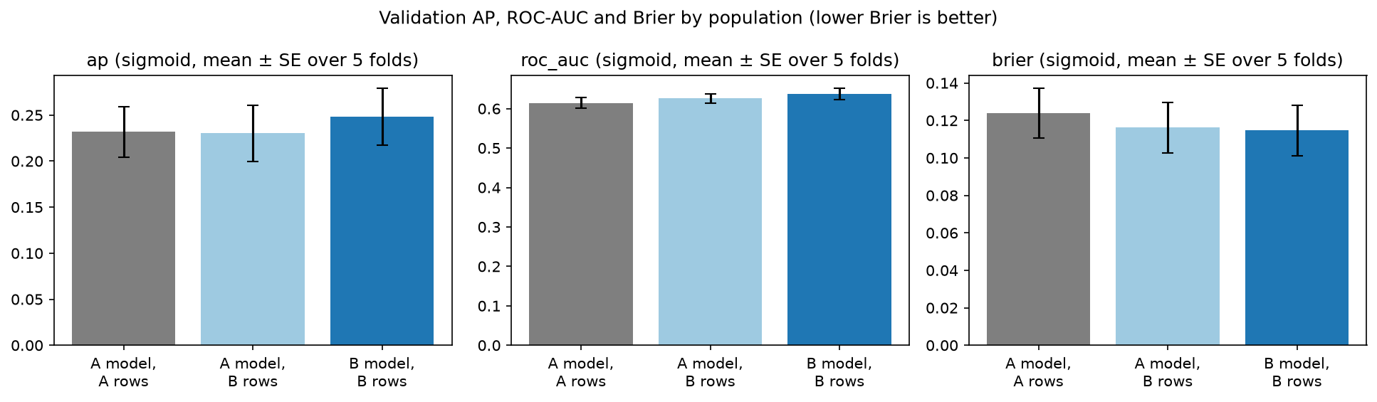
Figure 23. ROC-AUC and Brier by population, detractor alert (F.clf.auc_brier).
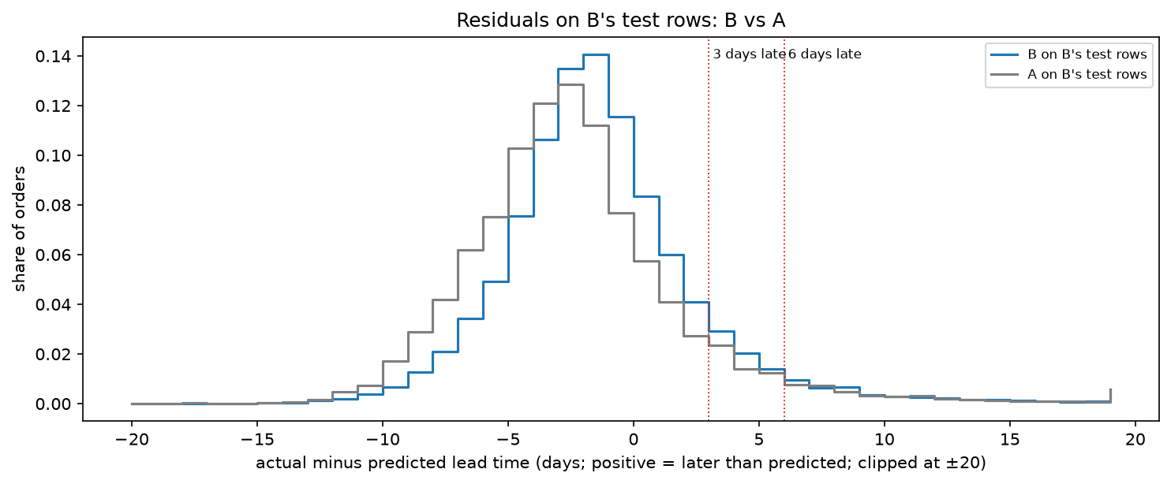
Figure 24. Residuals on B's test rows: B vs A (F.reg.residuals).
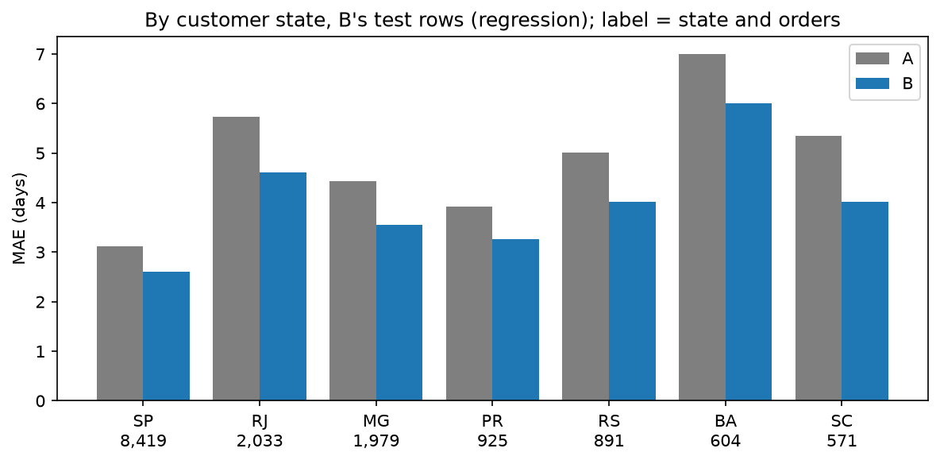
Figure 25. Lead-time error by customer state (F.reg.by_state).
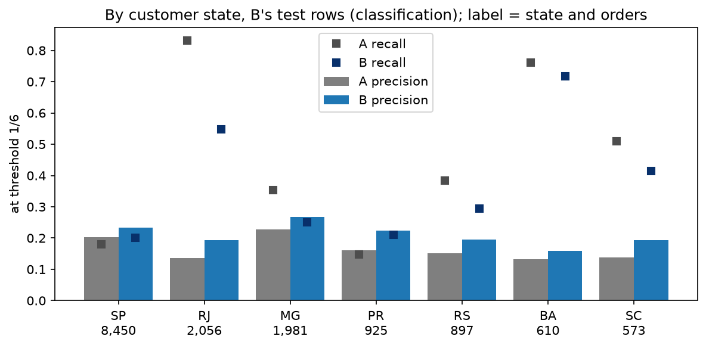
Figure 26. Detractor alert precision and recall by customer state (F.clf.by_state).
Which orders the alert gets wrong (observation on the stored test predictions, no refit; Table E4). At the frozen 1/6, Pipeline B raises 463 true and 1,766 false alerts and misses 1,078 detractors, 70% of all detractors on its test orders. Only 13% of the missed detractors arrived after Olist's estimate and 8% were handed over late (true alerts: 19% and 25%): for most of them the delivery went to plan, so the reason for the review lies in what the data does not hold at handover, such as the product or the seller's service. The false alerts are the mirror image: 23% were handed over late, but only 5% arrived after the estimate, so the carrier often made up the seller's delay. The alert catches delivery-driven complaints; the missed ones are a limit of the data, not of the threshold.
Table E4. Pipeline B's alert on its test orders by error group, at the frozen 1/6 and the operating 4/15: orders, orders delivered, share delivered after Olist's estimate (of those delivered), share handed over after the shipping limit, and median predicted risk (section 7.2; post-test view, no refit).
threshold | group | orders | delivered | share_delivered_after_olist_estimate | share_handed_over_late | median_risk
1/6 (frozen) | true alert | 463 | 448 | 0.1875 | 0.2505 | 0.2364
1/6 (frozen) | false alert | 1766 | 1763 | 0.05162 | 0.2282 | 0.2033
1/6 (frozen) | missed detractor | 1078 | 1016 | 0.1329 | 0.08256 | 0.1037
1/6 (frozen) | quiet order | 12185 | 12149 | 0.03976 | 0.04834 | 0.0944
4/15 (operating) | true alert | 187 | 186 | 0.1559 | 0.3262 | 0.3593
4/15 (operating) | false alert | 353 | 352 | 0.05966 | 0.3569 | 0.3304
4/15 (operating) | missed detractor | 1354 | 1278 | 0.1487 | 0.1064 | 0.1138
4/15 (operating) | quiet order | 13598 | 13560 | 0.04078 | 0.06369 | 0.0985

F. Tuning grids and the grid edge
Every configuration of every family, with its mean and standard error over the five validation folds and the gap between training and validation scores.
Table F1. Tuning grid, lead time.
family | params | validation_mean | validation_se | train_validation_gap
linear | {"alpha": 0.01} | 5.025 | 0.6115 | 1.164
linear | {"alpha": 0.1} | 5.024 | 0.6114 | 1.164
linear | {"alpha": 0.5} | 5.024 | 0.6113 | 1.163
linear | {"alpha": 1.0} | 5.023 | 0.6112 | 1.162
linear | {"alpha": 5.0} | 5.02 | 0.6099 | 1.158
linear | {"alpha": 10.0} | 5.02 | 0.6083 | 1.156
linear | {"alpha": 20.0} | 5.019 | 0.6056 | 1.153
linear | {"alpha": 50.0} | 5.02 | 0.6 | 1.148
linear | {"alpha": 100.0} | 5.021 | 0.5946 | 1.142
tree | {"max_depth": 4, "min_samples_leaf": 20} | 5.084 | 0.6428 | 1.065
tree | {"max_depth": 4, "min_samples_leaf": 50} | 5.088 | 0.6403 | 1.072
tree | {"max_depth": 4, "min_samples_leaf": 100} | 5.084 | 0.6426 | 1.065
tree | {"max_depth": 4, "min_samples_leaf": 200} | 5.084 | 0.6443 | 1.061
tree | {"max_depth": 5, "min_samples_leaf": 20} | 5.052 | 0.6432 | 1.108
tree | {"max_depth": 5, "min_samples_leaf": 50} | 5.061 | 0.6384 | 1.116
tree | {"max_depth": 5, "min_samples_leaf": 100} | 5.053 | 0.6394 | 1.104
tree | {"max_depth": 5, "min_samples_leaf": 200} | 5.058 | 0.6437 | 1.096
tree | {"max_depth": 6, "min_samples_leaf": 20} | 5.018 | 0.6524 | 1.143
tree | {"max_depth": 6, "min_samples_leaf": 50} | 5.008 | 0.6544 | 1.125
tree | {"max_depth": 6, "min_samples_leaf": 100} | 5.017 | 0.658 | 1.119
tree | {"max_depth": 6, "min_samples_leaf": 200} | 5.016 | 0.6613 | 1.099
tree | {"max_depth": 8, "min_samples_leaf": 20} | 5.001 | 0.6579 | 1.251
tree | {"max_depth": 8, "min_samples_leaf": 50} | 4.976 | 0.6605 | 1.188
tree | {"max_depth": 8, "min_samples_leaf": 100} | 4.974 | 0.6603 | 1.149
tree | {"max_depth": 8, "min_samples_leaf": 200} | 4.976 | 0.6676 | 1.103
tree | {"max_depth": 10, "min_samples_leaf": 20} | 5.053 | 0.6539 | 1.424
tree | {"max_depth": 10, "min_samples_leaf": 50} | 5.02 | 0.6526 | 1.302
tree | {"max_depth": 10, "min_samples_leaf": 100} | 4.995 | 0.6542 | 1.205
tree | {"max_depth": 10, "min_samples_leaf": 200} | 4.98 | 0.6588 | 1.121
tree | {"max_depth": 12, "min_samples_leaf": 20} | 5.103 | 0.6419 | 1.574
tree | {"max_depth": 12, "min_samples_leaf": 50} | 5.046 | 0.6513 | 1.364
tree | {"max_depth": 12, "min_samples_leaf": 100} | 4.996 | 0.6523 | 1.221
tree | {"max_depth": 12, "min_samples_leaf": 200} | 4.976 | 0.6562 | 1.12
tree | {"max_depth": 14, "min_samples_leaf": 20} | 5.138 | 0.6337 | 1.678
tree | {"max_depth": 14, "min_samples_leaf": 50} | 5.051 | 0.6485 | 1.384
tree | {"max_depth": 14, "min_samples_leaf": 100} | 4.993 | 0.6481 | 1.221
tree | {"max_depth": 14, "min_samples_leaf": 200} | 4.976 | 0.6562 | 1.12
tree | {"max_depth": 16, "min_samples_leaf": 20} | 5.163 | 0.6271 | 1.741
tree | {"max_depth": 16, "min_samples_leaf": 50} | 5.049 | 0.6443 | 1.387
tree | {"max_depth": 16, "min_samples_leaf": 100} | 4.994 | 0.6485 | 1.223
tree | {"max_depth": 16, "min_samples_leaf": 200} | 4.976 | 0.6562 | 1.12
tree | {"max_depth": 18, "min_samples_leaf": 20} | 5.165 | 0.6257 | 1.759
tree | {"max_depth": 18, "min_samples_leaf": 50} | 5.052 | 0.6453 | 1.391
tree | {"max_depth": 18, "min_samples_leaf": 100} | 4.993 | 0.6482 | 1.223
tree | {"max_depth": 18, "min_samples_leaf": 200} | 4.976 | 0.6562 | 1.12
forest | {"max_depth": 8, "max_features": "sqrt", "min_samples_leaf": 20} | 4.973 | 0.6554 | 1.054
forest | {"max_depth": 8, "max_features": "sqrt", "min_samples_leaf": 50} | 4.986 | 0.6519 | 1.033
forest | {"max_depth": 8, "max_features": "sqrt", "min_samples_leaf": 100} | 5.022 | 0.6484 | 1.028
forest | {"max_depth": 8, "max_features": "sqrt", "min_samples_leaf": 200} | 5.082 | 0.649 | 1.032
forest | {"max_depth": 10, "max_features": "sqrt", "min_samples_leaf": 20} | 4.935 | 0.6503 | 1.084
forest | {"max_depth": 10, "max_features": "sqrt", "min_samples_leaf": 50} | 4.963 | 0.6457 | 1.052
forest | {"max_depth": 10, "max_features": "sqrt", "min_samples_leaf": 100} | 5.003 | 0.6423 | 1.033
forest | {"max_depth": 10, "max_features": "sqrt", "min_samples_leaf": 200} | 5.072 | 0.6443 | 1.034
forest | {"max_depth": 12, "max_features": "sqrt", "min_samples_leaf": 20} | 4.909 | 0.6501 | 1.109
forest | {"max_depth": 12, "max_features": "sqrt", "min_samples_leaf": 50} | 4.939 | 0.645 | 1.053
forest | {"max_depth": 12, "max_features": "sqrt", "min_samples_leaf": 100} | 4.988 | 0.641 | 1.03
forest | {"max_depth": 12, "max_features": "sqrt", "min_samples_leaf": 200} | 5.069 | 0.6431 | 1.036
forest | {"max_depth": 14, "max_features": "sqrt", "min_samples_leaf": 20} | 4.894 | 0.646 | 1.128
forest | {"max_depth": 14, "max_features": "sqrt", "min_samples_leaf": 50} | 4.932 | 0.6439 | 1.059
forest | {"max_depth": 14, "max_features": "sqrt", "min_samples_leaf": 100} | 4.992 | 0.64 | 1.039
forest | {"max_depth": 14, "max_features": "sqrt", "min_samples_leaf": 200} | 5.068 | 0.643 | 1.036
forest | {"max_depth": 16, "max_features": "sqrt", "min_samples_leaf": 20} | 4.889 | 0.6458 | 1.145
forest | {"max_depth": 16, "max_features": "sqrt", "min_samples_leaf": 50} | 4.933 | 0.6441 | 1.067
forest | {"max_depth": 16, "max_features": "sqrt", "min_samples_leaf": 100} | 4.987 | 0.6402 | 1.037
forest | {"max_depth": 16, "max_features": "sqrt", "min_samples_leaf": 200} | 5.065 | 0.6428 | 1.035
forest | {"max_depth": 18, "max_features": "sqrt", "min_samples_leaf": 20} | 4.887 | 0.6462 | 1.157
forest | {"max_depth": 18, "max_features": "sqrt", "min_samples_leaf": 50} | 4.932 | 0.6441 | 1.07
forest | {"max_depth": 18, "max_features": "sqrt", "min_samples_leaf": 100} | 4.987 | 0.6403 | 1.038
forest | {"max_depth": 18, "max_features": "sqrt", "min_samples_leaf": 200} | 5.066 | 0.6431 | 1.035
Table F2. Tuning grid, detractor alert.
family | params | validation_mean | validation_se | train_validation_gap
linear | {"C": 0.01, "class_weight": null} | 0.2734 | 0.03179 | -0.04629
linear | {"C": 0.01, "class_weight": "balanced"} | 0.2721 | 0.03204 | -0.04556
linear | {"C": 0.1, "class_weight": null} | 0.2717 | 0.03348 | -0.03882
linear | {"C": 0.1, "class_weight": "balanced"} | 0.2699 | 0.03295 | -0.03957
linear | {"C": 0.5, "class_weight": null} | 0.2692 | 0.03389 | -0.03394
linear | {"C": 0.5, "class_weight": "balanced"} | 0.2671 | 0.03294 | -0.03595
linear | {"C": 1.0, "class_weight": null} | 0.2678 | 0.03386 | -0.03214
linear | {"C": 1.0, "class_weight": "balanced"} | 0.2658 | 0.033 | -0.03451
linear | {"C": 5.0, "class_weight": null} | 0.2646 | 0.03417 | -0.02802
linear | {"C": 5.0, "class_weight": "balanced"} | 0.2631 | 0.03329 | -0.03147
linear | {"C": 10.0, "class_weight": null} | 0.2633 | 0.03453 | -0.02621
linear | {"C": 10.0, "class_weight": "balanced"} | 0.2621 | 0.03341 | -0.03041
linear | {"C": 20.0, "class_weight": null} | 0.2626 | 0.03442 | -0.02561
linear | {"C": 20.0, "class_weight": "balanced"} | 0.2618 | 0.03354 | -0.03003
linear | {"C": 50.0, "class_weight": null} | 0.2616 | 0.03486 | -0.02443
linear | {"C": 50.0, "class_weight": "balanced"} | 0.2616 | 0.03372 | -0.02968
linear | {"C": 100.0, "class_weight": null} | 0.2616 | 0.03485 | -0.02464
linear | {"C": 100.0, "class_weight": "balanced"} | 0.2602 | 0.03442 | -0.0283
tree | {"class_weight": null, "max_depth": 4, "min_samples_leaf": 20} | 0.2272 | 0.02898 | -0.01755
tree | {"class_weight": null, "max_depth": 4, "min_samples_leaf": 50} | 0.2255 | 0.03001 | -0.01985
tree | {"class_weight": null, "max_depth": 4, "min_samples_leaf": 100} | 0.2279 | 0.02894 | -0.02255
tree | {"class_weight": null, "max_depth": 4, "min_samples_leaf": 200} | 0.2298 | 0.02967 | -0.03038
tree | {"class_weight": null, "max_depth": 5, "min_samples_leaf": 20} | 0.2386 | 0.03469 | -0.007572
tree | {"class_weight": null, "max_depth": 5, "min_samples_leaf": 50} | 0.2379 | 0.03671 | -0.01519
tree | {"class_weight": null, "max_depth": 5, "min_samples_leaf": 100} | 0.2394 | 0.03539 | -0.0199
tree | {"class_weight": null, "max_depth": 5, "min_samples_leaf": 200} | 0.2387 | 0.03499 | -0.02747
tree | {"class_weight": null, "max_depth": 6, "min_samples_leaf": 20} | 0.2202 | 0.02528 | 0.03157
tree | {"class_weight": null, "max_depth": 6, "min_samples_leaf": 50} | 0.2242 | 0.02953 | 0.0128
tree | {"class_weight": null, "max_depth": 6, "min_samples_leaf": 100} | 0.2283 | 0.02803 | 0.003448
tree | {"class_weight": null, "max_depth": 6, "min_samples_leaf": 200} | 0.2267 | 0.02792 | -0.007118
tree | {"class_weight": null, "max_depth": 8, "min_samples_leaf": 20} | 0.2125 | 0.02591 | 0.07815
tree | {"class_weight": null, "max_depth": 8, "min_samples_leaf": 50} | 0.2262 | 0.02888 | 0.03644
tree | {"class_weight": null, "max_depth": 8, "min_samples_leaf": 100} | 0.2292 | 0.02994 | 0.02061
tree | {"class_weight": null, "max_depth": 8, "min_samples_leaf": 200} | 0.2323 | 0.0278 | -0.001048
tree | {"class_weight": null, "max_depth": 10, "min_samples_leaf": 20} | 0.2071 | 0.02604 | 0.1208
tree | {"class_weight": null, "max_depth": 10, "min_samples_leaf": 50} | 0.2243 | 0.02955 | 0.06152
tree | {"class_weight": null, "max_depth": 10, "min_samples_leaf": 100} | 0.2333 | 0.02961 | 0.02892
tree | {"class_weight": null, "max_depth": 10, "min_samples_leaf": 200} | 0.2345 | 0.02852 | 0.003455
tree | {"class_weight": null, "max_depth": 12, "min_samples_leaf": 20} | 0.2086 | 0.0242 | 0.1508
tree | {"class_weight": null, "max_depth": 12, "min_samples_leaf": 50} | 0.2197 | 0.02889 | 0.08261
tree | {"class_weight": null, "max_depth": 12, "min_samples_leaf": 100} | 0.2325 | 0.02942 | 0.03714
tree | {"class_weight": null, "max_depth": 12, "min_samples_leaf": 200} | 0.2297 | 0.02915 | 0.01183
tree | {"class_weight": null, "max_depth": 14, "min_samples_leaf": 20} | 0.2018 | 0.02464 | 0.1816
tree | {"class_weight": null, "max_depth": 14, "min_samples_leaf": 50} | 0.2175 | 0.02886 | 0.09587
tree | {"class_weight": null, "max_depth": 14, "min_samples_leaf": 100} | 0.2287 | 0.02987 | 0.04515
tree | {"class_weight": null, "max_depth": 14, "min_samples_leaf": 200} | 0.2294 | 0.02916 | 0.01332
tree | {"class_weight": null, "max_depth": 16, "min_samples_leaf": 20} | 0.1997 | 0.02436 | 0.2039
tree | {"class_weight": null, "max_depth": 16, "min_samples_leaf": 50} | 0.2154 | 0.02817 | 0.1055
tree | {"class_weight": null, "max_depth": 16, "min_samples_leaf": 100} | 0.2281 | 0.02979 | 0.04758
tree | {"class_weight": null, "max_depth": 16, "min_samples_leaf": 200} | 0.2327 | 0.02822 | 0.01039
tree | {"class_weight": null, "max_depth": 18, "min_samples_leaf": 20} | 0.1979 | 0.02353 | 0.2203
tree | {"class_weight": null, "max_depth": 18, "min_samples_leaf": 50} | 0.2146 | 0.02728 | 0.1092
tree | {"class_weight": null, "max_depth": 18, "min_samples_leaf": 100} | 0.2284 | 0.02973 | 0.0481
tree | {"class_weight": null, "max_depth": 18, "min_samples_leaf": 200} | 0.2327 | 0.02823 | 0.01057
tree | {"class_weight": "balanced", "max_depth": 4, "min_samples_leaf": 20} | 0.2223 | 0.02828 | -0.00851
tree | {"class_weight": "balanced", "max_depth": 4, "min_samples_leaf": 50} | 0.2236 | 0.02779 | -0.0124
tree | {"class_weight": "balanced", "max_depth": 4, "min_samples_leaf": 100} | 0.2244 | 0.02792 | -0.01439
tree | {"class_weight": "balanced", "max_depth": 4, "min_samples_leaf": 200} | 0.2232 | 0.02756 | -0.01919
tree | {"class_weight": "balanced", "max_depth": 5, "min_samples_leaf": 20} | 0.2242 | 0.02919 | 0.009191
tree | {"class_weight": "balanced", "max_depth": 5, "min_samples_leaf": 50} | 0.2272 | 0.02945 | 0.002055
tree | {"class_weight": "balanced", "max_depth": 5, "min_samples_leaf": 100} | 0.2264 | 0.02866 | -0.002144
tree | {"class_weight": "balanced", "max_depth": 5, "min_samples_leaf": 200} | 0.2269 | 0.02836 | -0.0121
tree | {"class_weight": "balanced", "max_depth": 6, "min_samples_leaf": 20} | 0.2218 | 0.03004 | 0.03078
tree | {"class_weight": "balanced", "max_depth": 6, "min_samples_leaf": 50} | 0.2239 | 0.02934 | 0.02082
tree | {"class_weight": "balanced", "max_depth": 6, "min_samples_leaf": 100} | 0.2284 | 0.0272 | 0.007573
tree | {"class_weight": "balanced", "max_depth": 6, "min_samples_leaf": 200} | 0.2293 | 0.02838 | -0.006417
tree | {"class_weight": "balanced", "max_depth": 8, "min_samples_leaf": 20} | 0.2144 | 0.02992 | 0.07698
tree | {"class_weight": "balanced", "max_depth": 8, "min_samples_leaf": 50} | 0.2216 | 0.0275 | 0.04937
tree | {"class_weight": "balanced", "max_depth": 8, "min_samples_leaf": 100} | 0.226 | 0.02934 | 0.02796
tree | {"class_weight": "balanced", "max_depth": 8, "min_samples_leaf": 200} | 0.2304 | 0.02891 | 0.002987
tree | {"class_weight": "balanced", "max_depth": 10, "min_samples_leaf": 20} | 0.205 | 0.02637 | 0.1245
tree | {"class_weight": "balanced", "max_depth": 10, "min_samples_leaf": 50} | 0.2131 | 0.02793 | 0.07872
tree | {"class_weight": "balanced", "max_depth": 10, "min_samples_leaf": 100} | 0.2244 | 0.02875 | 0.04171
tree | {"class_weight": "balanced", "max_depth": 10, "min_samples_leaf": 200} | 0.227 | 0.02995 | 0.01144
tree | {"class_weight": "balanced", "max_depth": 12, "min_samples_leaf": 20} | 0.1994 | 0.02592 | 0.1646
tree | {"class_weight": "balanced", "max_depth": 12, "min_samples_leaf": 50} | 0.2128 | 0.02621 | 0.09793
tree | {"class_weight": "balanced", "max_depth": 12, "min_samples_leaf": 100} | 0.2208 | 0.02978 | 0.05227
tree | {"class_weight": "balanced", "max_depth": 12, "min_samples_leaf": 200} | 0.2299 | 0.02894 | 0.01138
tree | {"class_weight": "balanced", "max_depth": 14, "min_samples_leaf": 20} | 0.1938 | 0.02548 | 0.2015
tree | {"class_weight": "balanced", "max_depth": 14, "min_samples_leaf": 50} | 0.2107 | 0.02574 | 0.1144
tree | {"class_weight": "balanced", "max_depth": 14, "min_samples_leaf": 100} | 0.2193 | 0.02887 | 0.05748
tree | {"class_weight": "balanced", "max_depth": 14, "min_samples_leaf": 200} | 0.226 | 0.02981 | 0.01695
tree | {"class_weight": "balanced", "max_depth": 16, "min_samples_leaf": 20} | 0.1896 | 0.02547 | 0.2306
tree | {"class_weight": "balanced", "max_depth": 16, "min_samples_leaf": 50} | 0.2079 | 0.02687 | 0.1221
tree | {"class_weight": "balanced", "max_depth": 16, "min_samples_leaf": 100} | 0.2213 | 0.02799 | 0.0575
tree | {"class_weight": "balanced", "max_depth": 16, "min_samples_leaf": 200} | 0.2292 | 0.02878 | 0.01409
tree | {"class_weight": "balanced", "max_depth": 18, "min_samples_leaf": 20} | 0.1897 | 0.02501 | 0.2488
tree | {"class_weight": "balanced", "max_depth": 18, "min_samples_leaf": 50} | 0.2098 | 0.02576 | 0.1232
tree | {"class_weight": "balanced", "max_depth": 18, "min_samples_leaf": 100} | 0.2182 | 0.02841 | 0.06136
tree | {"class_weight": "balanced", "max_depth": 18, "min_samples_leaf": 200} | 0.2292 | 0.02876 | 0.01427
forest | {"class_weight": null, "max_depth": 8, "max_features": "sqrt", "min_samples_leaf": 20} | 0.2761 | 0.03041 | 0.0257
forest | {"class_weight": null, "max_depth": 8, "max_features": "sqrt", "min_samples_leaf": 50} | 0.2746 | 0.03054 | 0.0002213
forest | {"class_weight": null, "max_depth": 8, "max_features": "sqrt", "min_samples_leaf": 100} | 0.2703 | 0.03047 | -0.0153
forest | {"class_weight": null, "max_depth": 8, "max_features": "sqrt", "min_samples_leaf": 200} | 0.2625 | 0.02971 | -0.02304
forest | {"class_weight": null, "max_depth": 10, "max_features": "sqrt", "min_samples_leaf": 20} | 0.2745 | 0.03063 | 0.05163
forest | {"class_weight": null, "max_depth": 10, "max_features": "sqrt", "min_samples_leaf": 50} | 0.2739 | 0.03047 | 0.01286
forest | {"class_weight": null, "max_depth": 10, "max_features": "sqrt", "min_samples_leaf": 100} | 0.2708 | 0.03034 | -0.008784
forest | {"class_weight": null, "max_depth": 10, "max_features": "sqrt", "min_samples_leaf": 200} | 0.2642 | 0.03036 | -0.02214
forest | {"class_weight": null, "max_depth": 12, "max_features": "sqrt", "min_samples_leaf": 20} | 0.2739 | 0.02993 | 0.07694
forest | {"class_weight": null, "max_depth": 12, "max_features": "sqrt", "min_samples_leaf": 50} | 0.2733 | 0.03063 | 0.02425
forest | {"class_weight": null, "max_depth": 12, "max_features": "sqrt", "min_samples_leaf": 100} | 0.2692 | 0.03025 | -0.003239
forest | {"class_weight": null, "max_depth": 12, "max_features": "sqrt", "min_samples_leaf": 200} | 0.2634 | 0.02971 | -0.02047
forest | {"class_weight": null, "max_depth": 14, "max_features": "sqrt", "min_samples_leaf": 20} | 0.2745 | 0.02927 | 0.1011
forest | {"class_weight": null, "max_depth": 14, "max_features": "sqrt", "min_samples_leaf": 50} | 0.2726 | 0.03119 | 0.03286
forest | {"class_weight": null, "max_depth": 14, "max_features": "sqrt", "min_samples_leaf": 100} | 0.2692 | 0.03038 | -0.0008786
forest | {"class_weight": null, "max_depth": 14, "max_features": "sqrt", "min_samples_leaf": 200} | 0.2644 | 0.03032 | -0.02057
forest | {"class_weight": null, "max_depth": 16, "max_features": "sqrt", "min_samples_leaf": 20} | 0.2754 | 0.03005 | 0.1152
forest | {"class_weight": null, "max_depth": 16, "max_features": "sqrt", "min_samples_leaf": 50} | 0.2738 | 0.03039 | 0.03645
forest | {"class_weight": null, "max_depth": 16, "max_features": "sqrt", "min_samples_leaf": 100} | 0.2694 | 0.03046 | 0.0005274
forest | {"class_weight": null, "max_depth": 16, "max_features": "sqrt", "min_samples_leaf": 200} | 0.2645 | 0.0306 | -0.02002
forest | {"class_weight": null, "max_depth": 18, "max_features": "sqrt", "min_samples_leaf": 20} | 0.274 | 0.02946 | 0.1324
forest | {"class_weight": null, "max_depth": 18, "max_features": "sqrt", "min_samples_leaf": 50} | 0.2738 | 0.03103 | 0.0398
forest | {"class_weight": null, "max_depth": 18, "max_features": "sqrt", "min_samples_leaf": 100} | 0.2699 | 0.03025 | 0.0009521
forest | {"class_weight": null, "max_depth": 18, "max_features": "sqrt", "min_samples_leaf": 200} | 0.2645 | 0.0305 | -0.02017
forest | {"class_weight": "balanced", "max_depth": 8, "max_features": "sqrt", "min_samples_leaf": 20} | 0.2695 | 0.03025 | 0.04042
forest | {"class_weight": "balanced", "max_depth": 8, "max_features": "sqrt", "min_samples_leaf": 50} | 0.2679 | 0.03092 | 0.004336
forest | {"class_weight": "balanced", "max_depth": 8, "max_features": "sqrt", "min_samples_leaf": 100} | 0.2661 | 0.02988 | -0.01306
forest | {"class_weight": "balanced", "max_depth": 8, "max_features": "sqrt", "min_samples_leaf": 200} | 0.2588 | 0.03035 | -0.02386
forest | {"class_weight": "balanced", "max_depth": 10, "max_features": "sqrt", "min_samples_leaf": 20} | 0.2693 | 0.03016 | 0.07407
forest | {"class_weight": "balanced", "max_depth": 10, "max_features": "sqrt", "min_samples_leaf": 50} | 0.2675 | 0.03036 | 0.01984
forest | {"class_weight": "balanced", "max_depth": 10, "max_features": "sqrt", "min_samples_leaf": 100} | 0.2655 | 0.02999 | -0.006509
forest | {"class_weight": "balanced", "max_depth": 10, "max_features": "sqrt", "min_samples_leaf": 200} | 0.2593 | 0.03012 | -0.0221
forest | {"class_weight": "balanced", "max_depth": 12, "max_features": "sqrt", "min_samples_leaf": 20} | 0.2679 | 0.03052 | 0.1048
forest | {"class_weight": "balanced", "max_depth": 12, "max_features": "sqrt", "min_samples_leaf": 50} | 0.2689 | 0.03008 | 0.02958
forest | {"class_weight": "balanced", "max_depth": 12, "max_features": "sqrt", "min_samples_leaf": 100} | 0.2658 | 0.02956 | -0.003048
forest | {"class_weight": "balanced", "max_depth": 12, "max_features": "sqrt", "min_samples_leaf": 200} | 0.2596 | 0.03053 | -0.02124
forest | {"class_weight": "balanced", "max_depth": 14, "max_features": "sqrt", "min_samples_leaf": 20} | 0.2687 | 0.03031 | 0.1282
forest | {"class_weight": "balanced", "max_depth": 14, "max_features": "sqrt", "min_samples_leaf": 50} | 0.2681 | 0.02999 | 0.03707
forest | {"class_weight": "balanced", "max_depth": 14, "max_features": "sqrt", "min_samples_leaf": 100} | 0.2662 | 0.02996 | -0.001152
forest | {"class_weight": "balanced", "max_depth": 14, "max_features": "sqrt", "min_samples_leaf": 200} | 0.2592 | 0.03017 | -0.02085
forest | {"class_weight": "balanced", "max_depth": 16, "max_features": "sqrt", "min_samples_leaf": 20} | 0.2669 | 0.03034 | 0.1494
forest | {"class_weight": "balanced", "max_depth": 16, "max_features": "sqrt", "min_samples_leaf": 50} | 0.2687 | 0.03055 | 0.04106
forest | {"class_weight": "balanced", "max_depth": 16, "max_features": "sqrt", "min_samples_leaf": 100} | 0.2655 | 0.02966 | -0.000483
forest | {"class_weight": "balanced", "max_depth": 16, "max_features": "sqrt", "min_samples_leaf": 200} | 0.2592 | 0.02999 | -0.02066
forest | {"class_weight": "balanced", "max_depth": 18, "max_features": "sqrt", "min_samples_leaf": 20} | 0.2685 | 0.03024 | 0.1609
forest | {"class_weight": "balanced", "max_depth": 18, "max_features": "sqrt", "min_samples_leaf": 50} | 0.2689 | 0.03055 | 0.04307
forest | {"class_weight": "balanced", "max_depth": 18, "max_features": "sqrt", "min_samples_leaf": 100} | 0.2655 | 0.03005 | 0.0005076
forest | {"class_weight": "balanced", "max_depth": 18, "max_features": "sqrt", "min_samples_leaf": 200} | 0.2589 | 0.02992 | -0.02044

G. Data model and population chain
Every model row is one order. Table G1 shows how each of the nine raw tables reaches it (section 3).
Of Pipeline A's 76,925 development orders for lead time, 13,777 have a customer or seller outside the seven states, 606 lack a distance, 45 exceed the tighter cap and 1,264 fall in the warm-up, leaving 61,233. For the alert, the same steps and the two handover rules take 77,736 orders to 61,258. The test period holds 15,422 lead-time orders and 15,492 alert orders, 1,541 of them detractors.
The final fit uses fewer rows than the development set (59,683 for lead time, 59,188 for the alert) because a label must be known before the test period starts: an order delivered or reviewed after the cutoff cannot train the model that is tested on that period. Fold 5's training and validation rows together are fewer again, because the folds also purge customers who appear on both sides and require each training label to be known before its validation window (section 6).
Table G1. Data model: grain, key and join of each raw table.
Table | One row per | Key | How it reaches the order | Used for
orders | order | order_id | the unit of every model row | purchase time and status; delivery and carrier dates only for the lead-time label and the handover moment
order_items | item of an order | order_id, order_item_id | aggregated to the order, then one to one | counts of items, products, sellers and categories; total price, freight, weight and volume; the primary item
order_payments | payment of an order | order_id, payment_sequential | aggregated to the order, then one to one | main payment type, largest number of instalments
order_reviews | review of an order | review_id, order_id | aggregated to the order, then one to one | the detractor label (lowest valid score; first review as a check); never a predictor
customers | customer of an order | customer_id | orders to customers, many to one | customer state and ZIP prefix; customer_unique_id links repeat customers
sellers | seller | seller_id | through the items, many to one | seller state and ZIP prefix (primary seller; every seller for distance)
products | product | product_id | through the items, many to one | category, weight, dimensions
product_category_name_translation | category | product_category_name | through the products, many to one | English category name
geolocation | observed point of a ZIP prefix | geolocation_zip_code_prefix | median latitude and longitude per prefix inside Brazil, joined to customers and sellers on the prefix | seller-to-customer distance
Every removal from Pipeline B's population, by rule.
Table G2. Exclusions by rule, lead time.
step | rows
A development rows (s02, pre-cutoff, eligible) | 76925
removed: B_STATE | 13777
removed: B_DISTANCE | 606
removed: B_LEAD_CAP | 45
removed: B_WARMUP | 1264
B development rows | 61233
Table G3. Exclusions by rule, detractor alert.
step | rows
A development rows (s02, pre-cutoff, eligible) | 77736
removed: B_STATE | 13983
removed: B_DISTANCE | 618
removed: B_NO_HANDOVER | 461
removed: B_REVIEW_BEFORE_HANDOVER | 146
removed: B_WARMUP | 1270
B development rows | 61258

H. Model candidates on the five folds
The linear model beats the dummy in every fold, by 0.94 days of MAE on average, and the logistic model by 0.124 AP. The single tree is worse than the linear model in both tasks: -0.03 days, better in 2 of five folds, and -0.022 AP, better in 0. The forest is slightly better on average, 0.06 days (paired standard error 0.07, better in 3 folds), and more consistently so for the alert, 0.012 AP (standard error 0.005, better in 4 folds).
Table H1. Model candidates on the five folds, lead time.
family | estimator | train_mean | validation_mean | validation_se | kept
dummy | dummy_median | 4.794 | 5.969 | 0.7107 | True
linear/logistic | linear | 3.861 | 5.025 | 0.6115 | True
single tree | tree_reg | 3.949 | 5.053 | 0.6394 | False
forest | forest_reg | 3.911 | 4.963 | 0.6457 | False
Table H2. Model candidates on the five folds, detractor alert.
family | estimator | train_mean | validation_mean | validation_se | kept
dummy | dummy_prior | 0.1167 | 0.138 | 0.01983 | True
linear/logistic | logistic | 0.2369 | 0.2616 | 0.03494 | True
single tree | tree_clf | 0.2195 | 0.2394 | 0.03539 | False
forest | forest_clf | 0.2868 | 0.2739 | 0.03047 | False
Tables H1 and H2 give each family's training and validation score (mean of the five folds; the alert's AP before calibration). For the alert the plain logistic model scores about the same on its training and validation rows (AP 0.237 against 0.262), so it does not memorise the training orders; the forest fits its training rows more closely (0.287 against 0.274). For lead time every family's validation error is higher than its training error, by about as much for the dummy (4.79 against 5.97 days) as for the linear model (3.86 against 5.02): a model with no features shows the same gap, so it comes from slower validation windows, not from overfitting. The learning curves on fold 5 (figure below) train each model on the most recent 20% to 100% of its 47,415 training orders. The linear model's validation MAE is lowest with the most recent 20% (3.16 days, against 3.55 with all rows): recent orders predict the next weeks best, a sign of drift that Pipeline B's recent-history features address. The logistic model's validation AP stays near 0.230 while its training AP falls from 0.399 to 0.285, largely because older rows hold fewer detractors (the dummy's training AP, which equals the detractor share, falls from 0.176 to 0.135). More data narrows the gap without lifting validation much: the models are limited by what is known at the prediction moment, not by the number of orders.
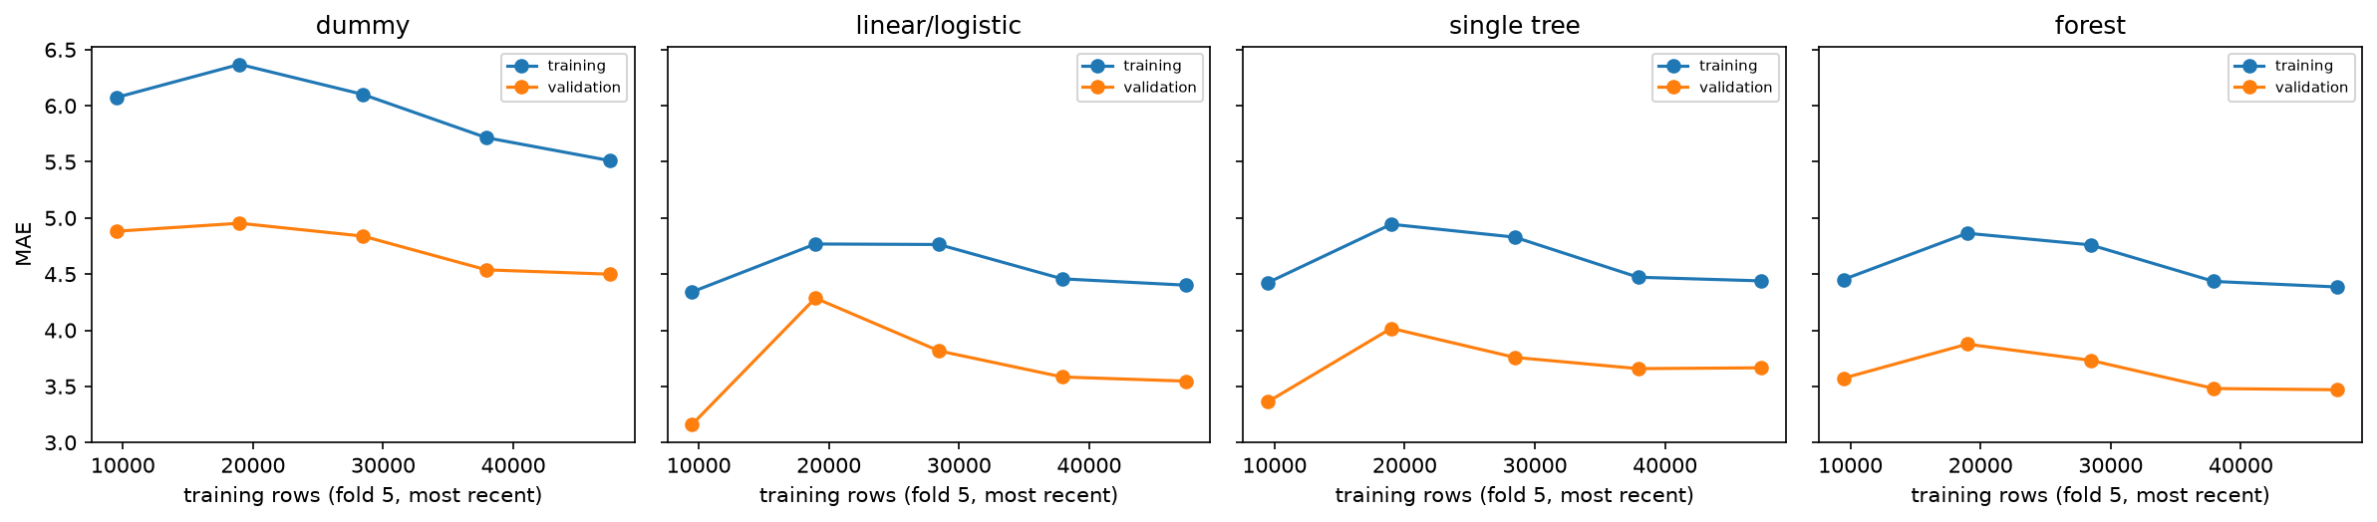
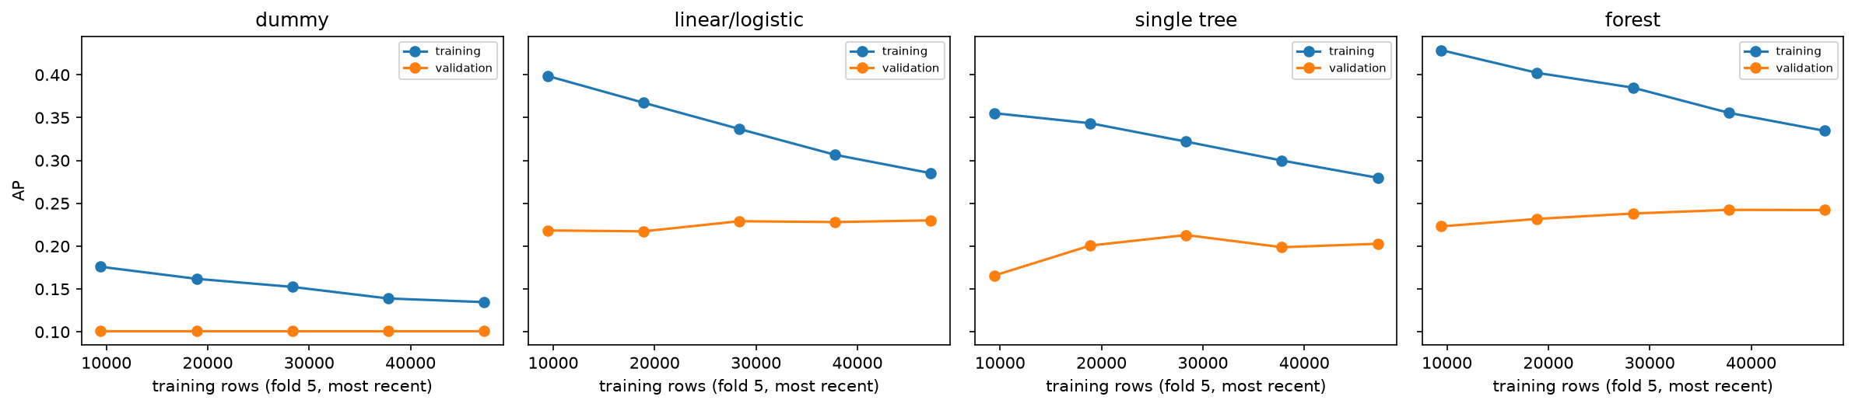
Figure 27. Learning curves on fold 5: training and validation score against the number of most recent training rows, by model family (lead time) (F.reg.learning_curves).
Figure 28. Learning curves on fold 5: training and validation score against the number of most recent training rows, by model family (detractor alert) (F.clf.learning_curves).

I. Feature ranking by fold
To check how much the selection of section 5.3 depends on the rows, the ranking was repeated inside each training fold.
This ranking differs from the selection ranking of section 5.3 (section 7.4): Spearman correlation 0.16 for lead time and 0.31 for the alert, with 7 and 6 of the top ten features shared. This is expected: selection scored one feature at a time on development orders, while importance is measured inside the fitted model, where correlated features share credit.
- Lead time: the selected sets overlap by 0.90 to 1.00 (mean 0.94), and 17 of the 21 selected features are kept in every fold.
- Detractor alert: overlap 0.68 to 1.00 (mean 0.88), weakest in fold 1, which has the fewest training orders; 18 of 25 are kept in every fold.
Table I1. Feature ranking by training fold, lead time.
fold | training_rows | selected | jaccard_with_B4 | added_vs_B4 | dropped_vs_B4 | spearman_ranks_vs_B4
1 | 7932 | 19 | 0.9048 |  | n_products, payment_installments_max | 0.9378
2 | 18077 | 21 | 0.9091 | n_payment_methods | payment_installments_max | 0.9651
3 | 26184 | 21 | 1 |  |  | 0.9836
4 | 37647 | 20 | 0.9524 |  | n_items | 0.974
5 | 47415 | 20 | 0.9524 |  | purchase_month | 0.9822
Table I2. Feature ranking by training fold, detractor alert.
fold | training_rows | selected | jaccard_with_B4 | added_vs_B4 | dropped_vs_B4 | spearman_ranks_vs_B4
1 | 7592 | 22 | 0.6786 | product_photos_qty, purchase_dayofweek, purchase_hour | distance_km_max, interstate_share, order_dispatch_days, seller_prior_dispatch_days, seller_prior_late_handover_days, total_price | 0.2203
2 | 17595 | 25 | 0.8519 | product_photos_qty, purchase_hour | distance_km_max, route_recent_carrier_transit_days | 0.6694
3 | 25529 | 27 | 0.9259 | category_missing_fraction, purchase_hour |  | 0.82
4 | 37140 | 26 | 0.9615 | purchase_hour |  | 0.9564
5 | 47237 | 25 | 1 |  |  | 0.9736
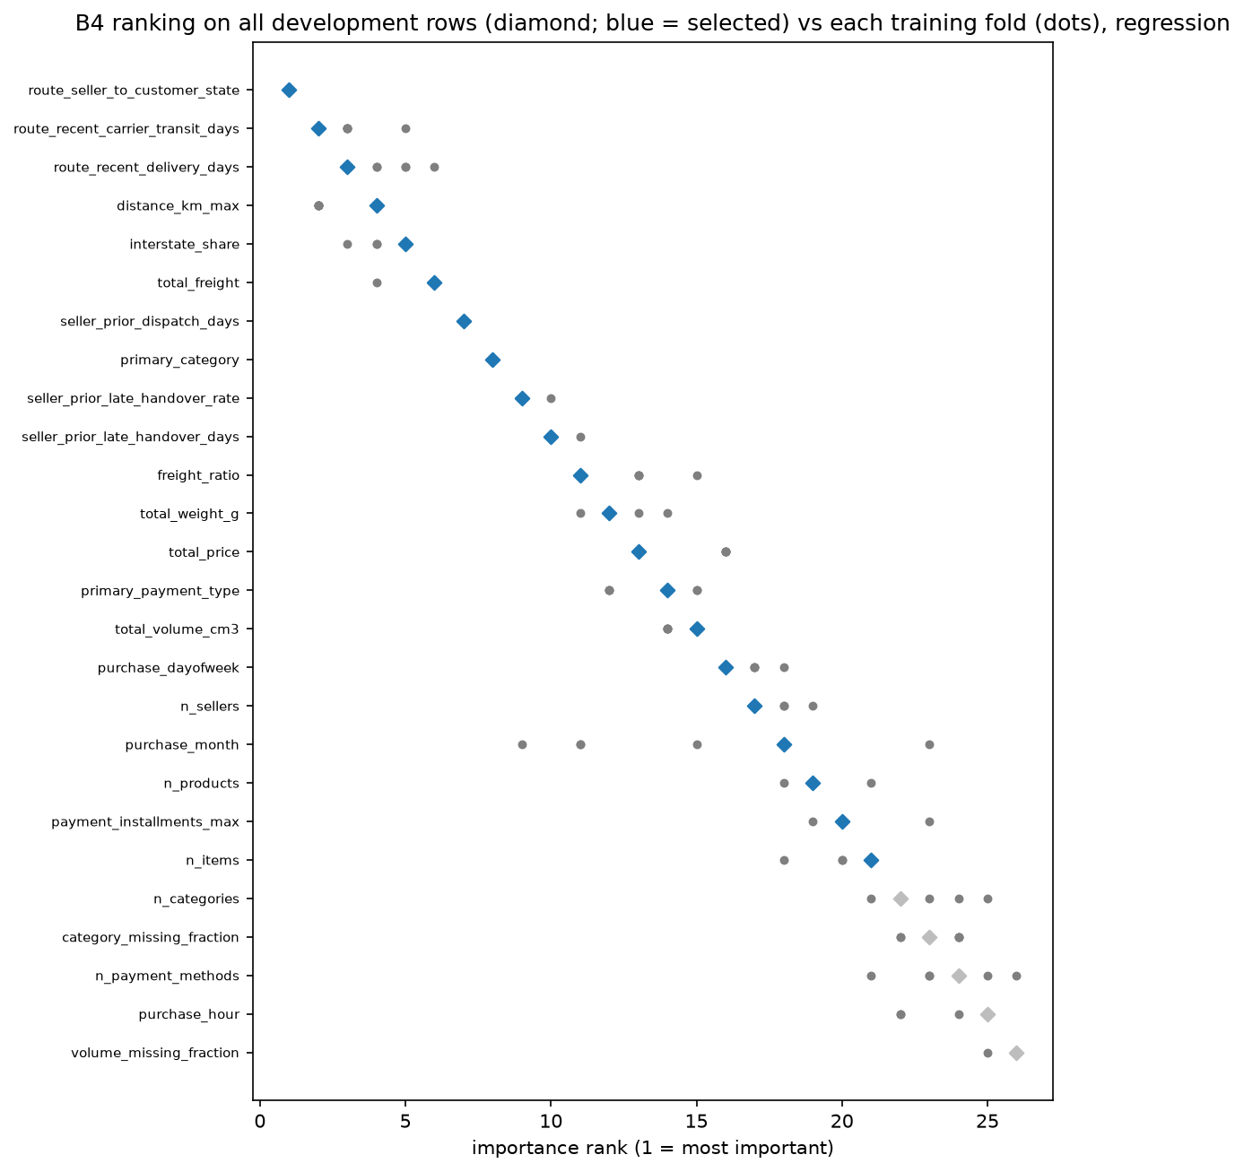
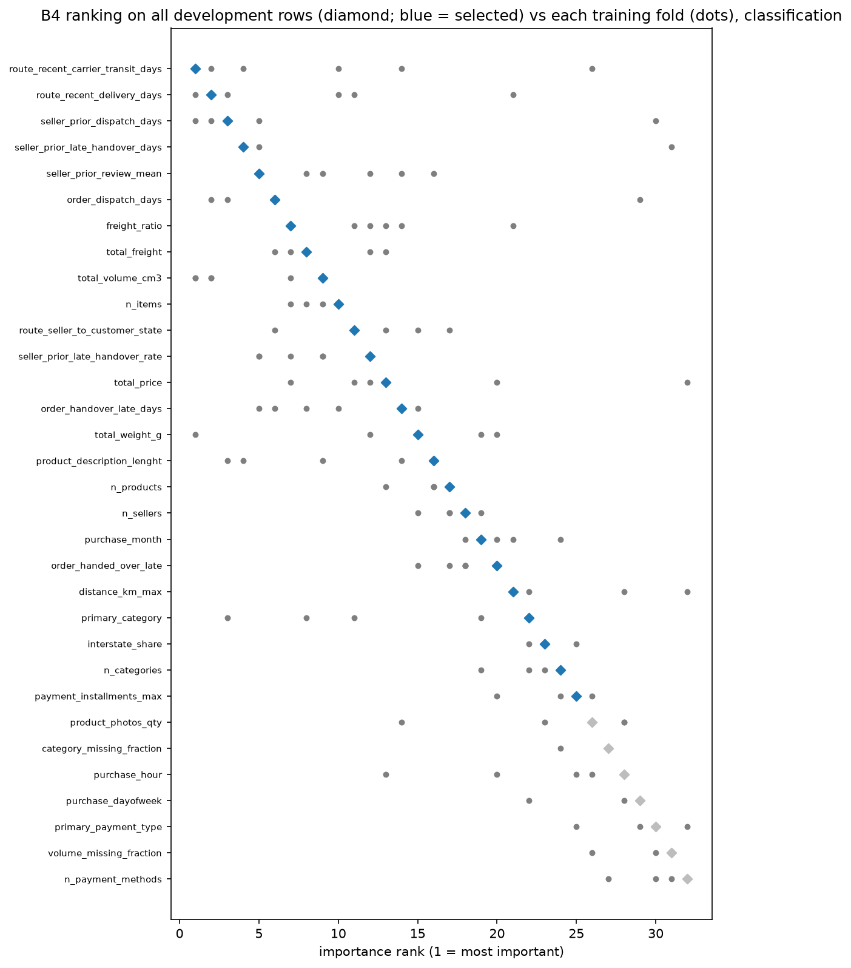
Figure 29. Ranking stability across the five folds, lead time (F.reg.ranking_stability).
Figure 30. Ranking stability across the five folds, detractor alert (F.clf.ranking_stability).

J. Correlation and variance inflation
- Pipeline A's pool, the inherited base. The exploratory stage computed pairwise correlations and a variance inflation factor (VIF) for each numeric predictor on development orders. A pair is flagged above an absolute correlation of 0.9, and a predictor above a VIF of 10. No predictor reached the VIF cut-off in either task (appendix J). One pair was identical on every development order, the missing-weight and missing-volume shares; the lower-ranked of the two was dropped (Table K7).
- What was not measured. Correlation and VIF were not computed for the new history features, which are averages of related quantities; the full-rank check rules out exact dependence but not strong correlation (section 10).
Variance inflation factor of each numeric predictor in Pipeline A's pool, development orders.
Table J1. Variance inflation factors of Pipeline A's pool, lead time.
feature | vif | vif_note
n_items | 1.656
n_products | 1.799
n_sellers | 1.857
n_categories | 4.821
total_price | 1.476
total_freight | 3.334
freight_ratio | 1.26
total_weight_g | 3.609
total_volume_cm3 | 3.473
weight_missing_fraction |  | constant on the complete rows
volume_missing_fraction |  | constant on the complete rows
category_missing_fraction | 4.271
distance_km_max | 1.685
distance_missing_fraction |  | constant on the complete rows
interstate_share | 1.501
purchase_month | 1.003
purchase_dayofweek | 1.002
purchase_hour | 1.001
payment_installments_max | 1.155
n_payment_methods | 1.002
Table J2. Variance inflation factors of Pipeline A's pool, detractor alert.
feature | vif | vif_note
n_items | 1.647
n_products | 1.802
n_sellers | 1.856
n_categories | 4.919
total_price | 1.475
total_freight | 3.322
freight_ratio | 1.259
total_weight_g | 3.498
total_volume_cm3 | 3.424
weight_missing_fraction |  | constant on the complete rows
volume_missing_fraction |  | constant on the complete rows
category_missing_fraction | 4.368
distance_km_max | 1.682
distance_missing_fraction |  | constant on the complete rows
interstate_share | 1.499
purchase_month | 1.003
purchase_dayofweek | 1.002
purchase_hour | 1.001
payment_installments_max | 1.154
n_payment_methods | 1.002
Table J3. Features dropped by Pipeline B's reduction step, detractor alert.
feature | flagged_by | paired_with
customer_state | nested in route (B-G-02) | route_seller_to_customer_state
primary_seller_state | nested in route (B-G-02) | route_seller_to_customer_state
distance_missing_fraction | constant
weight_missing_fraction | duplicate | volume_missing_fraction
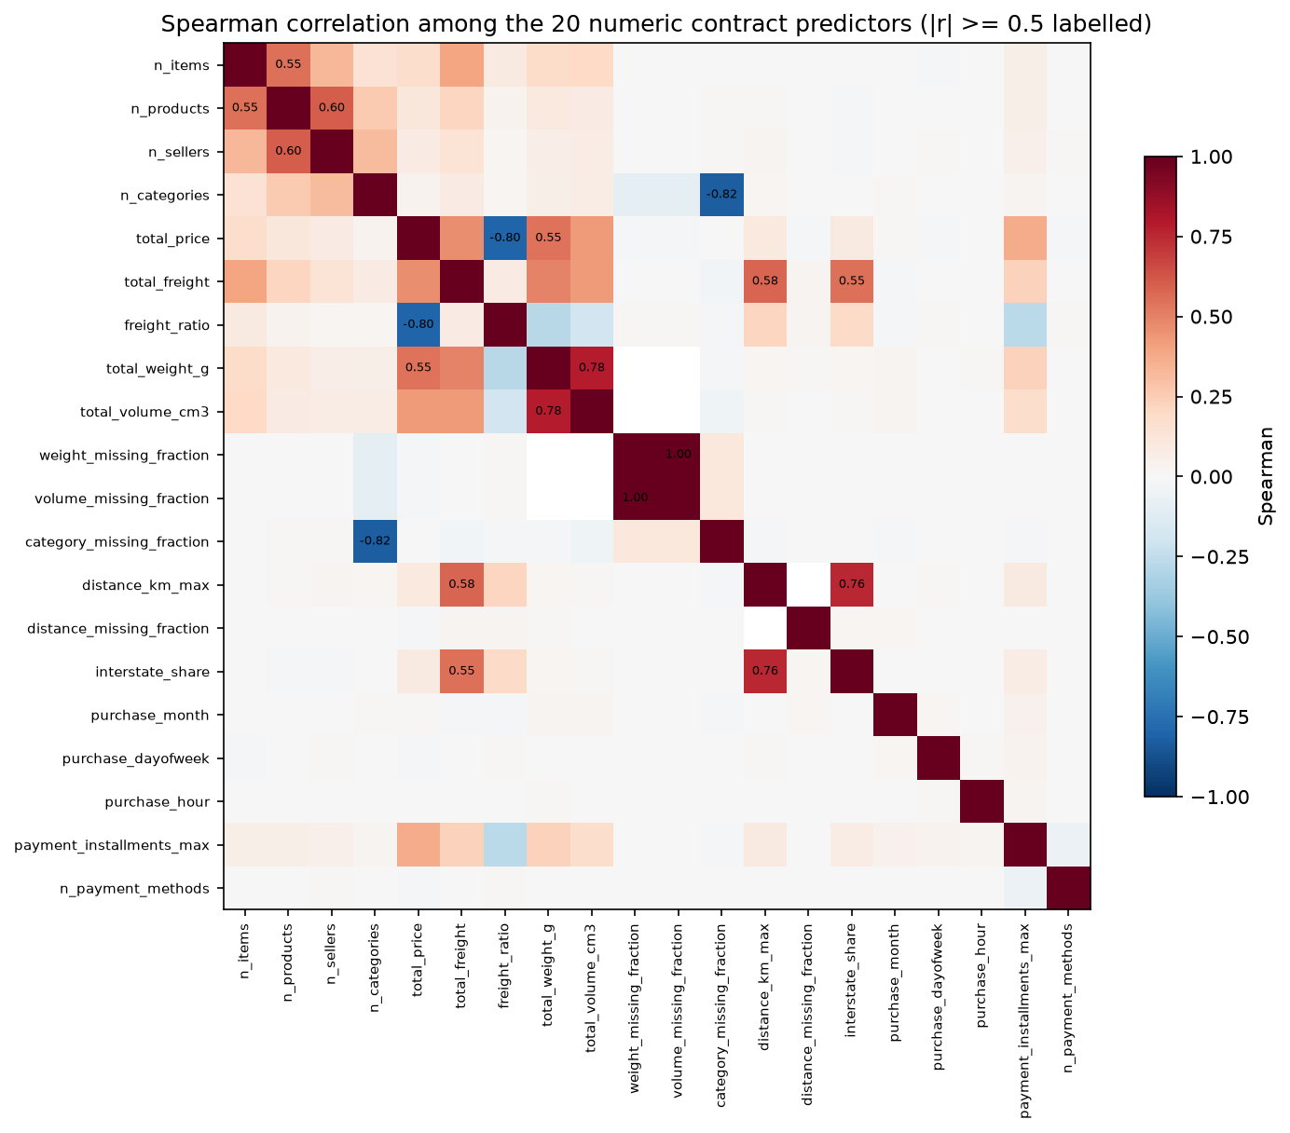
Figure 31. Pairwise correlations of Pipeline A's numeric predictors, development orders (F.A3.reg.correlation_heatmap).

K. Supporting tables for sections 1–10
These tables were moved from the body to keep it within the page limit; the body quotes their key numbers. They are in section order.
Table K1. Pipeline A's evidence and the changes it led to (section 1.1).
What Pipeline A's evidence showed | Change in Pipeline B | How it was checked before the test
The strongest signal of a bad review, late delivery (57.2% detractors when late against 9.5% on time), is unknown at checkout | The alert moves to carrier handover, where this order's dispatch delay is known; orders never handed over are flagged by a rule | Validation AP on the same rows (section 6.5)
Delivery speed varies with the route and changes over time (section 4), but checkout features carry no recent seller or route behaviour | Seller and route history features (section 5.1) | Ranking and selection (section 5.3); validation scores
Distant, thinly served states add noise that a single model fits poorly | Scope narrowed to the seven largest states with known distance; Pipeline A serves every other order | The scope effect is measured separately (section 7)
Table K2. Detractor results under the lowest-review and first-review labels, test orders (section 3).
model | label | ap | roc_auc | brier | precision | recall
B frozen | is_detractor (agreed label) | 0.1972 | 0.636 | 0.0867 | 0.2077 | 0.3005
B frozen | is_detractor_first (first review) | 0.1972 | 0.6363 | 0.08665 | 0.2077 | 0.3006
A frozen | is_detractor (agreed label) | 0.1785 | 0.604 | 0.08926 | 0.1583 | 0.3556
A frozen | is_detractor_first (first review) | 0.1785 | 0.6043 | 0.08921 | 0.1583 | 0.3558
Table K3. Population chain from Pipeline A's development orders to Pipeline B's rows (section 3).
Step | Lead time | Detractor alert
Pipeline A development orders (eligible, before the test period) | 76,925 | 77,736
Customer or seller outside the seven states | − 13,777 | − 13,983
Distance unknown | − 606 | − 618
Lead time above Pipeline B's cap | − 45 | —
Never handed over to the carrier | — | − 461
Reviewed at or before handover | — | − 146
First six weeks (history warm-up) | − 1,264 | − 1,270
Pipeline B's development orders | 61,233 | 61,258
Of these, with the label known before the test period (final fit) | 59,683 | 59,188
Fold 5: training rows / validation rows | 47,415 / 9,059 | 47,237 / 8,646
Test orders | 15,422 | 15,492 (1,541 detractors)
Table K4. Exploratory findings and the decisions they led to (section 4).
What the data shows | Decision it led to | Section
Right-skewed lead time with a long late tail | Log target and log day counts; keep the tail | 3
Late delivery and bad reviews go together | Alert at carrier handover; lateness never a predictor | 1, 6
Speed differs by route and state | Route feature and recent route speed; seven-state scope | 5, 6
Volumes and outcomes change over time | Time-ordered folds and test period | 6
Detractors are a minority | Average precision; cost-based threshold; class weight in the grid | 1, 6
One identical predictor pair | Dropped before selection | 5
Table K5. Pipeline B's new features (section 5.1).
Feature | Definition | Window | Reason
Route (seller state → customer state) | The pair of states the parcel travels between | — | Delivery time differs by origin and destination in ways distance alone misses
Seller prior late-handover rate | Share of the seller's earlier handovers made after their shipping limit | All complete weeks before the prediction week | A seller that dispatched late before is likely to do so again
Seller prior late-handover days | Mean days by which those earlier handovers missed the limit (0 if on time) | As above | The size of past delays, not only their frequency
Seller prior dispatch days | Mean days from purchase to handover over the seller's earlier orders | As above | Packing speed is part of every lead time
Route recent delivery days | Typical purchase-to-delivery time on the route | Weighted mean of the last three complete weeks (0.5, 0.3, 0.2) | Recent delivery conditions on the route
Route recent carrier transit days | Typical handover-to-delivery time on the route | As above | The carrier's part of the lead time, with the seller's delay removed
This order's handover lateness (alert only) | Whether, and by how many days, this order's handover missed its shipping limit | At handover | A late dispatch is new information about the coming delivery and review
This order's dispatch days (alert only) | Days from purchase to this order's handover | At handover | How long the customer has already waited
Table K6. Features removed by Pipeline B's reduction step, lead time (section 5.2).
feature | flagged_by | paired_with
customer_state | nested in route (B-G-02) | route_seller_to_customer_state
primary_seller_state | nested in route (B-G-02) | route_seller_to_customer_state
distance_missing_fraction | constant
weight_missing_fraction | duplicate | volume_missing_fraction
Table K7. Pipeline A's predictor pairs above the correlation cut-off (section 5.2).
feature_a | feature_b | pearson | spearman | identical
weight_missing_fraction | volume_missing_fraction | 1 | 1 | True
Table K8. Model ladder on the five folds, lead time, MAE in days (section 6.2).
comparison | mean_gain | paired_se | folds_better | kept_by_one_se_rule
linear/logistic vs dummy | 0.9442 | 0.1606 | 5 | True
single tree vs linear/logistic | -0.02855 | 0.1027 | 2 | False
forest vs linear/logistic | 0.06193 | 0.0677 | 3 | False
Table K9. Model ladder on the five folds, detractor alert, AP (section 6.2).
comparison | mean_gain | paired_se | folds_better | kept_by_one_se_rule
linear/logistic vs dummy | 0.1236 | 0.01742 | 5 | True
single tree vs linear/logistic | -0.02217 | 0.005108 | 0 | False
forest vs linear/logistic | 0.01232 | 0.005154 | 4 | False
Table K10. Plain against tuned models, lead time (section 6.3).
family | plain_mean | tuned_mean | tuned_se | paired_gain_of_tuned | paired_se | carried
linear/logistic | 5.025 | 5.021 | 0.5946 | 0.00412 | 0.02701 | plain
single tree | 5.053 | 5.084 | 0.6443 | -0.03087 | 0.02687 | plain
forest | 4.963 | 5.082 | 0.649 | -0.1193 | 0.02599 | plain
Table K11. Plain against tuned models, detractor alert (section 6.3).
family | plain_mean | tuned_mean | tuned_se | paired_gain_of_tuned | paired_se | carried
linear/logistic | 0.2616 | 0.2734 | 0.03179 | 0.0118 | 0.005107 | plain
single tree | 0.2394 | 0.2298 | 0.02967 | -0.009644 | 0.007588 | plain
forest | 0.2739 | 0.2625 | 0.02971 | -0.01144 | 0.002612 | plain
Table K12. Adoption check on Pipeline B's folds, lead time, MAE in days (section 6.5).
fold | b_rows | a_model_on_b_rows | b_model_on_b_rows | paired_gain_b_over_a
1 | 10323 | 3.724 | 3.722 | 0.001477
2 | 10364 | 5.516 | 5.468 | 0.04797
3 | 10443 | 5.755 | 5.614 | 0.1411
4 | 10429 | 7.11 | 6.772 | 0.3375
5 | 9059 | 3.607 | 3.547 | 0.06012
Table K13. Adoption check on Pipeline B's folds, detractor alert, AP (section 6.5).
fold | b_rows | a_model_on_b_rows | b_model_on_b_rows | paired_gain_b_over_a
1 | 10324 | 0.1407 | 0.1566 | 0.01585
2 | 10342 | 0.2386 | 0.2738 | 0.03512
3 | 10450 | 0.25 | 0.2762 | 0.02618
4 | 10453 | 0.3563 | 0.3713 | 0.01497
5 | 8646 | 0.2237 | 0.2301 | 0.006408
Table K14. Lead-time error by slice, test orders (section 7.1).
slice | judged_slices | too_few | pooled_mae_A | pooled_mae_B | mean_gain | sd_gain | slices_B_better
customer_state | 7 | 0 | 4.028 | 3.299 | -0.9297 | 0.275 | 7
route_seller_to_customer_state | 20 | 28 | 3.97 | 3.233 | -0.8155 | 0.3866 | 20
distance_band | 5 | 0 | 4.028 | 3.299 | -0.7444 | 0.3128 | 5
basket | 3 | 0 | 4.028 | 3.299 | -0.6387 | 0.0949 | 3
month | 4 | 0 | 4.028 | 3.299 | -0.5456 | 0.5487 | 3
Table K15. Where the gain comes from: validation scores by population (section 7.3).
 | Pipeline A, all states | Pipeline A, seven-state rows | Pipeline B, seven-state rows
Lead time, MAE (days) | 5.470 | 5.142 | 5.025
Detractor alert, AP | 0.232 | 0.230 | 0.248
Table K16. Recommended actions and their evidence (section 9).
Action | What the evidence shows | Label | Dashboard
Promise: B plus a buffer set on recent weeks at 5% late (candidate rule) | Olist's estimate: median 18.6 days, 5.5% late; the 5% rule gives 6.5 days without test data: median 15.0 days, 4.2% late on the test (post-test analysis); matching Olist's late share on those weeks (2.1%) would need 10.0 days; the 12.0-day buffer chosen on validation leaves 1.5% late. Shorter promises raised sales in an experiment (Cui et al., 2024) and a simulation (Salari et al., 2022) and lowered retention in the experiment; faster actual delivery raised sales at another retailer (Fisher et al., 2019) | Observation; operational rule; literature-supported hypothesis for sales | Lead time, promise buffer
Dispatch: flag missed dispatch and manage slow sellers | 37% of late orders were handed over late; the missed-dispatch rule has precision 21.2% and catches 16.8% of all detractors in the seven states, with no model | Observation; unmeasured mechanism for seller management | Detractor risk, missed dispatch
Transit: expedite after a late handover | 10% faster transit would put 3.1% of late orders on time | Scenario; unmeasured mechanism | ML deployment, scenarios
Service recovery: alert at handover | Pipeline B at 4/15: 5.6 alerts a day, precision 0.346, about 1.9 detractors reached a day; with the fallback at 1/6, 20.5 a day at precision 0.192; a 30% freight cut moves 15 of 95 still-late flagged orders below 4/15; test cost 9,211 against 9,505 with no alerts (Table K21) | Observation; proposed workflow (operational rule); association for the discount | Detractor risk, ML deployment
The limits that matter most for reading the results (section 10):
- Scope and moment. Pipeline B covers only orders whose customer and seller are in the seven states with a known distance; Pipeline A's frozen model serves every other order. Pipeline B's alert acts at handover and Pipeline A's at checkout, so part of the alert gain is the later moment.
- Post-test threshold. The operating threshold 4/15 was chosen after the test was read; the frozen 1/6 result is reported as the unbiased one.
- Drift and late deliveries possibly missing. The test period was faster and happier than development, and the slowest deliveries for the newest orders may not have arrived when the data was extracted, so the test error may look better than it will in operation.
- Optimistic validation, unstable alert features. Features were ranked once on all development orders, so validation scores are slightly optimistic (the test is unaffected); the alert's feature ranks move between folds; and correlation among the new history features was not measured.
- Recorded deviations. Sigmoid calibration was kept although the pre-set rule preferred raw probabilities; Pipeline B's fold 1 is below the training minimum; the forest's best configuration sits on its grid edge (section 6).
- Associations, not causes. No feature's effect on the outcome was tested; recommendations are labelled by evidence type (section 9).
- Business case. Section 9's comparisons were computed after the test, its scenarios are associations, the buffer rule was set on one window, and with no handover feed or action log the effect of a contact is unmeasured.
Table K17. Limitations and how each is handled (section 10).
Limit | What it means | How it is handled
Seven-state scope | Pipeline B covers only orders whose customer and seller are in the seven states with a known distance | Pipeline A's frozen model serves every other order, and each prediction shows which model made it
Different prediction moments | Pipeline B's alert acts at handover, Pipeline A's at checkout, so part of the gain is the later moment | Stated wherever the two are compared (section 7)
Post-test threshold | The operating threshold 4/15 was chosen after the test was read | The frozen 1/6 result is reported as the unbiased one
Calibration override | The pre-set rule would have kept raw probabilities; sigmoid calibration was kept so both pipelines share one scale | Recorded as a deviation (section 6.4)
Screening on pooled rows | Features were ranked once on all development orders, so validation scores are slightly optimistic | Ranking stability by fold is reported (section 5.3); the test is unaffected
Unstable alert ranking | For the alert, feature ranks move a lot between folds, most in the early folds | The selected set is read as a reasonable choice, not a unique one
Unmeasured correlation | Correlation and VIF were not computed for the new history features; full rank rules out only exact dependence | Coefficients of related history features are read with care
Grid edge | The forest's best configuration sits on the edge of its grid | The grid was fixed in advance and not extended after the test; the plain model is kept by the selection rule
Fold 1 below minimum | Pipeline B's first fold has fewer training orders than the pre-set minimum | Kept so both pipelines are compared on identical periods
Drift | The test period was faster and happier than development, and the route history features shifted most | Validation and test are reported separately; the promise buffer should be set on recent weeks
Latest deliveries possibly missing | The slowest deliveries for the newest orders may not have arrived when the data was extracted | The test error may look slightly better than it will in operation
Reproducibility | The frozen models' predictions reproduce exactly on another machine; refitting gives slightly different numbers across machines | Reproduction compares predictions exactly and refitted scores within a tolerance
Associations, not causes | Features describe association with the outcome, not the effect of acting on them | Recommendations are labelled by evidence type (section 9)
Table K18. Promises on Pipeline B's test orders (section 9; post-test analysis).
Promise | Median promise (days) | MAE (days) | Orders late
Olist's estimated delivery date | 18.6 | 12.6 | 5.5%
Dummy (median lead time) | 10.1 | 4.4 | 23.1%
Pipeline A | 9.8 | 4.0 | 21.8%
Pipeline B | 8.5 | 3.3 | 29.5%
Pipeline B + 3 days | 11.5 | 5.2 | 11.1%
Pipeline B + 5 days | 13.5 | 6.8 | 6.1%
Pipeline B + 6 days | 14.5 | 7.7 | 4.7%
Pipeline B + 12 days (buffer chosen on validation) | 20.5 | 13.4 | 1.5%
Pipeline B + 10 days (recent weeks, Olist's late share) | 18.5 | 11.5 | 2.1%
Pipeline B + 6.5 days (recent weeks, 5% late; recommended) | 15.0 | 8.2 | 4.2%
The recent-weeks rules are applied on the last validation fold only (2018-04-01 to 2018-05-24; no rolling backtest): at most 5% late gives 6.5 days (4.4% late on those weeks); Olist's estimate was late for 2.1% there, and matching it gives 10.0 days; a 10% target gives 3.5 days (9.6% late on the test). Transit scenario: under the recommended promise, 244 of 652 late orders were handed over late, and 20 of them would have arrived on time with transit 10% faster (against Olist's estimate, 13 of 328).
Table K19. Alert options on the test period: detractors reached a day = precision × alerts a day (section 9; post-test view; A at 4/15 is a threshold not tuned on the test).
Option | Population | Alerts a day | Precision | Detractors reached a day | Cost at 5:1 | Cost with no alert
Pipeline B at 4/15 | Seven states | 5.6 | 0.346 | 1.9 | 7,123 | 7,705
Pipeline A fallback at 1/6 | Outside the seven states | 14.9 | 0.133 | 2.0 | 2,088 | 1,800
Pipeline A fallback at 4/15 | Outside the seven states | 2.4 | 0.226 | 0.6 | 1,716 | 1,800
Missed-dispatch rule | Seven states, including orders never handed over; overlaps Pipeline B's alerts | 13.3 | 0.212 | 2.8 | 7,693 | 8,040
The rule and the fallback serve different orders, so one cannot replace the other; the rule's reach overlaps Pipeline B's and is not added to it.
Table K20. Freight scenarios on the 95 still-late orders Pipeline B flags under the recommended promise (45 detractors): alerts that fall below 4/15 (section 9; association, not an effect).
Scenario | Alerts that stop | Of which below the lowest training freight
Freight −20% | 7 | 1
Freight −30% | 15 | 2
Freight −50% | 29 | 8
Free shipping | 75 | 75
Table K21. Cost at 5:1 (a missed detractor weighs as five false alerts) against no alert, on the orders each model serves (section 9; thresholds set on validation, test a post-test view).
Policy | Validation | Test
Pipeline B, no alert | 35,000 | 7,705
Pipeline B at 1/6 | 30,371 | 7,156
Pipeline B at 4/15 | 32,853 | 7,123
Fallback, no alert | 9,750 | 1,800
Fallback at 1/6 | 8,889 | 2,088
Serving rule, no alert | 44,750 | 9,505
Serving rule: B at 4/15, fallback at 1/6 | 41,742 | 9,211
Serving rule: B at 4/15, no fallback alert | 42,603 | 8,923
Proposed workflow (section 9; operational rule: the dashboard covers the queue, the contact needs integration and the pilot). Customer service would set the threshold, work the daily queue (Pipeline B by risk, then the fallback by handover delay and order value), read each case file and let the reason for the risk pick the action (Table K22), from a new arrival date and an apology to a freight refund or a voucher; the contact happens outside the dashboard, and each week the priorities go to seller management. The review cap of 6 alerts a day applies to Pipeline B alone. A freight discount moves few still-late alerts below 4/15 (15 of 95 at 30% off; Table K20), an association, not an effect.
Table K22. From alert to action: the proposed workflow by the reason for the risk (section 9; operational rule, not a measured result; the contact itself happens outside the dashboard).
When | Reason for the risk (what the case file shows) | Action | Dashboard | Evidence
Daily | Seller handed over after the shipping limit (handover delay) | Message with a realistic new arrival date (prediction plus buffer) and an apology | 4.1 queue, 4.2 order details and predictions | Operational rule; that the message prevents the review is unmeasured
Daily | Slow or long route after a late handover | Ask the carrier to expedite | 4.2 scenario "Logistics −10%" | Scenario: 10% faster transit puts 3.1% of late orders on time
Daily | High freight for the order value | Freight refund, or a voucher for the next order | 4.2 freight scenarios; 4.3 list with CSV download | Association: 30% off freight moves 15 of 95 still-late alerts below 4/15
Daily | No handover by the shipping limit (missed dispatch) | Contact the seller, then offer the customer cancellation or a refund | 3.5 missed-dispatch rule (statistics only; listing these orders needs the live handover feed) | Observation: precision 21.2%, 16.8% of detractors caught
Daily | Any contacted customer | Voucher for the next order, to invite a repeat purchase | — | Unmeasured mechanism; the hold-back pilot compares reviews and repeat orders
Weekly | Sellers and routes that fall behind | Seller management works with them | 2.6 and 3.7 operational priorities; 4.3 list | Unmeasured mechanism
Monthly | Promise and alert drift | Reset the buffer on recent weeks after a rolling backtest; check alert precision and late share by state | 2.4 promise buffer; 3.4 alert work statistics | Operational rule

L. Dashboard screenshots
Input checks. Unknown states, impossible distances, orders without items and missing instalments are rejected with a clear message. Missing values, unseen categories and numeric inputs more than 4 standard deviations from the training mean are accepted with a warning.
Which stored file each tab reads is listed in deliverables/dashboard/app/DATA_AND_MODEL_SOURCES.md. On the detractor tab a radio button switches the alert statistics between validation and the test. The ML deployment tab lists the alerted held-out orders in the review order of section 9, with both predictions and two scenarios on the alert's inputs (logistics 10% faster; freight discounts), each labelled as an association, not the effect of the action. The app's tests check the loaders, the router, the stored thresholds and that the alert list matches the stored test predictions without reading a label. Screenshots follow.
Two views of the app, reading the stored test outputs.
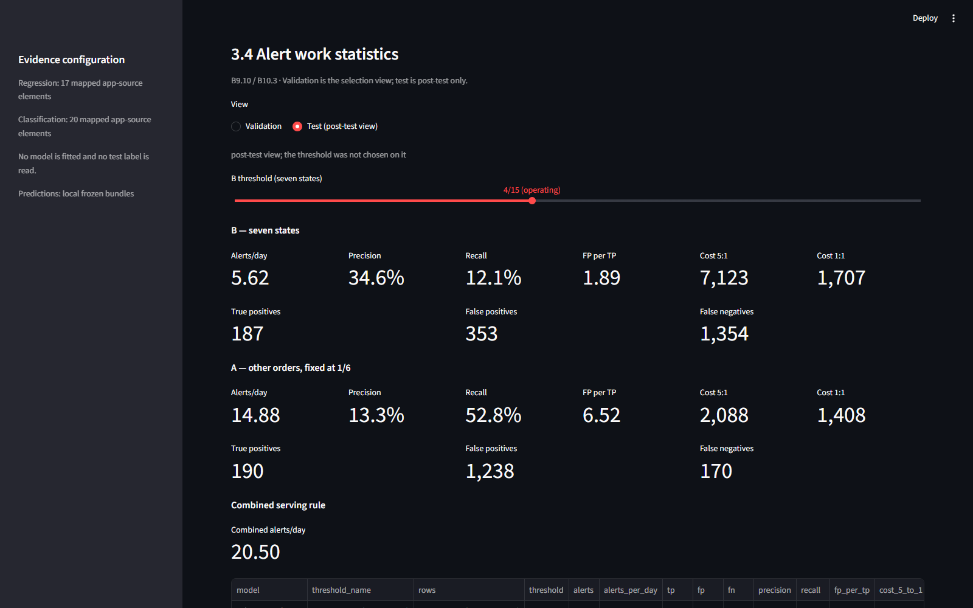
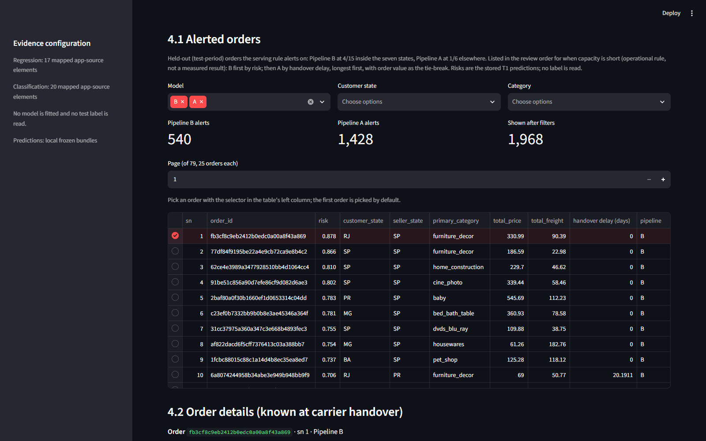
Screenshots 1–2. The detractor tab's alert statistics on the test period at the operating threshold 4/15 (S.05_alert_stats_test_4_15) and the ML deployment tab's list of alerted held-out orders (S.06_ml_deployment_alert_list).

M. Declaration of AI use
The team used Anthropic's Claude (Claude Code) throughout. It wrote and ran most of the pipeline code under the team's instructions, drafted the stage documentation, built the number register, and drafted this report and the slides. The team set the problem, the scope and every decision recorded in the project's decision logs, reviewed each stage before it was accepted, and checked the drafts. Every number in the report is filled from the stored pipeline outputs through the register, never typed; an audit script compares the report and slides against those outputs. The team checked the first twelve references against the publisher's record, and the claims made from each against that record; the two sources added in version 2.3 (Fisher et al., 2019; Salari et al., 2022) were checked against each DOI's Crossref record, with claims limited to the abstract, and signed off by the team (literature register).

N. Reproducing the experiment
The experiment can be rerun from the raw Olist tables with the code in the project repository (https://github.com/wuqianzong/Team11_IT5006_Ecommerce_Analytics_AY2627Sem1, branch main). The README's own Appendix A gives the setup (Python 3.13 and the pinned packages) and a single script that reruns both pipelines at the released version. The script checks that every modelling decision matches the release, and compares every output file with the release. The held-out test is not rerun, because it was read only once; the test results come from the frozen models, which re-predict them to within 1e-9 on any machine.
On the team's reference machine the rerun matches the release byte for byte, apart from seven files made on another machine that differ only by floating-point noise. On other machines, refitted validation scores can differ slightly, because floating-point arithmetic differs between machines; the modelling decisions and test results are unaffected. The README explains these differences.

