**API接口调用详解**

### 币种对(前面为代币类型后面为交易区):

#### 已开放：

**BIGT交易区：**CPL_BIGT

**BTC交易区：**CPL_BTC，BIGT_BTC

**ETH交易区：**CPL_ETH，BIGT_ETH

**CNDT交易区：**CPL_CNDT，BIGT_CNDT，TV_CNDT

#### 待开放：

**BIGT交易区：**ETH_BIGT，BTC_BIGT，LTC_BIGT，CPC_BIGT，TV_BIGT

**BTC交易区：**ETH_BTC，LTC_BTC，CPC_BTC，TV_BTC

**ETH交易区：**BTC_ETH，LTC_ETH，CPC_ETH，TV_ETH

**CNDT交易区：**ETH_CNDT，BTC_CNDT，LTC_CNDT，CPC_CNDT

### 行情API(行情接口都为get请求)

#### 行情

接口地址: <http://47.98.163.31:8888/api/data/v1/ticker>

接口描述: 查询行情

请求参数: market(币对)

响应参数:

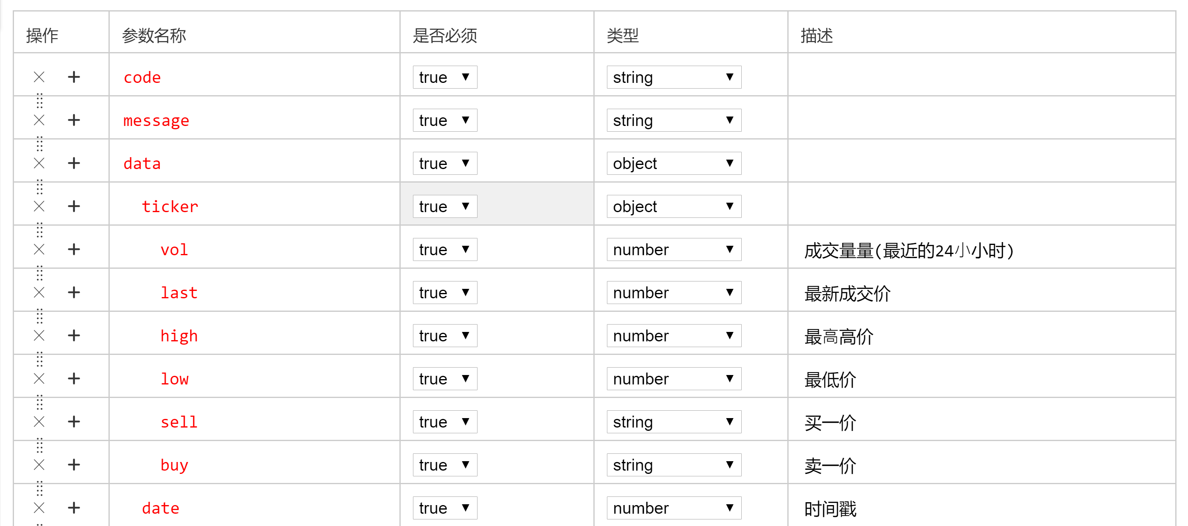

请求实例: http://47.98.163.31:8888/api/data/v1/ticker?market=BTC_ETH

响应实例:

|  |
| --- |
| {"code":"200","message":"成功","data":{"ticker":{"vol":0.0,"last":1.1,"high":0.0,"low":0.0,"sell":null,"buy":null},"date":1528282837798}} |

#### 深度

接口地址: http://47.98.163.31:8888/api/data/v1/depth

接口描述: 查询市场深度

请求参数: market(币对)

响应参数:

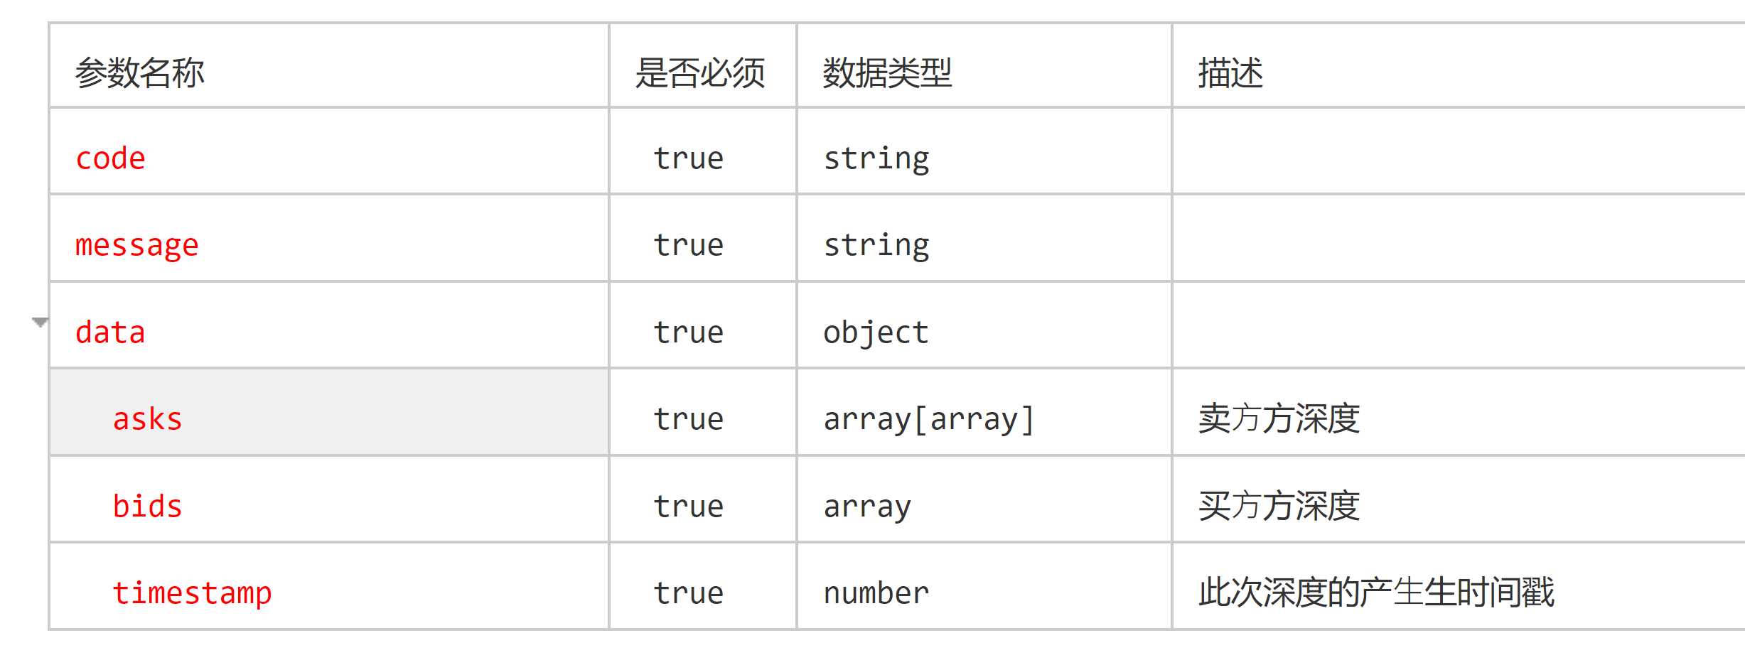

请求实例: <http://47.98.163.31:8888/api/data/v1/depth?market=BTC_ETH>

响应实例:

|  |
| --- |
| {  "code": "200",  "message": "成功",  "data": {  "asks": [  [1.100000, 12.000000]  ],  "bids": [],  "timestamp": 1528339031263  }  } |

#### 历史委托

接口地址: http://47.98.163.31:8888/api/data/v1/getTrades

接口描述: 查询历史委托

请求参数: market(币对)

响应参数:

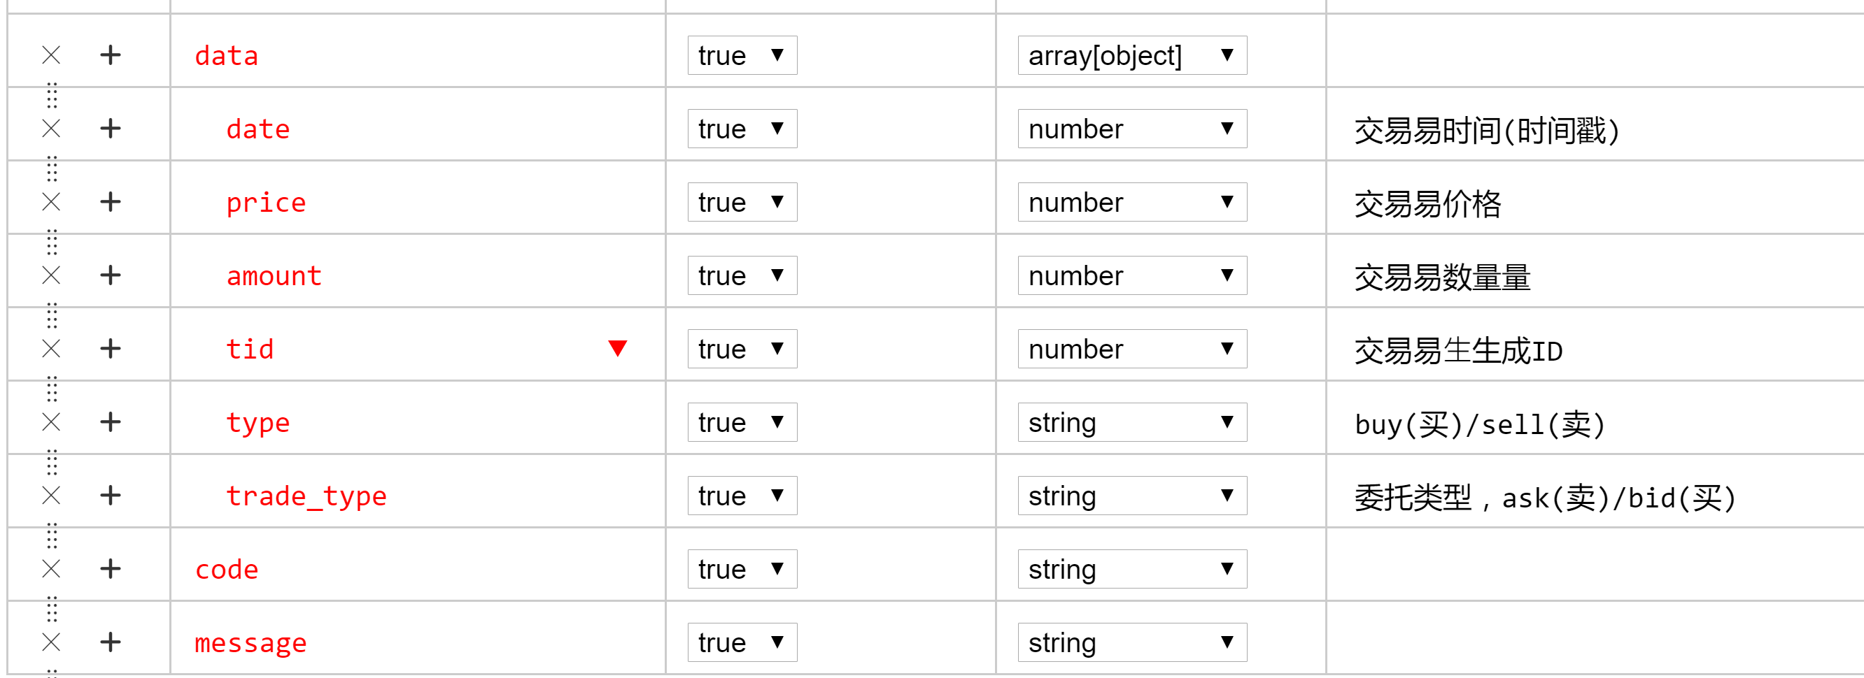

请求实例: http://47.98.163.31:8888/api/data/v1/getTrades?market=BTC_ETH

响应实例:

|  |
| --- |
| {  "code": "200",  "message": "成功",  "data": [{  "date": 1528188125000,  "price": 1.1,  "amount": 1.0,  "tid": 1412,  "type": "buy",  "trade_type": "bid"  }, {  "date": 1528107740000,  "price": 1.1,  "amount": 1.0,  "tid": 1411,  "type": "sell",  "trade_type": "ask"  }]  } |

#### K线

接口地址: [http://47.98.163.31:8888/api/data/v1/kline](http://47.98.163.31:8888/api/data/v1/kline?market=BTC_ETH&type=1min)

接口描述: 查询市场深度

请求参数: market(币对)

Type(1分钟15分钟5分钟1小时2小时4小时6小时12小时24小时1天7天 (换算成分钟))

响应参数:

. 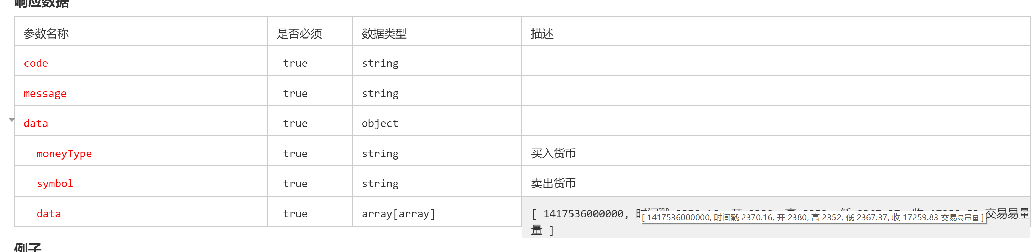

请求实例: <http://47.98.163.31:8888/api/data/v1/kline?market=BTC_ETH&type=1min>

响应实例:

|  |
| --- |
| {  "code": "200",  "message": "成功",  "data": {  "moneyType": "ETH",  "symbol": "BTC",  "data": [  [1528263581566, 0, 0, 0, 0, 0],  [1528281521566, 0, 0, 0, 0, 0]  ]  }  } |

### 交易api

注:

1.交易api请求时统一加以下四个参数

method:方法名例如访问委托下单时method= order取消时method=cancelOrder

accesskey: accesskey

sign: 请求加密签名

reqTime: 当前时间毫秒数

2.所有交易api都为post请求

#### 委托下单

接口地址: http://47.98.163.31:8888/api/api/order

接口描述: 委托下单

请求参数:

price: 单价

amount :交易数量

tradeType: 交易类型 0 买入 1卖出

currency: 币对

响应参数:

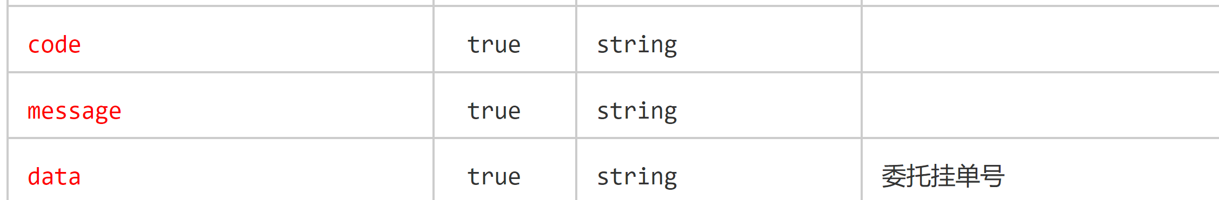

请求实例: <http://47.98.163.31:8888/api/api/order>

price:1

amount:1

tradeType:0

currency:ETH_BIGT

响应实例:

{

"code": "200",

"message": "交易成功",

"data": 136

}

#### 取消委托

接口地址: <http://47.98.163.31:8888/api/api/cancelOrder>

接口描述: 取消委托

请求参数:

currency: 币对

id: 委托挂单号

tradeType: 0买入1卖出

响应参数:

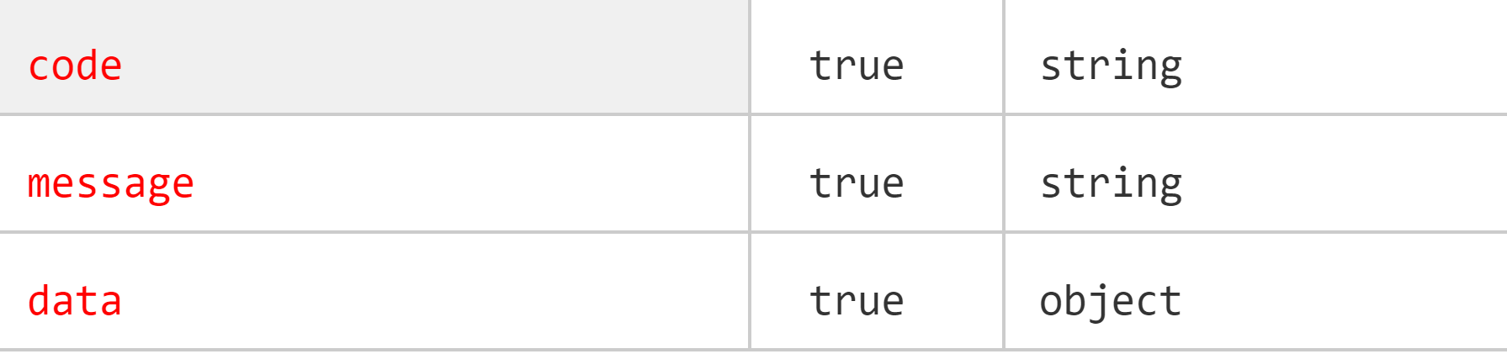

请求实例: [http://47.98.163.31:8888/api/api/cancelOrder](http://47.98.163.31:8888/api/api/cancelOrder%20)

id:139

tradeType:1

currency:ETH_BIGT

响应实例:

{

"code": "200",

"message": "成功",

"data": null

}

#### 获取委托买单或卖单

接口地址: <http://47.98.163.31:8888/api/api/getOrder>

接口描述: 获取委托买单或卖单

请求参数:

currency: 币对

tradeType: 0买入1卖出

id: 委托挂单号

响应参数:

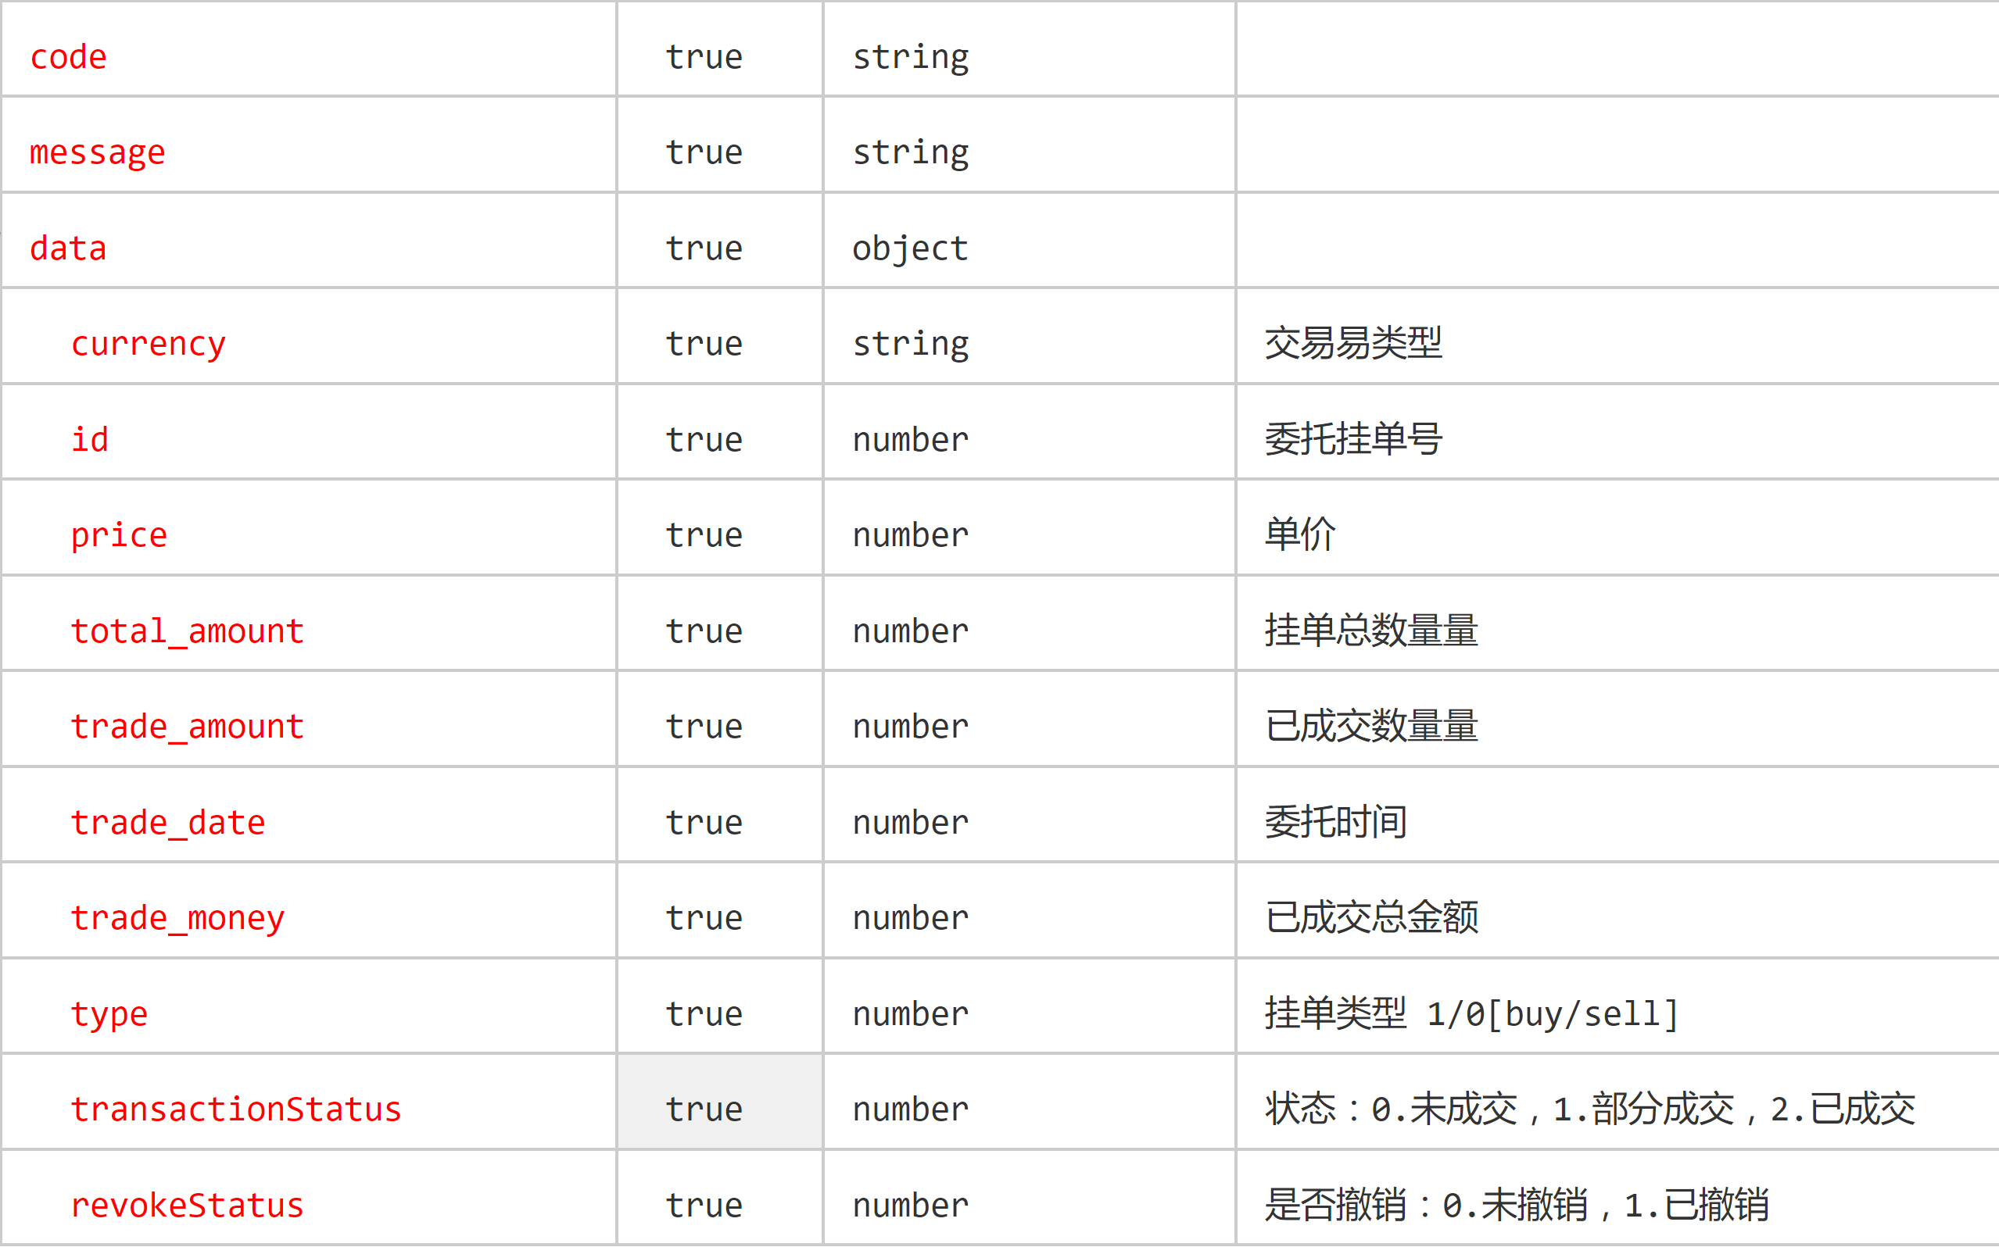

请求实例: <http://47.98.163.31:8888/api/api/order>

id:139

tradeType:1

currency:ETH_BIGT

acctType:1

响应实例:

{

"code": "200",

"message": "成功",

"data": {

"currency": "BIGT",

"id": 139,

"price": 1.1,

"total_amount": 1,

"trade_amount": 0,

"trade_date": 1528278890000,

"trade_money": 0,

"type": 0,

"transactionStatus": 0,

"revokeStatus": 1

}

}

#### 获取多个委托买单或卖单，每次请求返 回10条记录

接口地址: http://47.98.163.31:8888/api/api/getOrders

接口描述: 获取多个委托买单或卖单，每次请求返 回10条记录

请求参数:

currency: 币对

tradeType: 0买入1卖出

响应参数:

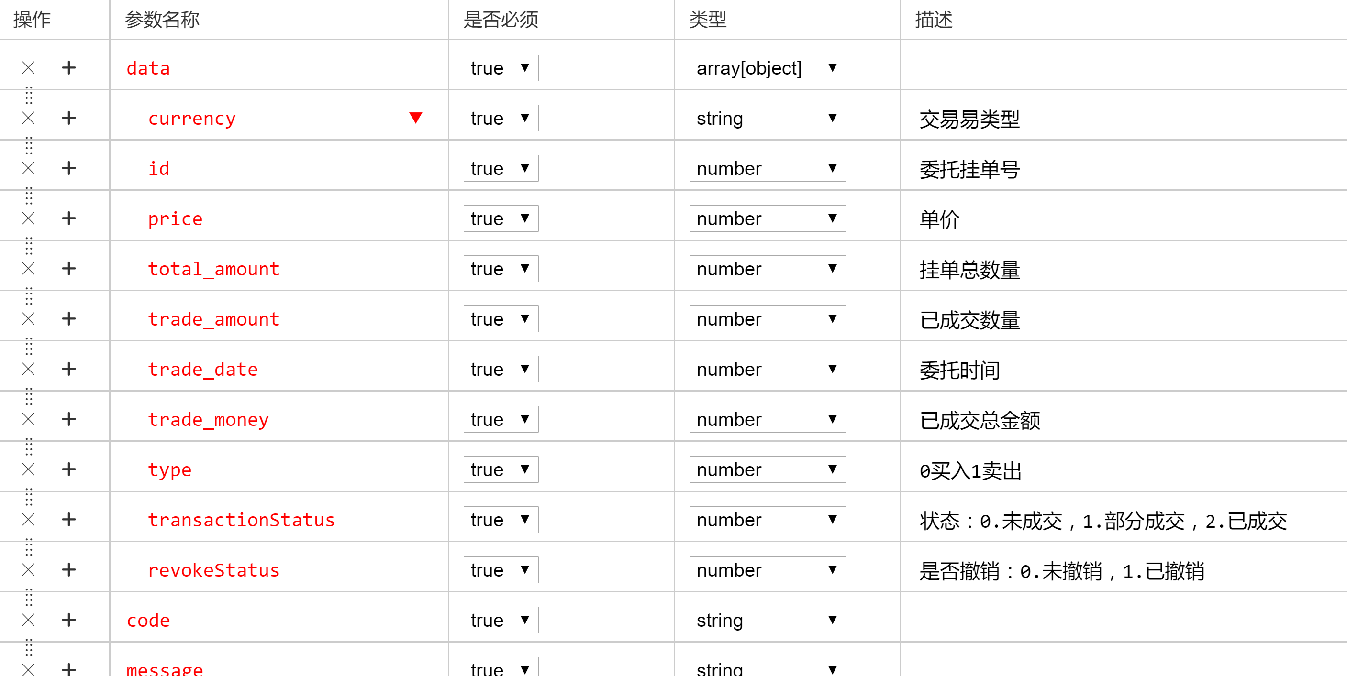

请求实例: http://47.98.163.31:8888/api/api/getOrders

响应实例:

|  |
| --- |
| {  "code": "200",  "message": "成功",  "data": [{  "currency": "BIGT",  "id": 139,  "price": 1.1,  "total_amount": 1,  "trade_amount": 0,  "trade_date": 1528278890000,  "trade_money": 0,  "type": 1,  "transactionStatus": 0,  "revokeStatus": 1  }, {  "currency": "BIGT",  "id": 133,  "price": 1,  "total_amount": 2,  "trade_amount": 2,  "trade_date": 1528188038000,  "trade_money": 2,  "type": 1,  "transactionStatus": 2,  "revokeStatus": 0  }]  } |

#### 获取多个委托

接口地址: <http://47.98.163.31:8888/api/api/getOrdersNew>

接口描述: (新)获取多个委托买单或卖单，每次请 求返回pageSize<100条记录

请求参数:

currency: 币对

tradeType: 0买入1卖出

pageSize: 每页数量

cpageIndex: 当前页数

响应参数:

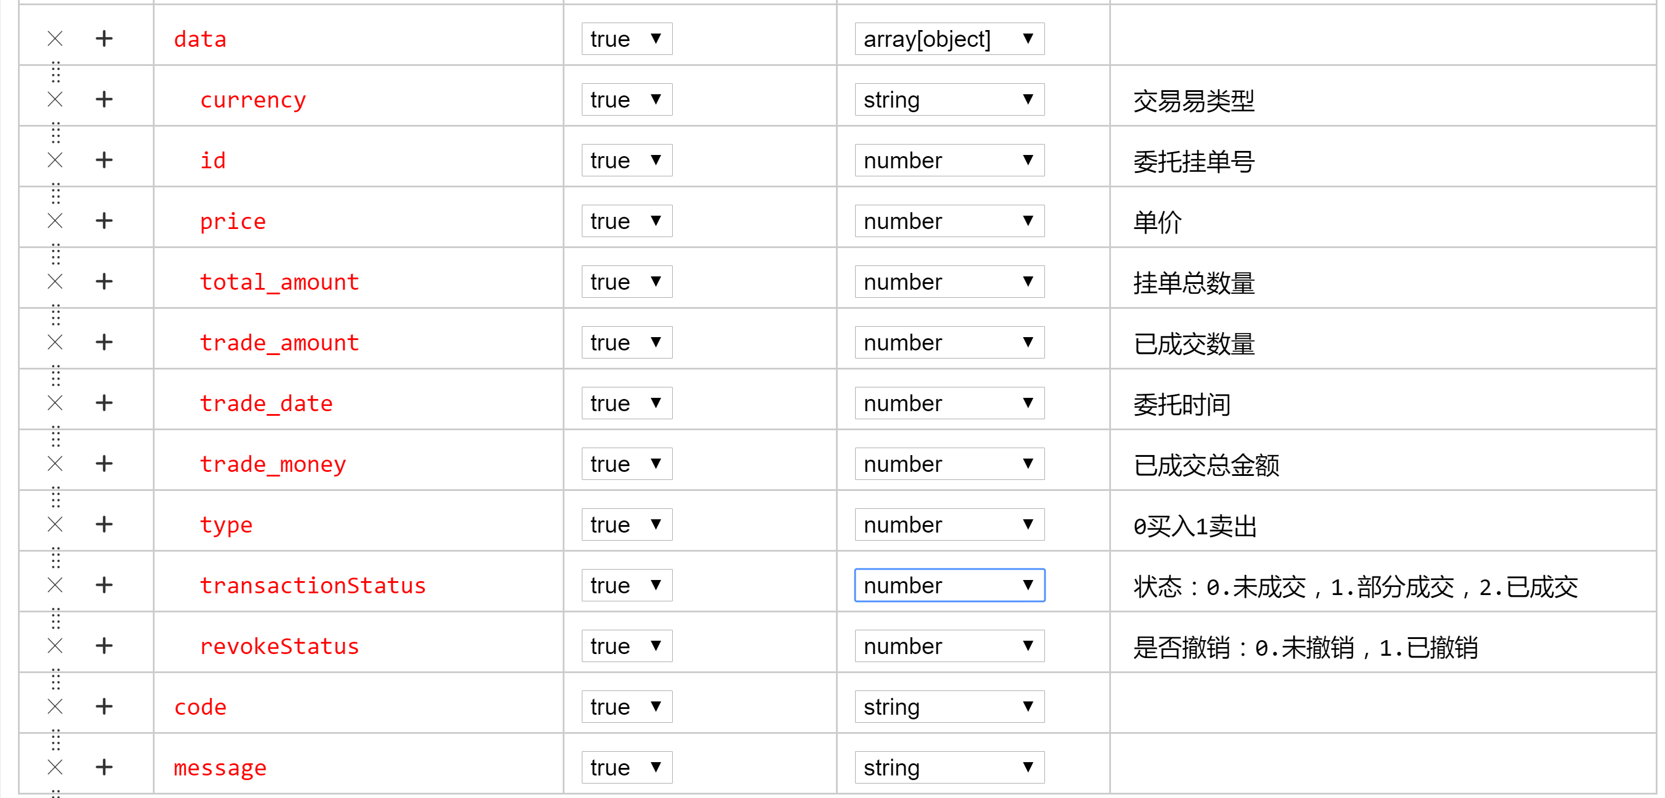

请求实例: <http://47.98.163.31:8888/api/api/getOrdersNew>

tradeType:1

currency:ETH_BIGT

pageSize:1

cpageIndex:10

响应实例:

{

"code": "200",

"message": "成功",

"data": [

{

"currency": "BIGT",

"id": 133,

"price": 1,

"total_amount": 2,

"trade_amount": 2,

"trade_date": 1528188038000,

"trade_money": 2,

"type": 1,

"transactionStatus": 2,

"revokeStatus": 0

}

]

}

#### 获取未成交或部份成交的买单和卖单

接口地址: http://47.98.163.31:8888/api/api/getUnfinishedOrdersIgnoreTradeType

接口描述: (新)获取多个委托买单或卖单，每次请 求返回pageSize<100条记录

请求参数:

currency: 币对

pageSize: 每页数量

pageIndex: 当前页数

响应参数:

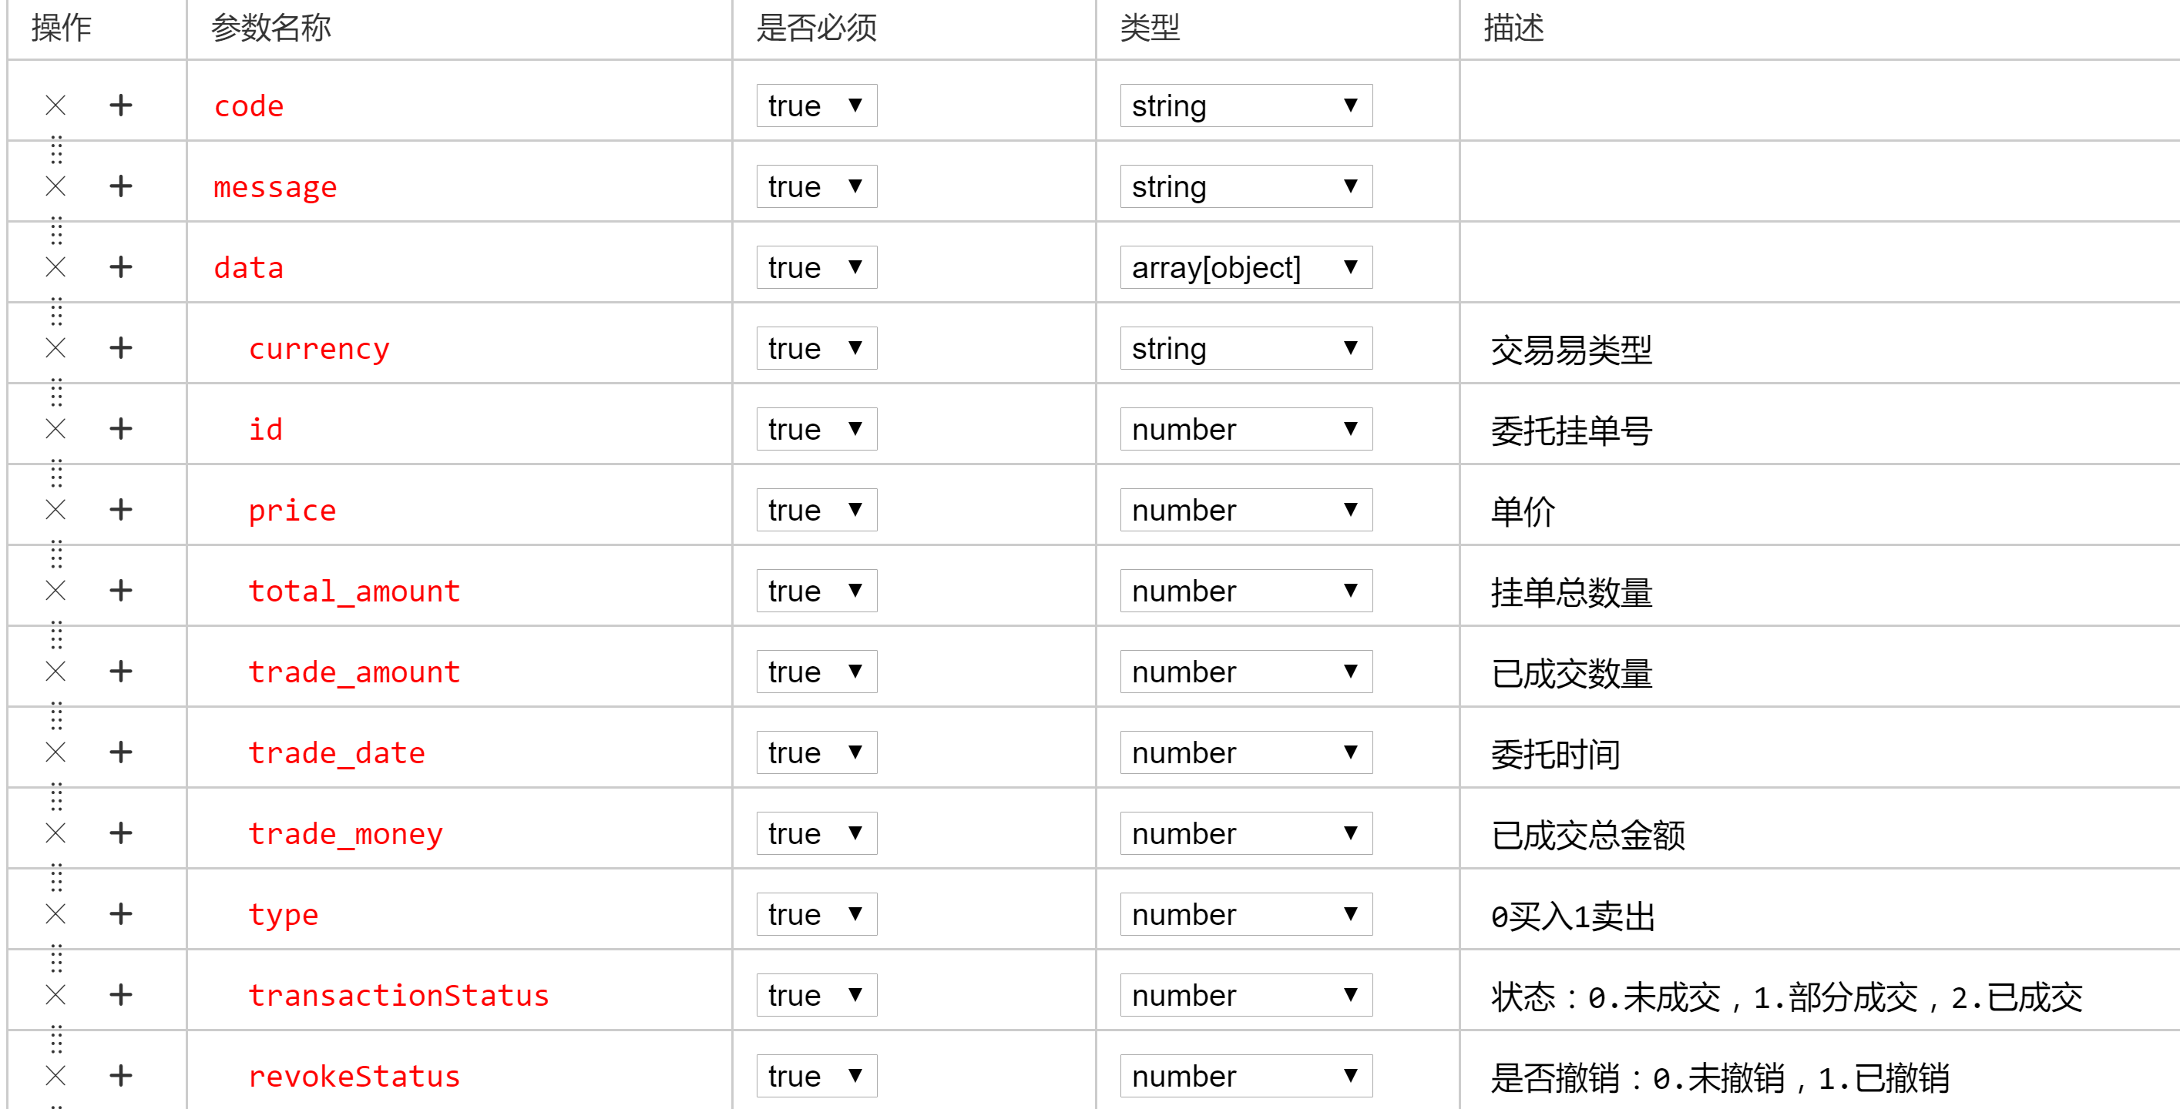

请求实例: <http://47.98.163.31:8888/api/api/getUnfinishedOrdersIgnoreTradeType>

currency:ETH_BIGT

pageSize:1

pageIndex:10

响应实例:

{

"code": "200",

"message": "成功",

"data": [

{

"currency": "BIGT",

"id": 138,

"price": 1.1,

"total_amount": 1,

"trade_amount": 0,

"trade_date": 1528278447000,

"trade_money": 0,

"type": 1,

"transactionStatus": 0,

"revokeStatus": 0

}

]

}

#### 获取用户信息

接口地址: <http://47.98.163.31:8888/api/api/getAccountInfo>

接口描述: (新)获取多个委托买单或卖单，每次请 求返回pageSize<100条记录

请求参数:

响应参数:

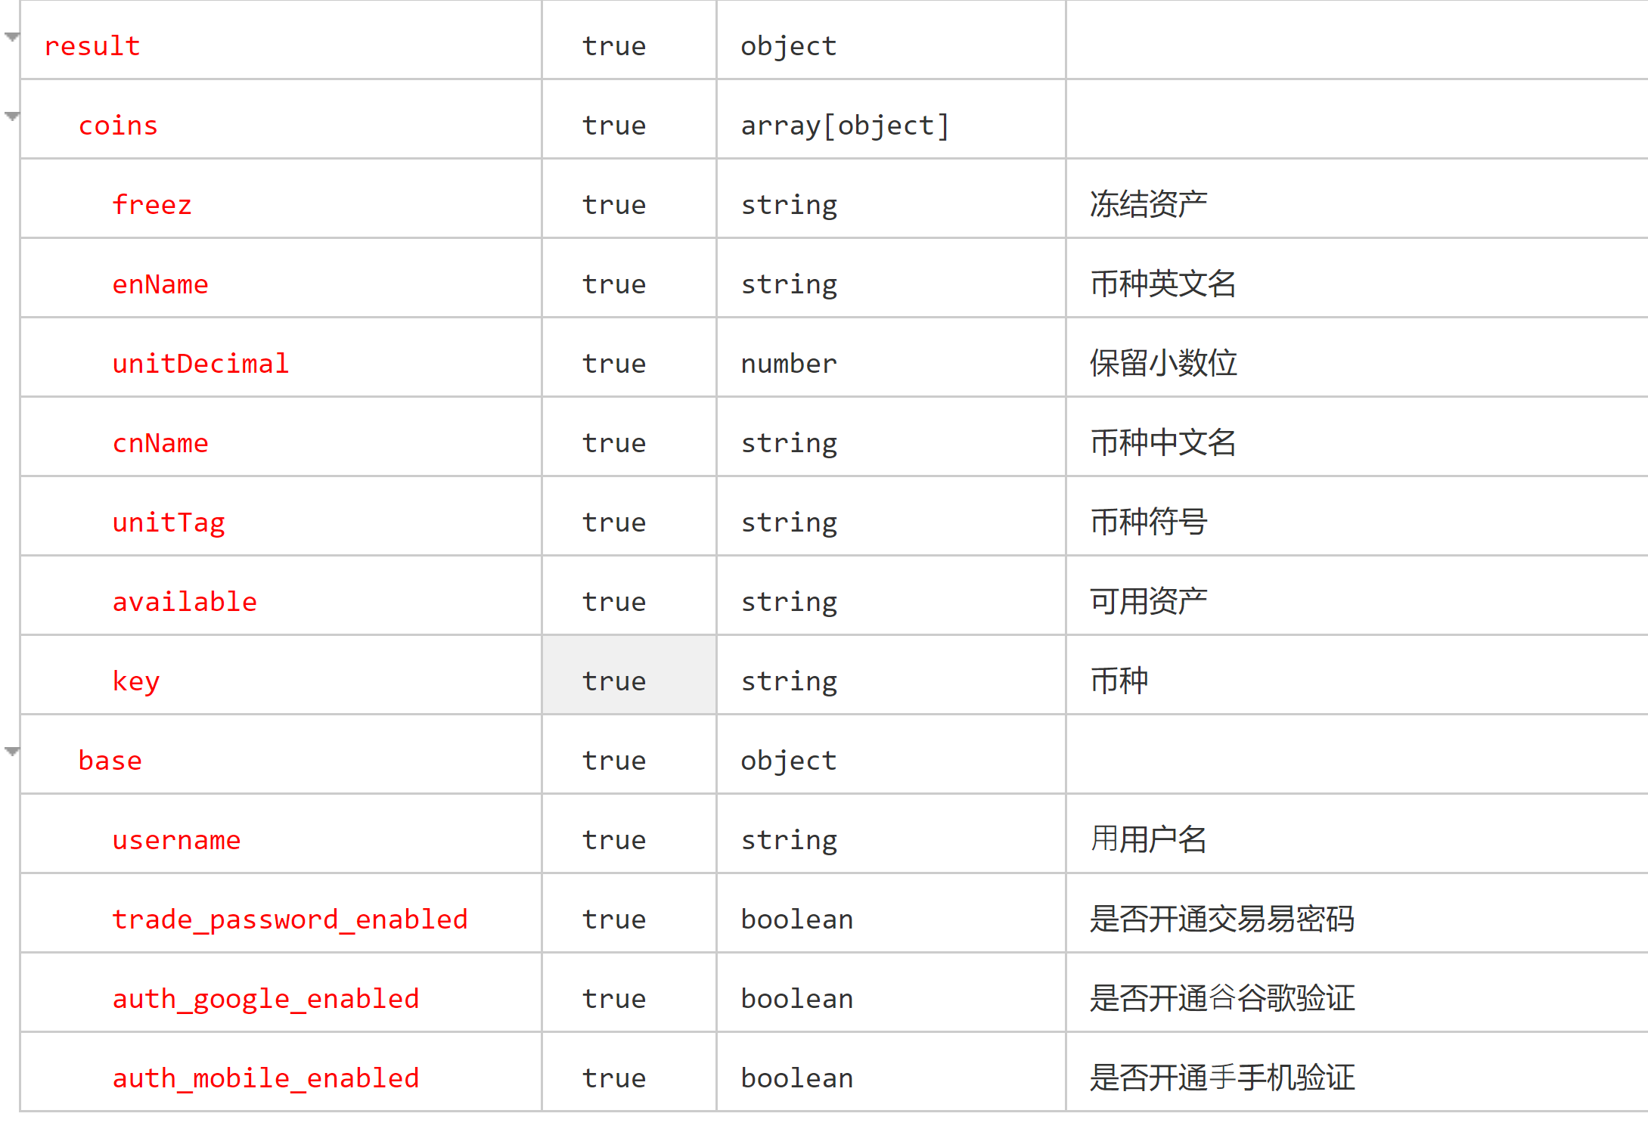

请求实例: <http://47.98.163.31:8888/api/api/getAccountInfo>

响应实例:

|  |
| --- |
| {  "code": "200",  "message": "成功",  "data": {  "coins": [{  "freez": "0.0",  "enName": "BTC",  "unitDecimal": 6,  "cnName": "比特币",  "unitTag": null,  "available": "0.8",  "key": null  }, {  "freez": "0.0",  "enName": "BTC",  "unitDecimal": 6,  "cnName": "比特币",  "unitTag": null,  "available": "0.8",  "key": null  }],  "base": {  "username": null,  "trade_password_enabled": true,  "auth_google_enabled": true,  "auth_mobile_enabled": true  }  }  } |