University of Southampton
Programming Language Concepts

OneLiner
A Haskell Interpreter for Streams

Date | 09.05.2019
Yavor Edipov | ye1g17
Frank Bryden | fjkb1u17

Introduction
OneLiner is an interpreter written in Haskell designed to performs computations on streams - potentially unbounded sequence of integers. This has had an impact on several design choices we have made during development. The syntax was inspired by the hard drive sectors alignment. The interpreter was developed using:
- Haskell
- Alex - lexer, which reads the input and breaks it into tokens
- Happy - parser, which performs a syntax analysis to check whether the input conforms the grammar rules
It follows a Functional Programming style and voids mutable data. Lazy Evaluation delays function evaluation until the time it is needed and it was a design choice that was considered as a necessity, given the input being unbounded.

Overview
OneLiner was designed to keep the grammar of the language simple and with the intention to stimulate creative thought. It operates on the input row by row and the programmer only writes the functions they want to be applied in each step of the execution. This encourages developers to focus on what output they would like to get by manipulating the input with mathematical functions instead of thinking about data, variables and user-defined functions. That’s correct, in this language one cannot declare their own data.
You are probably already wondering how you would be able to keep track of previous rows if data cannot be stored in a variable, for instance. Do not stress out just yet, you can do this with the help of accumulators.
The language supports only integers and several operations to perform on them - addition, multiplication, division, power, and modulo. What about subtraction? The language supports negation but not subtraction. Who needs subtraction anyways? The rest of operators provide us with enough expressivity in order to omit and forget about it. For instance, one can subtract numbers using addition and negation: 3 + (-1) = 3 – 1 = 2 (brackets can be omitted).

Getting Started
A simple program written in OneLiner looks as shown below. The input follows a particular syntax as well – it is a sequence of integers which take the following form:
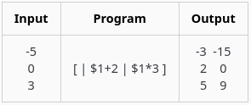
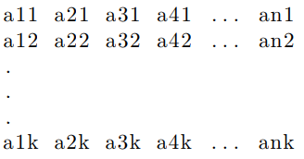

where every line is terminated with the new line character EOL and the file ends with EOF. The a’s are arbitrary (positive or negative) 32 bit integers.
Programs are contained in square brackets [...|…] and consist of blocks. The very first block, which in the example above is empty, is reserved (remember the inspiration from Hard Drive sectors) for the accumulators (if any). Blocks are separated using a pipe | and the number of pipes corresponds to the number of columns in the output (as in our case - 2). In this example, with $1 we access the first column of the input and define what function would be applied on each row of the input to produce the corresponding output in the first and the second column.
In order to keep our first program simple, in the example above it outputs 2 columns. On the first column, we apply addition and on the second – multiplication on each row of the input. One can apply more complex mathematical functions as well.

