March 20, 2019
Istvan Zeno Hevesi (izh1g17)
Yavor Edipov (ye1g17)
William Kewell (WK3G17)
Furqan Hashmi (MFH1G17)
Chris Wang (Lw2N17)

Ad-Auction board Increment 2

Group 13

Key Design Artifacts and Choices
To begin with, we began the development of application using Java 8. For the project we have decided to use Swing and AWT for the UI of the application as most of the team members are familiar with these technologies and this way everybody can easily make contribution. However, we have decided to migrate and use other technologies:
- Maven – dependency manager
  - The project can be easily ported on every machine
  - Loads all needed dependencies for compiling and working on the application
- JavaFX – manages the User Interface.
  - Allows applying better styles using Cascading Style Sheets (CSS).
  - Encourages the usage of Model-View-Controller (MVC) Design Pattern.
  - Manage concurrency in a better way so that the application remains responsive while doing resource-consuming tasks in the background.
- JFreeCharts-FX – charting
  - Library specifically built for creating charts
  - Supports different types of charts
  - Can be easily used to Plot data
- JFoenix – library for JavaFX
  - Support Material Design
  - Makes looks more pleasing to the eye and help with implementing accessibility features
- Junit – writing unit tests
  - Helps the team ensure that whenever a new feature is implemented, everything works as expected and does not introduce bugs
The reason we decided to migrate to using these new technologies are explained with the bullet points above. It is important to note that these new technologies bring value to the application and therefore to the customer. Furthermore, it allows the development team to maintain the application easier as well as easily introduce new features.
We have prioritized implementing filters which allow the user to interpret the data better and more efficiently.
Another thing that we fixed from the previous Increment was the display of the information. It is now in a more human-readable account so that the user can easily understand it.
We have introduced dark mode for the charting as some people might find easier to work this way. It helps as it reduced the strain on the eyes.

Key Storyboards
The UML Class Diagram describes the structure of a system by showing the system's classes, their attributes, operations (or methods), and the relationships among objects. We used it for general conceptual modeling of the structure of the application, and for detailed modeling translating the models into programming code. The UML Diagram can be seen in a separate file if needed for better readability. The file can be found after the attached picture below.
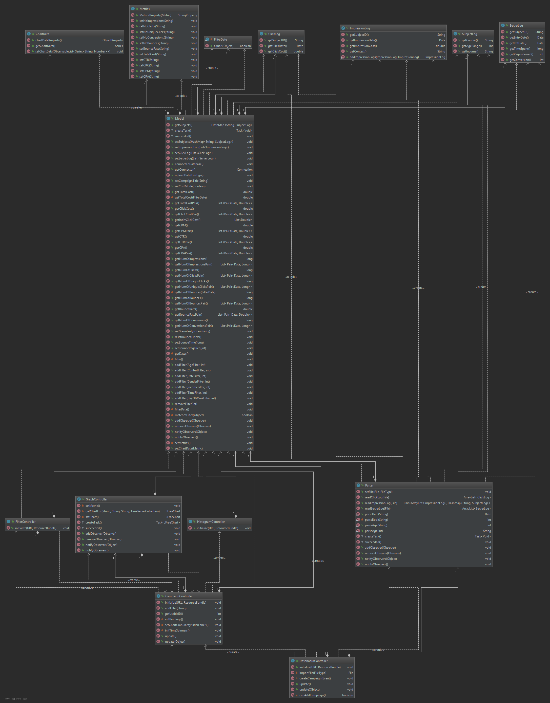
We have built a UML Usecase Diagram in order to get an overview of the system and how it would perform. It assisted us in picturing the interaction between the user and the system. The user can: Import Files, Control Data Filters and Visualization. Some of the actions do depend on others. For instances, in order for the user to be able to work with the data, it needs first to be parsed. However, in order for the system to parse the data in needs to be imported from files.
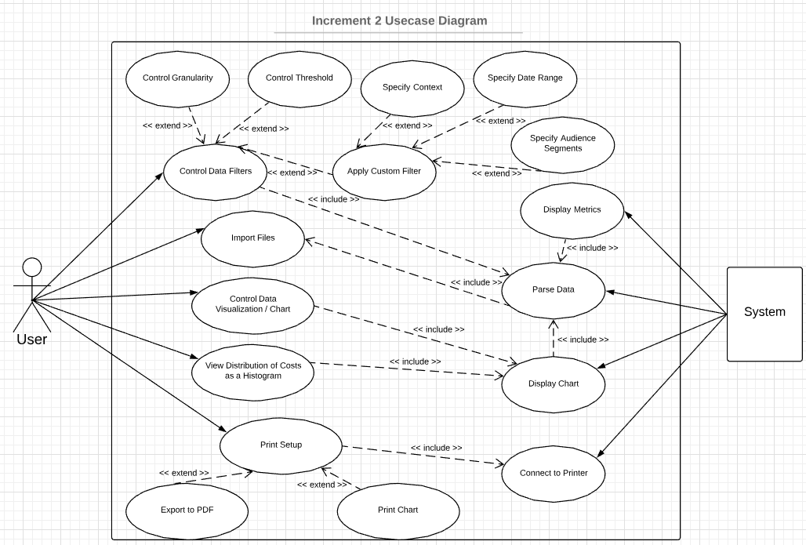

It was useful to build a UML Sequence Diagram as well to describe potential actions a user might take. This way we were able to implement needed features with a better understanding of the system and how it is supposed to behave.
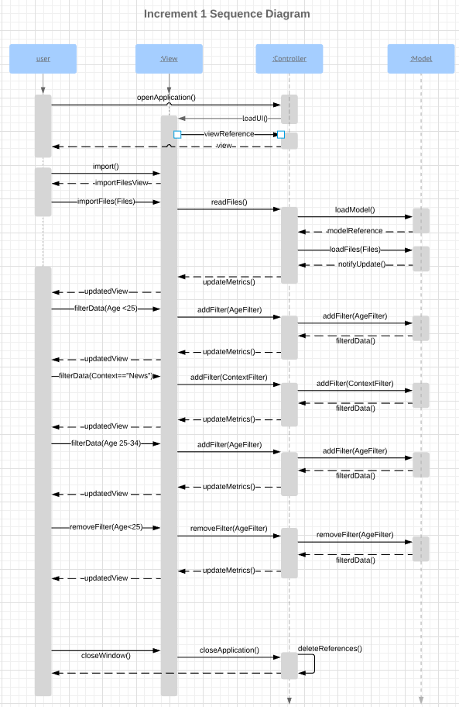

Key Test Outputs
Writing Junit Tests helps us prove the accuracy of the application. We have manually computed the expected results of certain operations using other tools and then tested these against the output of our program. As it can be seen from the picture (refer to the tests.ModelTests.java file for more details), the software passes all the written tests. However, as pointed by the supervisor these are not needed by the client so we use them just for development purposes. They said that the client is interested in the table below.
Another testing we did was the UI Testing where we ran the application and went through the actions a user would do and confirm that the expected result aligns with the actual result we get from the application. The table with these tests can be seen below.

Action Taken | Expected Outcome | Actual Outcome
Click “Import” under “Import impression log” | Directory browser should be displayed in a separate panel | Directory browser displayed in separate panel
Impression log selected | Import button should change to “Change File” button | Import button changes to “Change File”
Click “Import” under “Import click log” | Directory browser should be displayed in a separate panel | Directory browser displayed in separate panel
Click log selected | Import button should change to “Change File” button | Import button changes to “Change File”
Click “Import” under “Import server log” | Directory browser should be displayed in a separate panel | Directory browser displayed in separate panel
Server log selected | Import button should change to “Change File” button | Import button changes to “Change File”
Click “New campaign” button | UI should be initialized with no key metric selected, and the bounce rate automatically set | UI is initialized with no key metrics selected, and the bounce rate is automatically set
UI test #1
Importing correct files

UI test #2
Importing incorrect files
Action Taken | Expected Outcome | Actual Outcome
Click “Import” under “Import impression log” | Directory browser should be displayed in a separate panel | Directory browser displayed in separate panel
Click log selected | Import button should remain unchanged, no file is loaded | Import button doesn’t change, no file is loaded
Click “Import” under “Import click log” | Directory browser should be displayed in a separate panel | Directory browser displayed in separate panel
Server log selected | Import button should remain unchanged, no file is loaded | Import button doesn’t change, no file is loaded
Click “Import” under “Import Server log” | Directory browser should be displayed in a separate panel | Directory browser displayed in separate panel
Impression log selected | Import button should remain unchanged, no file is loaded | Import button doesn’t change, no file is loaded

UI test #3
Histogram test
Action Taken | Expected Outcome | Actual Outcome
Click “Click Cost Histogram” | New window displaying the Click Cost Histogram should appear | Click cost histogram is displayed  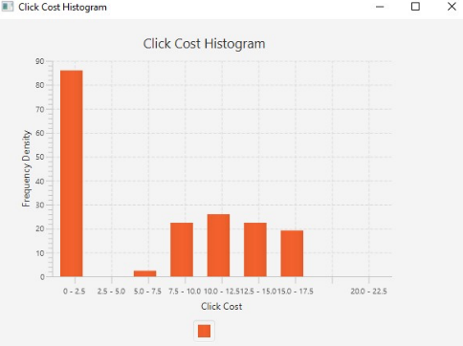

UI test #4
Filtering test
Action Taken | Expected Outcome | Actual Outcome
Click “New Filter” button | Add filter window should be displayed | Add filter window is displayed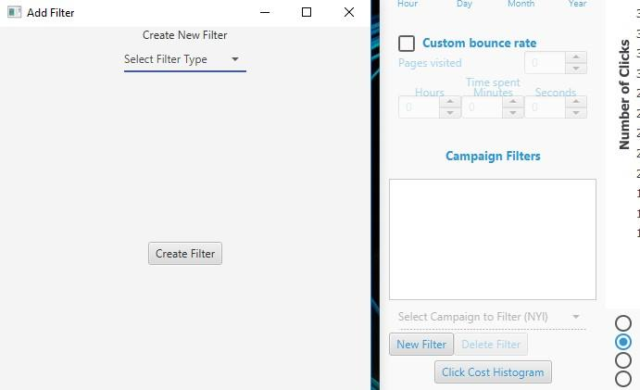
Click “Select Filter Type” dropdown bar | Filter types: “Age”, “Context”, “Gender”, “Income”, “Date Range” should be displayed | Filter types appear in the dropdown bar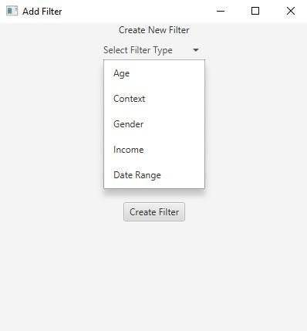
Select “Age” | “Select Age Range” dropdown menu should appear closed | Select Age Range dropdown menu appears closed
Click “Select Age Range” | Age ranges: “Under 25”, “25-34”, “35-44”, “45-54”, “Over 54” should appear | Age ranges are displayed correctly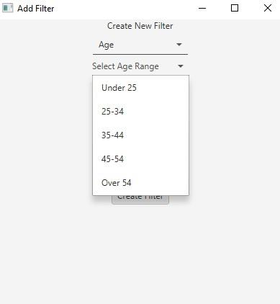
Select a range and click “Create Filter” | Filter should be added to the list “Campaign Filters”, displayed with a number before it. Create new filter window should remain open | Filter is created with numbering. Create new filter window still open.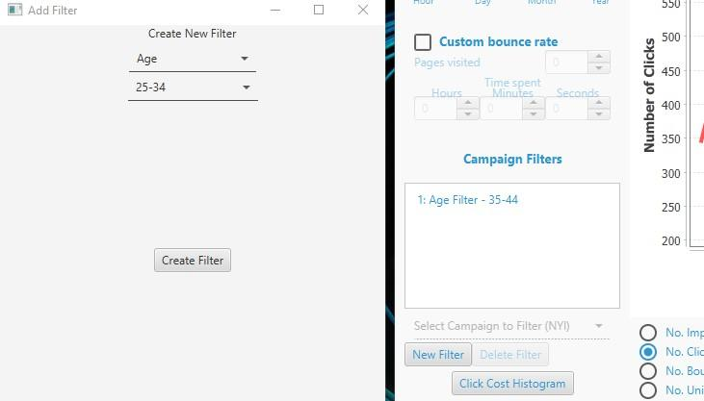

UI test #5
Dark mode test
Action Taken | Expected Outcome | Actual Outcome
Toggle “Dark mode” button | Font color should be blue. Main background color should be dark blue. Dark mode toggle should be green.  Chart background should be dark blue | Font and background colors are changed to their appropriate colors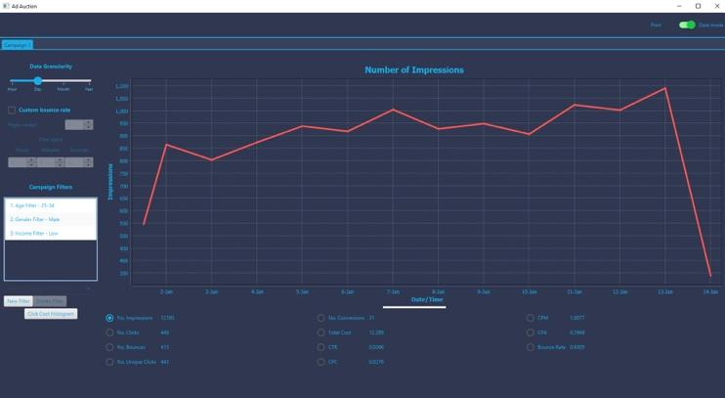

UI test #6
Testing print window
Action Taken | Expected outcome | Actual outcome
Click “Print” button | Printing options window should pop up (in case a printer is connected to the computer) | Print window pops up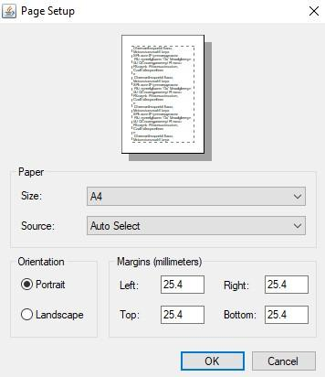

Responses to Feedback
We were very happy to receive the feedback from the previous review meeting as it helped us identify the issues we had. These include:
- Burndown chart was not in the correct format and design. As the supervisors said it was clear from development point of view but it did not make sense to the client.
  - We have responded to that by using other tools for creating it as suggested by the supervisors.
- Testing was clearly done but it was too technical. From the client’s point of view it was difficult to understand. For this reason, they suggested to have pictures and a table with the following structure: Action | Expected Result | Actual Result.
  - Our response was to do these for this increment. We now do include this table which can be seen above in the Key Test Outputs section.
- UML Diagrams had some concepts that were a bit confusing. For instance, in the Sequence Diagram we need a dashed line only one a value is returned according to the supervisor. The UML Class Diagram was a bit ambiguous because some of the arrows pointed towards the direction of dependence while others pointer to what extends what.
  - Sequence diagram response – we learnt the concepts better and tried our best to follow the specifications of different components.
  - UML Class Diagram – we now have the proper Relationship types on the lines so that they follow the conventions properly and are clear to interpret.

Planning

Increment 2 Burndown Chart
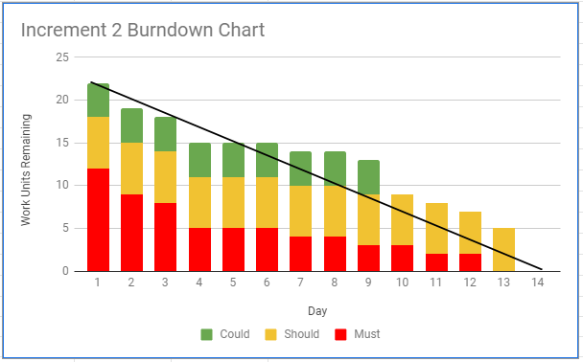
During development, we decided to push optimisation of the system forward from increment 3 to this increment. The reason for this was that we felt it would make more sense to optimise the system whilst working on it, rather than delaying it as this would increase the workload.
We also decided to push two of our “Could” and two of our “Should” tasks, 25, 26, 24 & 19 (the time of day granularity, day of week granularity, loading of multiple campaigns, and overlaying of charts), to our third increment. The reason for this was that we felt it would be easier to implement alongside our database implementation. Another factor in our decision was that, due to deciding to push optimisation forward, we didn’t have enough time to fully implement them. Instead, we decided to start implementing some of the accessibility/personalisation features.

Increment 3 Burndown Chart
