May 1, 2019

edipov y. (ye1g17)

Yavor Edipov (ye1g17)

William Kewell (WK3G17)

Furqan Hashmi (MFH1G17)

Chris Wang (Lw2N17)

Ad-Auction board Increment 3

Group 13

# Key Design Artifacts and Choices

* **Maven** –dependency manager
  + The project can be easily ported on every machine
  + Loads all needed dependencies for compiling and working on the application
* **MySQL** – persistent storage
  + We use a MySQL Database running on an Ubuntu Server.
  + Used to allow client to back-up their data.
* **JavaFX –** manages the User Interface.
  + Allows applying better styles using **Cascading Style Sheets (CSS).**
  + Encourages the usage of **Model-View-Controller (MVC)** Design Pattern.
  + Manage concurrency in a better way so that the application remains responsive while doing resource-consuming tasks in the background.
* **JFreeCharts-FX –** charting
  + Library specifically built for creating charts
  + Supports different types of charts
  + Can be easily used to Plot data
* **JFoenix –** library for JavaFX
  + Support Material Design
  + Makes looks more pleasing to the eye and help with implementing accessibility features
* **Junit –** writing unit tests
  + Helps the team ensure that whenever a new feature is implemented, everything works as expected and does not introduce bugs

We are a using a relation database (MySQL) as the data for the campaigns can be easily represented in rows and columns in a table. All team members have experience working with it which allows everybody to make a contribution to the implementation of various features with regards to it.

For the current increment our top priority were tasks which were pushed from Increment 2 to this one. These concern displaying metrics **per time of day** and metrics **per day of week**.

We have prioritized optimizing the application so that it runs smoother and does not cause delays which might frustrate the user. Furthermore, as requested by our client, main goal for this increment was to allow the client to back up their campaign data in a database and access it using a username or password.

Another thing that we have implemented is **highlighting times of high response** which we believe provides great value to the user.

# Key Storyboards

The **UML Class Diagram** describes the structure of a system by showing the system's classes, their attributes, operations (or methods), and the relationships among objects. We used it for general conceptual modeling of the structure of the application, and for detailed modeling translating the models into programming code. The UML Diagram can be seen in a separate file if needed for better readability. The file can be found after the attached picture below.

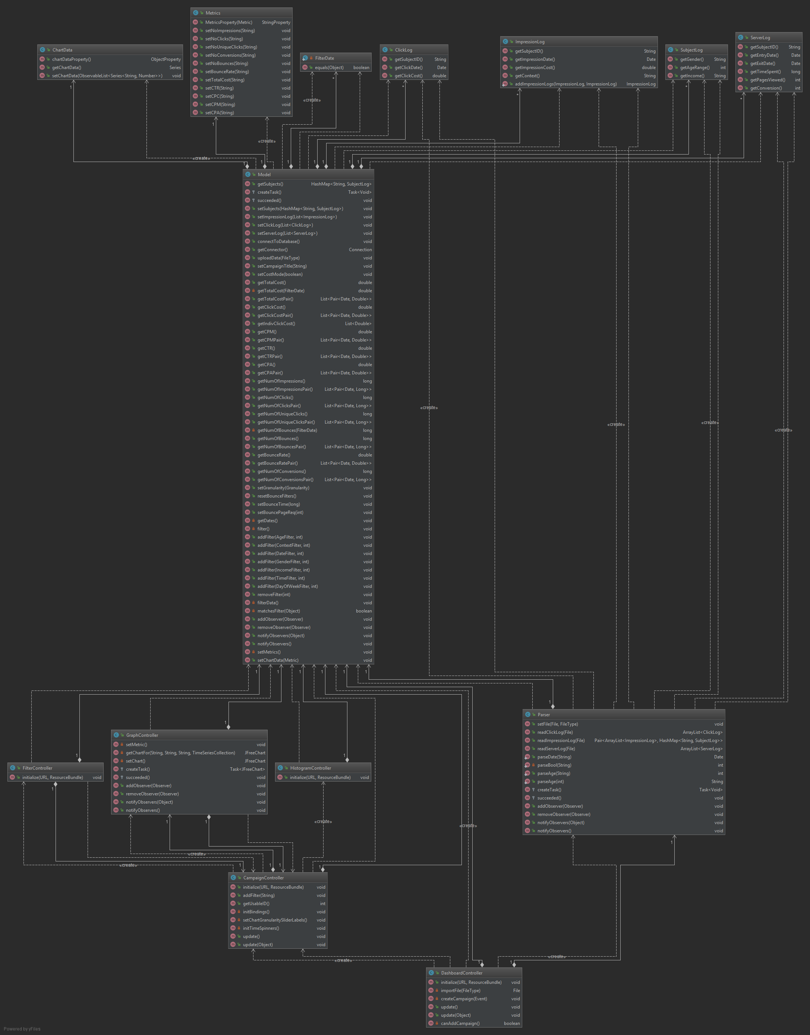



We have built a **UML Usecase Diagram** in order to get an overview of the system and how it would perform. It assisted us in picturing the interaction between the user and the system. Apart from the functionality from the previous increments the user can now create an account and back up their data in a database. They can use the application in offline mode as well so that they are not dependent on an internet connection.

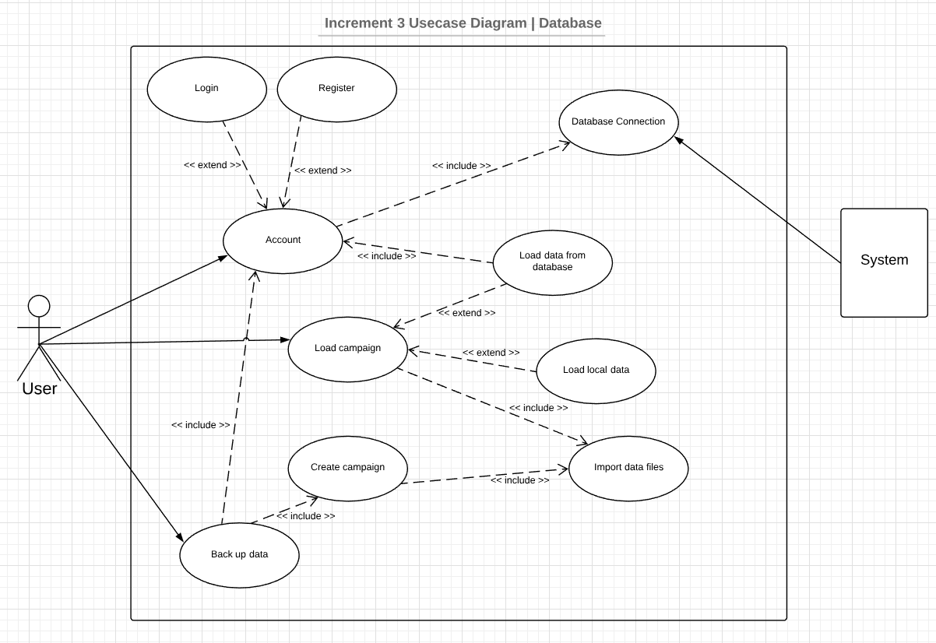

It was useful to build a **UML Sequence Diagram** as well to describe potential actions a user might take. This way we were able to implement needed features with a better understanding of the system and how it is supposed to behave.

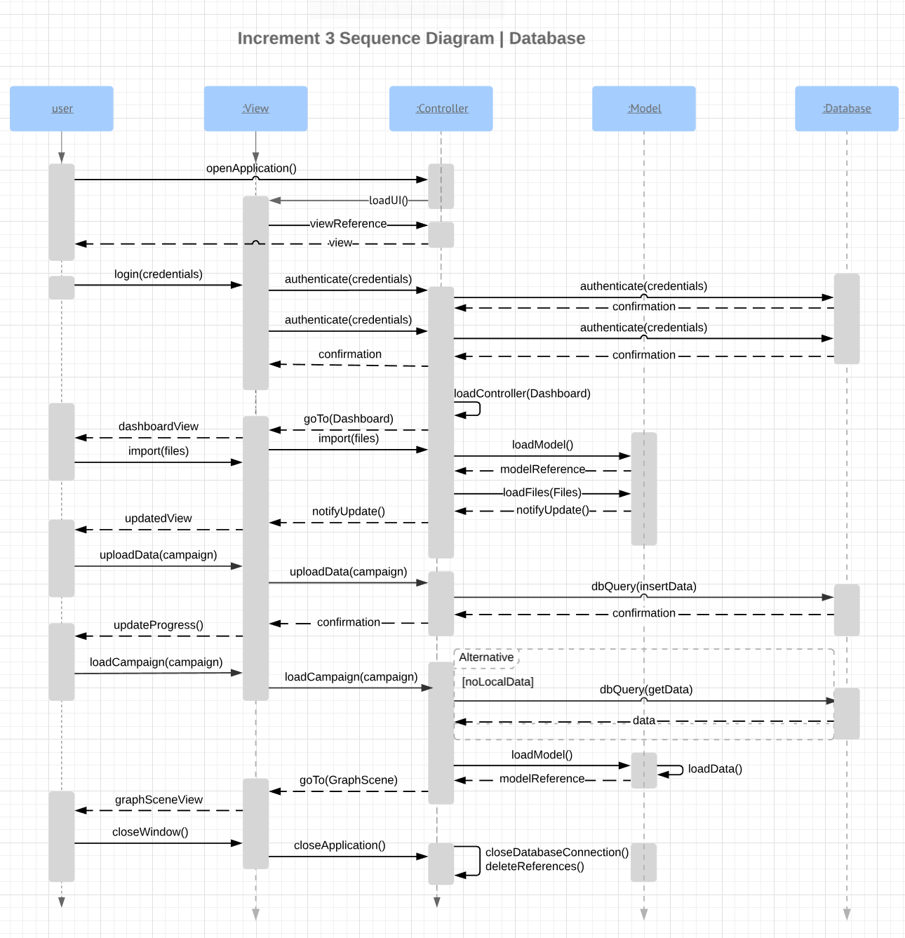

# Key Test Outputs

Writing **Junit Tests** helps us prove the accuracy of the application. We have manually computed the expected results of certain operations using other tools and then tested these against the output of our program. As it can be seen from the picture (refer to the tests.ModelTests.java file for more details), the software passes all the written tests. However, as pointed by the supervisor these are not needed by the client so we use them just for development purposes. They said that the client is interested in the table below.

Another testing we did was the UI Testing where we ran the application and went through the actions a user would do and confirm that the expected result aligns with the actual result we get from the application. The table with these tests can be seen below.

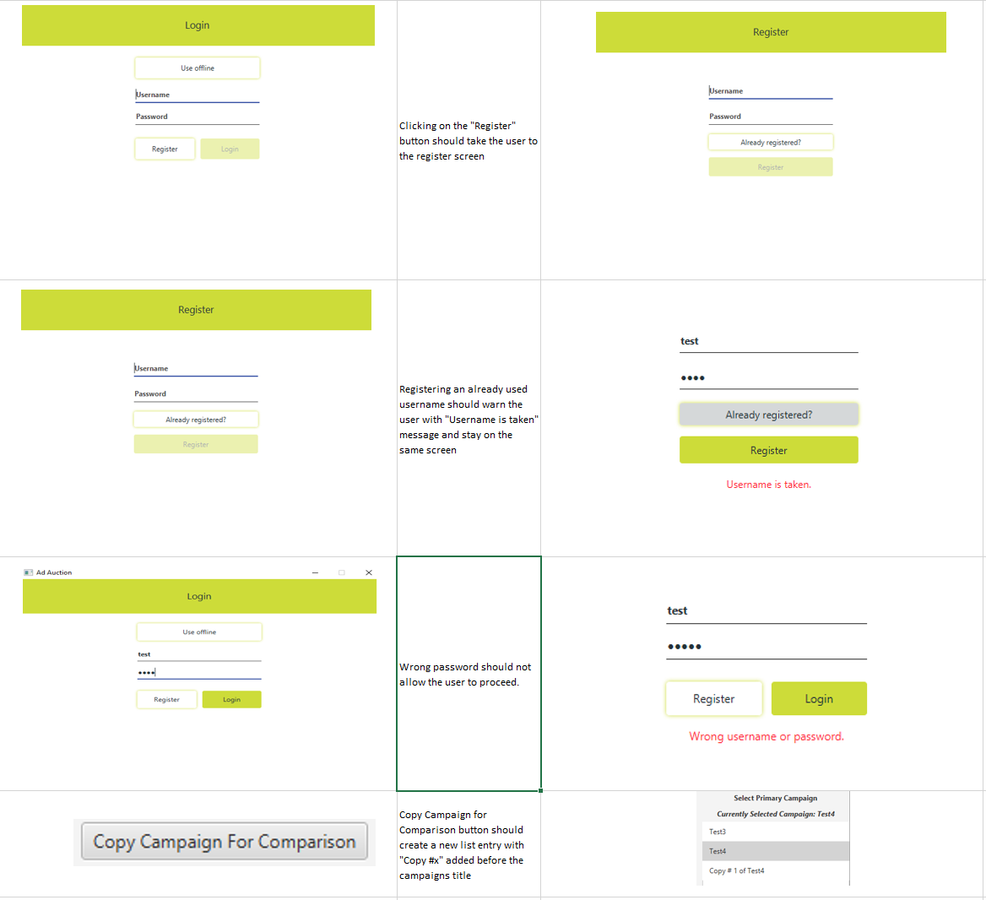

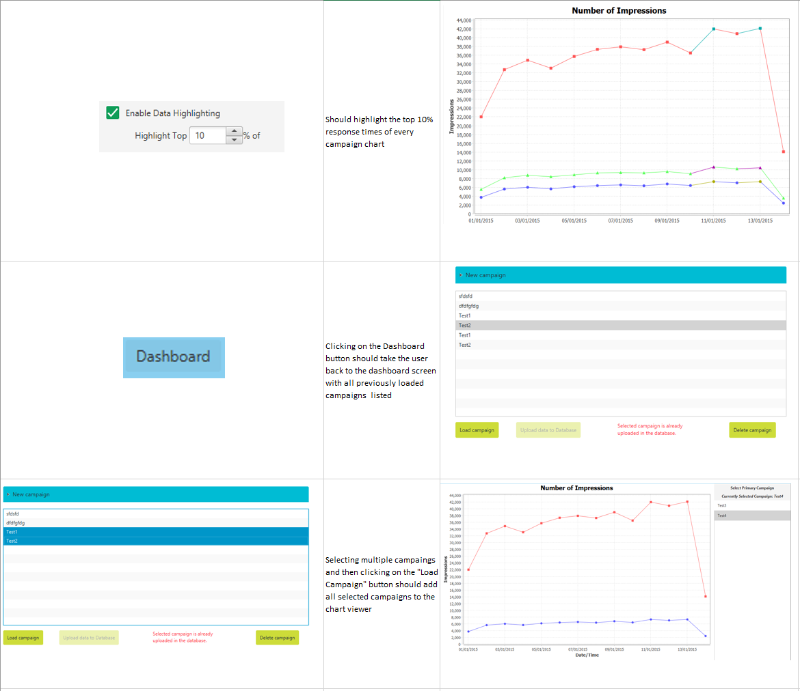

# Responses to Feedback

We were very happy to receive the feedback from the previous review meeting as it helped us identify the issues we had. There were issues mainly with the UI which we have now fixed which include:

* Graph’s Y-axis was not scaling properly. We now apply normalization to ensure the data is displayed properly and all the points needed can be properly seen.
* Data labels
  + We fixed the data labels to make them more
* We have added buttons to navigate back and forth in the application.
  + We wanted to ensure we allow reversal of actions as much as we could in order to bring a higher value to the user.
* Changed the granularity sliders to radio buttons and requested by the client.
  + This makes it easier for them to apply these filters.
* We identified an issue with the clicking on the buttons
  + We have not added a bigger value for the padding in order to make them more easily clickable.
* UI Rescaling
  + Client wanted us to disable rescaling so we now ensure the application is fixed in size.
* Remove disabled buttons
  + There were buttons we used for testing and had not removed them.
  + We now ensure there are no components that would confuse the user.

# Planning

## Increment 3 Burndown Chart

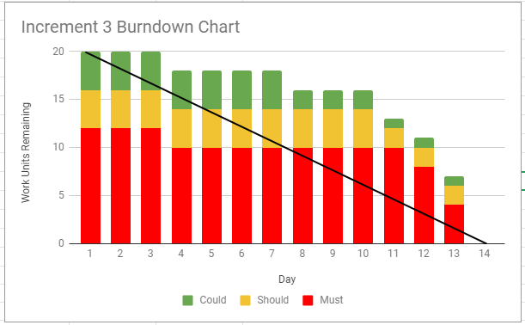

During the development process for the previous increment we had to push a few tasks to this increment and we did this setting them as a must. These are the tasks with regards to granularity which we wanted to ensure to deliver them this time and did them as the first thing in this increment. Furthermore, we built our own server in order to allow the client to backup their data. However, as we have limited resources we were unable to provide loading the data from the Database. We ran into issues with insufficient memory we were running a query to get data from the server. We did not have time for this increment and would definitely work on this if there were another one – to optimize the database queries so that they take less memory to execute. Another thing that we did not complete for this Increment is the “Web integration”. Our client had this as an optional requirement and it was set a “could”. For this reason we decided to put more effort into more important requirements.