A
Genes Pseudogenes
+5 -2
Hsal 11 2
6 +2 8 +6 -1
+1 Lhum 14 1
9 +3
Cflo 12 0
9 +2
Pbar 11 0
9 +14 -2
Sinv 21 2
9 +4 -5
+7 -1 15 Aech 14 6
+3 -4
Acep 14 5
β = 0.0054 δ = 0.0012

B
+2 -2
Hsal 11 2
6 +5 11 +4 -1
Lhum 14 1
11 +1
Cflo 12 0
11
Pbar 11 0
11 +12 -2
Sinv 21 2
11 +4 -5
+5 -1 15 Aech 14 6
+3 -4
Acep 14 5

β = 0.0038 δ = 0.0012

Supplementary fig S1. Two alternative scenarios (A and B) for the gains and losses of CSP genes in ants. Bold figures attached to each node describe the assumed number of functional genes at that node, and the number in italics above each branch tells the inferred numbers of new genes (plus sign) and genes that have become pseudogenes (minus sign) in that branch. The rates of gene birth (β) and death (δ) are calculated as

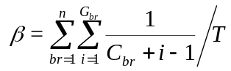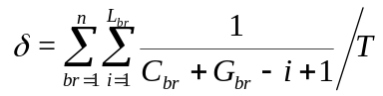

where n is the total number of branches in the tree, C_{br} is the ancestral number of genes at the beginning of the branch br, G_{br} is the number of new genes gained within the branch, L_{br} is the number lost by pseudogenization and T is the total length (time) of the phylogenetic tree. With these formulae, every gain is calculated per the existing number of genes in the genome. The death rate is calculated by assuming that the pseudogenization events happen after all the duplications.

The gene tree of CSP genes in ants has seven conservative clusters and one cluster which has expanded separately in many ant lineages. The phylogenetic tree, especially as regards the expanded group of genes, is not well resolved. We have assumed in scenarios A and B that the number of ancestral ant CSP genes has been either 8 or 11. Six of these could be orthologous with the honeybee genes. It is not possible to infer orthologous relationships reliably within the expanded group of CSP genes. However, the gene tree indicates that most expansions have been lineage-specific as genes from a single species tend to cluster together. The genes in the two leaf-cutting ants (Aech and Acep) often cluster together, including one pair of pseudogenes, indicating that they are orthologous pairs. However, both leaf-cutting ants have also small species-specific clusters, suggesting four species-specific duplications in Aech and three in Acep. The number of lost genes is simply counted from the observed pseudogenes.

