Calculating Sound Absorption Coefficients of Sound-Absorbing Materials Using Flow Resistivity
LIU Yi¹, YE He^{1,2}, Zhang Lingfeng¹, CHEN Ge ^{1,3}, WANG Yongxing ^{1,3*}
1 College of Mechanical Engineering, Donghua University, Shanghai 201620, China
2 China Textile Machinery Association, Beijing 10018, China
3 Engineering Research Center of Advanced Textile Machinery, Ministry of Education, Shanghai 201620, China

Abstract: MXene is an emerging class of two-dimensional (2D) layered transition metal carbides or nitrides. Due to the highly tunable components and surface functional groups, they hold great potential in electrocatalytic hydrogen evolution reaction (HER). However, MXene nanosheets suffer from a strong tendency to restack and a lack of active edge sites. In this work, the porous Ti₃C₂T_{x} was synthesized by an oxidation and etching two-step strategy and then characterized by a series of spectroscopic techniques. The obtained porous Ti₃C₂T_{x} possesses a large number of in-plane pores and shows a high specific surface area (111.4 m²/g). This not only creates abundant active edge sites but also enhances the mass transfer and increases the accessibility of the active sites. Compared with Ti₃C₂T_{x}, in a 0.5 mol/L H₂SO₄ electrolyte, the porous Ti₃C₂T_{x} shows a 1.7 times higher electrochemical surface area (440 mF/cm²), a 95.2% lower charge transfer resistance (12.8 Ω), and a 69.8% lower Tafel slope (144 mV/dec), and thus exhibits a lower overpotential (535.5 mV) with good stability at a current density of 10 mA/cm². At the same time, the HER performance of porous Ti₃C₂T_{x} can be further enhanced by near-infrared laser irradiation based on the localized surface plasmon resonance effect.
Keywords:porous Ti₃C₂T_{x}, hydrogen evolution reaction (HER); active edge site; localized surface plasmon resonance
CLC number: TS11 Document code: A
0 Introduction
Hydrogen is a renewable and green energy source, serving as a potential alternative to traditional fossil fuels, meeting the demands of sustainable social development^{[1]}. Electrochemical water splitting via the hydrogen evolution reaction (HER) is considered as the most economical and efficient method for hydrogen production^{[2]}. Pt-based noble metal materials have attracted great attention due to their efficient HER performance^{[3-5]}, but high cost and scarcity hinder their large-scale applications^{[6]}. Therefore, the rational design of economically efficient HER electrocatalysts is an important research topic at present^{[7-9]}. MXene is an emerging class of two-dimensional (2D) transition metal carbides or nitrides^{[10-12]} with exhibit excellent conductivity^{[13]}, highly tunable composition^{[14]}, and surface functional groups^{[15]}, holding great potential in HER^{[16]}. However, MXene nanosheet has a large aspect ratio structure, which mainly exposes in-plane sites with poor activity, leading to poor intrinsic a(1)ctivity^{[17-18]}. Moreover, due to the strong
Where $x_{0}$ is the response speed of the vibrating mass $m$, ${\dot{x}}_{0}$ is the velocity of the vibrating mass $m$, ${\ddot{x}}_{1}$ is the response acceleration of the vibrating mass $m$. $k(ω)$ is the equivalent support stiffness and$c(ω)$is the equivalent support damping of support system, both of which are functions of frequency $ω$.
When $γ≤\sqrt{2}/2$, the amplitude ratio $α\left(ω_{w}\right)>1$. $φ(ω_{w})$ is usually a very small number, so $cos⁡(φ\left(ω_{w}\right))≈1$ and the stiffness calculation expression of the support system at this time can be simplified to $k\left(ω\right)=m_{2}ω^{2}θ(ω)$, where $θ\left(ω\right)=(α^{2}\left(ω\right)−α\left(ω\right))/(α^{2}\left(ω\right)−2α\left(ω\right)+1)$, the sensitivity analysis between $α(ω)$ and $θ(ω)$ is shown as Fig.4(b).
When $1≤α(ω)≤1.14$, the change of $θ(ω)$ has a great impact on the value of $α(ω)$, a small change of $α(ω)$ will cause a large fluctuation to $θ(ω)$, and have a great impact on the results of the forced non-oscillation method experiment. To ensure the correctness of the experimental results, the amplitude must satisfy $α(ω)>1.14$. When $α(ω)>1.14$, the frequency ratio must satisfy $γ≥0.351(γ=0.351<0.354≈\sqrt{2}/4)$.

$Z_{s}=Z_{0}\coth{(}γl)$ (2)
Table 1 Material parameters
Material parameter | Material |  | Poisson's ratio |  | Density  /(kg·m/s^2)
Rubber O-rings | Nitrile Butadiene Rubber (NBR) | 0.49 |  | 1200
Other | Structure steel | 0.3 |  | 7850
1 Materials and methods
1.1 Materials
Saskjldjaslj asjdkas asjdkj aksjdjas jkjdasjk jasjdkajskd jasj kjdasj kajsjd asjk jkasj djasj kdjaskj djakskj dasj jdasjkjakj jaksdjasj jdajs dajs jkjasjd jask djas jdajk.
1.1.1 Materialss
topic at present^{[7-9]}. MXene is an emerging class of two-dimensional (2D) transition metal carbides or nitrides^{[10-12]} with exhibit excellent conductivity^{[13]}, highly tunable composition^{[14]}, and surface functional groups^{[15]}, holding great potential in HER^{[16]}. However, MXene nanosheet has a large aspect ratio structure, which mainly exposes in-

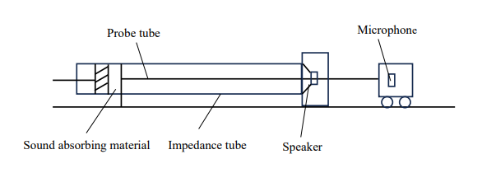
Fig. 5 Comparison of theoretical and experimental real part of acoustic impedance

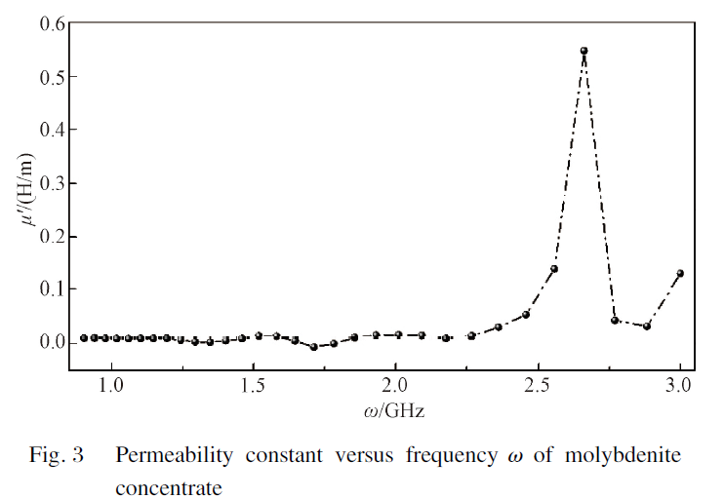
Fig. 6 Comparison of theoretical and experimental real part of acoustic impedance
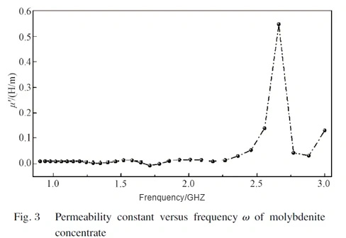
Fig. 7 Comparison of theoretical and experimental real part of acoustic impedance

References
[1] WU R, XU J, ZHAO C L, et al. Dopant triggered atomic configuration activates water splitting to hydrogen[J]. Nature Communications, 2023, 14: 2306.
[2] TURNER J A. Sustainable hydrogen production[J]. Science, 2004, 305(5686): 972-974.
[3] WEI J X, XIAO K, CHEN Y X, et al. In situ precise anchoring of Pt single atoms in spinel Mn₃O₄ for a highly efficient hydrogen evolution reaction[J]. Energy & Environmental Science, 2022, 15(11): 4592-4600.
[4] YANG L, GRZESCHIK R, JIANG P, et al. Tuning the electronic properties of platinum in hybrid-nanoparticle assemblies for use in hydrogen evolution reaction[J]. Angewandte Chemie International Edition, 2023, 62(25): e202301065.

多孔Ti₃C₂T_{x}用于高效电催化析氢反应
刘 影¹，惠明明¹，卜凡兴^{2*}，罗 维^{1*}
1．东华大学 材料科学与工程学院，上海201620
2．东华大学 材料科学与工程学院，南京 123456

摘 要：Mxene是一种新兴的二维过渡金属碳化物或氮化物，具有高度可调控的组分和表面官能团，在电催化析氢反应中表现出巨大的应用前景，但是MXene纳米片极易堆叠且缺乏活性的边缘位点。该研究通过氧化和刻蚀两步策略合成了多孔Ti₃C₂T_{x}，并采用一系列光谱学方法进行了表征。发现多孔Ti₃C₂T_{x}表面存在大量面内孔，具有很高的比表面积（111.4 m²/g），这不仅增加了大量边缘活性位点，而且提高了活性位点的可及性。相比于Ti₃C₂T_{x}，多孔Ti₃C₂T_{x}在0.5 mol/L H₂SO₄电解质中的电化学活性比表面积是Ti₃C₂T_{x}的1.7倍（440 mF/cm²），电荷转移电阻降低了95.2%（12.8 Ω），塔菲尔斜率降低了69.8%（144 mV/dec），因此在电流密度为10 mA/cm²时表现出了更低的过电位（535.5 mV），且具有很好的稳定性。同时，利用Ti₃C₂T_{x}的局域表面等离子体共振效应，可在近红外激光辐照下进一步提升多孔Ti₃C₂T_{x}电催化析氢反应性能。
关键词：多孔Ti₃C₂T_{x}；析氢反应；边缘活性位点；局域表面等离子体共振效应

Received date: 2023-10-06 Foundation item: National Natural Science Foundation of China (No. 51705545) * Correspondence should be addressed to ZHU Congyun, email: zcy711126@ 163.com Citation: ZHU C Y, SHAO Z Y, DING G F. Calculating sound absorption coefficients of sound-absorbing materials using flow resistivity [J]. Journal of Donghua University (English Edition), 2025, 42(2):

