Trying to run my PsychoPy code on lab computer:

- Lenovo ThinkCentre M-900
- Ubuntu 20.04

1. No serial port

Solution: commented out lines with serial ports, since we’re not using them

2. couldn’t show GUI
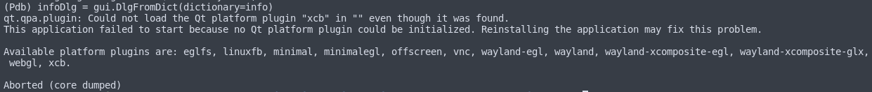
Solution: reinstall libxcb (check link below)

https://askubuntu.com/questions/308128/failed-to-load-platform-plugin-xcb-while-launching-qt5-app-on-linux-without

GUI showing successfully after this

TODO:

1. upload new stimuli (generated with ba_M2.wav), remember that when you start to measure individual HRTFs, you’ll need to generate the spatialized syllables, then upload to the folder, then run the EEG.

2. version control with git, first commit version on my computer to master branch, create a new branch called limn, a new branch called pitts, commit new codes to those branches

