线程基本概念
进程的两部分：
- 进程的内核对象： 用于OS管理进程
- 进程空间： 为线程的运行提供相关资源及管理

进程与线程的关系：
- 进程因线程的运行而存在
- 线程依赖于进程提供的空间

时间片：
关键词：
轮询，让出

线程相关API:
- 创建
- 挂起
- 恢复

线程与相关问题
利用wait相关函数，进行安全的处理，避免资源、代码等的遗漏、依赖等问题。
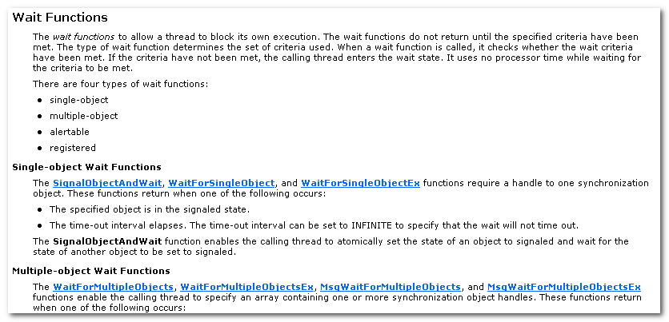
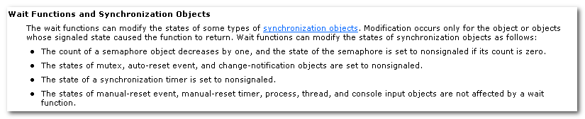

线程相关API

3.1 CreateThread
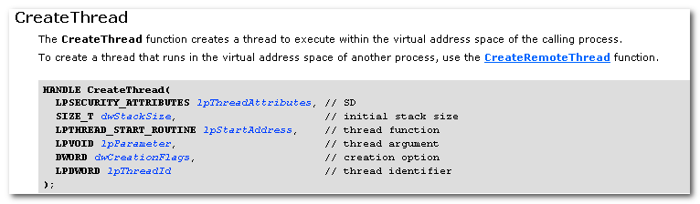

CreateThread function creates a thread to execute within the virtual address space of the calling process.

CreateRemoteThread: in the virtual address space of another process.

dwStackSize: the initial size of the stack.
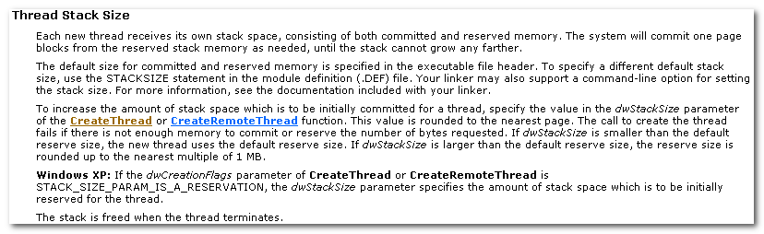
Each new thread receives its own stack space, consisting of both commited and reserved memory. The system will commit one page blocks from the reserved stack memory as needed, until the stack cannot grow any more.

The default size for committed and reserved memory is specified in the exe file header.
Use .DEF file STACKSIZE statement to specify the value.

The value is rounded to the nearest page.
The call to create the thread fails if there is not enough memory to commit or reserve the number of bytes requested.
If the dwStackSize is larger than the default reserve size, the reserve size is rounded up to the nearest multiple of 1MB.

Initially committed
If the dwCreationFlags parameter is STACK_SIZE_PARAM_IS_A_RESERVAION, the dwStackSize parameter specifies the amount of stack space which is to be initially reserved for the thread.

The number of threads a process can create is limited by the available virtual memory.
By default, every thread has one megabyte of stack space. Therefore, you can create at most 2048 threads.
Your app will have better performance if you create one thread per processor and build queues of requests for which the app maintains the context info.
A thread would process all requests in a queue b4 processing requests in the next queue.

When a thread terminates, the thread object attains a signaled state, satisfying any threads that were waiting on the object.

The thread object remains in the system until the thread has terminated and all handles to it have been closed through a call to CloseHandle.

3.2 ThreadProc

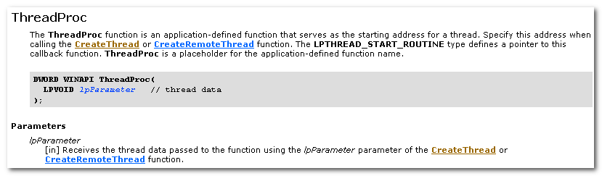
所传入的参数应该是在线程生命周期内的，否则可能出错。

It’s risky to pass the address of a local variable if the creating thread exists b4 the new thread, bkz the pointer becomes invalid.

Instead, either
- pass a pointer to dynamiclly allocated memory
- or make the creating thread wait for the new thread to terminate.

Synchronizing Execution of Multiple Threads.

A process can obtain the return value of the ThreadProc of a thread it created with CreateThread by calling GetExitCodeThread function.
A process cannot obtain the return value from the ThreadProc of a thread it created with CreateRemoteThread.

3.3 ResumeThread/SuspendThread
The ResumeThread function decrements a thread’s suspend count.
When the suspend count is decremented to zero, the execution of the thread is resumed.

SuspendThread, ResumeThread 不是一种安全的方式，可以考虑使用等待进行解决。

3.4 ExitThread
ExitThread is the preferred method of existing a thread.
When this function is called (either explicitly or by returning from a thread procedure), the current thread’s stack is deallocated and the thread terminates.

If the thread is the last thread in the process when this func is called, the thread’s process is also terminated.

The state of the thread object becomes signaled, releasing any other threads that had been waiting for the thread to terminate.
The thread’s termination status changes from STILL_ACTIVE to the value of the dwExitCode parameter.

Terminating a thread does not necessarily remove the thread object from the operating system. A thread object is deleted when the last handle to the thread is closed.

3.5 CreateEvent / SetEvent /ResetEvent
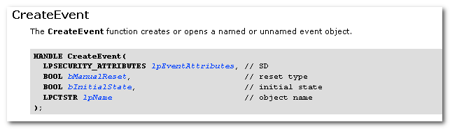
bManualReset:
Specifies whether a manual-reset or auto-reset event object is created.
If TRUE, then you must use the ResetEvent function to manually reset the state to nonsignaled.
If FALSE, the system automatically resets the state to nonsignaled after a single waiting thread has been released.

Any thread of the calling processing can specify the event-object handle in a call to one of the wait functions.
The single-object wait functions return when the state of the specified object is signaled.
The multiple-object wait function can be instructed to return either when any one or when all of the specified objects are signaled.
When a wait function returns, the waiting thread is released to continue its execution.

Use SetEvent function to set the state of an event object to signaled.
Use Reset function to reset the state of an event object to nonsignaled.
