同步
- Shared Resource
- Simultaneous access
- Multiple threads or processes
- Synchronization objects
  - Event
  - Mutex
  - Semaphore
  - Critical area
  - Interlockedxxx （原子操作，锁定系统总线，禁止线程的切换）

其中，event, mutex, semaphore 利用named objects,可以跨进程操作。

Synchronization
Coordinate multiple threads of execution.
Synchronize access to a resource.
Use one of the synchronization objects in one of the wait functions.
The state of a synchronization object is either signaled or nonsignaled.
The wait functions allow a thread to block its own execution until a specified nonsigned object is set to the signaled state.

2.0 Synchronization Objects
A synchronization object is an object whose handle can be specified in one of the wait functions to coordinate the execution of multiple threads.
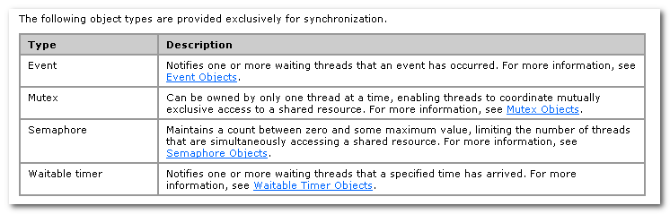
还应该再加上Critical Section.

Event: Notifies one or more waiting threads that an event has occurred.

Mutex: Can be owned by only one thread at a time, enabling threads to coordinate mutually exclusive access to a shared resource.

Semaphore: maintains a count between zero and some maximum value, limiting the number of threads that are simultaneously accessing a shared resource.
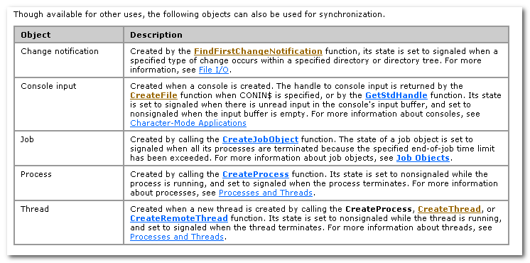
Process: its state is set to nonsignaled while the process is running, and set to signaled when the process terminates.
Thread: the same with process.

In some circumstances, you can also use a file, named pipe, or communications device as a synchronization object. However, their use for this purpose is discouraged.

Instead, use asynchronous I/O and wait on the event object set in the OVERLAPPED structure.
It is safer to use the event object because of the confusion that can occur when multiple simultaneous overlapped operation are performed on the same file, named pipe, or communications device.

2.1 Wait
The WaitForSingleObject function checks the current state of the specified object. If the object’s state is nonsignaled, the calling thread enters the wait state. It uses no processor time while waiting for the object state to become signaled or the time-out interval to elapse.
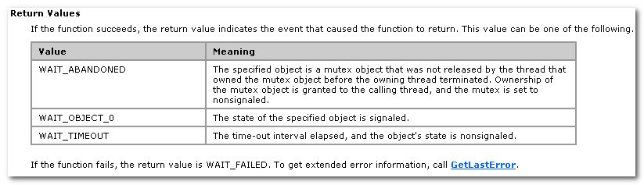
The function modifies the state of some types of synchronization objects. Modification occurs only for the object whose signaled state caused the function to return. E.g, the count of a semaphore object is decreased by one.

2.2 Mutext
U can use a mutex object to protect a shared resource from simultaneous access by multiple threads or processes.
Each thread must wait for ownership of the mutex b4 it can execute the code that access the shared resource.

Use the CloseHandle function to close the handle. The system closes the handle automatically when the process terminates. The event object is destroyed when its last handle has been closed.

This nonsignaled state blocks the execution of any threads that have specified the event object in a call to one of the wait functions.

A thread gets ownership of a mutex by specifying a handle to the mutex in one of the wait functions.
The thread that creates a mutex object can also get immediate ownership without using one of the wait functions.

Threads that are waiting for ownership of a mutex are placed in a FIFO queue.
Regardless of thread priority.
However, kernel-mode PACs xxxxxx,

2.3 Critical Section Objects
Critical section objects provide synchronization similar to that provided by mutex objects, except that critical section can be used only by the threads of a single process(不能进行跨进程的操作）。
Critical Section objects provide a slightly faster, more efficient mechanism for mutual-exclusion synchronization.

Like a mutex object, a critical section object can be owned by only one thread at a time, which makes it useful for protecting a shared resource from simultaneous access.
There is no guarantee about the order in which threads will obtain ownership of the critical section, however, the system will be fair to all threads.

If the critical section object is currently owned by another thread, EnterCriticalSection waits indefinitely for ownership.
In contrast, when a mutex object is used for mutual exclusion, the wait function accept a specified time-out interval.
The TryEnterCriticalSection function attempts to enter a critical section without blocking the calling thread.
The process is responsible for allocating the memory used by a critical section object, which it can do by declaring a var of type CRITICAL_SECTION.

Use structured exception handling or use the InitializeCriticalSectionAndSpinCount function to preallocate the event used by EnterCriticalSection instead of calling the InitializeCriticalSection function, which forces EnterCriticalSection to allocate the event.

The spin count is useful for critical sections of short duration that can experience high levels of contention. Consider a worst-case scenario, in which an app on an SMP system has 2 or 3 threads constantly allocating and releasing memory from the heap. The app serializes the heap with a critical section.
In a worst-case scenario, contention for the critical section is constant, and each thread makes an expensive call to the waitforsingleobject function.
However, if the spin count is set properly, the calling thread will not immediately call WaitForSingleObject when contention occurs.
Instead, the calling thread can acquire ownership of the critical section if it is released during the spin operation.

You can improve performance significantly by choosing a small spin count for a critical section of short duration. The heap manager uses a spin count of roughly 4000 for its per-heap critical sections. This gives great performance and scalability in almost all worst-case scenarios.

dwSpinCount specifies the spin count for the critical section object.
On multiprocessor sys, if the critical section is unavailable, the calling thread will spin dwSpinCount times b4 performing a wait operation on a semaphore associated with the critical section. If the critical section becomes free during the spin operation, the calling thread avoids the wait operation.

2.4 Semaphore
The state of a semaphore is signaled when its count is greater than zero and nonsignaled when it is zero.
The count is decreased by one whenever a wait function release a thread that was waiting for the semaphore. The count is increased by a specified amount by calling the ReleaseSemaphore funciton.

Typically, an app uses a semaphore to limit the number of threads using a resource.

Another use of ReleaseSemaphore is during an app’s initialization. The app can create a semaphore with an initial count of zero. This sets the semaphore’s state to nonsignaled and blocks all threads from accessing the protected resource. When the app finishes its initialization, it uses ReleaseSemaphore to increase the count to its max value, to permit normal access to the protected resource.

