多线程环境下的函数安全
前面利用同步对象，对多线程环境下的共同资源访问进行了同步。
- Shared Resource
- Simultaneous access
- Multiple threads or processes
- Synchronization objects

然而，C 库函数等的实现、调用，存在多线程安全问题, 比如一些全局的状态等。
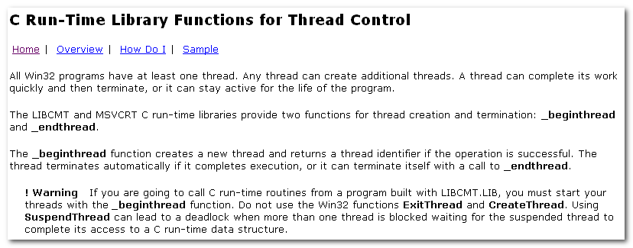


LIBCMT, MSVCRT

/MD Multithreaded DLL _MT, _DLL both multithread- and DLL-specific versions of the run-time routines are selected from
the standard .H files. This options also cause the compiler to place the MSVCRT.LIB into the .OBJ file.
Apps compiled with this option are statically linked to MSVCRT.LIB. This library provides a layer of code that allows the linker to resolve external references. The actual working code is contained in MSVCRT.DLL, which must be available at run time to apps linked with MSVCRT.LIB

/MDd Debug Multithreaded DLL _DEBUG, _MT, _DLL it also cause the
Compiler to place the MSVCRTD.LIB into the .OBJ file.

/ML Singled-Threaded Causes the compiler to place the library name LIBC.LIB into the .OBJ file so that the linker will
Use LIBC.LIB to resolve external symbols. This is the compiler’s default action. LIBC.LIB does not provide multithread support.

/MLd Debug Singled-Thread _DEBUG causes the compiler to place LIBCD.LIB into the .OBJ file.

/MT Multithread defines _MT so that multithread-specific version of the run-time routines are selected from the standard .h files. Causes the compiler to place LIBCMT.LIB into the .OBJ files so that the linker will use LIBCMT.LIB to
Resolve external symbols. Either MT or /MD( or their debug equivalents /MTd or /MDd) is required to create multithreaded programs.

/MTd Debug Multithreaded _DEBUG and _MT. Causes the compiler to place the LIBCMTD.LIB into the .OBJ file.

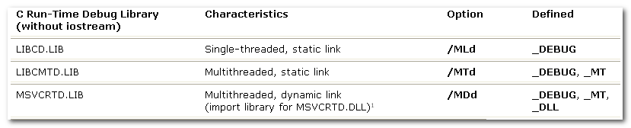

_beginthread/_beginthreadex
_beginthread() & _beginthreadex() are C runtime library calls that call CreateThread() behind the scenes. Once CreateThread() has returned, _beginthread/ex() takes care of additional bookkeeping to make the C runtime library usable & consistent in the new thread.

In C++ you should almost certainly use _beginthreadex() unless you won’t be linking to the C runtime library at all (aka MSVCRT*.dll/lib)

If you’re using the C/C++ runtime, u must use _beginthread()/ex() instead of CreateThread so that the runtime has a chance to perform its own thread initialization (setting up thread local storage).

To use _beginthread or _beginthreadex, the app must link with one of the multithreaded C run-time libraries.
LIBCMT.LIB : multithread static library, retain version
MSVCRT.LIB: Import library for MSVCRT.DLL, retail version.
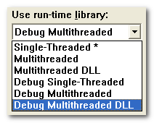
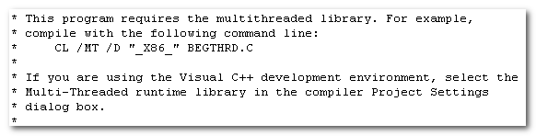
Use run-time library:
Single-Threaded : ML Debug: MLd
Multithreaded: MT MTd
Multithreaded DLL: MD MDd

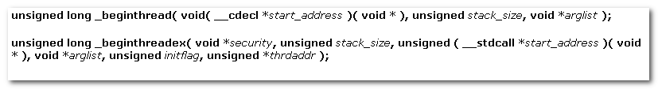
The _beginthread function creates a thread that begins execution of a routine at start_address.
The routine at start_address must use the _cdecl call convention and should have no return value. When the thread returns from that routine, it is terminated automatically.

_beginthreadex resembles the CreateThread API mode closely than does _beginthread.

_endthread or _endthreadex is called automatically when the thread returns from the routine returns from the routine passed as a parameter.

_endthread automatically close the thread handle(whereas _endthreadex does not).
Therefore, when using _beginthread and _endthread, do not explicitly close the thread handle by calling CloseHandle.
This behavior differs from the ExitThread API.

_beginthread function lets you pass multiple arguments to the thread.
_beginthread function initializes certain C run-time library variables. This is import only if you use the C run-time library in your threads.

MFC线程
切入点AfxBeginThread
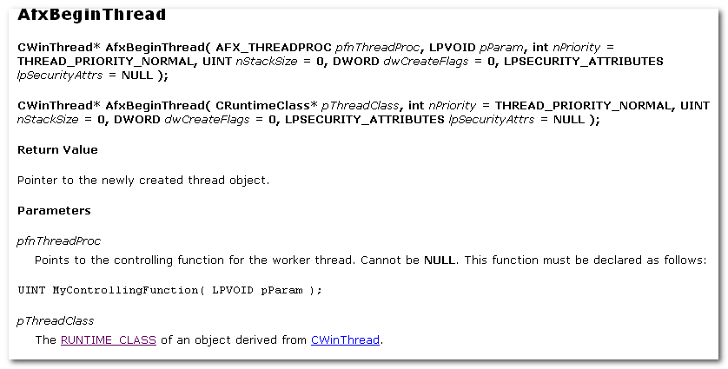
Controlling function for the Worker Thread

这里有不同的功能：
- The first form of AfxBeginThread creates a worker thread.
- The second form creates a user-interface thread.

3.1 Creating Worker Thread
A worker thread is commonly used to handle background tasks that the user shouldn’t have to wait for to continue using your application.

Checks are made throughout the procedure to make sure all objects are deallocated properly should any part of the creation fail.

Two normal situations cause a thread to terminate: The controlling functions exits or the thread is not allowed to run to completion.

AfxEndThread must be called from within the thread to be terminated. If you want to terminate a thread from another thread, you must set up a communication method between the two threads.

GetExitCodeThread

Multithreaded apps require stricter care than single-threaded apps when accessing data. Because there are multiple, independent paths of execution in use simultaneously in multithreaded applications, either the algorithms, the data, or both must be aware that data could be used by more than one thread at a time.

For size and performance reasons, MFC objects are not thread-safe at the object level, only at the class level.
This means that u can have two seperate threads manipulating two different CString objects, but not two threads manipulating the same CString object.
If u absolutely must have multiple threads manipulating the same object, protect such access with appropriate Win32 synchronization mechanisms.

As a general rule, a thread can access only MFC objects that it created.
BKZ temporary and permanent Windows handle maps are kept in thread local storage to ensure protection from simultaneous access from multiple threads.

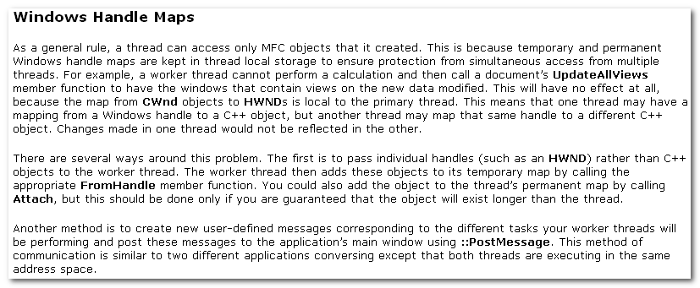

3.2 Create User-Interface Threads
A user-interface thread is commonly used to handle user input and respond to user events independently of thread executing other portions of the application.
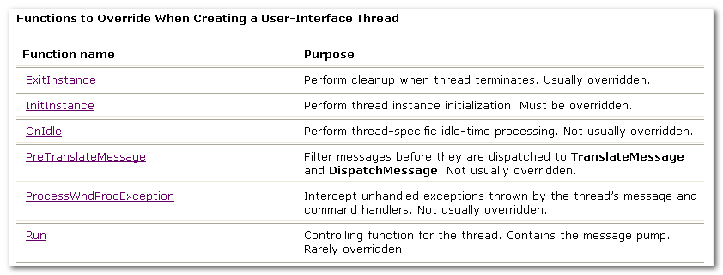
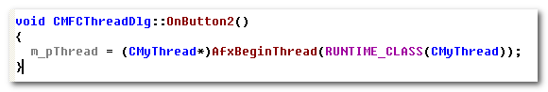

3.3 Window HANDLES MAPS
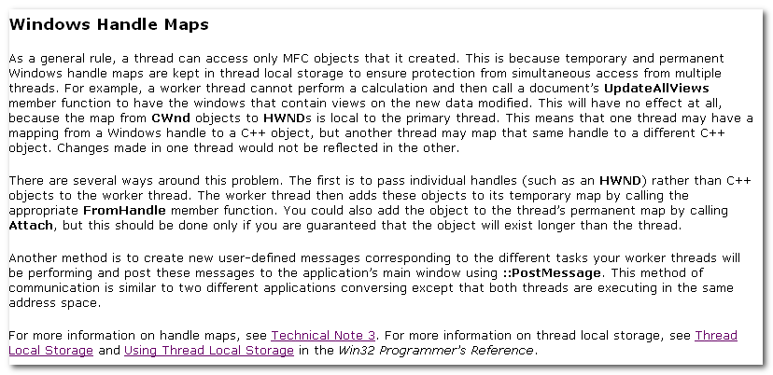

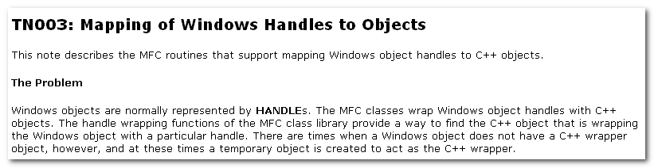
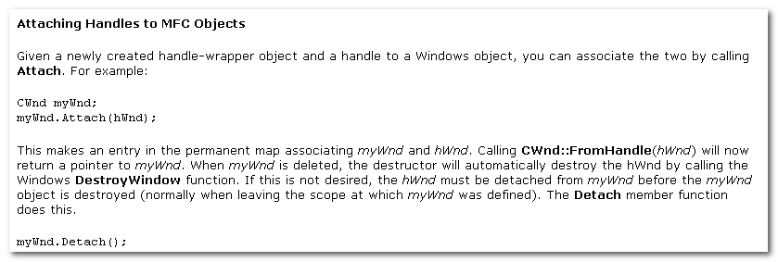

There are several ways around this problem.
- pass individual handles (such as an HWND) rather than C++ objects to the worker thread.
- Create new user-defined msg corresponding to the different tasks your worker thread will be performing and post these msgs to the app’s main window using ::PostMessage.

3.4 Communicating Between Threads
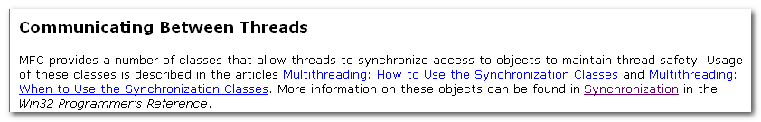

线程消息
切入点PostThreadMessage
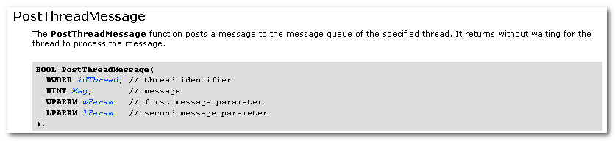
The function fails if the specified thread does not have a msg queue.
The system creates a thread’s msg queue when the thread makes its first call to one of the User or GDI functions.
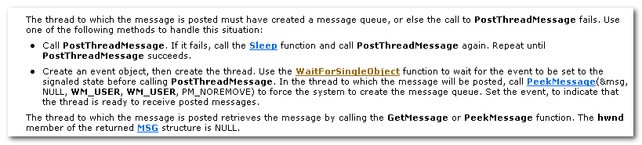
Message sent by PostThreadMessage are not associated with a window. Msg that are not associated with a window cannot be dispatched by the DispatchMessage function.
Therefore, if the recipient thread is in a modal loop(as used by MessageBox or DialogBox), the msg will be lost.

