进程数据共享

1.1 WM_COPYDATA
利用SendMessage向另外进程发送WM_COPYDATA消息，以对数据进行共享。

涉及：
- 发送方
- 内核
- 接收方

因数据在三者间多次拷贝（发送方===内核===接收方），效率不高，仅适用于小数据的共享处理。

此外，使用时也应注意：
- 使用SendMessage, 而非PostMessage， 前者需要等待接收方处理完毕，避免所需发送数据的释放等问题。

- 所需发送的数据，也应注意
The Data being passed must not contain pointers or other references to objects not accessible to the application receiving the data.

While this msg is being sent, the reference data must not be changed by another thread of the sending process.

The receiving app should consider the data read-only.
The lparam is valid only during the processing of the msg. The receiving application should not free the memory referenced by lParam.
If the receiving application must access the data aft SendMessage returns, it must copy the data into a local buffer.

DLL数据共享段
关键词：

//定义数据段
#pragma data_seg(xx)
//your data here
#pragma data_seg()

//设置数据段属性
#pragma comment(linker, “SECTION:xxx

mk:@MSITStore:E:\Program\MSDN\2001OCT\1033\vccore.chm::/html/_predir_pragma_directives.htm

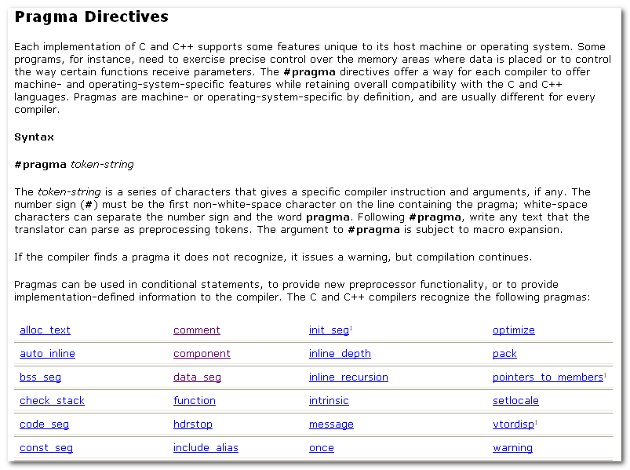

#Pragam directives offer a way for each compiler to offer machine- and operating-system-specific features while retaining overall compatibility with the C and C++ languages.

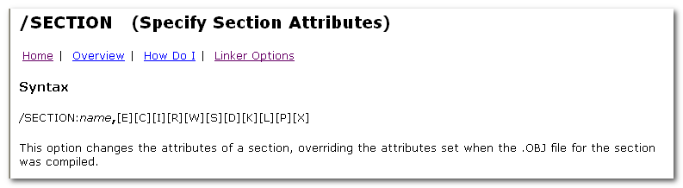

在前面，知道利用引用计数，映射等技术，使得同一份DLL可仅加载一次到内存中，为多个进程所引用。代码共享，数据在各进程间隔离。（写时复制）。

对数据段进行共享设置，则这些数据就像代码那样，在多个进程间共享，一改则改，达到通信的目的。

相较于WM_COPYDATA方式，有效率的提升。

文件映射、内存映射
关键词：
CreateFileMapping
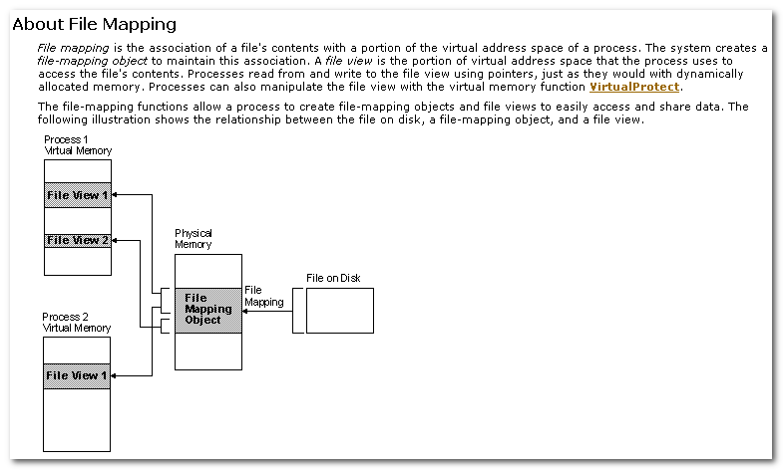

File Mapping is the association of a file’s contents with a portion of the virtual address space of a process.

A file view is the portion of virtual address space that the process uses to access the file’s contents.
Processes read from and write to the file view using pointers, just as they would dynamically allocated memory.

CreateFileMapping:
Creates or opens a named or unnamed file-mapping object for the specified file.
