远程线程注入
切入点：CreateRemoteThead

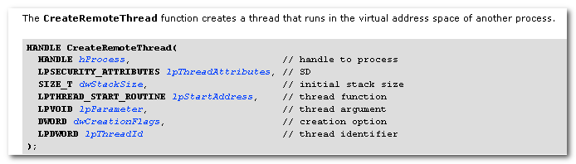
注意最小、必须权限，以减小失败的可能。
lpStartAddress: 线程过程函数必须在对方进程空间中。 The function must exist in the remote process.

为成功的创建线程，需要特别处理：
- HANDLE hProcess: 最小、必须权限
- lpStartAddress： 需在对方进程空间
- lpParameter: 基本数据类型可以直接传递，但针对较大的字符串等，需要保证使其 存在于对方进程空间中。

其中，lpStartAddress 可以通过所有进程都会加载的dll中的API来搞定，如LoadLibrary, FreeLibrary等，只要其原型满足LPTHREAD_START_ROUTINE.

而大参数的传递,需要利用VirtualAllocEx, WriteProcessMemory 在对方进程中申请空间，写入数据。

此外，需要注意相应的句柄等资源的处理，需要等待远程线程的结束。

GetExitCodeThread
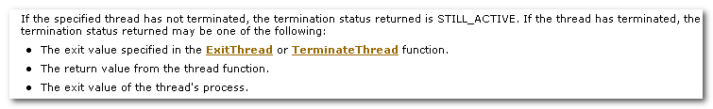
GetExitCodeProcess
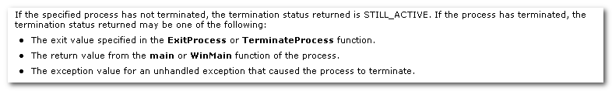

远程线程卸载
当注入的dll被卸载时
（可能的原因
- unsuccessful load of the DLL,
- termination of the process
- Call to the FreeLibrary
)

会触发DllMain的DLL_PROCESS_DETACH， DLLs 可以利用此时机进行相应的清理性操作。

比如，对消息响应过程的更改，要进行还原。
否则，当dll从被注入进程中卸载后，如果进程要引用dll中的代码，则会出错。

例如
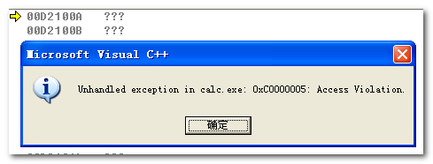

在卸载前，对此位置进行跟踪，会发现，它是替换的消息处理函数。（在加载基址偏移100A处）
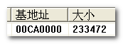
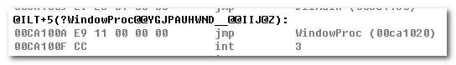
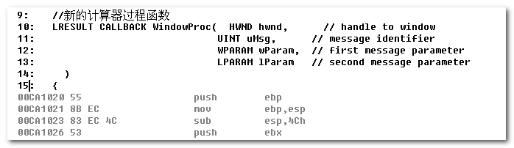
对此，进行如下的处理即可。
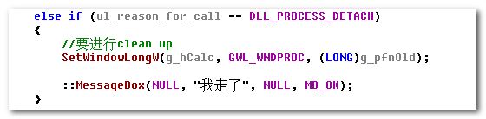

计算器Home键的处理
正常情况下，对Home键等应该是响应WM_KEYDOWN消息。
这也得到了验证。

但是，当输入数字后，情况发生了变化。对键盘的响应，不再是WM_KEYDOWN，而是WM_COMMAND消息。

这也从SPY++的消息监控中得以验证。
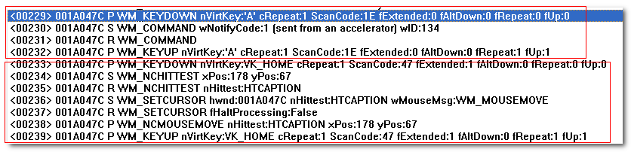
这是计算器启动后，对键盘按键1 和Home键的响应情况。

接着利用键盘输入数字
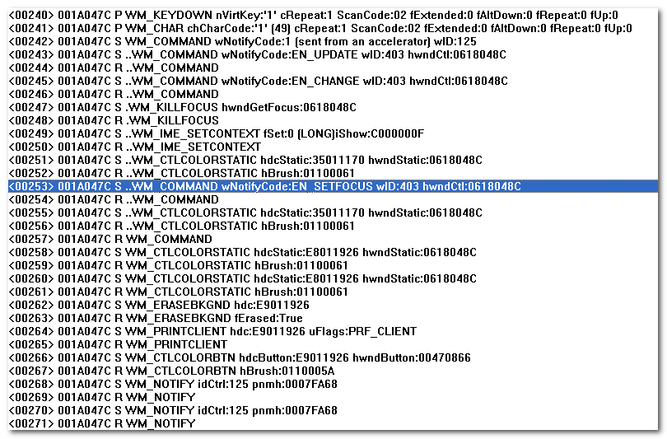
接着，再利用键盘输入非数字键，
此时，已经与上面发生了变化。

下面，对计算器进程的所有窗口进行消息监控
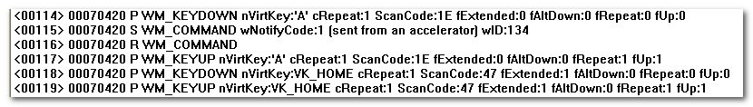
这是进程启动后，对键盘按键’A’和Home的消息响应。
同时注意这里的窗口00070420

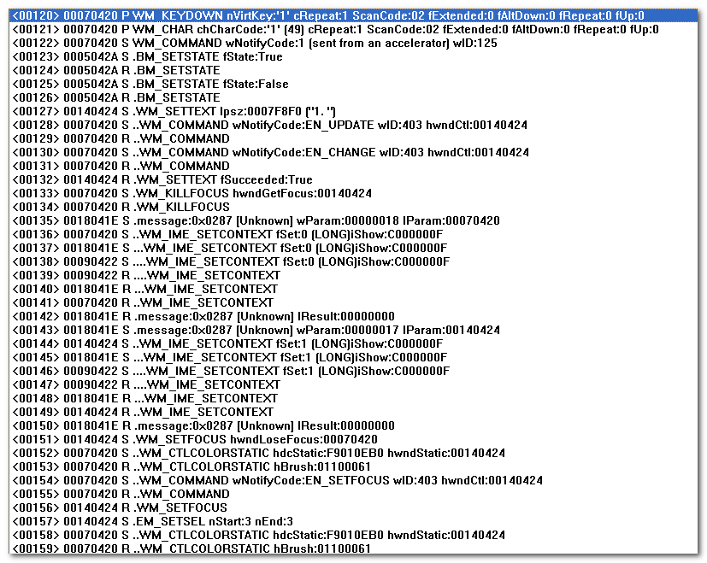
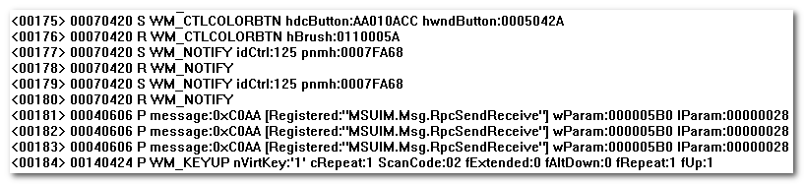
这是之后对数字1的响应，同样需要注意窗口句柄

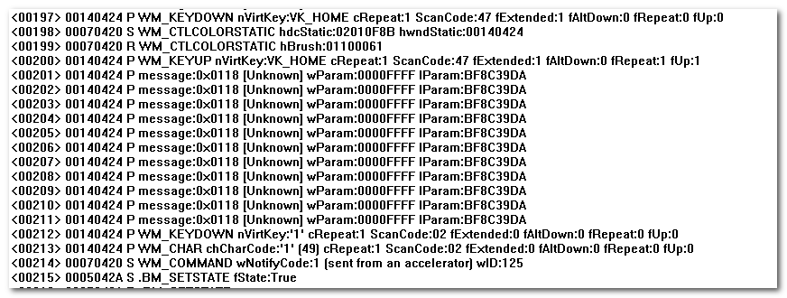
这是之后对Home和1的响应，可以看到窗口句柄已经发生了变化。

对这些窗口的关系进行观察
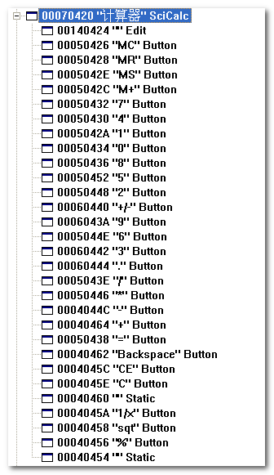

当然了，在Win7中可能不同。

所以，为拦截Home键（或者其他按键）的消息，需要对所有窗口的消息过程函数进行拦截。
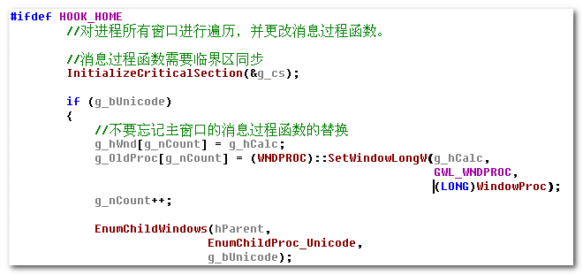

内存管理函数
VirtualAlloc

MEM_COMMIT: Allocates physical storage in memory or in the paging file on disk for the specified region of memory pages.
If a memoy page is not yet reserved, setting this value causes the function to both reserve and commit the memory page.

MEM_PHYSICAL: Allocates physical memory with read-write access. AWE

MEM_RESERVE: Reserves a range of the process’s virtual address space without
Allocating any actual physical storage in memory or in the paging file on disk.

MEM_RESET: specifies that the data in the memory range specified by lpAddress and dwSize is no longer of interest. The pages should not be read from or written to the paging file. However, the memory block will be used again later, so it should not be decommitted. This value cannot be used with any other value.

MEM_TOP_DOWN: allocates memory at the highest possible address.

The virtualAllocEx function can perform the following operations:
- commit a region of pages reserved by a previous call to the VirtualAllocEx function
- Reserve a region of free pages
- Reserve and commit a region of free pages.

You can use VirtualAllocEx to reserve a block of pages and then make additional calls to VirtualAllocEx to commit individual pages from the reserved block.
This lets you reserve a range of a process’s virtual address space without consuming physical storage until it is needed.

Each page of memory in a process’s virtual address space is in one of the following states:
Free : The page is not commited or reserved and is not accessible to the process. The virtualallocex function can reserve, or simultaneously reserve and commit, a free page.

Reserved: The page is reserved. The range of addresses cannot be used by other allocation functions, but the page is not accessible and has no physical storage associated with it. Can be released by
Virtualallocex, being a free page.

Commited: physical storage is allocated for the page, and access is controlled
By a protection code.

Virtual Address, Physical Address

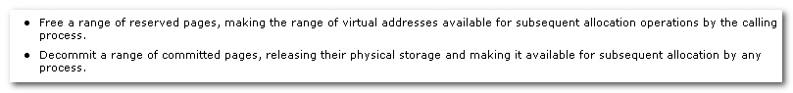
When pages are committed, storage is allocated in the paging file, but each page is initialized and allocated into physical memory only at the first attempt to read from or write to that page.

Reserved pages can be released only by freeing the entire block that was initially reserved by VirtualAlloc.

The heap managers are designed for memory blocks smaller than 4 megabytes.
If u expect your memory blocks to be larger than one or two megabytes, u can avoid significant performance degradation by using the VirtualAlloc or VirtualAllocEx function instead.

窗口函数
- 遍历窗口
EnumWindows: does not enumerate child windows, with a few except.,
GetWindow: risky to use
EnumChildWindow:

mk:@MSITStore:E:\Program\MSDN\2001OCT\1033\winui.chm::/hh/winui/windows_6w4z.htm
Creating, Enumerating, and Sizing Child Windows.

- GetWindowText, SetWindowText

