扫描码
关键词：
GetKeyBoardState, ToAscii

mk:@MSITStore:E:\Program\MSDN\2001OCT\1033\winui.chm::/hh/winui/keybinpt_4l9w.htm
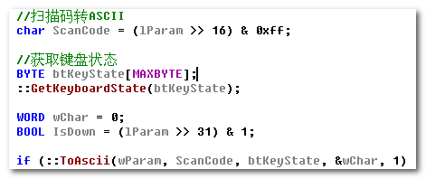
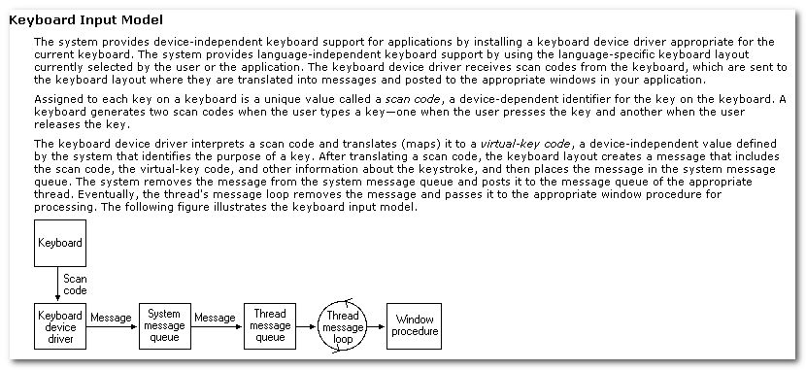
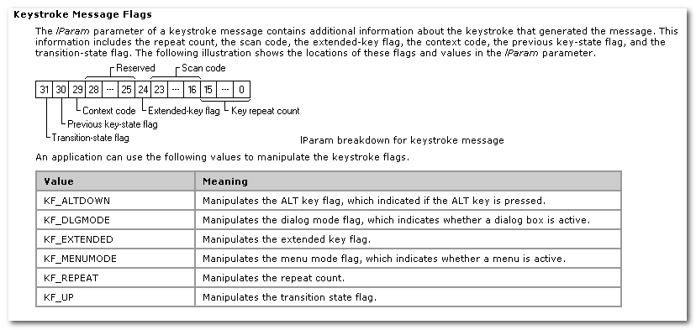
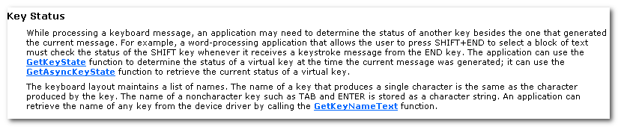

Hook
关键词：
SetWindowsHookEx, CallNextHookEx

关于Hook Procedure的规范：
- 推荐调用CallNextHookEx
- 返回TRUE时，不再调用原真实回调函数；返回FALSE没影响
- 有些Procedure不能修改参数，有些可以修改，但不会影响真实回调的参数。

TODO
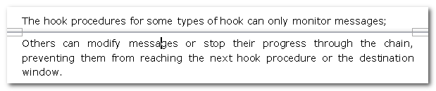

A hook is a point in the system message-handling mechanism where an application can install a subroutine to monitor the message traffic in the system and process certain types of messages b4 they reach the target window procedure.

The system maintains a separate hook chain for each type of hook.
A hook chain is a list of pointers to special, application-defined callback function called hook procedures.

The hook procedures for some types of hook can only monitor messages;
Others can modify messages or stop their progress through the chain, preventing them from reaching the next hook procedure or the destination window.

The SetWindowsHookEx function always install a hook procedure at the beginning of a hook chain.

Calling CallNextHookEx is optional, but it is highly recommended; otherwise, other applications that have installed hooks will not receive hook notifications and may behave incorrectly as a result.
You should call CallNextHookEx unless you absolutely need to prevent the notification from being seen by other applications.

A global hook monitors messages for all threads in the same desktop as the calling thread.
A global hook procedure can be called in the context of any application in the same desktop as the calling thread, so the procedure must be in a separate DLL module.

可修改

You can release a global hook procedure by using UnhookWindowsHooksEx, but this function does not free the DLL containing the hook procedure. Because global hook procedures are called in the process context of every application in the desktop, causing an implicit call to the loadlibrary function for all of those processes.

Because a call to the FreeLibrary function cannot be made for another process, there is then no way to free the DLL.
The system eventually frees the DLL aft all processes explicitly linked to the DLL have either terminated or called FreeLibrary and all processes that called the hook procedure have resumed processing outside the DLL.

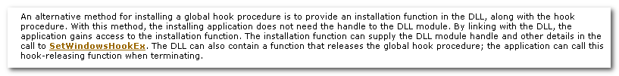

Lpfn:
Pointer to the hook procedure. If the dwThreadId param is zero or specifies the id of a thread created by a different process, the lpfn param must point to a hook procedure in a DLL. Otherwise, lpfn can point to a hook procedure in the code associated with the current process.

hMod:
Handle to the DLL containing the hook procedure pointed to by the lpfn paramter. The hMod must be set to NULL if the dwThreadId paramter specifies a thread created by the current process and if the hook procedure is within the code associated within the current process.

dwThreadId:
Specifies the id of the thread with which the hook procedure is to be associated. If this parameter is zero, the hook procedure is assciated with all existing threads running in the same desktop as the calling thread.

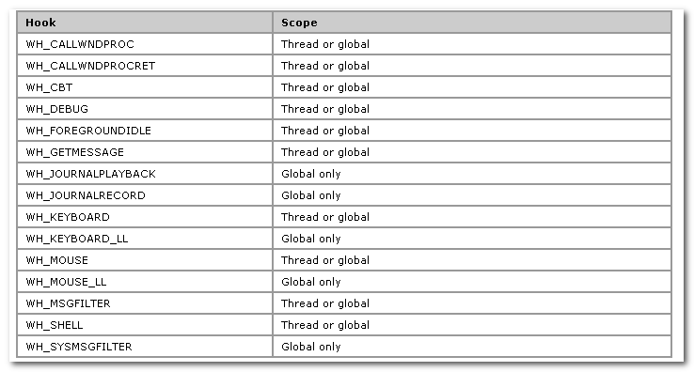

For a specified hook type, thread hooks are called first, then global hooks.

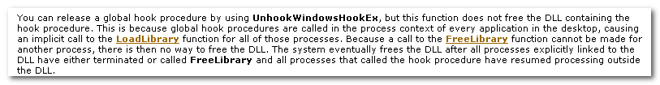

A thread-specific hook monitors messages for only an individual thread.

