Socket模式（同步、异步）
Accept,
Connect,
Recv/recvfrom
Send/sendto
Select

These routines can block if acting on a blocking socket.

Blocking: invoking a function that does not return until the associated operation is completed.

特别的，针对服务端进行相关处理，采用异步（非阻塞）模式。

可使用ioctlsocket 进行同步/异步的设置。
（关于I/O, 相关操作：创建、打开、读、写、控制）
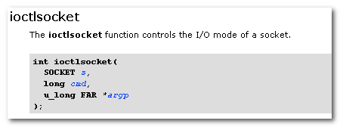
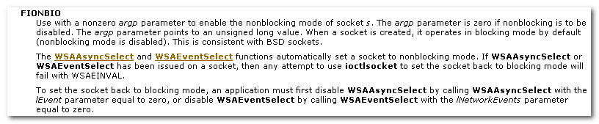
- 默认所创建的socket是阻塞模式（同步）的。
- 异步选择，事件选择模型相关的函数WSAAsyncSelect, WSAEventSelect 会自动的将socket设置为非阻塞模式（异步）
- Ioctlsocket并非仅是设置同步、异步问题，它的本意是控制。 Used to set or retrieve operating parameters associated with the socket, independent of the protocol and communication subsystems.

比如：
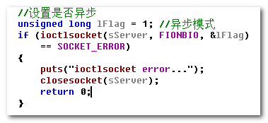
以及所带来的影响
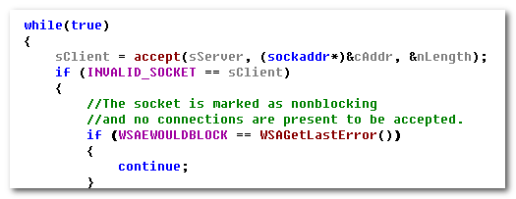

再回头来仔细看下accept:
The newly created socket is the socket that will handle the actual connection and has the same properties as socket s, including the asynchronous events registered with the WSAAsyncSelect or WSAEventSelect functions.

比如：

Server Application & Client Application
Blocking & Non-Blocking

Connection-Oriented socket & Connection-less socket

Socket模型
上面的同步/异步模式，是针对单一的socket相关的内容。

而socket模型，则是对多个socket的相关管理，从提升效率的角度。
比如，可以在一个线程中同时对多个socket进行操作。
- 选择模型(select) （带有超时的轮询机制）
- 异步选择模型（WSAAsyncSelect) （采用消息机制，仅适用于窗口程序）
- 事件选择模型（WSAEventSelect) （更为主动投递，避免大量消息问题）
- Overlapped I/O模型
- 完成端口模型

2.1 选择模型
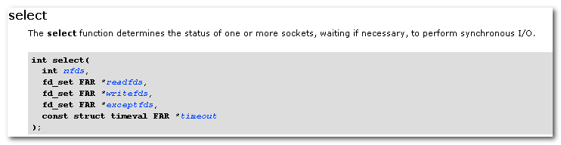

Determine the status of one or more sockets, waiting if necessary.

Optional pointer to a set of sockets to be checked for readability.

Maximum time for select to wait. Set the timeout parameter to NULL for blocking operation.
If time-out is a NULL pointer, select will block indefinitely until at least one descriptor meets the specified criteria.

The select function has no effect on the persistence of socket events registered with WSAAsyncSelect or WSAEventSelect.

Upon return, the structures are updated to reflect the subset of these sockets that meet the specified condition.

The parameter readfds identifies the sockets that are to be checked for readability.
If the socket is currently in the listen state, it will be marked as readable if an incoming connection request has been received such that an accept is guaranteed to complete without blocking.
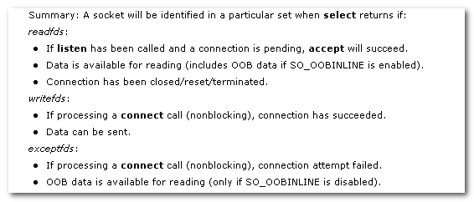

相关宏：
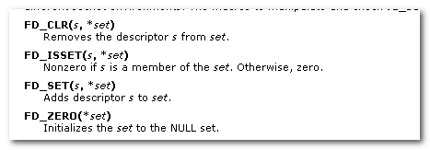

例子：
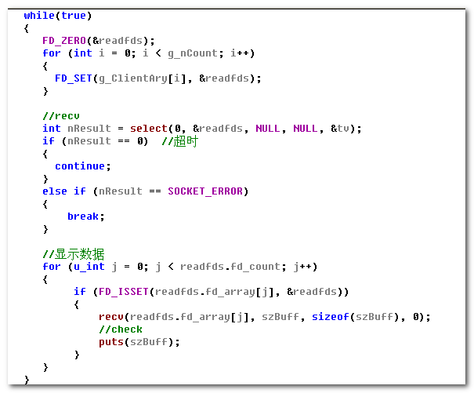

2.2异步选择模型
切入点：WSAAsyncSelect
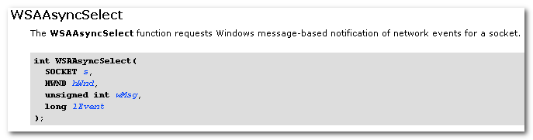
Requests Windows message-based notification of network events for a socket.

向窗口hWnd注册wMsg，以对socket s关注的网络事件lEvent进行监控通告。

The WSAAsyncSelect function is used to request that ws2_32.dll should send a message to the window hWnd whenever it detects any of the network events specified by the lEvent parameter.

Automatically sets socket s to nonblocking mode.

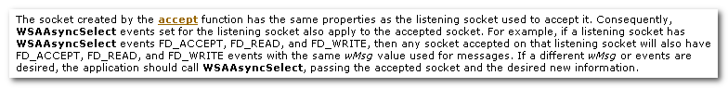
Accept 带来的“遗传”

As in the case of the select function, WSAAsyncSelect will frequently be used to determine when a data transfer operation (send or recv) can be issued with the expectation of immediate success.

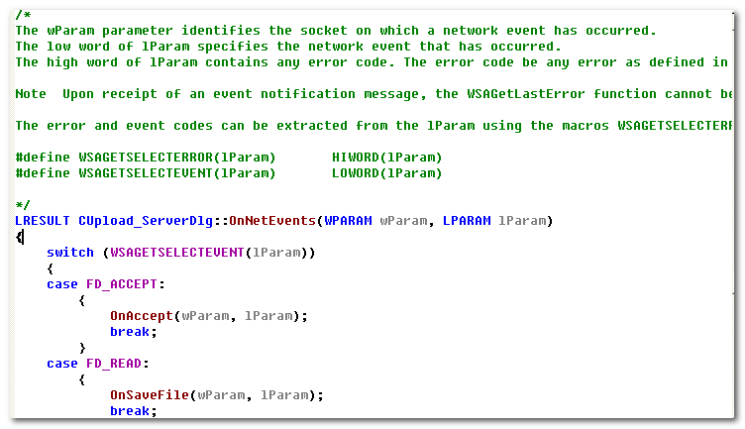

2.3 事件选择
关键词：WSAEventSelect
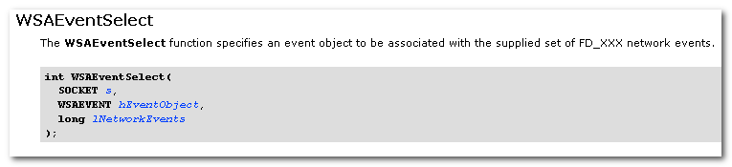
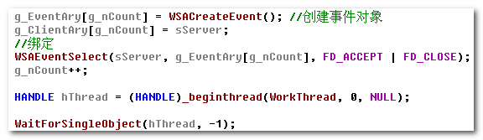
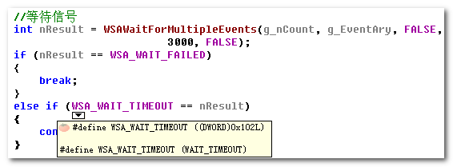

The socket’s internal record of network events is copied to the structure referenced by lpNetworkEvents, after which the internal network events record is cleared.

