SendMessage & PostMessage
SendMessage: 直接调用窗口过程函数
PostMessage : 往消息队列投递消息

The SendMessage function sends the specified message to a window or windows. It calls the window procedure for specified window and does not return until the window procedure has processed the message.

To send a message and return immediately, use the SendMessageCallback or SendNotifyMessage function.

To post a message to a thread’s message queue and return immediately, use the PostMessage or PostThreadMessage function.

UpdateWindow, BeginPaint, EndPaint, InvalidateRect
The UpdateWindow function updates the client area of the specified window by sending a WM_PAINT message to the window if the window’s update region is not empty. The function sends a WM_PAINT message directly to the window procedure of the specified window, bypassing the application queue.

You use the BeginPaint and EndPaint function to prepare for and complete the drawing in the client area.
BeginPaint returns a handle to the display device context used for drawing in the client area;
EndPaint ends the paint request and release the device context.

To make sure the string is visible when the window is first created, the WinMain function calls UpdateWindow immediately after creating and showing the window. This causes a WM_PAINT message to be sent immediately to the following procedure.

什么会发送WM_PAINT消息？
- 窗口缩放
- 窗口恢复
- 被遮挡部分移开
- UpdateWindow

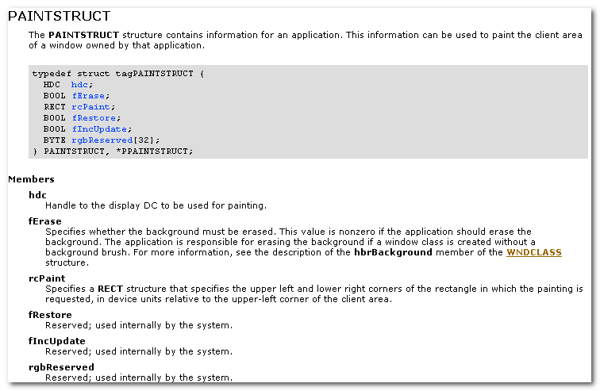
fErase: specifies whether the background must be erased. This value is nonzero if the app should erase the background. The app is responsible for erasing the background if a window class is created without a background brush.

The BeginPaint function automatically sets the clipping region of the device context to exclude any area outside the update region. The update region is set by the InvalidateRect or InvalidateRgn function and by the system after sizing, moving, creating, scrolling, or any other operation that affects the client area. The the update region is marked for erasing, BeginPaint sends a WM_ERASEBKGND message to the window.

An app should not call BeginPaint except in response to a WM_PAINT message.

If the window’s class has a background brush, BeginPaint uses that brush to erase the background of the update region b4 returning.

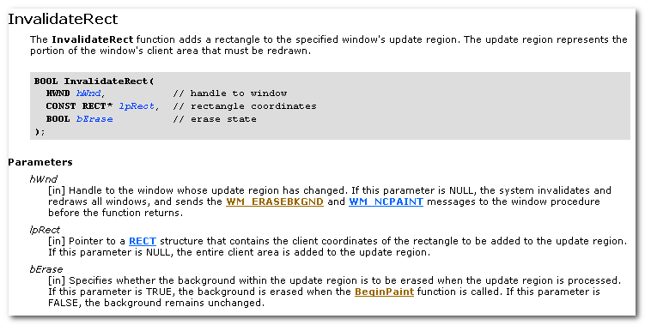
The InvalidateRect function adds a rectangle to the specified window’s update region. The update region represents the portion of the window’s client area that must be redrawn.

bErase: Specifies whether the background within the update region is to be erased when the update region is processed. If the parameter is TRUE, the background is erased when the BeginPaint function is called. If this parameter is FALSE, the background remains unchanged.

The invalidate areas accumulate in the update region until the region is processed when the next WM_PAINT message occurs or until the region is validated by using the ValidateRect or ValidateRgn function.

The system sends a WM_PAINT message to a window whenever its update region is not empty and there are no other messages in the application queue for that window.

If the bErase parameter is TRUE for any part of the update region, the background is erased in the entire region, not just in the special part.

WM_COMMAND
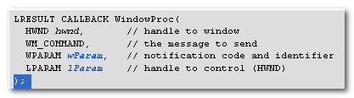
The WM_COMMAND message is sent when the user selects a command item from a menu, when a control sends a notification message to its parent window, or when an accelerator keystroke is translated.

lParam: 控件句柄， 不是控件为NULL
wParam:
高16位：快捷键为1， 菜单为0， 也可能为控件通告码
低16位：快捷键的ID， 菜单的ID，也可能为控件的ID

（一个控件可能有多个通告码）

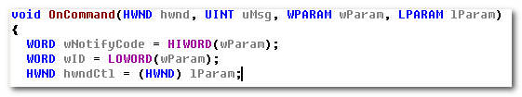

DialogBox
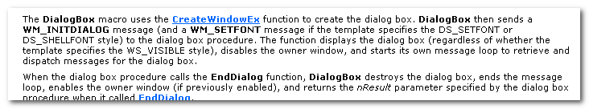
The DialogBox macro uses the CreateWindowEx function to create the dialog box.

DialogBox then sends a WM_INITDIALOG message(and a WM_SETFONT message if the template specifies the DS_SETFONT or DS_SHELLFONT style) to the dialog box procedure. The function displays the dialog box (regardless of whether the template specifies the WS_VISIBLE style), disables the owner window (所谓的模态）, and starts its own message loop to retrieve and dispatch message for the dialog box.

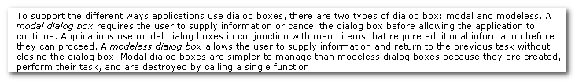
DialogBox creates a modal dialog box;
CreateDialog creates a modeless dialog box.

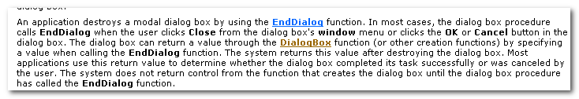

When the dialog box procedure calls the EndDialog function, DialogBox destroys the dialog box, ends the message loop, enables the owner window(if previously enabled), and returns the nResult parameter specified by the dialog box procedure when it called EndDialog.

5.消息机制调试的规范
- 调用OutPutDebugString(“xxx”) 输出调试信息
- 调试状态下，在OutPut窗口下观察输出信息，或者用DebugView查看。

