随着消息处理的深入，消息类型逐步增多，但可以试着从不同的角度进行总结、比对，把握主要脉络。

比如，鼠标消息、键盘消息、快捷键消息等等。

基本消息
如WM_CREATE, WM_CLOSE, WM_DESTROY。

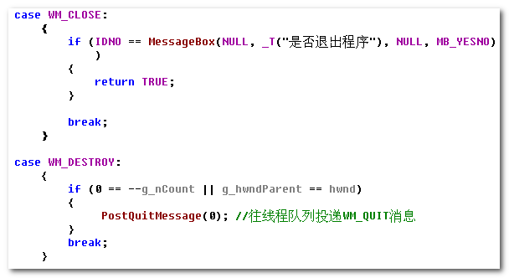

注意进程的结束。

鼠标消息
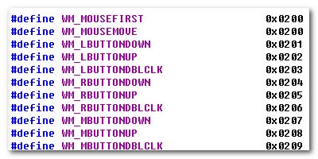
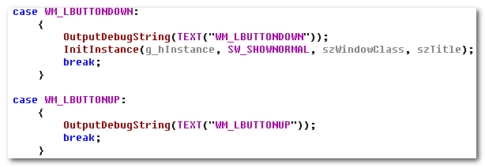

WM_COMMAND
这不是与鼠标消息、键盘消息等并列的，但是它所涉及的比较多，需要进行仔细处理。

The WM_COMMAND message is sent when the user selects a command item from a menu, when a control sends a notification message to its parent window, or when an accelerator keystroke is translated.

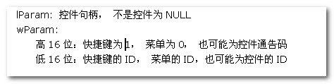
所以，它是菜单、控件、快捷键的处理入口。

3.1 Menu
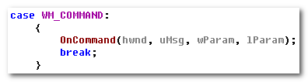
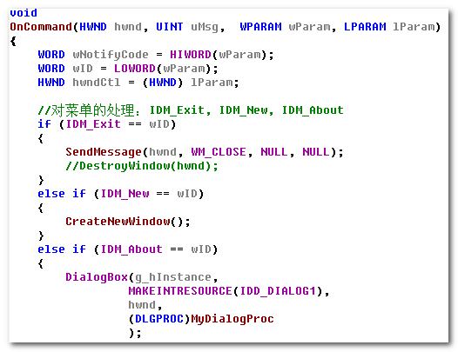

3.2 Dialog
特殊的，对于Dialog， （当然了，Dialog与它们并非等位）
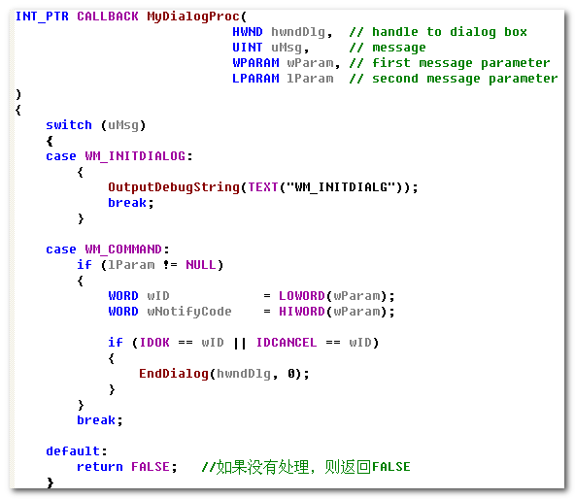

键盘消息
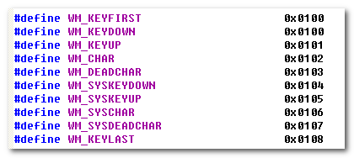
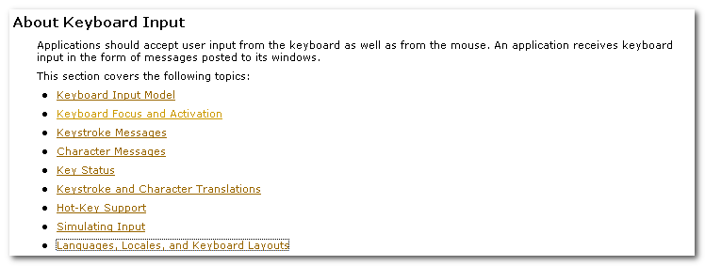
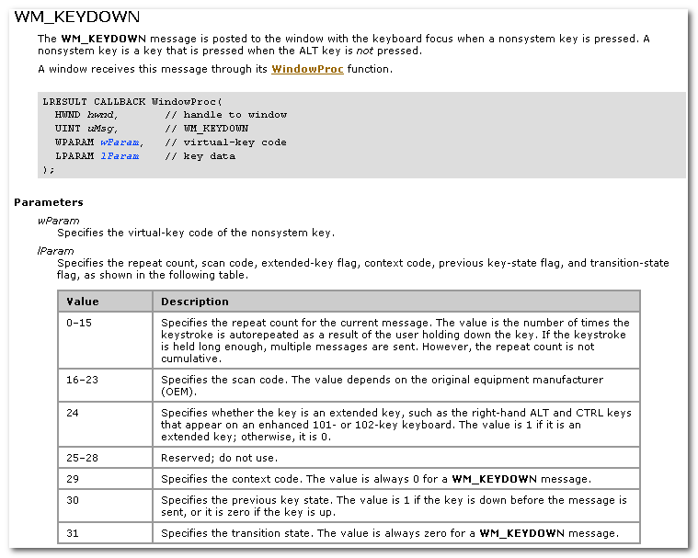

这里涉及：
- Nonsystem key : is a key that is pressed when the ALT key is not pressed.
- Virtual-key Code
- Scan Code

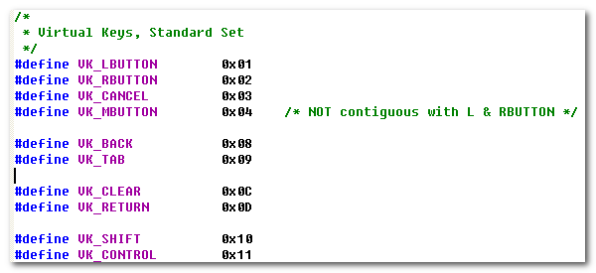
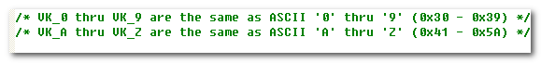
The keyboard device driver receives scan codes from the keyboard, which are sent to the keyboard layout where they are translated into messages and posted to the appropriate windows in your app.

Assigned to each key on a keyboard is a unique value called a scan code, a device-dependent identifier for the key on the keyboard.

The keyboard device driver interprets a scan code and translates(map) it to a virtual-key code, a device-independent value defined by the system that identifies the purpose of a key.

After translating a scan code, the keyboard layout creates a message that includes the scan code, the virtual-key code, and other info about the keystroke, and then places the message in the system message queue.
The system removes the message from the system message queue and posts it to the message queue of the appropriate thread. Eventually, the thread’s message loop removes the message and passes it to the appropriate window procedure for processing.
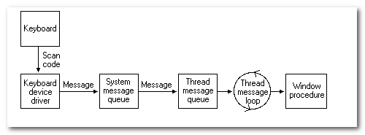

Pressing a key causes a WM_KEYDOWN or WM_SYSKEYDOWN message to be placed in the thread message queue attached to the window that has the keyboard focus.

WM_SYSKEYDOWN
The WM_SYSKEYDOWN message is posted to the window with the keyboard focus when the user presses the F10 key (which activates the menu bar)， or holds down the ALT key and then presses another key.
It also occurs when no window currently has the keyboard focus; in this case, the WM_SYSKEYDOWN message is sent to the active window.
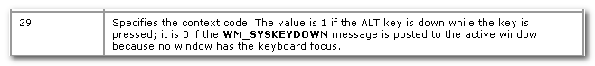

When the context code is zero, the message can be passed to the TranslateAccelerator function, which will handle it as though it were a normal key message instead of a character-key message. This allows accelerator keys to be used with the activate window even if the active window does not have the keyboard focus.

System and NonSystem Keystrokes
System keystrokes produces system keystroke message, WM_SYSTEMDOWN and WM_SYSTEMUP. Nonsystem keystrokes produce nonsystem keystroke messages, WM_KEYDOWN and WM_KEYUP.

If your window procedure must process a system keystroke message, make sure that after processing the message the procedure passes it to the DefWindowProc function. Otherwise, all system operations involving the ALT key will be disabled whenever the window has the keyboard focus. That is, the user won’t be able to access the window’s menus or System menu, or use the ALT + ESC or ALT + TAB key combination to activate a different window.

System keystroke messages are primarily for use by the system rather than by an app. The system uses them to provide its built-in keyboard interface to menus and to allow the user to control which window is active.

Nonsystem keystroke messages are for use by app windows. The DefWindowProc function does nothing with them. A window procedure can discard any nonsystem keystroke messages that it does not need.

A typical window procedure does not process keystroke messages from character keys. Instead, it uses the TranslateMessage function to convert the message into character message.

TranslateMessage function translates virtual-key messages into character messages. The character messages are posted to the calling thread’s message queue, to read the next time the thread calls the GetMessage or PeekMessage function.

Virtual-key messages && Character messages

If the message is translated(that is, a character message is posted to the thread’s message queue), then return value is nonzero.

If the message is WM_KEYDOWN, WM_KEYUP, WM_SYSKEYDOWN or WM_SYSTEMUP, the return value is nonzero, regardless of the translation.

TranslateMessage produces WM_CHAR messages only for keys that are mapped to ASCII characters by the keyboard driver.

If applications process virtual-key messages for some other purpose, they should not call TranslateMessage. For instance, an app should not call TranslateMessage if the TranslateAccelerator function returns a nonzero value.

If you app must obtain character input from the user, include the TranslateMessage function in the loop.

The TranslateAccelerator function processes accelerator keys for menu commands. The function translate a WM_KEYDOWN or WM_SYSKEYDOWN message to a WM_COMMAND or WM_SYSCOMMAND message and then sends the WM_COMMAND or WM_SYSCOMMAND message directly to the appropriate window procedure.

4.1 WM_KEYDOWN
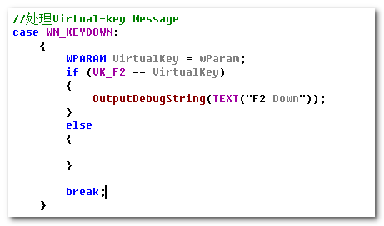

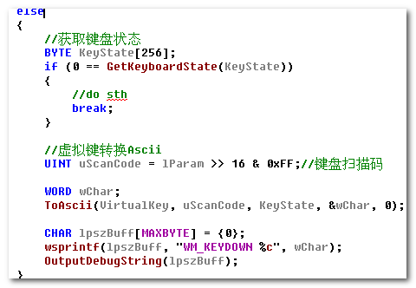

进行从Virtual-Key 到ASCII的转换。

4.2 WM_CHAR
在上面的WM_KEYDOWN中，我们手动的进行了Virtual-Key到ASCII的转换。
此外，还可以使用TranslateMessage进行.

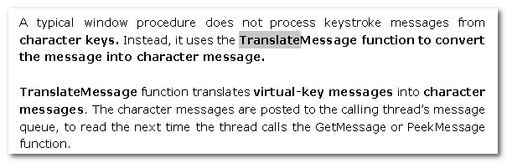
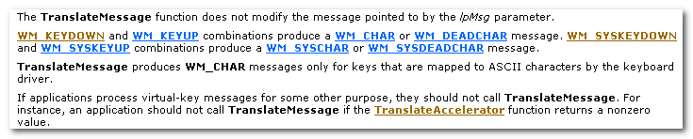
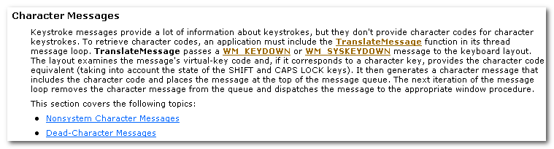

TranslateMessage passes a WM_KEYDOWN or WM_SYSKEYDOWN message to the keyboard layout. The layout examines the message’s virtual-key code and, if it coresponds to a character key, provides the character code equivalent. It then generates a character message that includes the character code and places the message at the top of the message queue. The next iteration of the message loop removes the character message from the queue and dispatches the message to the appropriate window procedure.

快捷键
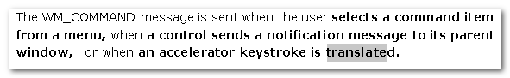
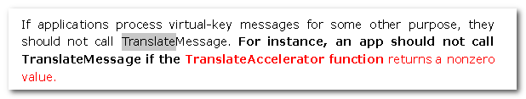
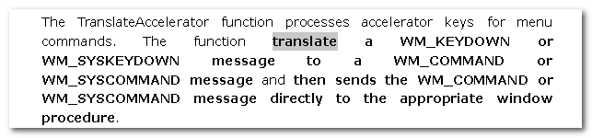

所以，这最终的处理，还是利用已经使用的WM_COMMAND或者WM_SYSCOMMAND.

When TranslateAccelerator returns a nonzero value and the message is translated, the application should not use the TranslateMessage function to process the message again.

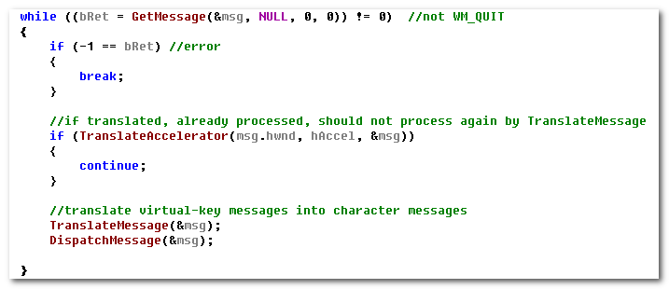
An accelerator need not correspond to a menu command.

If the accelerator command corresponds to a menu item, the app is sent WM_INITMENU and WM_INITMENUPOPUP message, as if the user were trying to display the menu. However, thz messages are not sent if any of the following conditions exist:
- The window is disabled.
- The accelerator key combination does not correspond to an item on the window menu and the window is minimized.
- A mouse capture is ineffect.

