消息类型：
- Windows标准消息（WM_XXX， 除了WM_COMMAND)
  - 鼠标消息
WM_LBUTTONDOWN, WM_LBUTTONUP, WM_MOUSEMOVE

  - 键盘消息
WM_KEYDOWN, WM_KEYUP, WM_CHAR

  - 窗口消息
WM_CREATE, WM_DESTORY, WM_CLOSE, WM_PAINT
WM_ERASEBKGND(BeginPaint也会发送）
WM_SHOWWINDOW

- 控件通告消息(WM_COMMAND, WM_NOTIFY)
目的：控件通告父窗口行为的产生
- 命令消息(WM_COMMAND)
菜单，快捷键，工具栏的消息

基本消息
如WM_CREATE, WM_CLOSE, WM_DESTROY。

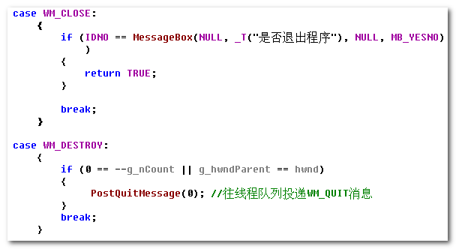

注意进程的结束。

鼠标消息
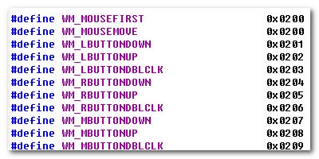
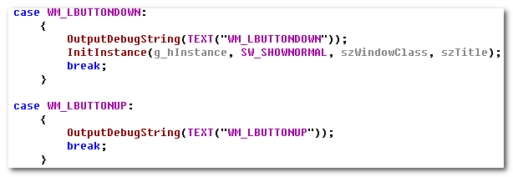

WM_COMMAND
这不是与鼠标消息、键盘消息等并列的，但是它所涉及的比较多，需要进行仔细处理。

The WM_COMMAND message is sent when the user selects a command item from a menu, when a control sends a notification message to its parent window, or when an accelerator keystroke is translated.

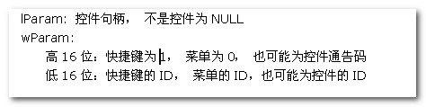
所以，它是菜单、控件、快捷键的处理入口。

3.1 Menu
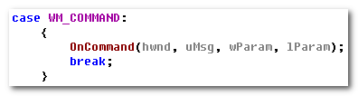
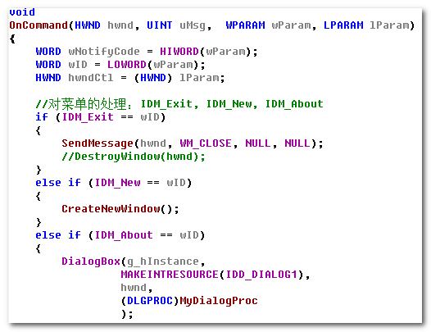

3.2 Dialog
特殊的，对于Dialog， （当然了，Dialog与它们并非等位）
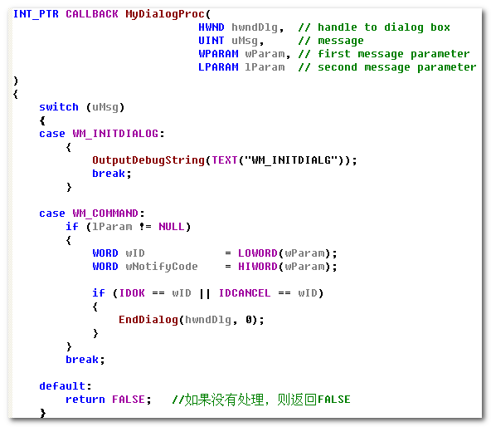

键盘消息
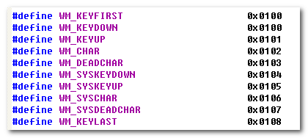
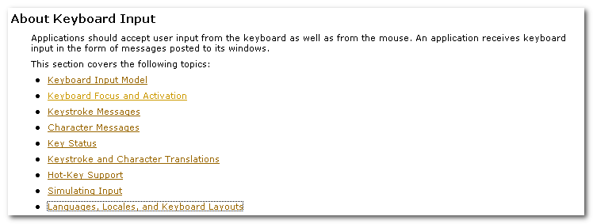
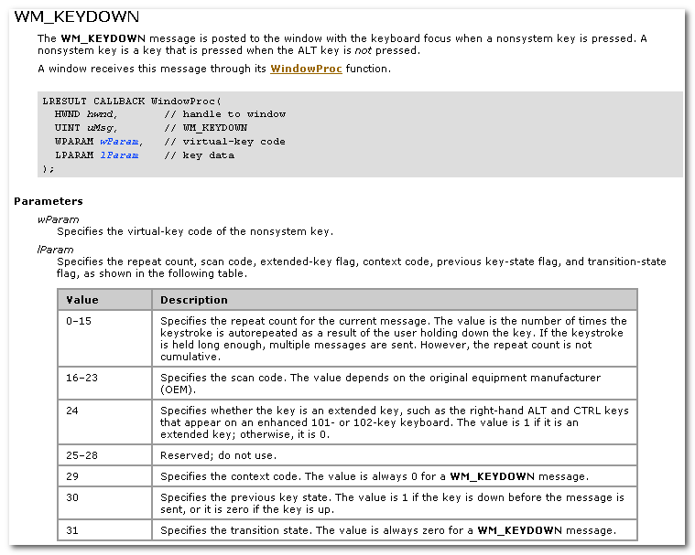

这里涉及：
- Nonsystem key : is a key that is pressed when the ALT key is not pressed.
- Virtual-key Code
- Scan Code

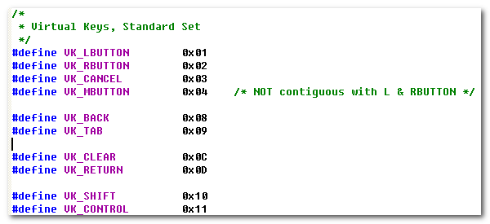
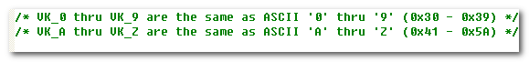
The keyboard device driver receives scan codes from the keyboard, which are sent to the keyboard layout where they are translated into messages and posted to the appropriate windows in your app.

Assigned to each key on a keyboard is a unique value called a scan code, a device-dependent identifier for the key on the keyboard.

The keyboard device driver interprets a scan code and translates(map) it to a virtual-key code, a device-independent value defined by the system that identifies the purpose of a key.

After translating a scan code, the keyboard layout creates a message that includes the scan code, the virtual-key code, and other info about the keystroke, and then places the message in the system message queue.
The system removes the message from the system message queue and posts it to the message queue of the appropriate thread. Eventually, the thread’s message loop removes the message and passes it to the appropriate window procedure for processing.
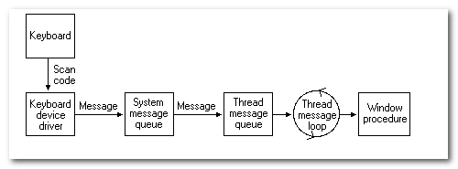

Pressing a key causes a WM_KEYDOWN or WM_SYSKEYDOWN message to be placed in the thread message queue attached to the window that has the keyboard focus.

WM_SYSKEYDOWN
The WM_SYSKEYDOWN message is posted to the window with the keyboard focus when the user presses the F10 key (which activates the menu bar)， or holds down the ALT key and then presses another key.
It also occurs when no window currently has the keyboard focus; in this case, the WM_SYSKEYDOWN message is sent to the active window.
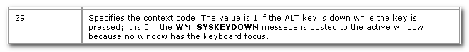

When the context code is zero, the message can be passed to the TranslateAccelerator function, which will handle it as though it were a normal key message instead of a character-key message. This allows accelerator keys to be used with the activate window even if the active window does not have the keyboard focus.

System and NonSystem Keystrokes
System keystrokes produces system keystroke message, WM_SYSTEMDOWN and WM_SYSTEMUP. Nonsystem keystrokes produce nonsystem keystroke messages, WM_KEYDOWN and WM_KEYUP.

If your window procedure must process a system keystroke message, make sure that after processing the message the procedure passes it to the DefWindowProc function. Otherwise, all system operations involving the ALT key will be disabled whenever the window has the keyboard focus. That is, the user won’t be able to access the window’s menus or System menu, or use the ALT + ESC or ALT + TAB key combination to activate a different window.

System keystroke messages are primarily for use by the system rather than by an app. The system uses them to provide its built-in keyboard interface to menus and to allow the user to control which window is active.

Nonsystem keystroke messages are for use by app windows. The DefWindowProc function does nothing with them. A window procedure can discard any nonsystem keystroke messages that it does not need.

A typical window procedure does not process keystroke messages from character keys. Instead, it uses the TranslateMessage function to convert the message into character message.

TranslateMessage function translates virtual-key messages into character messages. The character messages are posted to the calling thread’s message queue, to read the next time the thread calls the GetMessage or PeekMessage function.

Virtual-key messages && Character messages

If the message is translated(that is, a character message is posted to the thread’s message queue), then return value is nonzero.

If the message is WM_KEYDOWN, WM_KEYUP, WM_SYSKEYDOWN or WM_SYSTEMUP, the return value is nonzero, regardless of the translation.

TranslateMessage produces WM_CHAR messages only for keys that are mapped to ASCII characters by the keyboard driver.

If applications process virtual-key messages for some other purpose, they should not call TranslateMessage. For instance, an app should not call TranslateMessage if the TranslateAccelerator function returns a nonzero value.

If you app must obtain character input from the user, include the TranslateMessage function in the loop.

The TranslateAccelerator function processes accelerator keys for menu commands. The function translate a WM_KEYDOWN or WM_SYSKEYDOWN message to a WM_COMMAND or WM_SYSCOMMAND message and then sends the WM_COMMAND or WM_SYSCOMMAND message directly to the appropriate window procedure.

4.1 WM_KEYDOWN
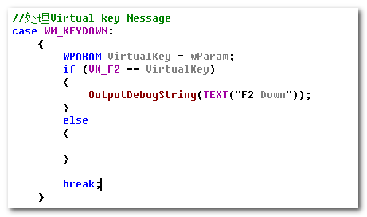

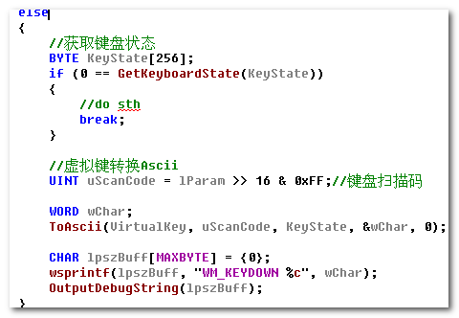

进行从Virtual-Key 到ASCII的转换。

4.2 WM_CHAR
在上面的WM_KEYDOWN中，我们手动的进行了Virtual-Key到ASCII的转换。
此外，还可以使用TranslateMessage进行.

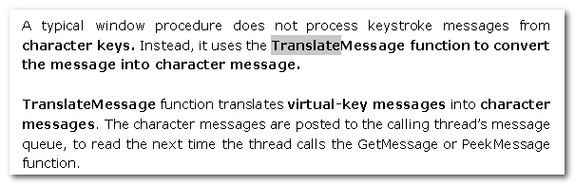
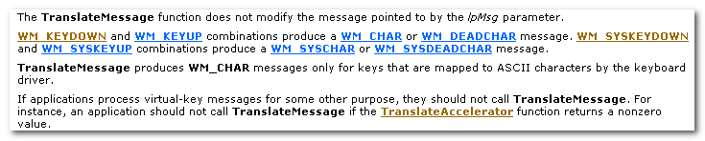
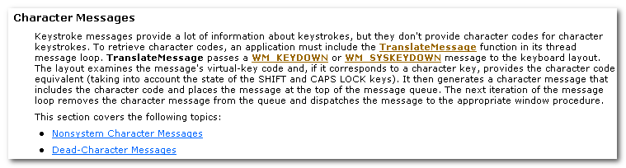

TranslateMessage passes a WM_KEYDOWN or WM_SYSKEYDOWN message to the keyboard layout. The layout examines the message’s virtual-key code and, if it coresponds to a character key, provides the character code equivalent. It then generates a character message that includes the character code and places the message at the top of the message queue. The next iteration of the message loop removes the character message from the queue and dispatches the message to the appropriate window procedure.

快捷键
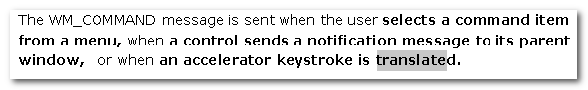
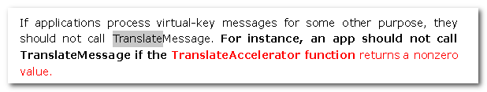
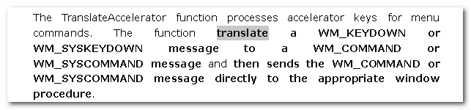

所以，这最终的处理，还是利用已经使用的WM_COMMAND或者WM_SYSCOMMAND.

When TranslateAccelerator returns a nonzero value and the message is translated, the application should not use the TranslateMessage function to process the message again.

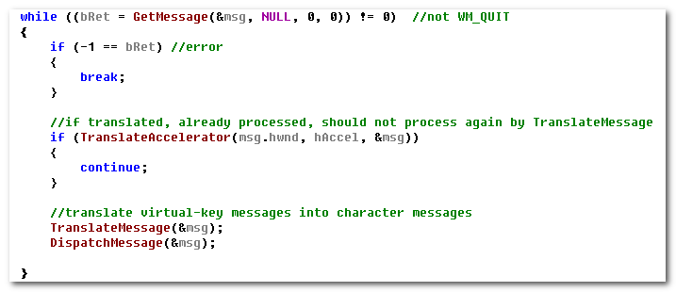
An accelerator need not correspond to a menu command.

If the accelerator command corresponds to a menu item, the app is sent WM_INITMENU and WM_INITMENUPOPUP message, as if the user were trying to display the menu. However, thz messages are not sent if any of the following conditions exist:
- The window is disabled.
- The accelerator key combination does not correspond to an item on the window menu and the window is minimized.
- A mouse capture is ineffect.

通告消息
在前面我们知道WM_COMMAND处理MENU, ACCELERATOR, CONTROL三类消息。
而其中，控件也是窗口的一种，它也有相应的消息处理。
- 对于一些系统已经预设的控件，它的消息处理也是系统所负责的。用户仅需按照相应的约定进行处理即可。
- 用户也可自定义消息， WM_USER + id

它们的共同点是：
子窗口获知自身状态的改变，需SendMessage or PostMessage 到父窗口，让父窗口来进行相应的处理。

这种子窗口向父窗口发送消息的机制，就是通告消息。同时，它也可以携带额外的信息。

6.1 ListBox
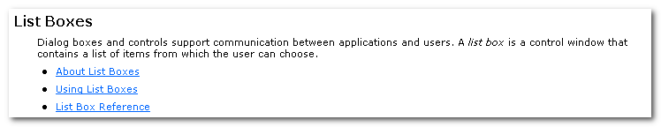
Dialog boxes and controls support communication between applications and users.
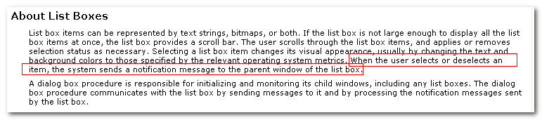
When the user selects or deselects an item, the system sends a notification message to the parent window of the list box.

A dialog box procedure is responsible for initializing and monitoring its child windows, including any list boxes. The dialog box procedure communicates with the list box by sending messages to it and by processing the notification messages sent by the list box.

List Box <-----------------------> Parent Dialog

6.1.1 初始化（父窗口发送给控件）
ListBox 作为DialogBox（或者其他窗口）的子窗口，我们要对其进行操作，首先要获取到其句柄。 这可通过其父句柄，利用GetDlgItem实现。
You can use the GetDlgItem function with any parent-child window pair, not just with dialog boxes. As long as the hDlg parameter specifies a parent window and the child window has a unique identifier, GetDlgItem returns a valid handle to the child window.

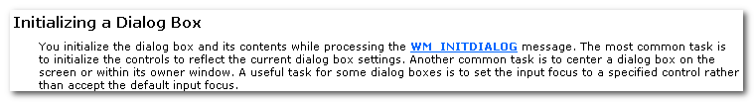
You Initialize the dialog box and its contents while processing the WM_INITDIALOG message. The most common task is to initialize the controls to reflect the current dialog box settings.

Another common task is to center a dialog box on the screen or within its owner window.

A useful task for some dialog boxes is to set the input focus to a specified control rather than accept the default input focus.

要知道，ListBox是作为系统预设的控件存在的，已经对消息处理进行了封装，我们要完成对其对操作，需要SendMessage 或者PostMessage。
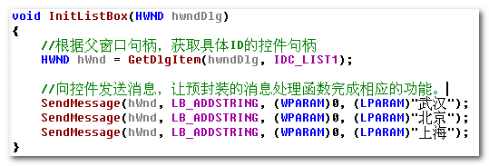
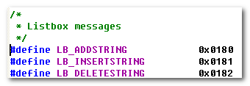
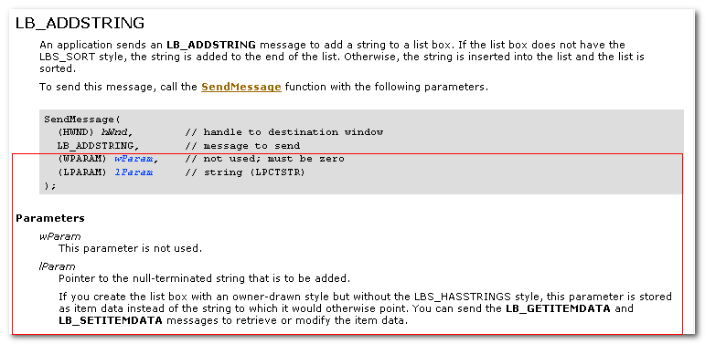
在利用SendMessage发送消息时，要特别注意wParam, lParam, 在不同的消息中，它们的含义、要求不同。

这样，系统就负责完成了ListBox的操作

6.1.2父窗口的消息处理（父窗口处理来自控件的通告消息）
The dialog box procedure communicates with the list box by sending messages to it and by processing the notification messages sent by the list box.

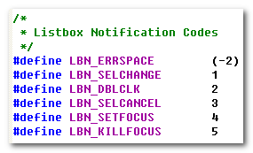
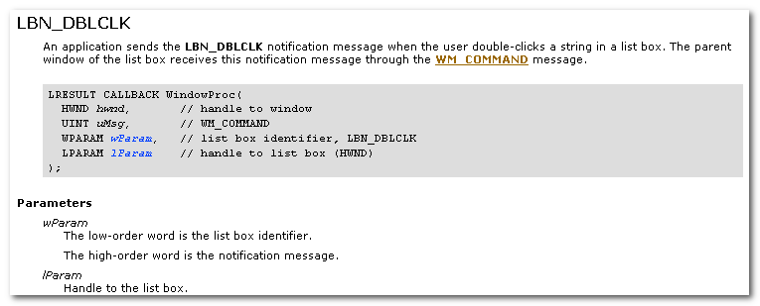
An application sends the LBN_DBLCLK notification message when the user double-click a string in a list box. The parent window of the list box receives this notification message through the WM_COMMAND message.

这里，我们看到List Box的Notification message 是通过WM_COMMAND来进行传递的。

而在下面的一个案例中（List-View control)中，其消息是通过WM_NOTIFY进行传递的。
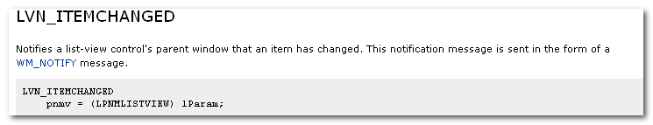

那么，为啥是通过不同的方式呢？
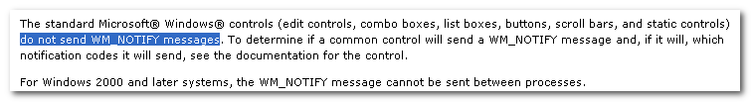
也就是说，控件消息的传递方式，是由具体的控件实现所设定的，没有明确的准则。
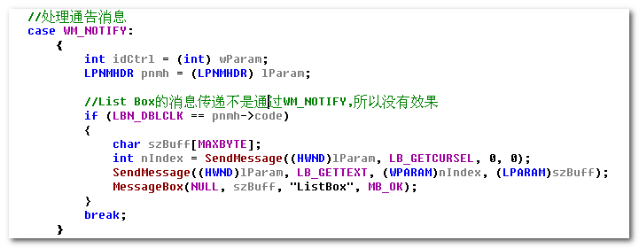

6.2 List-View Control
具体的处理，可参看相应的MSDN。其处理流程与List Box类似，但是相应的差别，如消息类型，消息传递机制（WM_NOTIFY)
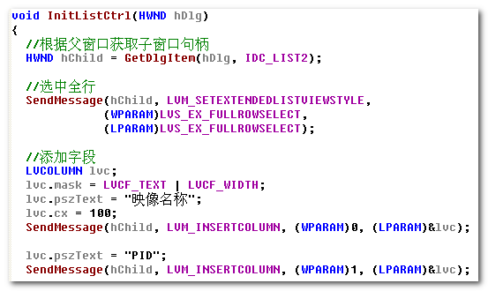

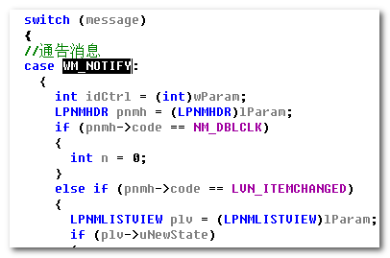

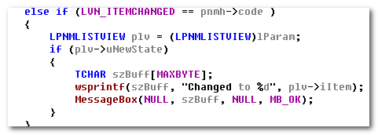

OverView
Apps define the general behavior and appearance of their windows by creating window classes and corresponding window procedures.

A window class identifies default characteristics such as whether the window processes mouse button clicks or has a menu.
The corresponding window procedure contains code that defines the behavior of the window, carries out requested tasks, and processes user input.

Apps generate output for a window by using the GDI functions. Bkz all windows share the display screen, apps do not receive access to the entire screen. Instead, the system aligns and clips all output to fit within the corresponding windows. Apps can draw in a window in response to a request from the system or while processing input messages. When the size or position of a window changes, the system typically sends a message to the app requesting that it paint any peviously unexposed area of its window.

Apps receive mouse and keyboard input in the form of messages. The system translates mouse movement, mouse button clicks, and keystrokes into input messages and places these messages in the message queue for the app. The system automatically provides a queue for each app. The app uses message functions to extract message from the queue and dispatch them to the appropriate window procedure for processing.

Apps can process the mouse and keyboard input directly or let the system translate this low-level input to command messages by using menus and keyboard accelerators.

Apps often respond to command messages by prompting the user for additional info with dialog boxes. A dialog box is a temporary window that displays info or requests input. A dialog box typically includes controls——small, single-purpose windows —— that represent buttons and boxes through which the user provides info. These are controls for typing text, scrolling text, selecting items from a list of items, and so on. Dialog boxes manage and process the input from these controls, making this info available to the app so that it can complete the requested command.

7.1 Message and Message Queue
Windows-based apps wait for the system to pass input to them.

System-Defined Messages
The system sends or posts a system-defined message when it communicates with an app.
An app can also send or post system-defined messages. Apps generally use these messages to control the operation of control windows created by using preregistered window classes.

Symbolic constants specify the category to which system-defined messages belong. The prefix of the constant identifies the type of window that can interpret and process the message.

The system maintains a single system message queue and one thread-specific message queue for each GUI thread.

A thread can post a message to its own message queue or to the queue of another thread by using PostMessage or PostThreadMessage function.

Message Routing
- posted to a message queue:
They are primarily the result of user input entered through the mouse or keyboard, such as WM_MOUSEMOVE, WM_LBUTTONDOWN, WM_KEYDOWN and WM_CHAR message, WM_TIMER, WM_PAINT, WM_QUIT.

- Nonqueued messages:
Sent immediately to the dst window procedure, bypassing the system message queue and thread queue.

All window classes are process specific.

Any app can post and send messages.
An app typically posts a message to notify a specific window to perform a task.

A common programming error is to assume that the PostMessage function always posts a message. This is not true when the message queue is full. An app should check the return value of the PostMessage function to determine whether the msg has been posted and, if it has not been, repost it.

An app typically sends a message to notify a window procedure to perform a task immediately.

Parent and child windows often communicate by sending msg to each other. For example, a parent window that has an edit control as its child window can set the text of the control by sending a msg to it. The control can notify the parent window of changes to the text that are carried out by the user by sending msg back to the parent.

Parent and child windows often communicate by sending msg to each other.
对这一点，要有深刻的理解，因为后续的，一些操作，不一定要由自身完成，可以让parent window或者child window来完成。

Message Deadlocks
A thread that calls the SendMessage function to send a msg to another thread cannot continue executing until the window procedure that receives the msg returns. If the receiving thread yields control while processing the msg, the sending thread cannot continue executing, because it is waiting for SendMessage to return. If the receiving thread is attached to the same queue as the sender, it can cause an app deadlock to occur.

Note that the receiving thread need not yield control explicitly; calling any of the following functions can cause a thread to yield control implicitly:
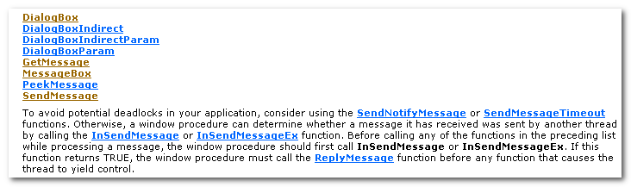

Each msg consists of a msg id and two parameters, wParam and lParam. The msg id is a unique value that specifies the msg purpose. The parameters provide additional info that is message-specific, but the wParam parameter is generally a type value that provides more info about the msg.

7.2 Window
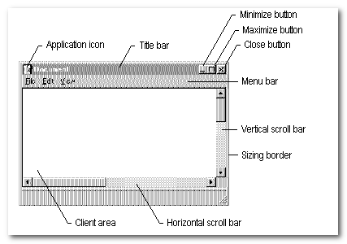
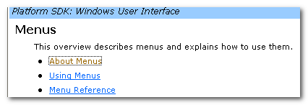
A child window can have a unique integer identifier. Child window identifiers are import when working with control windows. An app directs a controls’s activity by sending it messges. The app uses the control’s child window id to direct the messages to the control.
In addition, a control sends notification msg to its parent window.

