UNICODE, _UNICODE
Function prototypes: generic, ANSI, Unicode
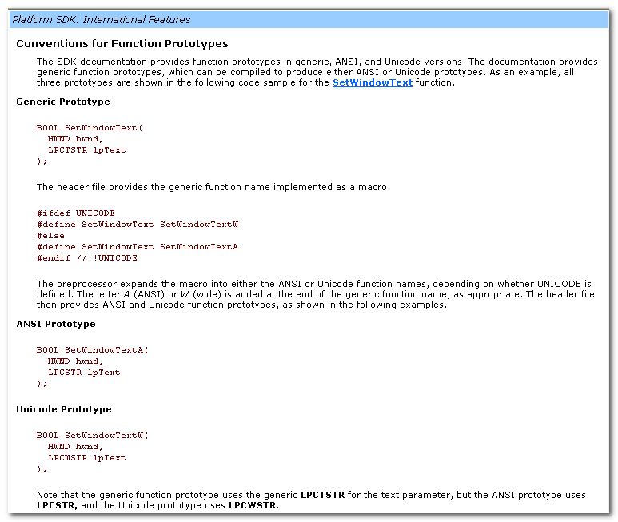
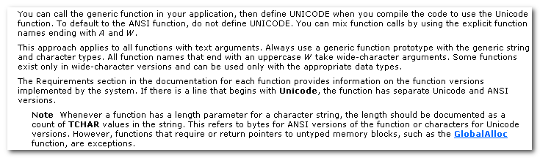

Windows.h 中函数的ANSI, 或者Unicode版本，是通过UNICODE宏来控制的。
比如，
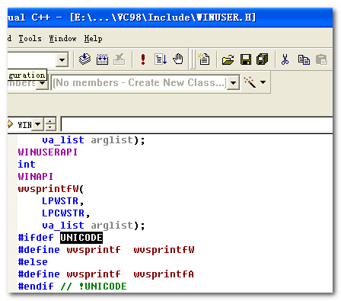

在tchar.h 中，ANSI或者Unicode版本，是通过_UNICODE宏来控制的。
比如，
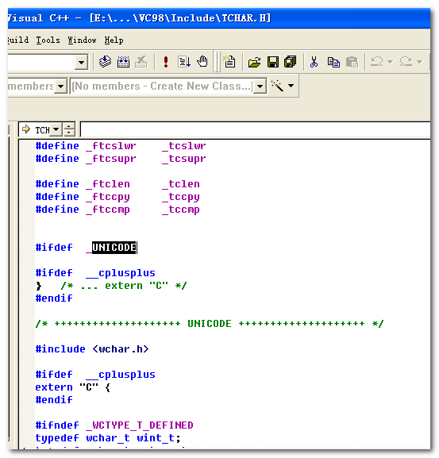

以及_MBCS（多字符集）。

应确保要么同时定义了UNICODE 和_UNICODE, 要么一个都不定义

窗口程序
(后续随着MFC的学习，可以再回头来看到底都做了啥，Spy++中处理)
窗口程序的一般处理流程：
- _tWinMain
- 设计、注册窗口类
RegisterClass
- 创建并显示窗口
CreateWindow
- 消息循环
GetMessage

其中，消息循环处理机制，是以线程为处理的。
可以取线程消息队列中的任一消息处理，并删除
也可以取线程消息队列指定窗口中获取一个消息处理，并删除。

//Associating a Window Procedure with a Window Class.
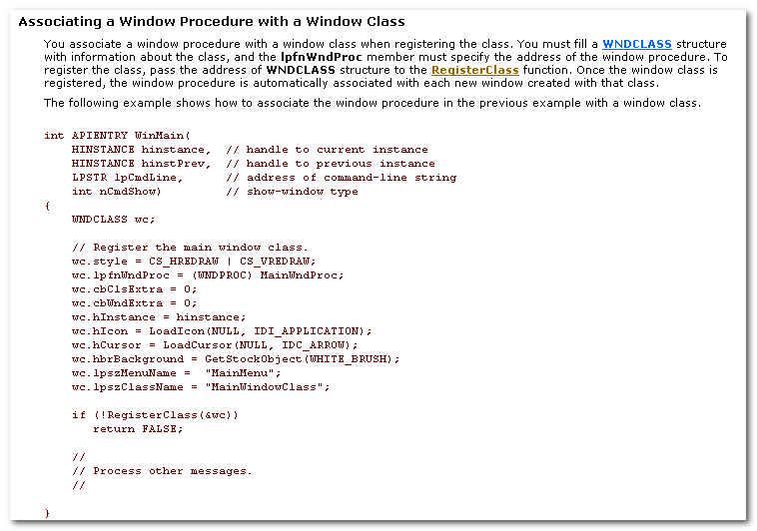

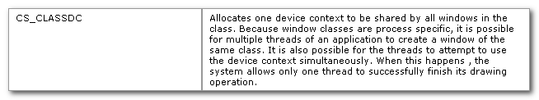

Window classes are process specific, it is possible for multiple threads of an applicaton to create a window of the same class.

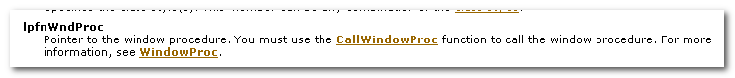

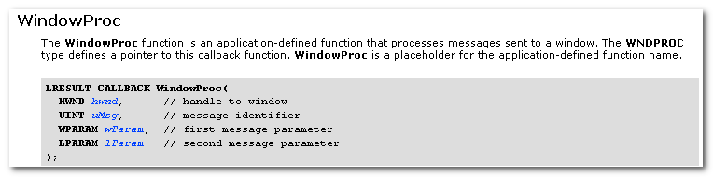

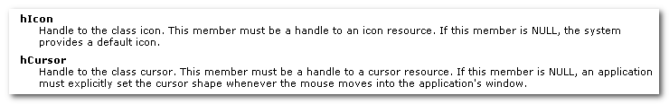

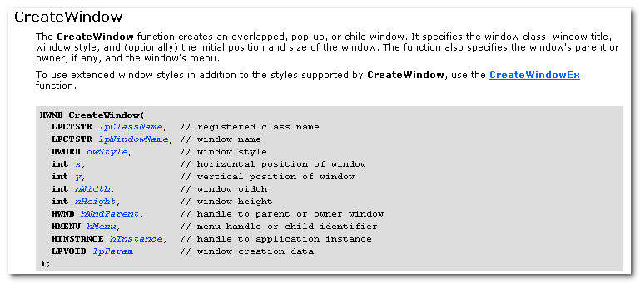
The CreateWindow function creates an overlapped, pop-up, or child window.
It specifies the window class, window titles, window style,and (optionally) the initial position and size of the window.
The function also specifies the window’s parent or owner, if any, and the window’s menu.
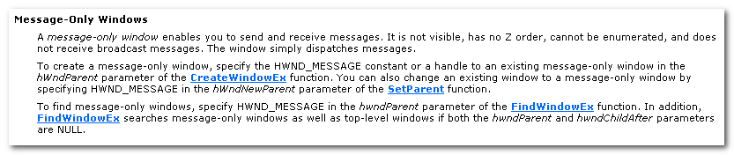

关于窗口，如窗口遍历，Z-order, EnumWindow, Parent , Owner, 等等
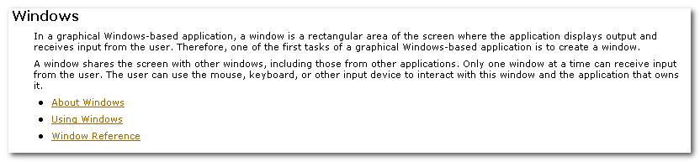
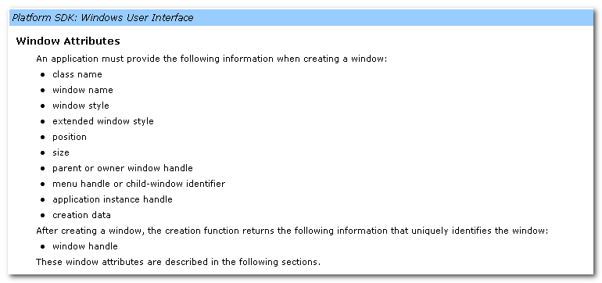
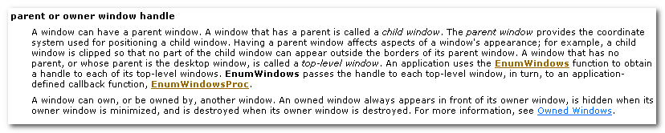
A window that has no parent, or whose parent is the desktop window, is called a top-level window.
An application uses the EnumWindows function to obtain a handle to each of its top-level windows. EnumWindow passes the handle to each top-level window, in turn, to an application-defined callback function, EnumWindowProc.

A window can own, or be owned by, another window.
An owned window always appears in front of its owner window, is hidden when its owner window is minimized, and is destroyed when its owner window is destroyed.
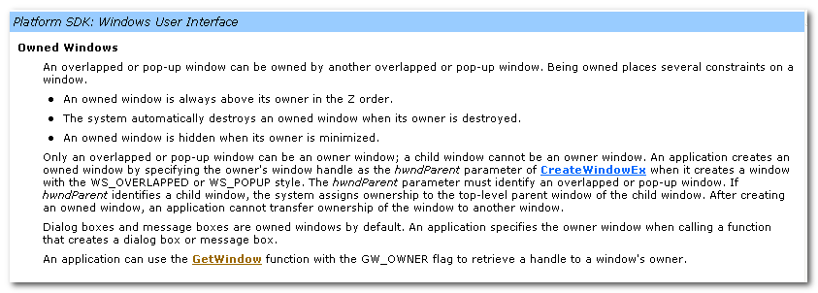
Being owned places several constraints on a window:
- an owned window is always above its owner in the Z order.
- The system automatically destroys an owned window when its owner is destroyed.
- An owned window is hidden when its owner is minimized.

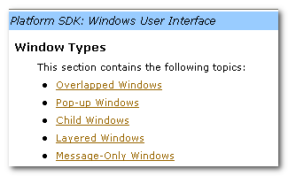
An overlapped window is a top-level window that has a title bar, xxxx
An overlapped window used as a main window typically includes all of these components.

A child window must have a parent window.

An application can change the parent window of an existing child window by calling the SetParent function.
If the SetParent specifies a NULL handle, the desktop window becomes the new parent window.

A child window has only one parent window, but a parent can have any number of child windows. Each child window, in turn, can have child windows. In this chain of windows, each child window is called a descendant window of the original parent window.
An application uses the IsChild function to discover whether a given window is a child window or a descendant window of a given parent window.
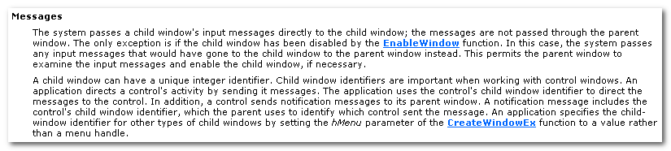

The foreground thread has a normal base priority of 9; a background thread has a normal base priority of 7.

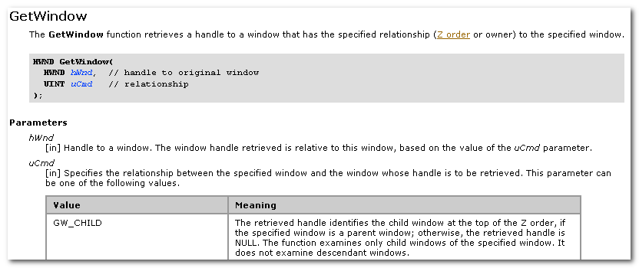
uCmd specifies the relationship between the specified window and the window whose handle is to be retrieved.
GW_CHILD: The retrieved handle identifies the child at the top of the Z order, if the specified window is a parent window;
Otherwise, the retrieved handle is NULL.
The function examines only child windows of the specified window. It does not examine descendant windows.

GW_ENABLEPOPUP: The retrieved handle identifies the enabled popup window owned by the specified window(the search uses
the first such window found using GW_HWNDNEXT); otherwise, if there are no enabled popup windows, the retrieved handle is that of the specified window.

GW_HWNDFIRST: The retrieved handle identifies the window of the same type that is highest in the Z order.
If the specified window is a topmost window, the handle identifies the topmost window that is highest in the Z order.
If the specified window is a top-level window, the handle identifies the top-level window that is highest in the Z order.
If the specified window is a child window, the handle identifies the sibling window that is lowest in the Z order.

GW_HWNDNEXT: The retrieved handle identifies the window below the
Specified window in the Z order.
If the specified window is a topmost window, the handle identifies the topmost window below the specified window.
If the specified window is a top-level window, the handle identifies the top-level window below the specified window.
If the specified window is a child window, the handle identifies the sibling window below the specified window.

The system maintains the Z order in a single list. It adds windows to the Z order based on whether they are topmost windows, top-level windows, or child windows.
A topmost window overlaps all other non-topmost windows, regardless of whether it is the active or foreground window.
A topmost window has the WS_EX_TOPMOST style.
All topmost window appear in the Z order b4 any non-topmost windows.
A child windows is grouped with its parent in Z order.

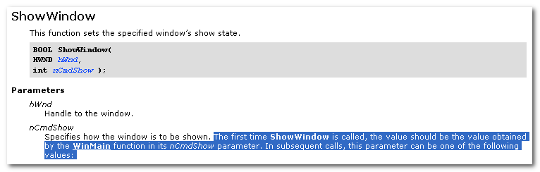

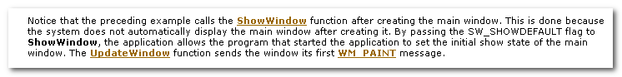

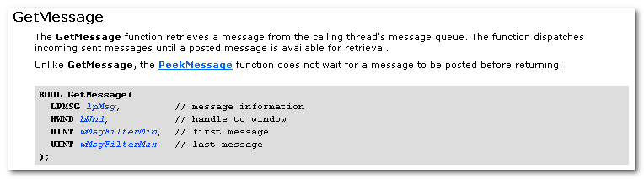
The GetMessage function retrieves a message from the calling thread’s message queue. The functon dispatches incoming sent messages until a posted message is available for retrieval.
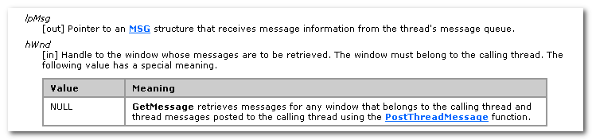
Handle to the Window whose message are to be retrieved. The window must belong to the calling thread. (线程可以有多个窗口，
When hWnd is NULL, GetMessage retrieves message for any window that belongs to the calling thread and thread messages posted to the calling thread using the PostThreadMessage function.

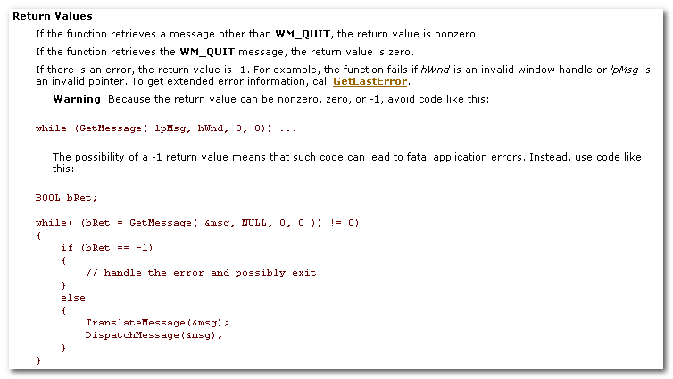

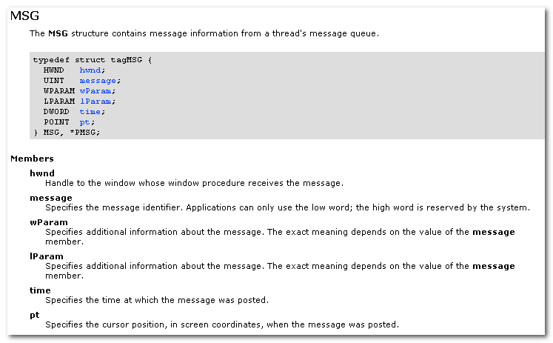
Handle to the window whose window procedure receive the message.
Message, specifies the message identifier.

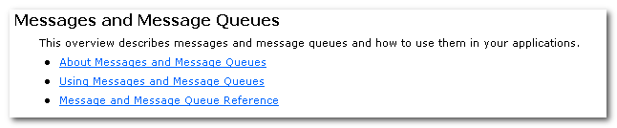

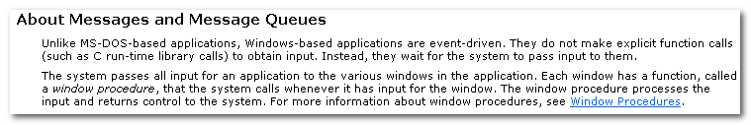

Windows-based application are event-driven. They do not make explicit function calls to obtain input. They wait for the system to pass input to them.

The system passes all input for an app to the various windows in the app. Each window has a function, called a window procedure, that the system calls whenever it has input to the window.
The window procedure processes the input and returns control to the system.

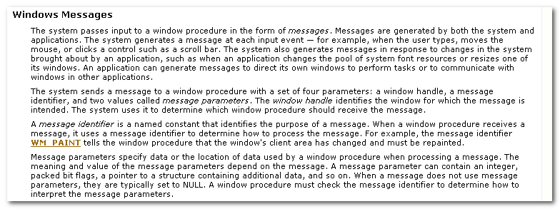
Messages are generated by both the system and app.
An application can generate message to direct its own windows to perform tasks or to communicate with windows in other application.

The system sends a message to a window procedure with a set of four parameters:
- a window handle: identifies the window for which the message is intended.
- A message identifier: a named constant that identifies the purpose of a message. When a window procedure receive a message, it uses a message identifier to determine how to process the message.
- Message parameters specify data or the location of data used by a window procedure when processing a message. The meaning and value of the message parameters depend on the message. A message parameter can contain an inter, packed bit flags, a pointer to a structer containing additional data, and so on. When a message does not use message parameters, they are typically set to NULL. A window procedure must check the message identifier to determine how to interpret the message parameters.

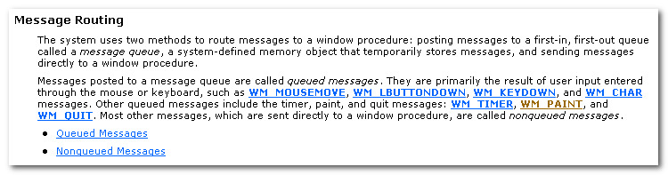
The system uses 2 methods to route message to a window procedure:
- posting message to a first-in, first-out queue called a message queue, a system-defined memory object that temporary stores messages, and sending messages directly to a window procedure.
- Most other messages, which are sent directly to a windo procedure, are called nonqueued message.

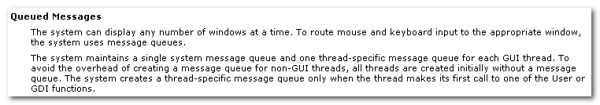
The system can display any number of windows at a time.
To route mouse and keyboard input to the appropriate window, the system use message queues.

The system maintains a single system message queue and one thread-specific message queue for each GUI thread.

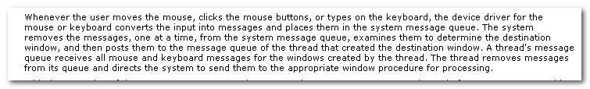
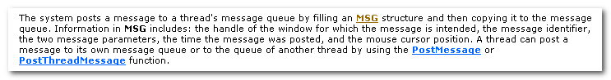
The system posts a message to a thread’s message queue by filling an MSG structure and then copying it to the message queue.
Information in MSG includes: the handle of the window for which the message is intended, the message identifier, the two message parameters, the time the message was posted, and the mouse cursor position.

A thread can post a message to its own message queue or to the queue of another thread by using PostMessage or PostThreadMessage function.

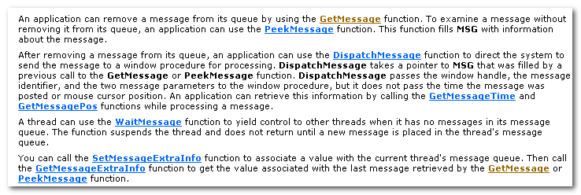
An application can remove a message from its queue by using the GetMessage function.

To examine a message without removing it from its queue, an app can use the PeekMessage function. This function fills MSG with info about the message.

After removing a message from its queue, an app can use the DispatchMessage function to direct the system to send the message to a window procedure for processing. DispatchMessage takes a pointer to MSG that was filled by a previous call to the GetMessage or PeekMessage function.

DispatchMessage passes the window handle, the message identifier, and the two message parameters to the window procedure, but it does not pass the time the message was posted or mouse cursor position. An app can retrieve this info by calling the GetMessageTime and GetMessagePos functions while processing a message.

A thread can use the WaitMessage function to yield control to other threads when it has no message in its message queue.

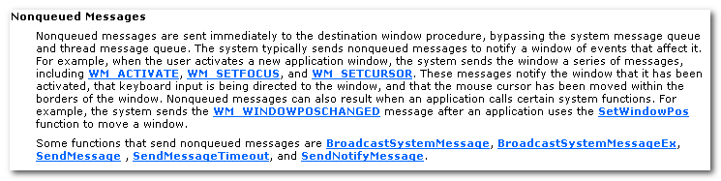

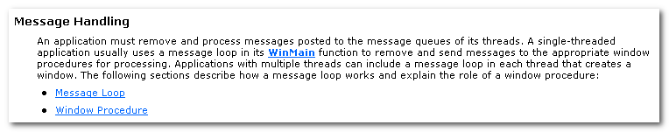
An application must remove and process messages posted to the message queues of its threads. A single thread app usually use a message loop in its WinMain function to remove and send message to the appropriate window procedures for processing.
App with multiple threads can include a message loop in each thread that creates a window.

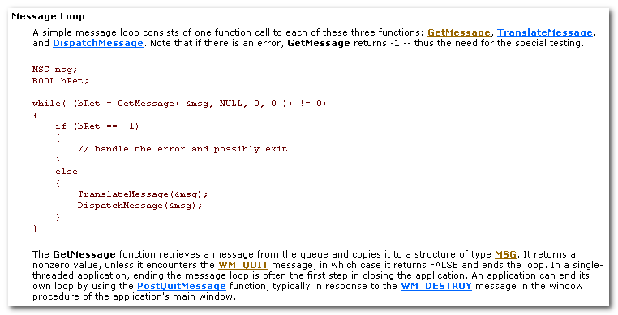

An application can end its own loop by using the PostQuitMessage function, typically in response to the WM_DESTROY message in the window procedure of the application’s main window.

If you specify a window handle as the 2nd parameter of GetMessage, only messages for the specified window are retrieved from the queue.
GetMessage can also filter message in the queue, retrieving only those messages that fall within a specified range.

A thread’s message loop must include TranslateMessage if the thread is to receive character input from the keyboard. ... To retrieve this value, the message loop must contain TranslateMessage, which translates the virtual-key message into a character message and places it back into the application message queue. The character message can then be removed upon a subsequent iteration of the message loop and dispatched to a window procedure.

The DispatchMessage function sends a message to the window procedure associated with the window handle specified in the MSG structure. If the window handle is HWND_TOPMOST, DispatchMessage sends the message to the window procedure of all top-level windows in the system.
If the window handle is NULL, DispatchMessage does nothing with the message.

Only one message loop is needed for a message queue, even if an application contains many windows.

DispatchMessage always dispatches the message to the proper window. This is bkz each message in the queue is an MSG structure that contains the handle of the window to which the message belongs.

You can modify a message loop in a variety of ways. E.g, you can retrieve messages from the queue without dispatching them to a window. This is useful for applications that post messages not specifying a window. You can also direct GetMessage to search for specifc messages, leaving other messages in the queue.

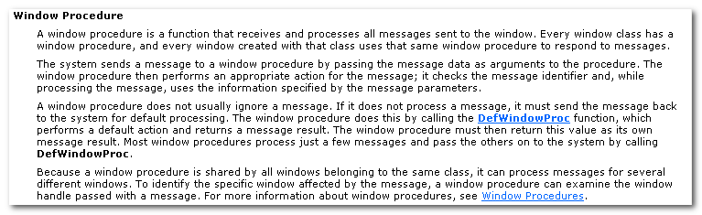
A window procedure is a function that receives and processes all messages sent to the window. Evey window class has a window procedure,and every window created with that class uses that same window procedure to respond to the message.

A window procedure does not usually ignore a message. If it does not process a message, it must send the message back to the system for default processing. The window procedure does this by calling the DefWindowProc function, which performs a default action and returns a message result.

Bkz a window procedure is shared by all windows belonging to the same class, it can process messages for several different windows. To identify the specific window affected by the message, a window procedure can examine the window handle passed with a message.

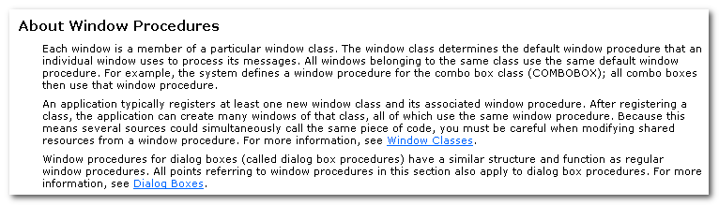

Each window is a member of a particular window class. All windows belongs to the same class use the same default window procedure.

An applicaton typically register at least one new window class and its associated window procedure. After registering a class, the app can create many windows of that class, all of which use the same window procedure.

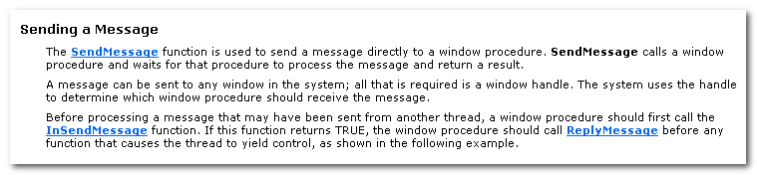

The SendMessage function is used to send a message directly to a window procedure.

A message can be sent to any window in the system. All that is required is a window handle. The system uses the handle to determine which window procedure should receive the message.

