- Dialog based
- Single document
- Multiple documents

1.Dialog Based

- CApp
- CDlg

1.1 类结构与文件结构
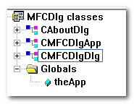
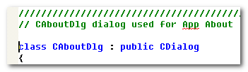

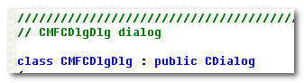
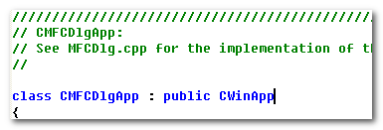

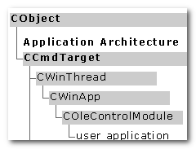
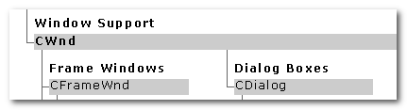
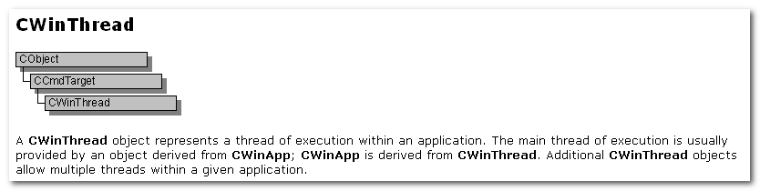
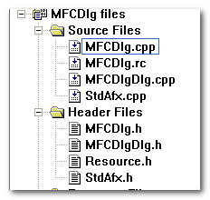
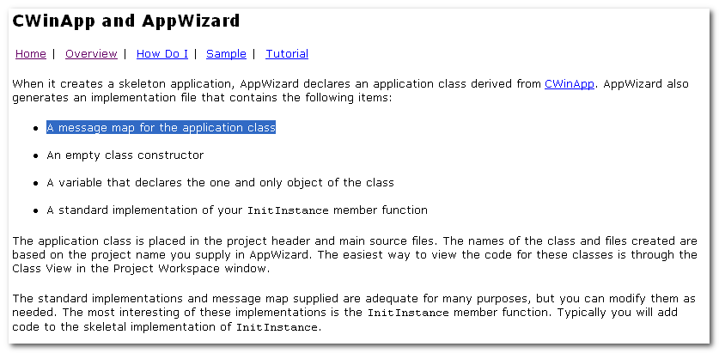

1.2 CWinApp
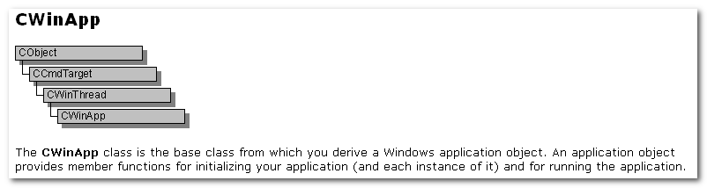

1.2.1 继承自CWinApp的唯一全局类对象的定义
Each app that uses the MFC can only contain one object derived from CWinApp. This obj is constructed when other C++ global objects are constructed and is already available when Windows calls the WinMain function. Declare your derived CWinApp object at the global level.

注：
- 仅能有一个继承自CWinApp的类对象
- 定义一个继承自CWinApp的全局类对象，使其在WinMain完成构造
- 关于CWinApp的构造，稍后再进行跟踪

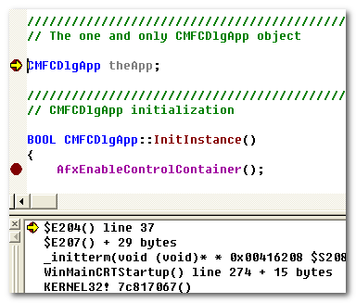

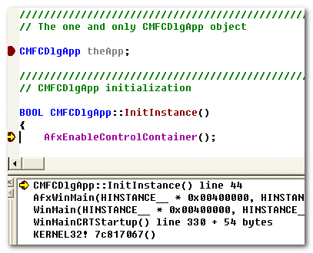

1.2.2 InitInstance 的隐藏
When you derive an app class from CWinApp, Override the InitInstance member function to create your app’s main window object.

注： 在自己的类内重写CWinApp::InitInstance， 以对其进行隐藏



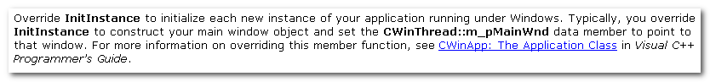
注： 设置CWinThread::m_pMainWnd 指向自己的窗口
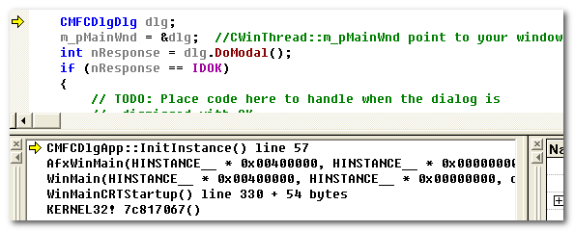

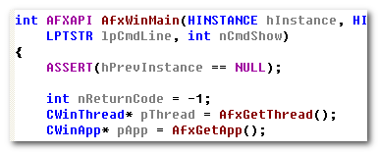

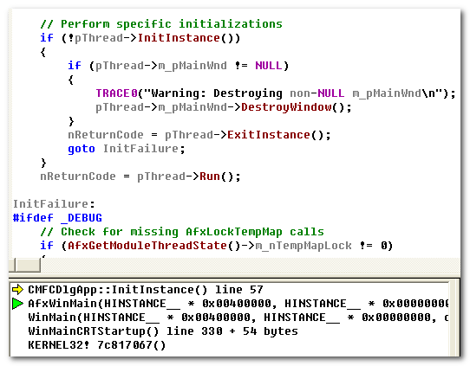
注： 这是AfxWinMain中对m_pMainThread的使用。

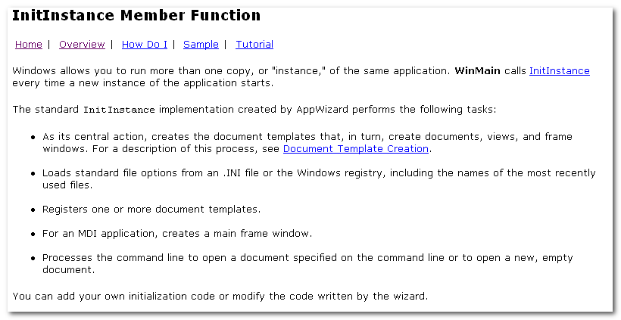

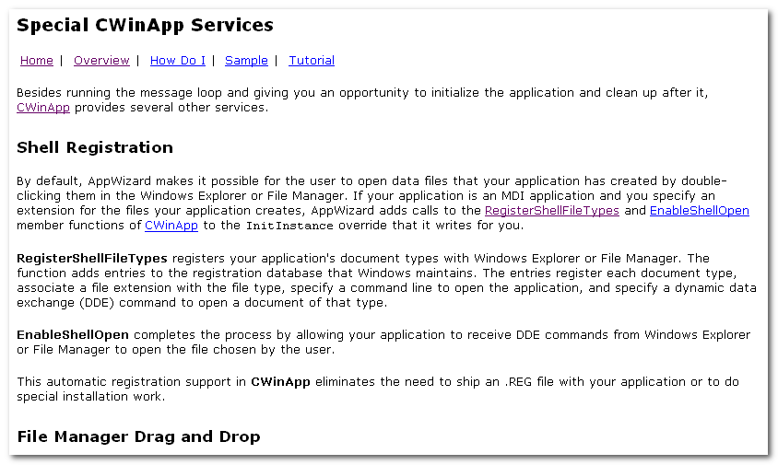

1.2.3 关于CWinApp
上面是从新建的应用角度的跟踪，现在从CWinApp自身的角度来进行了解（前面有全局对象的构造，可作为线索）

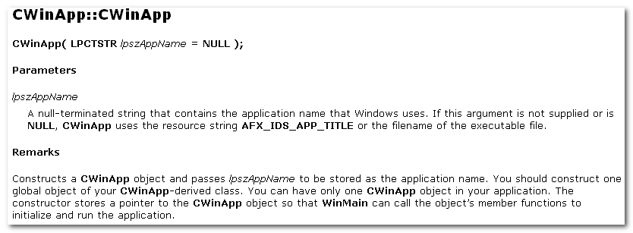
The constructor stores a pointer to the CWinApp object so that WinMain can call the object’s member functions to initialize and run the app.

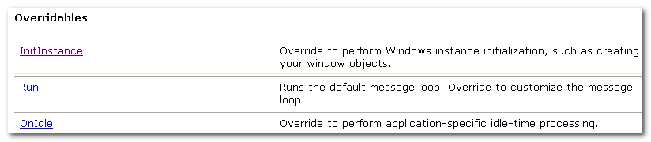

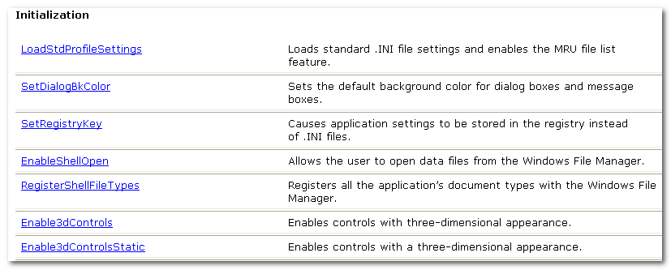

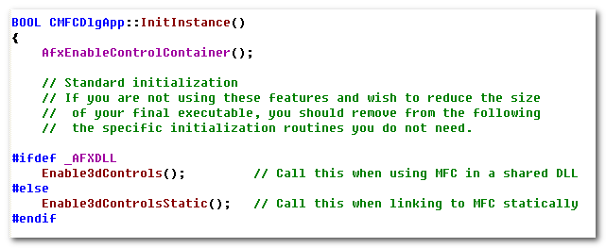

在跟踪CWinApp的构造前，来看下它的继承情况。

1.2.4 CWinThread
Two general types of threads:
- worker threads: no msg pump
- User-interface threads: like CWinApp and classes derived from it

这里没有太明显的信息，先来跟踪下CWinApp的构造

1.2.5 CWinApp的构造
CWinThread 的初始化
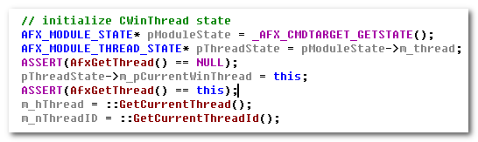

CWinApp
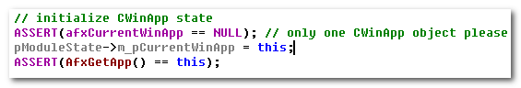

1.2.6 WinMain——InitInstance
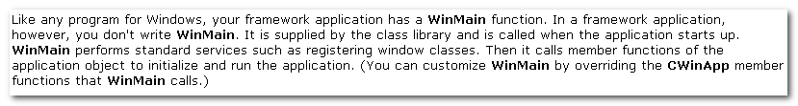
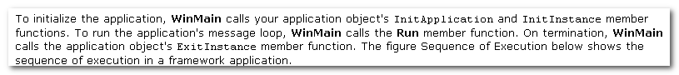

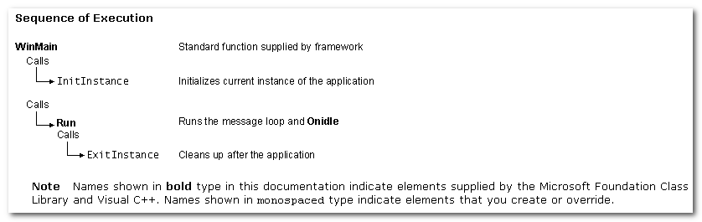
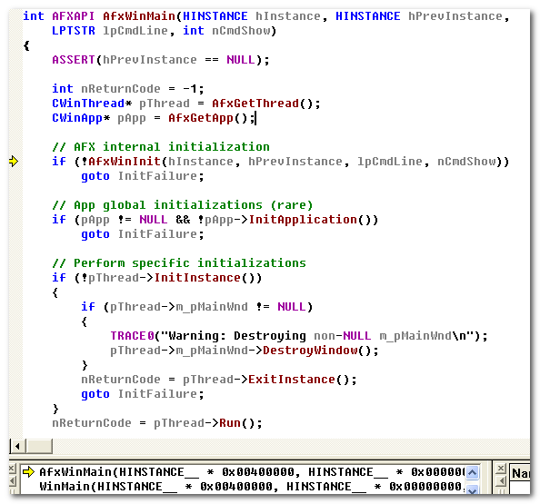

InitInstance:

见前面1.2.2 InitInstance 的隐藏

此外，在不同的应用中，InitInstance的实现不同的，所看到的效果也不一样。
比如： Dialog Based应用中，
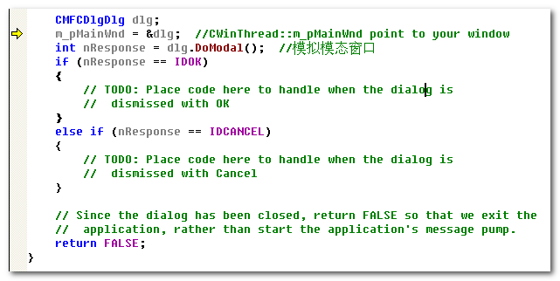

1.2.7 WinMain——Run
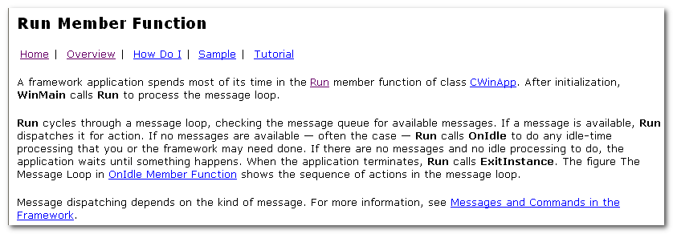
Msg loop, dispatch

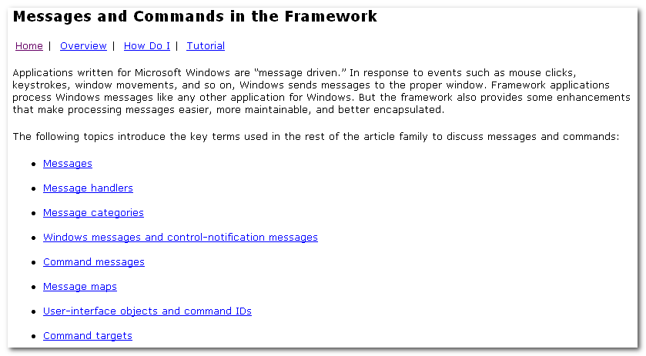
mk:@MSITStore:E:\Program\MSDN\2001OCT\1033\vccore.chm::/html/_core_message_categories.htm

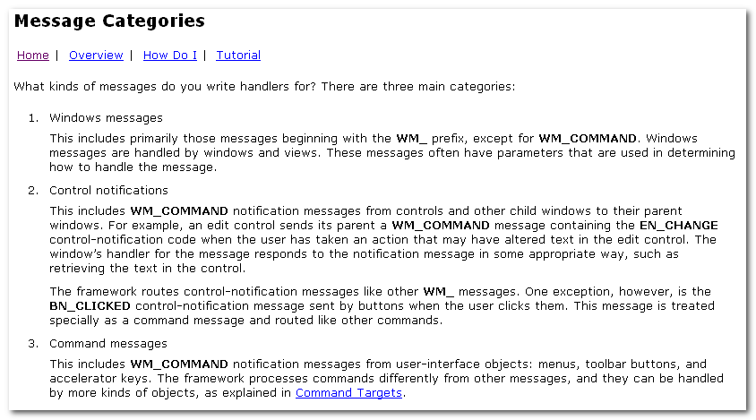
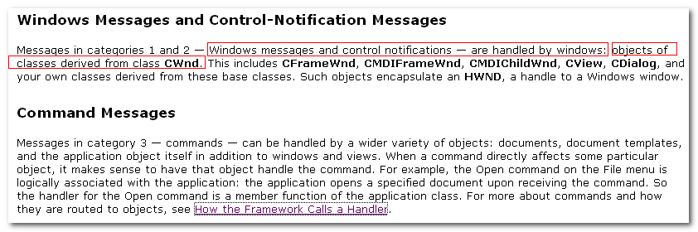

Each object capable of receiving msg or commands has its own msg map that pairs a msg or command with the name of its handler.
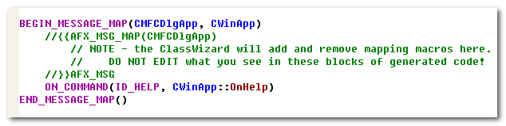
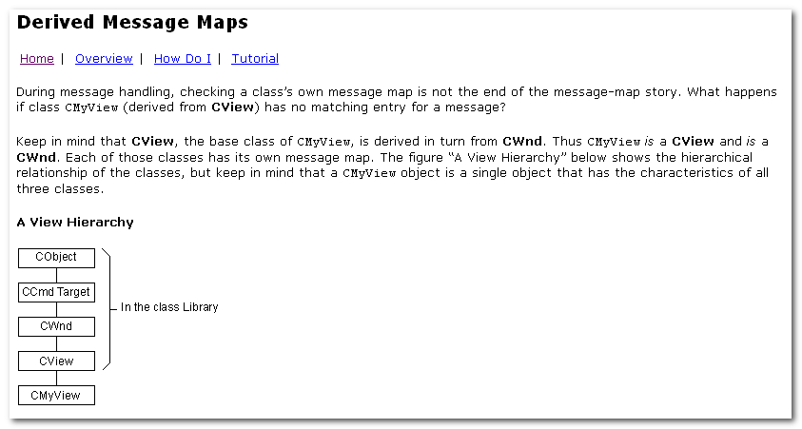
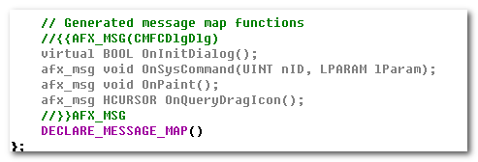

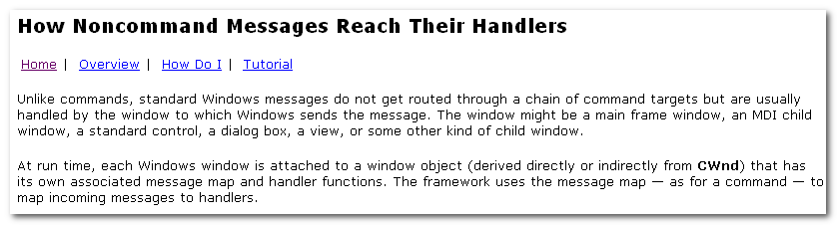
Standard Windows msg do not get routed through a chain of command targets but are usually handled by the window to which Windows sends the msg.

关于Run
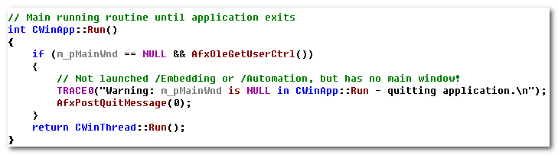
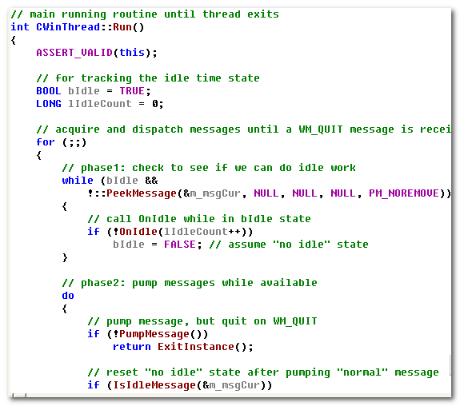

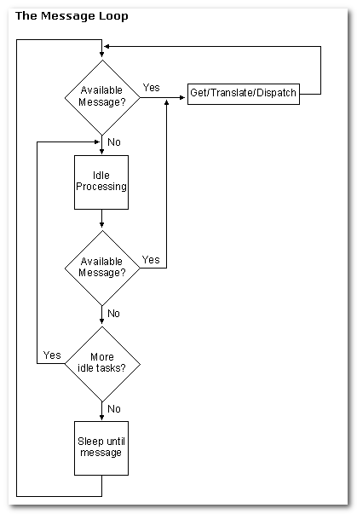
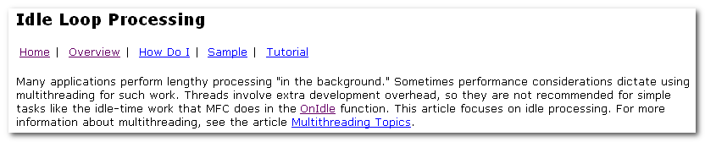

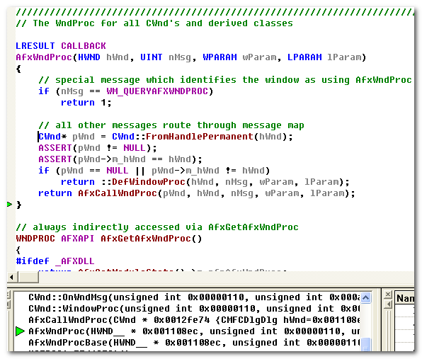
消息处理: AfxWndProc, AfxCallWndProc, CWnd::WinProc, CWnd::OnWndMsg, CDialog::HandleInitDialog

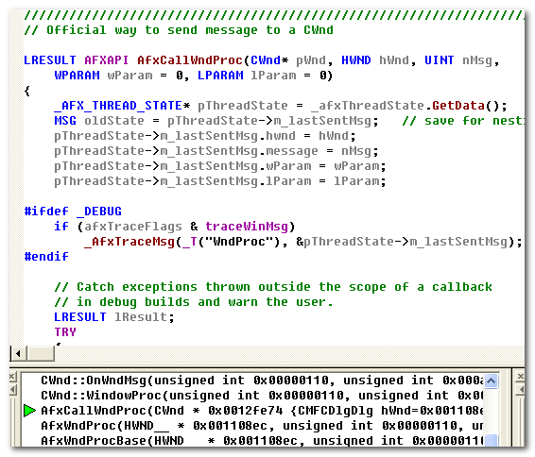
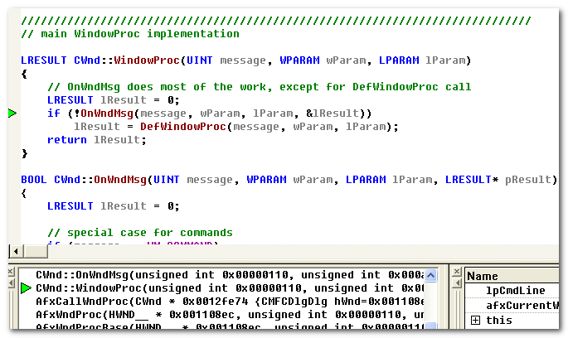
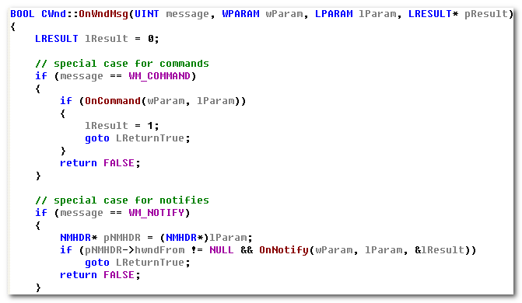

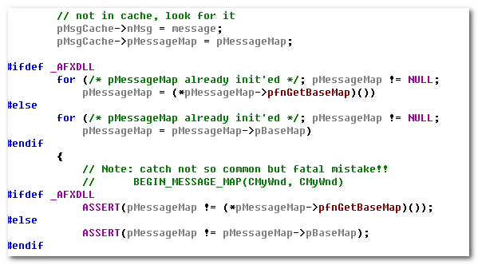

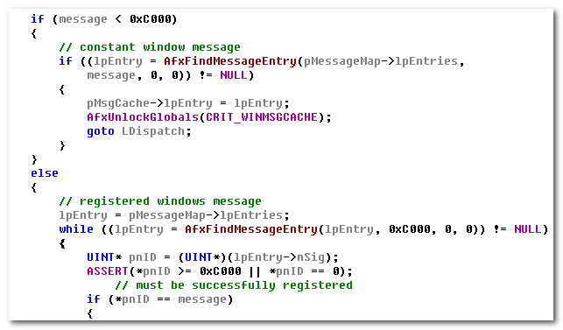

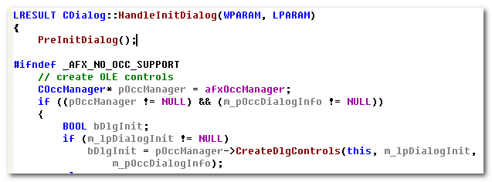

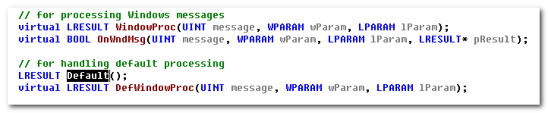

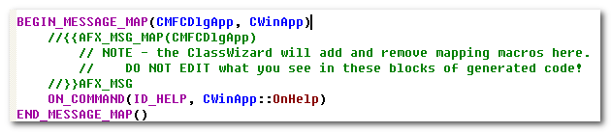

1.2.8 CCmdTarget
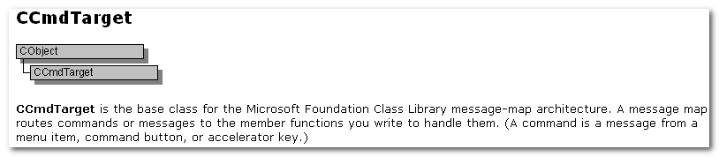

Document / View
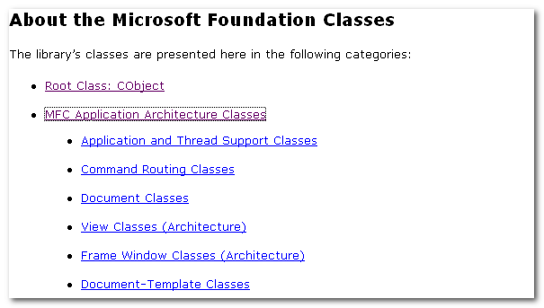
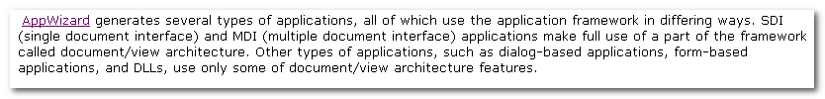
Document/View architecture
所以，还是来了解下Document/View

2.1 类结构与文件结构
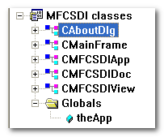
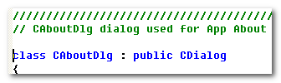
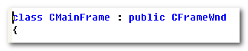
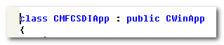
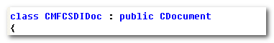
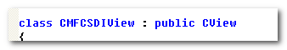
Document / View applications contain one or more sets of documents, views, and frame windows. A document-template object associates the classes for each document/view/frame set.

All MFC apps have at least two objects: an app obj derived from CWinApp, and some sort of main window obj, derived ( often indirectly) from CWnd. (Most of ten, the main window is derived from CFrameWnd, CMDIFrameWnd, or CDialog, all of which are derived from CWnd).

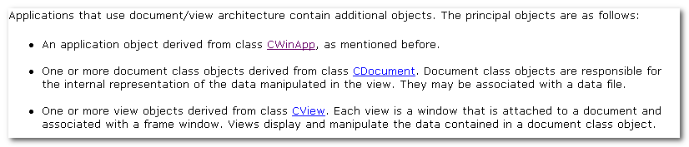

Applications that use document / view arch contain additional objs:
- CWinApp
- One or more document class objects derived from class CDocument. Document class objects are responsible for the internal representation of the data manipulated in the view. They may be associated with a data file.
- One or more view objects derived from class CView. Each view is a window that is attached to a document and associated with a frame window. View display and manipulate the data contained in a document class object.
- Document/View apps also contain frame windows (derived from CFrameWnd) and document templates(derived from CDocTemplate)

