DDX (Dialog Data Exchange)
Dialog Data Exchange and Validation

Dialog data exchange (DDX) is an easy way to initialize the controls in your dialog box and to gather data input by the user.
Dialog data validation (DDV) is an easy way to validate data entry in a dialog box.

Called by the framework to exchange and validate dialog data.

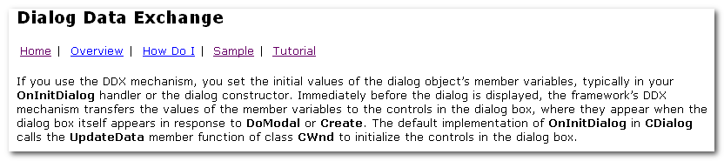
- set the initial values of the dialog obj’s member variables, typically in your OnInitDialog handler or the dialog constructor.

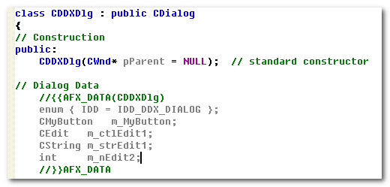
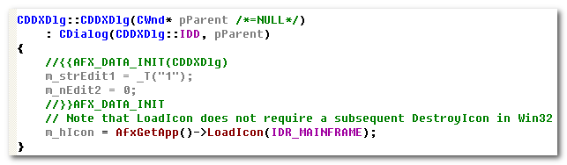

- Transfers the values of the member variables to the controls in the dialog box.
The default of OnInitDialog in CDialog calls the UpdateData member function of class CWnd to initialize the controls in the dialog box.

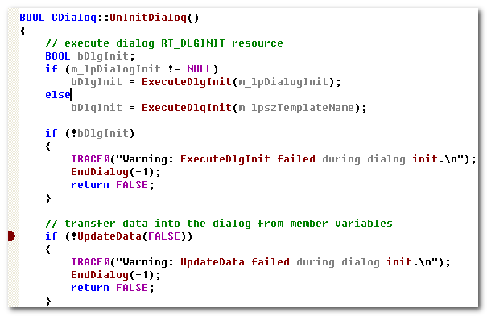

- Transfer values from the controls to the member variables
When the user clicks the OK button ( or whenever you call the UpdateData member function with the argument TRUE).

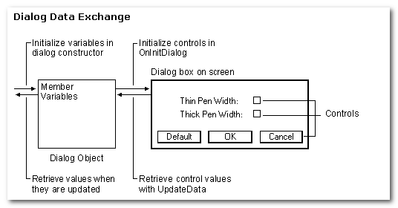
To carry out the exchange, UpdateData sets up a CDataExchange obj and calls your dialog class’s override of CDialog’s DoDataExchange member function. DoDataExchange takes an argument of type CDataExchange. The CDataExchange obj passed to UpdateData represents the context of the exchange, defining such info as the direction of the exchange.

When you override DoDataExchange, you specify a call to one DDX function per data member(control). Each DDX function knows how to exchange data in both directions.
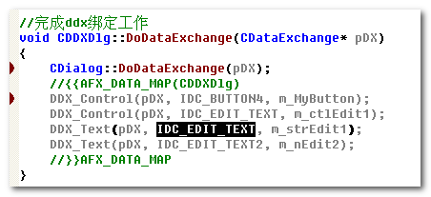

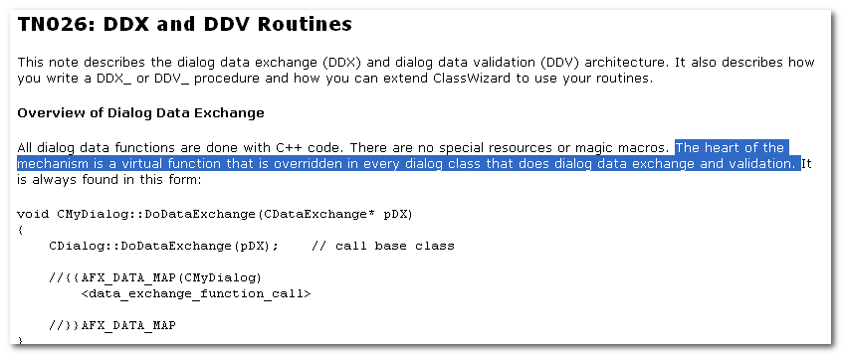

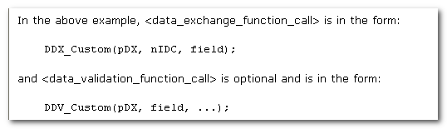’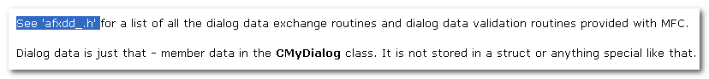
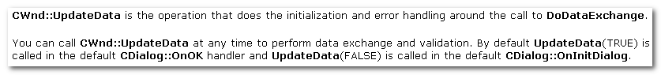
CWnd::UpdateData is the operation that does the initialization and error handling around the call to DoDataExchange.

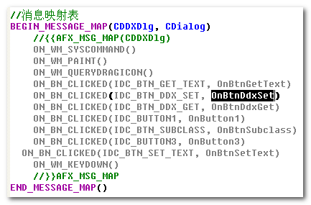
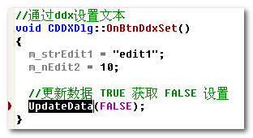
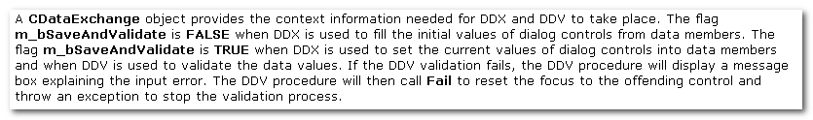
The flag m_bSaveAndValidate is TRUE when DDX is used to set the current values of dialog controls into data members (that is to save data to member variables) and when DDV is used to validate the data values (that is to Validate)
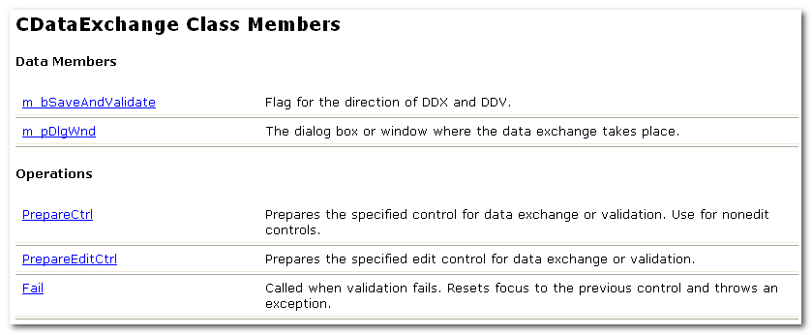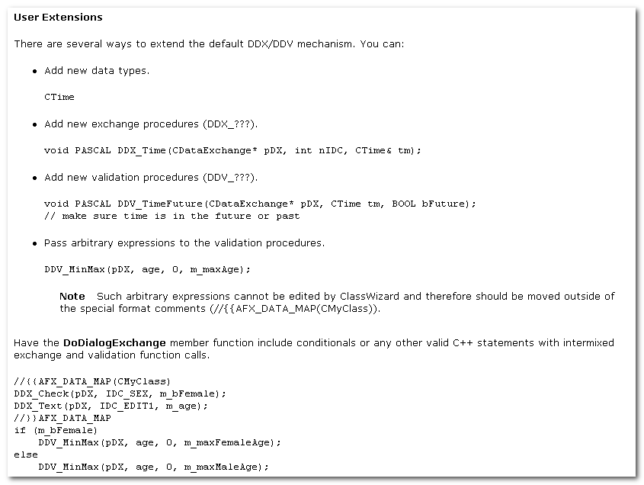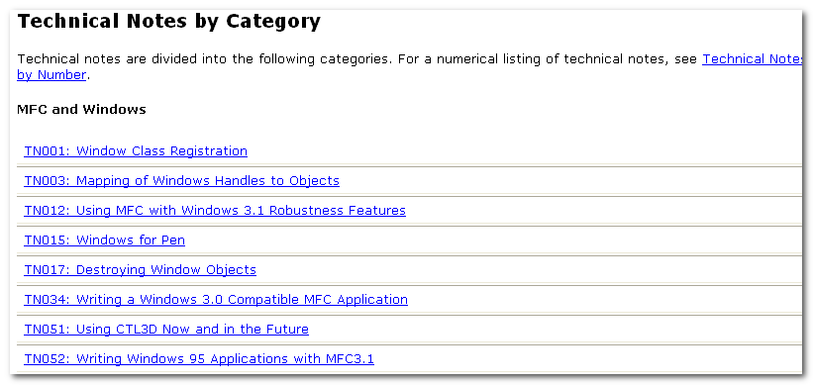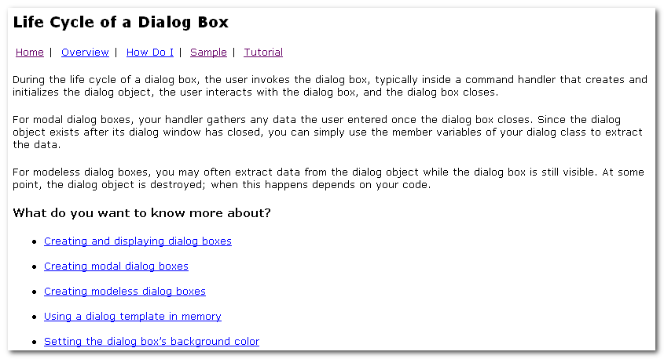.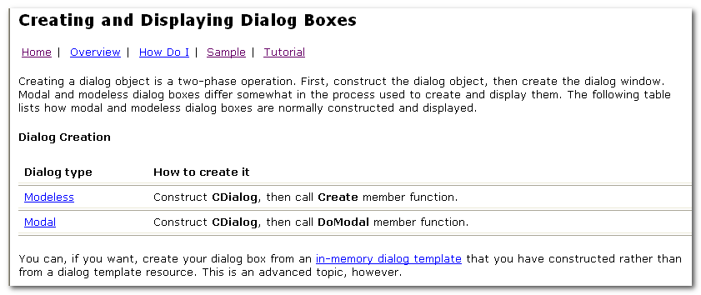

- Xxxx

DDX的类型
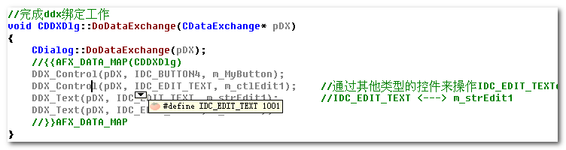
正如这里所体现出来的，有两种类型：
- DDX_Text
- DDX_Control

2.1 DDX_Text (value)
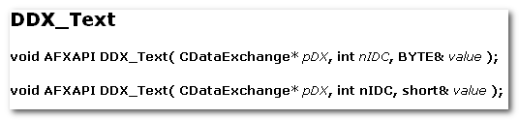
重载实现
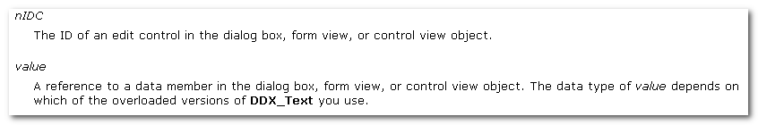

The DDX_Text function manages the transfer of int, UINT... data between an edit control in a dialog box, form view, or control view and a CString data member of the dialog box, form view, or control view object.
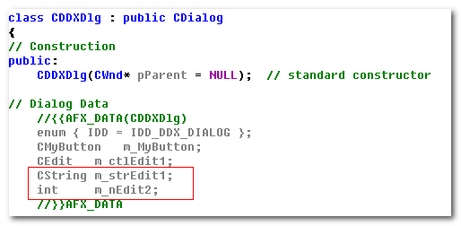
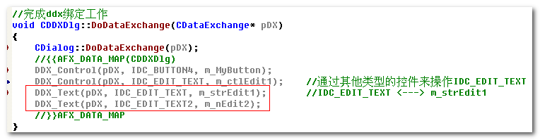

2.2 DDX_Control (control)
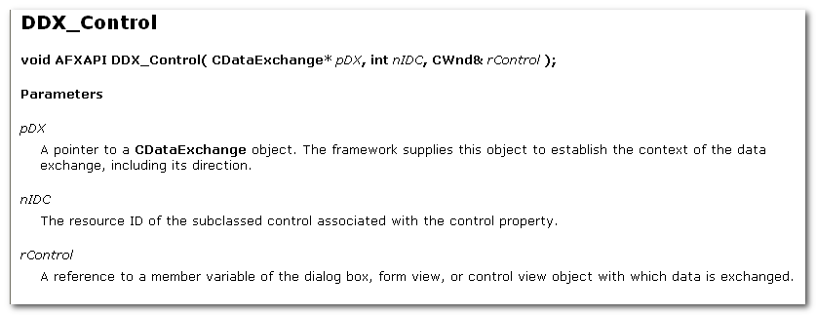
The resource ID of the subclassed control associated with the control property.

A reference to a member variable of the dialog box, form view, or control view obj with which data is exchanged.

The DDX_Control function manages the transfer of data between a subclassed control in a dialog box, form view, or control view obj and a CWnd data member of the dialog box , form view, or control view obj.

这里就涉及到两个概念：
- subclassed control
- CWnd data member

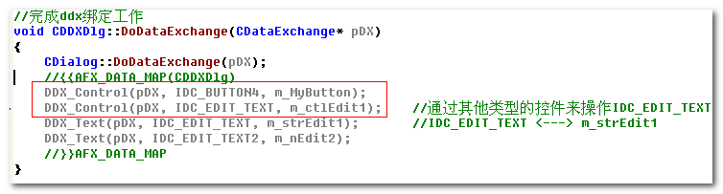
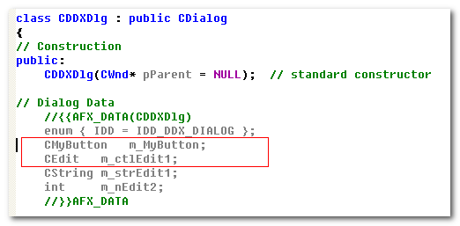
这里就涉及到两个概念：
1) subclassed control (这在后面的子类化中介绍）
2) CWnd data member

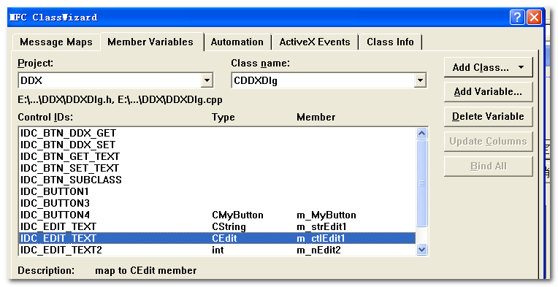
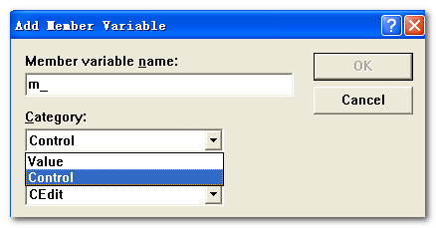

子类化
关键词：
通过修改过程函数，来修改控件的功能
::SetWindowLong

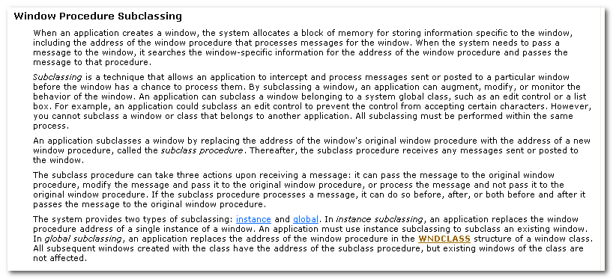
When an app creates a window, the system allocates a block of memory for storing info specific to the window, including the addr of the window procedure that processes msg for the window.
When the system needs to pass a msg to the window, it searches the window-specific info for the address of the window procedure and passes the msg to that procedure.

Subclassing is a technique that allows an app to intercept and process msg sent or posted to a particular window b4 the window has a chance to process them. By subclassing a window, an app can augment, modify, or monitor the behavior of the window.
An app can subclass a window belonging to a system global class, such as an edit control, or a list box.
However, you cannot subclass a window or class that belongs to another application.
All subclassing must be performed within the same process.

An app subclasses a window by replacing the addr of the window’s original window procedure with the addr of a new window procedure, called the subclass procedure. Thereafter, the subclass procedure receives any msg sent or posted to the window.

The subclass procedure can take 3 actions upon receiving a msg:
- it can pass the msg to the original window procedure.
- Modify the msg and pass it to the original window procedure.
- Process the msg and not pass it to the original window procedure.

If the subclass procedure processes a msg, it can do so b4, aft, or both b4 and aft it passes the msg to the original window procedure.

The system provides 2 types of subclassing:
- Instance
An app replaces the window procedure addr of a single instance of a window.
An app must use instance subclassing to subclass an existing window.
- Global
An app replaces the addr of the window procedure in the WNDCLASS structure of a window class.
All subsequent windows created with the class have the address of the subclass procedure, but existing windows of the class are not affected.

3.3 Instance Subclassing (SetWindowLong)
An app subclasses an instance of a window by using the SetWindowLong function.
The app passes the GWL_WNDPROC flag, the handle to the window to subclass, and the addr of the subclass procedure to SetWindowLong.
The subclass procedure can reside in either the app’s executable or dll.

BKZ instance subclassing occurs aft a window is created, you cannot add any extra bytes to the window. App that subclass a window should use the window’s property list to store any data needed for an instance of the subclassed window.

3.4 Global Subclassing
To globally subclass a window, the app must have a handle to a window of the class. The app also needs the handle to remove the subclass.

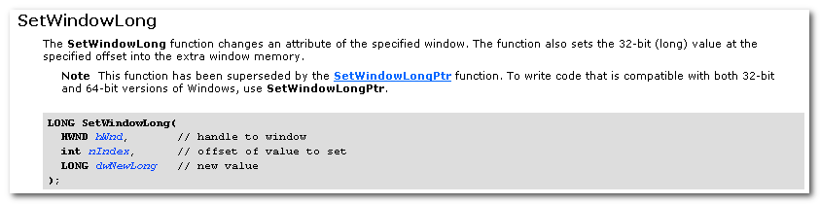
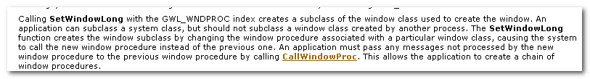
Calling SetWindowLong with the GWL_WNDPROC index creates a subclass of the window class used to create the window. An app can subclass a system class, but should not subclass a window class created by another process.
The SetWindowLong function creates the window subclass by changing the window procedure associated with a particular window class, causing the system to call the new window procedure instead of the previous one. An app must pass any msg not processed by the new window procedure to the previous window procedure by calling CallWindowProc. This allows the app to create a chain of window procedures.

3.1 SDK方式
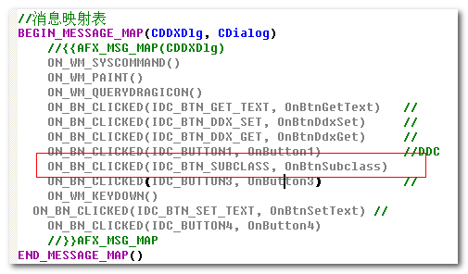

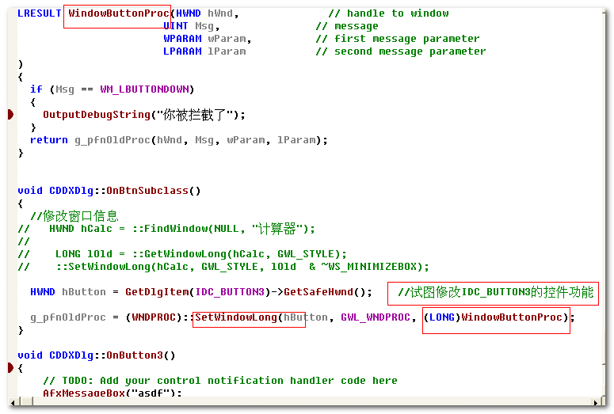

但是这样的直接处理存在问题：
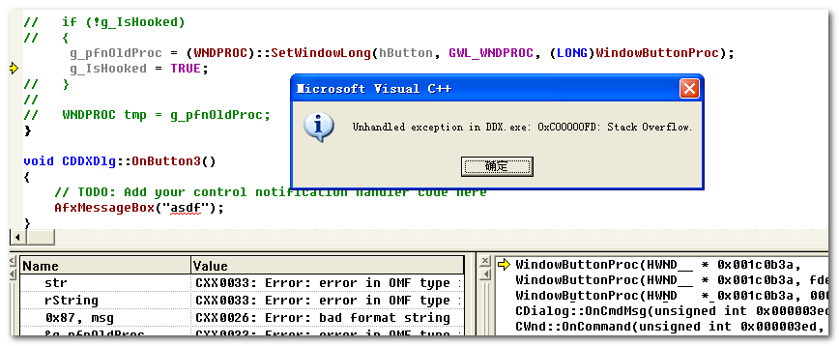

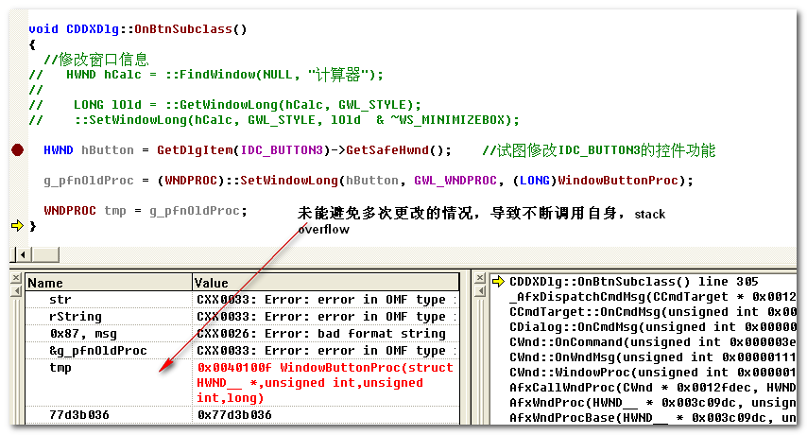

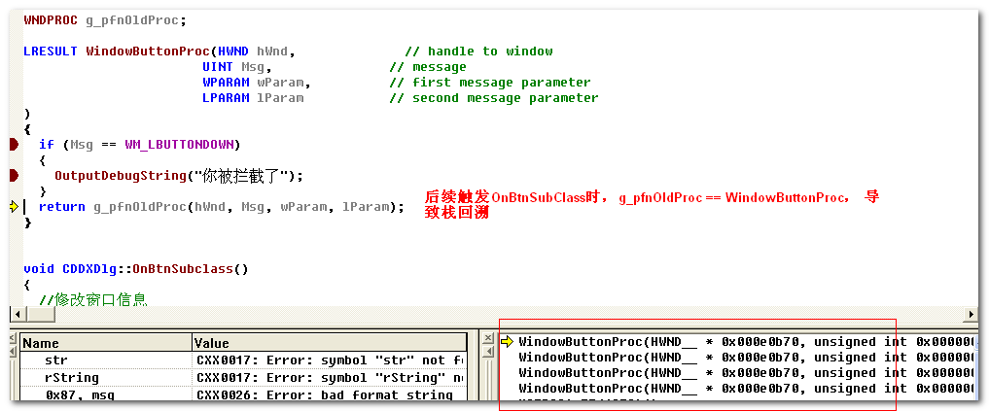

可用如下的方式进行解决——避免多次变换。
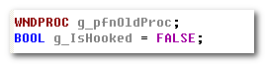
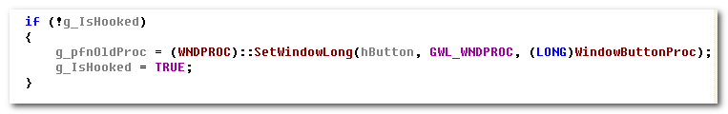

3.2 MFC方式
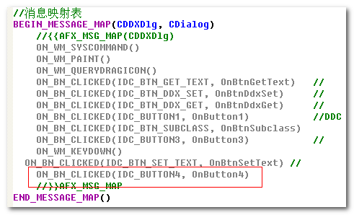
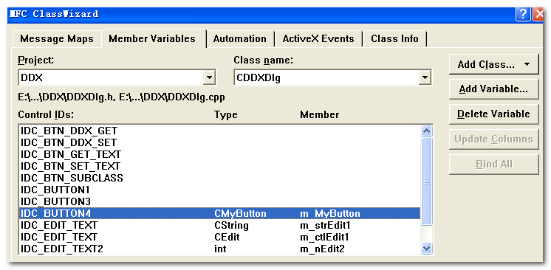
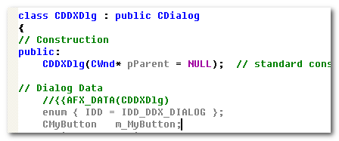
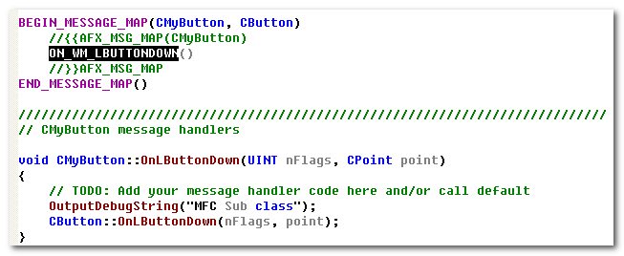

Controls
Each predefined window class has a corresponding set of notification and control messages.
App rely on the notification message to determine when the user has provided input to the controls.
App use the control message to retrieve info from the controls and to manipulate the appearance and behavior of the controls.

When an app creates a control, the control is the child of a window identified by the app. The relationship is important because a control sends msg, called notification msg, to its parent window when events, such as input from the user, occur in the control. The app relies on these notification msg to determine what action the user wants the app to take.

Control Messages:
BKZ controls are windows, an app can manipulate them by using the window-management functions, such as the ShowWindow and EnableWindow functions.
If the window class for a control supports control messages, an app can also manipulate a control of that class by using the SendMessage function to send these message to the control.
A parent window or other windows send control msg to direct a control to perform specific tasks. The window procedure processes these msg and carries out the requested action.

4.1 Edit control
WM_COMMAND msg.
A parent window can send msg to an edit control in a dialog box by calling the SendDlgItemMessage function.

The user makes editing requests by using the keyboard and mouse. The system sends each request to the edit control’s parent window in the form of a WM_COMMAND msg. The msg includes the edit control id in the low-order word of the wParam parameter, the handle of the edit control in the lParam parameter, and an edit notification msg corresponding to the user’s action in the high-order word of the wParam parameter.

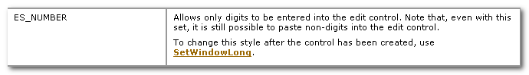

作业

5.1 子类化Edit控件，加入只能输入数字的功能
从上面的Edit Control Window Style 可知，我们可以通过SetWindowLong来进行设置。 只不过，这里不再是GWL_WNDPROC, 而是GWL_STYLE
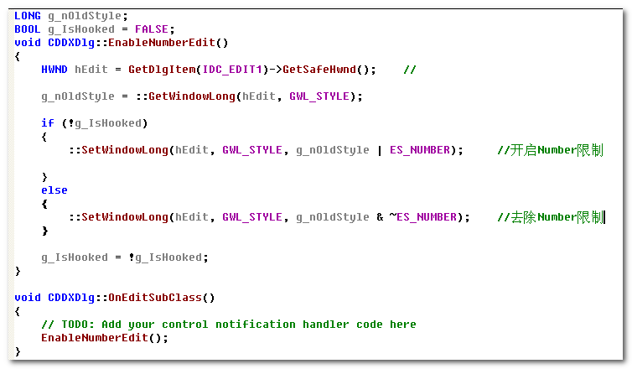

此外,在theAPP进行InitInstance时，默认的进行Number限制。
就可以达到如下的情况
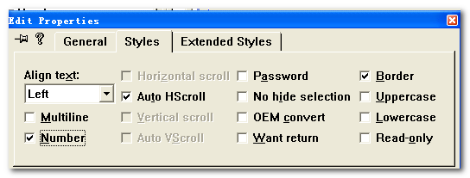

但是，应该知道，不能防止剪切的非数字输入。

5.2 响应Dialog WM_KEYDOWN消息
无论FOCUS在Dialog的哪个控件上，发生按键动作时，都会触发Dialog的WM_KEYDOWN消息。

可以这样设计：
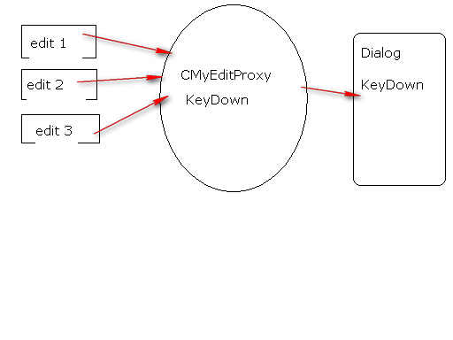
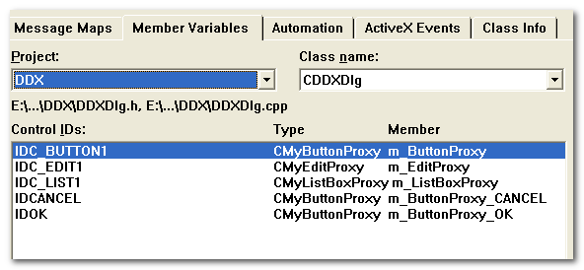
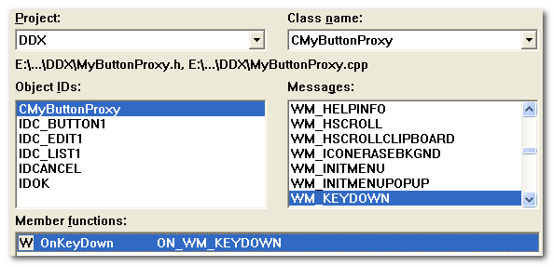

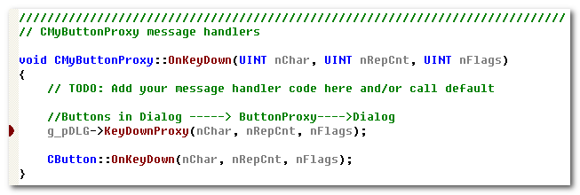
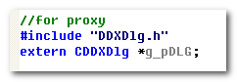
这里使用CDDXDlg *， 以及KeyDownProxy作为Dialog::OnKeyDown的包装，主要是考虑访问问题。

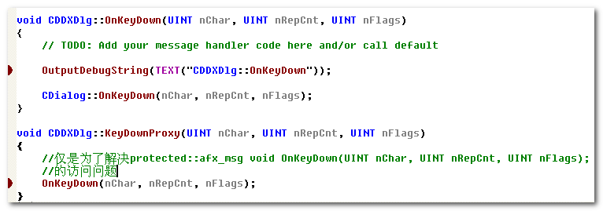
CDDXDlg *g_pDLG;
CDDXDlg dlg;
g_pDLG = &dlg; //for proxy

