画笔、画刷的设置

1.1画笔、画刷相关的属性
CPen
CBrush

1.2 常用控件的使用
如Radio, Edit, Button,
以及一些公用对话框的使用

1.3 主窗口与设置对话框间的通信
不同窗口间的通信

1.4 DC，Pen, Brush
dc.selectobject(pen);
dc.selectobject(brush);

撤销与重做

2.1 逻辑梳理
撤销的可行性
重做的可行性
撤销与重做间的关系
新动作对撤销、重做的影响

2.2 数据结构
链表（栈）2个，分别用于撤销、重做
存放shape对象指针

2.3存在的问题
此时，存在重复释放问题：
- 画线后，shape * 存在主链表中
- 同时，它也存在可撤销链表中
这样，当进程退出时，就存在重复释放问题。

当有不同的动作时，如移动、修改等，撤销、重做的逻辑。
需要考虑可能的重复释放等问题。

可考虑引用计数

不同动作
上面的撤销、重做仅是对画线动作的特定处理。
如果有更多的动作，如移动、修改、旋转等，仍然需要很好的解决多态问题，减小后续新增、修改的复杂性。

可像工厂模式那样进行处理：撤销、重做

撤销、重做是真多具体动作的撤销、重做。
如画动作、移动动作。

http://blog.csdn.net/lcl_data/article/details/9080909
http://blog.csdn.net/playstudy/article/details/7864007

引用计数
为解决不同动作所、撤销、重做，所引起的图形指针被存放在不同的链表中，可能的重复释放问题。

此时引用计数的引入，需要考虑如下问题：
- 保证View中工厂模式正确的生产对象
- 保证图形的保存、撤销、重绘，相应的链表
- 同时，要尽可能变动较小。

关于引用计数：
- 以资源为中心的单独计数
- 可将引用计数融入到原功能类中进行实现
这样改动较大，但思路比较清晰
- 引用计数类和功能类分离，让功能类继承引用计数， 可
- 引用计数类和功能类分离，让引用计数继承功能类

不同动作
无论是上面的撤销、重做，还是计数问题，都离不开具体动作的讨论。
所以，先来考虑不同动作。

Graphic Objects
Windows provides a variety of drawing tools to use in device contexts.
It provides pens to draw lines, brushes to fill interiors, and fonts to draw text.
MFC provides graphic-object classes equivalent to the drawing tools in windows.
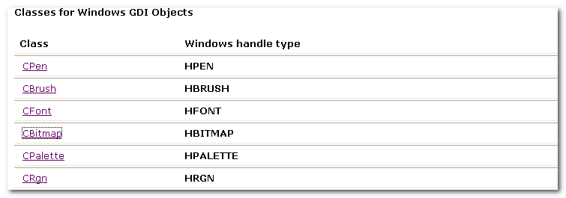
Each graphic-object class in the class library has a cast operator that will cast an MFC object to the associated windows handle.
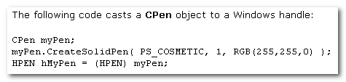

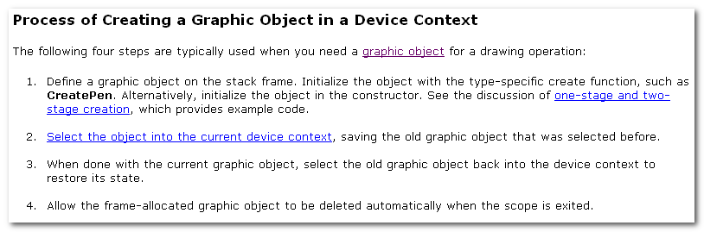

One-stage and two-stage creation.
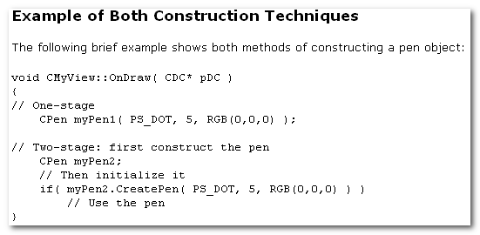
Two-stage construction is always safer.
In one-stage construction, the constructor could throw an exception if you provide incorrect arguments or memory allocation fails.
That problem is avoided by two-stage construction, although you do have to check for failure.

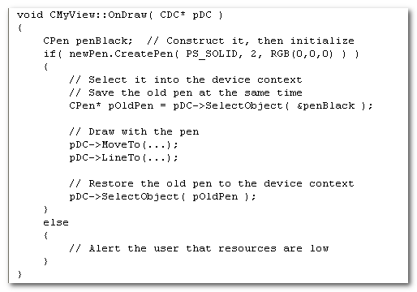
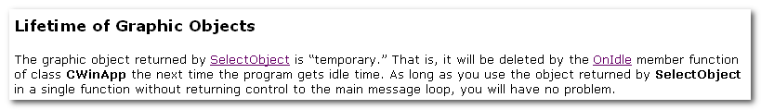

Device Contexts
A device context is a windows data structure containing info about the drawing attributes of a device such as a display or a printer.
All drawing calls are made through a device-context object, which encapsulates the Windows APIs for drawing lines, shapes, and text.

Device contexts allow device-independent drawing in Windows, can be used to draw to the screen, to the printer, or to a metafile.

7.1 CDC
CDC
The CDC objects provides member functions for working with a device context, such as a display or printer, as well as members for working with a display context associated with the client area of a window.

Do all drawing through the member functions of a CDC object.
The class provides member functions for device-context operations,
- working with drawing tools, type-safe GDI object selection,
- Working with colors and palettes
- Getting and setting drawing attributes
- Mapping, working with the viewport
- Working with the window extent
- Converting coordinates
- Working with regions
- Clipping,
- Drawing lines, and drawing simple shapes, ellipses, and polygons.
- Drawing text, working with fonts, using printer escapes, scrolling, and playing metafiles.

Derived classes:
- CPaintDC encapsulates calls to BeginPaint and EndPaint.
- CClientDC manages a display context associated with a window’s client area.
- CWindowDC manages a display context associated with an entire window, including its frame and controls.
- CMetaFileDC associates a device context with a metafile.

CreateCompatibleDC: Creates a memory-device context that is compatible with another device context. You can use it to prepare images in memory.

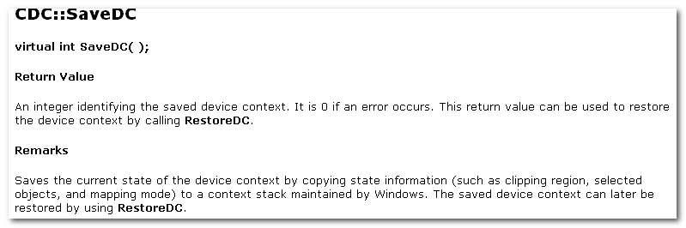
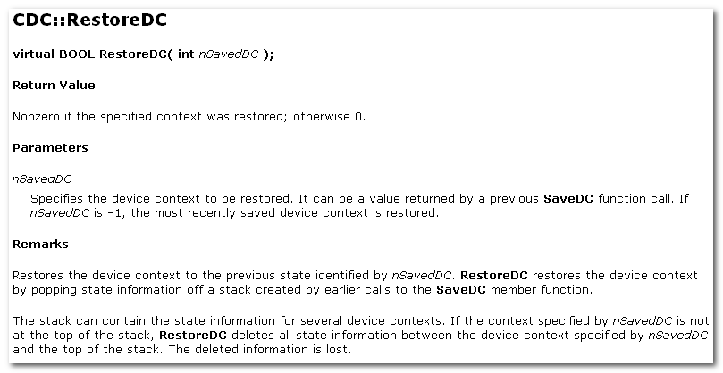
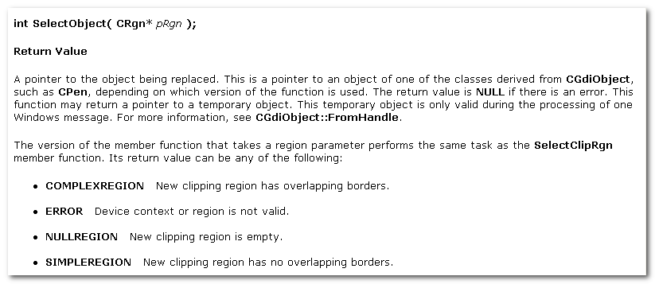

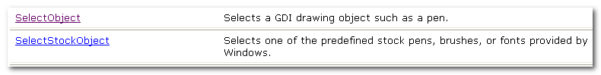
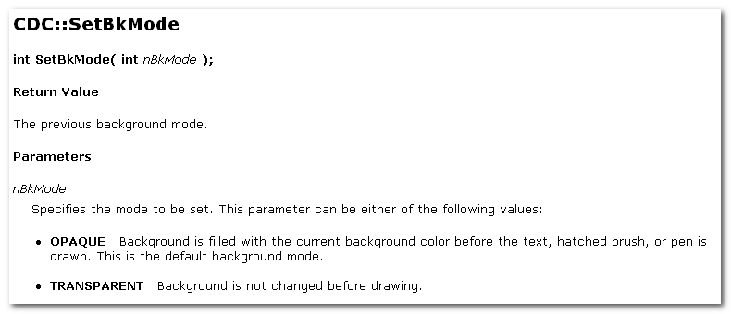
OPAQUE TRANSPARENT
The background mode defines whether the system removes existing background colors on the drawing surface b4 draw text, hatched brushes, or any pen style that is not a solid line.

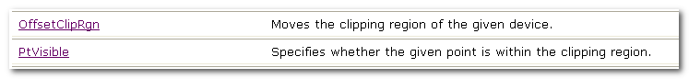

7.2 CPaintDC
CPaintDC objects
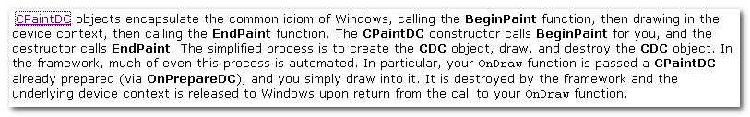
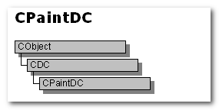

CClientDC objects
CMetaFileDC objects

Drawing in View

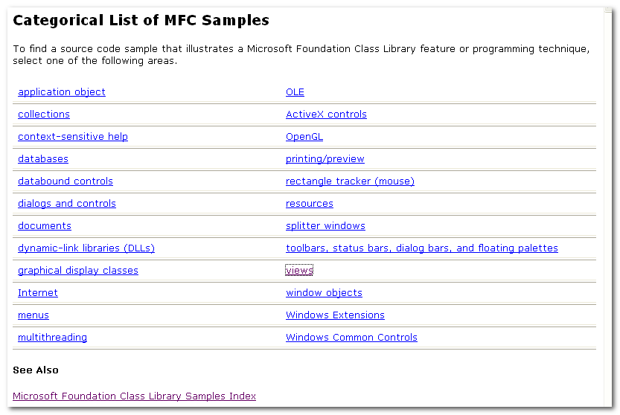

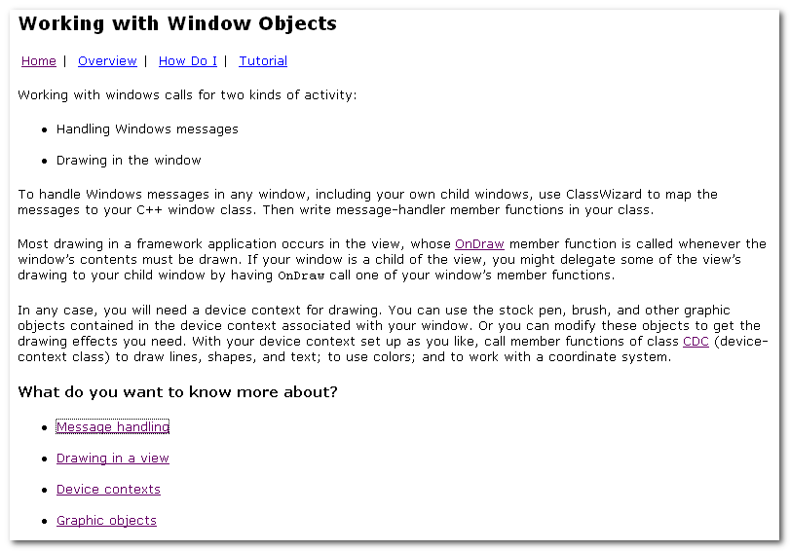

Your app might need to implement direct mouse drawing in the view.
The Scribble tutorial example shows how to handle the WM_LBUTTONDOWN, WM_MOVESEMOVE, and WM_LBUTTONUP messages respectively to begin, continue, and end the drawing of a line segment.
On the other hand, you might sometimes need to interpret a mouse click in your view as a selection. Your view’s OnLButtonDown handler function would determine whether the user was drawing or selecting.
If selecting, the handler would determine whether the click was within the bounds of some object in the view and, if so, alter the display to show the object as selected.

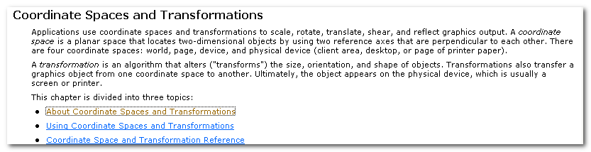
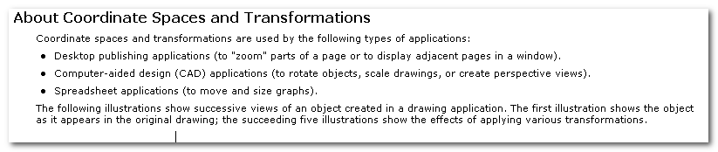
Coordinate Spaces and Transformations

