Serialization (Object Persistence)
‘Serialization’ is the process of writing or reading an object to or from a persistent storage medium.
Allow objects to persistent between runs of your program.

The basic idea of serialization is that an object should be able to write its current state, usually indicated by the value of its member variables, to persistent storage.
Later, the object can be re-created by reading, or deserializing, the object’s state from the storage.
Serialization handles all the details of object pointers and circular references to objects that are used when you serialize an object.
A key point is that the object itself is responsible for reading and writing its own state.
Thus, for a class to be serialization, it must implement the basic serialization operations.

MFC uses an object of the CArchive class as an intermediary between the object to be serialized and the storage medium.
The object is always associated with a CFile object, from which it obtains the necessary info for serialization, including the file name and whether the requested operation is a read or write.
The object that performs a serialization operation can use the CArchive object without regard to the nature of the storage medium.

A CArchive object uses overloaded insertion ( <<) and extraction(>>) operations to perform writing and reading operations.
The CArchive class is for binary-format serialized objects.
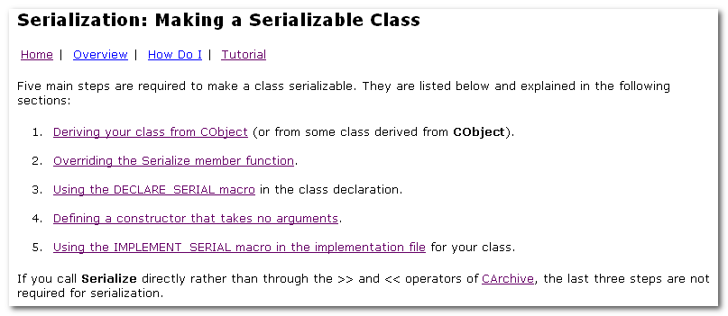

The Serialize member function, which is defined in the CObject class, is responsible for actually serializing the data necessary to capture an object’s current state.

CArchive::Read and CArchive::Write member functions to read and write large amounts of untyped data.

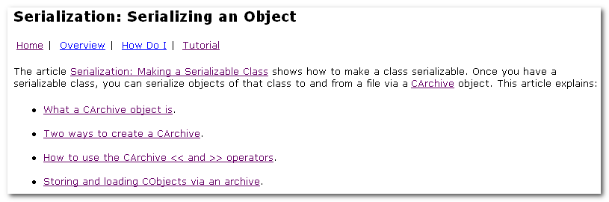
Once you have a serializable class, you can serialize objects of that class to and from a file via CArchive object.

Translate data between a file and your serialization object by using the << and >> operators for CArchive or , in some cases, by calling the Serialize function of a CObject-derived class.

A CArchive object provides a type-safe buffering mechanism for writing or reading serializable objects to or from a CFile object.

The life of a CArchive object is limited to one pass through writing objects to a file or reading objects from a file.

When an archive stores objects to a file, the archive attaches the CRuntimeClass name to the objects.
Then, when another archive loads objects from a file to memory, the CObject-dervied objects are dynamically reconstructed based on the CRuntimeClass of the objects.

A given object may be referenced more than once as it is written to the file by the storing archive.
The loading archive, however, will reconstruct the object only once.

Buffering
As data is serialized to an archive, the archive accumulates the data until its buffer is full. Then the archive writes its buffer to the CFile object pointed to by the CArchive object.
Similarly, as you read data from an archive, it reads data from the file to its buffer and then from the buffer to your deserialized object.
This buffering reduces the number of times a hard disk is physically read, thus improving your application’s performance.

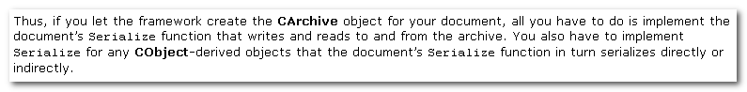

In certain cases, you should call the Serialize function of the object, where the CArchive object is a parameter of the Serialize call, as opposed to using the << or >> operator of the CArchive.

The important fact to keep in mind is that the CArchive >> operator constructs the COjbect in memory based on CRuntimeClass info previously written to the file by the storing archive.

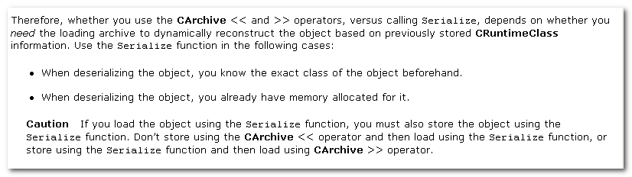

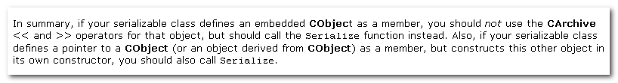

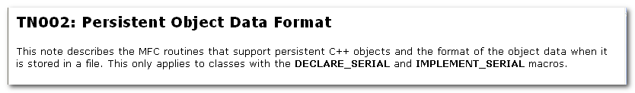

Persistent Object Data Format

The MFC implementation for persistent data relies on a compact binary format for saving the data for many objects in a single contiguous part of a file.
The binary format provides the structure for how the data is stored, but it is the object’s Serialize member function that provides the actual data saved by the object.

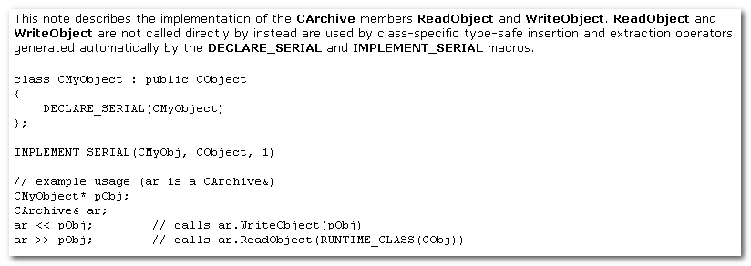
Arcobj.cpp
Arccore.cpp

CArchive::WriteObject, ReadObject

CArchive::WriteObject:
Writes header data used to reconstruct the object: the type of the object and the state of the object.
This member function is also responsible for maintaining the identity of the object being written out, so that only a single copy is saved, regardless of the number of pointers to that object ( including circular pointers).

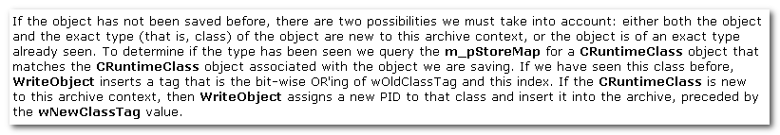

Calling Serialize Directly
There are many cases where the overhead of the general object archive schema of WriteObject and ReadObject is not necessary or desired.
This is the common case of serializing the data into a CDocument.
In this case the Serialize member function of the CDocument is called directly, not with the extract or insert operators. The contents of the document may in turn use the more general object archive schema.

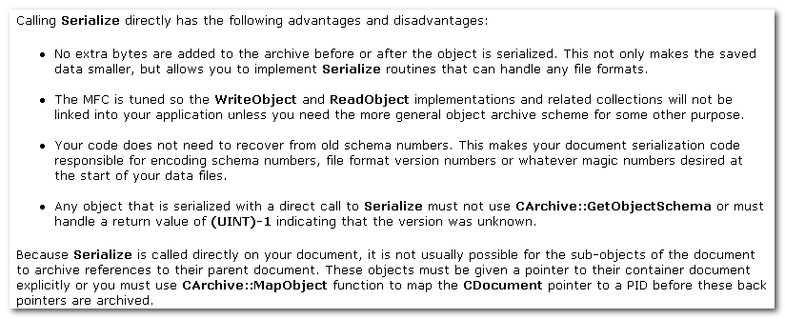

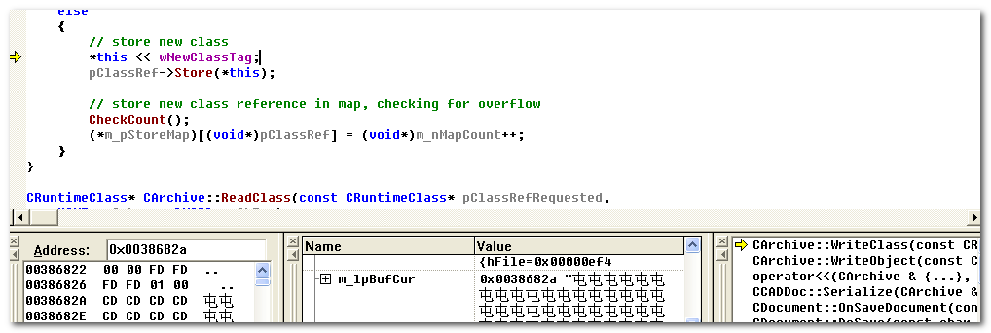
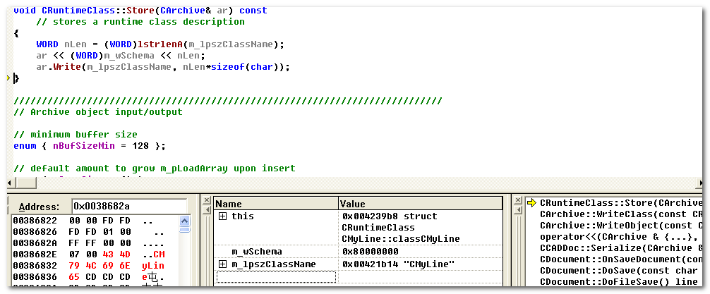
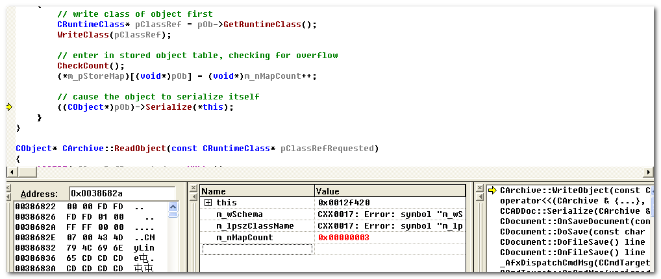
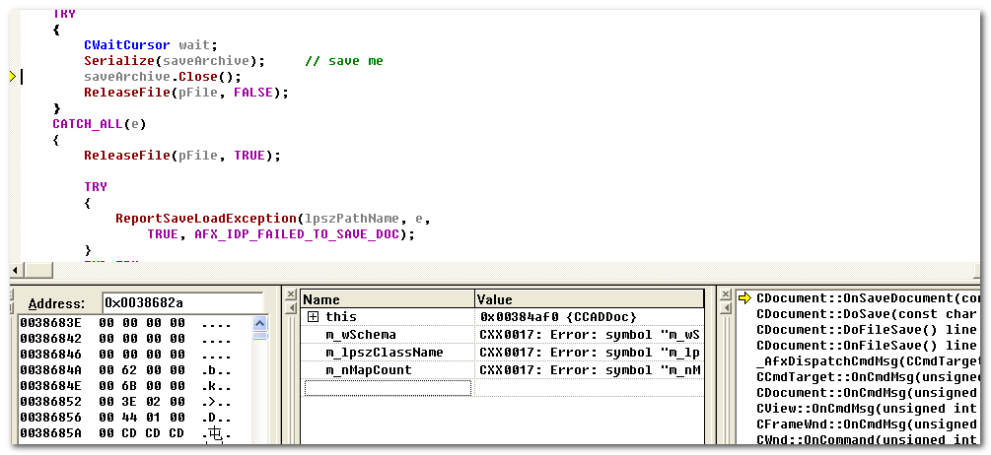
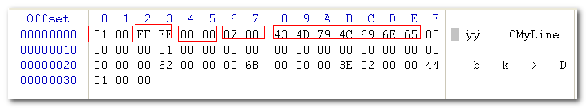

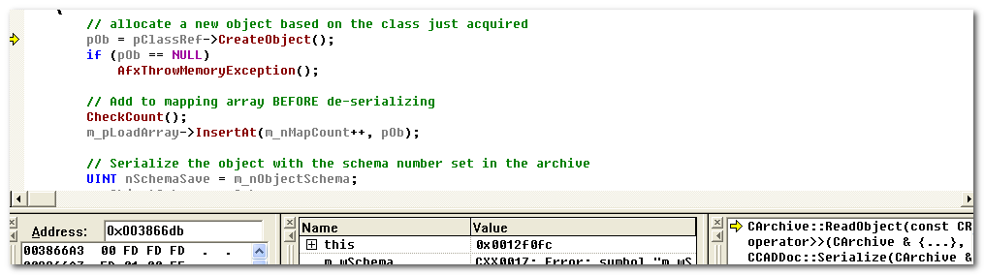
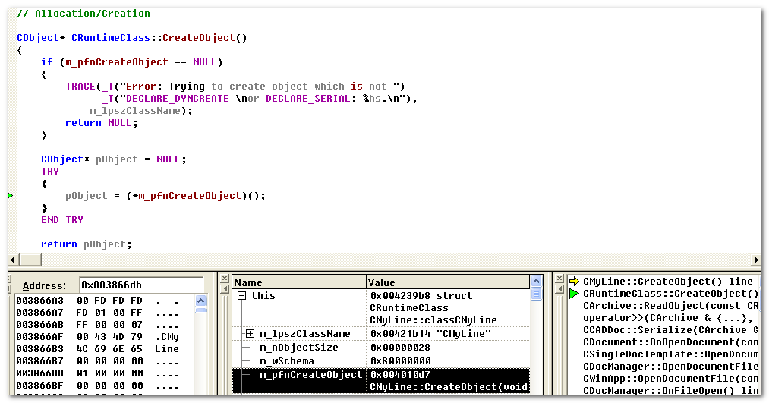
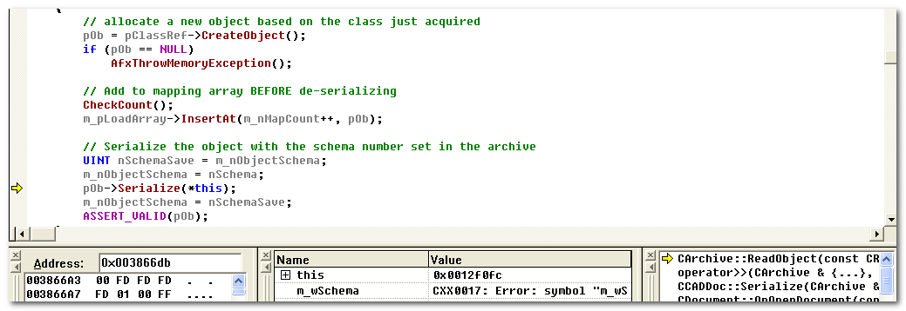

CArchive
