寻址方式
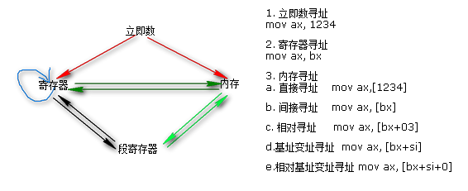
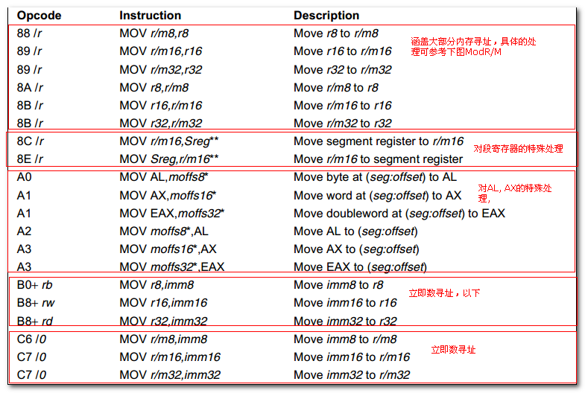
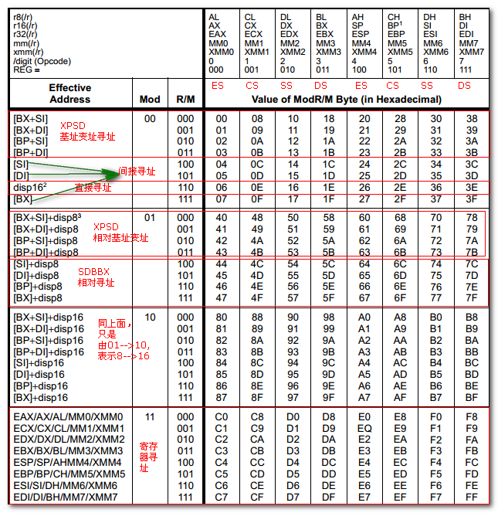

各指令
以IA32 VOL2 手册为准，进行解读，注意相关细节。
IA-32 Intel Architecture Software Developer's Manual Volume 2 Instruction Set Reference 1.pdf

2.1 XCHG
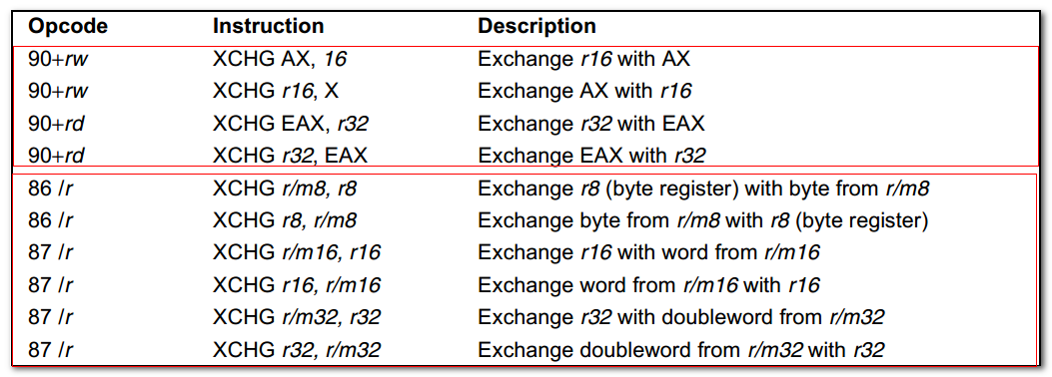
Exchanges the contents of the destination ( first） and source (second) operands.
- The operands can be two general-purpose registers
- Or a register and a memory location.
- If a memroy operand is referenced, the processor’s locking protocol is automatically implemented for the duration of the exchange operation, regardless of the presence or absence of the LOCK prefix or of the value of the IOPL).
- Useful for implementing semaphores or similar data structure for process synchronization.

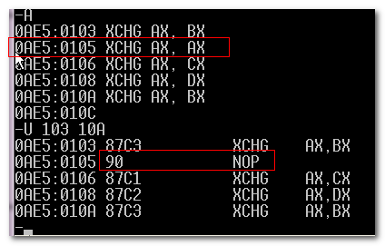
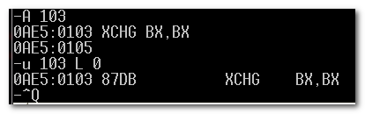
常用的占位指令：
- NOP
- XCHG AX, AX
- MOV DI, DI
像这些，不会有什么影响的指令。

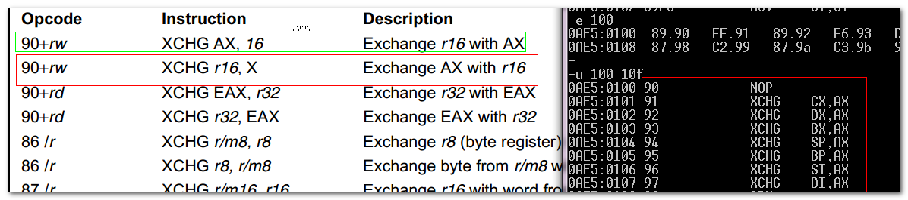
对AX的特殊处理。

不太理解这里的两个90 + rw, 90+rd 以及下面的86 /r, 87 /r
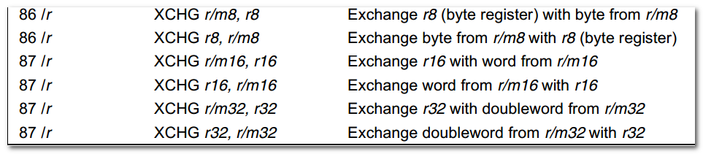
只能在两者中选择一个。
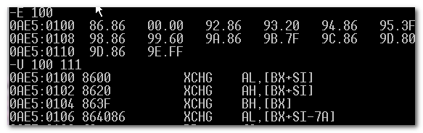

可重用之前的代码进行编程实现。

2.2 XLAT / XLATB ---- Table Loop-up Translation
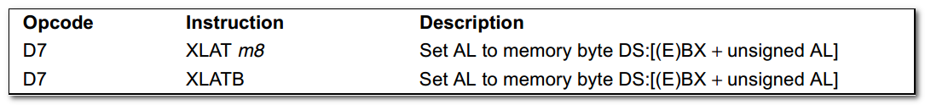
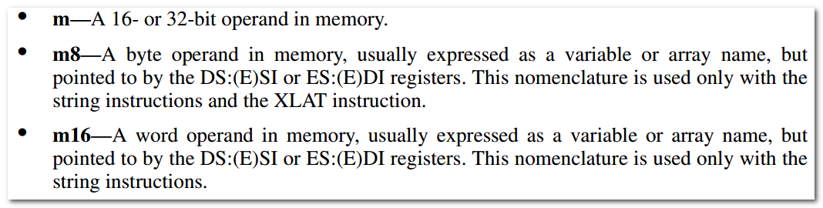
Set AL to memory byte DS:[BX+unsigned AL]

Locates a byte entry in a table in memory, using the contents of the AL register as a table index, then copies the contents of the table entry back into the AL register.

The XLAT and XLATB instructions get the base address of the table in memory from DS:EBX or DS:BX (depending on the address-size attribute of the instruction, 32 or 16). (DS can be overridden.)

The base address is always specified by the DS:(E)BX registers, which must be loaded correctly before the XLAT instruction is executed.

If AddressSize = 16
Then
AL <---(DS:BX + ZeroExtend(AL))
ELSE
AL <--(DS:EBX + ZeroExtend(AL))

