JMP
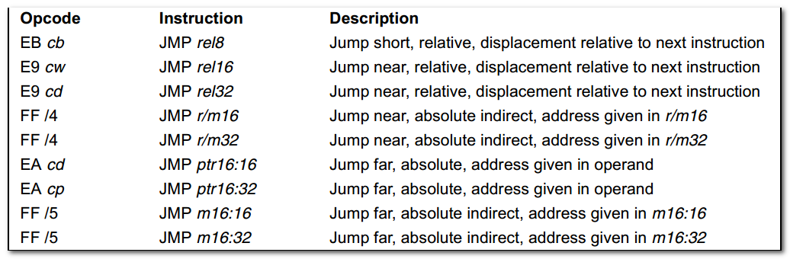
Cb, cw, cd, cp: A 1-byte, 2-byte, 4-byte, or 6-byte value following the opcode that is used to specify a code offset and possibly a new value for the code segment register.

Rel8: A relative address in the range from 128 bytes b4 the end of the instruction to 127 bytes after the end of the instruction.
Rel16 and rel32: A relative address within the same code segment as the instruction assembled.

Ptr16:16 and ptr16:32 --- A far pointer, typically in a code segment different from that of the instruction. The notation 16:16 indicates that the value of the pointer has two parts. The value to the left of the colon is a 16-bit selector or value destined for the code segment register. The value to the right corresponds to the offset within the destination segment.

Transfers program control to a different point in the instruction stream without recording return information.
The destination(target) operand specifies the address of the instruction being jumped to.
This operand can be an immediate value, a general-purpose register, or a memory location.

This instruction can be used to execute four different types of jumps:
- Near jump : A jump to an instruction within the current code segment, sometimes referred to as an intrasegment jump. (2byte)

- Short jump: A near jump where the jump range is limited to -128 to +127 from the current EIP value. (1byte)

- Far jump --- A jump to an instruction located in a different segment than the current code segment but at the same privilege level, sometimes referred to as an intersegment jump.

Near and Short Jumps
When executing a near jump, the processor jumps to the address (within the current code segment) that is specified with the target operand.
The target operand specifies
- either an absolute offset ( that is an offset from the base of the code segment)
- Or a relative offset ( a signed displacement relative to the current value of the instruction pointer in the EIP register)

A near jump to a relative offset of 8-bits(rel8) is referred to as a short jump.

An absolute offset is specified indirectly in a general-purpose register or a memory location(r/m16 or r/m32). Absolute offset are loaded directly into the EIP register.

A relative offset(rel8, rel16, or rel32) is generally specified as a label in assembly code, but at the machine code level, it is encoded as a signed 8-, 16-, or 32-bit immediate value. The value is added to the value in the EIP register. (Here, the EIP register contains the address of the instruction following the JMP instruction.)

跳转影响程序执行效率。

Jcc
无符号数:
Above 高
Below 低

有符号数
Greater 大
Less 小

LOOP

